On entering the church

P Lord, I love the habitation of Your house and the place

where Your glory dwells. In the multitude of Your tender

mercies prepare my heart that I may enter Your house to

worship and confess Your holy name; through Jesus Christ,

my God and Lord.

Before worship

C O Lord, our creator, redeemer, and comforter, as we come

together to worship You in spirit and in truth, we humbly

pray that You would open our hearts to the preaching of

Your Word so that we may repent of our sins, believe in

Jesus Christ as our only Savior, and grow in grace and

holiness. Hear us for His sake.

571 God Loved the World So That He Gave

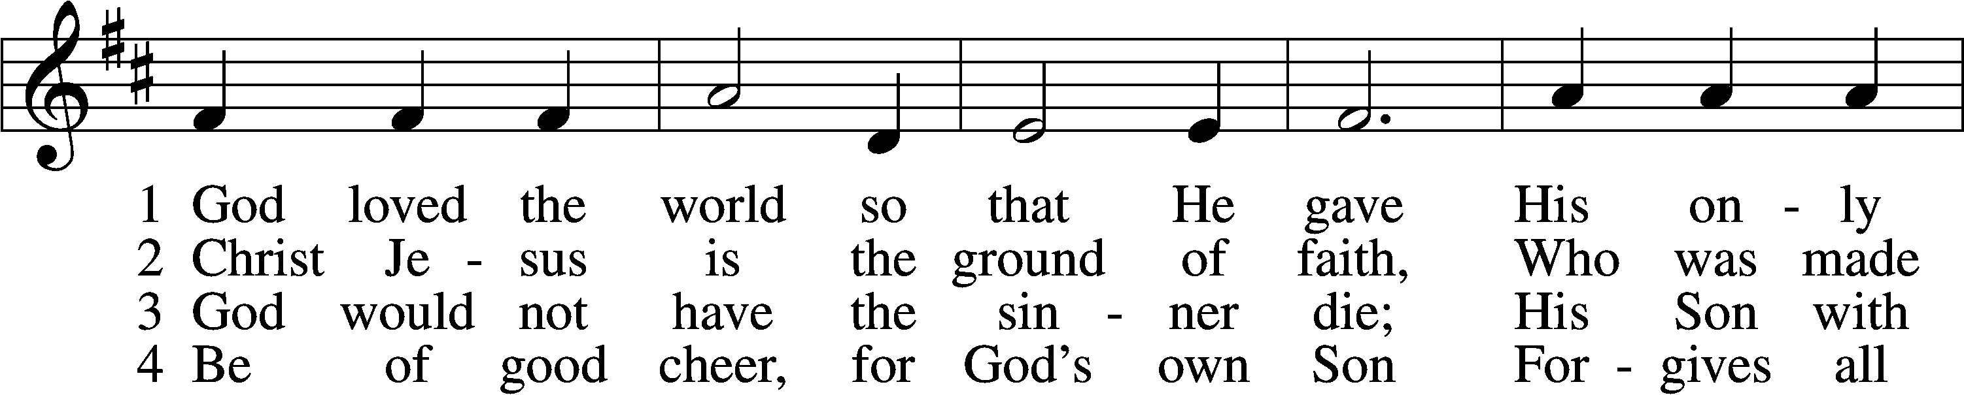

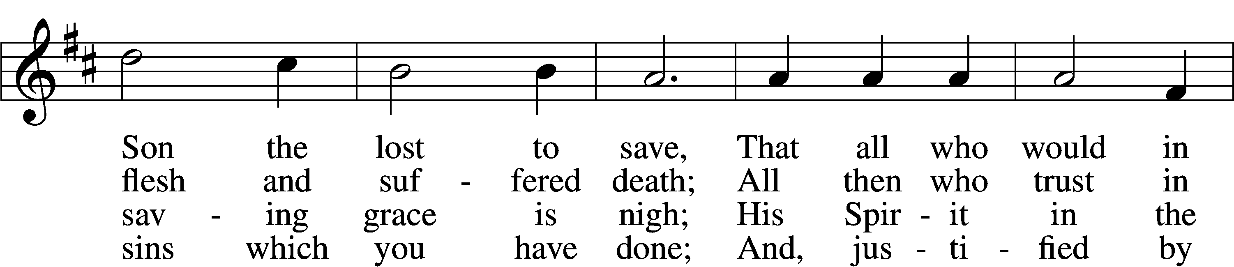

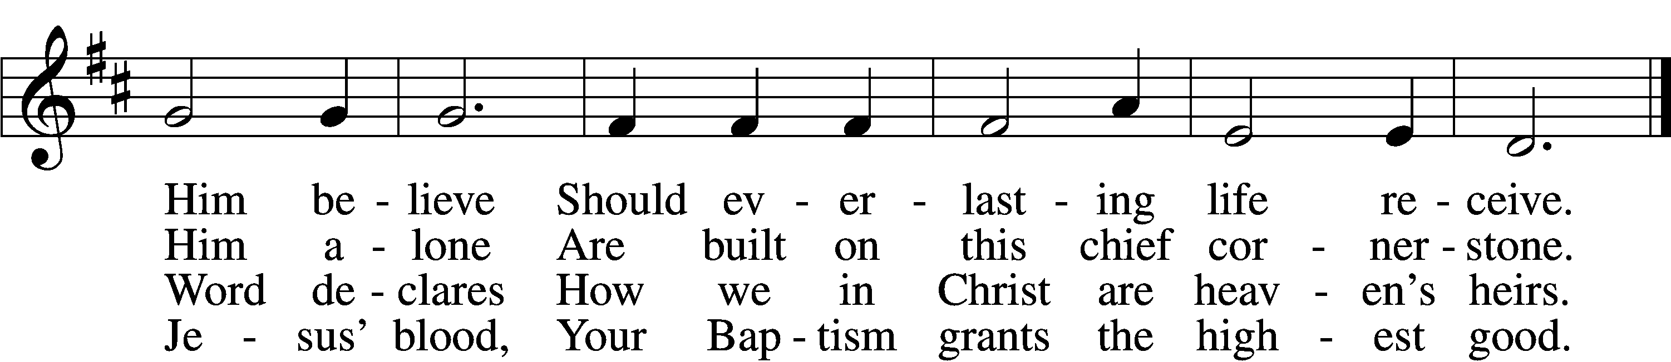

5 If you are sick, if death is near,  
This truth your troubled heart can cheer:  
Christ Jesus saves your soul from death;  
That is the firmest ground of faith.

D 6 Glory to God the Father, Son,  
And Holy Spirit, Three in One!  
To You, O blessèd Trinity,  
Be praise now and eternally!

Text: Heiliges Lippen- und Hertzens-Opffer, c. 1778, Stettin; tr. August Crull, 1845–1923, alt.  
Tune: George J. Elvey, 1816–93  
Text and tune: Public domain

# Confession and Absolution

The sign of the cross may be made by all in remembrance of their Baptism.

Invocation Matthew 28:19b; 18:20

P In the name of the Father and of the T Son and of the Holy Spirit.

C **Amen.**

Exhortation Hebrews 10:22; Psalm 124:8; Psalm 32:5

P Beloved in the Lord! Let us draw near with a true heart and confess our sins unto God our Father, beseeching Him in the name of our Lord Jesus Christ to grant us forgiveness.

P Our help is in the name of the Lord,

C **who made heaven and earth.**

P I said, I will confess my transgressions unto the Lord,

C **and You forgave the iniquity of my sin.**

Silence for reflection on God’s Word and for self-examination.

Confession of Sins

P Almighty God, our maker and redeemer, we poor sinners confess unto You that we are by nature sinful and unclean and that we have sinned against You by thought, word, and deed. Wherefore we flee for refuge to Your infinite mercy, seeking and imploring Your grace for the sake of our Lord Jesus Christ.

C **O most merciful God, who has given Your only-begotten Son to die for us, have mercy upon us and for His sake grant us remission of all our sins; and by Your Holy Spirit increase in us true knowledge of You and of Your will and true obedience to Your Word, to the end that by Your grace we may come to everlasting life; through Jesus Christ, our Lord. Amen.**

Declaration of Grace Mark 16:16; John 1:12

P Almighty God, our heavenly Father, has had mercy upon us and has given His only Son to die for us and for His sake forgives us all our sins. To those who believe on His name He gives power to become the children of God and has promised them His Holy Spirit. He that believes and is baptized shall be saved.  
  
Grant this, Lord, unto us all.

C **Amen.**

# Service of the Word

Introit Psalm 91:9–13; antiphon: vv. 15–16

When he calls to me, I will answer him; I will be with him in trouble;  
 I will rescue him and honor him.  
**With long life I will satisfy him  
 and show him my salvation.**Because you have made the Lord your dwelling place—  
 the Most High, who is my refuge—  
**no evil shall be allowed to befall you,  
 no plague come near your tent.**For he will command his angels concerning you  
 to guard you in all your ways. **On their hands they will bear you up,  
 lest you strike your foot against a stone.**  
You will tread on the lion and the adder;  
 the young lion and the serpent you will trample underfoot.

Gloria Patri

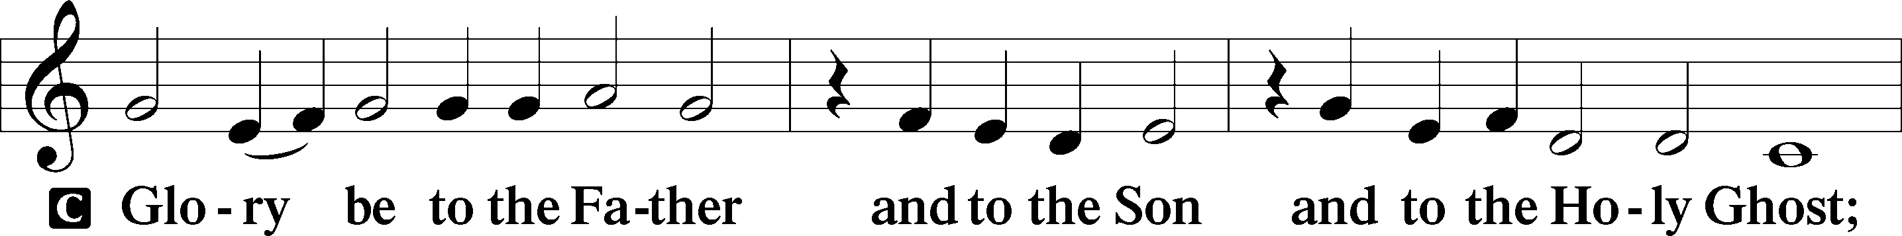

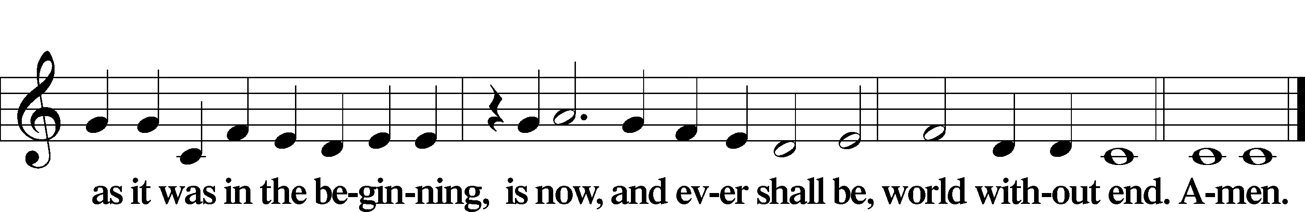

Kyrie Mark 10:47

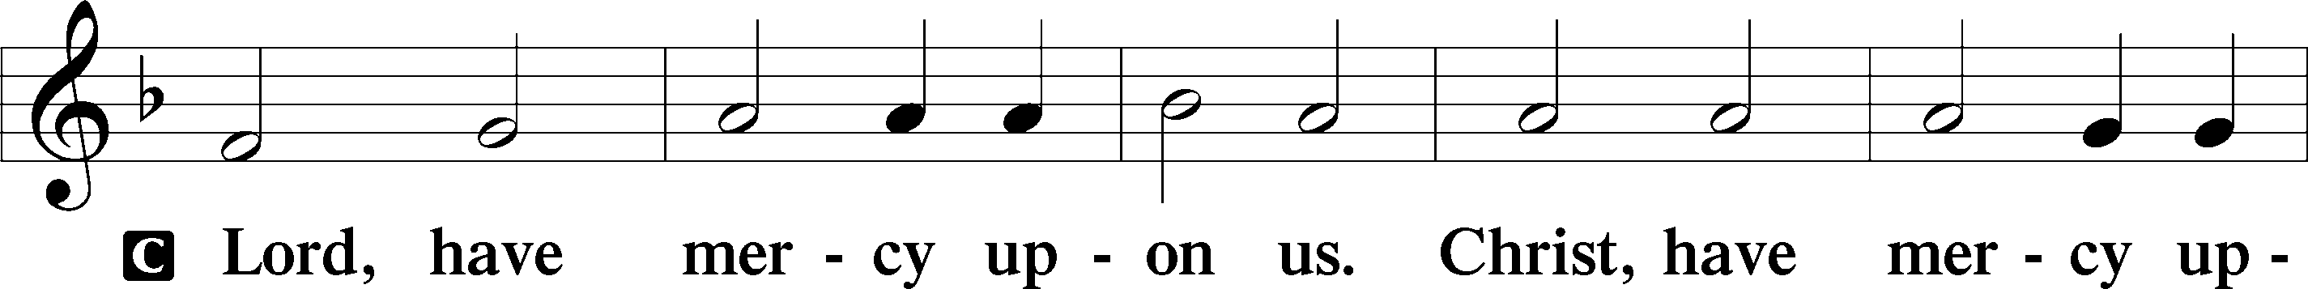

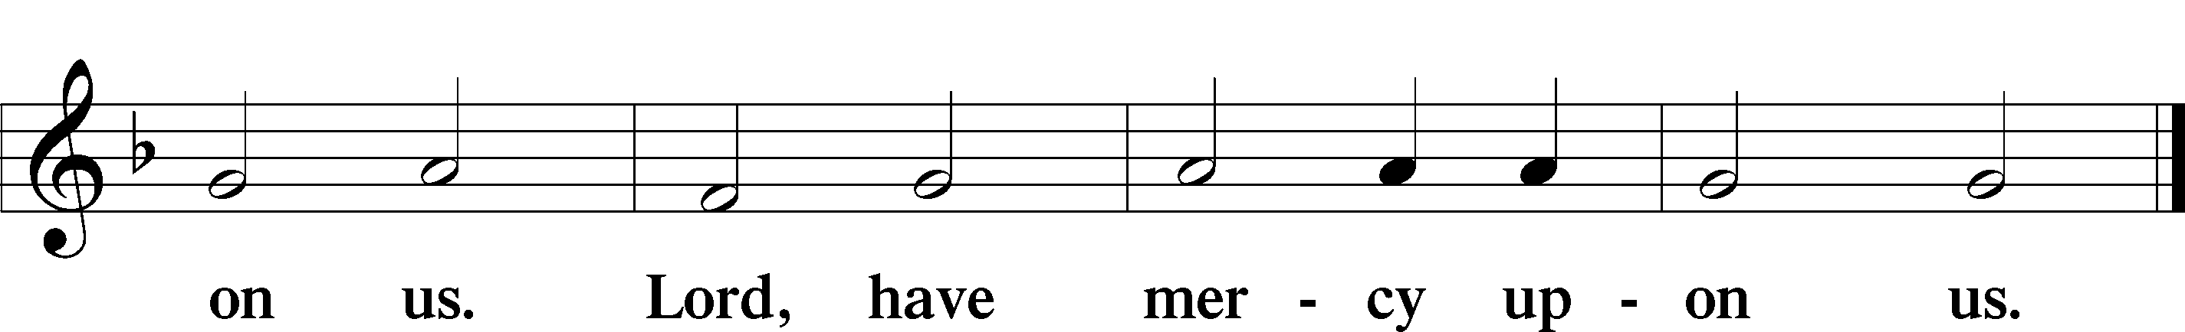

Salutation and Collect of the Day

P The Lord be with you.

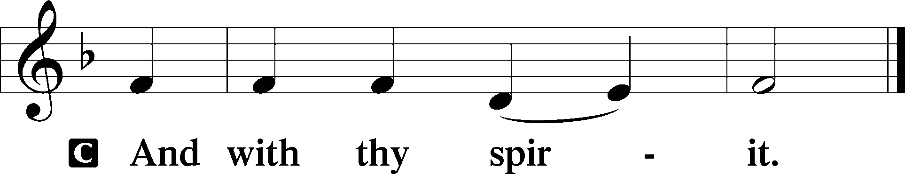

P Let us pray.

O Lord God, You led Your ancient people through the wilderness and brought them to the promised land. Guide the people of Your Church that following our Savior we may walk through the wilderness of this world toward the glory of the world to come; through Jesus Christ, Your Son, our Lord, who lives and reigns with You and the Holy Spirit, one God, now and forever.

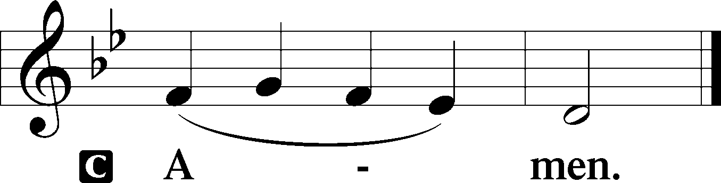

Sit

Old Testament Reading Deuteronomy 26:1–11

1“When you come into the land that the Lord your God is giving you for an inheritance and have taken possession of it and live in it, 2you shall take some of the first of all the fruit of the ground, which you harvest from your land that the Lord your God is giving you, and you shall put it in a basket, and you shall go to the place that the Lord your God will choose, to make his name to dwell there. 3And you shall go to the priest who is in office at that time and say to him, ‘I declare today to the Lord your God that I have come into the land that the Lord swore to our fathers to give us.’ 4Then the priest shall take the basket from your hand and set it down before the altar of the Lord your God.

5“And you shall make response before the Lord your God, ‘A wandering Aramean was my father. And he went down into Egypt and sojourned there, few in number, and there he became a nation, great, mighty, and populous. 6And the Egyptians treated us harshly and humiliated us and laid on us hard labor. 7Then we cried to the Lord, the God of our fathers, and the Lord heard our voice and saw our affliction, our toil, and our oppression. 8And the Lord brought us out of Egypt with a mighty hand and an outstretched arm, with great deeds of terror, with signs and wonders. 9And he brought us into this place and gave us this land, a land flowing with milk and honey. 10And behold, now I bring the first of the fruit of the ground, which you, O Lord, have given me.’ And you shall set it down before the Lord your God and worship before the Lord your God. 11And you shall rejoice in all the good that the Lord your God has given to you and to your house, you, and the Levite, and the sojourner who is among you.”

A This is the Word of the Lord.

C **Thanks be to God.**

Gradual Hebrews 12:2

[O come, let us fix our eyes on] Jesus,  
 the founder and perfecter of our faith,  
**who for the joy that was set before him endured the cross, despising the shame,  
 and is seated at the right hand of the throne of God.**

Epistle Romans 10:8b–13

“The word is near you, in your mouth and in your heart” (that is, the word of faith that we proclaim); 9because, if you confess with your mouth that Jesus is Lord and believe in your heart that God raised him from the dead, you will be saved. 10For with the heart one believes and is justified, and with the mouth one confesses and is saved. 11For the Scripture says, “Everyone who believes in him will not be put to shame.” 12For there is no distinction between Jew and Greek; the same Lord is Lord of all, bestowing his riches on all who call on him. 13For “everyone who calls on the name of the Lord will be saved.”

Stand

Holy Gospel Luke 4:1–13

P The Holy Gospel according to St. Luke, the fourth chapter.

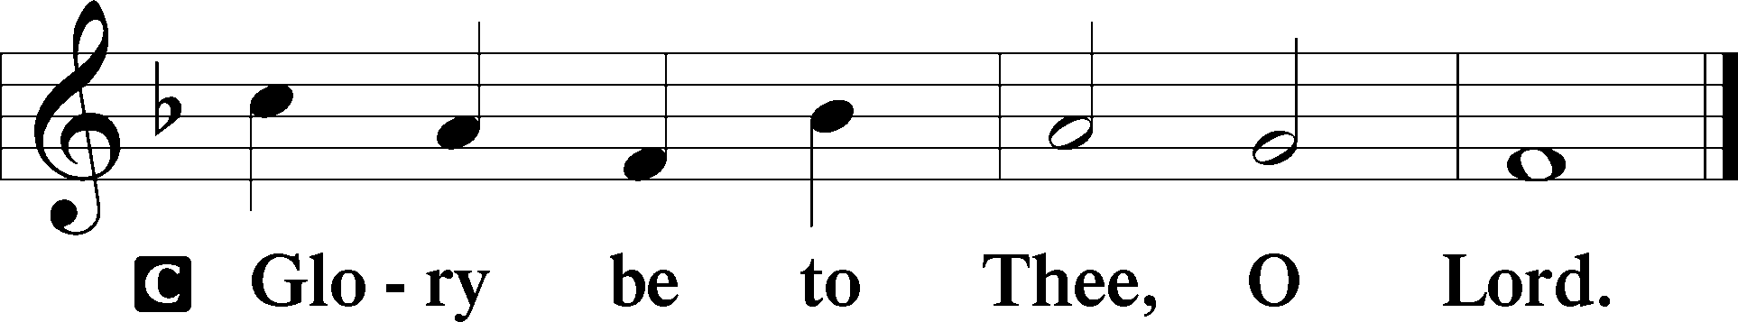

1Jesus, full of the Holy Spirit, returned from the Jordan and was led by the Spirit in the wilderness 2for forty days, being tempted by the devil. And he ate nothing during those days. And when they were ended, he was hungry. 3The devil said to him, “If you are the Son of God, command this stone to become bread.” 4And Jesus answered him, “It is written, ‘Man shall not live by bread alone.’” 5And the devil took him up and showed him all the kingdoms of the world in a moment of time, 6and said to him, “To you I will give all this authority and their glory, for it has been delivered to me, and I give it to whom I will. 7If you, then, will worship me, it will all be yours.” 8And Jesus answered him, “It is written,

“‘You shall worship the Lord your God,  
 and him only shall you serve.’”

9And he took him to Jerusalem and set him on the pinnacle of the temple and said to him, “If you are the Son of God, throw yourself down from here, 10for it is written,

“‘He will command his angels concerning you,  
 to guard you,’

11and

“‘On their hands they will bear you up,  
 lest you strike your foot against a stone.’”

12And Jesus answered him, “It is said, ‘You shall not put the Lord your God to the test.’” 13And when the devil had ended every temptation, he departed from him until an opportune time.

P This is the Gospel of the Lord.

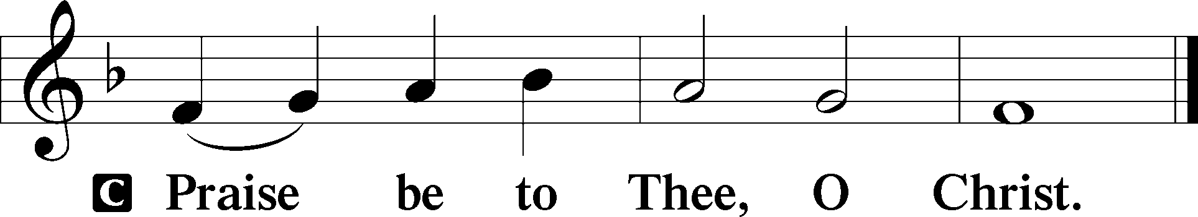

Apostles’ Creed

C **I believe in God, the Father Almighty,**

**maker of heaven and earth.**

**And in Jesus Christ, His only Son, our Lord,**

**who was conceived by the Holy Spirit,**

**born of the virgin Mary,**

**suffered under Pontius Pilate,**

**was crucified, died and was buried.**

**He descended into hell.**

**The third day He rose again from the dead.**

**He ascended into heaven**

**and sits at the right hand of God the Father Almighty.**

**From thence He will come to judge the living and the dead.**

**I believe in the Holy Spirit,**

**the holy Christian Church,**

**the communion of saints,**

**the forgiveness of sins,**

**the resurrection of the body,**

**and the life** T **everlasting. Amen.**

Sit

Children's Sermon

418 O Lord, throughout These Forty Days

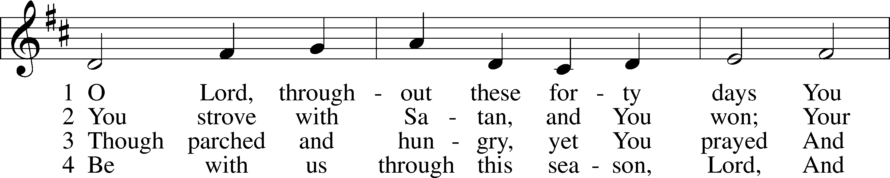

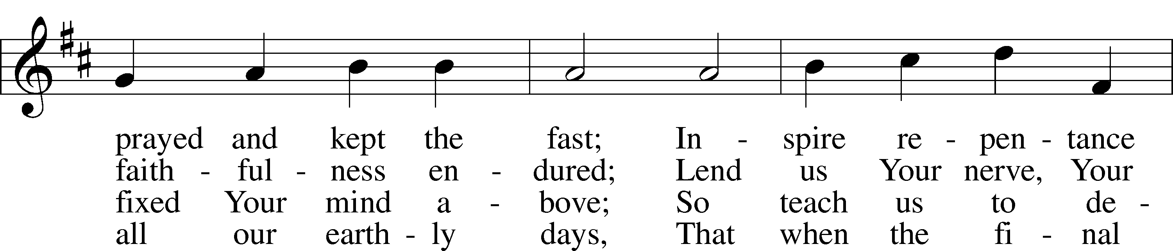

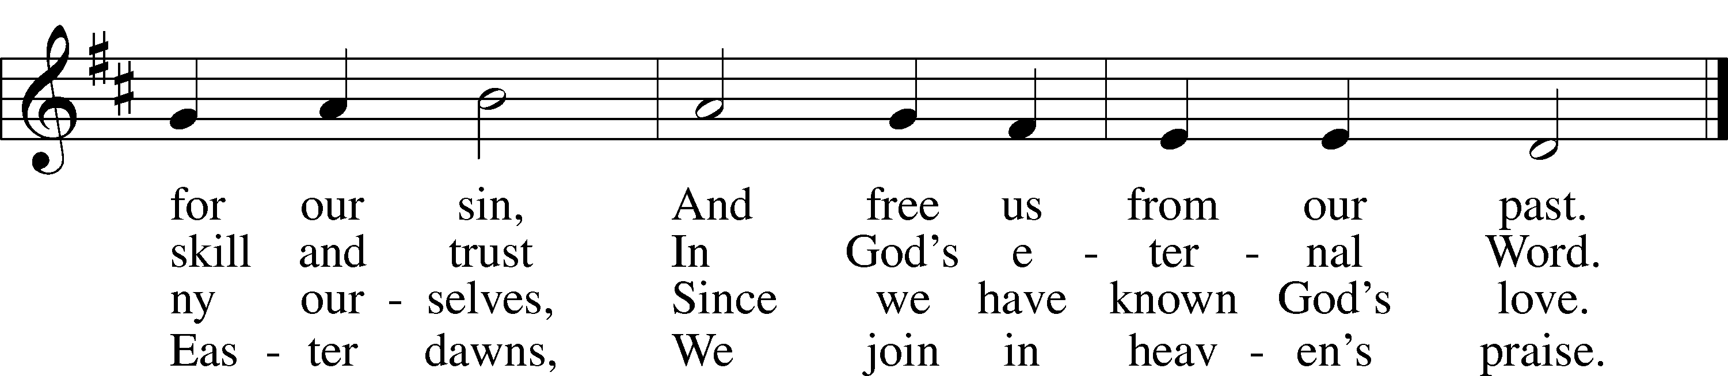

Text: based on Claudia F. Hernaman, 1838–98; para. Gilbert E. Doan, 1930–2024  
Tune: The Psalmes of David in Prose and Meeter, 1635, Edinburgh  
Text: © 1978 Lutheran Book of Worship. Used by permission: LSB Hymn License no. 110005011  
Tune: Public domain

Sermon

Votum

P The peace of God, which passes all understanding, keep your hearts and minds in Christ Jesus.

C **Amen.**

Stand

Offertory Psalm 51:10–12

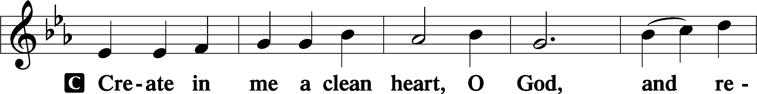

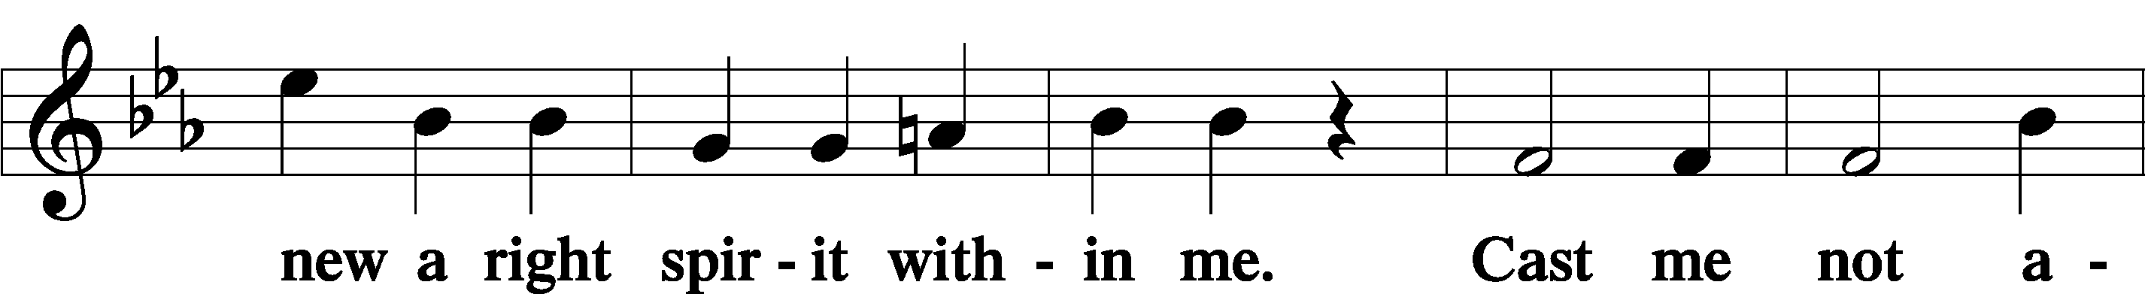

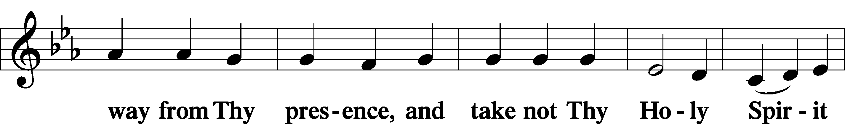

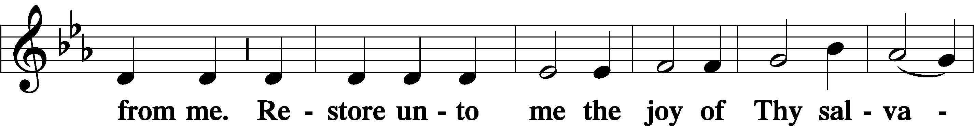

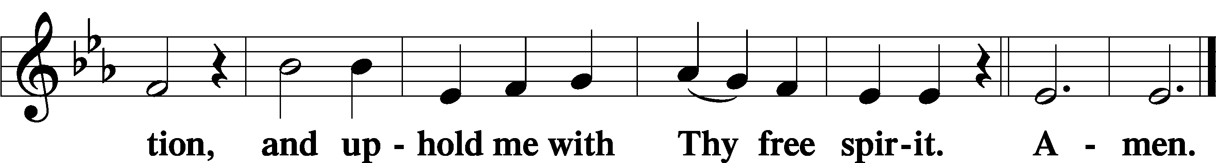

Offering

805 Praise God, from Whom All Blessings Flow

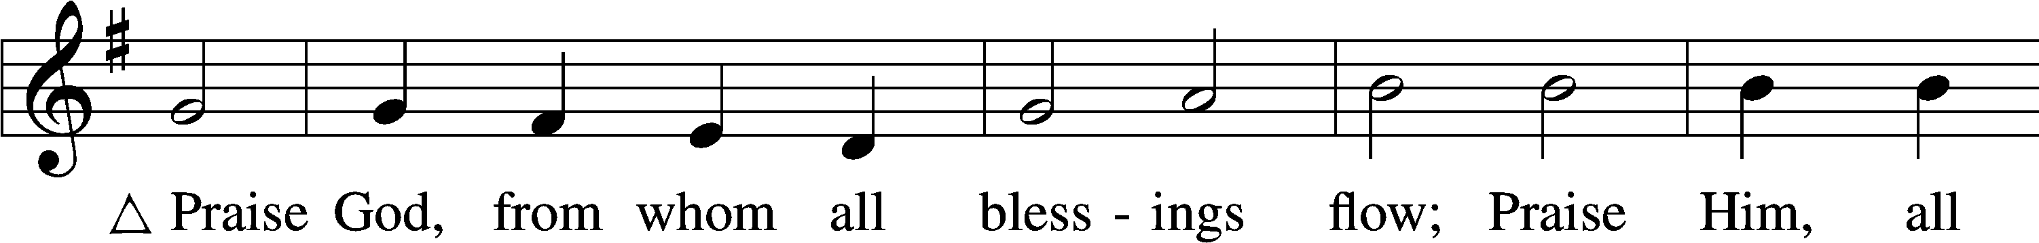

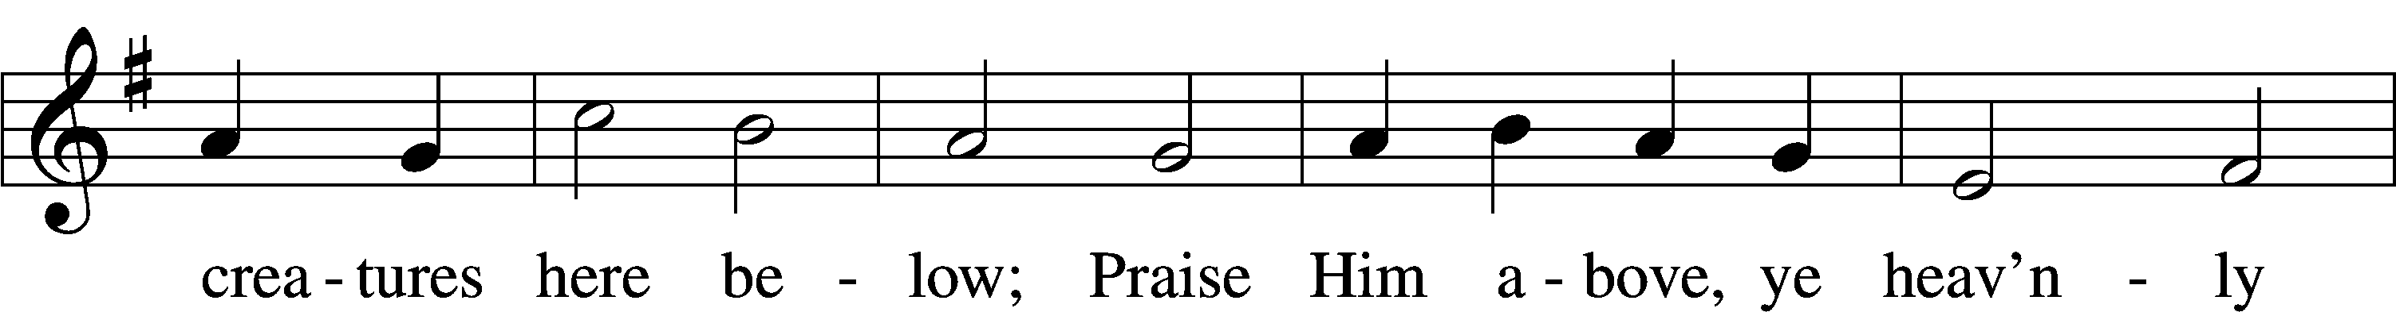

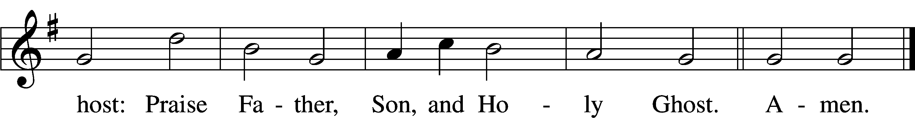

Text: Thomas Ken, 1637–1711  
Tune: Trente quatre Pseaumes de David, 1551, Geneva, ed. Louis Bourgeois  
Text and tune: Public domain

Prayer of the Church

Lord’s Prayer Matthew 6:9–13

P Lord, remember us in Your kingdom and teach us to pray:

C **Our Father who art in heaven,**

**hallowed be Thy name,**

**Thy kingdom come,**

**Thy will be done on earth**

**as it is in heaven;**

**give us this day our daily bread;**

**and forgive us our trespasses**

**as we forgive those**

**who trespass against us;**

**and lead us not into temptation,**

**but deliver us from evil.**

**For Thine is the kingdom**

**and the power and the glory**

**forever and ever. Amen.**

Collect for the Word

Blessed Lord, You have caused all Holy Scriptures to be written for our learning. Grant that we may so hear them, read, mark, learn, and inwardly digest them that, by the patience and comfort of Your holy Word, we may embrace and ever hold fast the blessed hope of everlasting life; through Jesus Christ, Your Son, our Lord, who lives and reigns with You and the Holy Spirit, one God, now and forever.

Benediction

P The Lord bless you and keep you.

The Lord make His face shine on you and be gracious to you.

The Lord look upon you with favor and T give you peace.

C **Amen.**

656 A Mighty Fortress Is Our God

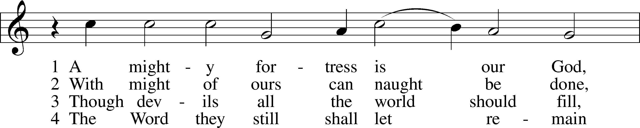

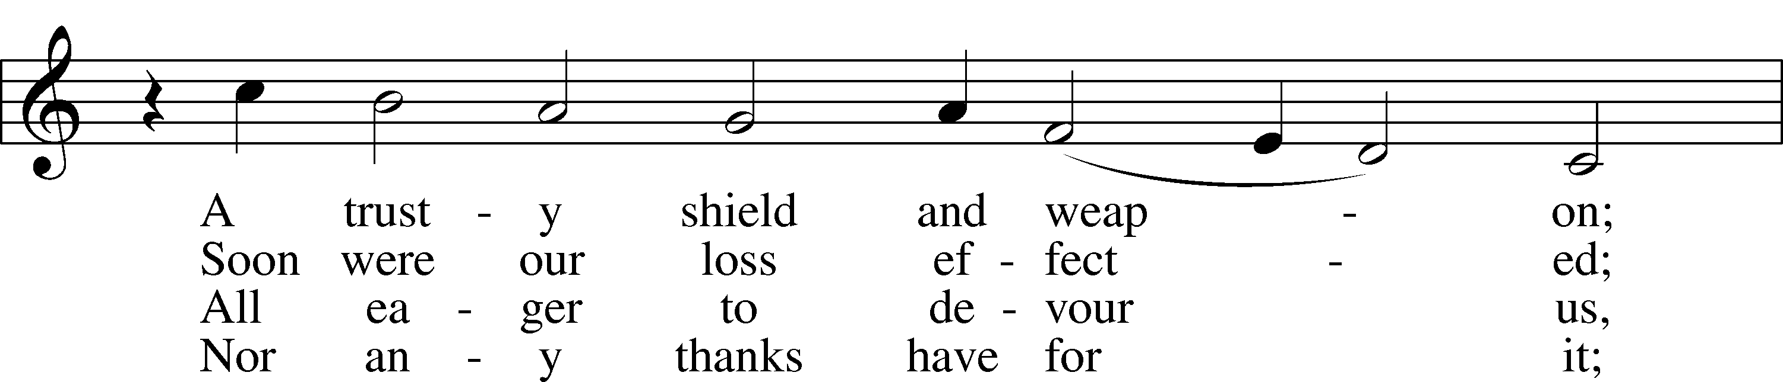

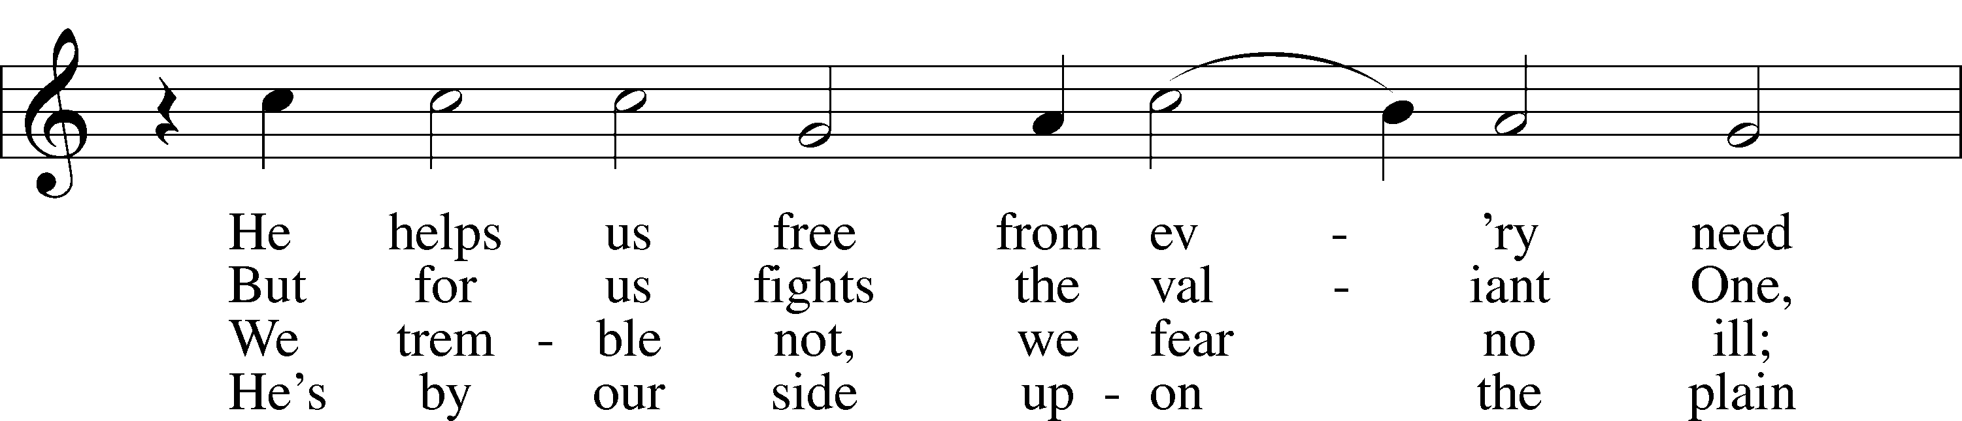

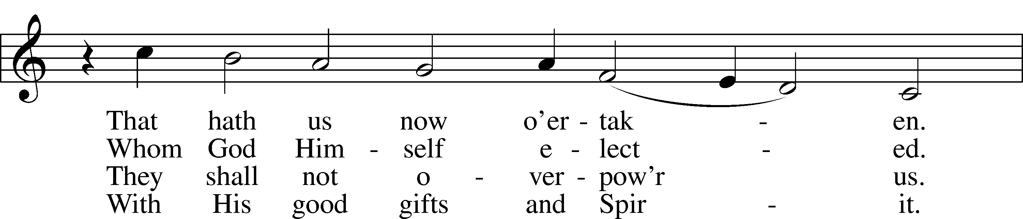

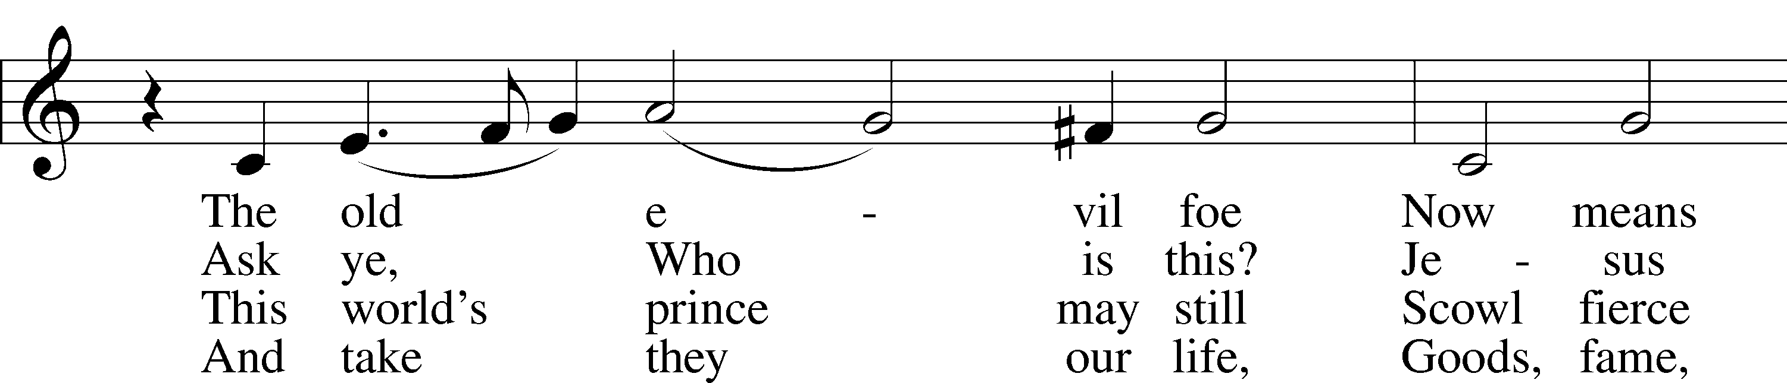

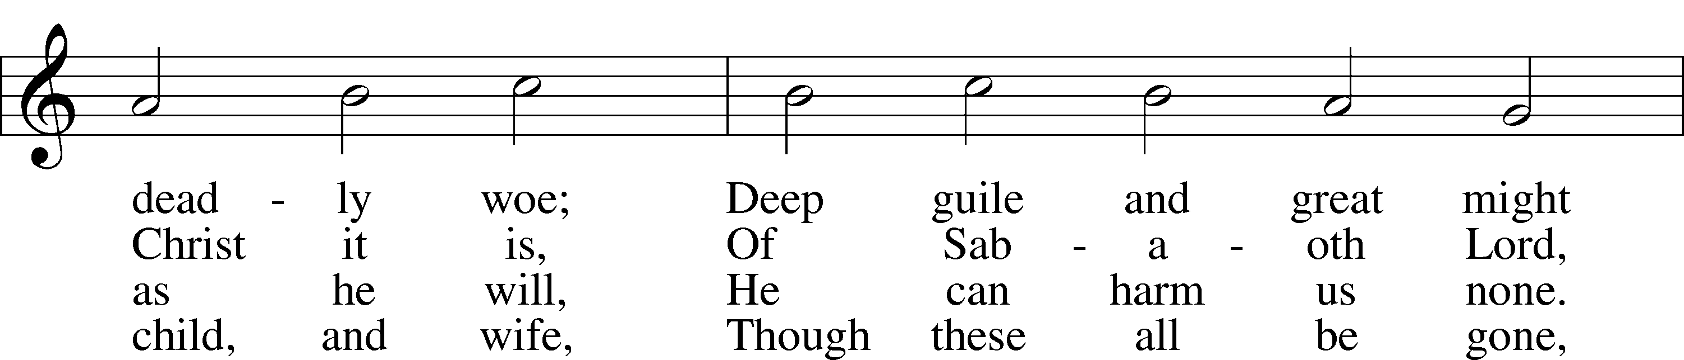

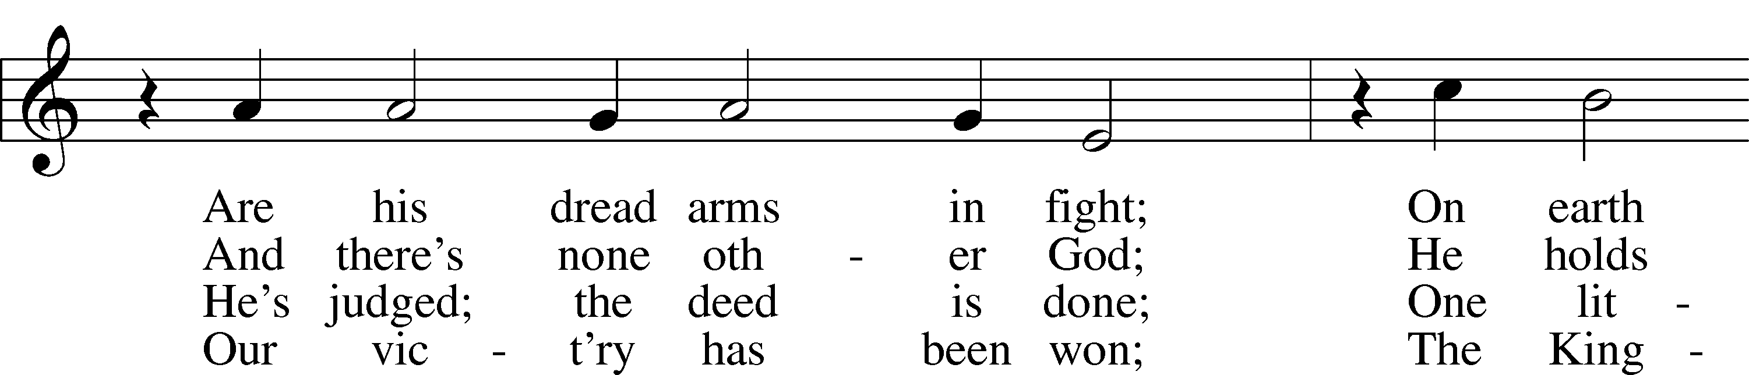

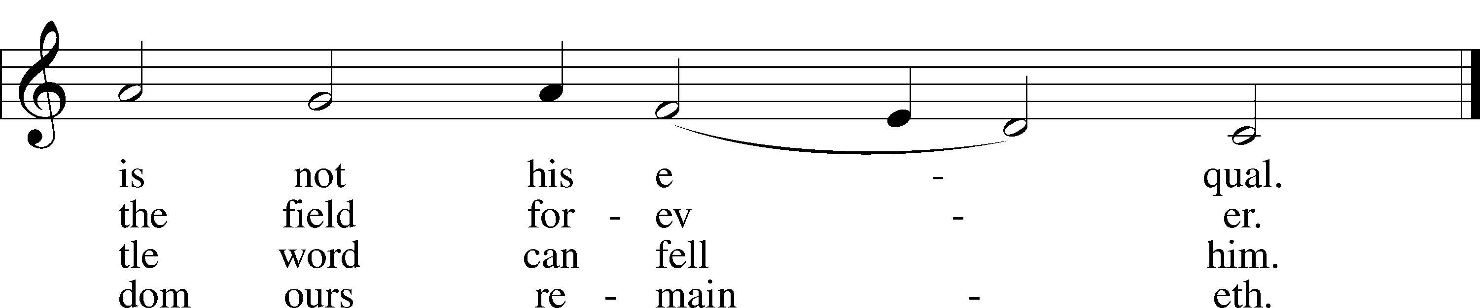

Text: tr. composite  
Text and tune: Martin Luther, 1483–1546  
Text and tune: Public domain

Acknowledgments

Unless otherwise indicated, Scripture quotations are from the ESV® Bible (The Holy Bible, English Standard Version®), copyright © 2001 by Crossway, a publishing ministry of Good News Publishers. Used by permission. All rights reserved.

Created by Lutheran Service Builder © 2025 Concordia Publishing House.