
March 2026

The Lenten season is a season of penitence (repentance) and preparation. We repent of our sins as we prepare for the death and resurrection of Jesus. Some people use the season of Lent in order to give up something. While this can be a good practice when done in the right spirit, many times it is done in the wrong spirit. If you give up something, and expect that this makes you more acceptable, or holy. in God’s sight, this act is an act of Pietism.
According to Webster’s Dictionary (online) Pietism: (n) a 17th century German religious movement rejecting intellectualism and stressing Bible study and personal religious experience; emphasis on devotional experience and practices. The personal religious experience might include music that sounds good and has a nice beat. For example: many people like Leonard Cohen’s Hallelujah. When you read the lyrics to the song, it has nothing to do with Jesus or worship.
The first verse of that song states: Now I've heard there was a secret chord / That David played, and it pleased the Lord / But you don't really care for music, do you? / It goes like this, the fourth, the fifth / The minor falls, the major lifts / The baffled king composing Hallelujah
What you can see in the lyrics are a chord progression. Nothing about the Lord. Yet, there are videos of ministers and priests that are singing this while in their vestments (during the service). For the Pietist, this is acceptable to be used in worship services.
What is the danger in this you might ask. When the service gets twisted and contorted to what each person wants in that service, God is lost. To one person who wants to have modern music played, we get Hallelujah. To another person who wants to have a spiritual awakening that allows them to raise their hands during the sermon and say “Amen”, is this about the message preached? Or is it the action (response) that is their main concern?
Martin Luther used the word “enthusiast” to refer to those who “boast they have the Spirit without and before the Word”. Enthusiasm dethrones God and His Word as the ultimate authority in matters of faith and conscience and sets up logic, tradition, emotions, or some specific person—perhaps yourself, perhaps the Pope—as the ultimate authority who interprets God’s Word to you. Or, as Luther said, “they judge Scripture or the spoken Word and explain and stretch it at their pleasure.”

This is why we (St. Peter Lutheran Church and the LCMS as a whole) use the historic liturgy. This liturgy has stood the test of time. As you may see from the text citations found in the hymnal, the liturgy is the Word of God. This is also why we use the hymns found in the hymnals (LSB and TLH). These hymns have been thoroughly reviewed. They have stood the test of time. They will endure the test of time in the future.
In this time of Lent, I will include CPH’s Lenten Confessions reading plan. — Pastor De Young

Parts of the Liturgy

Confession and Absolution
We can indeed approach God with confidence. And yet, because we stand on this side of our Lord’s final return, we still have with us the devil, the world, and our sinful flesh. We have not yet faced the final judgment.
And so, with sin still working in us, the condemnation of God’s Law must still confront us, lest we have any delusions that we might have something to boast of before our mighty Judge.
Above all else, Confession and Absolution keep us honest — honest with ourselves and honest before God. The act of confession is not some work that we lay before the Father’s throne; rather, it is the simple acknowledgment that God’s Word is true and right and that when we measure ourselves against its demands, we come up short.
God’s Word says “you shall not give false testimony,” but in truth we have lied and gossiped and slandered. And so, the Christian confesses: “Lord, Your Word is true; I have sinned.”
There are three basic ways to handle sin and guilt. One is to ignore or minimize them. We’ve all been tempted in that direction more than a few times. Isn’t that, after all, what our sinful human nature is all about?
Another way is to institutionalize them, especially the guilt part. After all, if you can keep people feeling just guilty enough, you will keep them coming back for more.
The third way is to give sin and guilt their proper due, and then to silence them. That is the way of God’s absolution. With his forgiveness, our sin is removed from us as far as the east is from the west.
Christians know that, but they also need to hear it often. We need to be reminded that those familiar words, “I forgive you all your sins,” are not just some impersonal announcement. They say what they mean and accomplish what they promise. Jesus himself said to his disciples that the sins they forgive are forgiven (John 20:23).
The last and greatest absolution that will ever be spoken to us will be at the last judgment. In the final pages of the Chronicles of Narnia, C.S. Lewis provides a marvelous description of this event.
As each individual comes before Aslan — the lion who is Lewis’ figure for Christ — one of two things happens: either the person gazes directly into Aslan’s face and recognizes his forgiving countenance, or, upon seeing the lion’s stern demeanor, passes into his long shadow, forever to be separated from Christ.
In the Confession and Absolution we are being readied for our appearance before Christ on the Last Day. And hidden behind those comforting words that our sins are forgiven is the invitation, “Come, you who are blessed by my father, inherit the kingdom prepared for you from the foundation of the world” (Matt. 25:34).
When our Lord speaks those words to us at the Last Day, Confession and Absolution as we know it will cease, for we will then bask in the eternal absolution of the Lamb.



Celebrate March’s Baptism Birthdays
& their years as heirs of God’s kingdom!

Date | Name | Years
1st | David Geis | 65
2th | Charlie Pace | 12
4th | Kyle Cawell | 7
13th | Darlee Allen | 15
14th | Jazlyn McComack | 5
15th | Delanie Anderson | 34
 | Valarie Gill | 34
 | Katie Jones | 28
17th | Dalton Fechtler | 24
 | Lee Hughes | 30
19th | Walker Dyson | 3
21st | Ashley Shaw | 33
30th | Lilly Gill | 29

Serving in God’s House this month

Elder of the Month | Travis Dyson
Counters | Brent Husfeld / Darren Gill
Altar Guild | Lisa Lawson / Rebecca Horton
Altar Care | Sherry Hammer / Carla Hughes / Chanda Lee
Guest Monitor | Darlene Geis

Week | Acolytes | Reader
March 01 | Avery Henry & Bella Caswell | Lee Hughes
March 08 | Emily Keyes & Parker Lawson | Arn Anderson
March 15 | Molly Gilmore & Max Gilmore | Bryan Roth
March 22 | Karlee Hughes & Annallee Osbon | William Pickett
March 29 | Parker Lawson, Kegann Gilmore & Max Gilmore | Lee Hughes






Snow Day Fun!









































s























Church Roof Replacement in Progress










Baptism of Ridge Morris





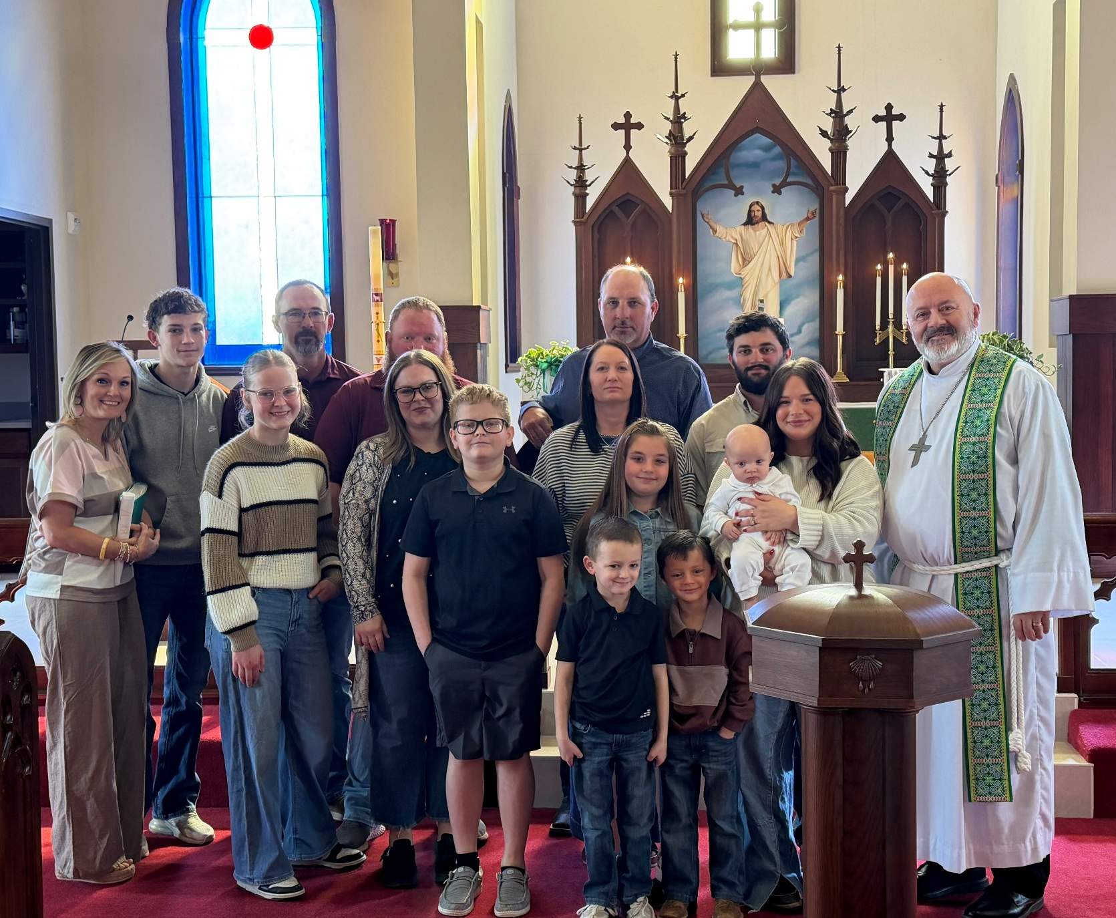




FFA Fundraising Fish Fry


































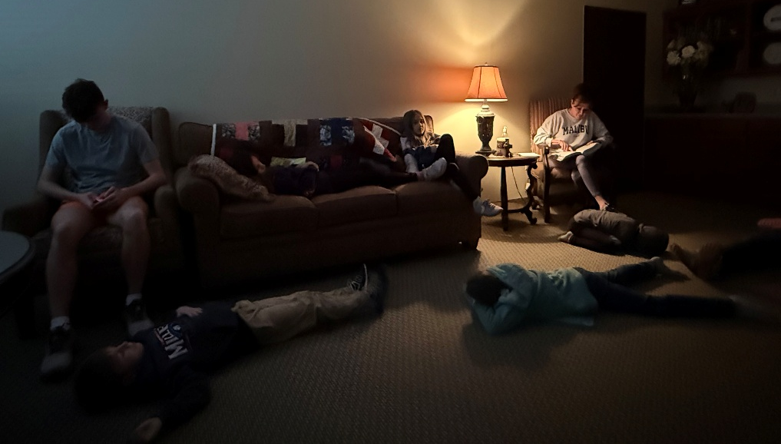





























Did you know we have a Facebook & Instagram?

You can find the links to our socials on our website at: www.stpetertex.com

Follow us for important updates, verse-of-the-week posts, and more!
In case you missed last month’s weekly verse posts:



