On entering the church

P Lord, I love the habitation of Your house and the place
where Your glory dwells. In the multitude of Your tender
mercies prepare my heart that I may enter Your house to
worship and confess Your holy name; through Jesus Christ,
my God and Lord.

Before worship

C O Lord, our creator, redeemer, and comforter, as we come
together to worship You in spirit and in truth, we humbly
pray that You would open our hearts to the preaching of
Your Word so that we may repent of our sins, believe in
Jesus Christ as our only Savior, and grow in grace and
holiness. Hear us for His sake.

610 Lord Jesus, Think on Me
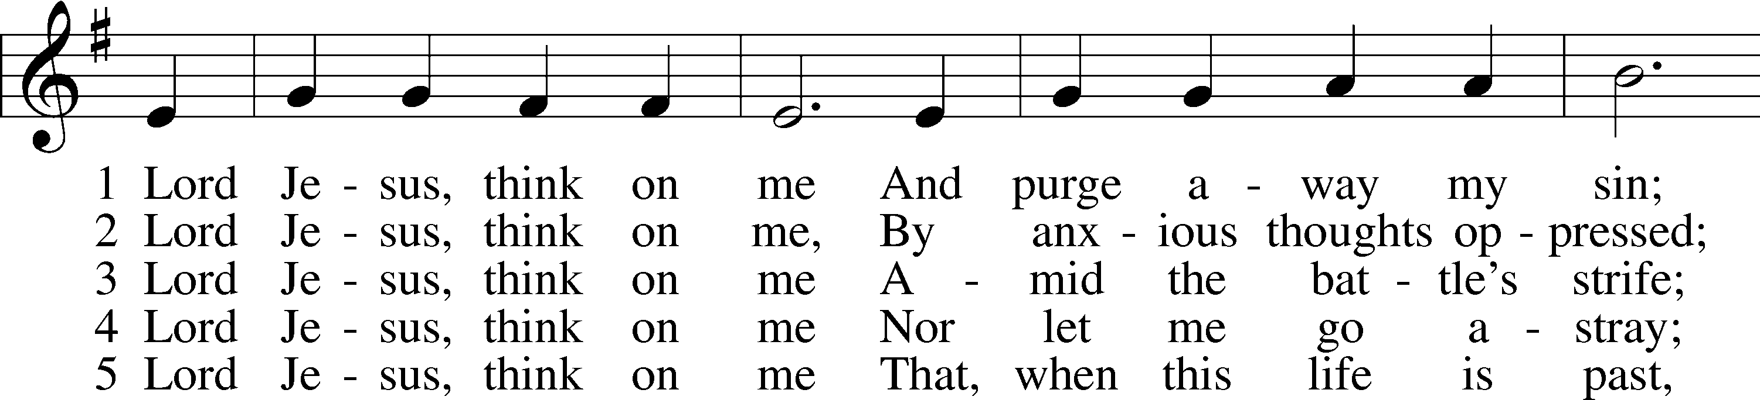
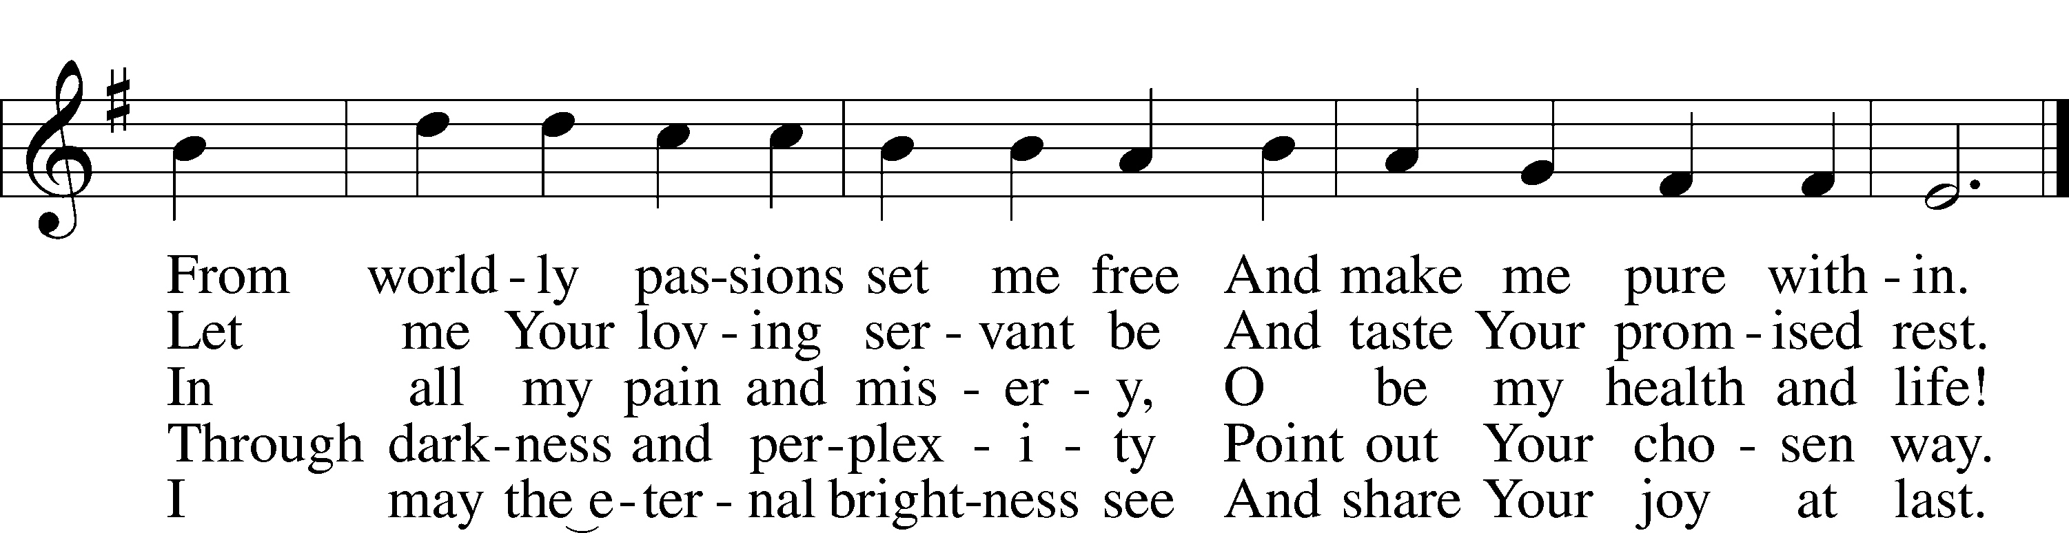
Text: Synesius of Cyrene, c. 365–c. 414; tr. Allen W. Chatfield, 1808–96, alt.
Tune: William Daman, c. 1540–1591
Text and tune: Public domain
Confession and Absolution
The sign of the cross may be made by all in remembrance of their Baptism.

Invocation Matthew 28:19b; 18:20
P In the name of the Father and of the T Son and of the Holy Spirit.
C Amen.

Exhortation Hebrews 10:22; Psalm 124:8; Psalm 32:5
P Beloved in the Lord! Let us draw near with a true heart and confess our sins unto God our Father, beseeching Him in the name of our Lord Jesus Christ to grant us forgiveness.

P Our help is in the name of the Lord,
C who made heaven and earth.
P I said, I will confess my transgressions unto the Lord,
C and You forgave the iniquity of my sin.

Silence for reflection on God’s Word and for self-examination.

Confession of Sins
P Almighty God, our maker and redeemer, we poor sinners confess unto You that we are by nature sinful and unclean and that we have sinned against You by thought, word, and deed. Wherefore we flee for refuge to Your infinite mercy, seeking and imploring Your grace for the sake of our Lord Jesus Christ.
C O most merciful God, who has given Your only-begotten Son to die for us, have mercy upon us and for His sake grant us remission of all our sins; and by Your Holy Spirit increase in us true knowledge of You and of Your will and true obedience to Your Word, to the end that by Your grace we may come to everlasting life; through Jesus Christ, our Lord. Amen.

Declaration of Grace Mark 16:16; John 1:12
P Almighty God, our heavenly Father, has had mercy upon us and has given His only Son to die for us and for His sake forgives us all our sins. To those who believe on His name He gives power to become the children of God and has promised them His Holy Spirit. He that believes and is baptized shall be saved.
Grant this, Lord, unto us all.
C Amen.

Service of the Word

Introit Psalm 134; antiphon: Psalm 33:8
Let all the earth fear the Lord;
let all the inhabitants of the world stand in awe of him!
Come, bless the Lord, all you servants of the Lord,
who stand by night in the house of the Lord!
Lift up your hands to the holy place
and bless the Lord!
May the Lord bless you from Zion,
he who made heaven and earth!

Gloria Patri
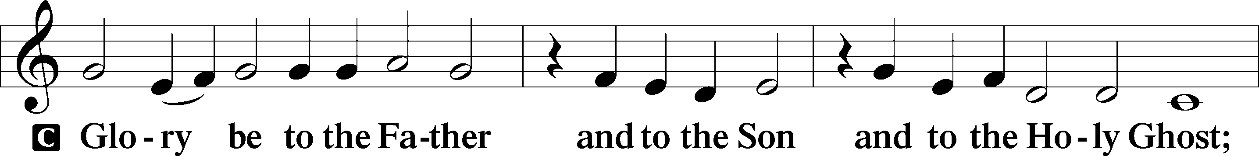
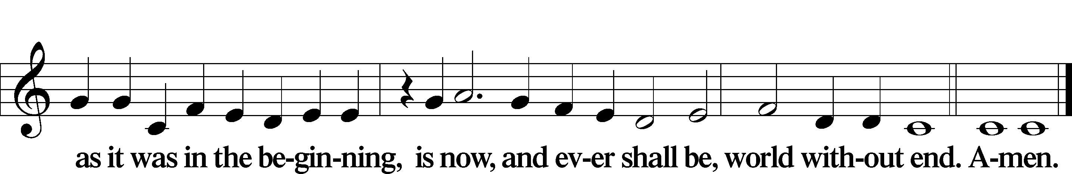

Kyrie Mark 10:47
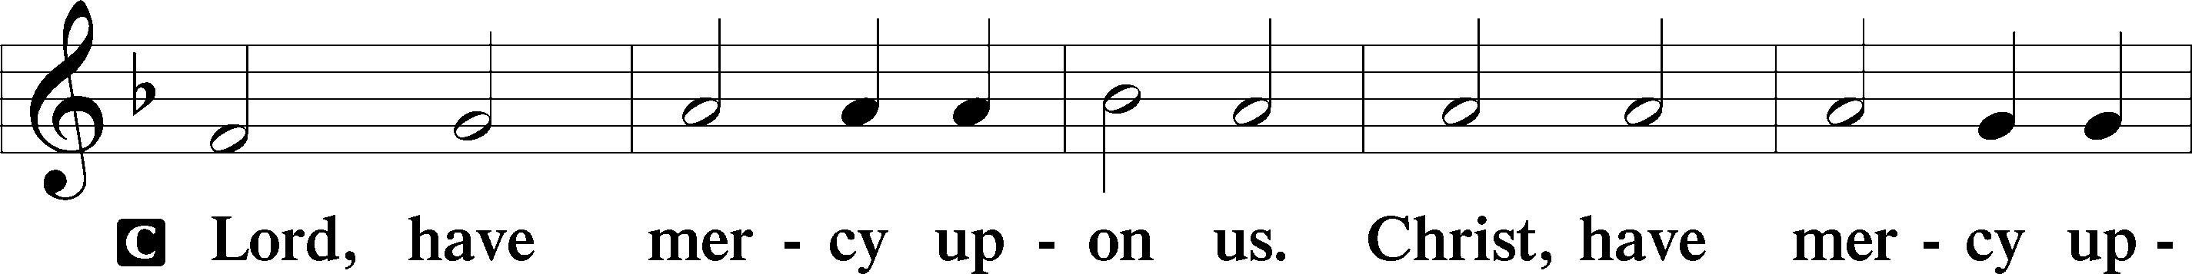
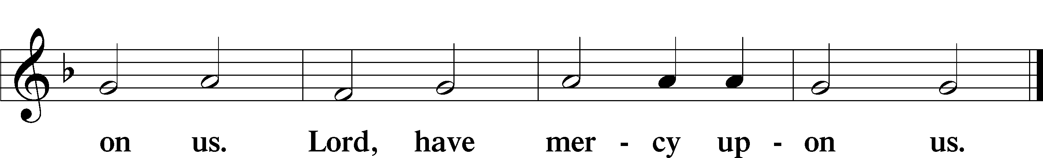

Gloria in Excelsis Luke 2:14; John 1:29
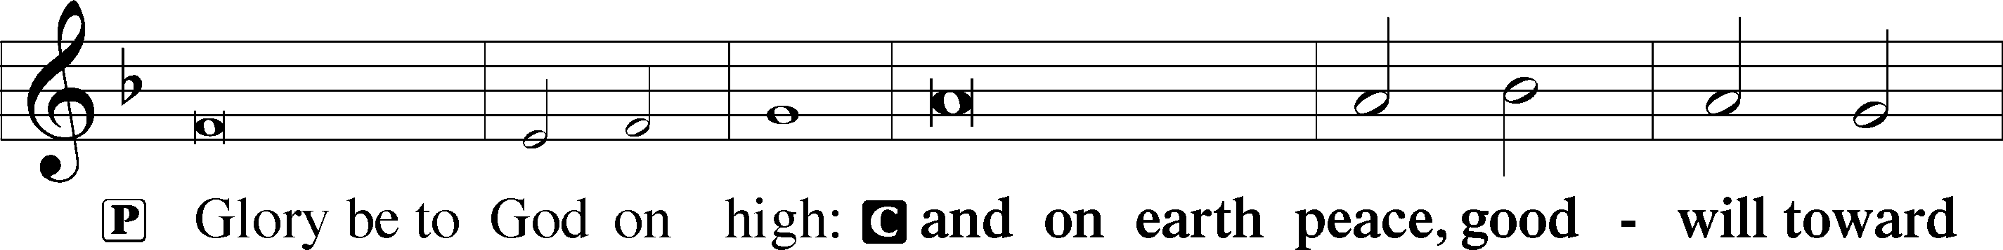
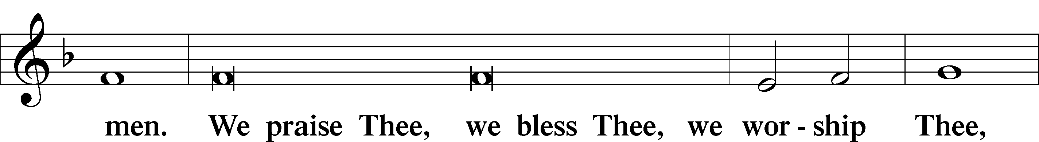
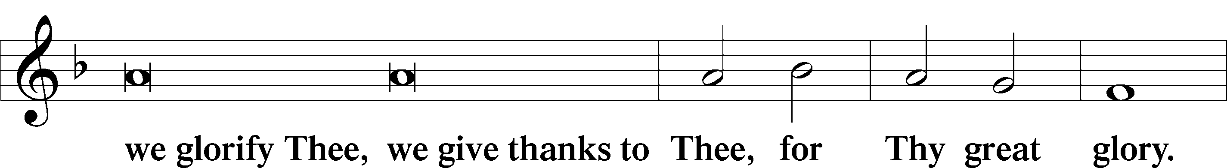
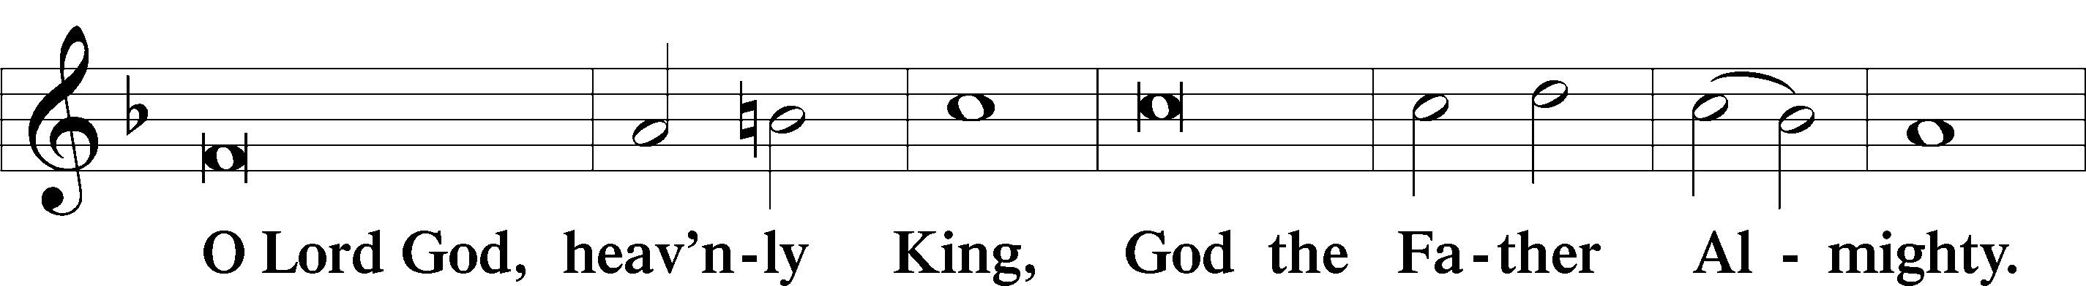
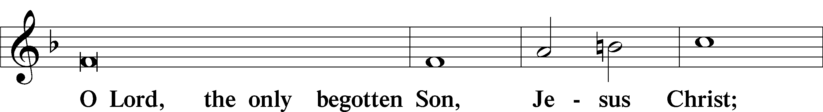
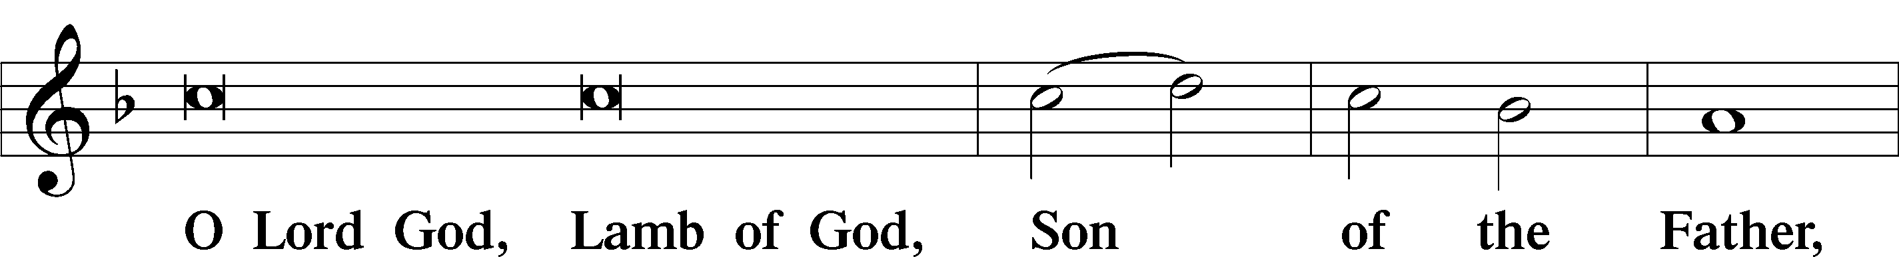
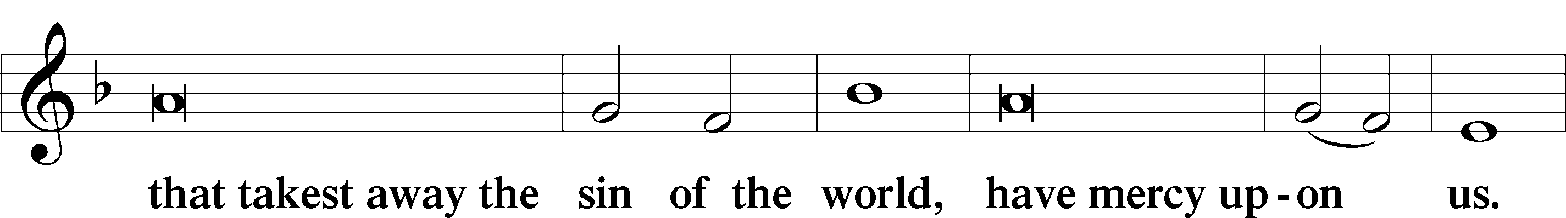
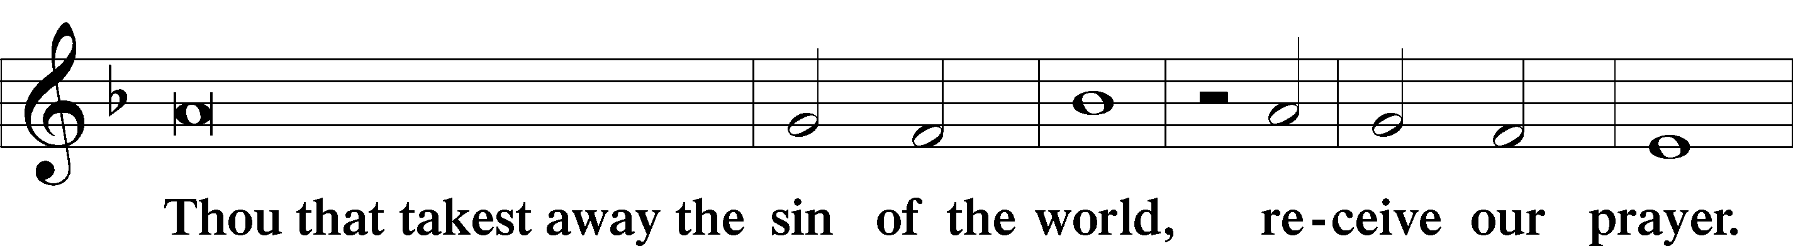
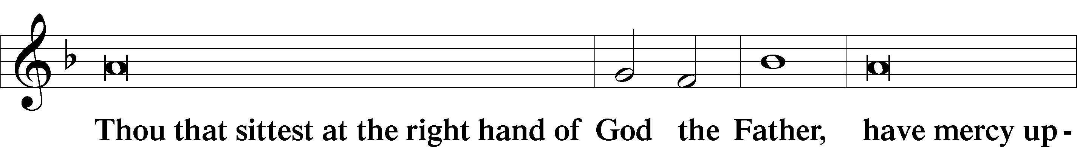
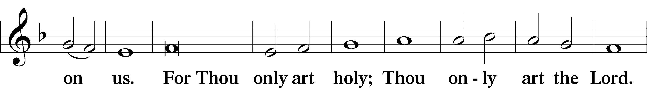
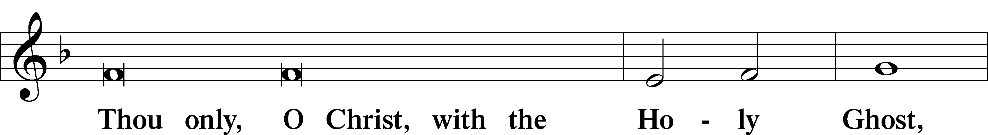
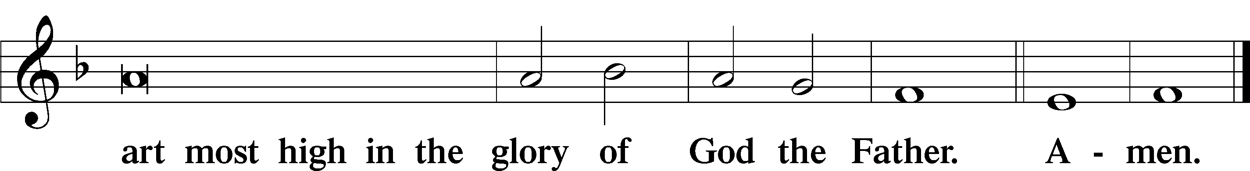

Salutation and Collect of the Day
P The Lord be with you.
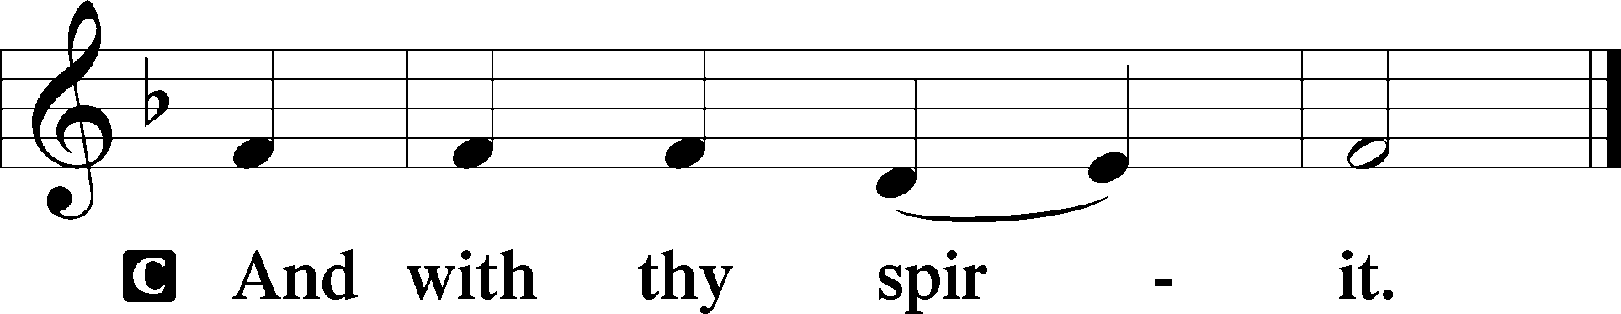

P Let us pray.
Lord Jesus Christ, You reign among us by the preaching of Your cross. Forgive Your people their offenses that we, being governed by Your bountiful goodness, may enter at last into Your eternal paradise; for You live and reign with the Father and the Holy Spirit, one God, now and forever.

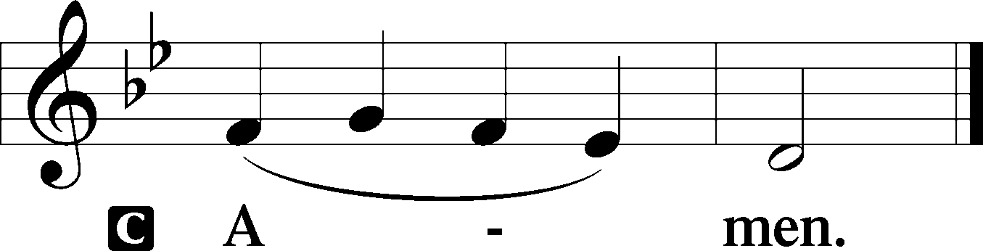

Sit

Old Testament Reading Malachi 3:13–18
13“Your words have been hard against me, says the Lord. But you say, ‘How have we spoken against you?’ 14You have said, ‘It is vain to serve God. What is the profit of our keeping his charge or of walking as in mourning before the Lord of hosts? 15And now we call the arrogant blessed. Evildoers not only prosper but they put God to the test and they escape.’”
16Then those who feared the Lord spoke with one another. The Lord paid attention and heard them, and a book of remembrance was written before him of those who feared the Lord and esteemed his name. 17“They shall be mine, says the Lord of hosts, in the day when I make up my treasured possession, and I will spare them as a man spares his son who serves him. 18Then once more you shall see the distinction between the righteous and the wicked, between one who serves God and one who does not serve him.”

A This is the Word of the Lord.
C Thanks be to God.

Gradual Revelation 7:14b; Psalm 84:5
These are the ones coming out of the great tribulation.
They have washed their robes and made them white in the blood of the Lamb.
Blessèd are those whose strength is in you,
in whose heart are the highways to Zion.

Epistle Colossians 1:13–20
13He has delivered us from the domain of darkness and transferred us to the kingdom of his beloved Son, 14in whom we have redemption, the forgiveness of sins.
15He is the image of the invisible God, the firstborn of all creation. 16For by him all things were created, in heaven and on earth, visible and invisible, whether thrones or dominions or rulers or authorities—all things were created through him and for him. 17And he is before all things, and in him all things hold together. 18And he is the head of the body, the church. He is the beginning, the firstborn from the dead, that in everything he might be preeminent. 19For in him all the fullness of God was pleased to dwell, 20and through him to reconcile to himself all things, whether on earth or in heaven, making peace by the blood of his cross.

Stand

Alleluia
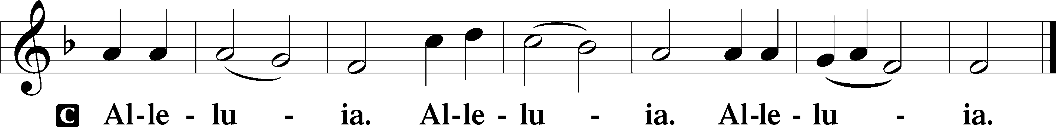

Holy Gospel Luke 23:27–43
P The Holy Gospel according to St. Luke, the twenty-third chapter.

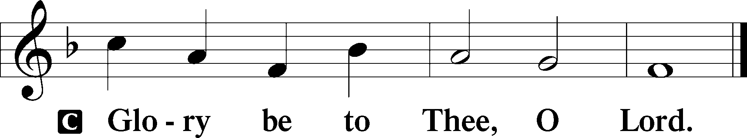

27And there followed [Jesus] a great multitude of the people and of women who were mourning and lamenting for him. 28But turning to them Jesus said, “Daughters of Jerusalem, do not weep for me, but weep for yourselves and for your children. 29For behold, the days are coming when they will say, ‘Blessed are the barren and the wombs that never bore and the breasts that never nursed!’ 30Then they will begin to say to the mountains, ‘Fall on us,’ and to the hills, ‘Cover us.’ 31For if they do these things when the wood is green, what will happen when it is dry?”
32Two others, who were criminals, were led away to be put to death with him. 33And when they came to the place that is called The Skull, there they crucified him, and the criminals, one on his right and one on his left. 34And Jesus said, “Father, forgive them, for they know not what they do.” And they cast lots to divide his garments. 35And the people stood by, watching, but the rulers scoffed at him, saying, “He saved others; let him save himself, if he is the Christ of God, his Chosen One!” 36The soldiers also mocked him, coming up and offering him sour wine 37and saying, “If you are the King of the Jews, save yourself!” 38There was also an inscription over him, “This is the King of the Jews.”
39One of the criminals who were hanged railed at him, saying, “Are you not the Christ? Save yourself and us!” 40But the other rebuked him, saying, “Do you not fear God, since you are under the same sentence of condemnation? 41And we indeed justly, for we are receiving the due reward of our deeds; but this man has done nothing wrong.” 42And he said, “Jesus, remember me when you come into your kingdom.” 43And he said to him, “Truly, I say to you, today you will be with me in Paradise.”

P This is the Gospel of the Lord.

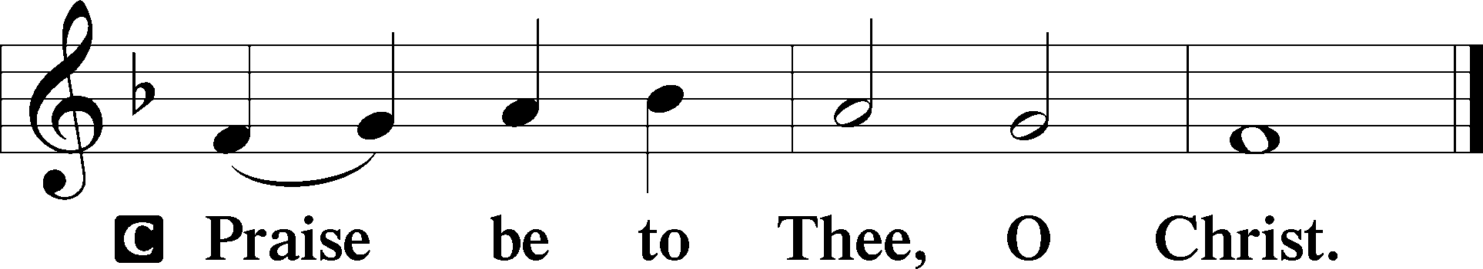

Apostles’ Creed
C I believe in God, the Father Almighty,
maker of heaven and earth.

And in Jesus Christ, His only Son, our Lord,
who was conceived by the Holy Spirit,
born of the virgin Mary,
suffered under Pontius Pilate,
was crucified, died and was buried.
He descended into hell.
The third day He rose again from the dead.
He ascended into heaven
and sits at the right hand of God the Father Almighty.
From thence He will come to judge the living and the dead.

I believe in the Holy Spirit,
the holy Christian Church,
the communion of saints,
the forgiveness of sins,
the resurrection of the body,
and the life T everlasting. Amen.

Sit

Children's Sermon

905 Come, Thou Almighty King
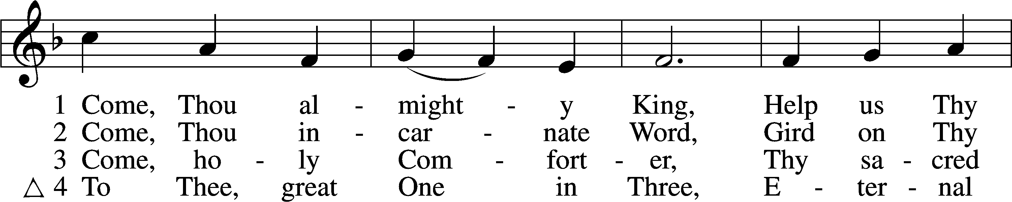
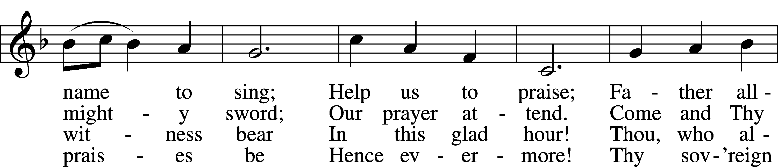
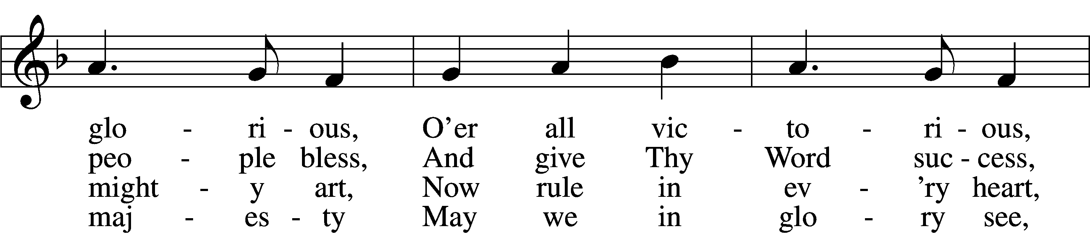
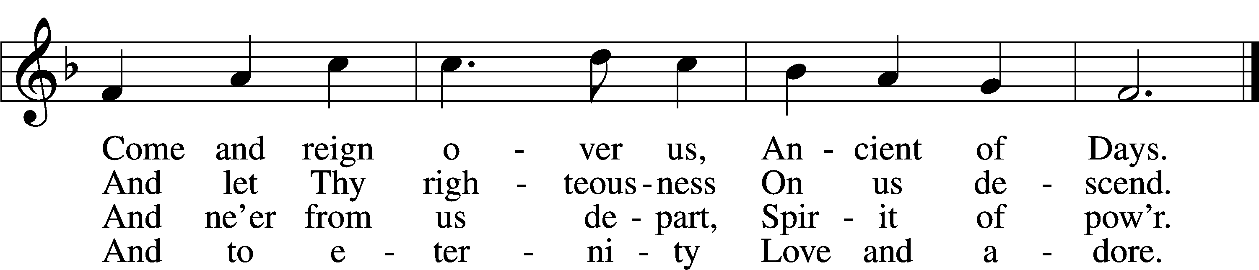
Text: English, before 1760, alt.
Tune: Felice de Giardini, 1716–96
Text and tune: Public domain

Sermon

422 On My Heart Imprint Your Image
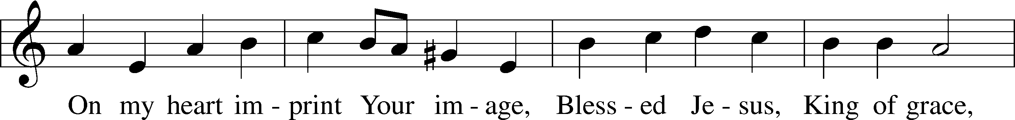
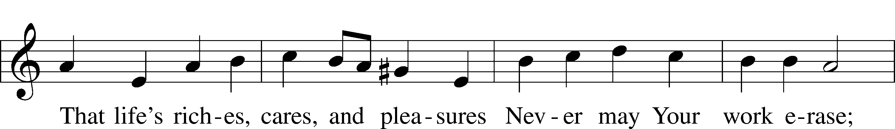
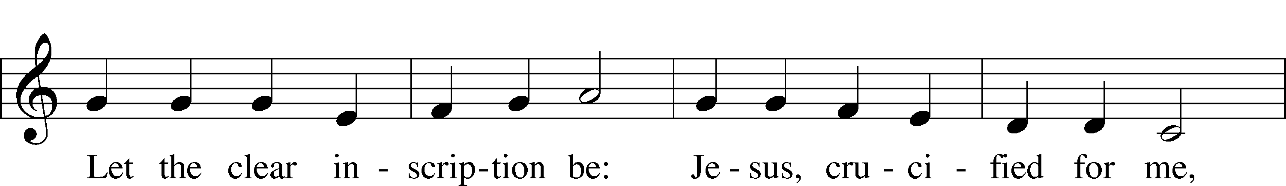
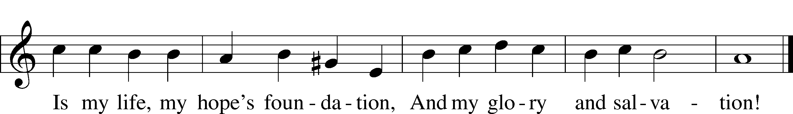
Text: Thomas Hansen Kingo, 1634–1703; tr. Peer O. Strömme, 1856–1921, alt.
Tune: Johann Balthasar König, 1691–1758
Text and tune: Public domain

Votum
P The peace of God, which passes all understanding, keep your hearts and minds in Christ Jesus.
C Amen.

Stand

Offertory Psalm 51:10–12
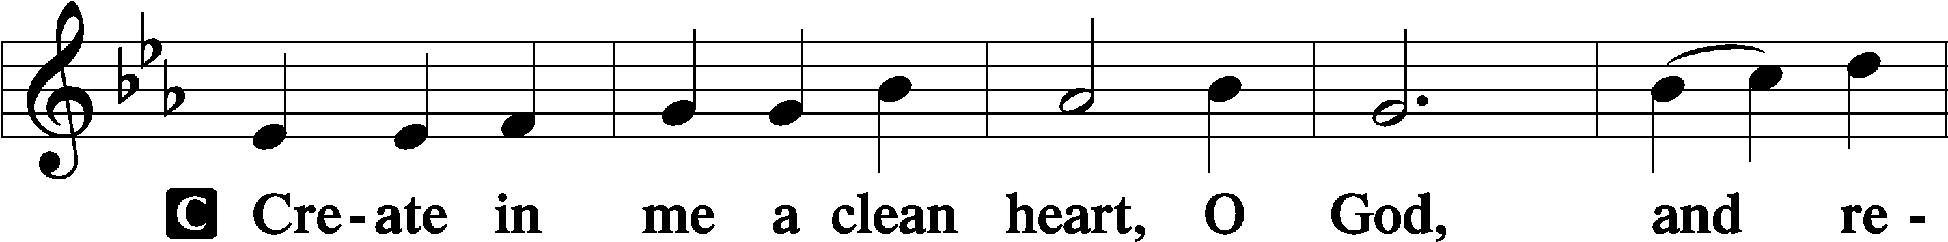
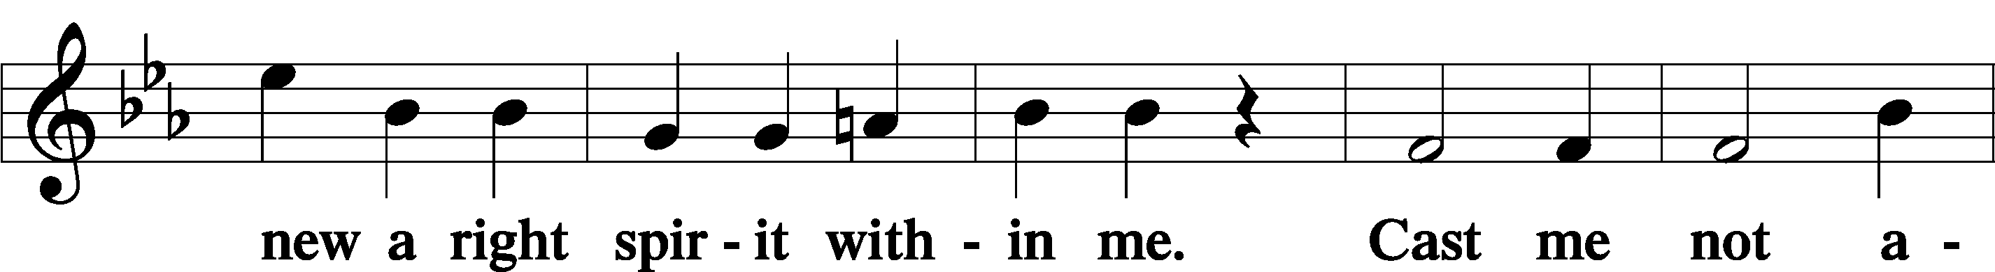
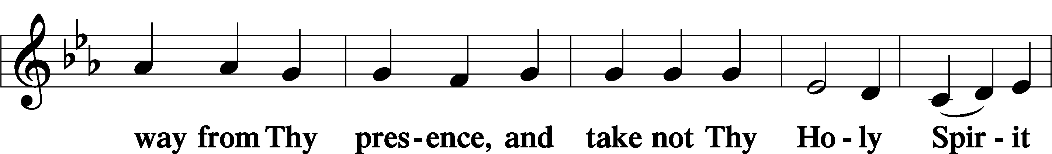
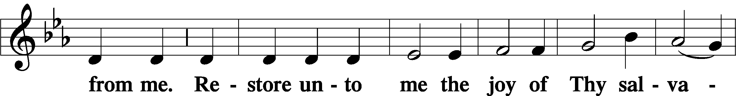
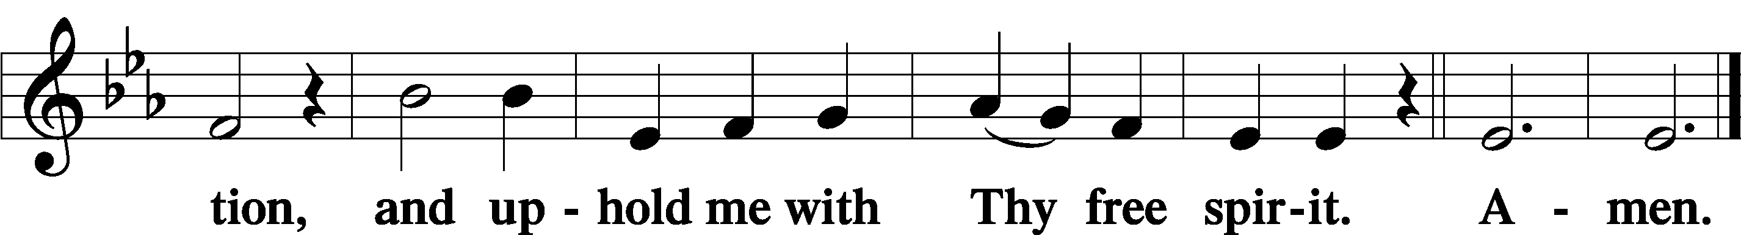

Offering

805 Praise God, from Whom All Blessings Flow
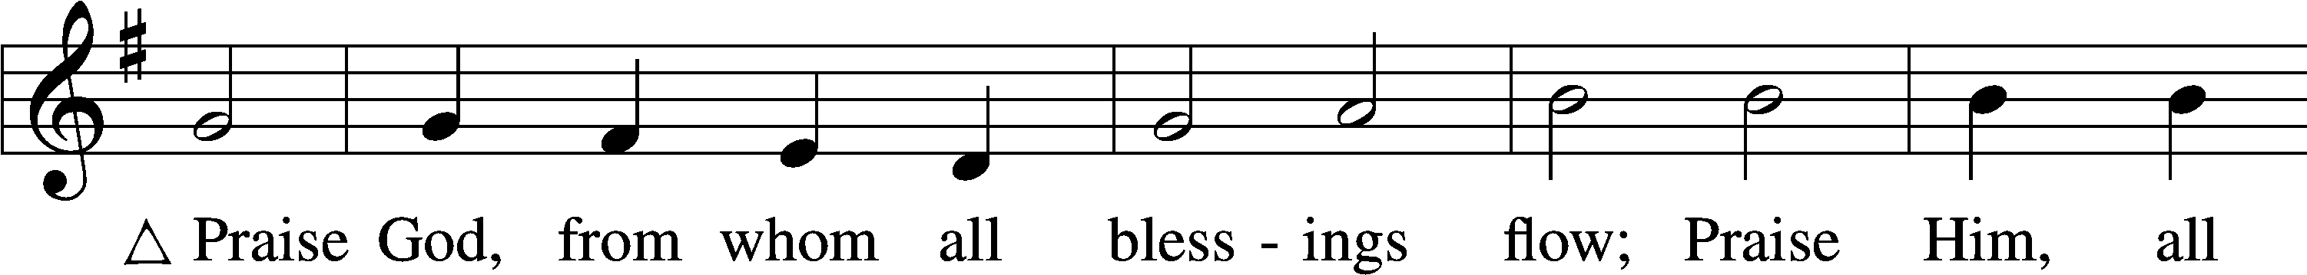
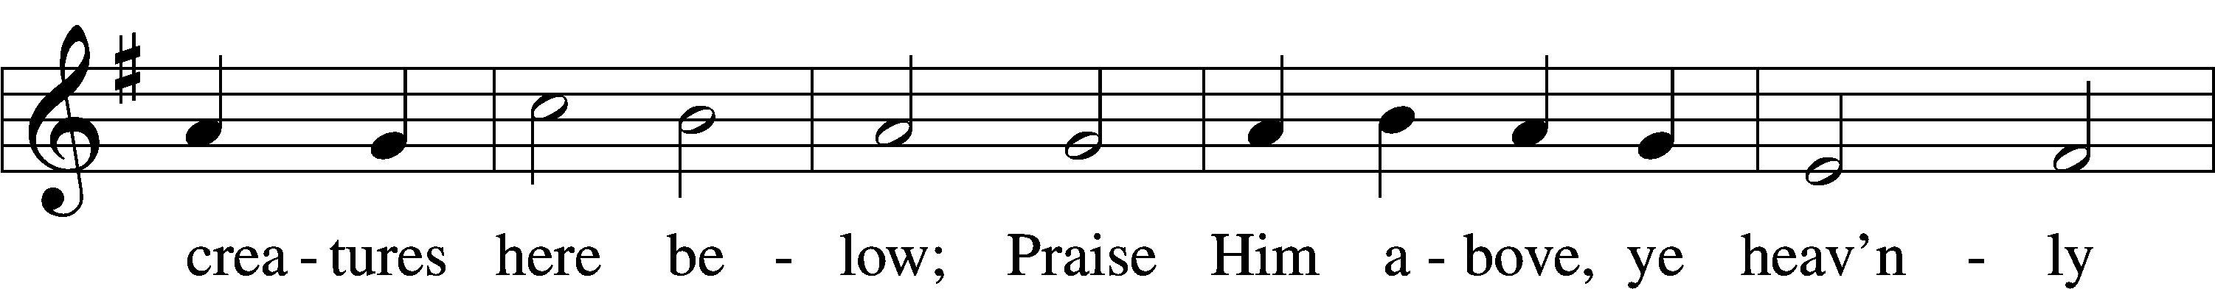
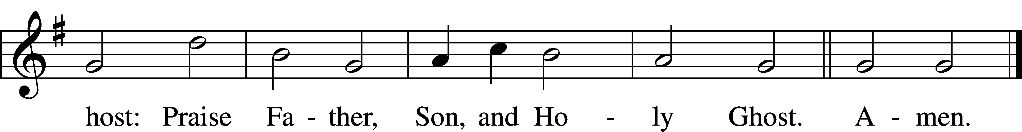
Text: Thomas Ken, 1637–1711
Tune: Trente quatre Pseaumes de David, 1551, Geneva, ed. Louis Bourgeois
Text and tune: Public domain

Prayer of the Church

Lord’s Prayer Matthew 6:9–13
P Lord, remember us in Your kingdom and teach us to pray:
C Our Father who art in heaven,
hallowed be Thy name,
Thy kingdom come,
Thy will be done on earth
as it is in heaven;
give us this day our daily bread;
and forgive us our trespasses
as we forgive those
who trespass against us;
and lead us not into temptation,
but deliver us from evil.
For Thine is the kingdom
and the power and the glory
forever and ever. Amen.

Collect for the Word

Blessed Lord, You have caused all Holy Scriptures to be written for our learning. Grant that we may so hear them, read, mark, learn, and inwardly digest them that, by the patience and comfort of Your holy Word, we may embrace and ever hold fast the blessed hope of everlasting life; through Jesus Christ, Your Son, our Lord, who lives and reigns with You and the Holy Spirit, one God, now and forever.

Benediction
P The Lord bless you and keep you.
The Lord make His face shine on you and be gracious to you.
The Lord look upon you with favor and T give you peace.
C Amen.

741 Jesus Christ, My Sure Defense
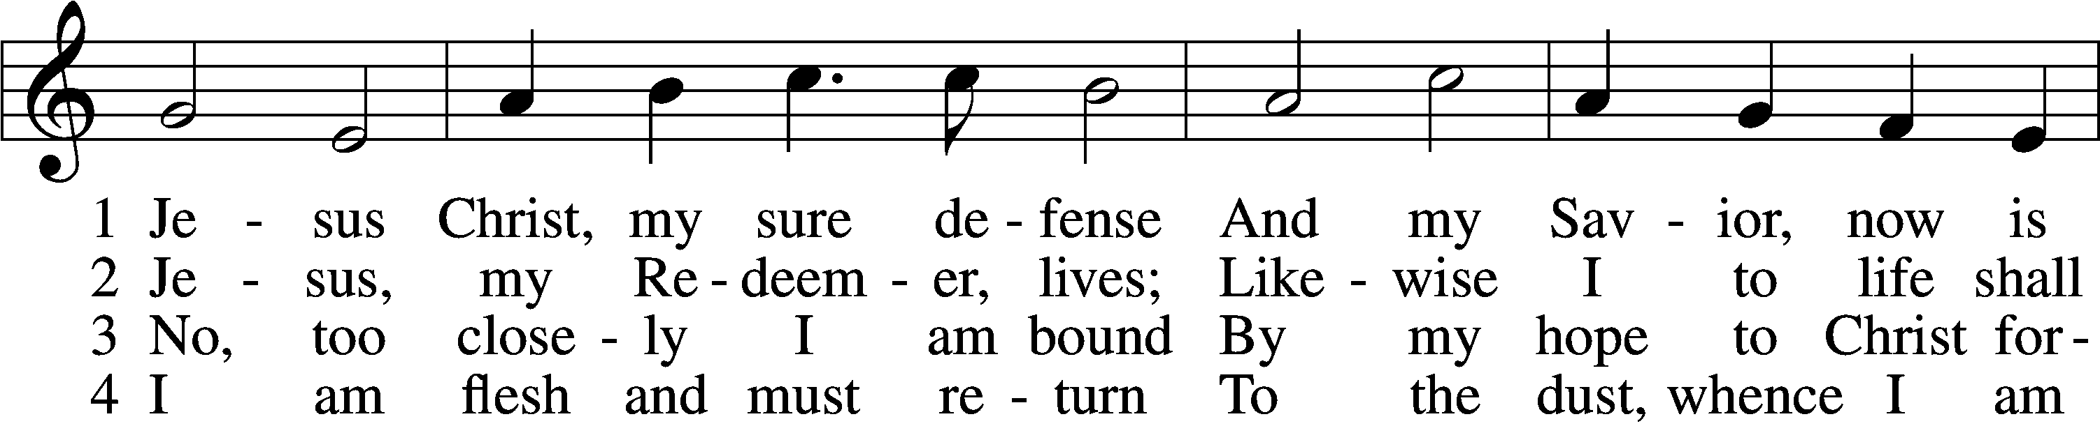
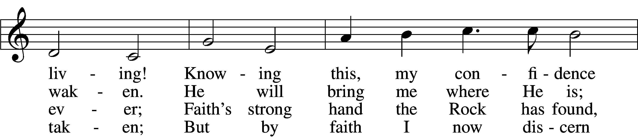
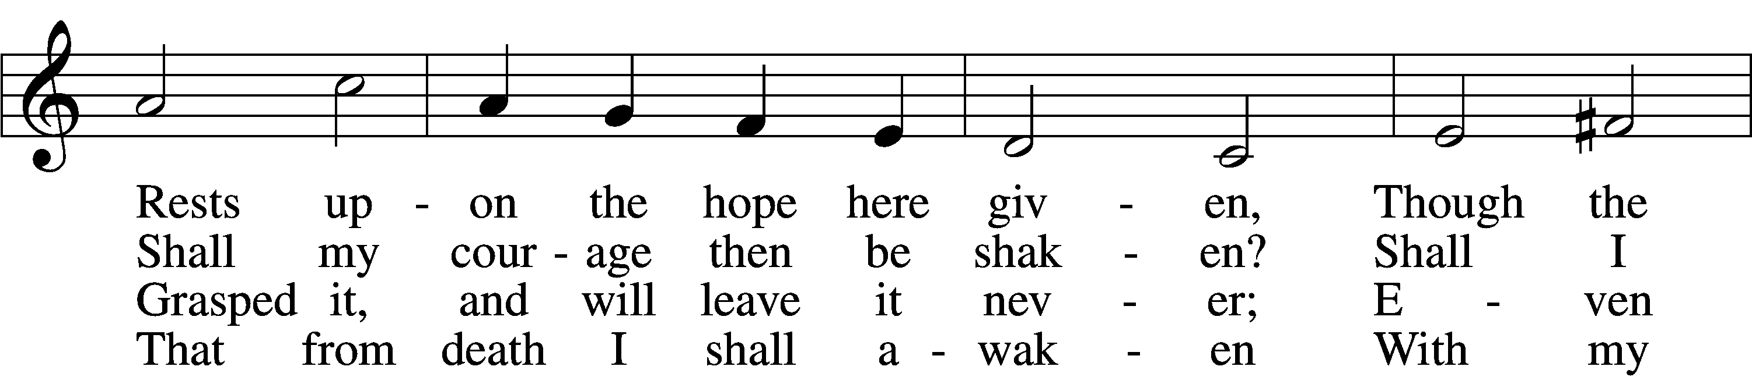
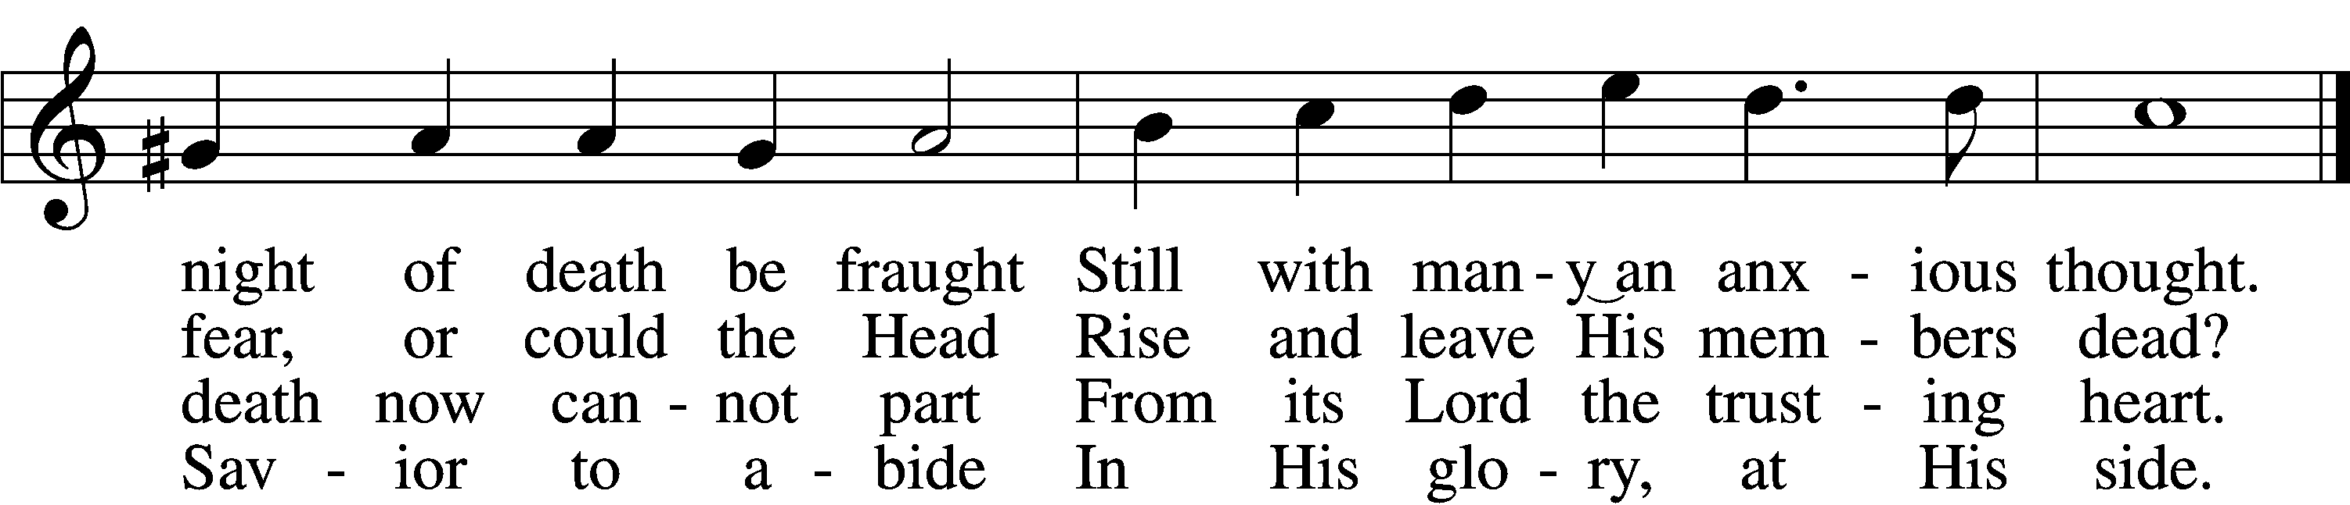

5 Glorified, I shall anew
With this flesh then be enshrouded;
In this body I shall view
God, my Lord, with eyes unclouded;
In this flesh I then shall see
Jesus Christ eternally.

6 Then take comfort and rejoice,
For His members Christ will cherish.
Fear not, they will hear His voice;
Dying, they will never perish;
For the very grave is stirred
When the trumpet’s blast is heard.

7 Laugh to scorn the gloomy grave
And at death no longer tremble;
He, the Lord, who came to save
Will at last His own assemble.
They will go their Lord to meet,
Treading death beneath their feet.

8 O, then, draw away your hearts
From all pleasures base and hollow;
Strive to share what He imparts
While you here His footsteps follow.
As you now still wait to rise,
Fix your hearts beyond the skies!
Text: Otto von Schwerin, 1616–79; tr. Catherine Winkworth, 1827–78, alt.
Tune: Johann Crüger, 1598–1662
Text and tune: Public domain
Acknowledgments
Unless otherwise indicated, Scripture quotations are from the ESV® Bible (The Holy Bible, English Standard Version®), copyright © 2001 by Crossway, a publishing ministry of Good News Publishers. Used by permission. All rights reserved.
Created by Lutheran Service Builder © 2025 Concordia Publishing House.

