On entering the church

P Lord, I love the habitation of Your house and the place
where Your glory dwells. In the multitude of Your tender
mercies prepare my heart that I may enter Your house to
worship and confess Your holy name; through Jesus Christ,
my God and Lord.

Before worship

C O Lord, our creator, redeemer, and comforter, as we come
together to worship You in spirit and in truth, we humbly
pray that You would open our hearts to the preaching of
Your Word so that we may repent of our sins, believe in
Jesus Christ as our only Savior, and grow in grace and
holiness. Hear us for His sake.

424 O Christ, You Walked the Road
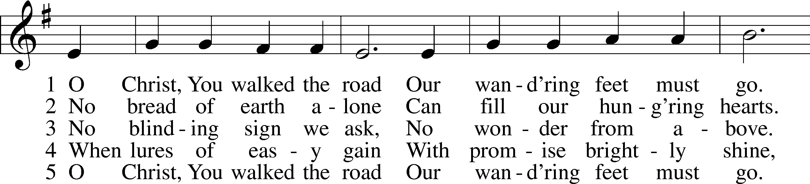
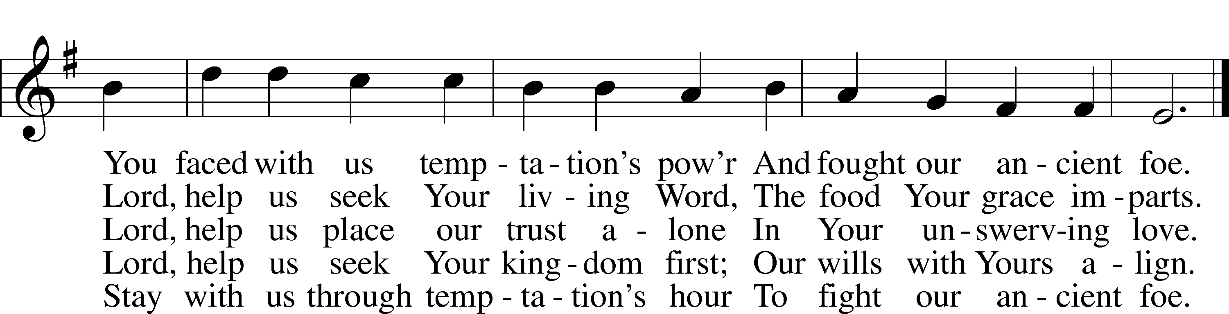
Text: Herman G. Stuempfle, Jr., 1923–2007
Tune: William Daman, c. 1540–1591
Text: © 1997 GIA Publications, Inc. Used by permission: LSB Hymn License no. 110005011
Tune: Public domain

Confession and Absolution

The sign of the cross may be made by all in remembrance of their Baptism.

Invocation Matthew 28:19b; 18:20
P In the name of the Father and of the T Son and of the Holy Spirit.
C Amen.

Exhortation Hebrews 10:22; Psalm 124:8; Psalm 32:5
P Beloved in the Lord! Let us draw near with a true heart and confess our sins unto God our Father, beseeching Him in the name of our Lord Jesus Christ to grant us forgiveness.

P Our help is in the name of the Lord,
C who made heaven and earth.
P I said, I will confess my transgressions unto the Lord,
C and You forgave the iniquity of my sin.

Silence for reflection on God’s Word and for self-examination.

Confession of Sins
P Almighty God, our maker and redeemer, we poor sinners confess unto You that we are by nature sinful and unclean and that we have sinned against You by thought, word, and deed. Wherefore we flee for refuge to Your infinite mercy, seeking and imploring Your grace for the sake of our Lord Jesus Christ.
C O most merciful God, who has given Your only-begotten Son to die for us, have mercy upon us and for His sake grant us remission of all our sins; and by Your Holy Spirit increase in us true knowledge of You and of Your will and true obedience to Your Word, to the end that by Your grace we may come to everlasting life; through Jesus Christ, our Lord. Amen.

Declaration of Grace Mark 16:16; John 1:12
P Almighty God, our heavenly Father, has had mercy upon us and has given His only Son to die for us and for His sake forgives us all our sins. To those who believe on His name He gives power to become the children of God and has promised them His Holy Spirit. He that believes and is baptized shall be saved.
Grant this, Lord, unto us all.
C Amen.

Service of the Word

Introit Psalm 91:1–2, 9–10, 13; antiphon: vv. 15a, c, 16
When he calls to me, I will answer him;
I will rescue him and honor him.
With long life I will satisfy him
and show him my salvation.
He who dwells in the shelter of the Most High
will abide in the shadow of the Almighty.
I will say to the Lord, “My refuge and my fortress,
my God, in whom I trust.”
Because you have made the Lord your dwelling place—
the Most High, who is my refuge—
no evil shall be allowed to befall you,
no plague come near your tent.
You will tread on the lion and the adder;
the young lion and the serpent you will trample underfoot.

Gloria Patri
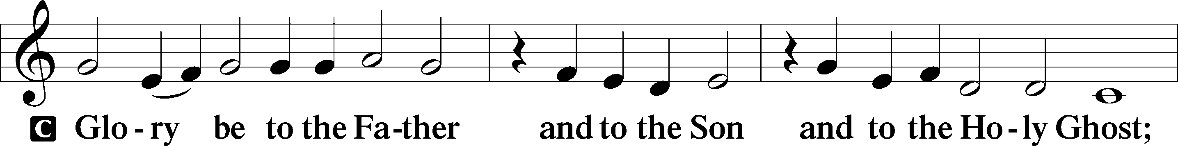
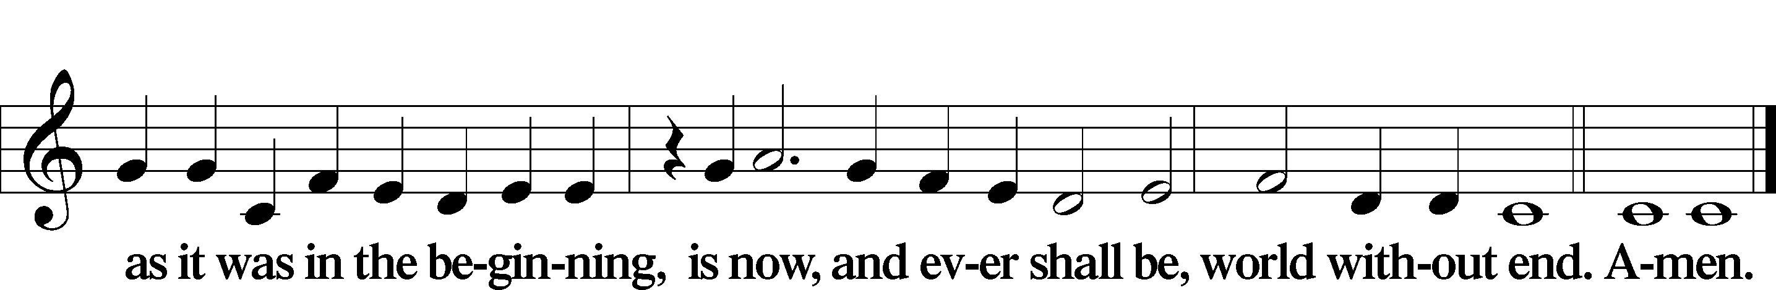

Kyrie Mark 10:47
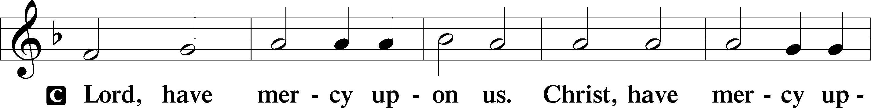
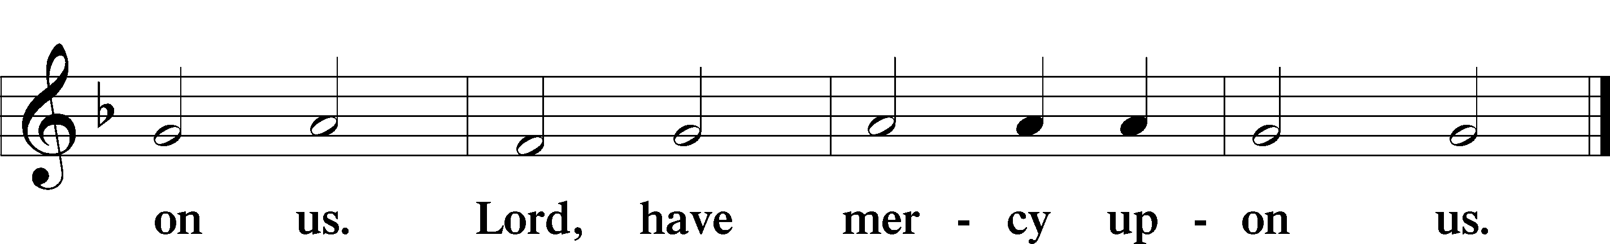

Salutation and Collect of the Day
P The Lord be with you.
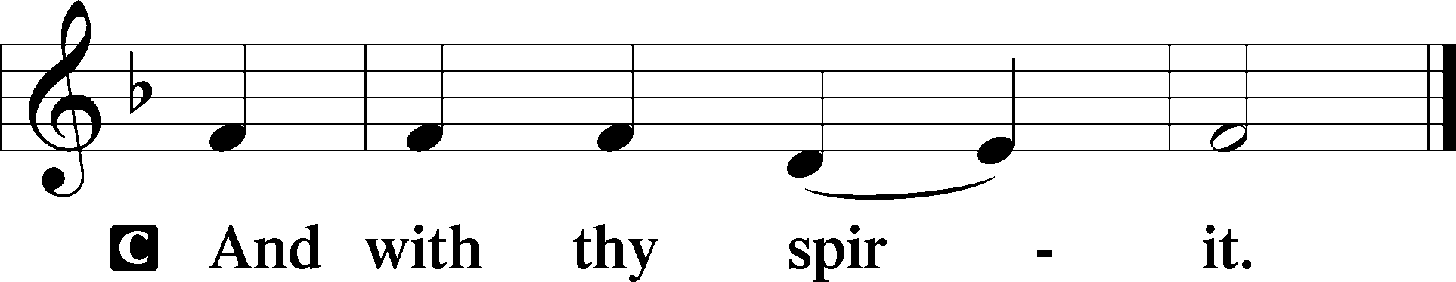

P Let us pray.
O Lord God, You led Your ancient people through the wilderness and brought them to the promised land. Guide the people of Your Church that following our Savior we may walk through the wilderness of this world toward the glory of the world to come; through Jesus Christ, Your Son, our Lord, who lives and reigns with You and the Holy Spirit, one God, now and forever.

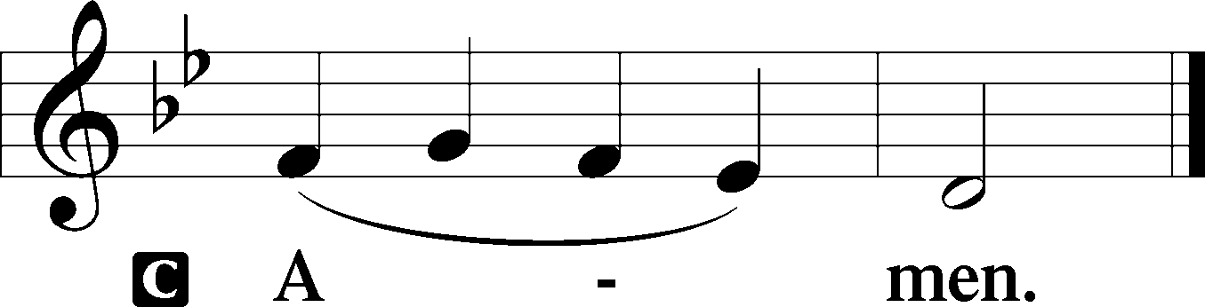

Sit

Old Testament Reading 1 Samuel 17:40–51
40Then [David] took his staff in his hand and chose five smooth stones from the brook and put them in his shepherd’s pouch. His sling was in his hand, and he approached the Philistine.
41And the Philistine moved forward and came near to David, with his shield-bearer in front of him. 42And when the Philistine looked and saw David, he disdained him, for he was but a youth, ruddy and handsome in appearance. 43And the Philistine said to David, “Am I a dog, that you come to me with sticks?” And the Philistine cursed David by his gods. 44The Philistine said to David, “Come to me, and I will give your flesh to the birds of the air and to the beasts of the field.” 45Then David said to the Philistine, “You come to me with a sword and with a spear and with a javelin, but I come to you in the name of the Lord of hosts, the God of the armies of Israel, whom you have defied. 46This day the Lord will deliver you into my hand, and I will strike you down and cut off your head. And I will give the dead bodies of the host of the Philistines this day to the birds of the air and to the wild beasts of the earth, that all the earth may know that there is a God in Israel, 47and that all this assembly may know that the Lord saves not with sword and spear. For the battle is the Lord’s, and he will give you into our hand.”
48When the Philistine arose and came and drew near to meet David, David ran quickly toward the battle line to meet the Philistine. 49And David put his hand in his bag and took out a stone and slung it and struck the Philistine on his forehead. The stone sank into his forehead, and he fell on his face to the ground.
50So David prevailed over the Philistine with a sling and with a stone, and struck the Philistine and killed him. There was no sword in the hand of David. 51Then David ran and stood over the Philistine and took his sword and drew it out of its sheath and killed him and cut off his head with it. When the Philistines saw that their champion was dead, they fled.

A This is the Word of the Lord.
C Thanks be to God.

Gradual Psalm 91:11–12
He will command his angels concerning you
to guard you in all your ways.
On their hands they will bear you up,
lest you strike your foot against a stone.

Epistle 2 Corinthians 6:1–10
1Working together with him, then, we appeal to you not to receive the grace of God in vain. 2For he says,
“In a favorable time I listened to you,
and in a day of salvation I have helped you.”
Behold, now is the favorable time; behold, now is the day of salvation. 3We put no obstacle in anyone’s way, so that no fault may be found with our ministry, 4but as servants of God we commend ourselves in every way: by great endurance, in afflictions, hardships, calamities, 5beatings, imprisonments, riots, labors, sleepless nights, hunger; 6by purity, knowledge, patience, kindness, the Holy Spirit, genuine love; 7by truthful speech, and the power of God; with the weapons of righteousness for the right hand and for the left; 8through honor and dishonor, through slander and praise. We are treated as impostors, and yet are true; 9as unknown, and yet well known; as dying, and behold, we live; as punished, and yet not killed; 10as sorrowful, yet always rejoicing; as poor, yet making many rich; as having nothing, yet possessing everything.

Stand

Holy Gospel Matthew 4:1–11
P The Holy Gospel according to St. Matthew, the fourth chapter.

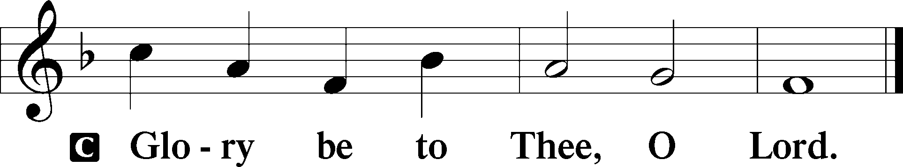

1Then Jesus was led up by the Spirit into the wilderness to be tempted by the devil. 2And after fasting forty days and forty nights, he was hungry. 3And the tempter came and said to him, “If you are the Son of God, command these stones to become loaves of bread.” 4But he answered, “It is written,
“‘Man shall not live by bread alone,
but by every word that comes from the mouth of God.’”
5Then the devil took him to the holy city and set him on the pinnacle of the temple 6and said to him, “If you are the Son of God, throw yourself down, for it is written,
“‘He will command his angels concerning you,’
and
“‘On their hands they will bear you up,
lest you strike your foot against a stone.’”
7Jesus said to him, “Again it is written, ‘You shall not put the Lord your God to the test.’” 8Again, the devil took him to a very high mountain and showed him all the kingdoms of the world and their glory. 9And he said to him, “All these I will give you, if you will fall down and worship me.” 10Then Jesus said to him, “Be gone, Satan! For it is written,
“‘You shall worship the Lord your God
and him only shall you serve.’”
11Then the devil left him, and behold, angels came and were ministering to him.

P This is the Gospel of the Lord.

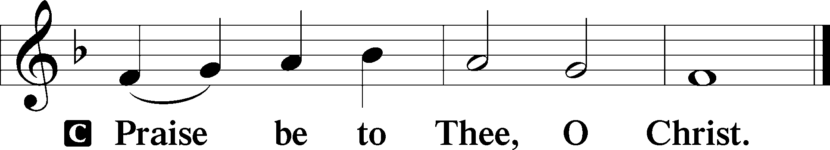

Apostles’ Creed
C I believe in God, the Father Almighty,
maker of heaven and earth.

And in Jesus Christ, His only Son, our Lord,
who was conceived by the Holy Spirit,
born of the virgin Mary,
suffered under Pontius Pilate,
was crucified, died and was buried.
He descended into hell.
The third day He rose again from the dead.
He ascended into heaven
and sits at the right hand of God the Father Almighty.
From thence He will come to judge the living and the dead.

I believe in the Holy Spirit,
the holy Christian Church,
the communion of saints,
the forgiveness of sins,
the resurrection of the body,
and the life T everlasting. Amen.

Sit

Children's Sermon

656 A Mighty Fortress Is Our God
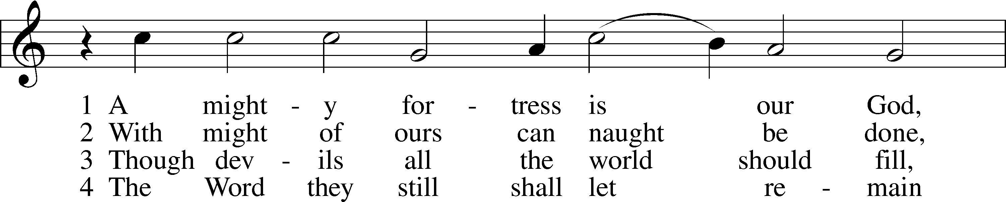
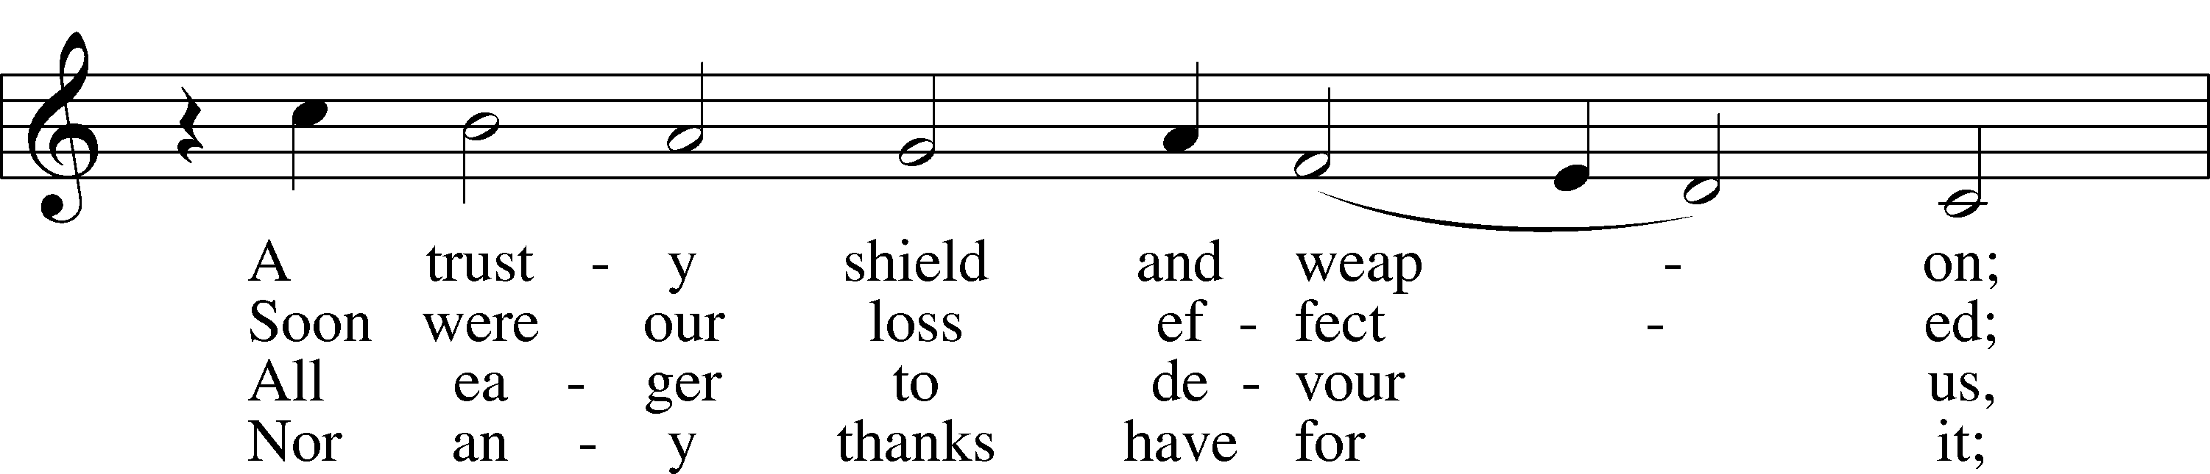
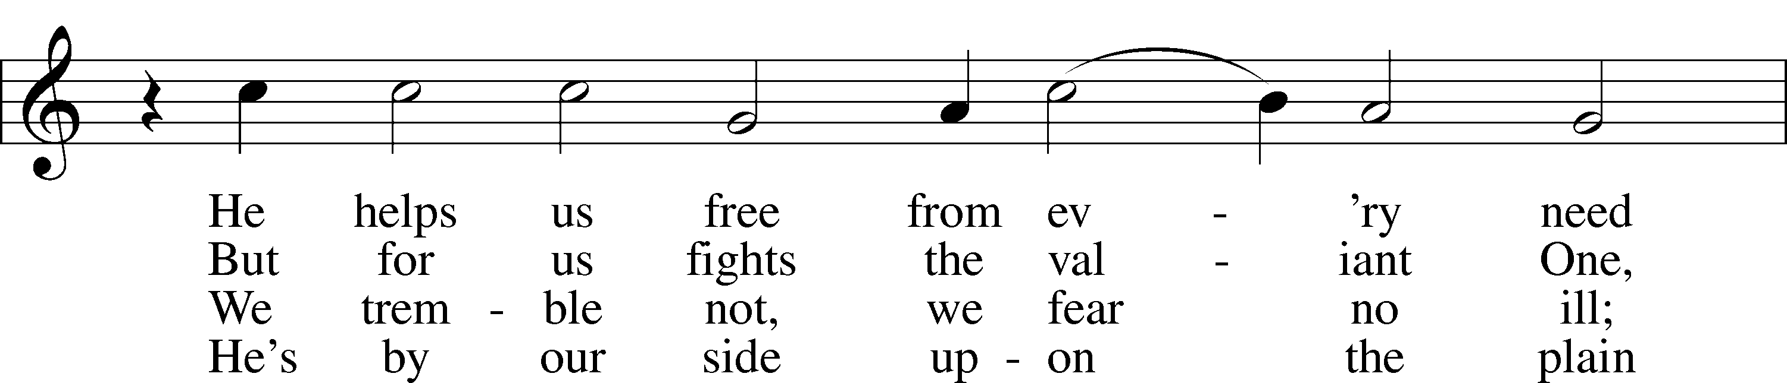
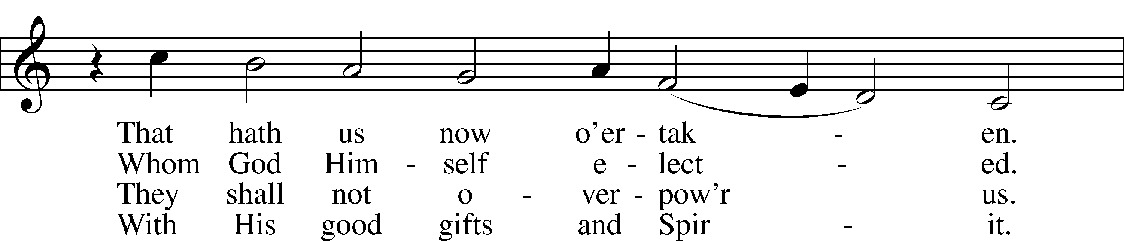
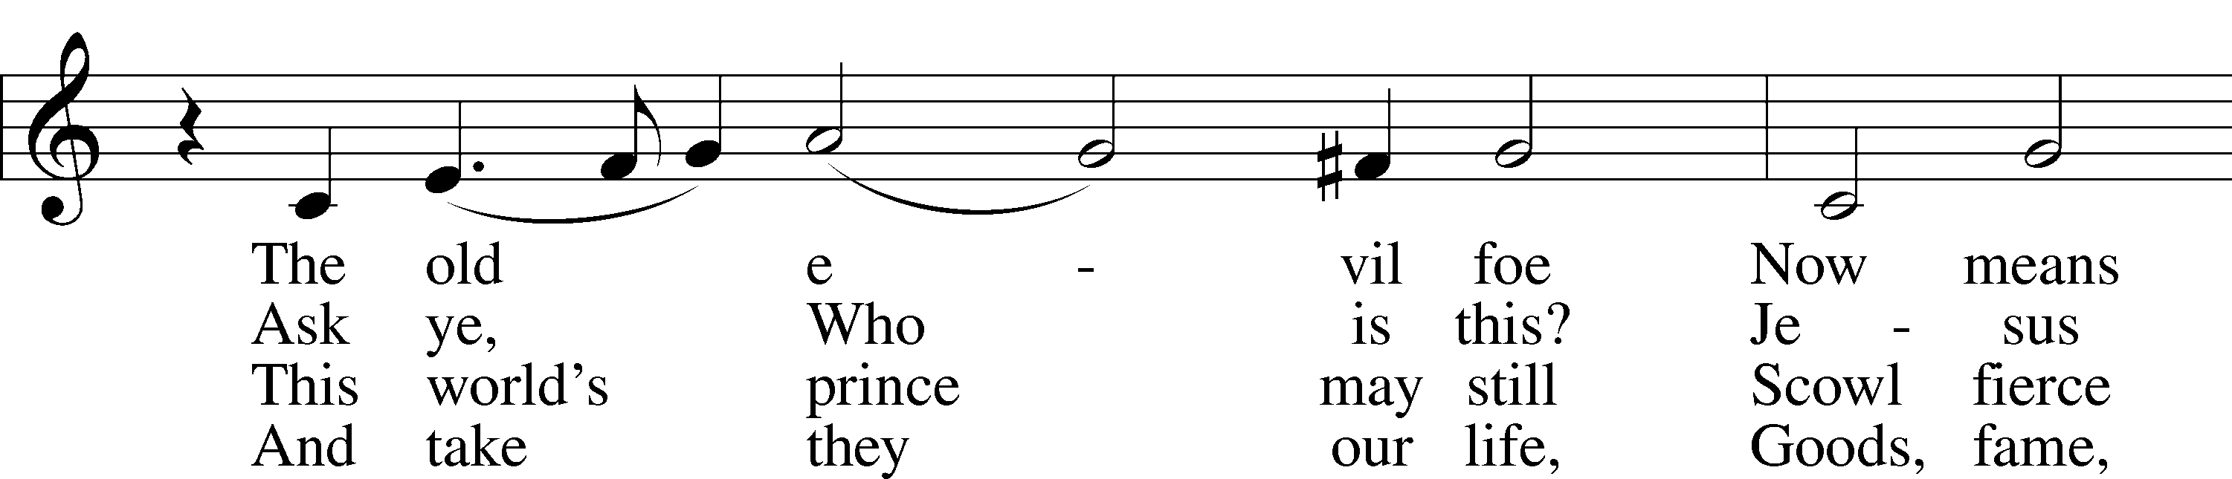
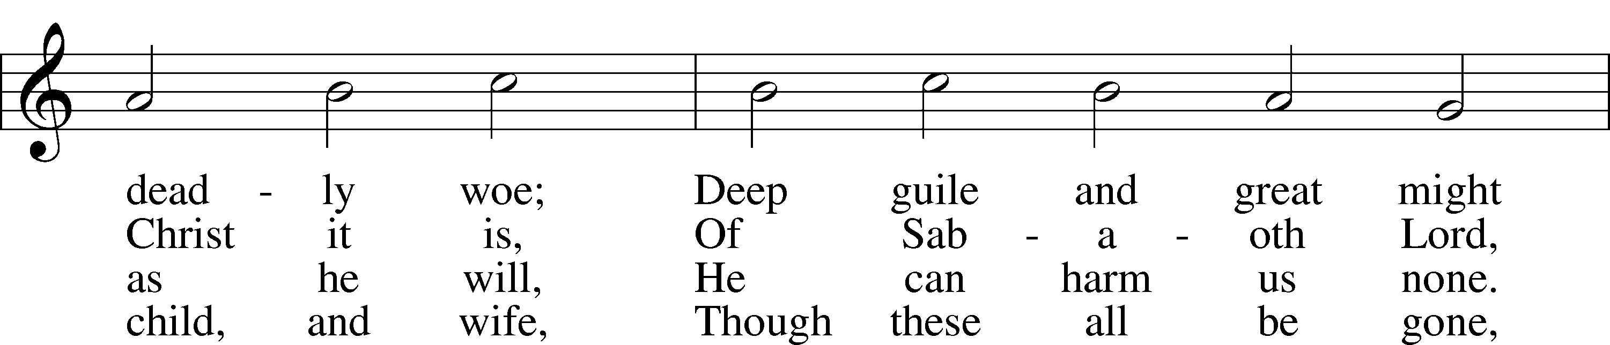
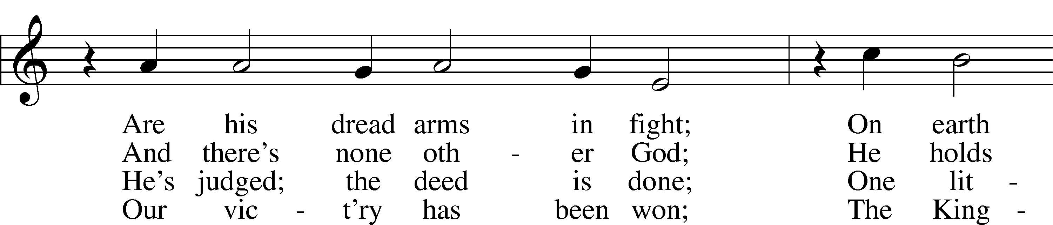
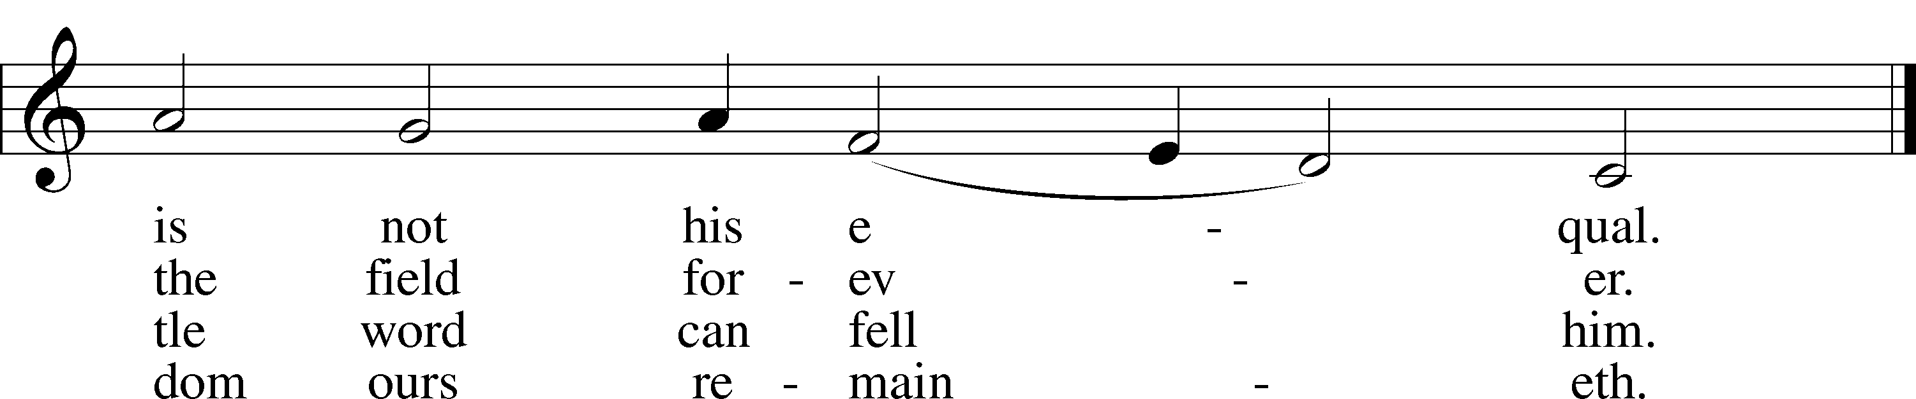
Text: tr. composite
Text and tune: Martin Luther, 1483–1546
Text and tune: Public domain

Sermon

Votum
P The peace of God, which passes all understanding, keep your hearts and minds in Christ Jesus.
C Amen.

Stand

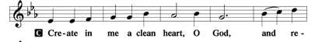
Offertory Psalm 51:10–12

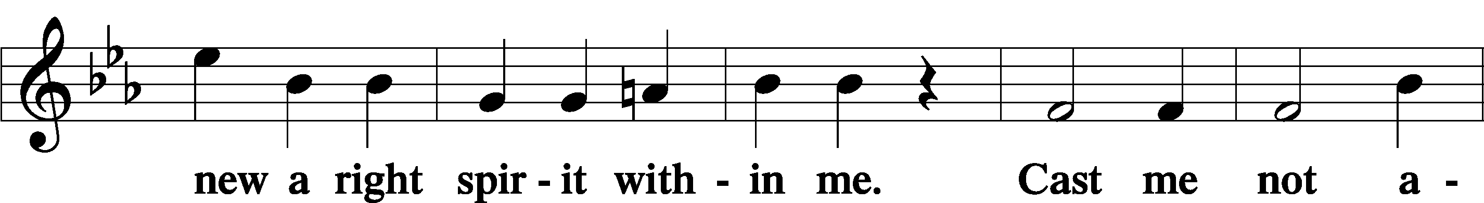
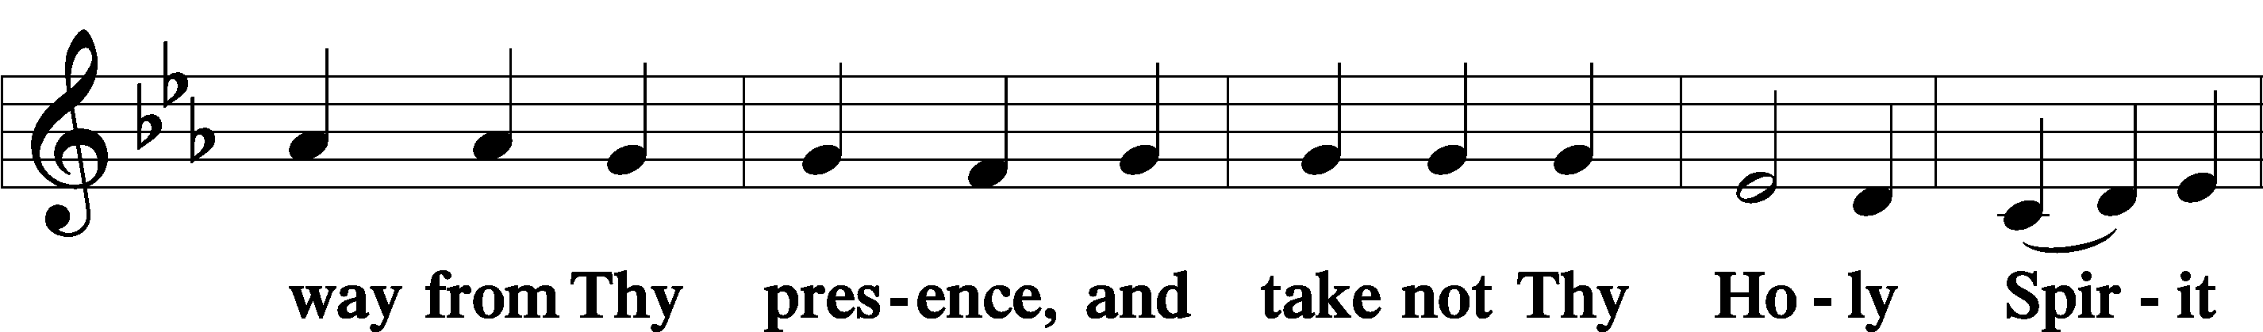
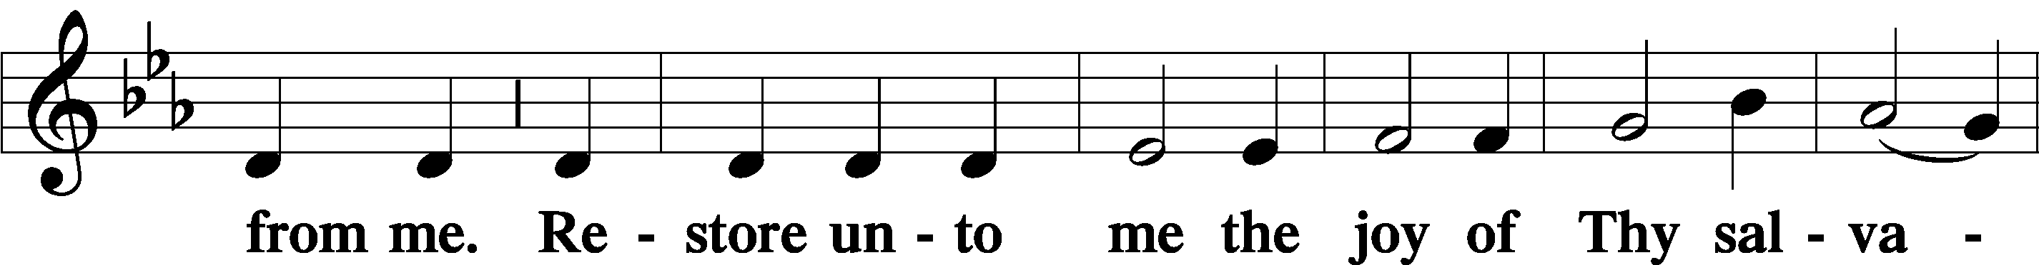
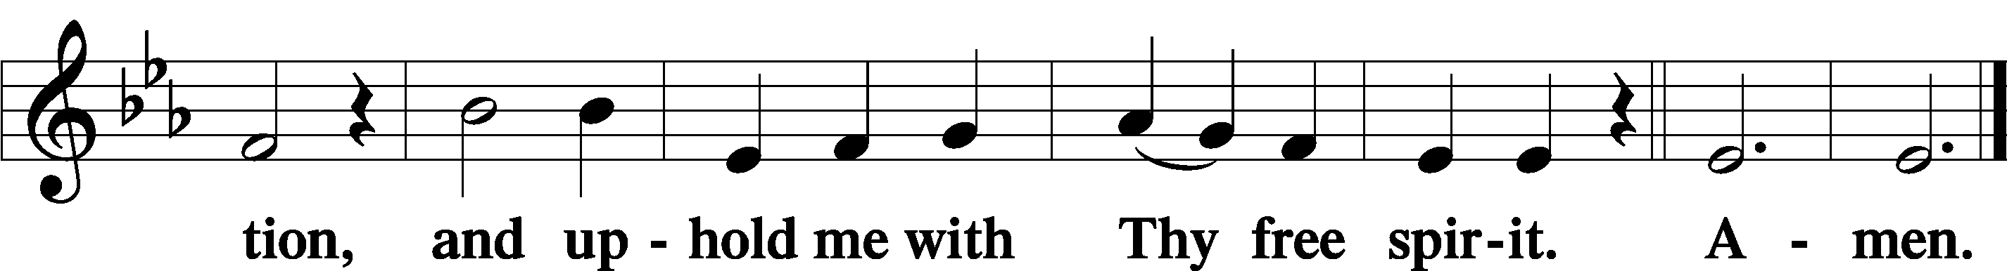

Offering

805 Praise God, from Whom All Blessings Flow
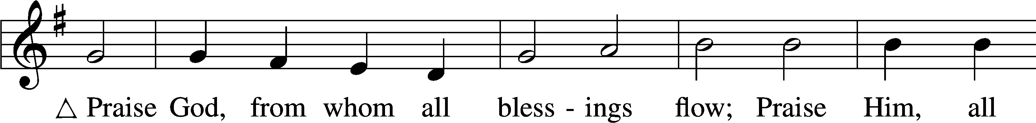
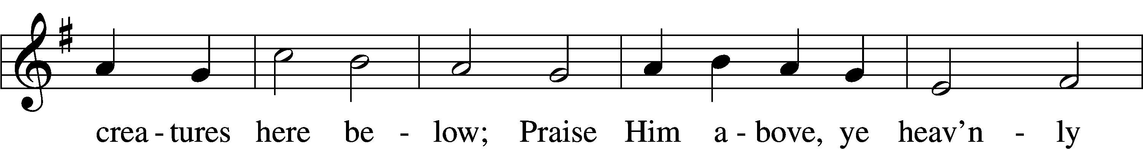
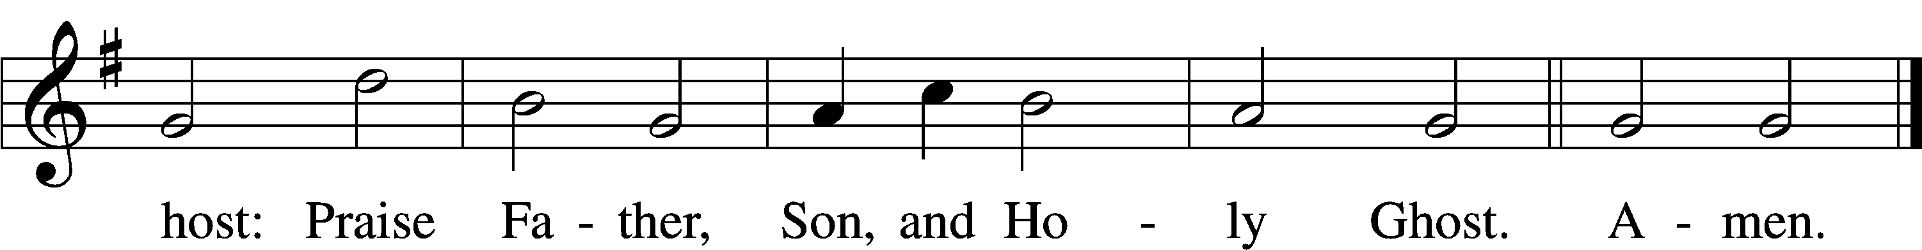
Text: Thomas Ken, 1637–1711
Tune: Trente quatre Pseaumes de David, 1551, Geneva, ed. Louis Bourgeois
Text and tune: Public domain

Prayer of the Church

Lord’s Prayer Matthew 6:9–13
P Lord, remember us in Your kingdom and teach us to pray:
C Our Father who art in heaven,
hallowed be Thy name,
Thy kingdom come,
Thy will be done on earth
as it is in heaven;
give us this day our daily bread;
and forgive us our trespasses
as we forgive those
who trespass against us;
and lead us not into temptation,
but deliver us from evil.
For Thine is the kingdom
and the power and the glory
forever and ever. Amen.

Collect for the Word

Blessed Lord, You have caused all Holy Scriptures to be written for our learning. Grant that we may so hear them, read, mark, learn, and inwardly digest them that, by the patience and comfort of Your holy Word, we may embrace and ever hold fast the blessed hope of everlasting life; through Jesus Christ, Your Son, our Lord, who lives and reigns with You and the Holy Spirit, one God, now and forever.

Benediction
P The Lord bless you and keep you.
The Lord make His face shine on you and be gracious to you.
The Lord look upon you with favor and T give you peace.
C Amen.

655 Lord, Keep Us Steadfast in Your Word
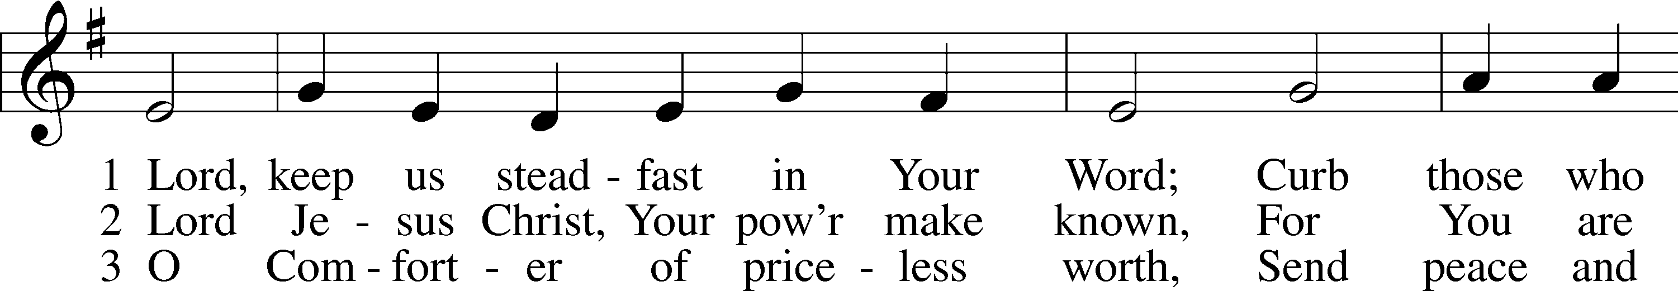
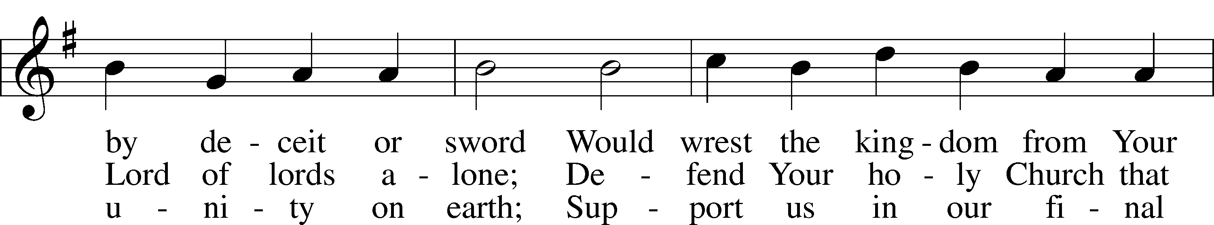
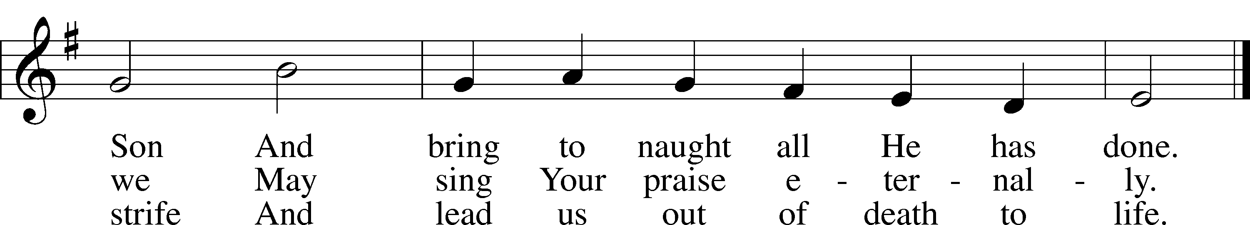
Text: Martin Luther, 1483–1546; tr. Catherine Winkworth, 1827–78, alt.
Tune: Geistliche Lieder auffs new gebessert, 1543, Wittenberg, ed. Joseph Klug
Text and tune: Public domain

Acknowledgments
Unless otherwise indicated, Scripture quotations are from the ESV® Bible (The Holy Bible, English Standard Version®), copyright © 2001 by Crossway, a publishing ministry of Good News Publishers. Used by permission. All rights reserved.
Created by Lutheran Service Builder © 2026 Concordia Publishing House.

