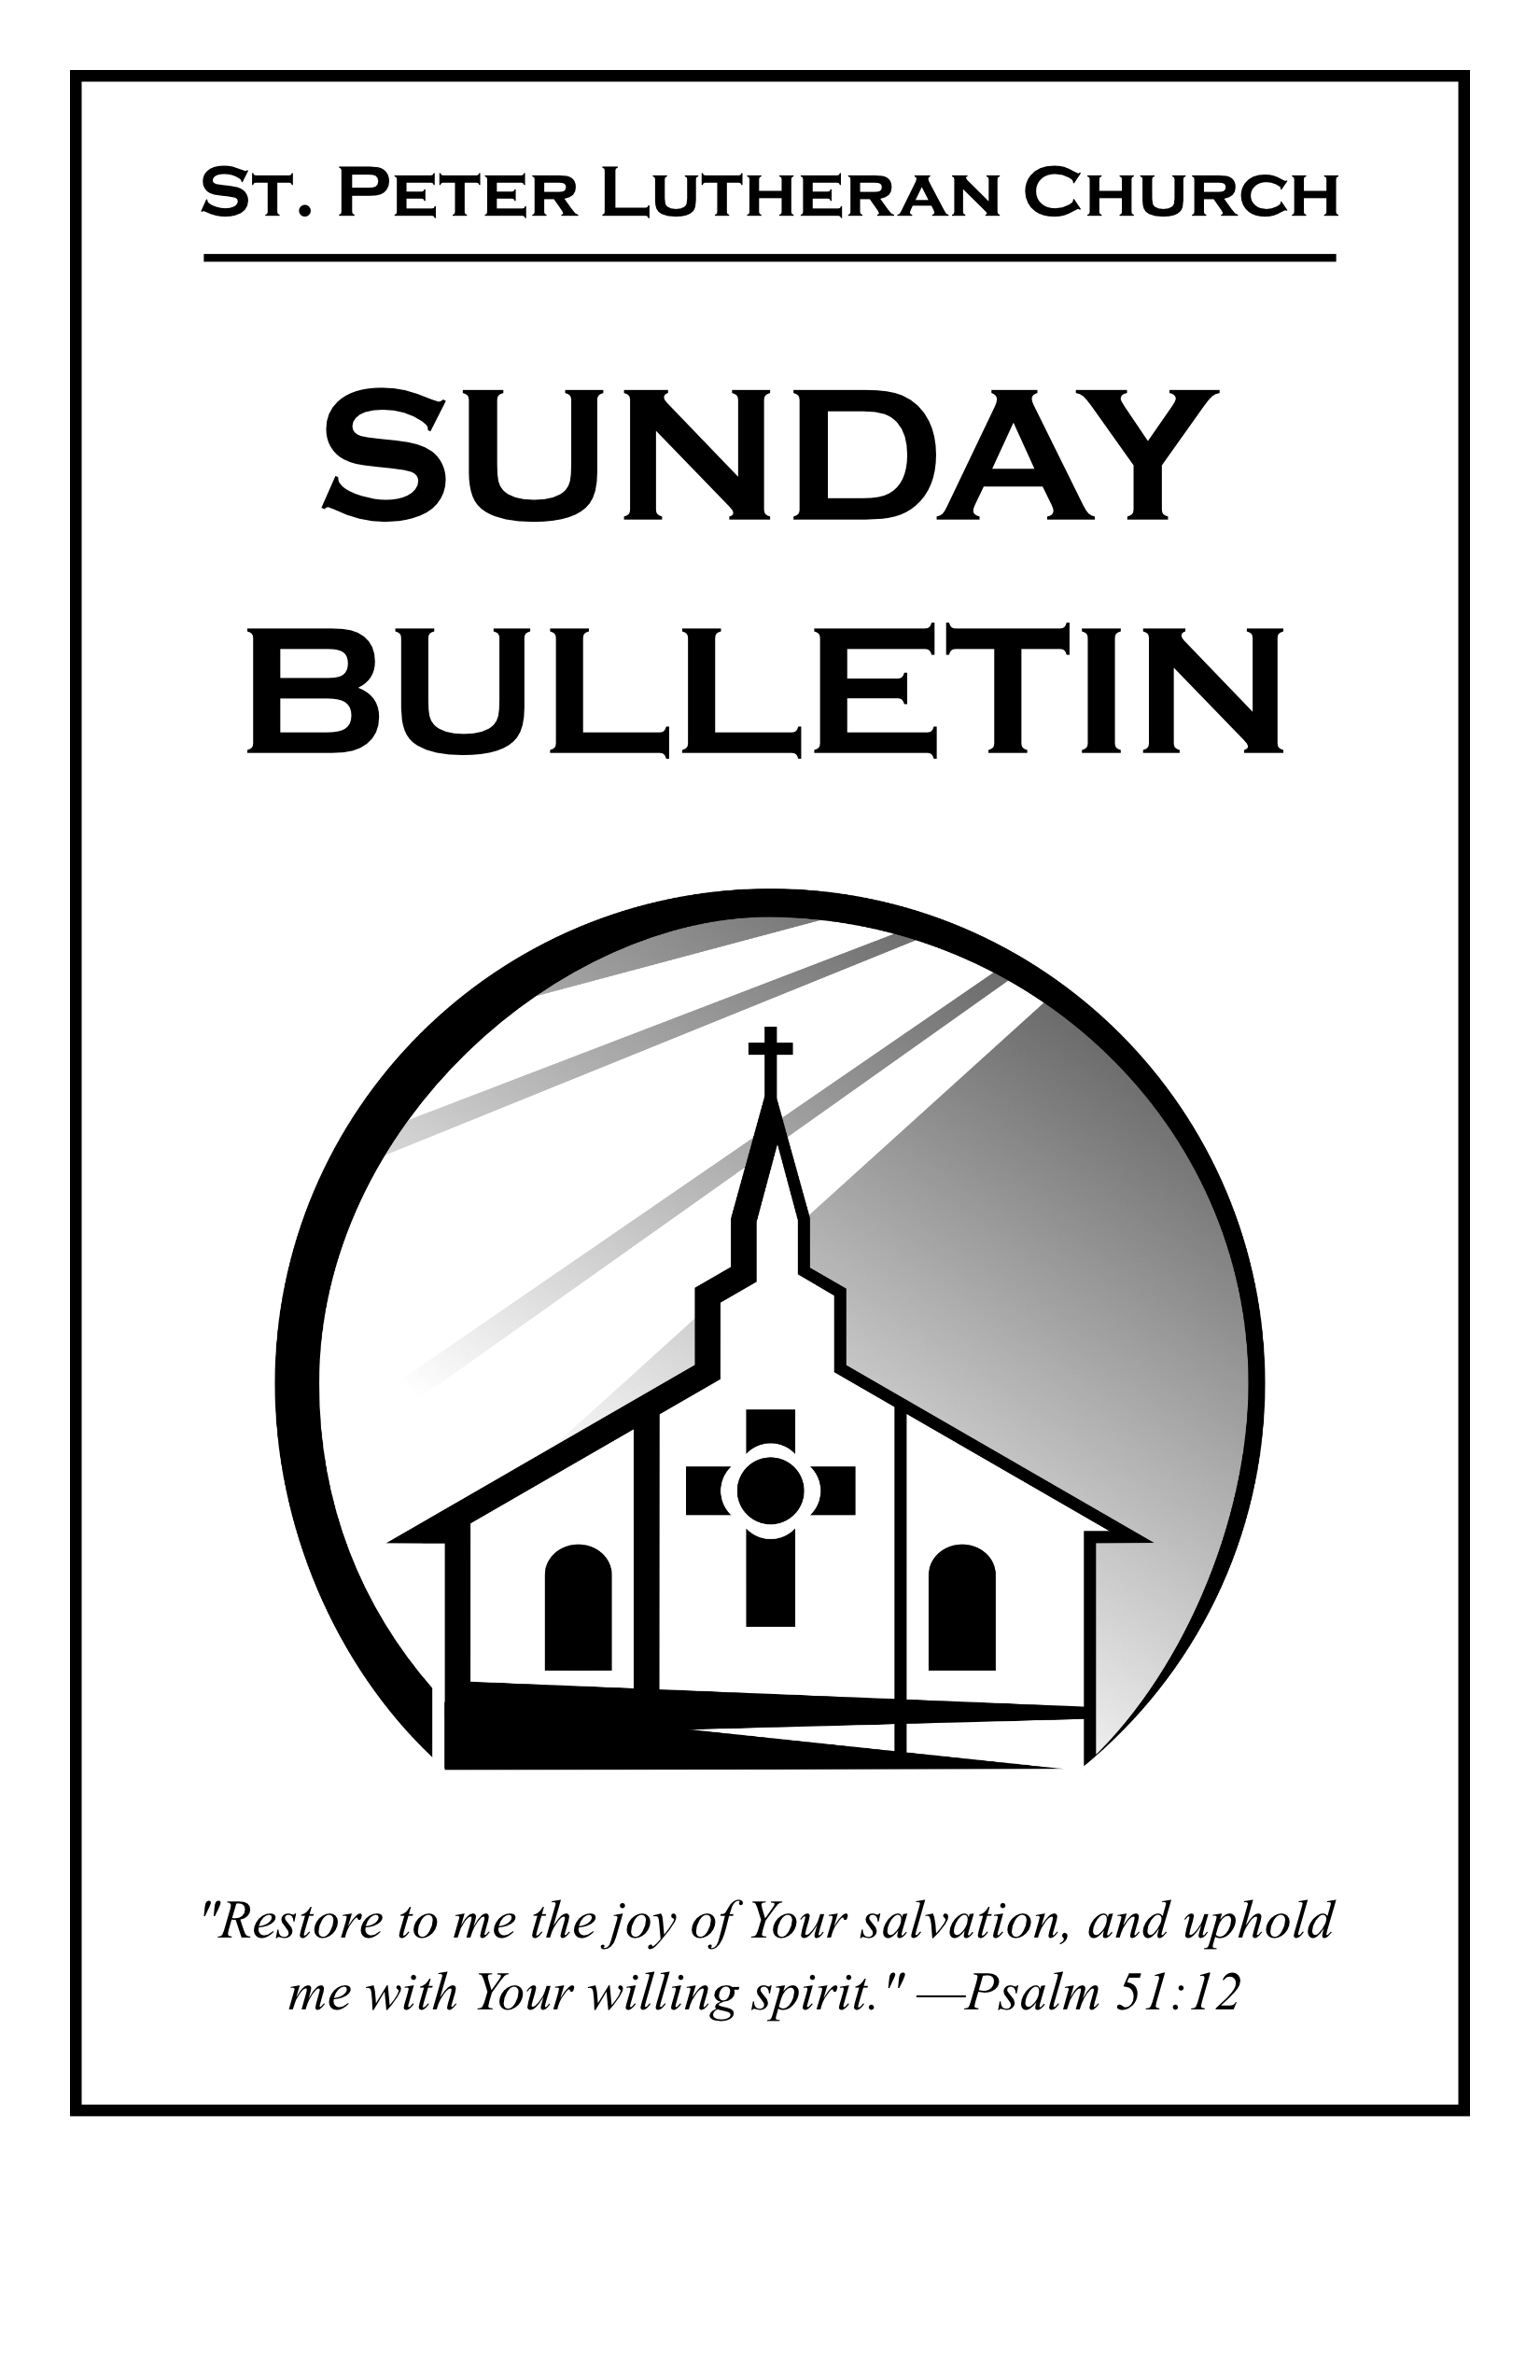

Third Sunday after Pentecost

June 14, 2026



St. Peter Lutheran Church
Missouri Synod
906 Highway 59N, P.O. Box 133

Bowie, Texas 76230

Church (940) 872-1886 Fax ((940) 872-8837

Church E-mail: stpetertexscty@att.net

Website: www.stpetertex.com
To Our Guests and Visitors
We welcome all our friends in Christ who have come to worship with us. If you are a guest, please feel at home with us, sign our guest register, and worship with us whenever you are able. If you do not have a church home, we invite you to consider becoming a part of our church family.

Communion Statement
The Lord’s Supper is celebrated at this congregation in the confession and glad confidence that, as He says, our Lord gives into our mouths not only bread and wine but His very Body and Blood to eat and drink for the forgiveness of sins and to strengthen our union with Him and with one another.
Our Lord invites to His table those who trust in His words, repent of all sin, and set aside any refusal to forgive and love as He forgives and loves us, that they may show forth His death until He comes.

Because those who eat and drink our Lord’s Body and Blood unworthily do so to their great harm and because Holy Communion is a confession of the faith which is confessed at this altar, guests who are not confirmed members of a LCMS congregation and have not previously communed at this altar, are asked to first speak with our pastor.
If you are unable to do so before the service, it is out of Christian love and care for your souls that we ask you to refrain from communing this morning.
For further study, please see Matthew 5:23ff; 10:32ff; 18:15-35; 26:26-29; 1 Corinthians 11:17-34.
If you desire to receive a blessing for yourself or your children, please approach during communion, cross your arms over your chest and bow your head as you kneel at the altar rail.

Divine Service (Setting 3) without Holy Communion Pg 184
(Worshipers who have difficulty rising and standing during our services may remain seated with our complete understanding.)

We Come Before God with Praise and Confession
hymn “Christ, Whose Glory Fills the Skies” LSB 873

The Confession and Absolution 184
Service of the Word 186
introit
Introit Psalm 67:4–7; antiphon: v. 3
Let the peoples praise you, O God;
let all the peoples praise you!
Let the nations be glad and sing for joy,
for you judge the peoples with equity and guide the nations upon earth.
Let the peoples praise you, O God;
let all the peoples praise you!
The earth has yielded its increase;
God, our God, shall bless us.
God shall bless us;
let all the ends of the earth fear him!
Gloria Patri & Kyrie & Gloria In Excelsis 186
Salutation and Collect for the Day 189
Almighty, eternal God, in the Word of Your apostles and prophets You have proclaimed to us Your saving will. Grant us faith to believe Your promises that we may receive eternal salvation; through Jesus Christ, our Lord, who lives and reigns with You and the Holy Spirit, one God, now and forever.

Scripture Readings & Gradual
Old Testament Exodus 19:2–8
2[The people of Israel] set out from Rephidim and came into the wilderness of Sinai, and they encamped in the wilderness. There Israel encamped before the mountain, 3while Moses went up to God. The Lord called to him out of the mountain, saying, “Thus you shall say to the house of Jacob, and tell the people of Israel: 4You yourselves have seen what I did to the Egyptians, and how I bore you on eagles’ wings and brought you to myself. 5Now therefore, if you will indeed obey my voice and keep my covenant, you shall be my treasured possession among all peoples, for all the earth is mine; 6and you shall be to me a kingdom of priests and a holy nation. These are the words that you shall speak to the people of Israel.” 7So Moses came and called the elders of the people and set before them all these words that the Lord had commanded him. 8All the people answered together and said, “All that the Lord has spoken we will do.” And Moses reported the words of the people to the Lord.

Gradual Psalm 145:3, 5b, 6b
Great is the Lord, and greatly to be praised,
and his greatness is unsearchable.
On your wondrous works, I will meditate,
and I will declare your greatness.

Epistle Romans 5:6–15
6For while we were still weak, at the right time Christ died for the ungodly. 7For one will scarcely die for a righteous person—though perhaps for a good person one would dare even to die— 8but God shows his love for us in that while we were still sinners, Christ died for us. 9Since, therefore, we have now been justified by his blood, much more shall we be saved by him from the wrath of God. 10For if while we were enemies we were reconciled to God by the death of his Son, much more, now that we are reconciled, shall we be saved by his life. 11More than that, we also rejoice in God through our Lord Jesus Christ, through whom we have now received reconciliation. 12Therefore, just as sin came into the world through one man, and death through sin, and so death spread to all men because all sinned— 13for sin indeed was in the world before the law was given, but sin is not counted where there is no law. 14Yet death reigned from Adam to Moses, even over those whose sinning was not like the transgression of Adam, who was a type of the one who was to come. 15But the free gift is not like the trespass. For if many died through one man’s trespass, much more have the grace of God and the free gift by the grace of that one man Jesus Christ abounded for many.

Alleluia p190
Gospel Matthew 9:35—10:20
35Jesus went throughout all the cities and villages, teaching in their synagogues and proclaiming the gospel of the kingdom and healing every disease and every affliction. 36When he saw the crowds, he had compassion for them, because they were harassed and helpless, like sheep without a shepherd. 37Then he said to his disciples, “The harvest is plentiful, but the laborers are few; 38therefore pray earnestly to the Lord of the harvest to send out laborers into his harvest.” 1And he called to him his twelve disciples and gave them authority over unclean spirits, to cast them out, and to heal every disease and every affliction. 2The names of the twelve apostles are these: first, Simon, who is called Peter, and Andrew his brother; James the son of Zebedee, and John his brother; 3Philip and Bartholomew; Thomas and Matthew the tax collector; James the son of Alphaeus, and Thaddaeus; 4Simon the Cananaean, and Judas Iscariot, who betrayed him. 5These twelve Jesus sent out, instructing them, “Go nowhere among the Gentiles and enter no town of the Samaritans, 6but go rather to the lost sheep of the house of Israel. 7And proclaim as you go, saying, ‘The kingdom of heaven is at hand.’ 8Heal the sick, raise the dead, cleanse lepers, cast out demons. You received without paying; give without pay. 9Acquire no gold nor silver nor copper for your belts, 10no bag for your journey, nor two tunics nor sandals nor a staff, for the laborer deserves his food. 11And whatever town or village you enter, find out who is worthy in it and stay there until you depart. 12As you enter the house, greet it. 13And if the house is worthy, let your peace come upon it, but if it is not worthy, let your peace return to you. 14And if anyone will not receive you or listen to your words, shake off the dust from your feet when you leave that house or town. 15Truly, I say to you, it will be more bearable on the day of judgment for the land of Sodom and Gomorrah than for that town. 16“Behold, I am sending you out as sheep in the midst of wolves, so be wise as serpents and innocent as doves. 17Beware of men, for they will deliver you over to courts and flog you in their synagogues, 18and you will be dragged before governors and kings for my sake, to bear witness before them and the Gentiles. 19When they deliver you over, do not be anxious how you are to speak or what you are to say, for what you are to say will be given to you in that hour. 20For it is not you who speak, but the Spirit of your Father speaking through you.”

Apostles’ Creed
children’s message
hymn of the Day “God Moves in a Mysterious Way” LSB 765
sermon “Insanity is…”
Offertory p192
Offering
Offering Hymn “Praise God From Whom All Blessings Flow” LSB 805
(Sung as offering is brought forward, congregation rises)

Prayer of the Church
The Lord’s Prayer
Collect
Benediction
Triple Amen
Closing Hymn “Thine Forever, God of Love” LSB 687
_____________________________________________________________________________________________________________________________________________________________________________________________________________________________________________________________________________________________________________________________________________________________________________________________________________________________________________________________________________________________________________________________________________________________________________________________________________________________________________________________________

SERVING IN GODS HOUSE TODAY

Officiant | Rev. Dale Snyder
Elder | David Geis
Reader | Bryan Roth
Acolytes | Parker Lawson & Annallee Osbon
Counters | Lee Hughes / David Geis
Altar Guild | Lisa Lawson / Rebecca Horton
Altar Care | Maleisa Belcher / Becky Geis
Guest Monitor | Kelly Roth

THIS WEEK AT ST PETER

Sunday | Sunday School | 9:30 a.m.
 | Worship w/Holy Communion after Worship | 10:30 a.m.
Wednesday | Bible Study | 7:00 p.m.
Saturday | AFG Planning Meeting | Noon
Vacation Bible School, Monday through Friday, 8 am to 11:30 am

NEXT WEEK AT ST PETER

Sunday | Sunday School/Bible Classes | 9:30 a.m.
 | Worship w/Holy Communion | 10:30 a.m.
Monday | Quilting | 9:00 a.m.
Wednesday | Bible Study | 7:00 p.m.

SERVING IN JUNE

Elder of the Month | David Geis
Counters | Lee Hughes / David Geis
Altar Guild | Lisa Lawson / Rebecca Horton
Altar Care | Maleisa Belcher / Becky Geis
Guest Monitor | Kelly Roth

Birthdays: June 14 Lark Shaw
17 Denny Keyes
19 Edwin Kleinhans
Anniversaries: June 15 Art & Clara Noack
16 Darren & Valery Gill
______________________________________________________________________________________________________

News & Other Information

Vacation Bible School — Registration for VBS (June 15-19, 8 – 11:30 am) is now open with no deadline. Forms can be found either in the narthex or on our website. For those who like to volunteer to help out, there is a sign-up sheet on the narthex table.

Volunteer Call — Altar Guild very short on members and needs help. Please prayerfully consider serving in our church. To discuss becoming an Altar Guild member, please contact Rebecca Horton.

Hearing Assistance — A wireless communication system is available to assist those with hearing issues to better hear the sermon. You may request a receiving unit from Pastor or William Pickett.

To all members: if you need to speak to a Pastor at this time, Pastor Brummett is available to take calls at (940) 886-7468. For anything else, please contact the church elders or other church leaders.

Mary Atkinson, Graphic Designer and Secretary
- Email: stpetertexscty@gmail.com
- Office Phone: (940) 872-1886
- Personal Phone: (940) 634-3032
____________________________________________________________________________________________________________


Please fill out a “Cares and Concerns” card located in the Narthex for prayer requests.

Bonnie Brisco – Diagnosed with Lymphoma in her face and is
starting treatments (mother of a co-worker to Lisa Lawson).
Gary Burkhart – Diagnosed with kidney cancer (Art Noack’s Brother-in-Law).
Mike Dunn – Diagnosed with prostate cancer (Debra Keyes’s Stepfather).
Debbie Garrett – Diagnosed with breasts cancer (Glenda Roth’s Sibling).
Bryleigh Gresham – In remission for her acute lymphoblastic leukemia (student in Maci Ferguson’s class).
Beth Hiatt – Diagnosed with stage 4 breast cancer (friend of Ashley Keyes).
Michelle McCaniless – Undergoing chemotherapy treatment, they are unable to operate on lung tumors (friend of Malley Underwood).
Jessica Miller – Ovarian cancer terminal. Still on meds and treatments but has surpassed timeline the Drs. initially gave her, 24 months (friend of Chanda Lee).
Bill Miller – Recovering from surgery to remove colon cancer tumor (friend of Terry Henry).
Chris Mitchell – Has been put on several ‘trial options’ for Esophageal/tongue cancer; some seem to be working, still struggles with strength and side effects of treatments, not able to work. (friend of Chanda Lee).

Rick Baker – Compound Fracture to his leg. Had second surgery, all went well and will be non-weight bearing for 3 months possibly. The recovery will be longer (father-in-law of Reisha Baker).
Kevin Cox – Received a heart transplant (friend of Terisa Johnston).
Jennifer H. – Diagnosed with stage 1 breast cancer (friend of Gillis and D’Ann Hammett).
Robert Johnston – Recovering at home.
Rhonda Pyle – Recovering from back surgery.
David Rhyne – health issues (father of Camerin Rhyne Dyson).
Thelma Roth – Recovering from Respiratory Distress in Sanger with her daughter.
Norma Scheppmann – Several medical issues.
Brooklynn Schissbauer – Her baby was diagnosed with Turner Syndrome in her last sonogram (granddaughter of Debbie Herriage).
Josh Smith – On dialysis for heart and kidneys (friend of Levi Yowell).
Billy Don Smith – At home and under hospice care.
Caden & Lucas Wolsey –
Juliana & Katie Falbo –

IN THE MILITARY SHUT -INS

Sid Mayfield – US Navy Edwin Kleinhans Charles Roth
Connor Ogrodnick – US Navy Cholly Hargrove Thelma Roth

Our Stewardship 06/14/2026

General Fund | $ 5,133.00 | 57
_________________________________________________________________________________________________________

Did you know we have a Facebook & Instagram?

You can find the links to our socials on our website at: www.stpetertex.com

Follow us for important updates, verse-of-the-week posts, and more!

