On entering the church

P Lord, I love the habitation of Your house and the place

where Your glory dwells. In the multitude of Your tender

mercies prepare my heart that I may enter Your house to

worship and confess Your holy name; through Jesus Christ,

my God and Lord.

Before worship

C O Lord, our creator, redeemer, and comforter, as we come

together to worship You in spirit and in truth, we humbly

pray that You would open our hearts to the preaching of

Your Word so that we may repent of our sins, believe in

Jesus Christ as our only Savior, and grow in grace and

holiness. Hear us for His sake.

578 Thy Strong Word

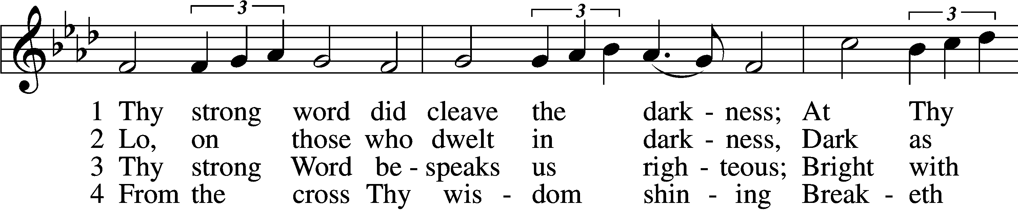

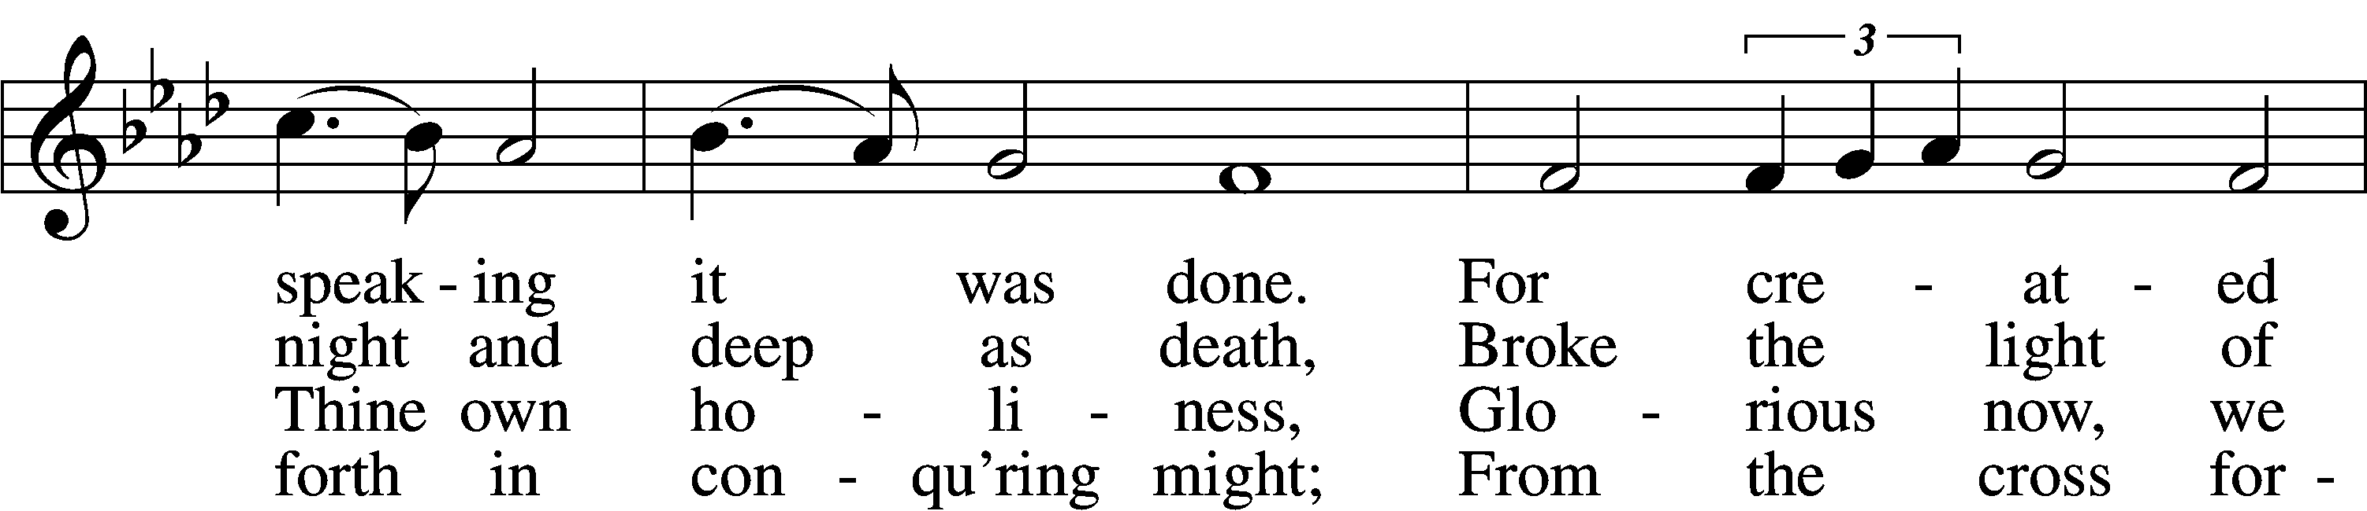

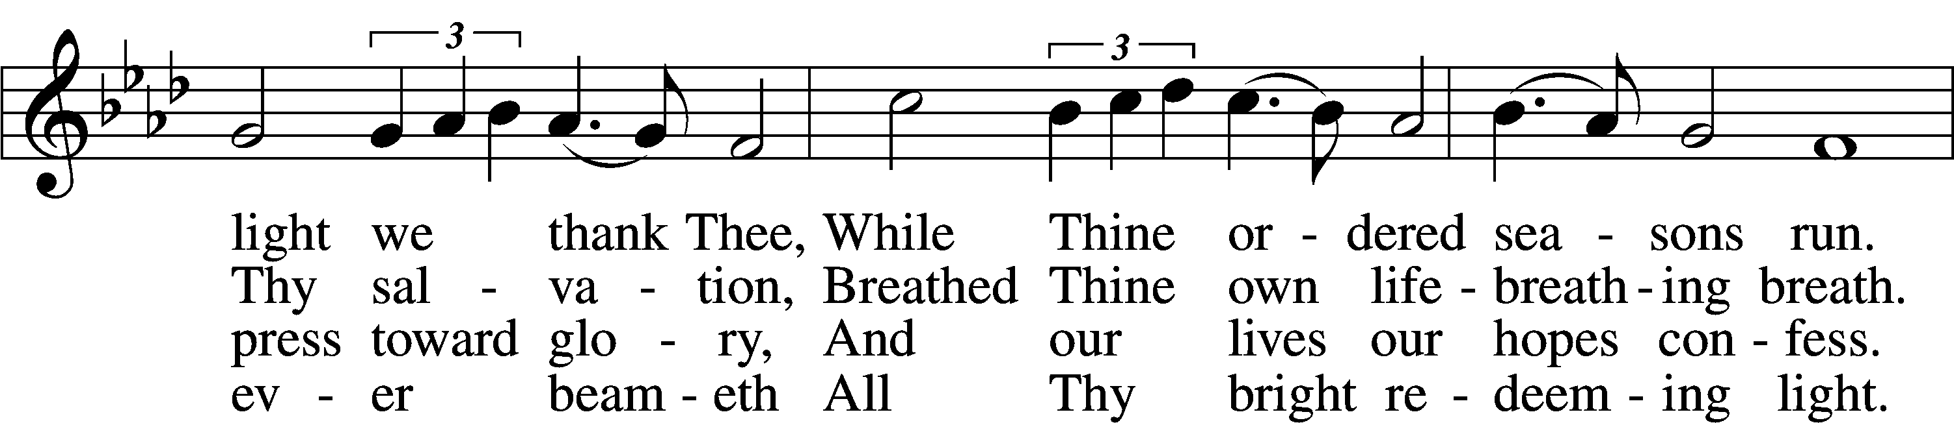

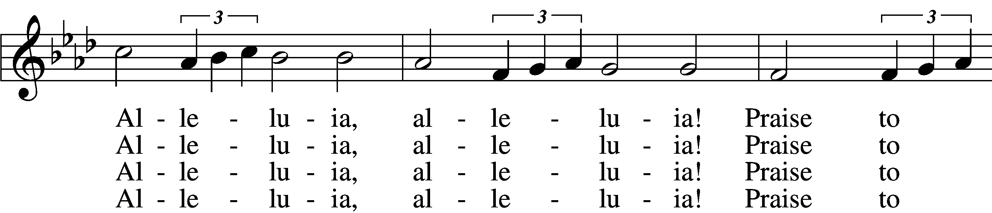

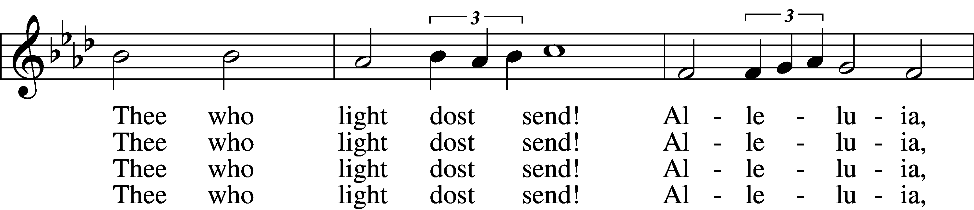

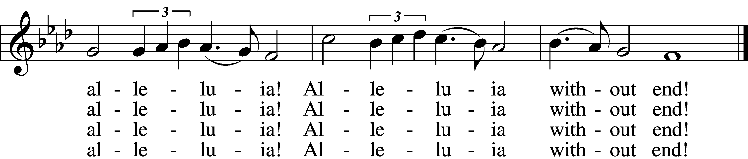

5 Give us lips to sing Thy glory,  
 Tongues Thy mercy to proclaim,  
Throats that shout the hope that fills us,  
 Mouths to speak Thy holy name.  
Alleluia, alleluia!  
 May the light which Thou dost send  
Fill our songs with alleluias,  
 Alleluias without end!

D 6 God the Father, light-creator,  
 To Thee laud and honor be.  
To Thee, Light of Light begotten,  
 Praise be sung eternally.  
Holy Spirit, light-revealer,  
 Glory, glory be to Thee.  
Mortals, angels, now and ever  
 Praise the holy Trinity!

Text: Martin H. Franzmann, 1907–76  
Tune: Thomas J. Williams, 1869–1944  
Text: © 1969 Concordia Publishing House. Used by permission: LSB Hymn License no. 110005011  
Tune: Public domain

# Confession and Absolution

Stand

The sign of the cross may be made by all in remembrance of their Baptism.

Invocation Matthew 28:19b; 18:20

P In the name of the Father and of the T Son and of the Holy Spirit.

C **Amen.**

Exhortation Psalm 124:8; Psalm 130:3–4; Luke 18:13

P Our help is in the name of the Lord,

C **who made heaven and earth.**

P If You, O Lord, kept a record of sins, O Lord, who could stand?

C **But with You there is forgiveness; therefore You are feared.**

P Since we are gathered to hear God’s Word, call upon Him in prayer and praise, and receive the body and blood of our Lord Jesus Christ in the fellowship of this altar, let us first consider our unworthiness and confess before God and one another that we have sinned in thought, word, and deed, and that we cannot free ourselves from our sinful condition. Together as His people let us take refuge in the infinite mercy of God, our heavenly Father, seeking His grace for the sake of Christ, and saying: God, be merciful to me, a sinner.

Kneel/Stand

Confession of Sins

C **Almighty God, have mercy upon us, forgive us our sins, and lead us to everlasting life. Amen.**

Absolution [John 20:19–23]

P Almighty God in His mercy has given His Son to die for you and for His sake forgives you all your sins. As a called and ordained servant of Christ, and by His authority, I therefore forgive you all your sins in the name of the Father and of the T Son and of the Holy Spirit.

C **Amen.**

Stand

# Service of the Word

Introit Psalm 55:1, 12–14, 16; antiphon: v. 22

Cast your burden on the Lord, and he will sustain you;  
 he will never permit the righteous to be moved.  
**Give ear to my prayer, O God,  
 and hide not yourself from my plea for mercy!**For it is not an enemy who taunts me—then I could bear it;  
 it is not an adversary who deals insolently with me—then I could hide from him.  
**But it is you, a man, my equal,  
 my companion, my familiar friend.**  
We used to take sweet counsel together;  
 within God’s house we walked in the throng.  
**But I call to God,  
 and the Lord will save me.  
Glory be to the Father and to the Son**  
 **and to the Holy Spirit;**  
**as it was in the beginning,**  
 **is now, and will be forever. Amen.**  
Cast your burden on the Lord, and he will sustain you;  
 he will never permit the righteous to be moved.

Kyrie Mark 10:47

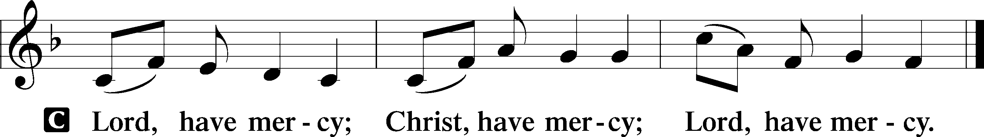

Gloria in Excelsis Luke 2:14; John 1:29

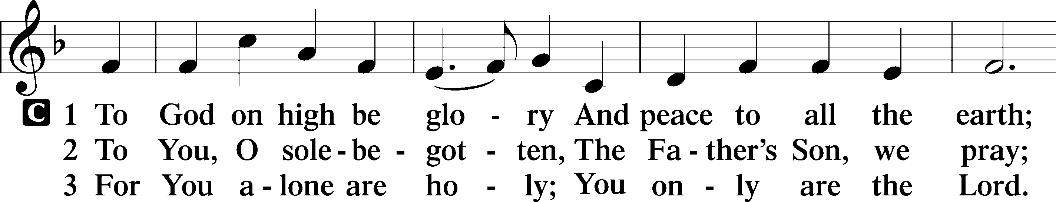

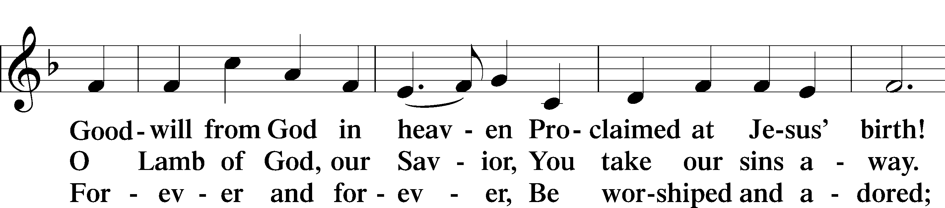

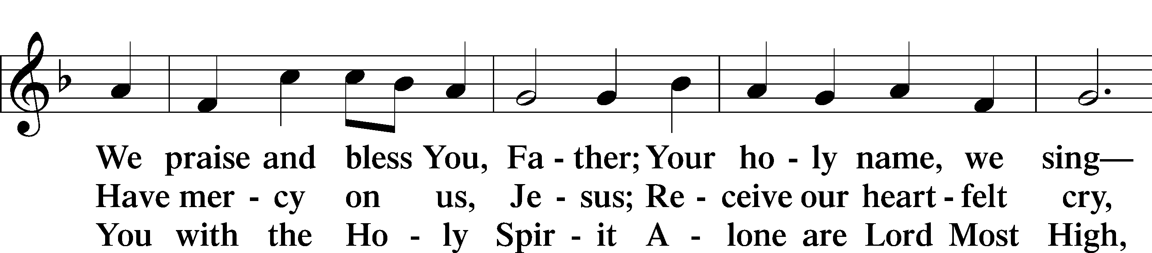

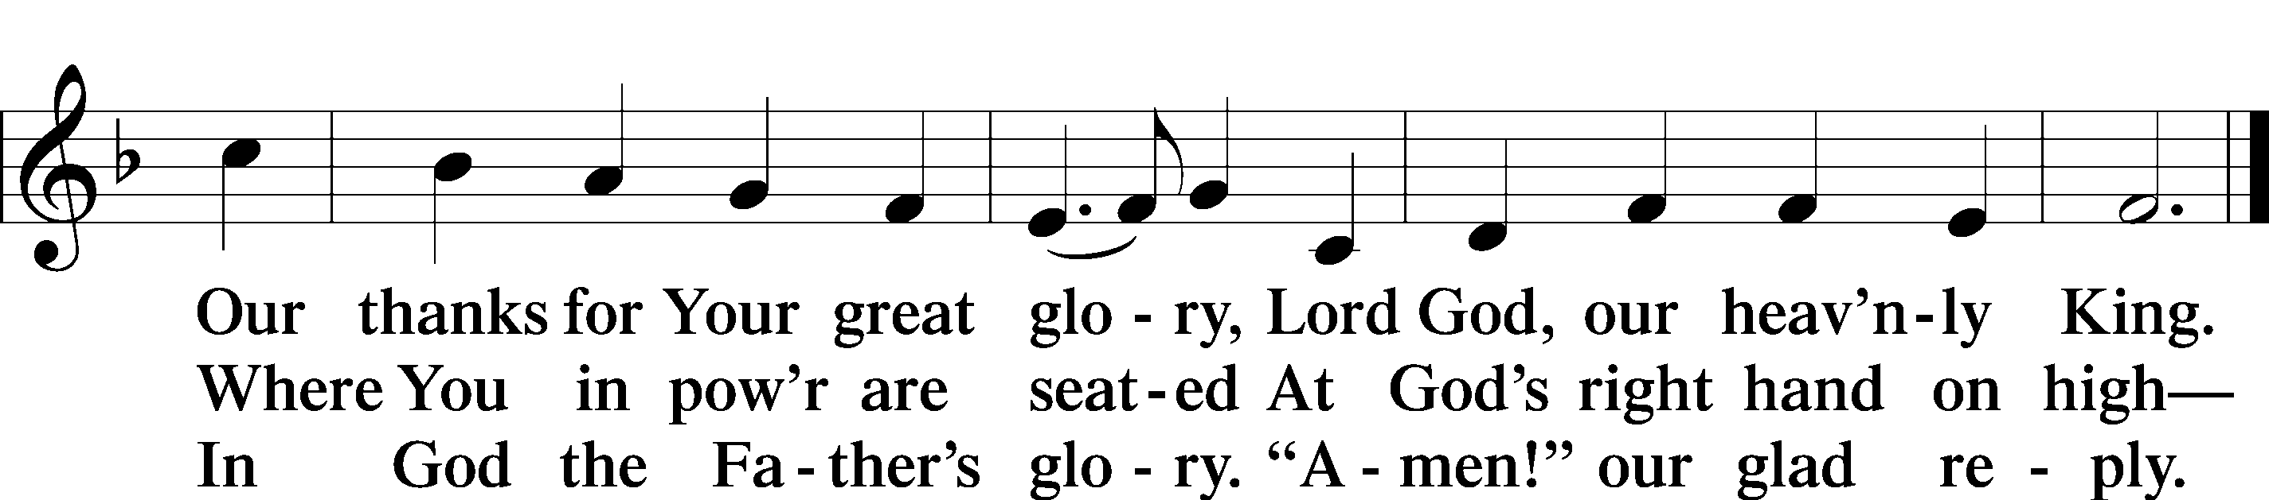

Text: Stephen P. Starke

Salutation and Collect of the Day

P The Lord be with you.

C **And also with you.**

P Let us pray.

Merciful Lord, cleanse and defend Your Church by the sacrifice of Christ. United with Him in Holy Baptism, give us grace to receive with thanksgiving the fruits of His redeeming work and daily follow in His way; through the same Jesus Christ, Your Son, our Lord, who lives and reigns with You and the Holy Spirit, one God, now and forever.

C **Amen.**

Sit

Old Testament Reading Jeremiah 23:16–29

16Thus says the Lord of hosts: “Do not listen to the words of the prophets who prophesy to you, filling you with vain hopes. They speak visions of their own minds, not from the mouth of the Lord. 17They say continually to those who despise the word of the Lord, ‘It shall be well with you’; and to everyone who stubbornly follows his own heart, they say, ‘No disaster shall come upon you.’”

18For who among them has stood in the council of the Lord  
 to see and to hear his word,  
 or who has paid attention to his word and listened?  
19Behold, the storm of the Lord!  
 Wrath has gone forth,  
a whirling tempest;  
 it will burst upon the head of the wicked.  
20The anger of the Lord will not turn back  
 until he has executed and accomplished  
 the intents of his heart.  
In the latter days you will understand it clearly.

21“I did not send the prophets,  
 yet they ran;  
I did not speak to them,  
 yet they prophesied.  
22But if they had stood in my council,  
 then they would have proclaimed my words to my people,  
and they would have turned them from their evil way,  
 and from the evil of their deeds.

23“Am I a God at hand, declares the Lord, and not a God afar off? 24Can a man hide himself in secret places so that I cannot see him? declares the Lord. Do I not fill heaven and earth? declares the Lord. 25I have heard what the prophets have said who prophesy lies in my name, saying, ‘I have dreamed, I have dreamed!’ 26How long shall there be lies in the heart of the prophets who prophesy lies, and who prophesy the deceit of their own heart, 27who think to make my people forget my name by their dreams that they tell one another, even as their fathers forgot my name for Baal? 28Let the prophet who has a dream tell the dream, but let him who has my word speak my word faithfully. What has straw in common with wheat? declares the Lord. 29Is not my word like fire, declares the Lord, and like a hammer that breaks the rock in pieces?”

A This is the Word of the Lord.

C **Thanks be to God.**

Gradual Psalm 34:9, 19, alt.

Fear the Lord, you his saints,  
 for those who fear him lack nothing!  
**Many are the afflictions of the righteous,  
 but the Lord delivers him out of them all.**

Epistle Hebrews 11:17—12:3

17By faith Abraham, when he was tested, offered up Isaac, and he who had received the promises was in the act of offering up his only son, 18of whom it was said, “Through Isaac shall your offspring be named.” 19He considered that God was able even to raise him from the dead, from which, figuratively speaking, he did receive him back. 20By faith Isaac invoked future blessings on Jacob and Esau. 21By faith Jacob, when dying, blessed each of the sons of Joseph, bowing in worship over the head of his staff. 22By faith Joseph, at the end of his life, made mention of the exodus of the Israelites and gave directions concerning his bones.

23By faith Moses, when he was born, was hidden for three months by his parents, because they saw that the child was beautiful, and they were not afraid of the king’s edict. 24By faith Moses, when he was grown up, refused to be called the son of Pharaoh’s daughter, 25choosing rather to be mistreated with the people of God than to enjoy the fleeting pleasures of sin. 26He considered the reproach of Christ greater wealth than the treasures of Egypt, for he was looking to the reward. 27By faith he left Egypt, not being afraid of the anger of the king, for he endured as seeing him who is invisible. 28By faith he kept the Passover and sprinkled the blood, so that the Destroyer of the firstborn might not touch them.

29By faith the people crossed the Red Sea as if on dry land, but the Egyptians, when they attempted to do the same, were drowned. 30By faith the walls of Jericho fell down after they had been encircled for seven days. 31By faith Rahab the prostitute did not perish with those who were disobedient, because she had given a friendly welcome to the spies.

32And what more shall I say? For time would fail me to tell of Gideon, Barak, Samson, Jephthah, of David and Samuel and the prophets— 33who through faith conquered kingdoms, enforced justice, obtained promises, stopped the mouths of lions, 34quenched the power of fire, escaped the edge of the sword, were made strong out of weakness, became mighty in war, put foreign armies to flight. 35Women received back their dead by resurrection. Some were tortured, refusing to accept release, so that they might rise again to a better life. 36Others suffered mocking and flogging, and even chains and imprisonment. 37They were stoned, they were sawn in two, they were killed with the sword. They went about in skins of sheep and goats, destitute, afflicted, mistreated— 38of whom the world was not worthy—wandering about in deserts and mountains, and in dens and caves of the earth.

39And all these, though commended through their faith, did not receive what was promised, 40since God had provided something better for us, that apart from us they should not be made perfect.

1Therefore, since we are surrounded by so great a cloud of witnesses, let us also lay aside every weight, and sin which clings so closely, and let us run with endurance the race that is set before us, 2looking to Jesus, the founder and perfecter of our faith, who for the joy that was set before him endured the cross, despising the shame, and is seated at the right hand of the throne of God.

3Consider him who endured from sinners such hostility against himself, so that you may not grow weary or fainthearted.

A This is the Word of the Lord.

C **Thanks be to God.**

Stand

Alleluia and Verse

Alleluia

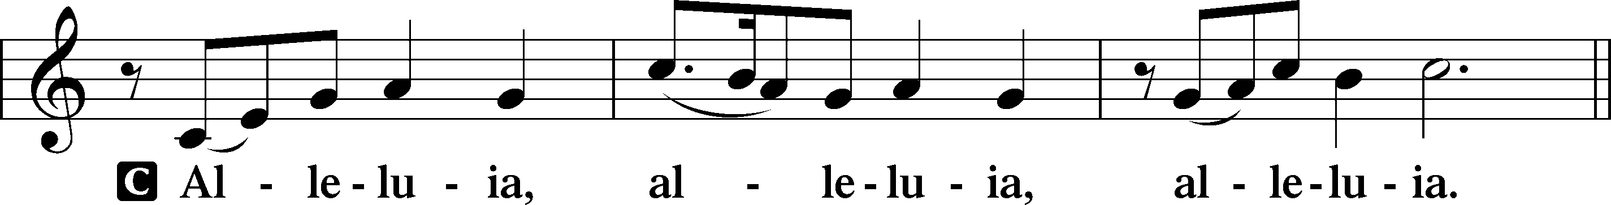

Verse John 20:31

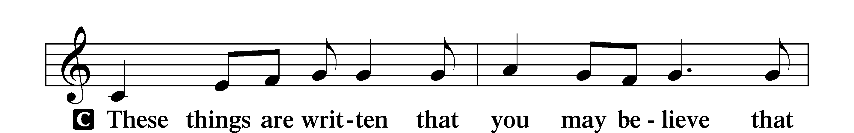

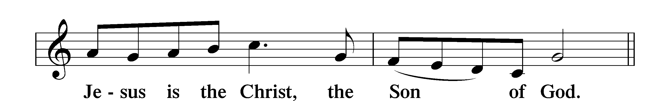

Alleluia

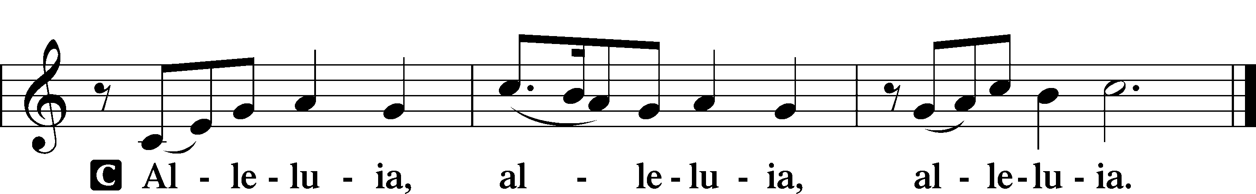

Holy Gospel Luke 12:49–56

P The Holy Gospel according to St. Luke, the twelfth chapter.

C **Glory to You, O Lord.**

49[Jesus said:] “I came to cast fire on the earth, and would that it were already kindled! 50I have a baptism to be baptized with, and how great is my distress until it is accomplished! 51Do you think that I have come to give peace on earth? No, I tell you, but rather division. 52For from now on in one house there will be five divided, three against two and two against three. 53They will be divided, father against son and son against father, mother against daughter and daughter against mother, mother-in-law against her daughter-in-law and daughter-in-law against mother-in-law.”

54He also said to the crowds, “When you see a cloud rising in the west, you say at once, ‘A shower is coming.’ And so it happens. 55And when you see the south wind blowing, you say, ‘There will be scorching heat,’ and it happens. 56You hypocrites! You know how to interpret the appearance of earth and sky, but why do you not know how to interpret the present time?”

P This is the Gospel of the Lord.

C **Praise to You, O Christ.**

Nicene Creed

C **I believe in one God,**

**the Father Almighty,**

**maker of heaven and earth**

**and of all things visible and invisible.**

**And in one Lord Jesus Christ,**

**the only-begotten Son of God,**

**begotten of His Father before all worlds,**

**God of God, Light of Light,**

**very God of very God,**

**begotten, not made,**

**being of one substance with the Father,**

**by whom all things were made;**

**who for us men and for our salvation came down from heaven**

**and was incarnate by the Holy Spirit of the virgin Mary**

**and was made man;**

**and was crucified also for us under Pontius Pilate.**

**He suffered and was buried.**

**And the third day He rose again according to the Scriptures**

**and ascended into heaven**

**and sits at the right hand of the Father.**

**And He will come again with glory to judge both the living and the dead,**

**whose kingdom will have no end.**

**And I believe in the Holy Spirit,**

**the Lord and giver of life,**

**who proceeds from the Father and the Son,**

**who with the Father and the Son together is worshiped and glorified,**

**who spoke by the prophets.**

**And I believe in one holy Christian and apostolic Church,**

**I acknowledge one Baptism for the remission of sins,**

**and I look for the resurrection of the dead**

**and the life** T **of the world to come. Amen.**

Sit

Children's Sermon

828 We Are Called to Stand Together

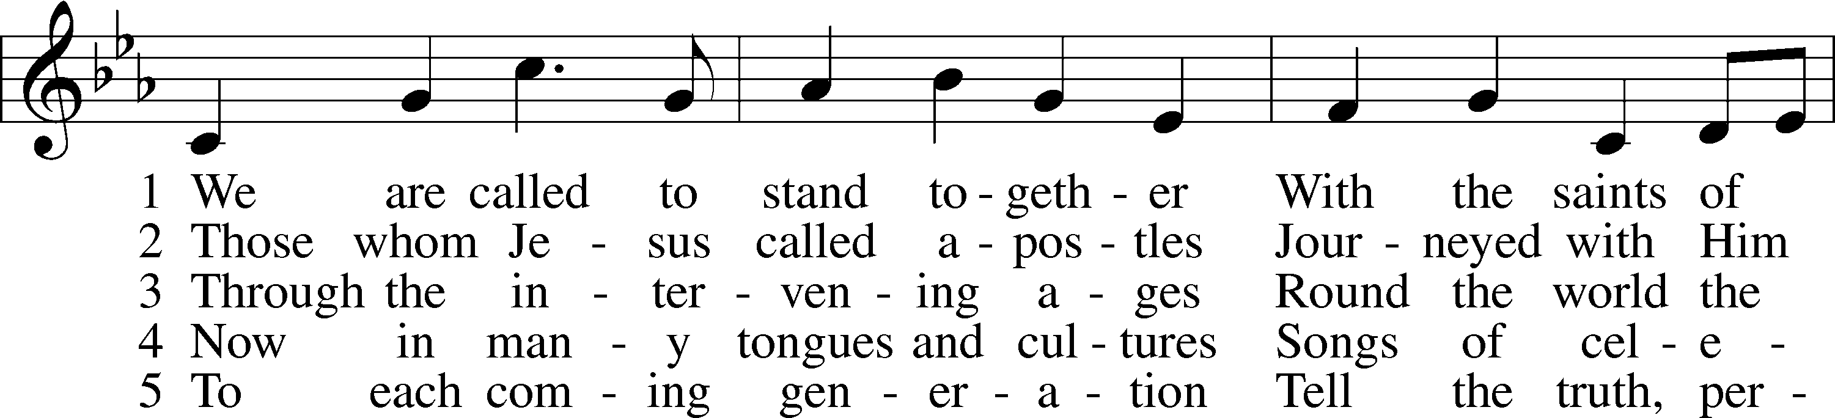

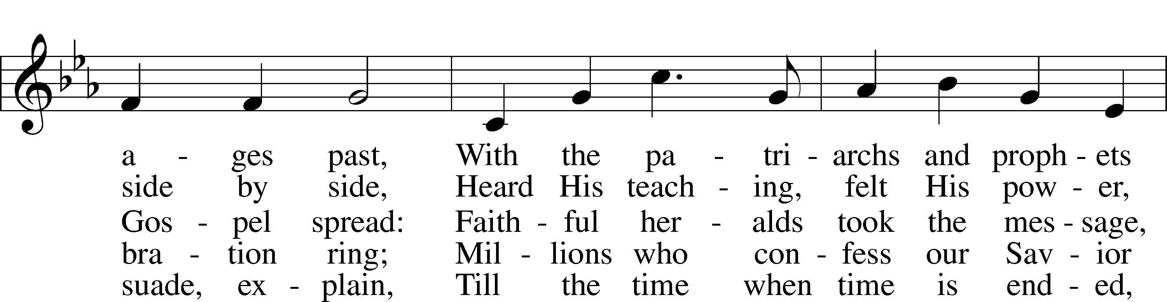

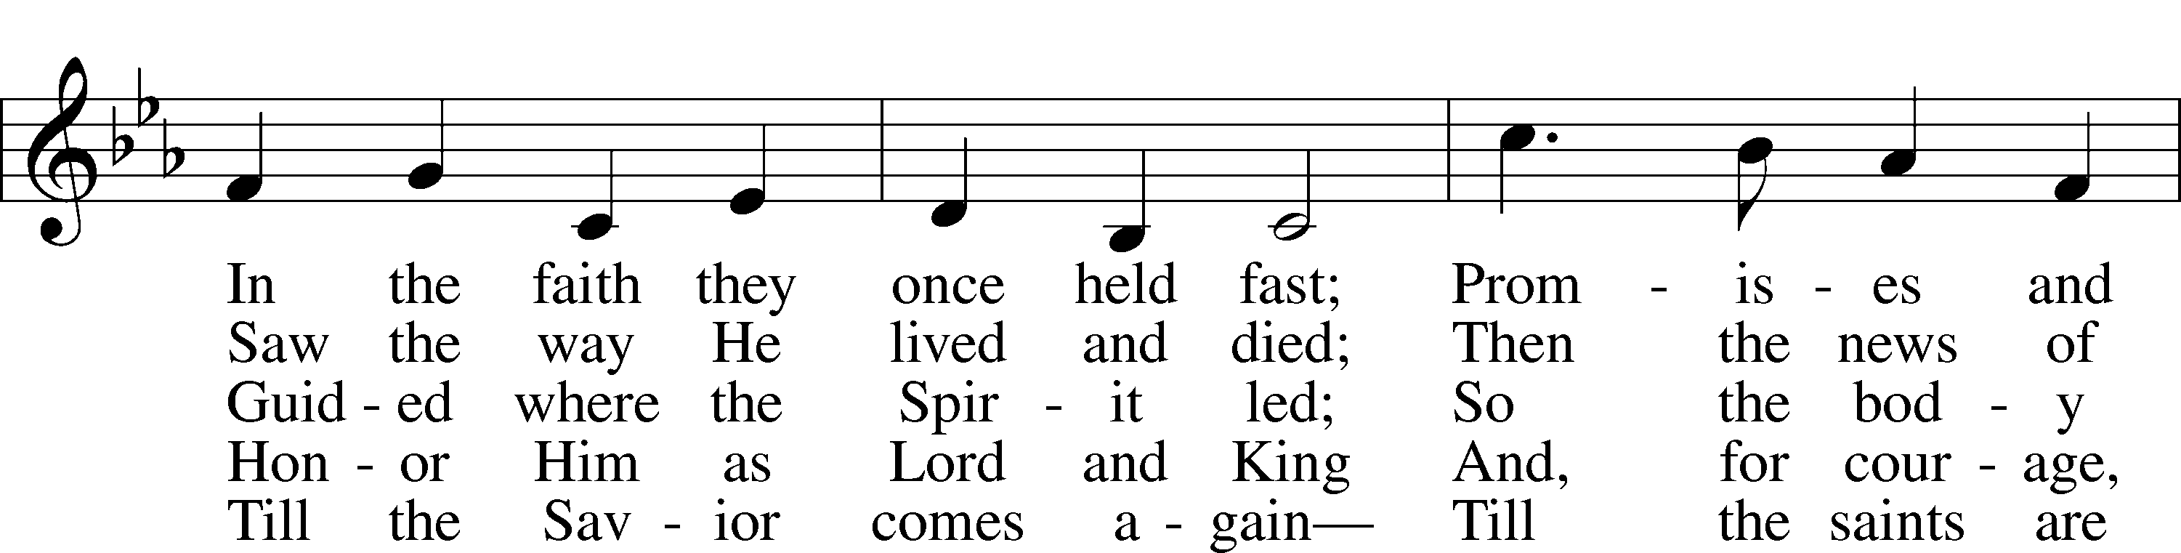

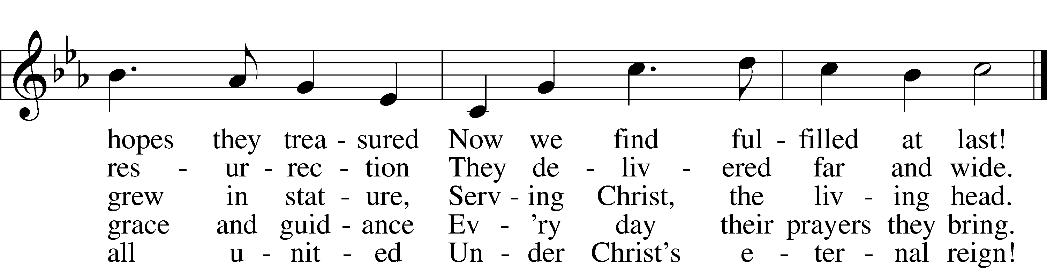

Text: Martin E. Leckebusch, 1962  
Tune: Henry V. Gerike, 1948  
Text: © 2000 Kevin Mayhew Ltd. Used by permission: LSB Hymn License no. 110005011  
Tune: © 1973 Henry V. Gerike. Used by permission: LSB Hymn License no. 110005011

Sermon

Stand

Prayer of the Church

Following the prayers, the people may greet one another in the name of the Lord, saying, “Peace be with you,” as a sign of reconciliation and of the unity of the Spirit in the bond of peace (Matt. 5:22–24; Eph. 4:1–3).

Sit

805 Praise God, from Whom All Blessings Flow

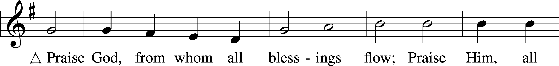

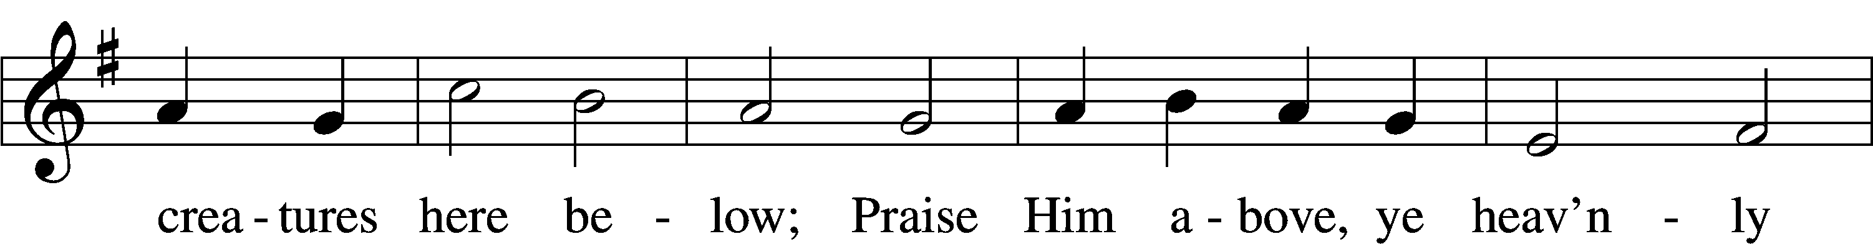

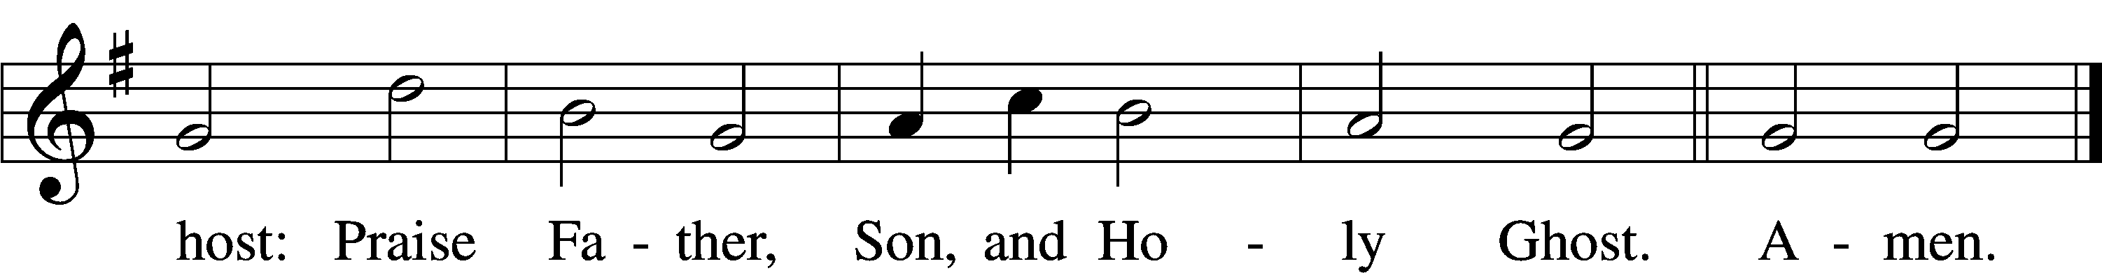

Text: Thomas Ken, 1637–1711  
Tune: Trente quatre Pseaumes de David, 1551, Geneva, ed. Louis Bourgeois  
Text and tune: Public domain

Offering

# Service of the Sacrament

Stand

Preface 2 Timothy 4:22; [Colossians 3:1]; [Psalm 136]

P The Lord be with you.

C **And also with you.**

P Lift up your hearts.

C **We lift them to the Lord.**

P Let us give thanks to the Lord our God.

C **It is right to give Him thanks and praise.**

P It is truly good, right, and salutary that we should at all times and in all places give thanks to You, O Lord, holy Father, almighty and everlasting God, for the countless blessings You so freely bestow on us and all creation. Above all, we give thanks for Your boundless love shown to us when You sent Your only-begotten Son, Jesus Christ, into our flesh and laid on Him our sin, giving Him into death that we might not die eternally. Because He is now risen from the dead and lives and reigns to all eternity, all who believe in Him will overcome sin and death and will rise again to new life. Therefore with angels and archangels and with all the company of heaven we laud and magnify Your glorious name, evermore praising You and saying:

Sanctus Isaiah 6:3; Matthew 21:9

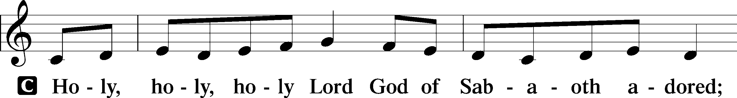

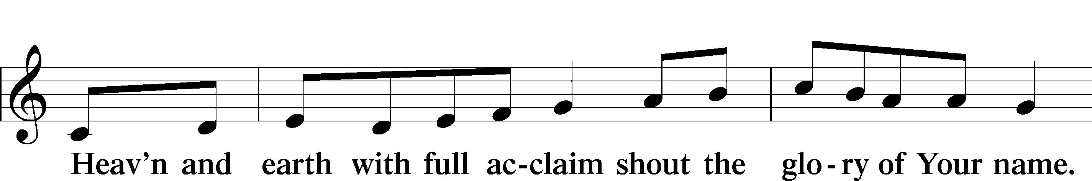

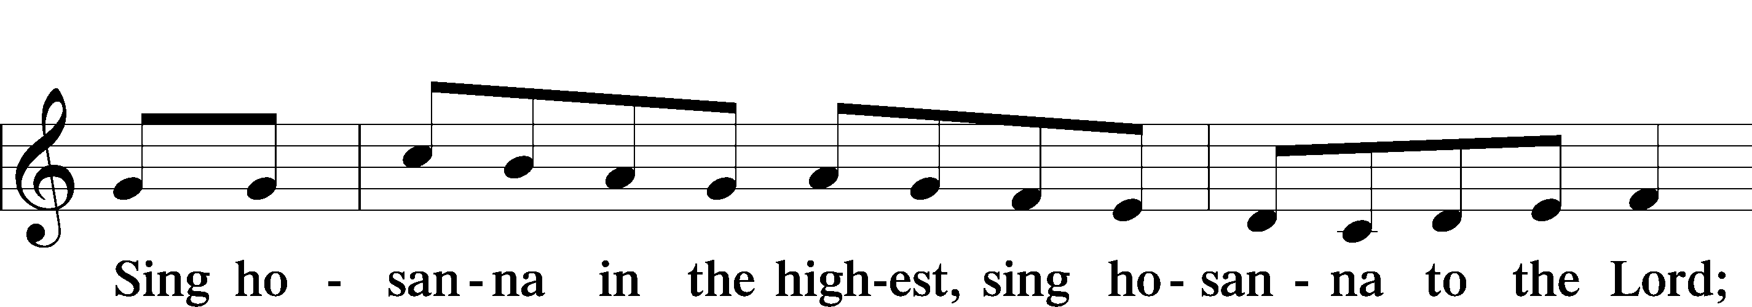

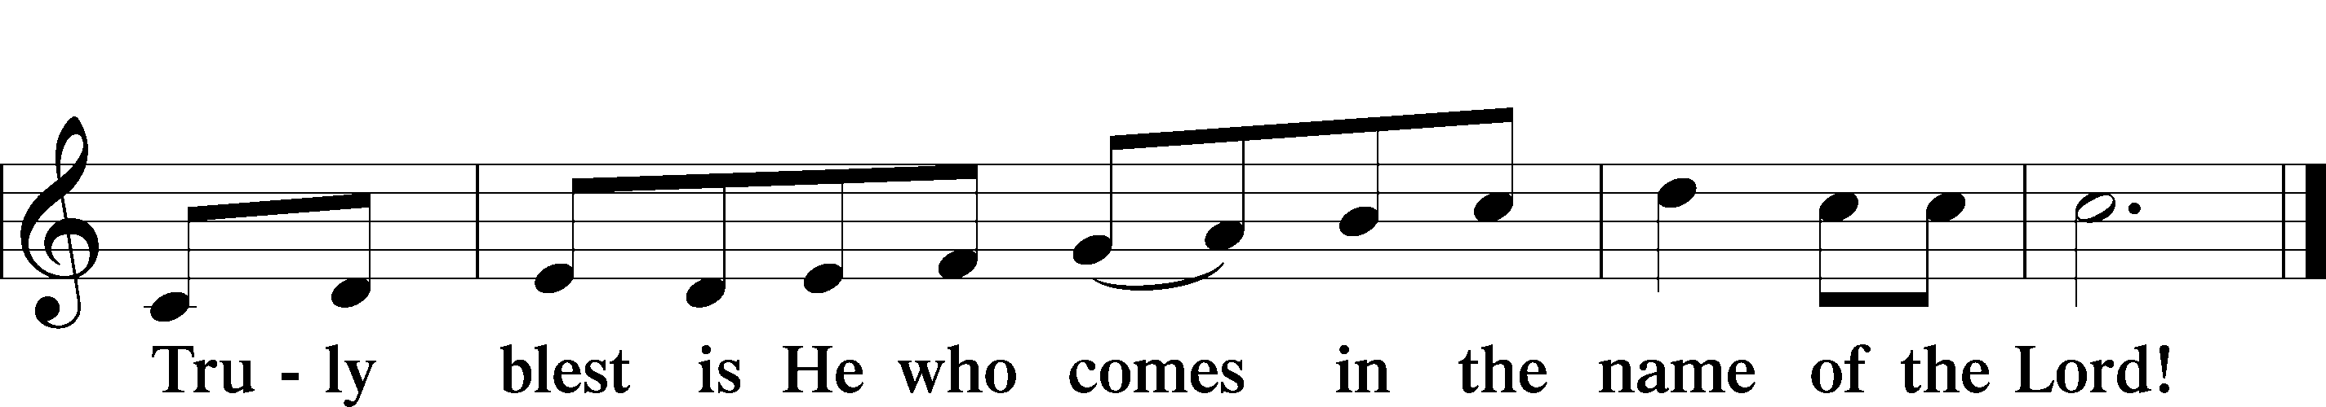

Text: Stephen P. Starke

Prayer of Thanksgiving

P Blessed are You, O Lord our God, king of all creation, for You have had mercy on us and given Your only-begotten Son that whoever believes in Him should not perish but have eternal life.

In Your righteous judgment You condemned the sin of Adam and Eve, who ate the forbidden fruit, and You justly barred them and all their children from the tree of life. Yet, in Your great mercy, You promised salvation by a second Adam, Your Son, Jesus Christ, our Lord, and made His cross a life-giving tree for all who trust in Him.

We give You thanks for the redemption You have prepared for us through Jesus Christ. Grant us Your Holy Spirit that we may faithfully eat and drink of the fruits of His cross and receive the blessings of forgiveness, life, and salvation that come to us in His body and blood.

Hear us as we pray in His name and as He has taught us:

Lord’s Prayer

C **Our Father who art in heaven,**

**hallowed be Thy name,**

**Thy kingdom come,**

**Thy will be done on earth**

**as it is in heaven;**

**give us this day our daily bread;**

**and forgive us our trespasses**

**as we forgive those**

**who trespass against us;**

**and lead us not into temptation,**

**but deliver us from evil.**

**For Thine is the kingdom**

**and the power and the glory**

**forever and ever. Amen.**

The Words of Our Lord

P Our Lord Jesus Christ, on the night when He was betrayed, took bread, and when He had given thanks, He broke it and gave it to the disciples and said: “Take, eat; this is My T body, which is given for you. This do in remembrance of Me.”

In the same way also He took the cup after supper, and when He had given thanks, He gave it to them, saying: “Drink of it, all of you; this cup is the new testament in My T blood, which is shed for you for the forgiveness of sins. This do, as often as you drink it, in remembrance of Me.”

Pax Domini

P The peace of the Lord be with you always.

C **Amen.**

Agnus Dei John 1:29

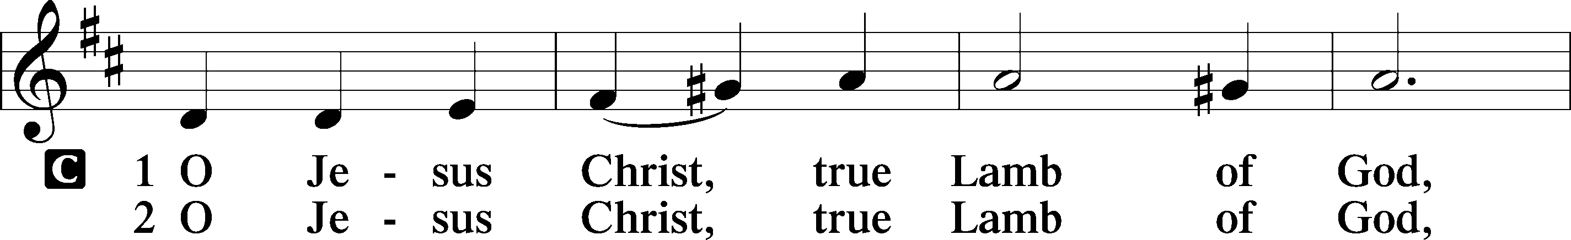

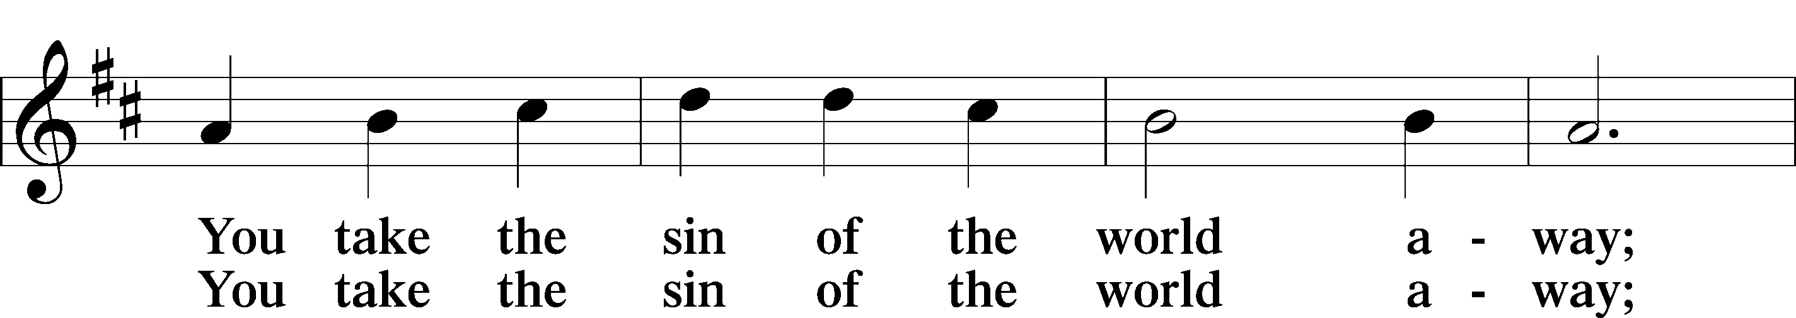

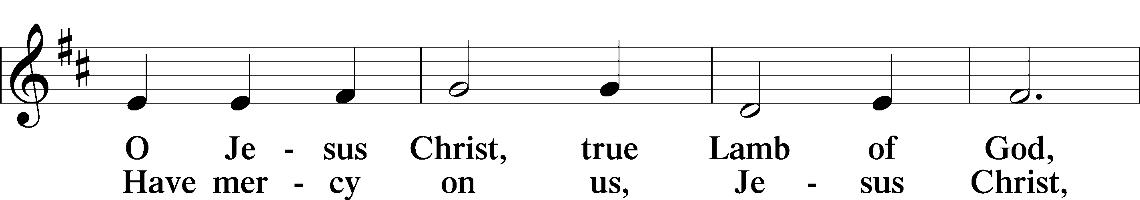

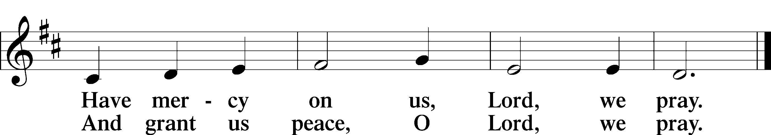

Text: Stephen P. Starke

Sit

Distribution

The pastor and those who assist him receive the body and blood of Christ first and then distribute them to those who come to receive, saying:

Take, eat; this is the true body of our Lord and Savior Jesus Christ, given into death for your sins.

**Amen.**

Take, drink; this is the true blood of our Lord and Savior Jesus Christ, shed for the forgiveness of your sins.

**Amen.**

In dismissing the communicants, the following is said:

The Dismissal

P The body and blood of our Lord Jesus Christ strengthen and preserve you in body and soul to life everlasting. Depart T in peace.

C **Amen.**

913 O Holy Spirit, Enter In

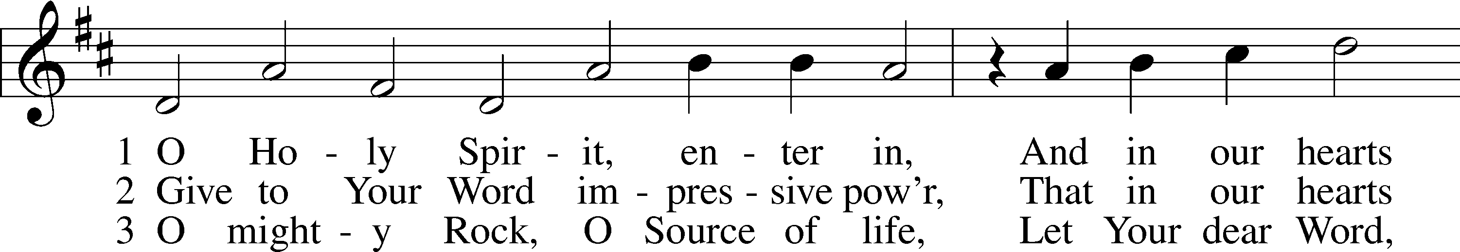

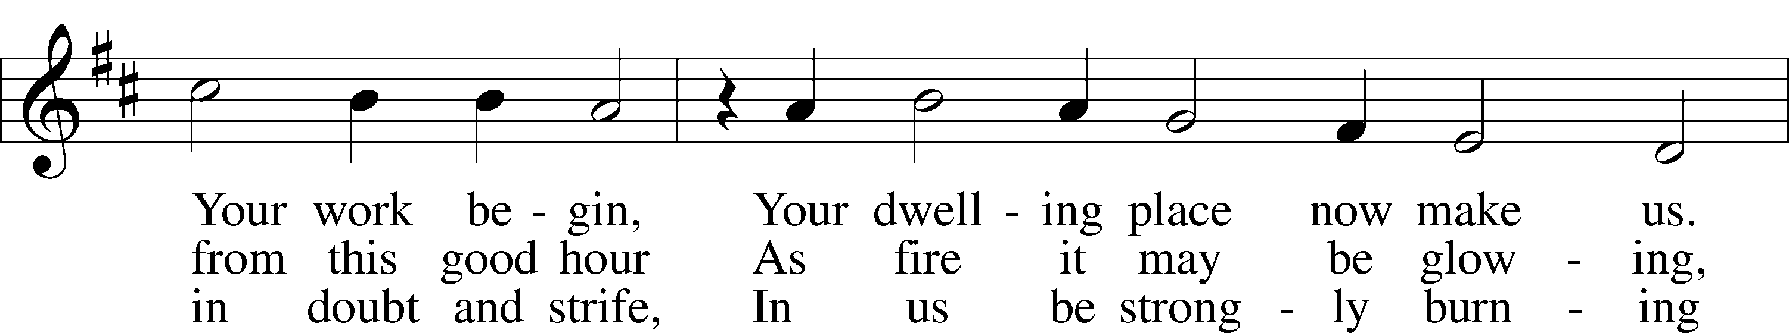

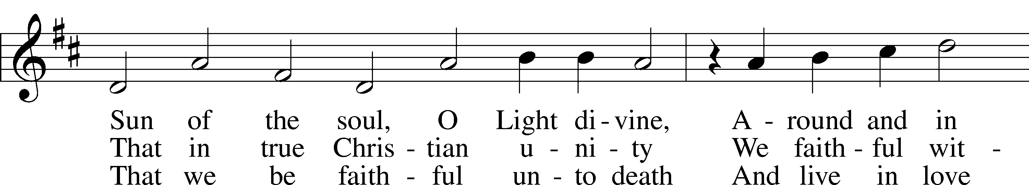

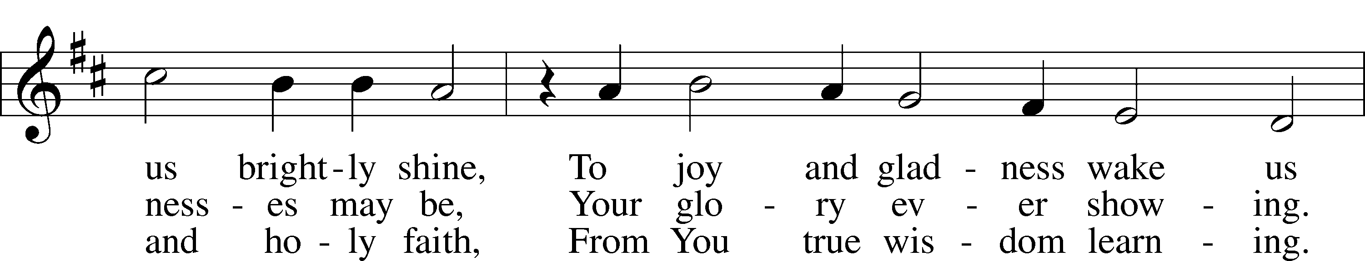

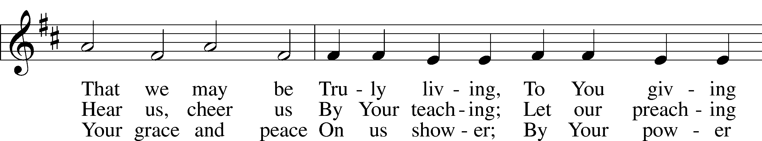

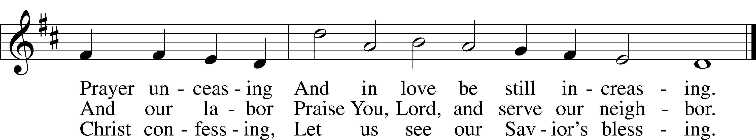

Text: Michael Schirmer, 1606–73, adapt.; (sts. 1, 3): tr. Catherine Winkworth, 1827–78, alt.; (st. 2): tr. The Lutheran Hymnal, 1941, alt.  
Tune: Philipp Nicolai, 1556–1608  
Text and tune: Public domain

720 We Walk by Faith and Not by Sight

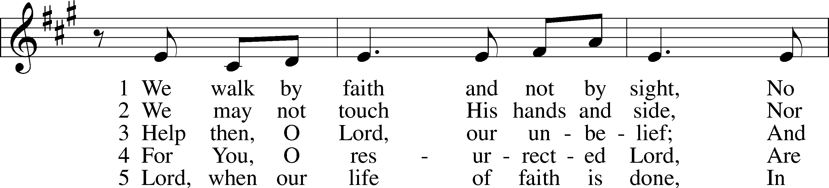

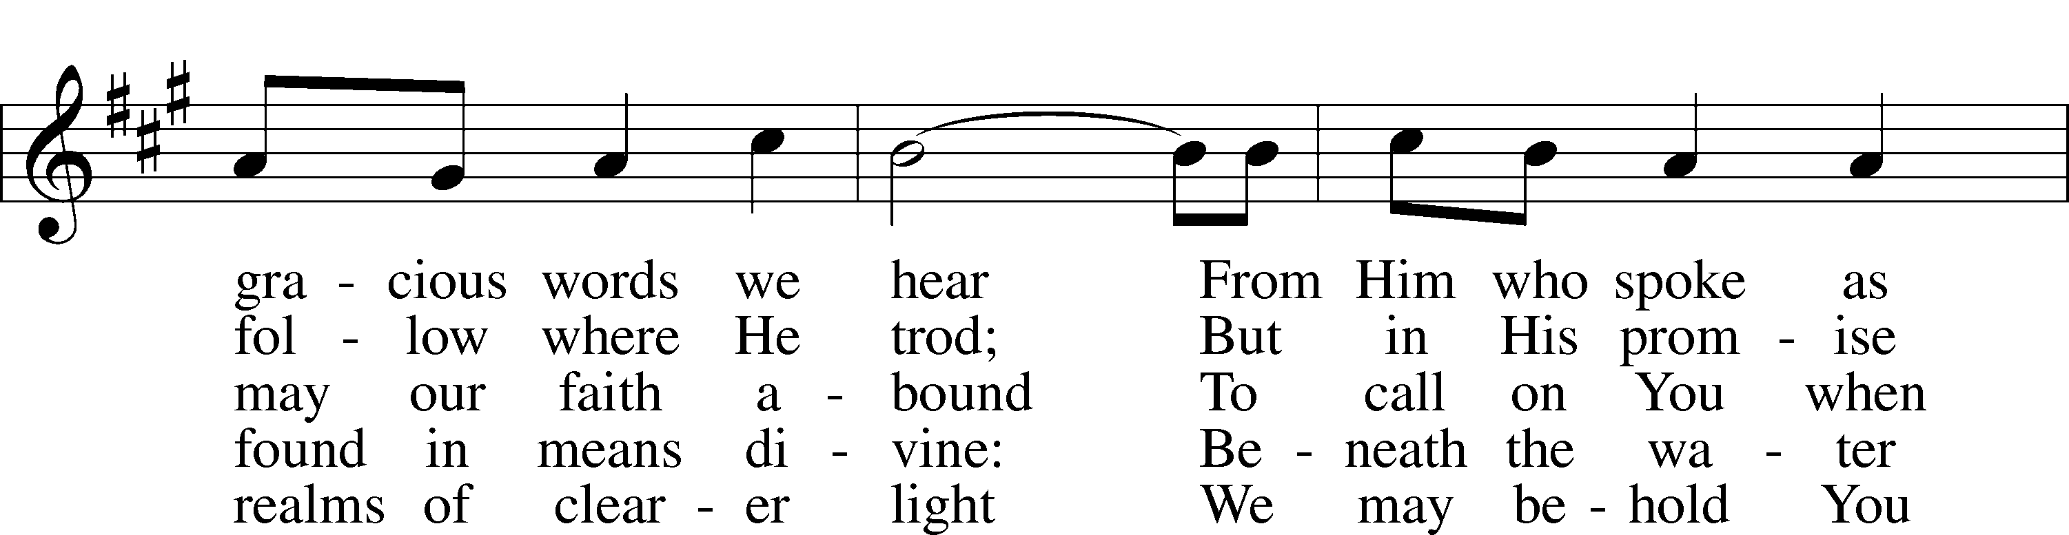

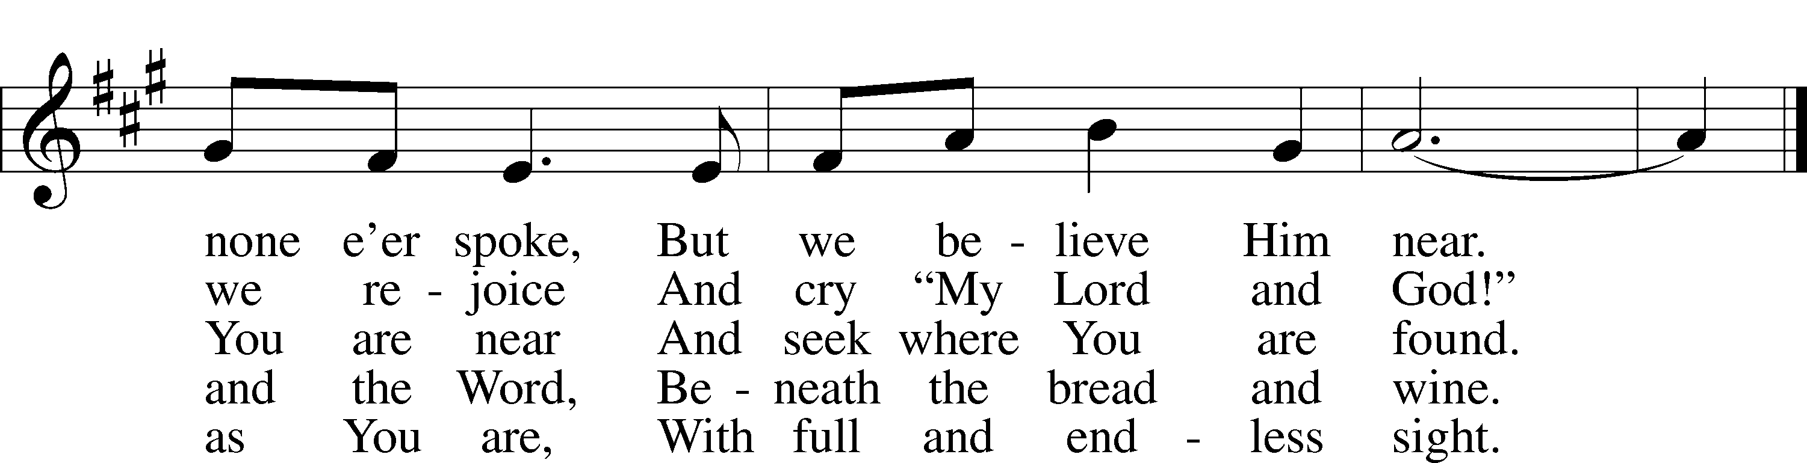

Text: Henry Alford, 1810–71, alt.  
Tune: Marty Haugen, 1950  
Text: Public domain  
Tune: © 1984 GIA Publications, Inc. Used by permission: LSB Hymn License no. 110005011

729 I Am Trusting Thee, Lord Jesus

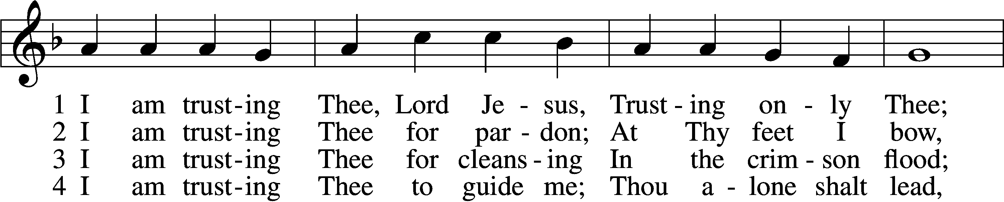

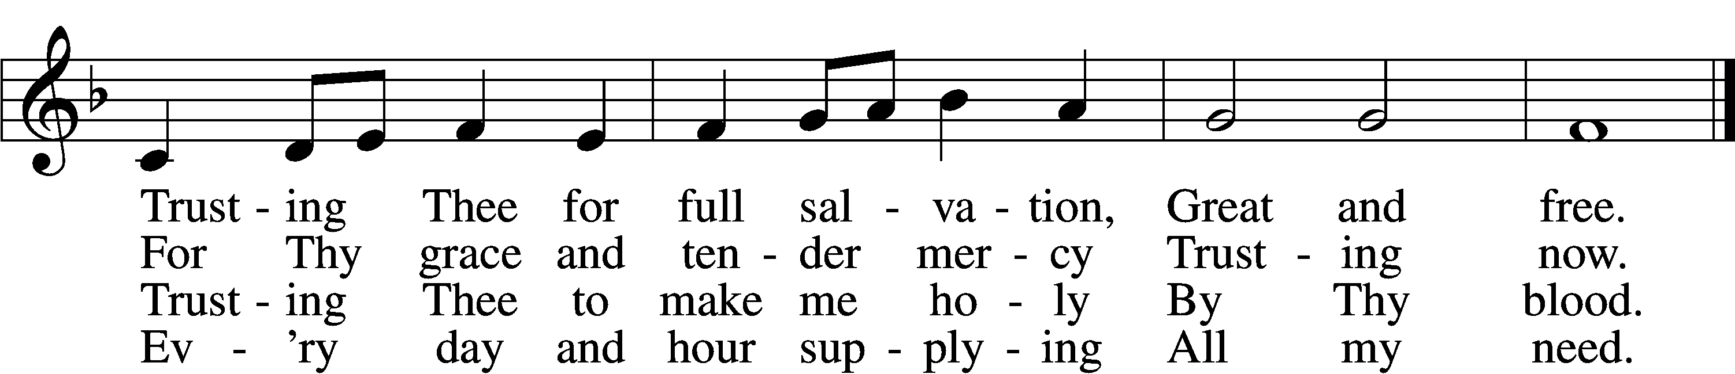

5 I am trusting Thee for power;  
 Thine can never fail.  
Words which Thou Thyself shalt give me  
 Must prevail.

6 I am trusting Thee, Lord Jesus;  
 Never let me fall.  
I am trusting Thee forever  
 And for all.

Text: Frances R. Havergal, 1836–79  
Tune: Henry W. Baker, 1821–77  
Text and tune: Public domain

924 Lord, Dismiss Us with Your Blessing

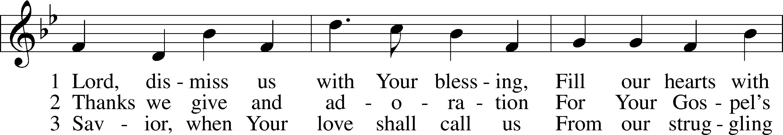

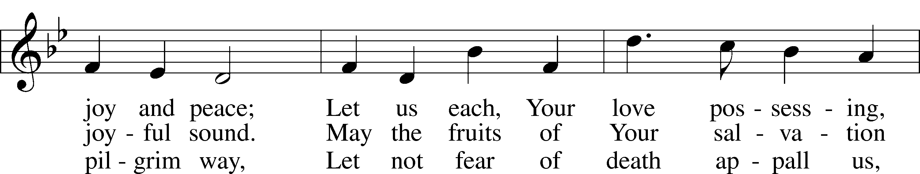

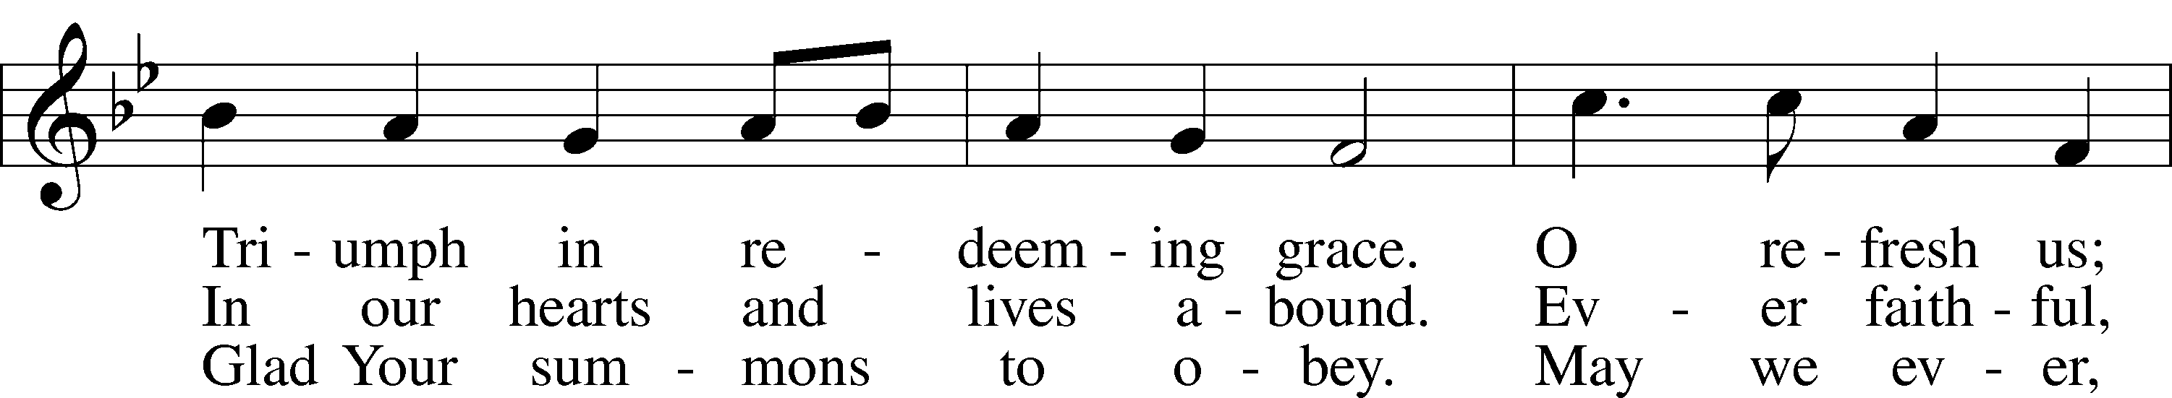

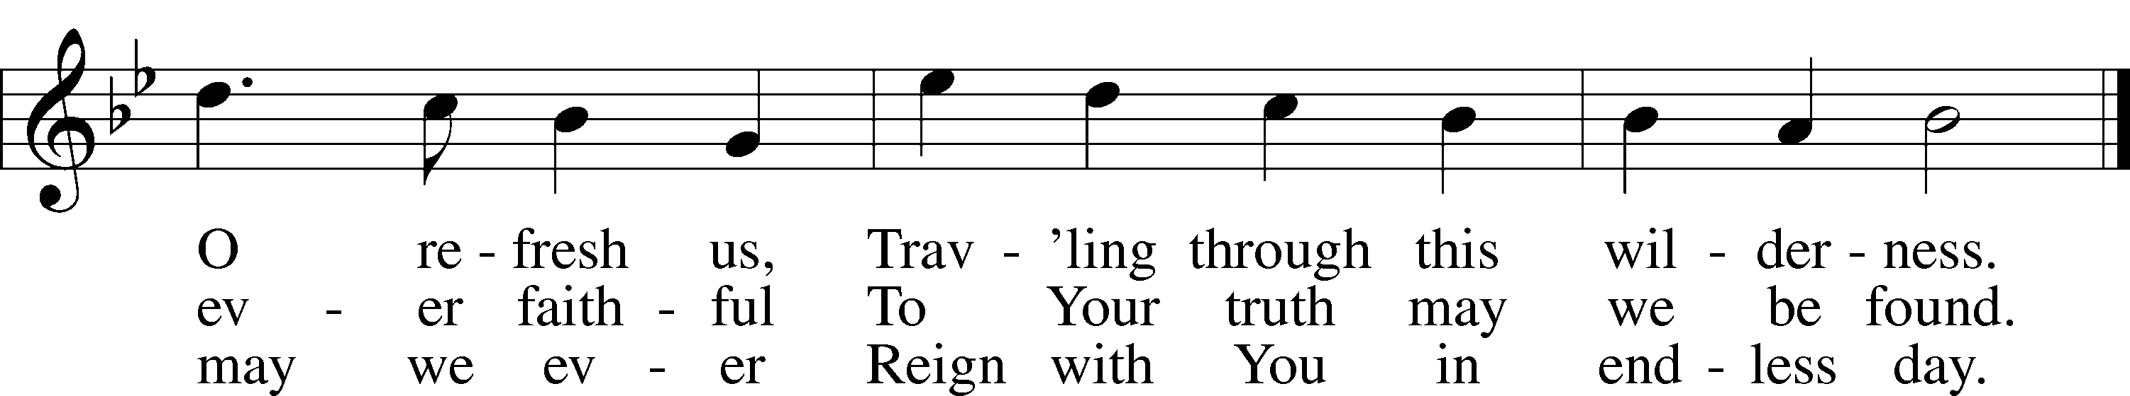

Text (sts. 1–2): attr. John Fawcett, 1740–1817, alt.; (st. 3): Godfrey Thring, 1823–1903, alt.  
Tune: Henry T. Smart, 1813–79  
Text and tune: Public domain

Stand

Nunc Dimittis Luke 2:29–32

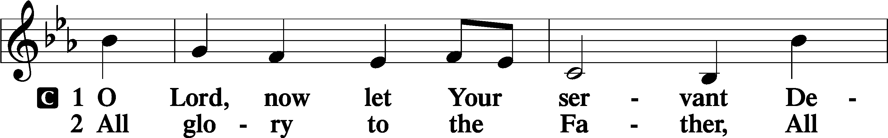

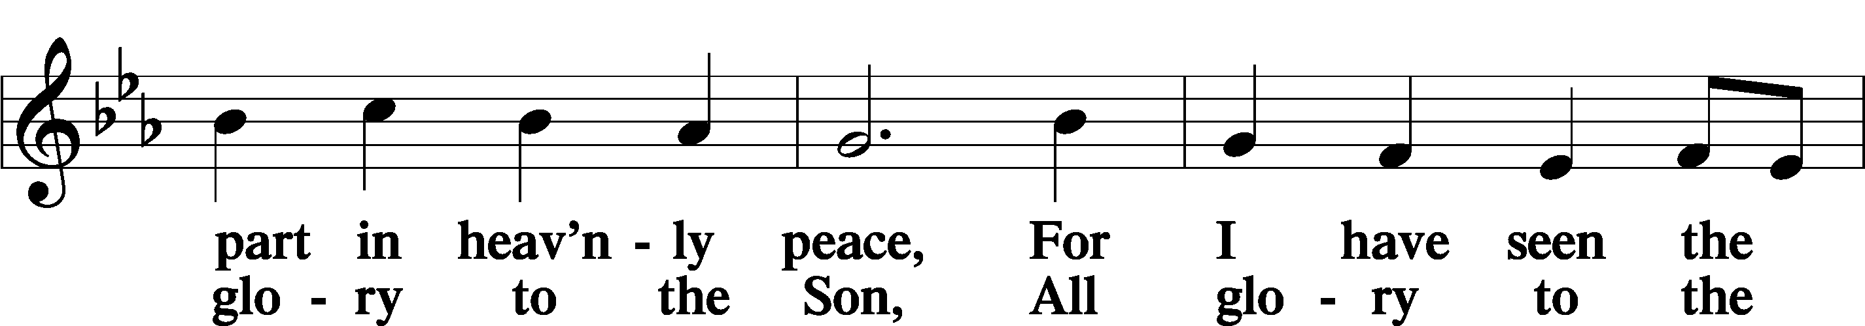

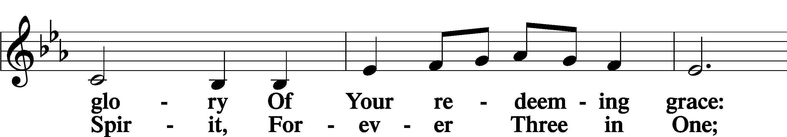

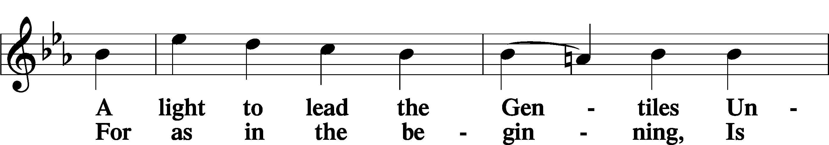

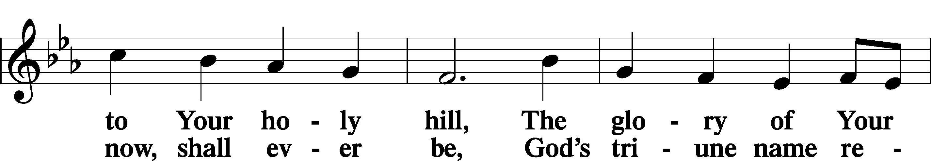

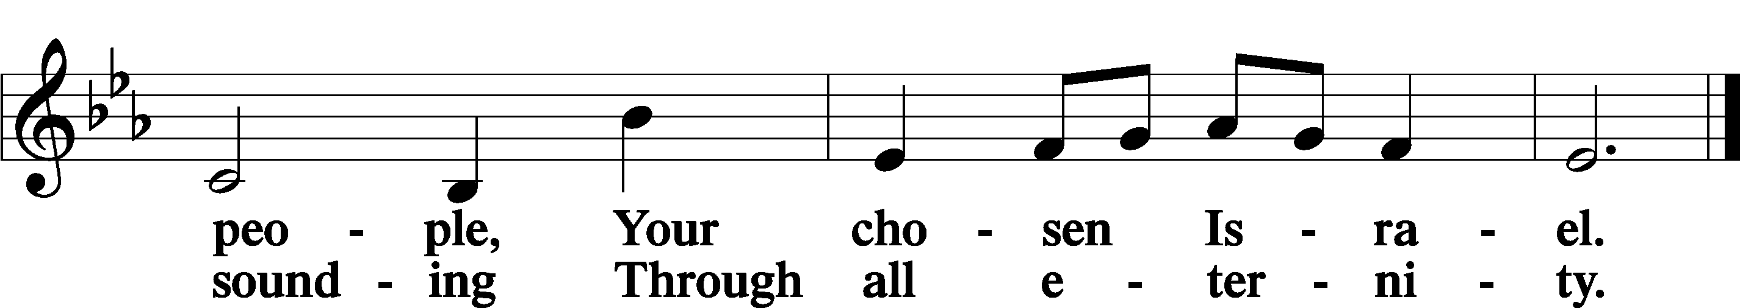

Post-Communion Collect

A Let us pray.

We give thanks to You, almighty God, that You have refreshed us through this salutary gift, and we implore You that of Your mercy You would strengthen us through the same in faith toward You and in fervent love toward one another; through Jesus Christ, Your Son, our Lord, who lives and reigns with You and the Holy Spirit, one God, now and forever.

C **Amen.**

Benedicamus Psalm 103:1

A Let us bless the Lord.

C **Thanks be to God.**

Benediction

P The Lord bless you and keep you.

The Lord make His face shine on you and be gracious to you.

The Lord look upon you with favor and T give you peace.

C **Amen.**

694 Thee Will I Love, My Strength, My Tower

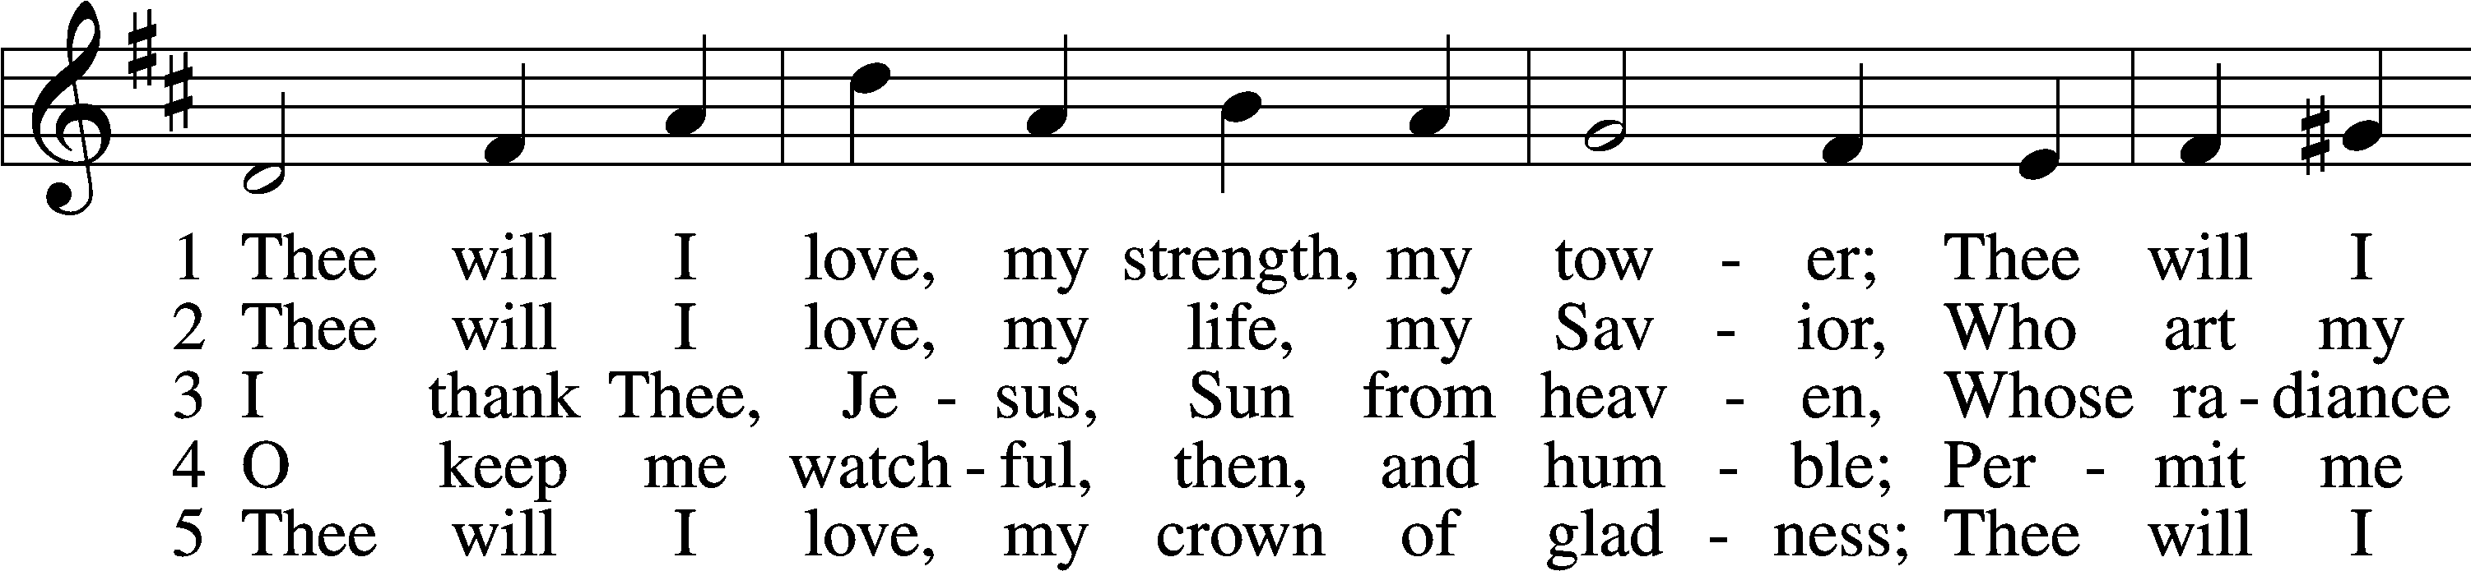

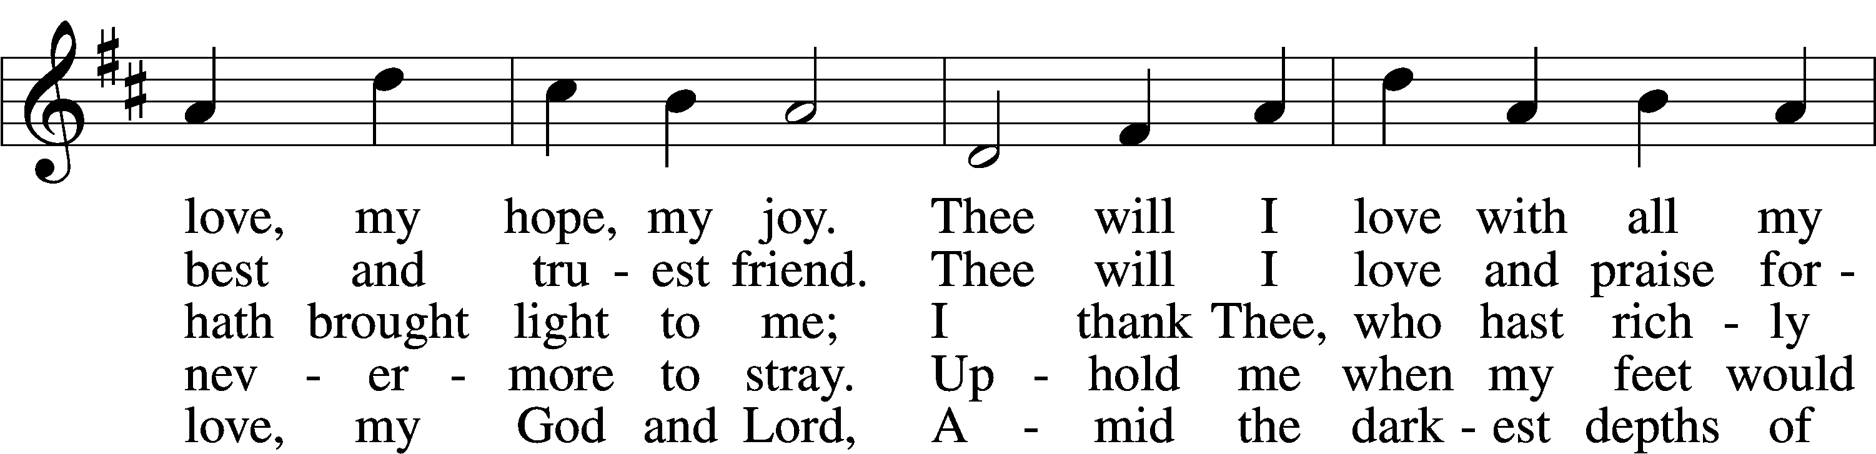

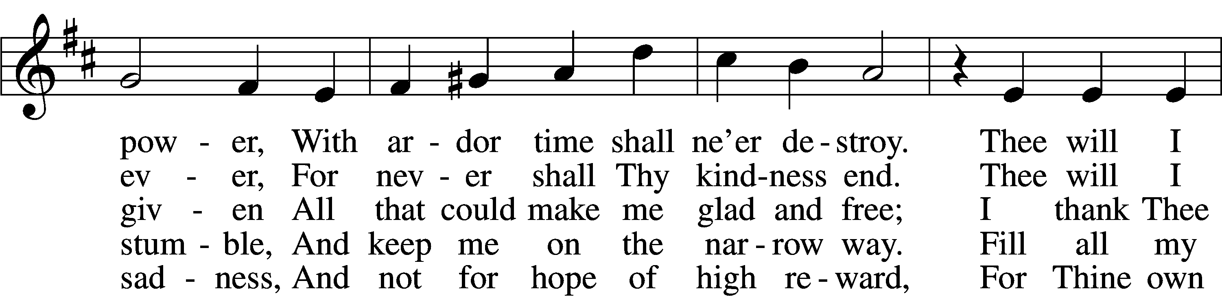

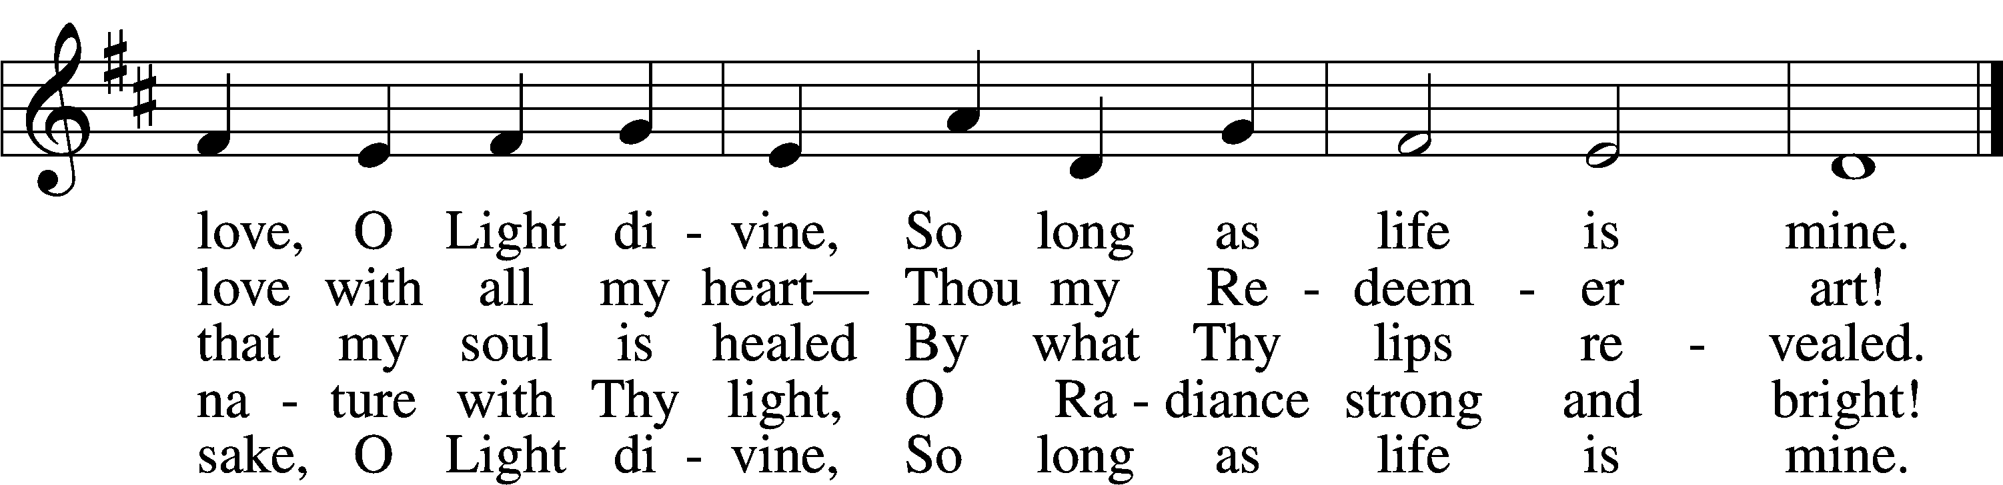

Text: Johann Scheffler, 1624–77; tr. Catherine Winkworth, 1827–78, alt.  
Tune: Harmonischer Lieder-Schatz, 1738, Frankfurt  
Text and tune: Public domain

Acknowledgments

Divine Service, Setting Four from Lutheran Service Book

Unless otherwise indicated, Scripture quotations are from the ESV® Bible (The Holy Bible, English Standard Version®), copyright © 2001 by Crossway, a publishing ministry of Good News Publishers. Used by permission. All rights reserved.

Created by Lutheran Service Builder © 2025 Concordia Publishing House.