On entering the church

P Lord, I love the habitation of Your house and the place

where Your glory dwells. In the multitude of Your tender

mercies prepare my heart that I may enter Your house to

worship and confess Your holy name; through Jesus Christ,

my God and Lord.

Before worship

C O Lord, our creator, redeemer, and comforter, as we come

together to worship You in spirit and in truth, we humbly

pray that You would open our hearts to the preaching of

Your Word so that we may repent of our sins, believe in

Jesus Christ as our only Savior, and grow in grace and

holiness. Hear us for His sake.

650 Holy Spirit, Ever Dwelling

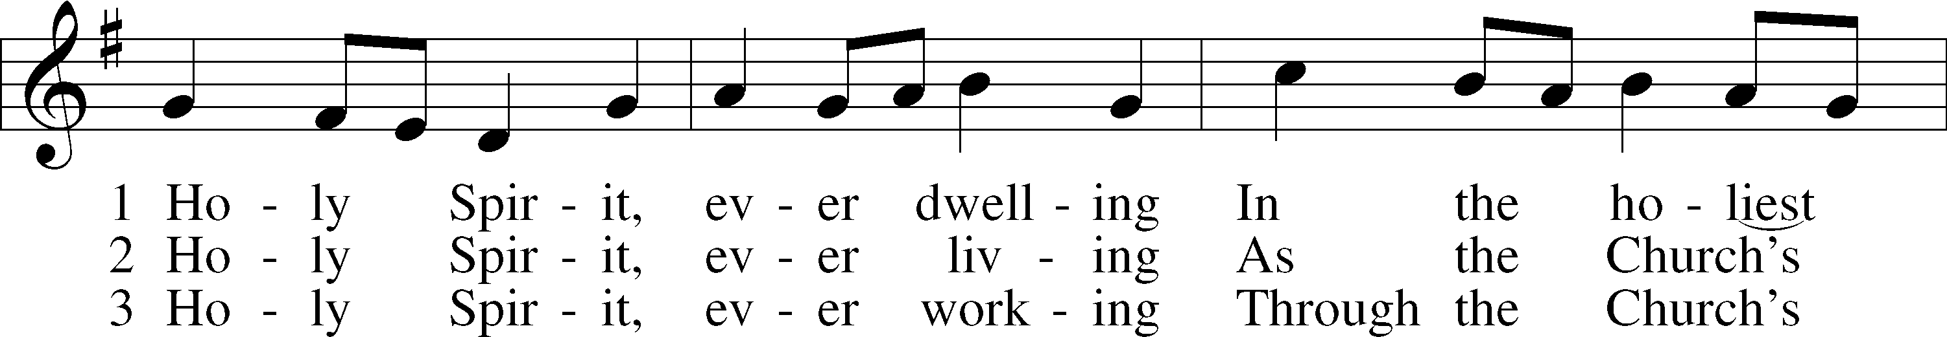

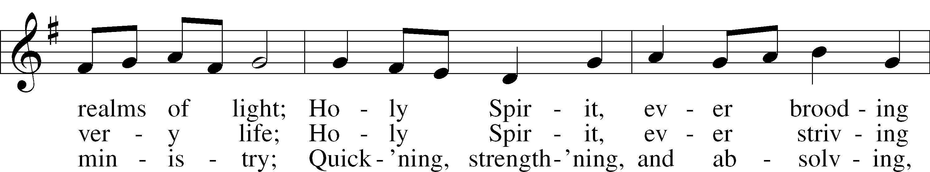

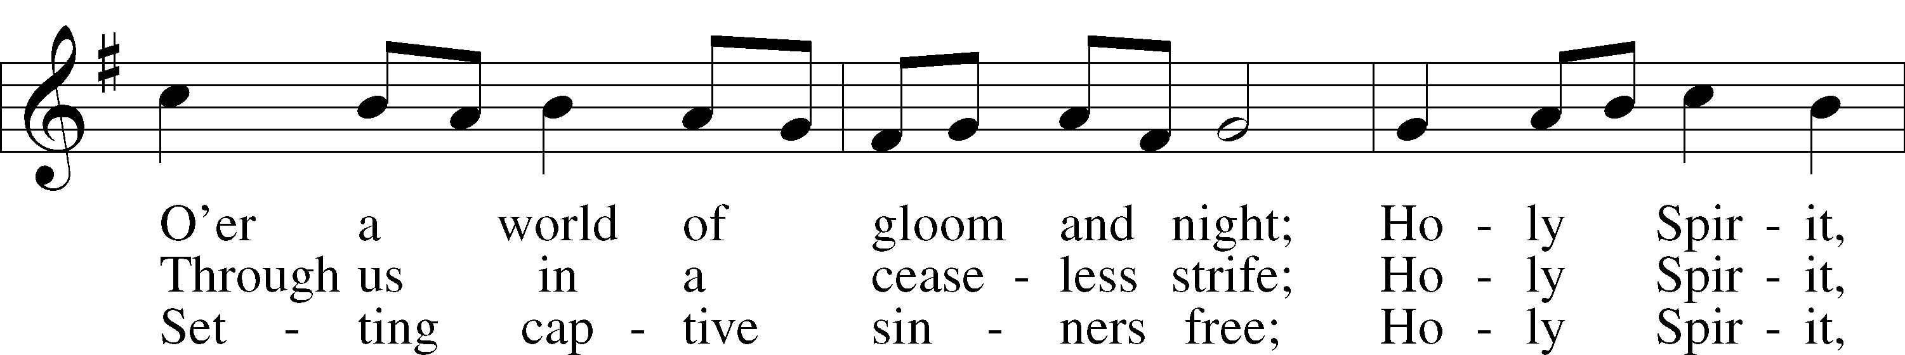

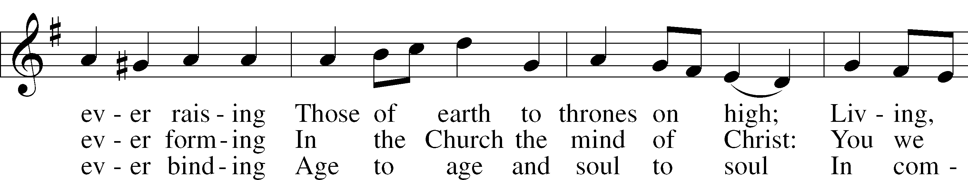

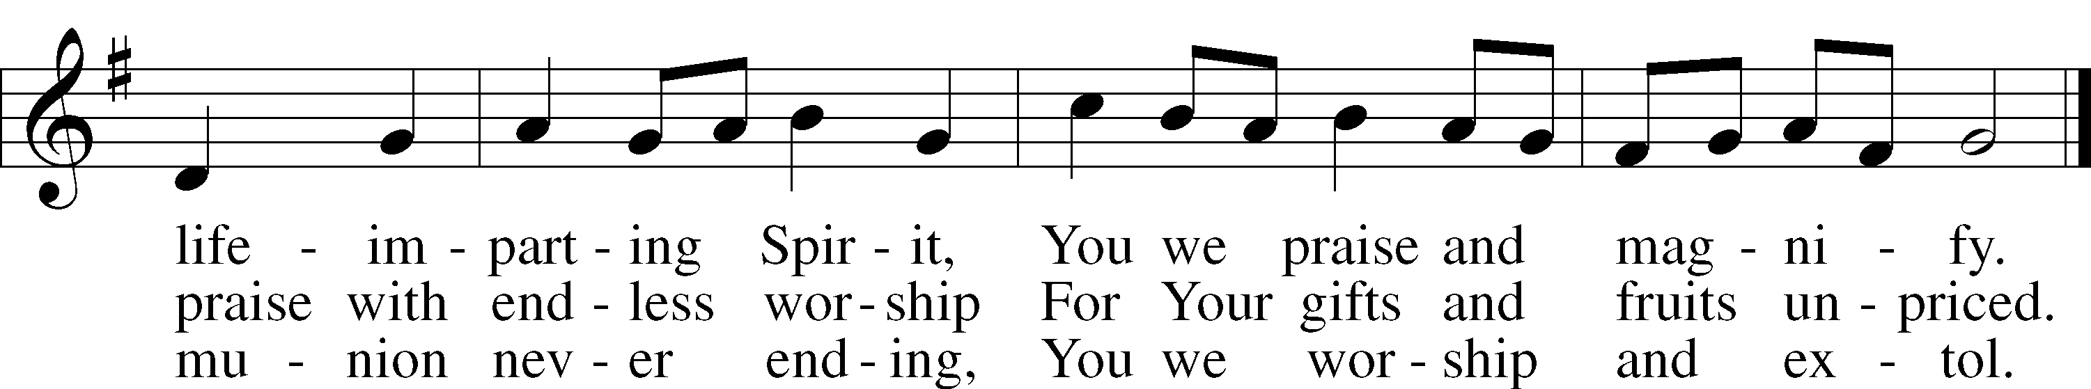

Text: Timothy Rees, 1874–1939, alt.  
Tune: Oude en Nieuwe Hollantse . . . Contredansen, c. 1710, Amsterdam  
Text and tune: Public domain

# Confession and Absolution

Stand

The sign of the cross may be made by all in remembrance of their Baptism.

Invocation Matthew 28:19b; 18:20

P In the name of the Father and of the T Son and of the Holy Spirit.

C **Amen.**

Exhortation Hebrews 10:22; Psalm 124:8; Psalm 32:5

P Beloved in the Lord! Let us draw near with a true heart and confess our sins unto God our Father, beseeching Him in the name of our Lord Jesus Christ to grant us forgiveness.

P Our help is in the name of the Lord,

C **who made heaven and earth.**

P I said, I will confess my transgressions unto the Lord,

C **and You forgave the iniquity of my sin.**

Kneel/Stand

Silence for reflection on God’s Word and for self-examination.

Confession of Sins

P Almighty God, our maker and redeemer, we poor sinners confess unto You that we are by nature sinful and unclean and that we have sinned against You by thought, word, and deed. Wherefore we flee for refuge to Your infinite mercy, seeking and imploring Your grace for the sake of our Lord Jesus Christ.

C **O most merciful God, who has given Your only-begotten Son to die for us, have mercy upon us and for His sake grant us remission of all our sins; and by Your Holy Spirit increase in us true knowledge of You and of Your will and true obedience to Your Word, to the end that by Your grace we may come to everlasting life; through Jesus Christ, our Lord. Amen.**

Declaration of Grace Mark 16:16; John 1:12

P Almighty God, our heavenly Father, has had mercy upon us and has given His only Son to die for us and for His sake forgives us all our sins. To those who believe on His name He gives power to become the children of God and has promised them His Holy Spirit. He that believes and is baptized shall be saved.  
  
Grant this, Lord, unto us all.

C **Amen.**

Stand

# Service of the Word

Introit Psalm 104:24, 27–28, 30; antiphon: Liturgical Text

Come, Holy Spirit, fill the hearts of the faithful,  
 and kindle in them the fire of your love. Alleluia.  
**O Lord, how manifold are your works! In wisdom have you made them all;  
 the earth is full of your creatures.**These all look to you,  
 to give them their food in due season.  
**When you give it to them, they gather it up;  
 when you open your hand, they are filled with good things.**When you send forth your Spirit, they are created,  
 and you renew the face of the ground.

Gloria Patri

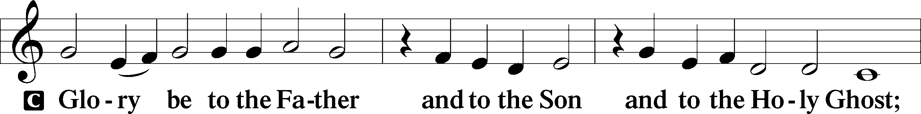

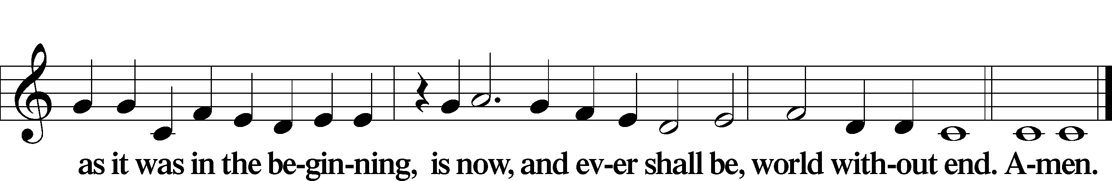

Kyrie Mark 10:47

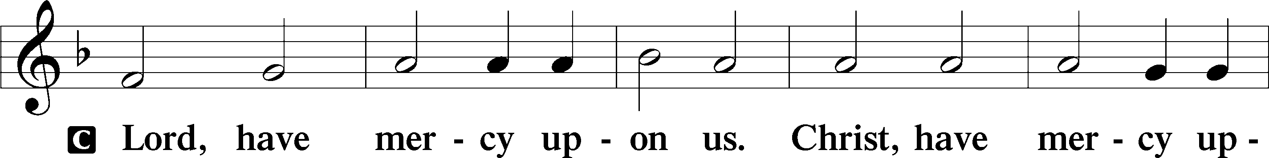

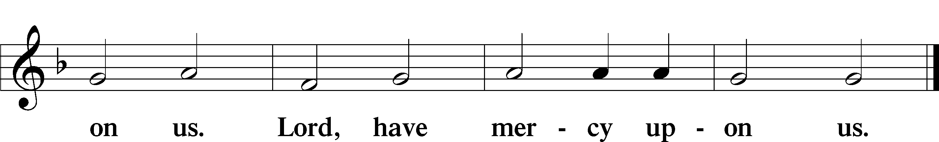

Gloria in Excelsis Luke 2:14; John 1:29

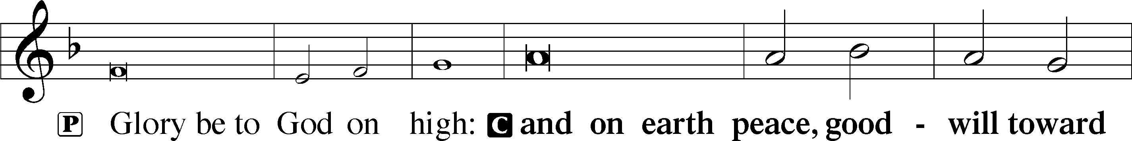

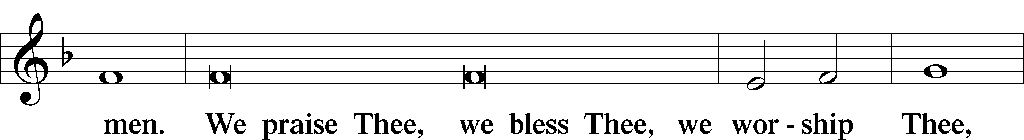

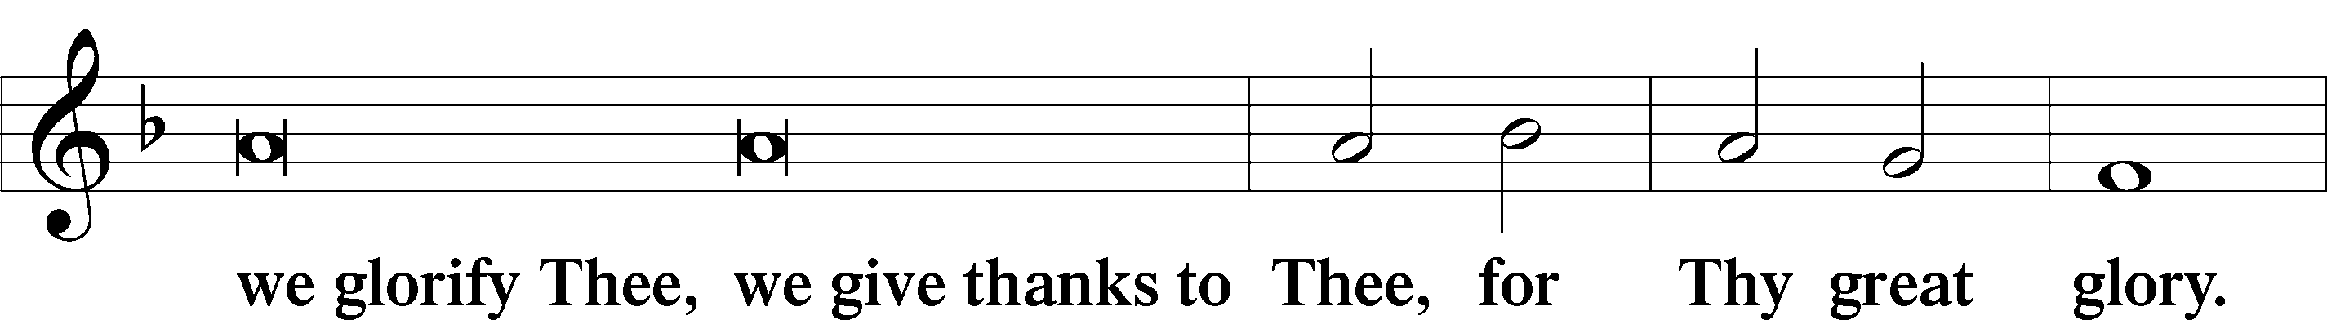

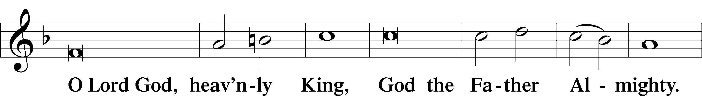

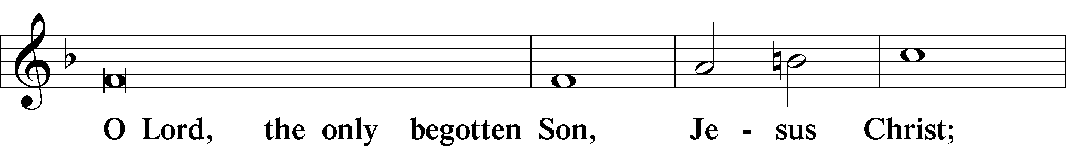

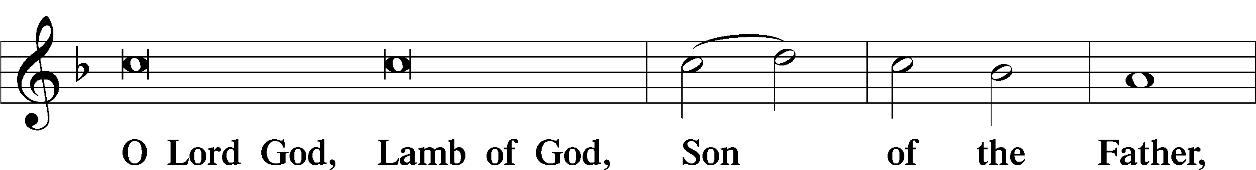

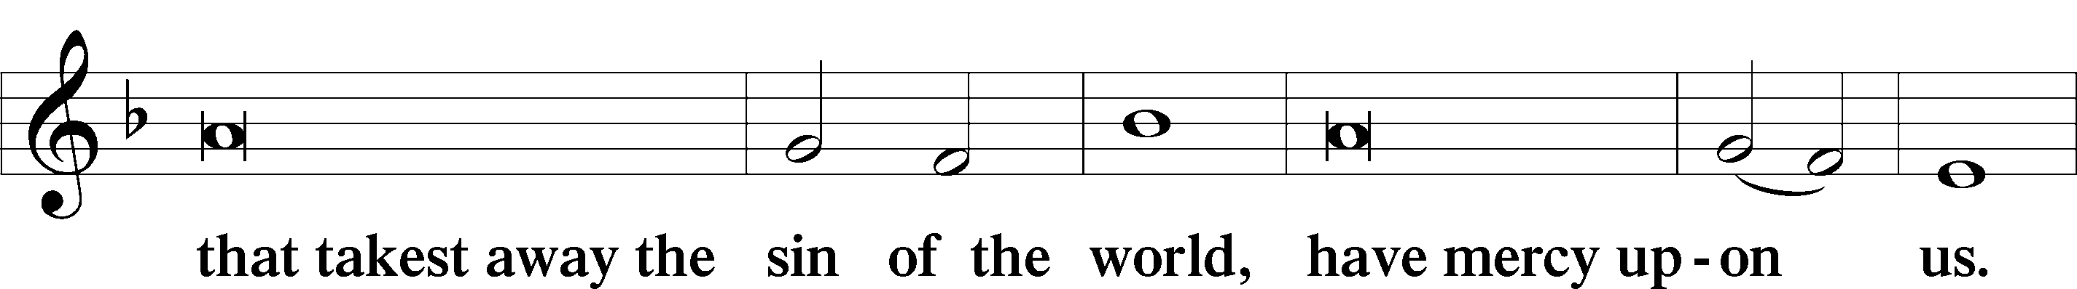

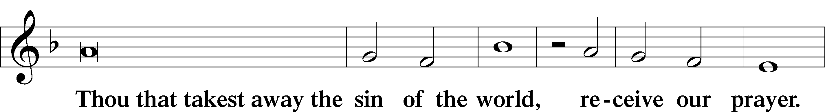

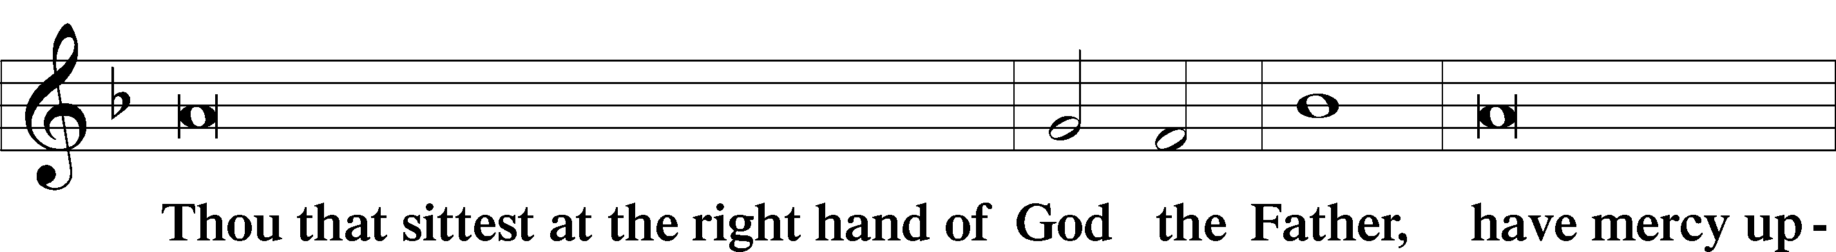

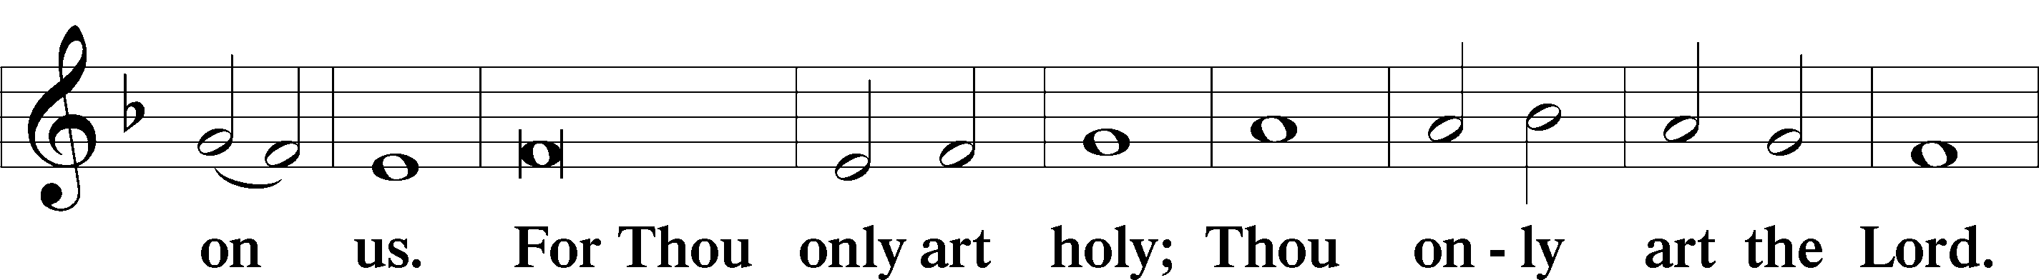

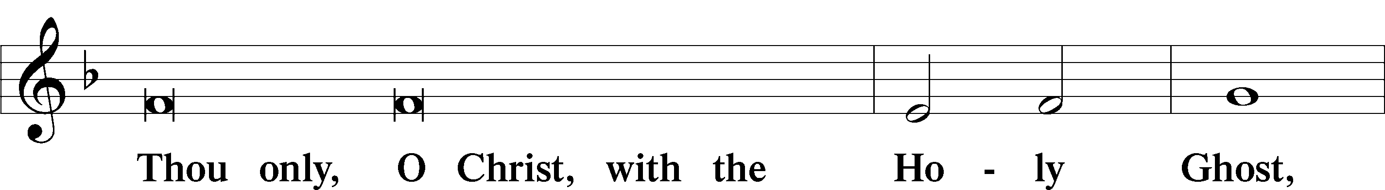

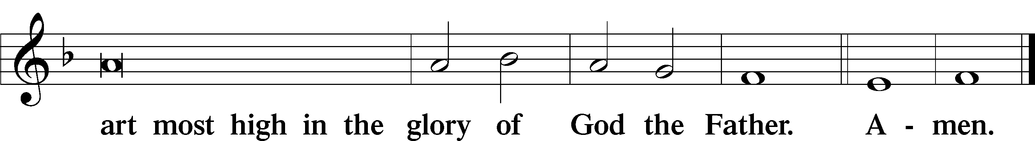

Salutation and Collect of the Day

P The Lord be with you.

C **And with thy spirit.**

P Let us pray.

O God, on this day You once taught the hearts of Your faithful people by sending them the light of Your Holy Spirit. Grant us in our day by the same Spirit to have a right understanding in all things and evermore to rejoice in His holy consolation; through Jesus Christ, Your Son, our Lord, who lives and reigns with You and the Holy Spirit, one God, now and forever.

C **Amen.**

Sit

Old Testament Reading Genesis 11:1–9

1Now the whole earth had one language and the same words. 2And as people migrated from the east, they found a plain in the land of Shinar and settled there. 3And they said to one another, “Come, let us make bricks, and burn them thoroughly.” And they had brick for stone, and bitumen for mortar. 4Then they said, “Come, let us build ourselves a city and a tower with its top in the heavens, and let us make a name for ourselves, lest we be dispersed over the face of the whole earth.” 5And the Lord came down to see the city and the tower, which the children of man had built. 6And the Lord said, “Behold, they are one people, and they have all one language, and this is only the beginning of what they will do. And nothing that they propose to do will now be impossible for them. 7Come, let us go down and there confuse their language, so that they may not understand one another’s speech.” 8So the Lord dispersed them from there over the face of all the earth, and they left off building the city. 9Therefore its name was called Babel, because there the Lord confused the language of all the earth. And from there the Lord dispersed them over the face of all the earth.

A This is the Word of the Lord.

C **Thanks be to God.**

Gradual Acts 2:17b; Romans 10:10

I will pour out my Spirit on all flesh,  
 and your sons and your daughters shall prophesy.  
**With the heart one believes and is justified,  
 and with the mouth one confesses and is saved.**

Second Reading Acts 2:1–21

1When the day of Pentecost arrived, they were all together in one place. 2And suddenly there came from heaven a sound like a mighty rushing wind, and it filled the entire house where they were sitting. 3And divided tongues as of fire appeared to them and rested on each one of them. 4And they were all filled with the Holy Spirit and began to speak in other tongues as the Spirit gave them utterance.

5Now there were dwelling in Jerusalem Jews, devout men from every nation under heaven. 6And at this sound the multitude came together, and they were bewildered, because each one was hearing them speak in his own language. 7And they were amazed and astonished, saying, “Are not all these who are speaking Galileans? 8And how is it that we hear, each of us in his own native language? 9Parthians and Medes and Elamites and residents of Mesopotamia, Judea and Cappadocia, Pontus and Asia, 10Phrygia and Pamphylia, Egypt and the parts of Libya belonging to Cyrene, and visitors from Rome, 11both Jews and proselytes, Cretans and Arabians—we hear them telling in our own tongues the mighty works of God.” 12And all were amazed and perplexed, saying to one another, “What does this mean?” 13But others mocking said, “They are filled with new wine.”

14But Peter, standing with the eleven, lifted up his voice and addressed them, “Men of Judea and all who dwell in Jerusalem, let this be known to you, and give ear to my words. 15For these men are not drunk, as you suppose, since it is only the third hour of the day. 16But this is what was uttered through the prophet Joel:

17“‘And in the last days it shall be, God declares,  
that I will pour out my Spirit on all flesh,  
 and your sons and your daughters shall prophesy,  
and your young men shall see visions,  
 and your old men shall dream dreams;  
18even on my male servants and female servants  
 in those days I will pour out my Spirit, and they shall prophesy.  
19And I will show wonders in the heavens above  
 and signs on the earth below,  
 blood, and fire, and vapor of smoke;  
20the sun shall be turned to darkness  
 and the moon to blood,  
 before the day of the Lord comes, the great and magnificent day.  
21And it shall come to pass that everyone who calls upon the name of the Lord shall be saved.’”

A This is the Word of the Lord.

C **Thanks be to God.**

Stand

Alleluia

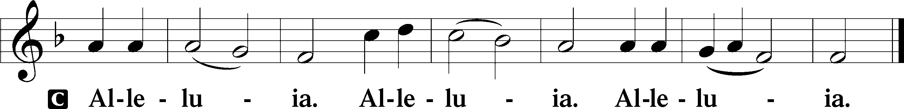

Holy Gospel John 14:23–31

P The Holy Gospel according to St. John, the fourteenth chapter.

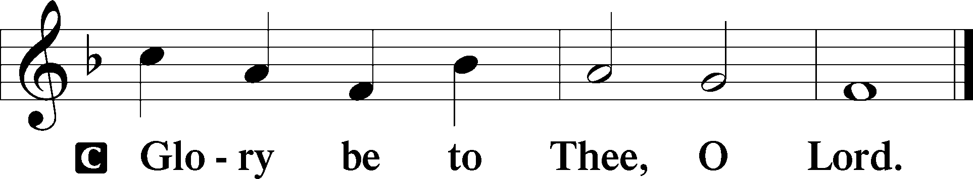

23Jesus answered him, “If anyone loves me, he will keep my word, and my Father will love him, and we will come to him and make our home with him. 24Whoever does not love me does not keep my words. And the word that you hear is not mine but the Father’s who sent me.

25“These things I have spoken to you while I am still with you. 26But the Helper, the Holy Spirit, whom the Father will send in my name, he will teach you all things and bring to your remembrance all that I have said to you. 27Peace I leave with you; my peace I give to you. Not as the world gives do I give to you. Let not your hearts be troubled, neither let them be afraid. 28You heard me say to you, ‘I am going away, and I will come to you.’ If you loved me, you would have rejoiced, because I am going to the Father, for the Father is greater than I. 29And now I have told you before it takes place, so that when it does take place you may believe. 30I will no longer talk much with you, for the ruler of this world is coming. He has no claim on me, 31but I do as the Father has commanded me, so that the world may know that I love the Father. Rise, let us go from here.”

P This is the Gospel of the Lord.

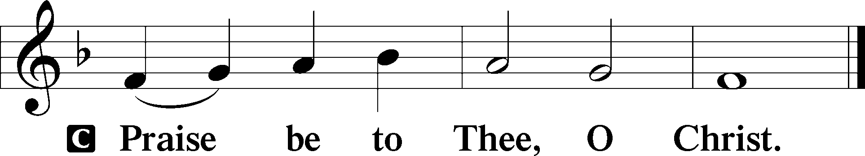

Apostles’ Creed

C **I believe in God, the Father Almighty,**

**maker of heaven and earth.**

**And in Jesus Christ, His only Son, our Lord,**

**who was conceived by the Holy Spirit,**

**born of the virgin Mary,**

**suffered under Pontius Pilate,**

**was crucified, died and was buried.**

**He descended into hell.**

**The third day He rose again from the dead.**

**He ascended into heaven**

**and sits at the right hand of God the Father Almighty.**

**From thence He will come to judge the living and the dead.**

**I believe in the Holy Spirit,**

**the holy Christian Church,**

**the communion of saints,**

**the forgiveness of sins,**

**the resurrection of the body,**

**and the life** T **everlasting. Amen.**

Sit

Children's Sermon

498 Come, Holy Ghost, Creator Blest

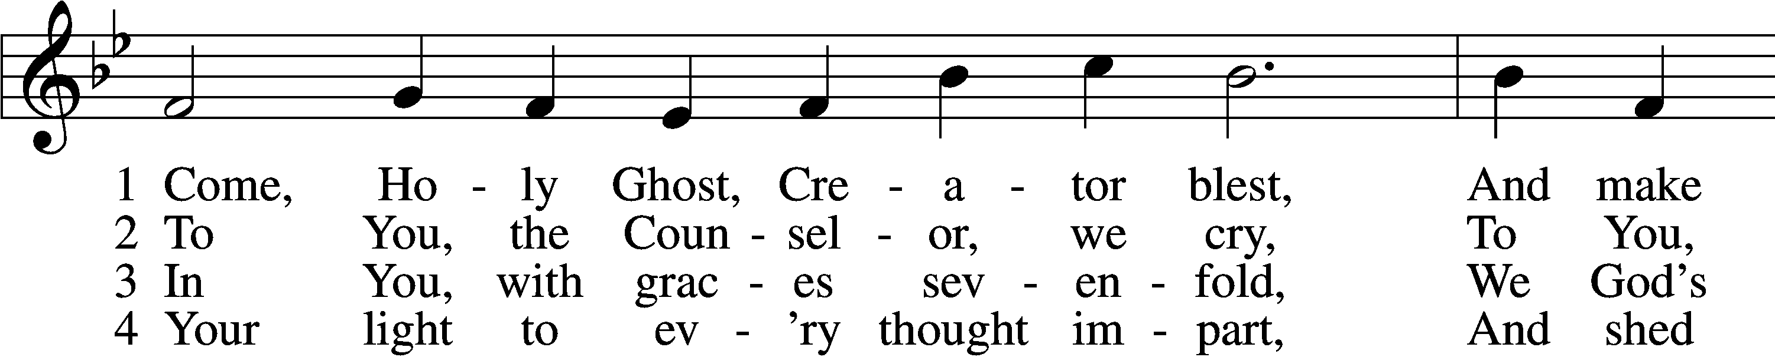

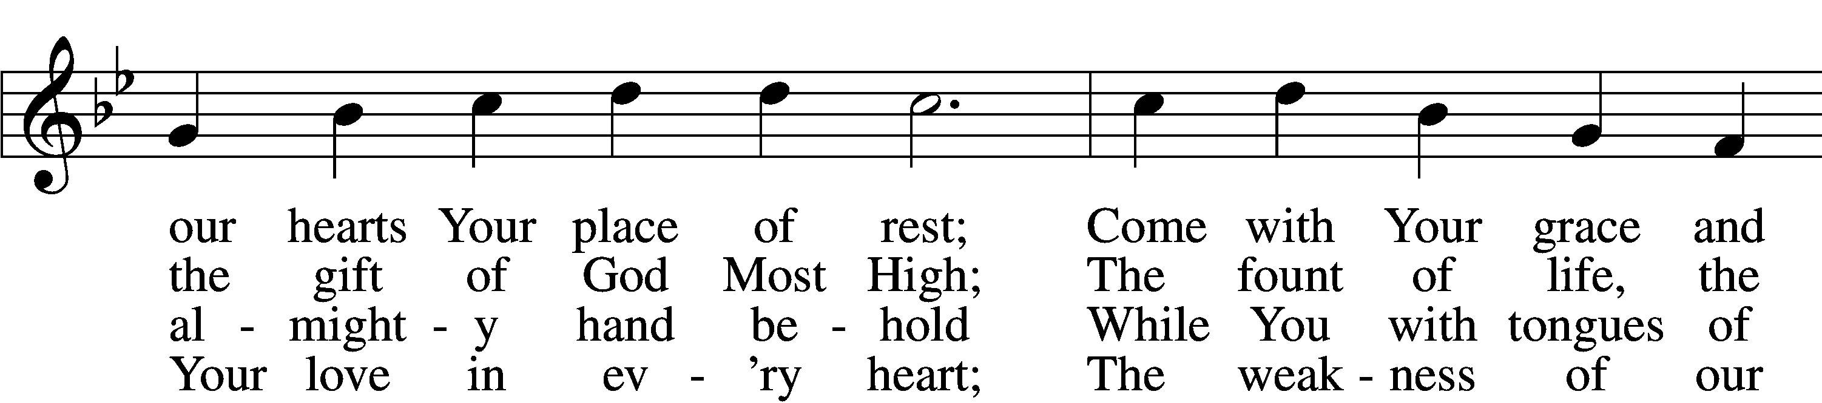

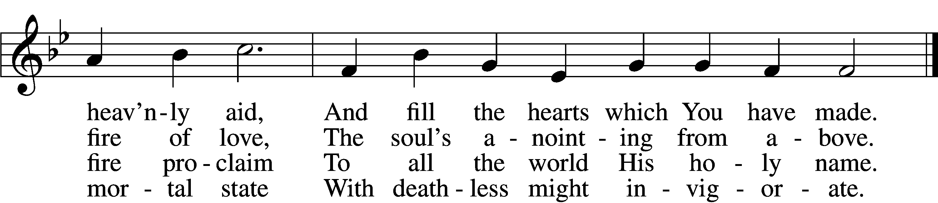

5 Drive far away our wily foe,  
And Your abiding peace bestow;  
With You as our protecting guide,  
No evil can with us abide.

6 Teach us to know the Father, Son,  
And You, from both, as Three in One  
That we Your name may ever bless  
And in our lives the truth confess.

D 7 Praise we the Father and the Son  
And Holy Spirit, with them One,  
And may the Son on us bestow  
The gifts that from the Spirit flow!

Text: attr. Rabanus Maurus, 776–856; tr. Edward Caswall, 1814–78, alt.  
Tune: Geistliche Lieder auffs new gebessert, 1533, Wittenberg, ed. Joseph Klug  
Text and tune: Public domain

Sermon

Votum

P The peace of God, which passes all understanding, keep your hearts and minds in Christ Jesus.

C **Amen.**

Stand

Offertory Psalm 51:10–12

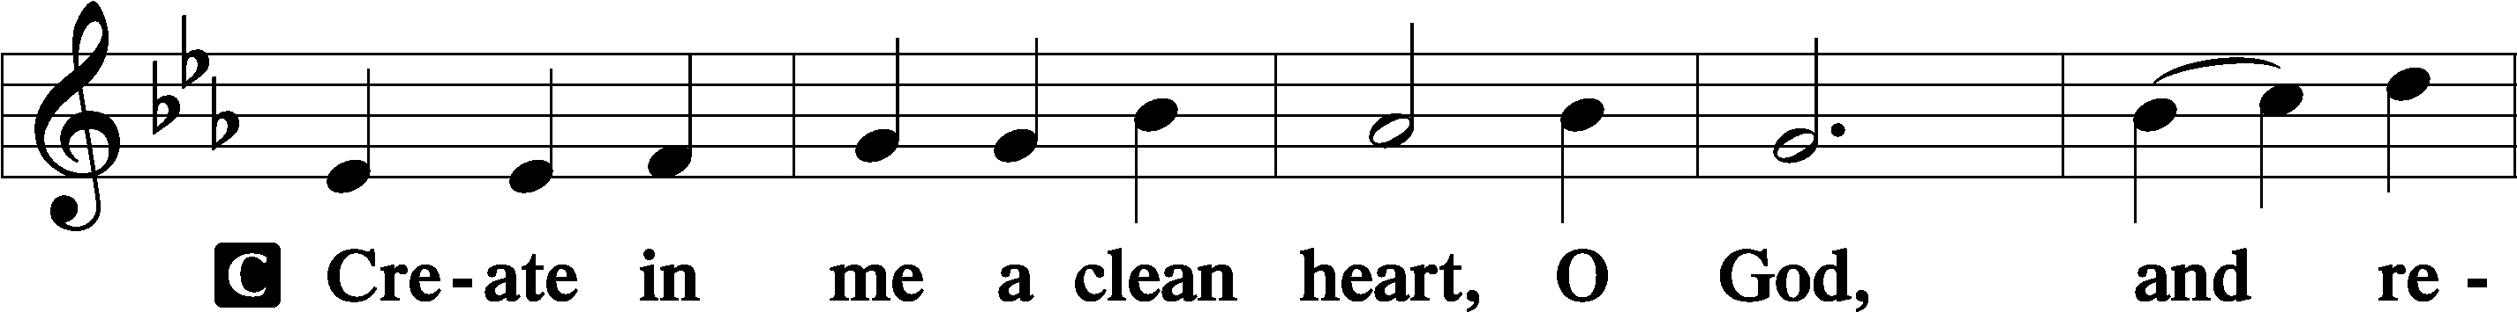

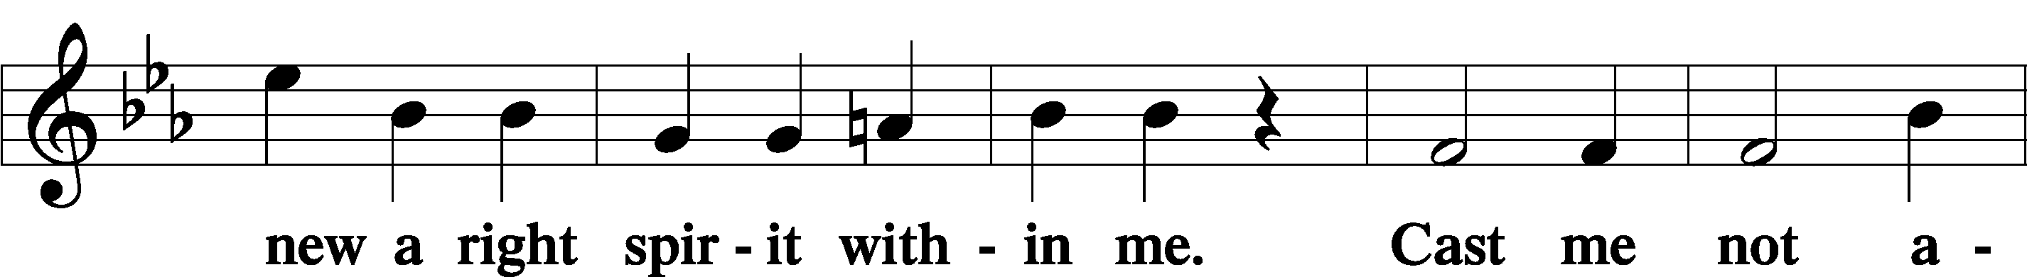

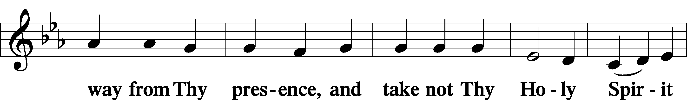

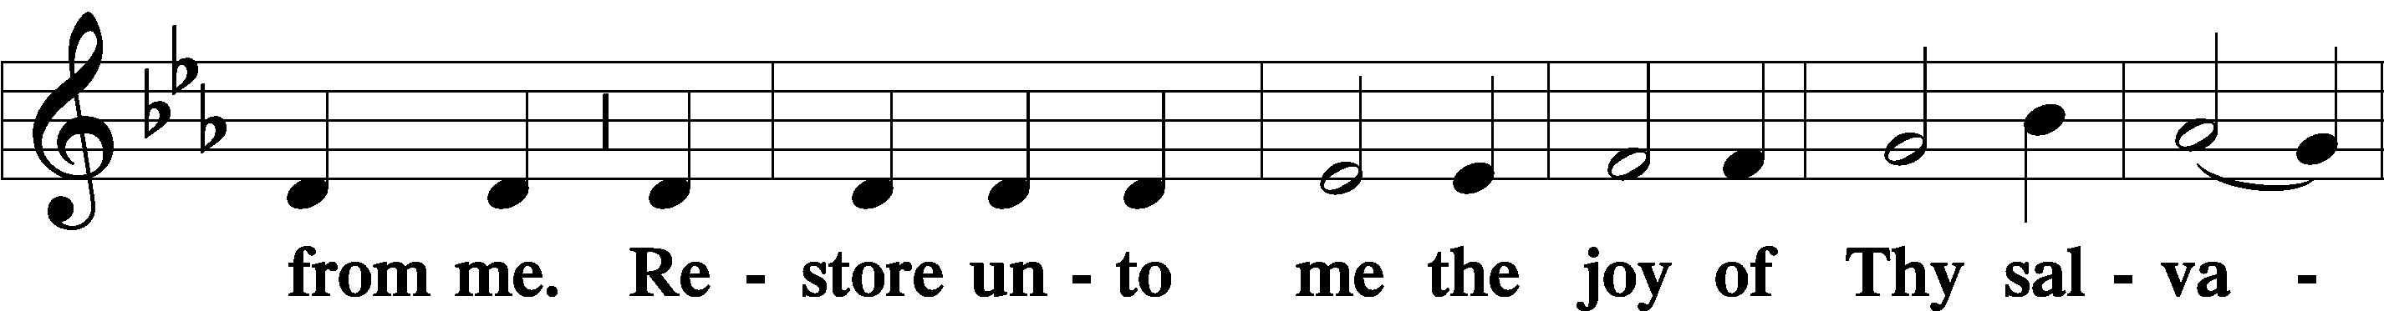

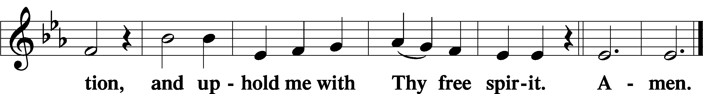

Sit

Offering

Hymn

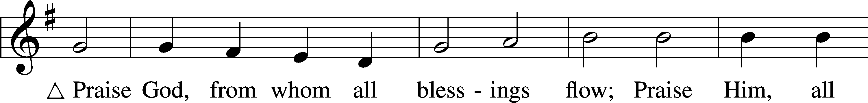

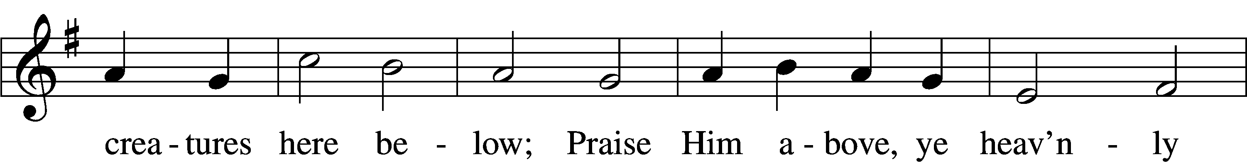

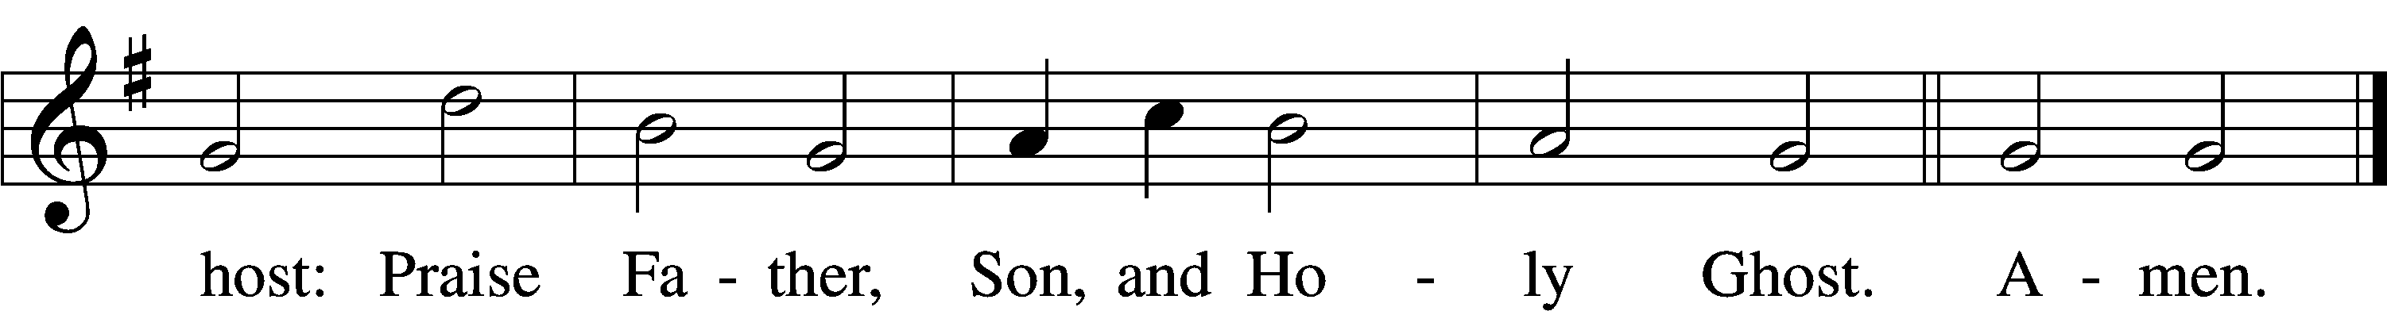

Text: Thomas Ken, 1637–1711  
Tune: Trente quatre Pseaumes de David, 1551, Geneva, ed. Louis Bourgeois  
Text and tune: Public domain

Stand

Prayer of the Church

Lord’s Prayer Matthew 6:9–13

P Lord, remember us in Your kingdom and teach us to pray:

C **Our Father who art in heaven,**

**hallowed be Thy name,**

**Thy kingdom come,**

**Thy will be done on earth**

**as it is in heaven;**

**give us this day our daily bread;**

**and forgive us our trespasses**

**as we forgive those**

**who trespass against us;**

**and lead us not into temptation,**

**but deliver us from evil.**

**For Thine is the kingdom**

**and the power and the glory**

**forever and ever. Amen.**

Collect for the Word

Blessed Lord, You have caused all Holy Scriptures to be written for our learning. Grant that we may so hear them, read, mark, learn, and inwardly digest them that, by the patience and comfort of Your holy Word, we may embrace and ever hold fast the blessed hope of everlasting life; through Jesus Christ, Your Son, our Lord, who lives and reigns with You and the Holy Spirit, one God, now and forever.

Benediction

P The Lord bless you and keep you.

The Lord make His face shine on you and be gracious to you.

The Lord look upon you with favor and T give you peace.

C **Amen.**

Sit

Stand

Benediction Numbers 6:24–26

P The Lord bless you and keep you.

The Lord make His face shine upon you and be gracious unto you.

The Lord lift up His countenance upon you and T give you peace.

C **Amen, amen, amen.**

500 Creator Spirit, by Whose Aid

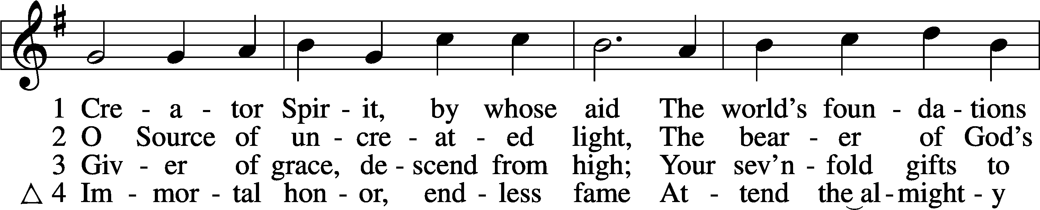

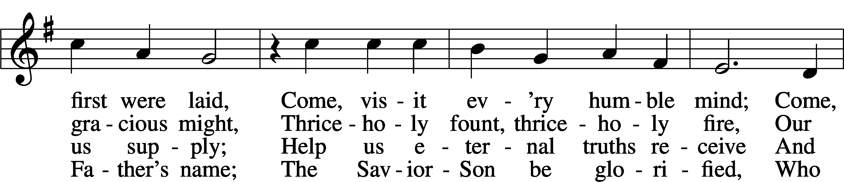

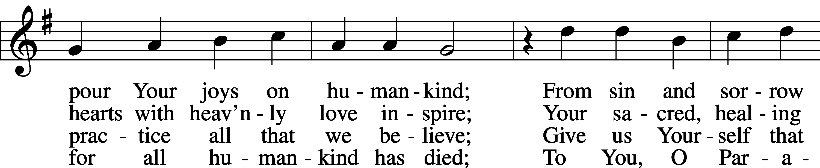

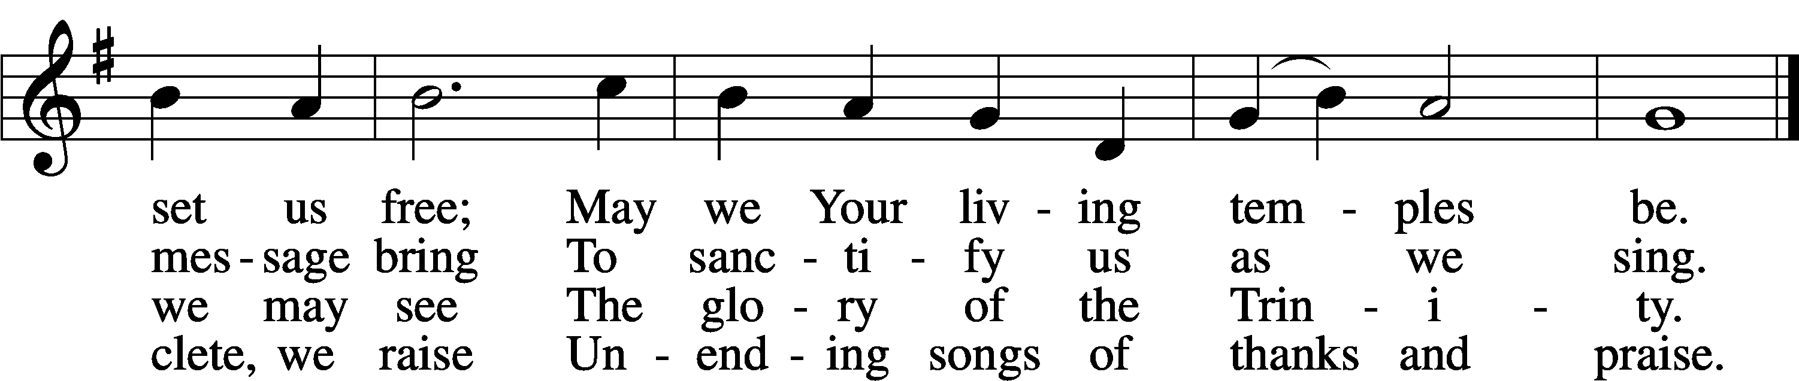

Text: attr. Rabanus Maurus, 776–856; tr. John Dryden, 1631–1700, alt.  
Tune: Gesangbuch . . . Psalmen, Geistliche Lieder, 1541, Strassburg, alt.  
Text and tune: Public domain

Acknowledgments

Divine Service, Setting Three from Lutheran Service Book

Unless otherwise indicated, Scripture quotations are from the ESV® Bible (The Holy Bible, English Standard Version®), copyright © 2001 by Crossway, a publishing ministry of Good News Publishers. Used by permission. All rights reserved.

Created by Lutheran Service Builder © 2025 Concordia Publishing House.