On entering the church

P Lord, I love the habitation of Your house and the place
where Your glory dwells. In the multitude of Your tender
mercies prepare my heart that I may enter Your house to
worship and confess Your holy name; through Jesus Christ,
my God and Lord.

Before worship

C O Lord, our creator, redeemer, and comforter, as we come
together to worship You in spirit and in truth, we humbly
pray that You would open our hearts to the preaching of
Your Word so that we may repent of our sins, believe in
Jesus Christ as our only Savior, and grow in grace and
holiness. Hear us for His sake.

728 How Firm a Foundation
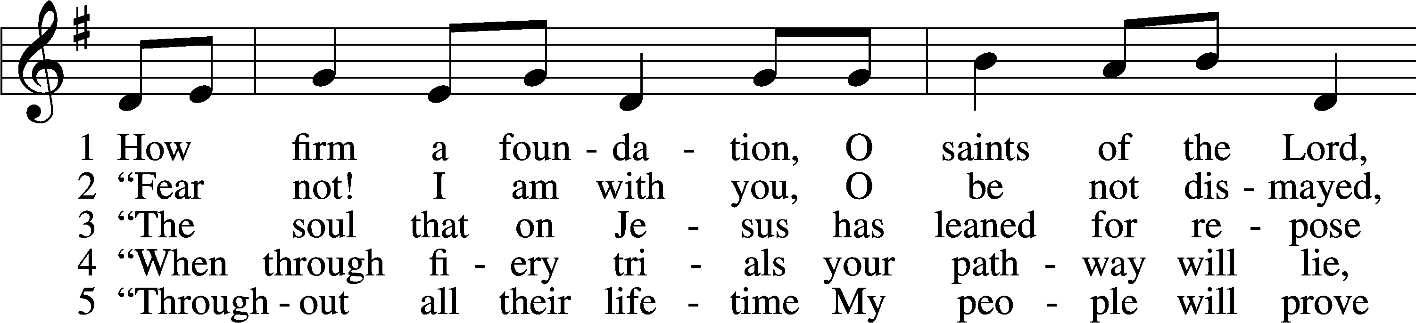
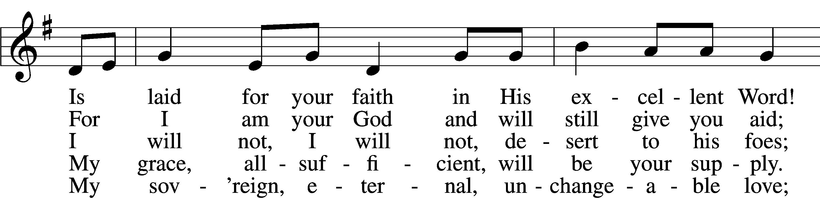
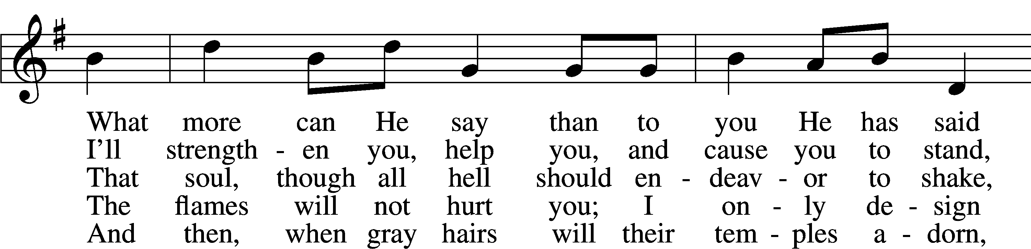
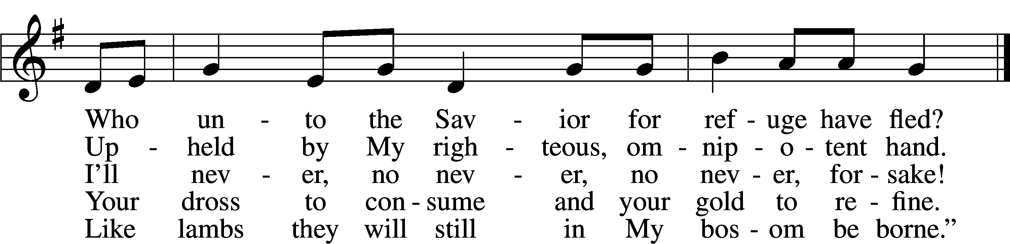
Text: A Selection of Hymns, 1787, London, alt.
Tune: Genuine Church Music, 1832, Winchester
Text and tune: Public domain

Confession and Absolution
Stand

The sign of the cross may be made by all in remembrance of their Baptism.

Invocation Matthew 28:19b; 18:20
A In the name of the Father and of the T Son and of the Holy Spirit.
C Amen.

Exhortation Hebrews 10:22; Psalm 124:8; Psalm 32:5
P Beloved in the Lord! Let us draw near with a true heart and confess our sins unto God our Father, beseeching Him in the name of our Lord Jesus Christ to grant us forgiveness.

A Our help is in the name of the Lord,
C who made heaven and earth.
A I said, I will confess my transgressions unto the Lord,
C and You forgave the iniquity of my sin.

Kneel/Stand

Silence for reflection on God’s Word and for self-examination.

Confession of Sins
A O almighty God, merciful Father,
C I, a poor, miserable sinner, confess unto You all my sins and iniquities with which I have ever offended You and justly deserved Your temporal and eternal punishment. But I am heartily sorry for them and sincerely repent of them, and I pray You of Your boundless mercy and for the sake of the holy, innocent, bitter sufferings and death of Your beloved Son, Jesus Christ, to be gracious and merciful to me, a poor, sinful being.

Absolution [John 20:19–23]
P Upon this your confession, I, by virtue of my office, as a called and ordained servant of the Word, announce the grace of God unto all of you, and in the stead and by the command of my Lord Jesus Christ I forgive you all your sins in the name of the Father and of the T Son and of the Holy Spirit.
C Amen.

Stand
Service of the Word
Introit Psalm 8:1, 4–6; antiphon: v. 2
Out of the mouth of babes and infants, you have established strength because of your foes,
to still the enemy and the avenger.
O Lord, our Lord, how majestic is your name in all the earth!
You have set your glory above the heavens.
What is man that you are mindful of him,
and the son of man that you care for him?
Yet you have made him a little lower than the heavenly beings
and crowned him with glory and honor.
You have given him dominion over the works of your hands;
you have put all things under his feet.

Gloria Patri
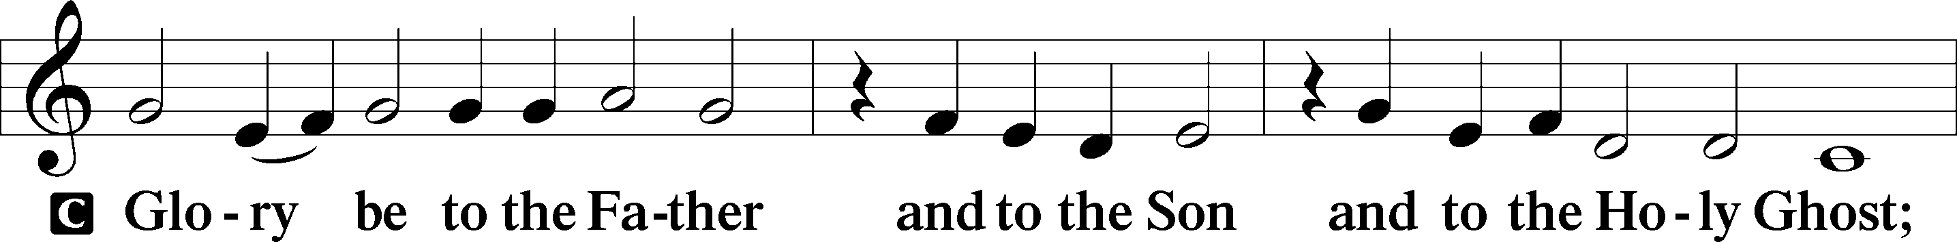
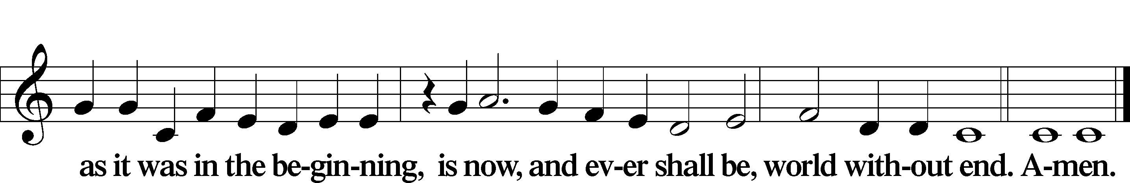

Kyrie Mark 10:47
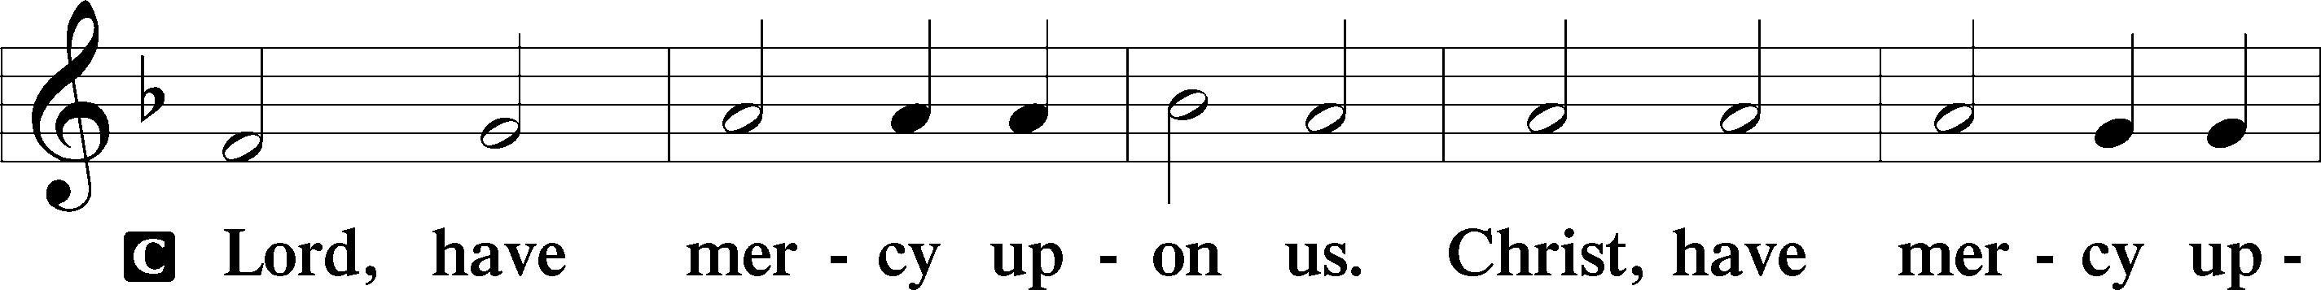
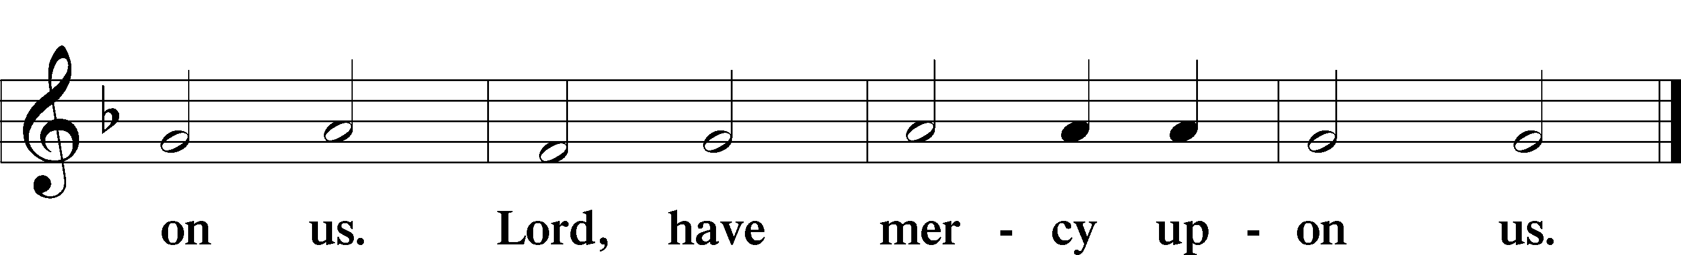

Gloria in Excelsis Luke 2:14; John 1:29
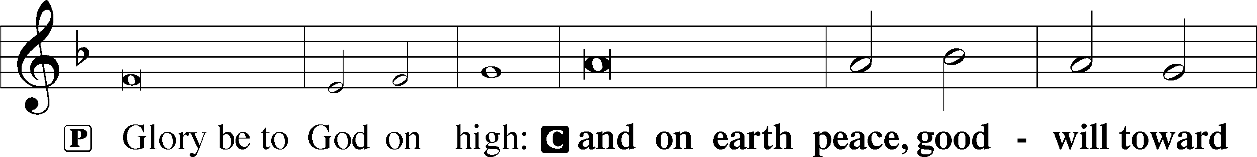
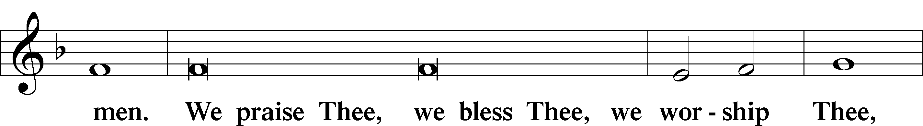
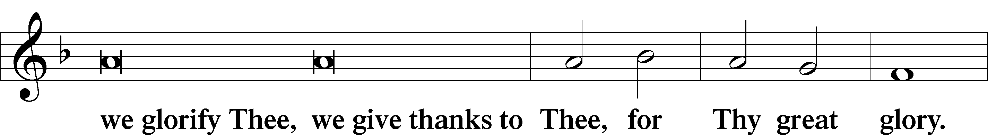
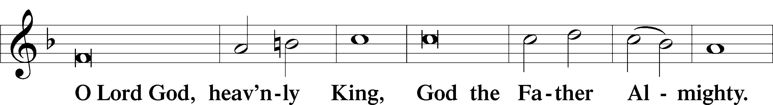
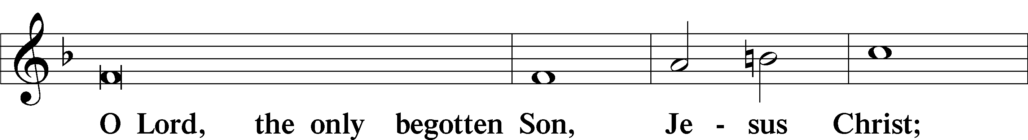
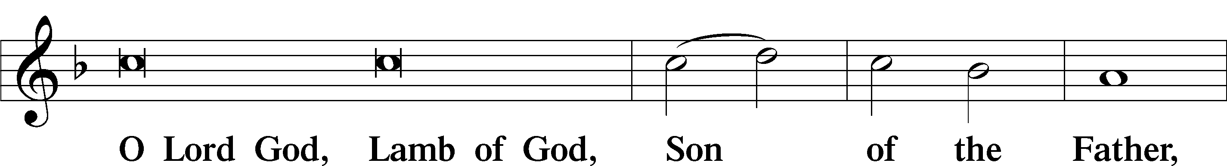
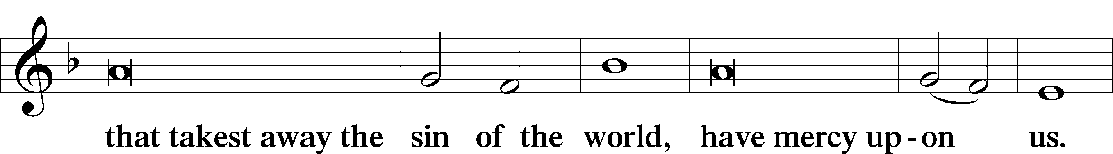
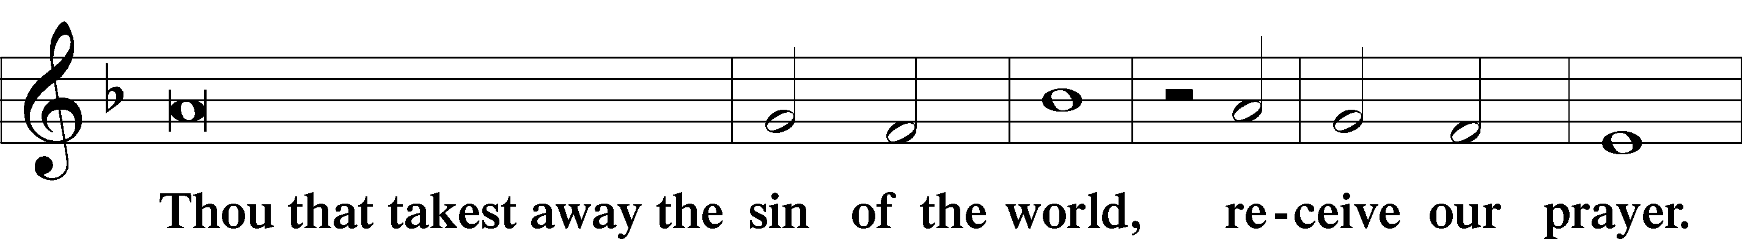
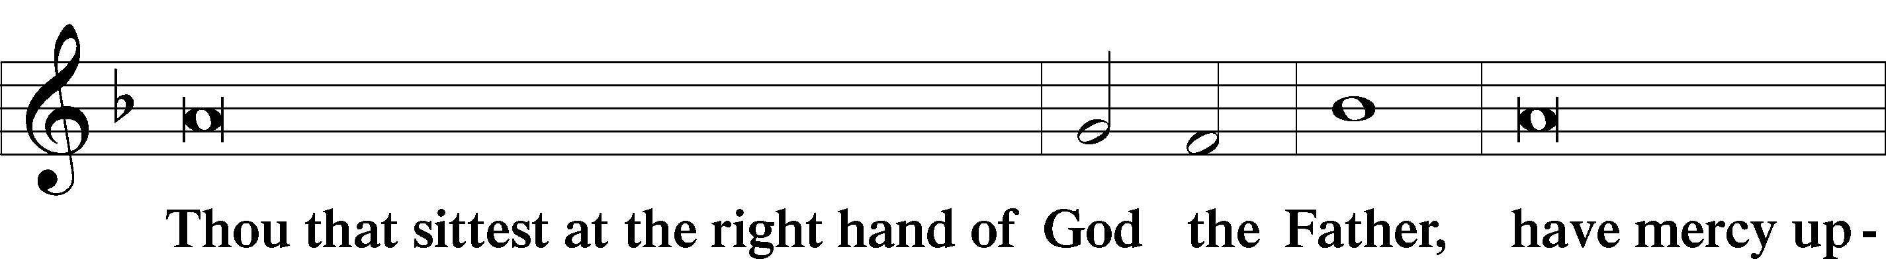
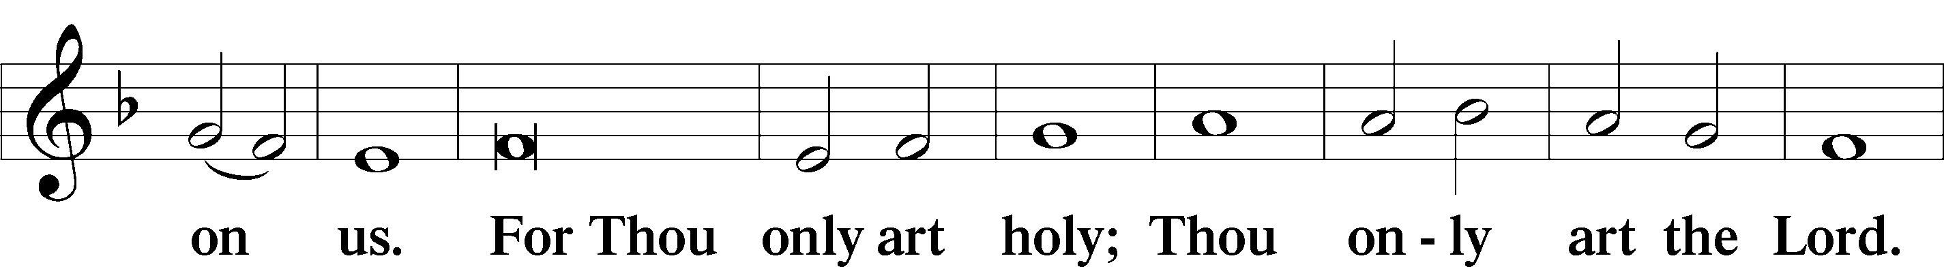
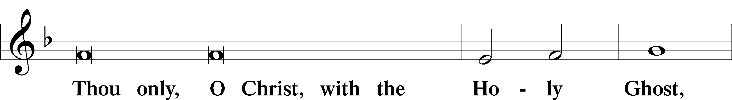
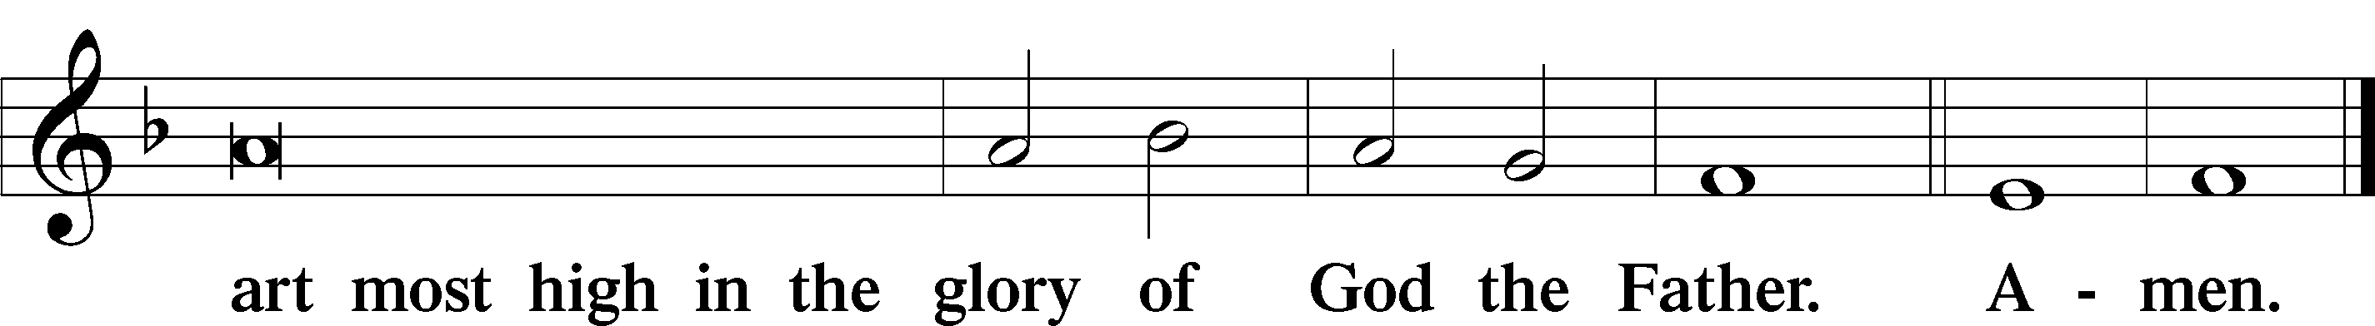

Salutation and Collect of the Day
A The Lord be with you.
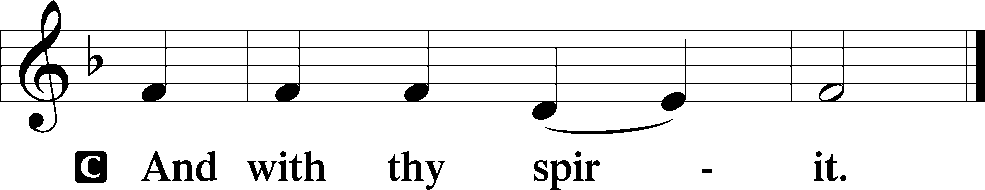

A Let us pray.
Almighty God, You have poured into our hearts the true Light of Your incarnate Word. Grant that this Light may shine forth in our lives; through the same Jesus Christ, Your Son, our Lord, who lives and reigns with You and the Holy Spirit, one God, now and forever.

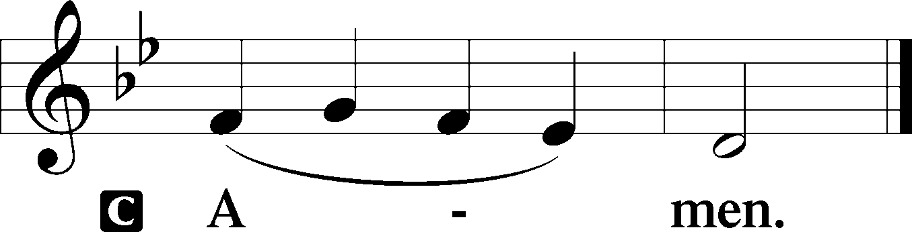

Sit

Old Testament Reading Genesis 46:1–7
1So Israel took his journey with all that he had and came to Beersheba, and offered sacrifices to the God of his father Isaac. 2And God spoke to Israel in visions of the night and said, “Jacob, Jacob.” And he said, “Here am I.” 3Then he said, “I am God, the God of your father. Do not be afraid to go down to Egypt, for there I will make you into a great nation. 4I myself will go down with you to Egypt, and I will also bring you up again, and Joseph’s hand shall close your eyes.”
5Then Jacob set out from Beersheba. The sons of Israel carried Jacob their father, their little ones, and their wives, in the wagons that Pharaoh had sent to carry him. 6They also took their livestock and their goods, which they had gained in the land of Canaan, and came into Egypt, Jacob and all his offspring with him, 7his sons, and his sons’ sons with him, his daughters, and his sons’ daughters. All his offspring he brought with him into Egypt.

A This is the Word of the Lord.
C Thanks be to God.

Gradual Psalm 106:47; Isaiah 63:16b
Save us, O Lord our God, and gather us from among the nations,
that we may give thanks to your holy name and glory in your praise.
You, O Lord, are our Father,
our Redeemer from of old is your name.

Epistle 1 Peter 4:12–19
12Beloved, do not be surprised at the fiery trial when it comes upon you to test you, as though something strange were happening to you. 13But rejoice insofar as you share Christ’s sufferings, that you may also rejoice and be glad when his glory is revealed. 14If you are insulted for the name of Christ, you are blessed, because the Spirit of glory and of God rests upon you. 15But let none of you suffer as a murderer or a thief or an evildoer or as a meddler. 16Yet if anyone suffers as a Christian, let him not be ashamed, but let him glorify God in that name. 17For it is time for judgment to begin at the household of God; and if it begins with us, what will be the outcome for those who do not obey the gospel of God? 18And
“If the righteous is scarcely saved,
what will become of the ungodly and the sinner?”
19Therefore let those who suffer according to God’s will entrust their souls to a faithful Creator while doing good.

A This is the Word of the Lord.
C Thanks be to God.

Stand

Alleluia
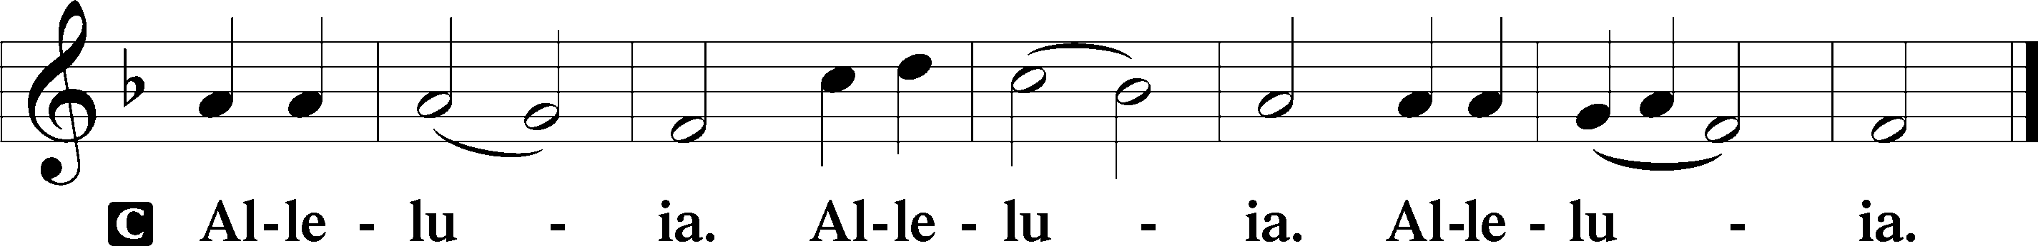

Holy Gospel Matthew 2:13–23
P The Holy Gospel according to St. Matthew, the second chapter.

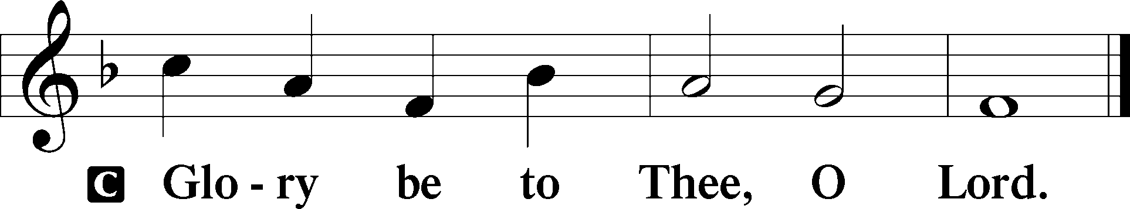

13When [the wise men] had departed, behold, an angel of the Lord appeared to Joseph in a dream and said, “Rise, take the child and his mother, and flee to Egypt, and remain there until I tell you, for Herod is about to search for the child, to destroy him.” 14And he rose and took the child and his mother by night and departed to Egypt 15and remained there until the death of Herod. This was to fulfill what the Lord had spoken by the prophet, “Out of Egypt I called my son.”
16Then Herod, when he saw that he had been tricked by the wise men, became furious, and he sent and killed all the male children in Bethlehem and in all that region who were two years old or under, according to the time that he had ascertained from the wise men. 17Then was fulfilled what was spoken by the prophet Jeremiah:
18“A voice was heard in Ramah,
weeping and loud lamentation,
Rachel weeping for her children;
she refused to be comforted, because they are no more.”
19But when Herod died, behold, an angel of the Lord appeared in a dream to Joseph in Egypt, 20saying, “Rise, take the child and his mother and go to the land of Israel, for those who sought the child’s life are dead.” 21And he rose and took the child and his mother and went to the land of Israel. 22But when he heard that Archelaus was reigning over Judea in place of his father Herod, he was afraid to go there, and being warned in a dream he withdrew to the district of Galilee. 23And he went and lived in a city called Nazareth, that what was spoken by the prophets might be fulfilled: “He shall be called a Nazarene.”

P This is the Gospel of the Lord.

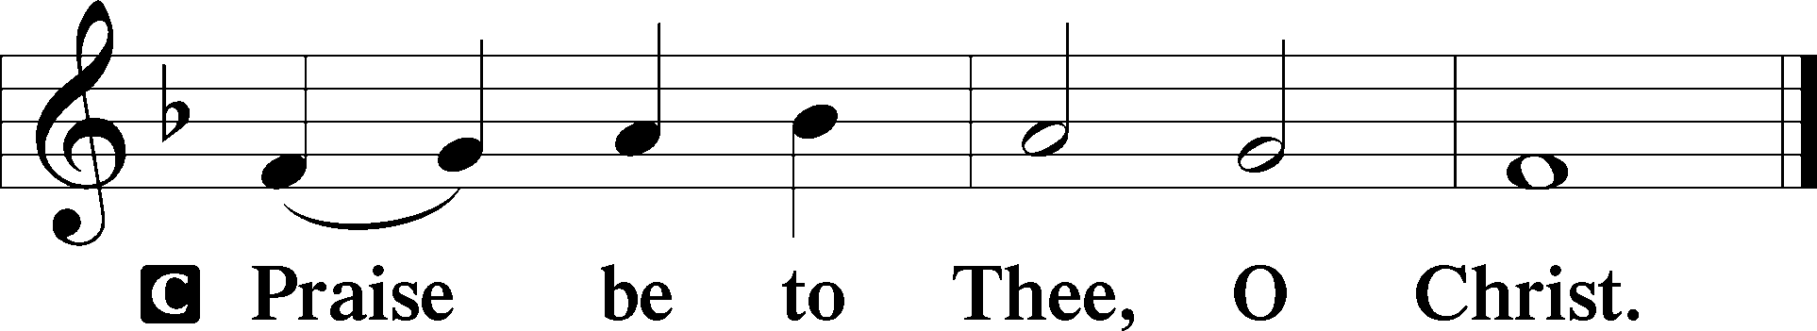

Nicene Creed
C I believe in one God,
the Father Almighty,
maker of heaven and earth
and of all things visible and invisible.
And in one Lord Jesus Christ,
the only-begotten Son of God,
begotten of His Father before all worlds,
God of God, Light of Light,
very God of very God,
begotten, not made,
being of one substance with the Father,
by whom all things were made;
who for us men and for our salvation came down from heaven
and was incarnate by the Holy Spirit of the virgin Mary
and was made man;
and was crucified also for us under Pontius Pilate.
He suffered and was buried.
And the third day He rose again according to the Scriptures
and ascended into heaven
and sits at the right hand of the Father.
And He will come again with glory to judge both the living and the dead,
whose kingdom will have no end.
And I believe in the Holy Spirit,
the Lord and giver of life,
who proceeds from the Father and the Son,
who with the Father and the Son together is worshiped and glorified,
who spoke by the prophets.
And I believe in one holy Christian and apostolic Church,
I acknowledge one Baptism for the remission of sins,
and I look for the resurrection of the dead
and the life T of the world to come. Amen.

Sit

Children's Sermon

716 I Walk in Danger All the Way
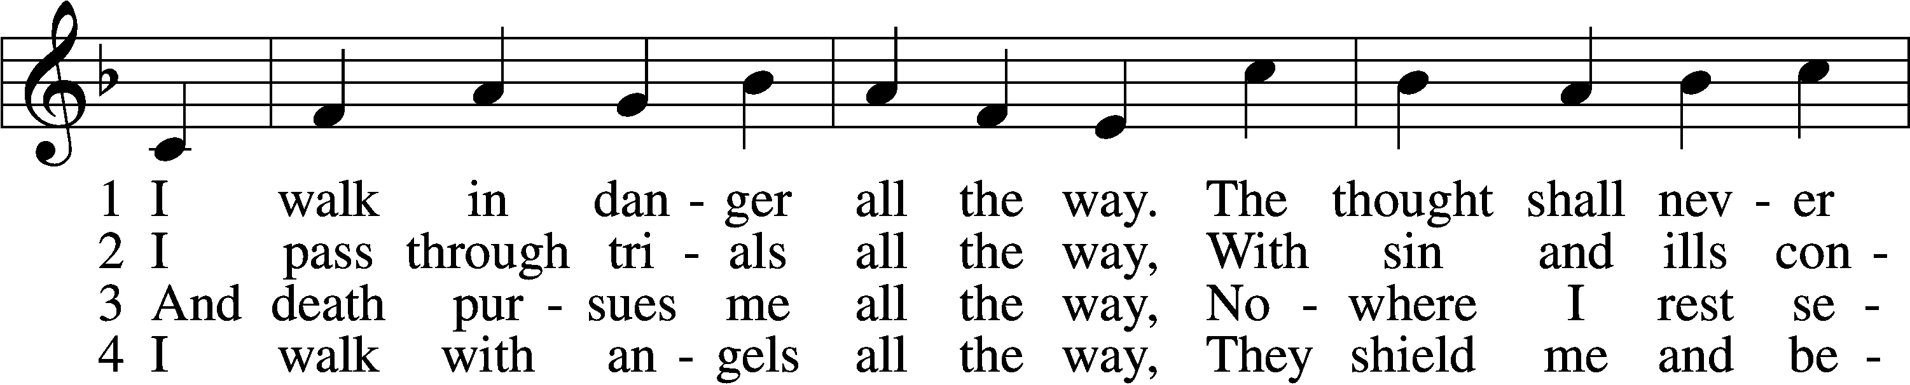
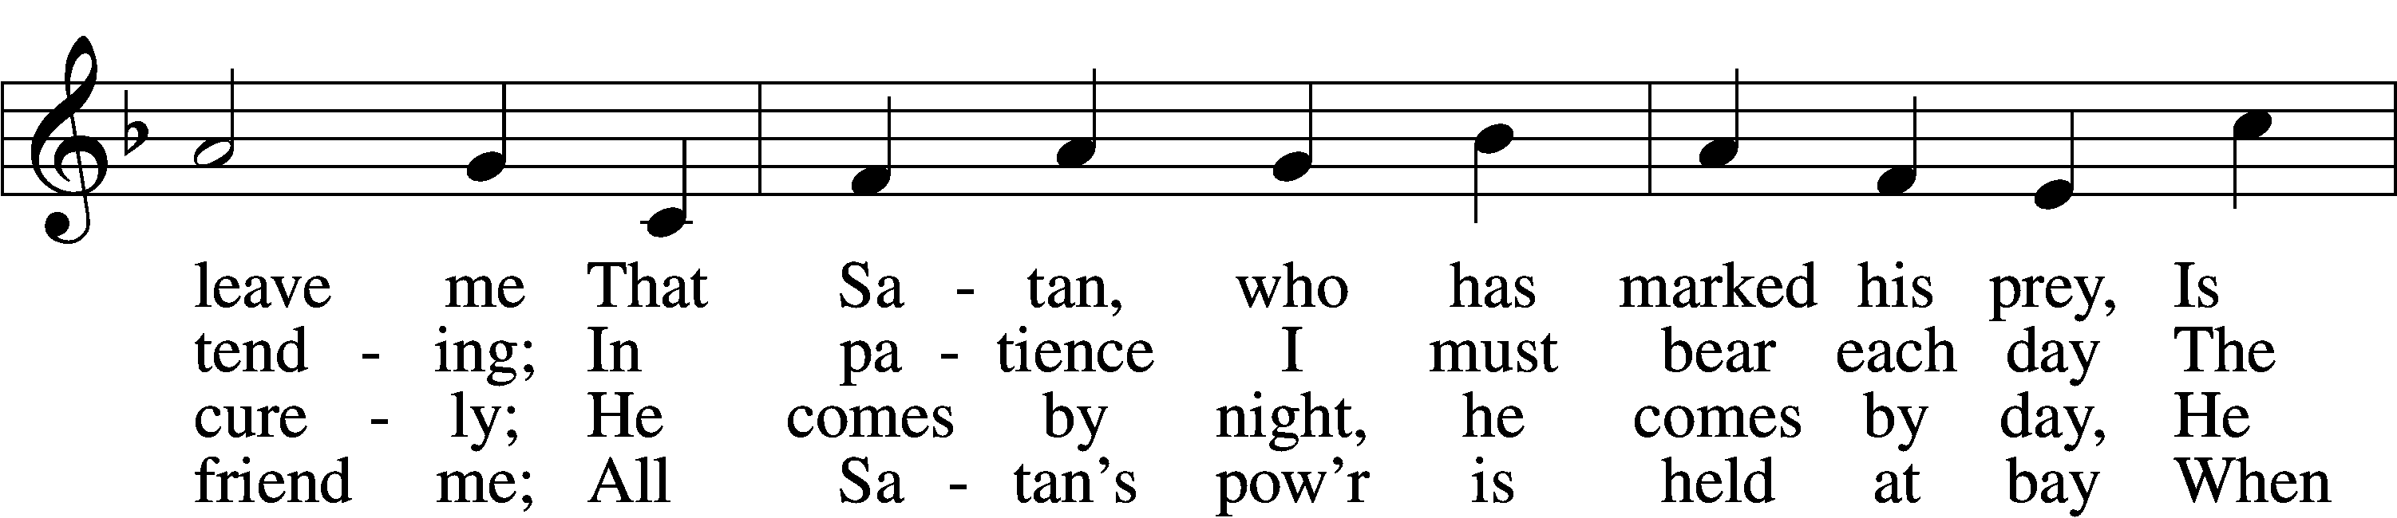
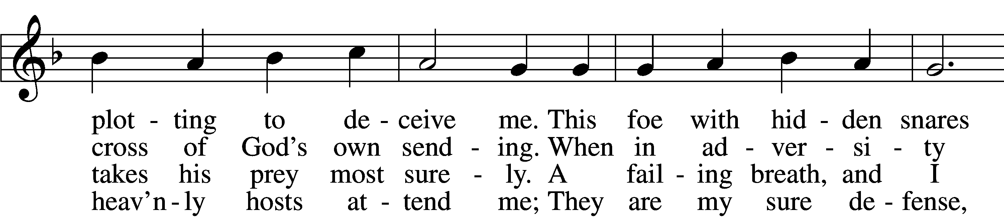
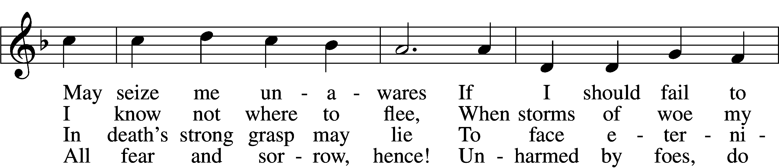
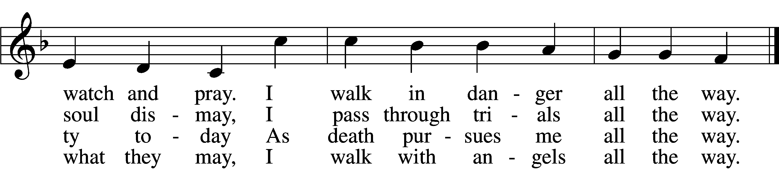

5 I walk with Jesus all the way,
His guidance never fails me;
Within His wounds I find a stay
When Satan’s pow’r assails me;
And by His footsteps led,
My path I safely tread.
No evil leads my soul astray;
I walk with Jesus all the way.

6 My walk is heav’nward all the way;
Await, my soul, the morrow,
When God’s good healing shall allay
All suff’ring, sin, and sorrow.
Then, worldly pomp, begone!
To heav’n I now press on.
For all the world I would not stay;
My walk is heav’nward all the way.
Text: Hans Adolf Brorson, 1694–1764; tr. Ditlef G. Ristad, 1863–1938, alt.
Tune: Geist-reiches Gesang-Buch, 1708, 4th ed., Halle, ed. Johann A. Freylinghausen
Text and tune: Public domain

Sermon

Votum
P The peace of God, which passes all understanding, keep your hearts and minds in Christ Jesus.
C Amen.

Stand

Offertory Psalm 51:10–12
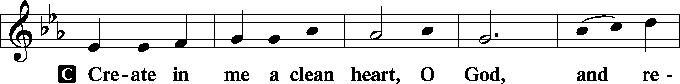
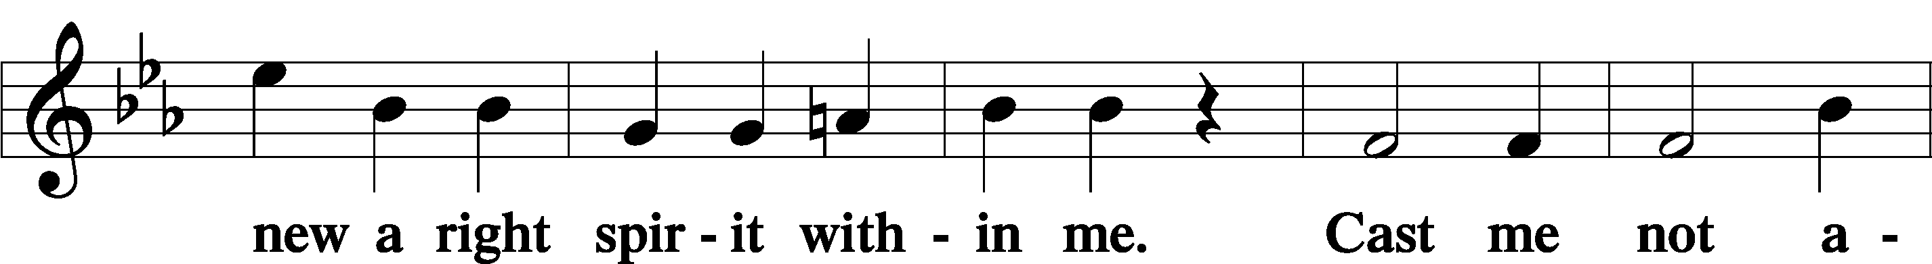
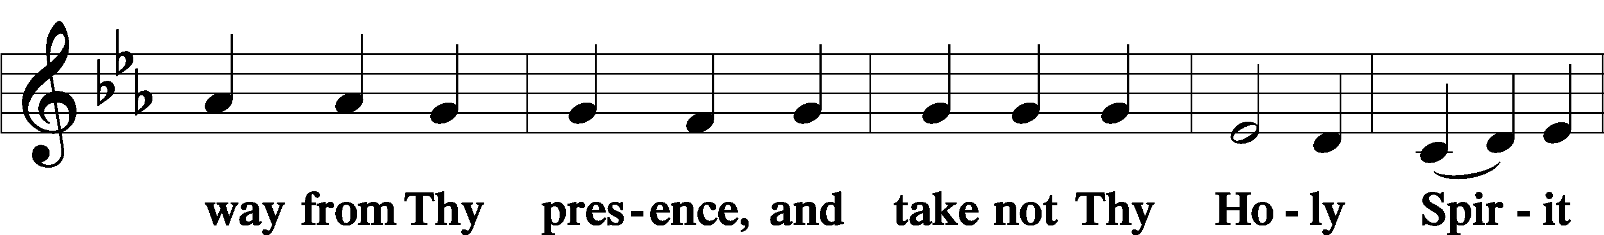
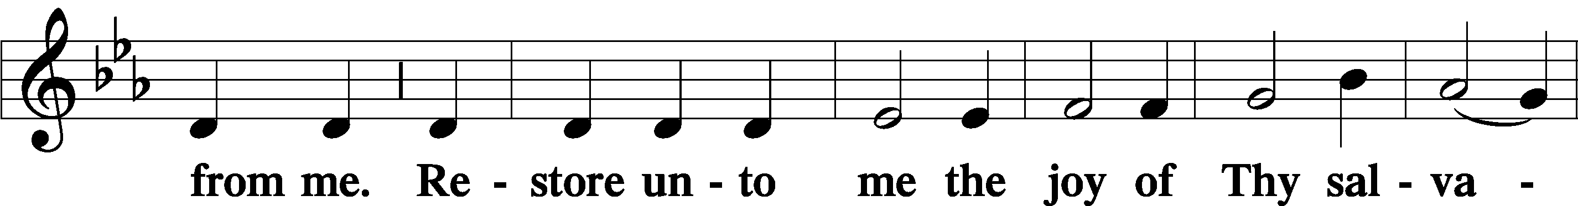
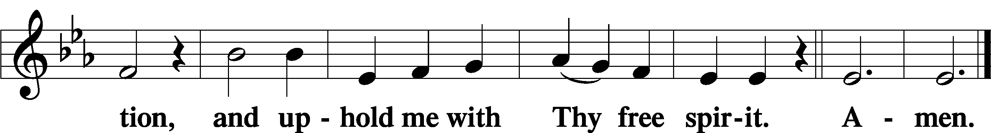

Sit

805 Praise God, from Whom All Blessings Flow
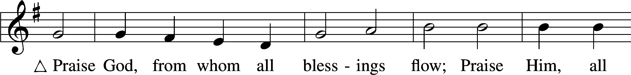
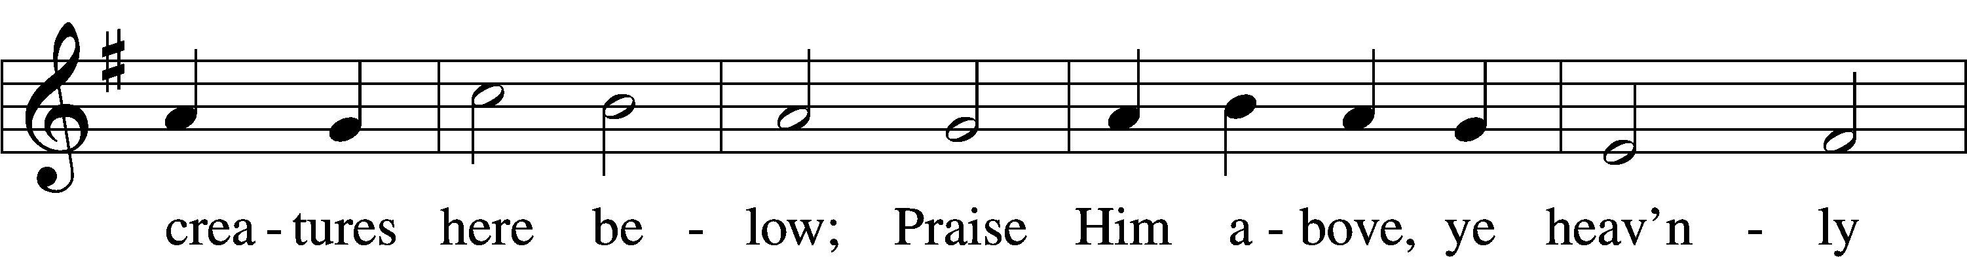
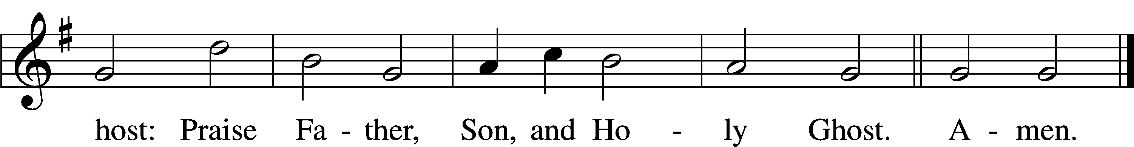
Text: Thomas Ken, 1637–1711
Tune: Trente quatre Pseaumes de David, 1551, Geneva, ed. Louis Bourgeois
Text and tune: Public domain

Offering

Stand

Prayer of the Church

Service of the Sacrament

Preface 2 Timothy 4:22; [Colossians 3:1]; [Psalm 136]
P The Lord be with you.
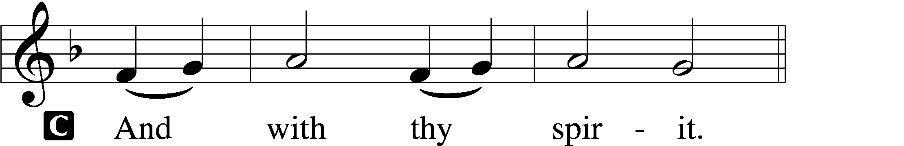

P Lift up your hearts.
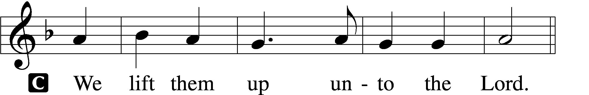

P Let us give thanks unto the Lord, our God.
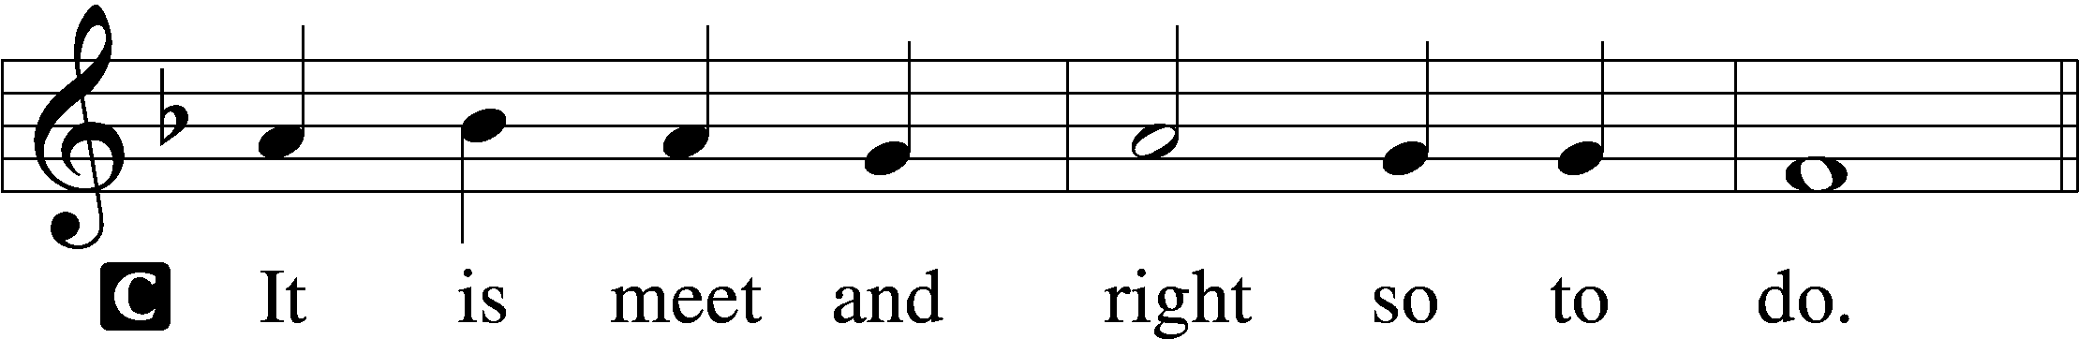

Proper Preface (Full)
P It is truly meet, right, and salutary that we should at all times and in all places give thanks to You, holy Lord, almighty Father, everlasting God, through Jesus Christ, our Lord; for in the mystery of the Word made flesh You have given us a new revelation of Your glory that, seeing You in the person of Your Son, we may know and love those things which are not seen. Therefore with angels and archangels and with all the company of heaven we laud and magnify Your glorious name, evermore praising You and saying:

Sanctus Isaiah 6:3; Matthew 21:9
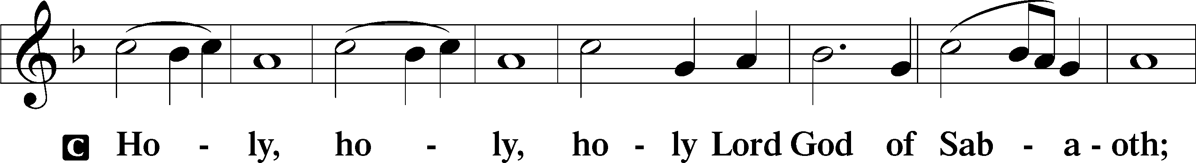
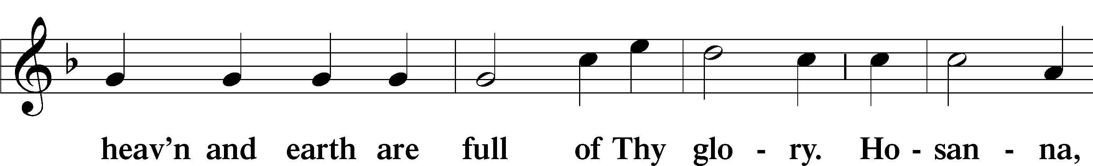
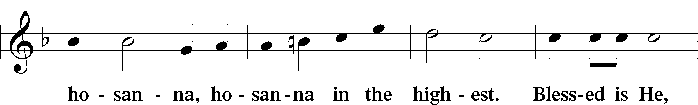
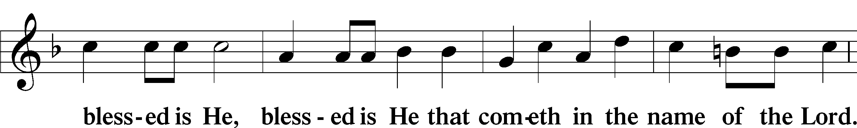
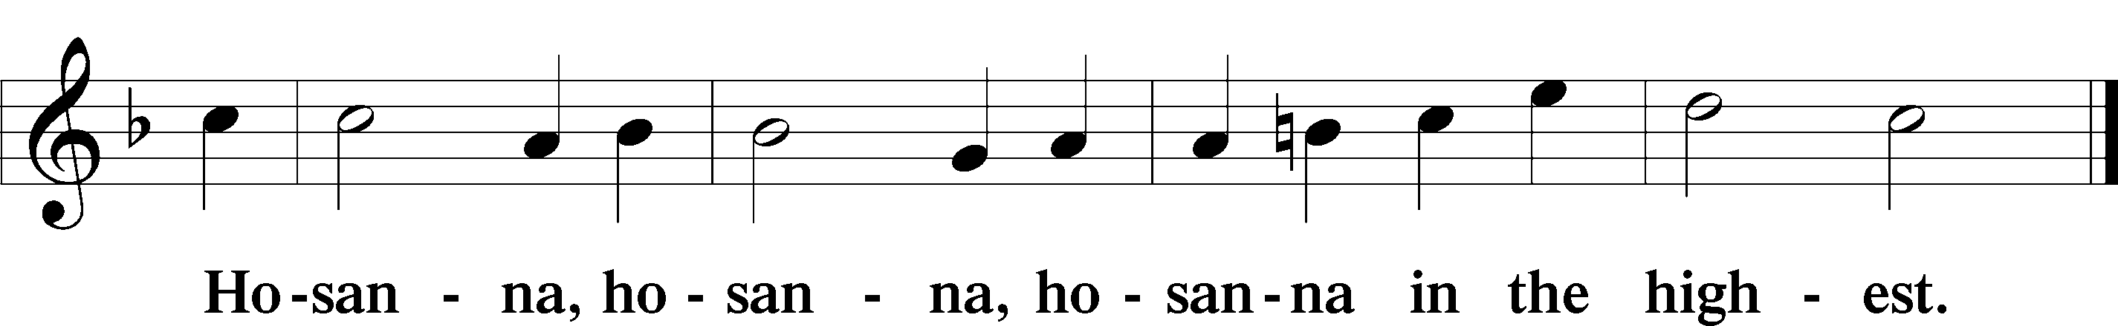

Lord’s Prayer Matthew 6:9–13
P Our Father who art in heaven,
hallowed be Thy name,
Thy kingdom come,
Thy will be done on earth as it is in heaven;
give us this day our daily bread;
and forgive us our trespasses as we forgive those who trespass against us;
and lead us not into temptation,
but deliver us from evil.
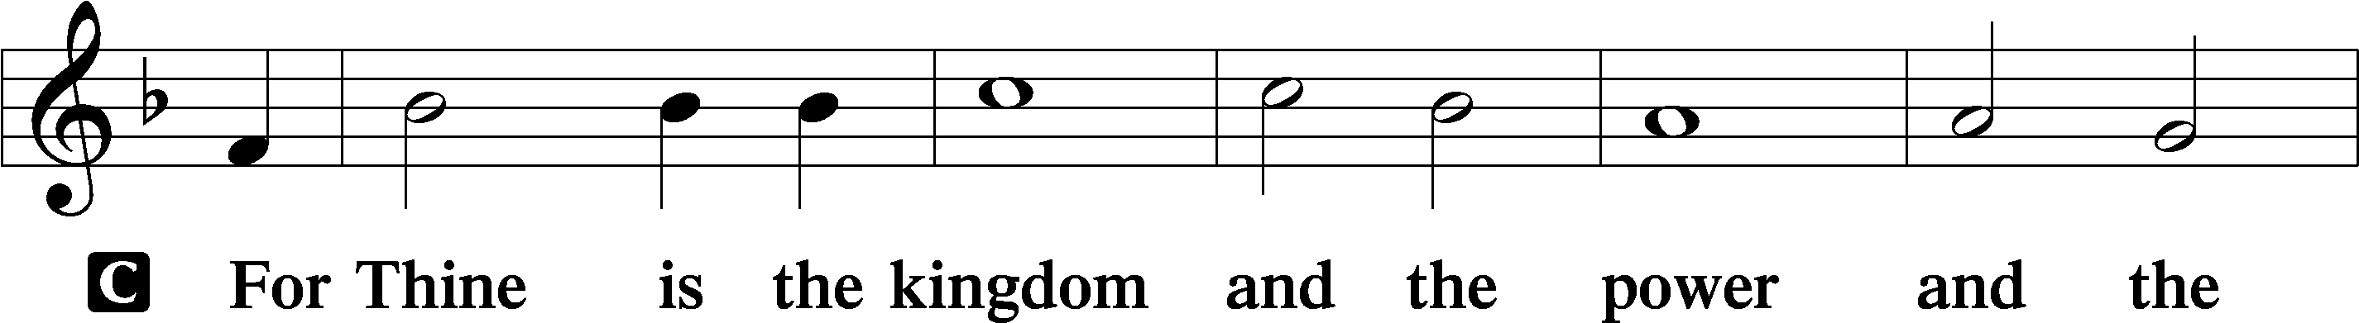
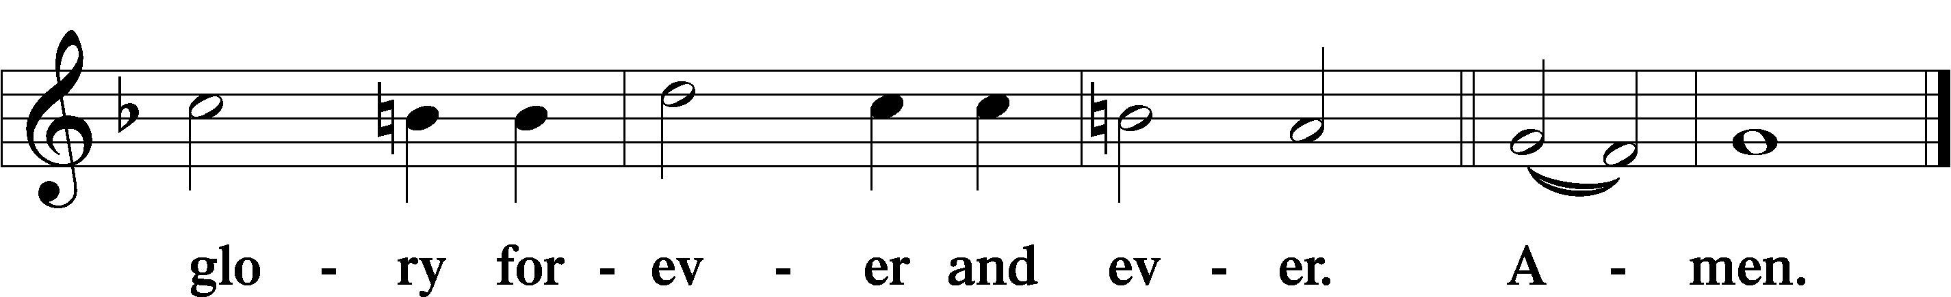

The Words of Our Lord Matthew 26:26–28; Mark 14:22–24; Luke 22:19–20; 1 Corinthians 11:23–25
P Our Lord Jesus Christ, on the night when He was betrayed, took bread, and when He had given thanks, He broke it and gave it to the disciples and said: “Take, eat; this is My T body, which is given for you. This do in remembrance of Me.”

In the same way also He took the cup after supper, and when He had given thanks, He gave it to them, saying: “Drink of it, all of you; this cup is the new testament in My T blood, which is shed for you for the forgiveness of sins. This do, as often as you drink it, in remembrance of Me.”

Pax Domini John 20:19
P The peace of the Lord be with you always.

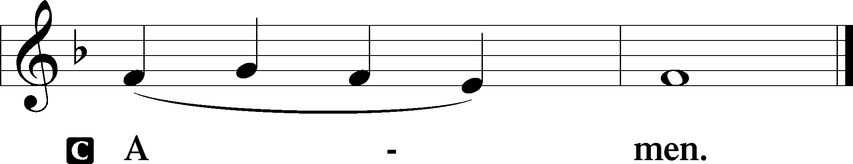

Agnus Dei John 1:29
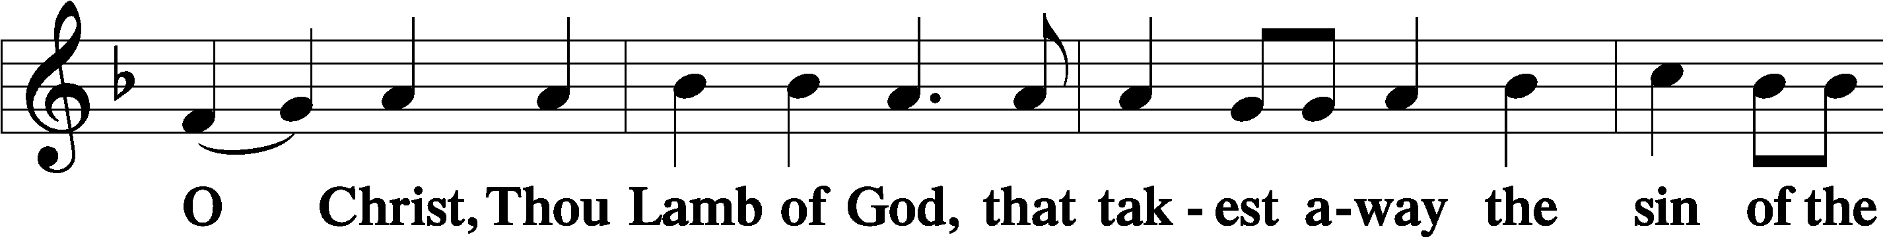
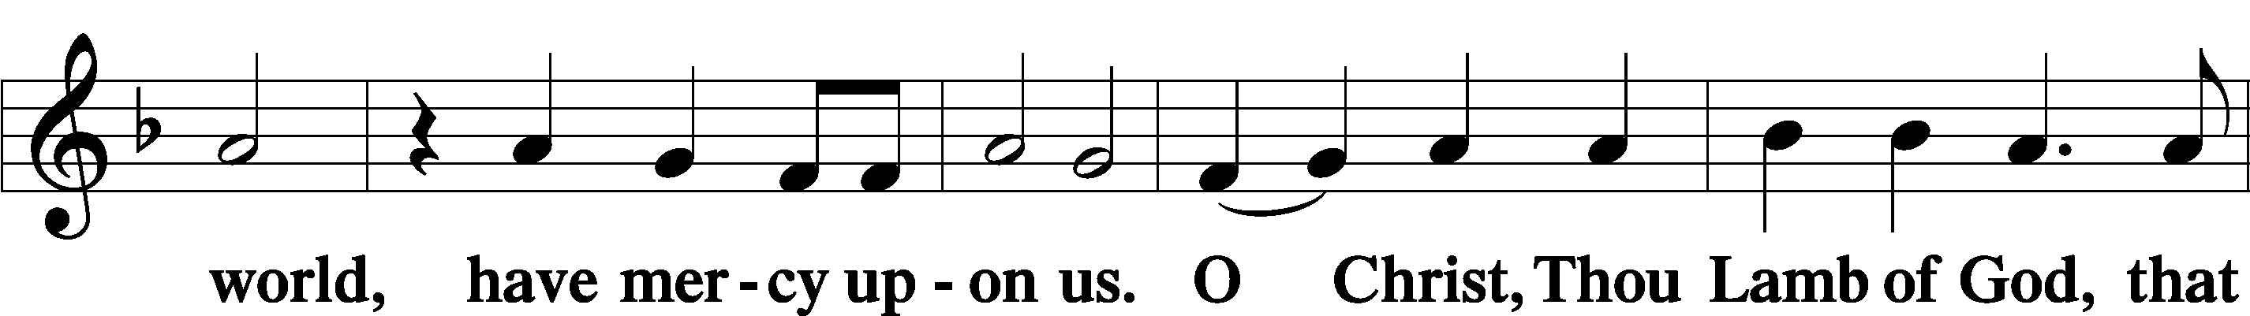
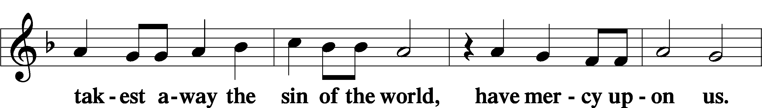
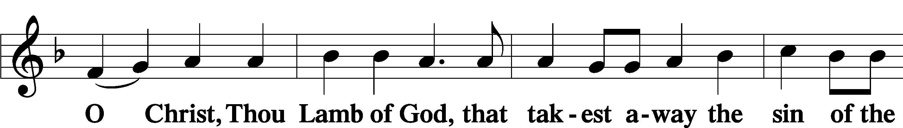
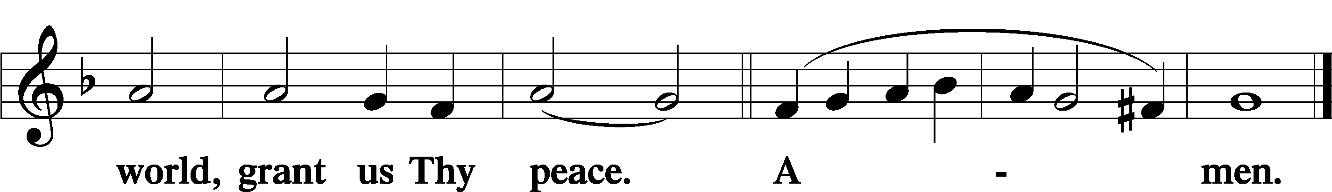

Sit

Distribution

The pastor and those who assist him receive the body and blood of Christ first and then distribute them to those who come to receive, saying:

Take, eat; this is the true body of our Lord and Savior Jesus Christ, given into death for your sins.
Amen.

Take, drink; this is the true blood of our Lord and Savior Jesus Christ, shed for the forgiveness of your sins.
Amen.

In dismissing the communicants, the following is said:

The Dismissal
P The body and blood of our Lord Jesus Christ strengthen and preserve you in body and soul to life everlasting. Depart T in peace.
C Amen.

This Is the Feast Revelation 5:12–13; 19:5–9
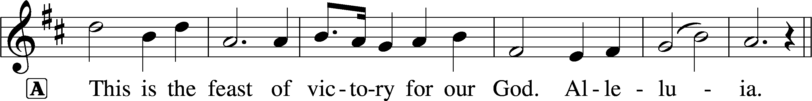
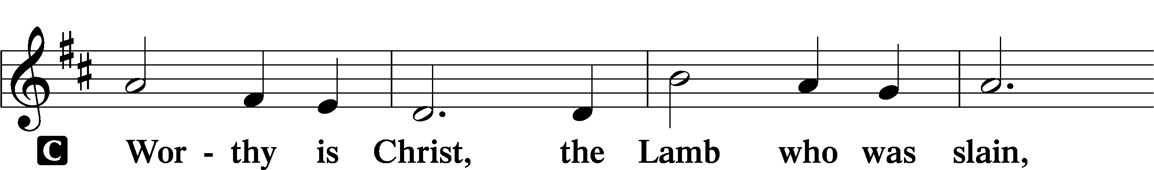
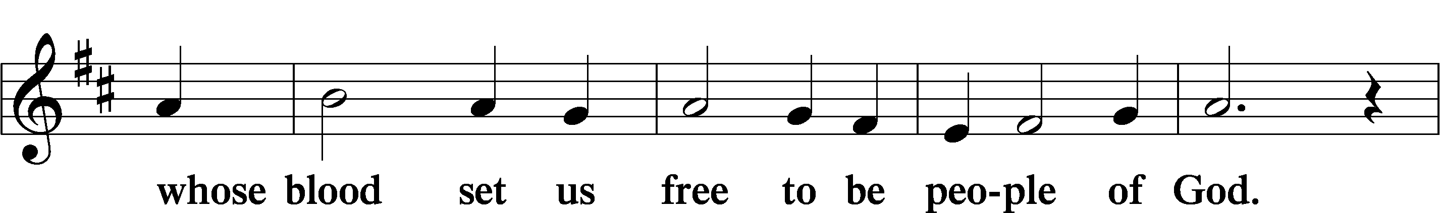
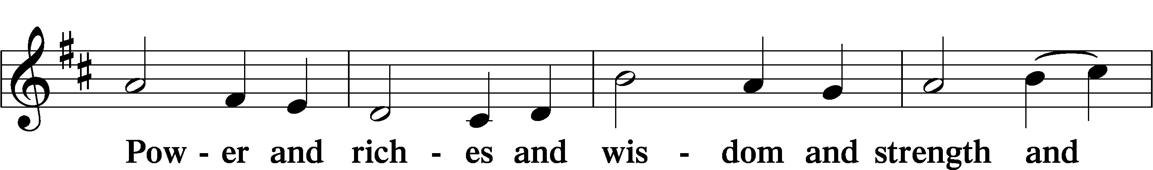
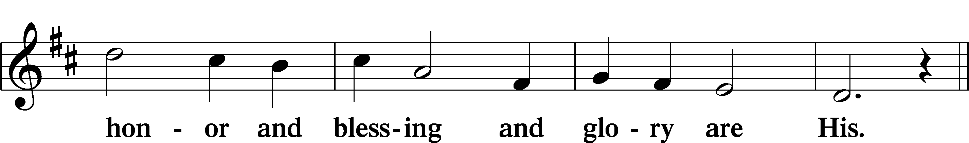
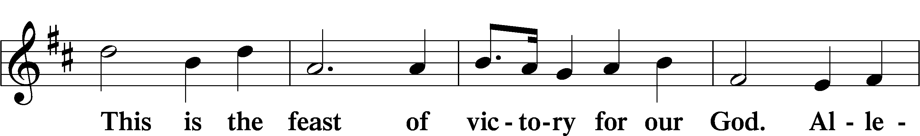
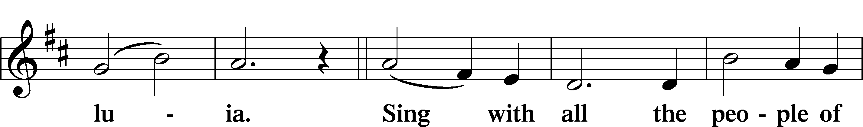
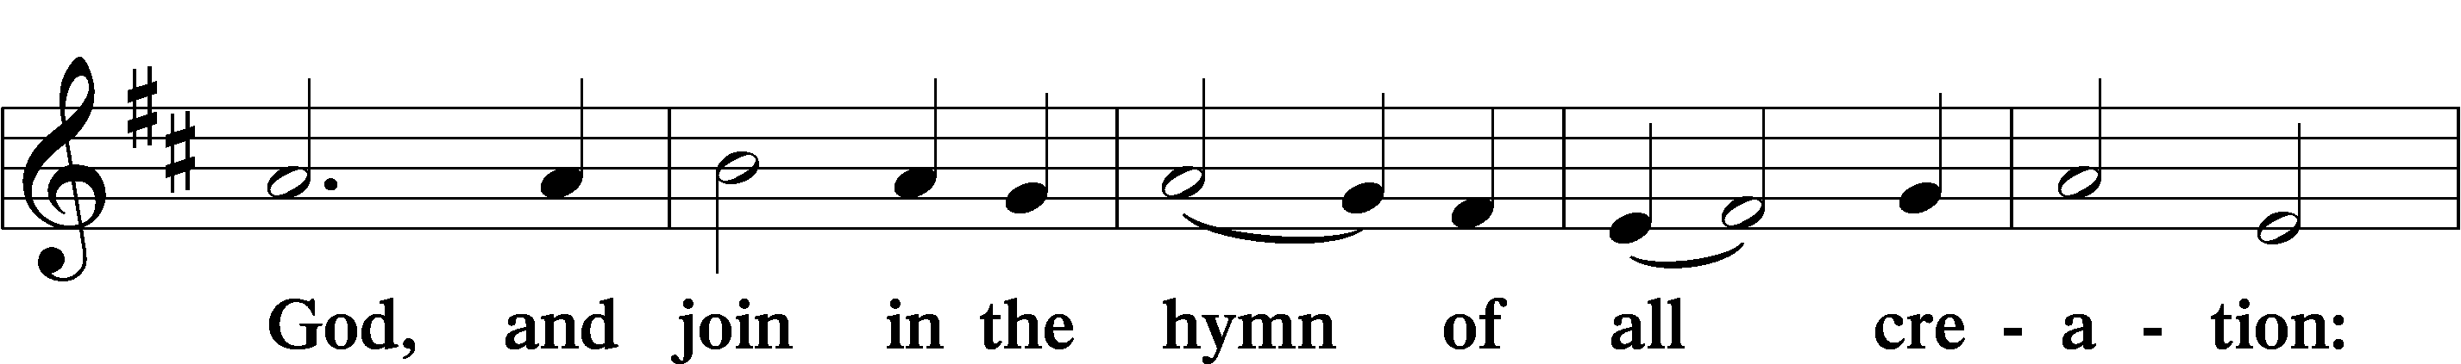
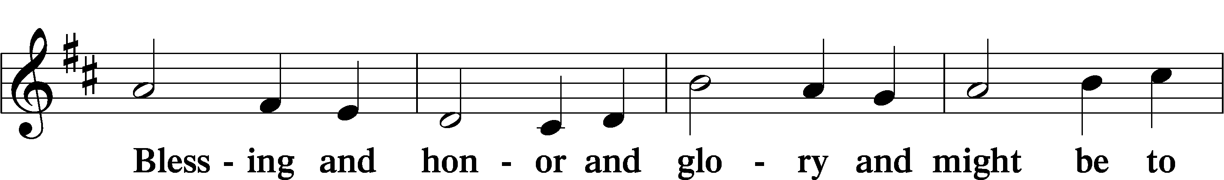
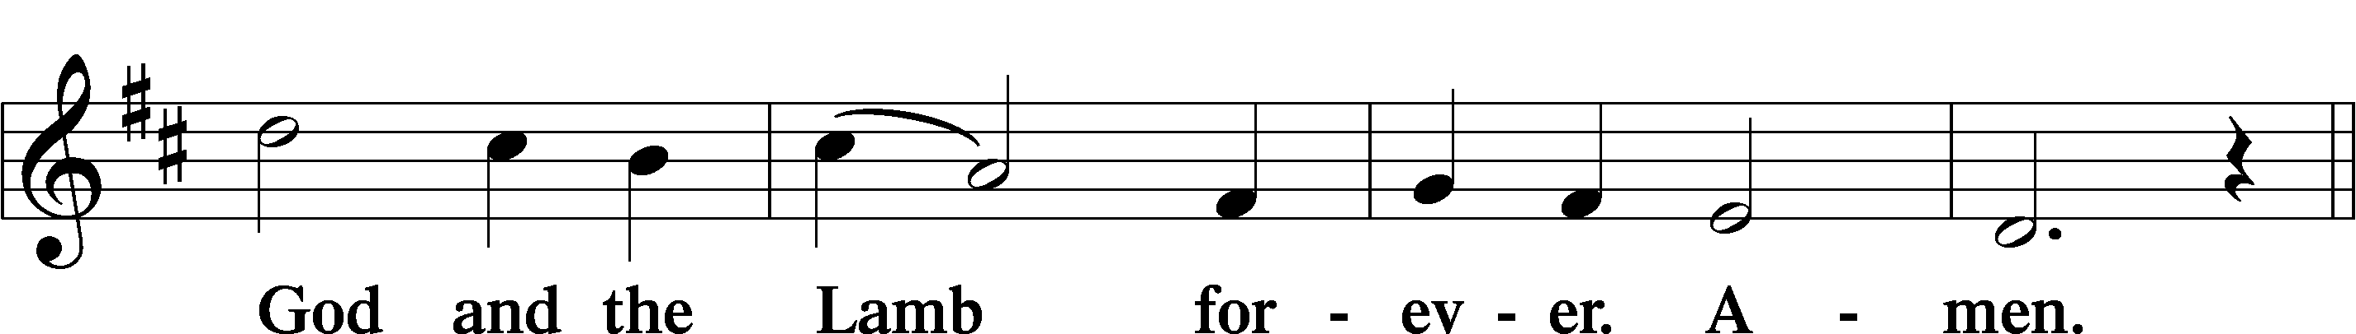
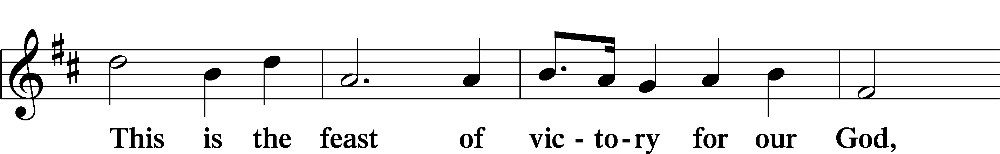
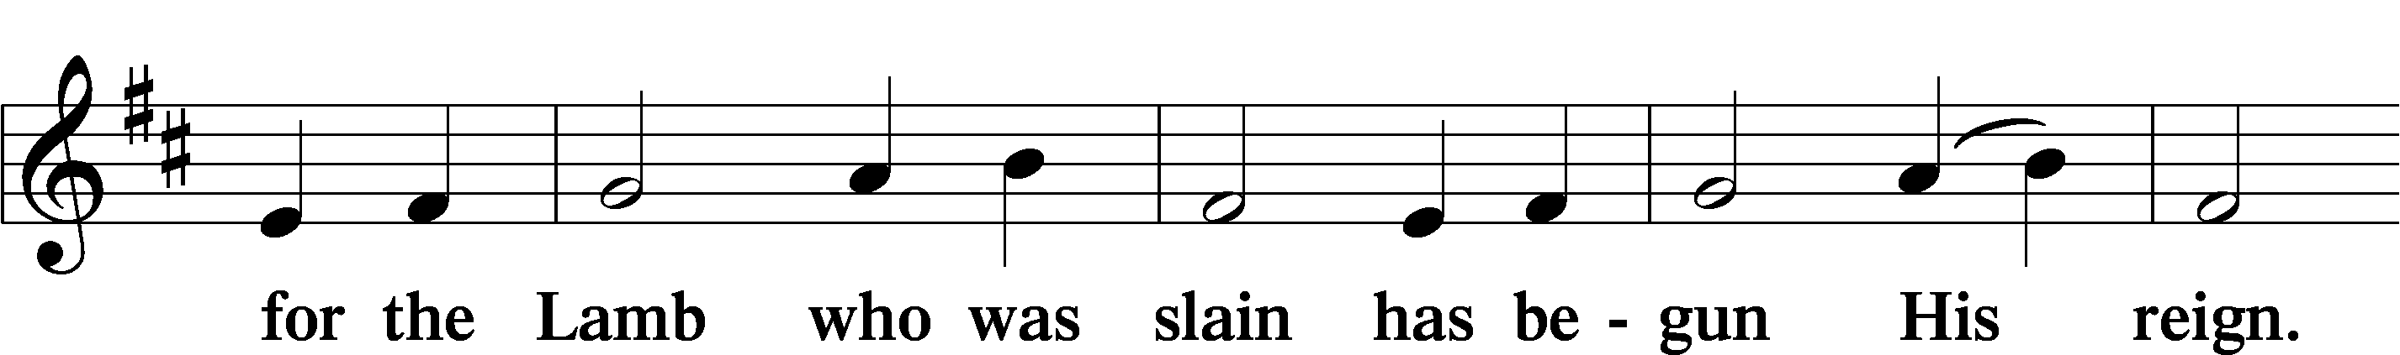
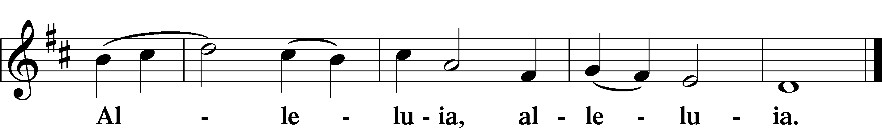
722 Lord, Take My Hand and Lead Me
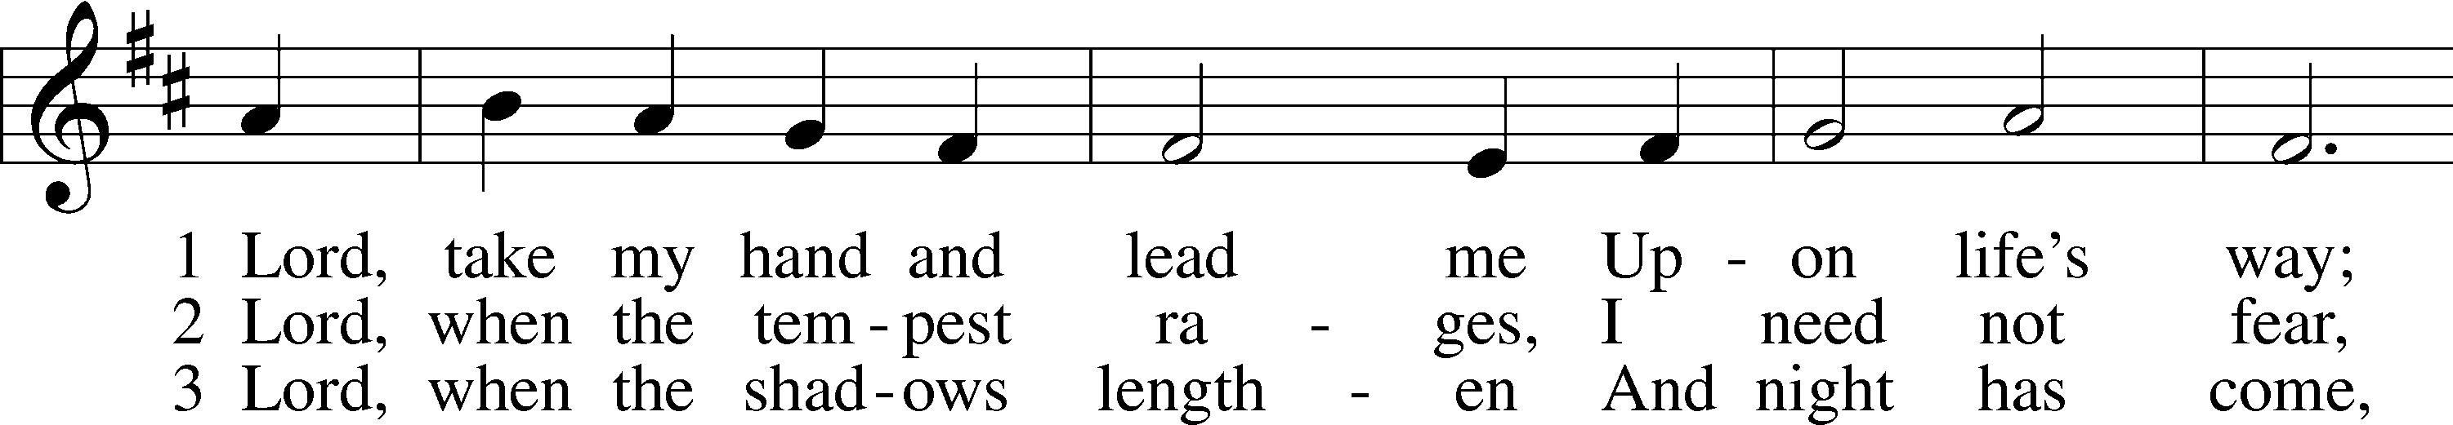
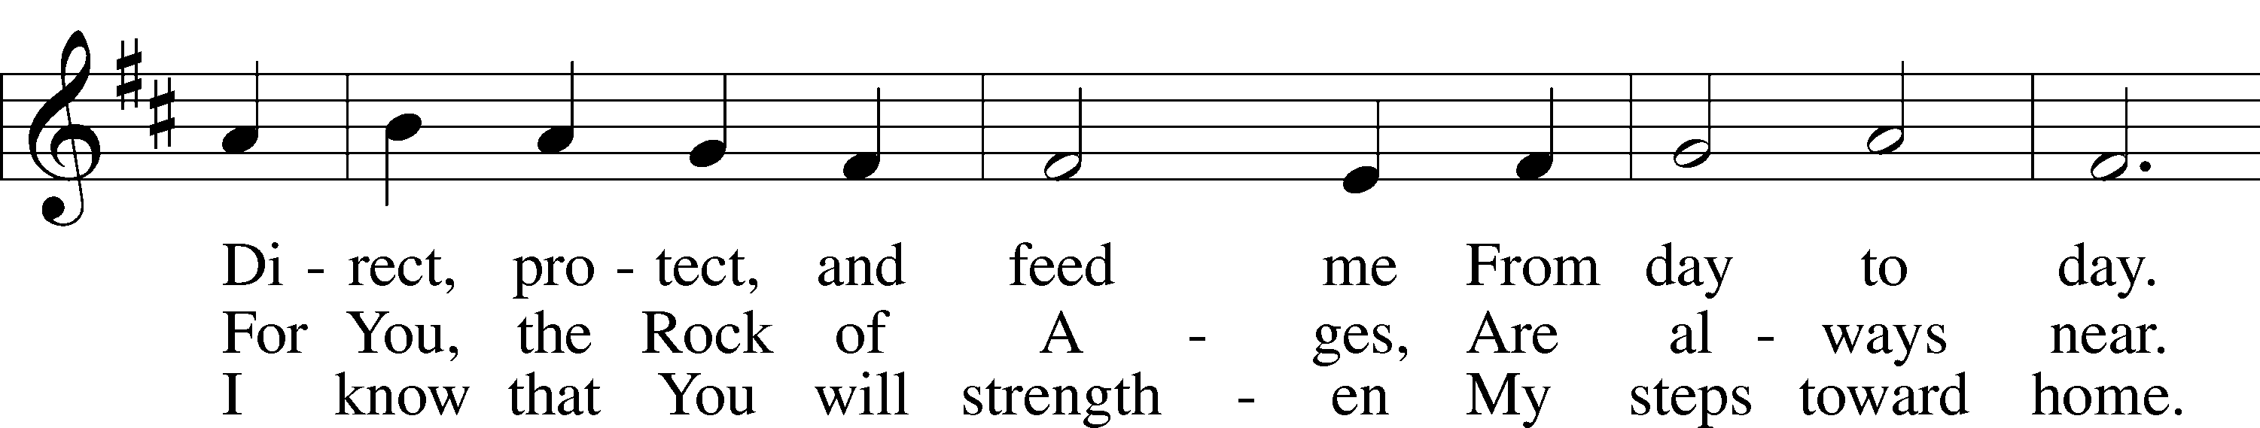
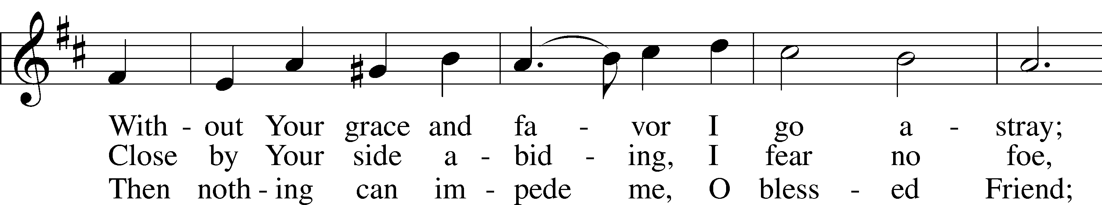
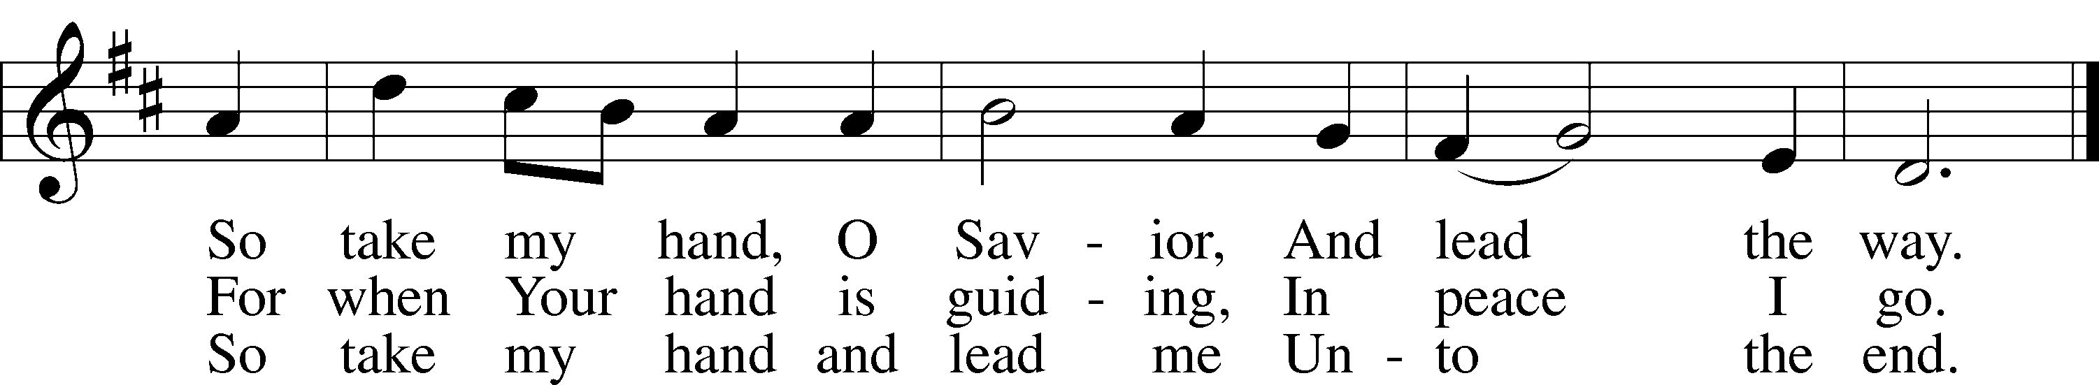
Text: Julie von Hausmann, 1825–1901; tr. Lutheran Book of Worship, 1978, alt.
Tune: P. Friedrich Silcher, 1789–1860
Text: © 1978 Lutheran Book of Worship. Used by permission: LSB Hymn License no. 110005011
Tune: Public domain

623 Lord Jesus Christ, We Humbly Pray
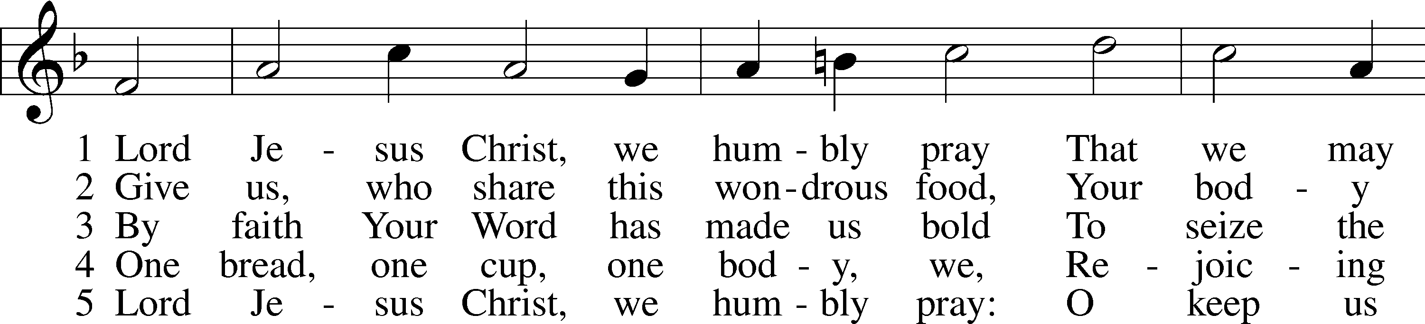
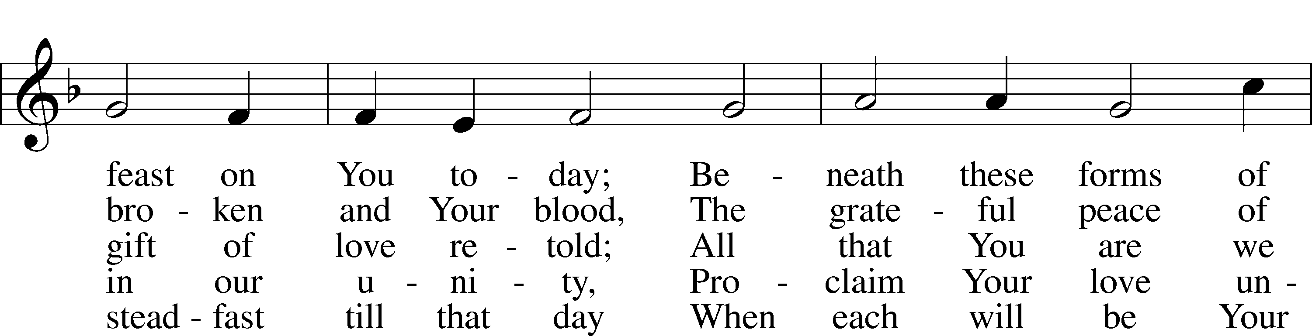
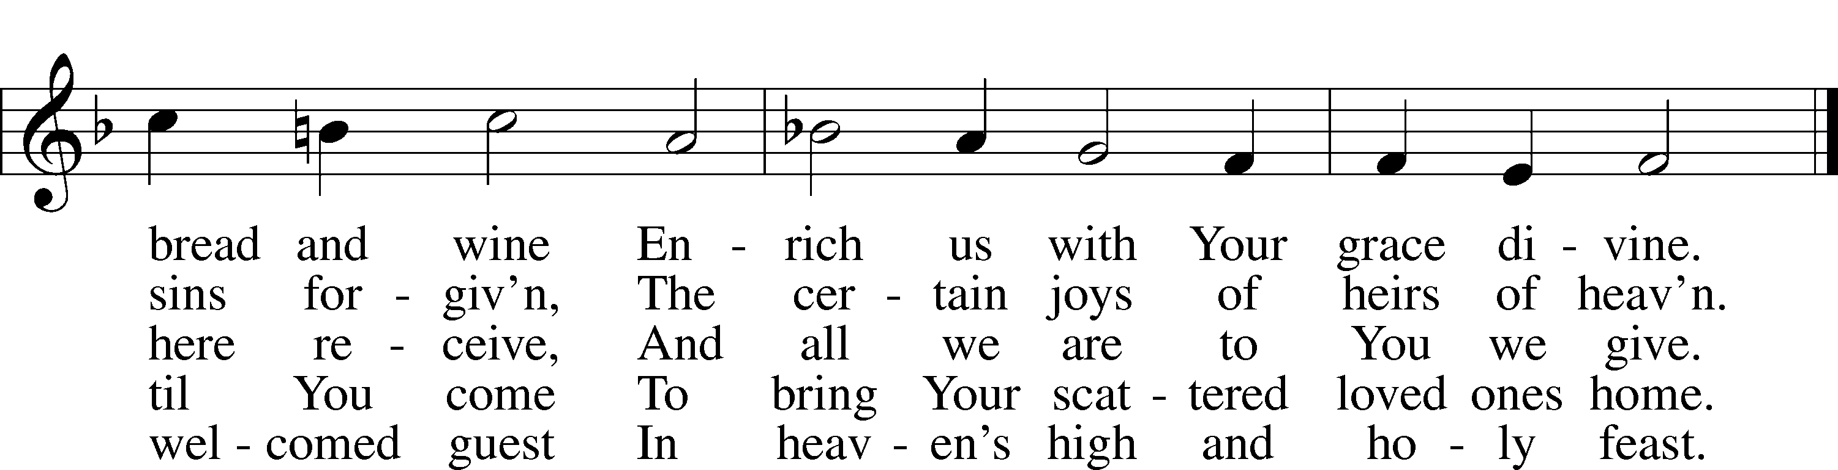
Text: Henry E. Jacobs, 1844–1932, alt.
Tune: Cantionale Germanicum, 1628, Gochsheim
Text and tune: Public domain

617 O Lord, We Praise Thee
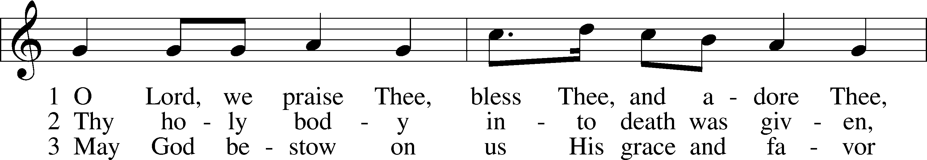
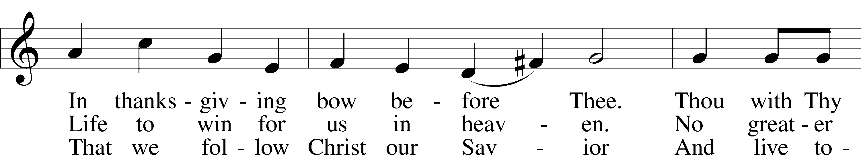
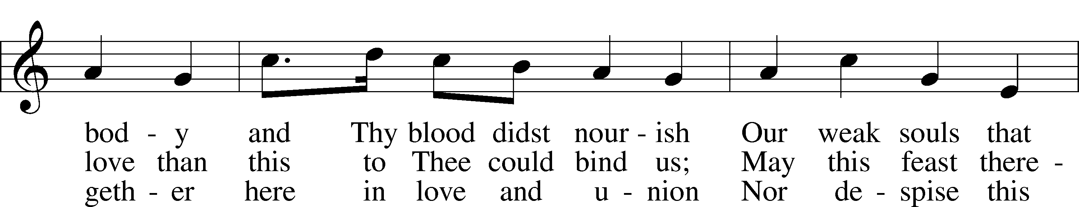
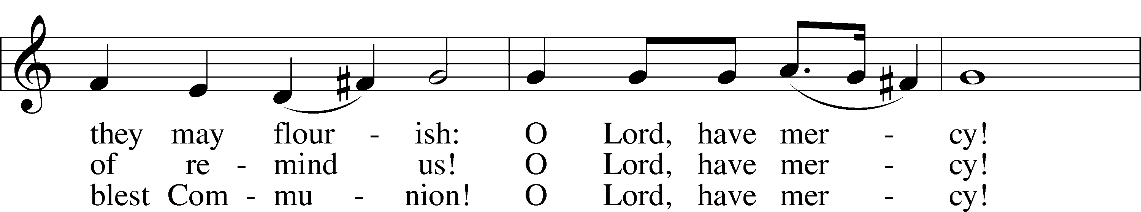
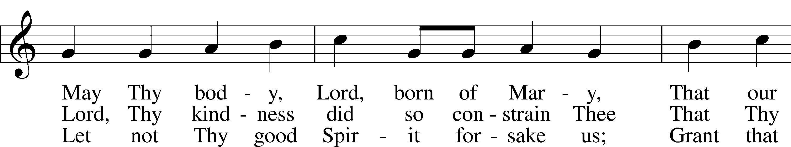
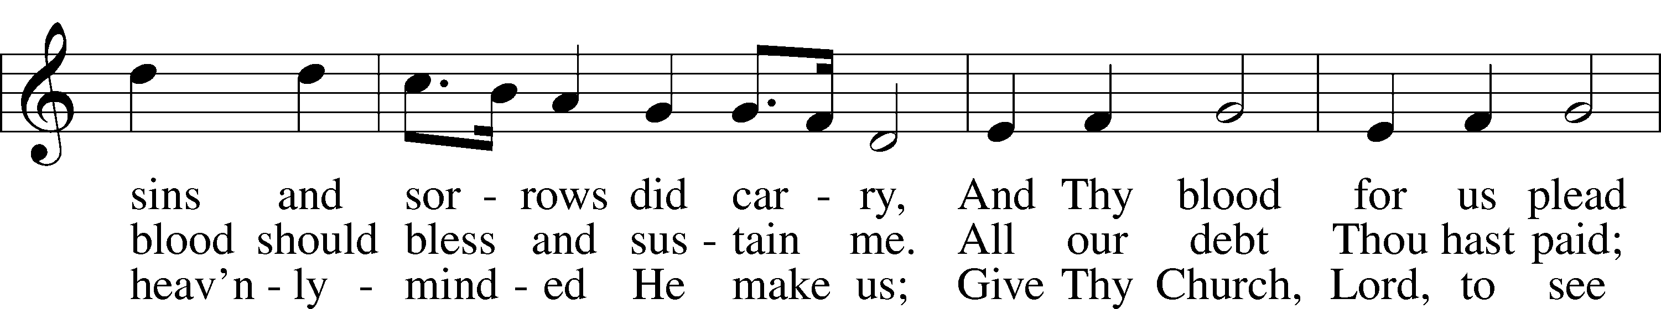
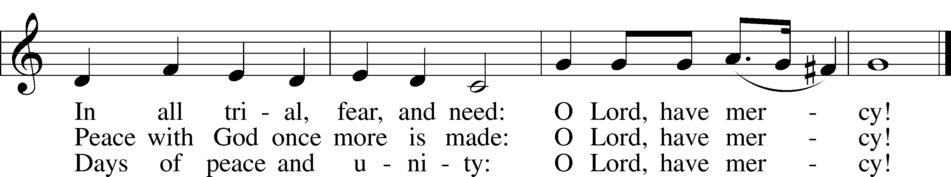
Text: tr. The Lutheran Hymnal, 1941, alt.; (st. 1): German, 14th cent.; (sts. 2–3): Martin Luther, 1483–1546
Tune: Geystliche gesangk Buchleyn, 1524, Wittenberg, ed. Johann Walter
Text: © 1941 Concordia Publishing House. Used by permission: LSB Hymn License no. 110005011
Tune: Public domain

Stand

Nunc Dimittis Luke 2:29–32
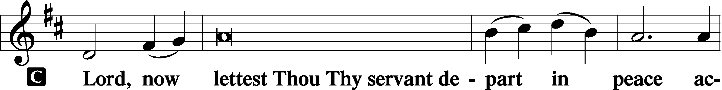

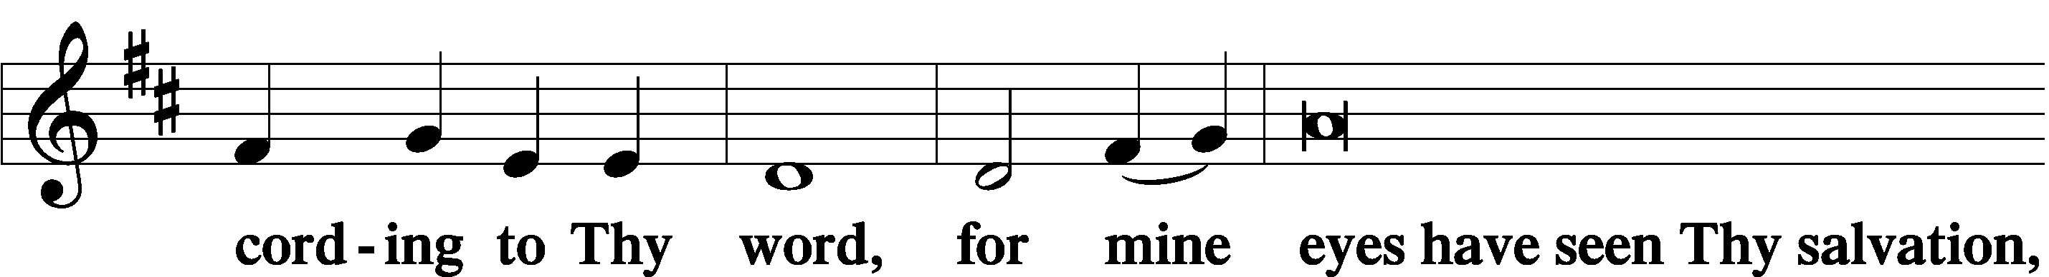

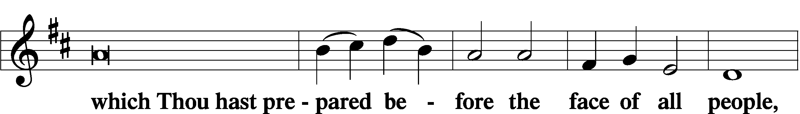

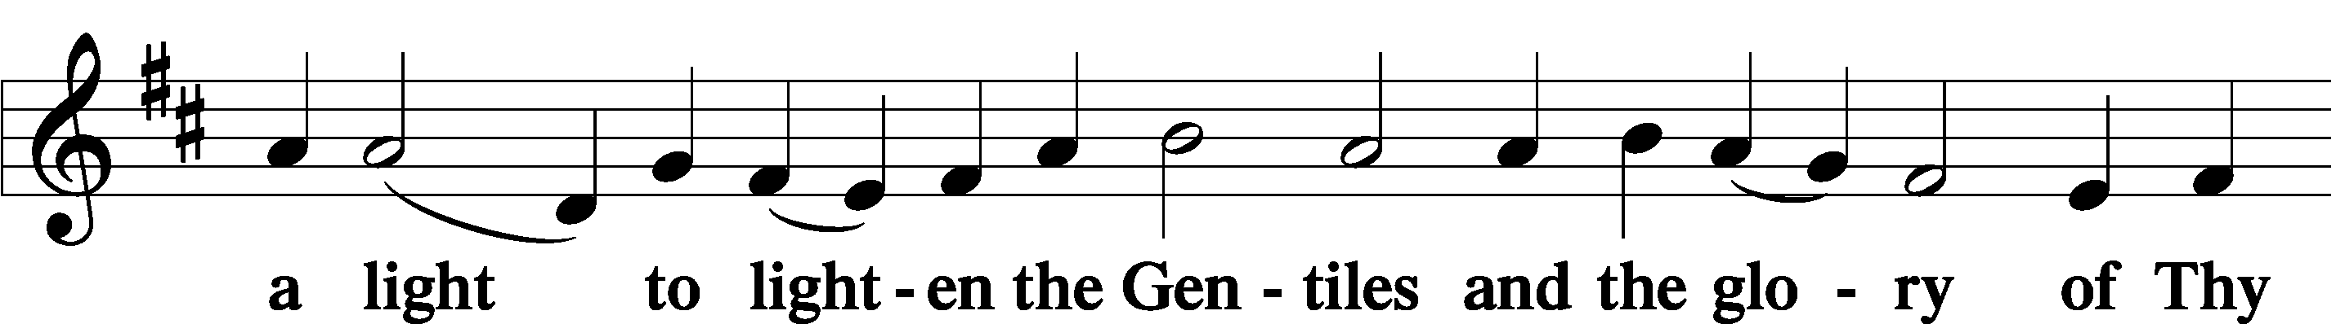

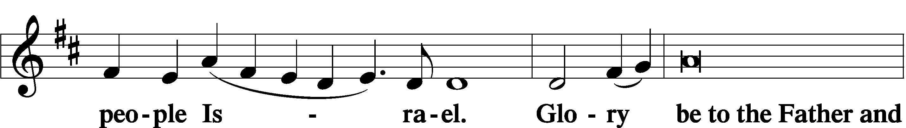

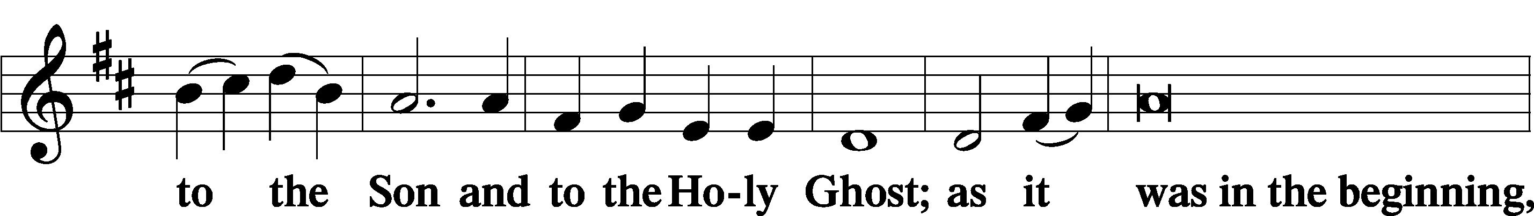

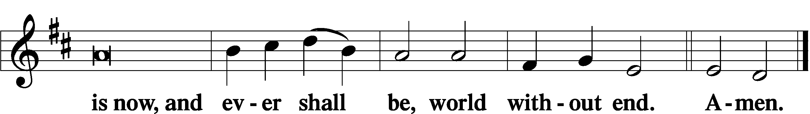

Thanksgiving Psalm 107:1
A O give thanks unto the Lord, for He is good,

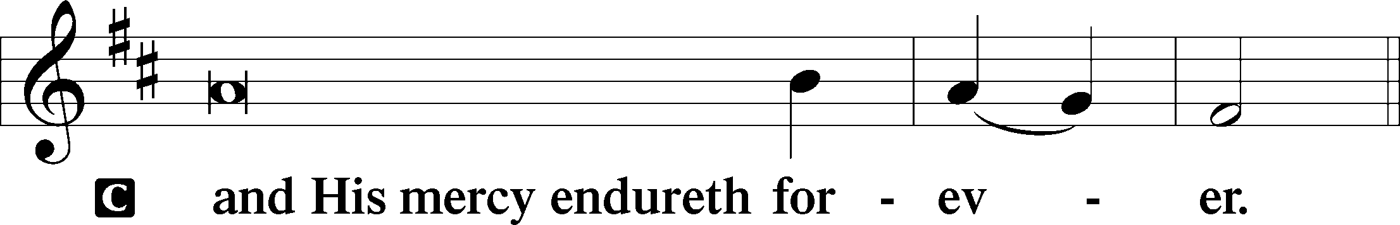

Post-Communion Collect
A Let us pray.
We give thanks to You, almighty God, that You have refreshed us through this salutary gift, and we implore You that of Your mercy You would strengthen us through the same in faith toward You and in fervent love toward one another; through Jesus Christ, Your Son, our Lord, who lives and reigns with You and the Holy Spirit, one God, now and forever.

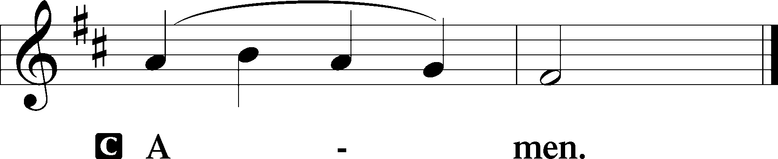

Salutation 2 Timothy 4:22
P The Lord be with you.

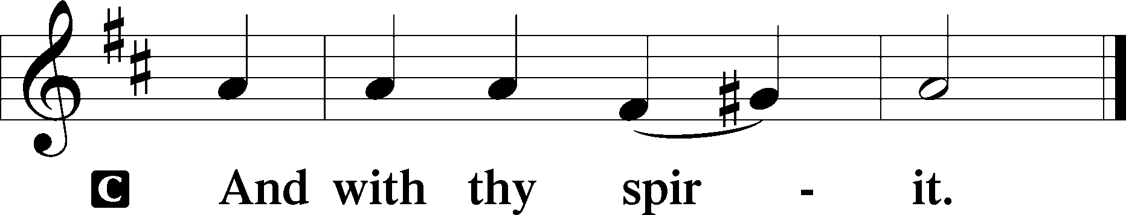

Benedicamus Psalm 103:1
P Bless we the Lord.

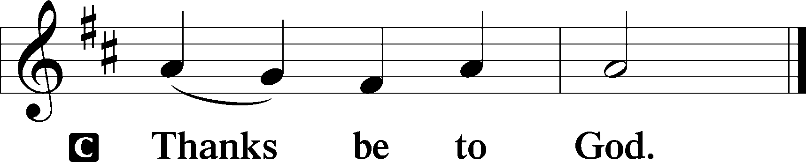

Benediction Numbers 6:24–26
P The Lord bless you and keep you.
The Lord make His face shine upon you and be gracious unto you.
The Lord lift up His countenance upon you and T give you peace.
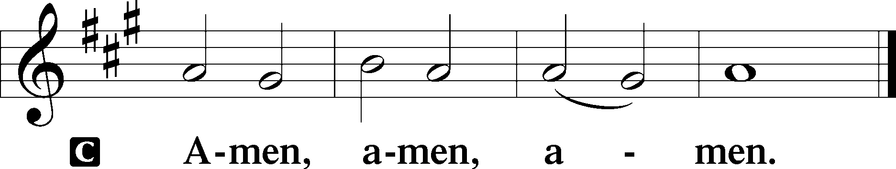

685 Let Us Ever Walk with Jesus
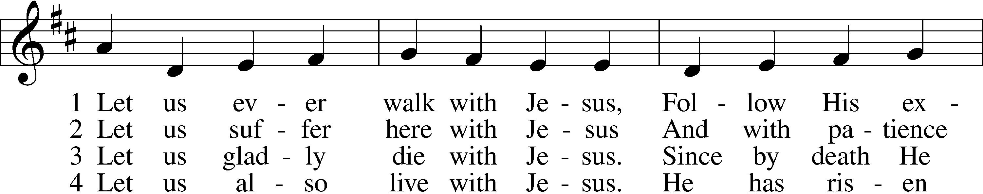
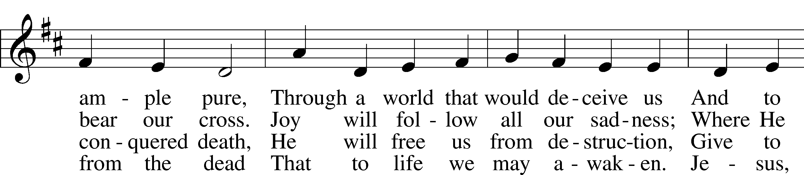
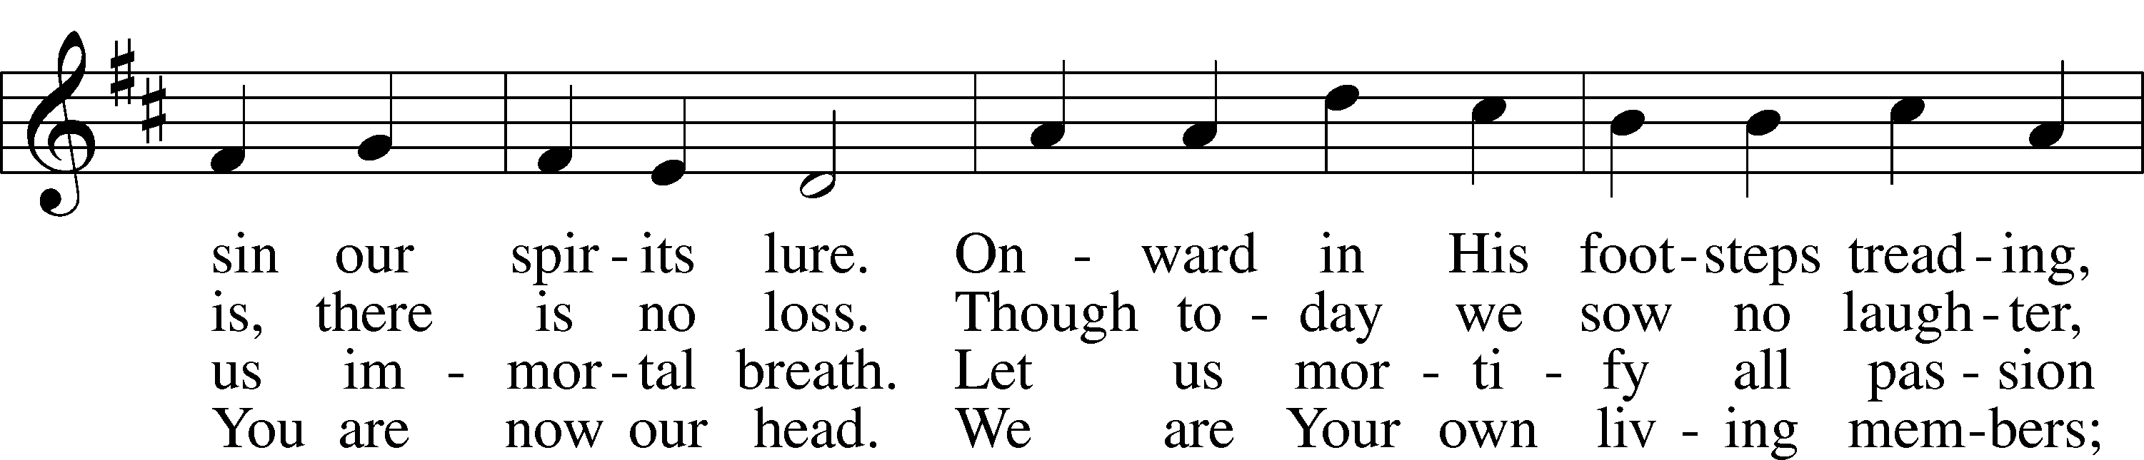
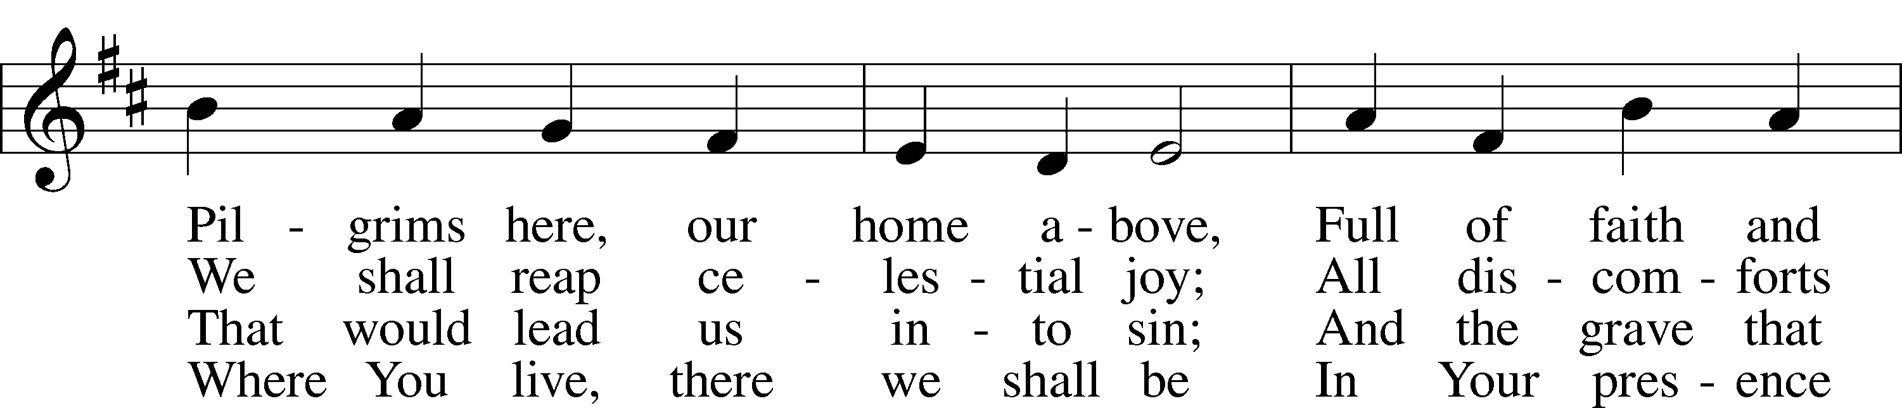
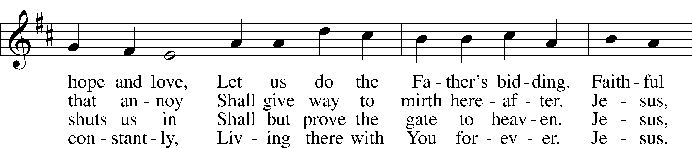
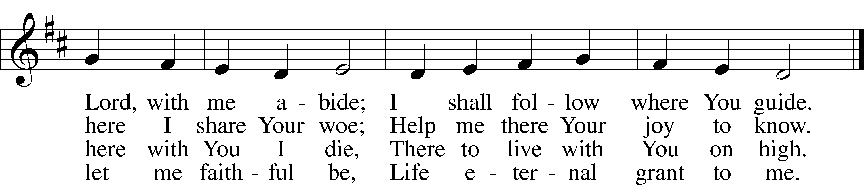
Text: Sigismund von Birken, 1626–81; tr. Lutheran Book of Worship, 1978, alt.
Tune: Georg G. Boltze, 18th cent.
Text: © 1978 Lutheran Book of Worship. Used by permission: LSB Hymn License no. 110005011
Tune: Public domain
Acknowledgments
Divine Service, Setting Three from Lutheran Service Book
Unless otherwise indicated, Scripture quotations are from the ESV® Bible (The Holy Bible, English Standard Version®), copyright © 2001 by Crossway, a publishing ministry of Good News Publishers. Used by permission. All rights reserved.
Created by Lutheran Service Builder © 2025 Concordia Publishing House.

