On entering the church

P Lord, I love the habitation of Your house and the place

where Your glory dwells. In the multitude of Your tender

mercies prepare my heart that I may enter Your house to

worship and confess Your holy name; through Jesus Christ,

my God and Lord.

Before worship

C O Lord, our creator, redeemer, and comforter, as we come

together to worship You in spirit and in truth, we humbly

pray that You would open our hearts to the preaching of

Your Word so that we may repent of our sins, believe in

Jesus Christ as our only Savior, and grow in grace and

holiness. Hear us for His sake.

851 Lord of Glory, You Have Bought Us

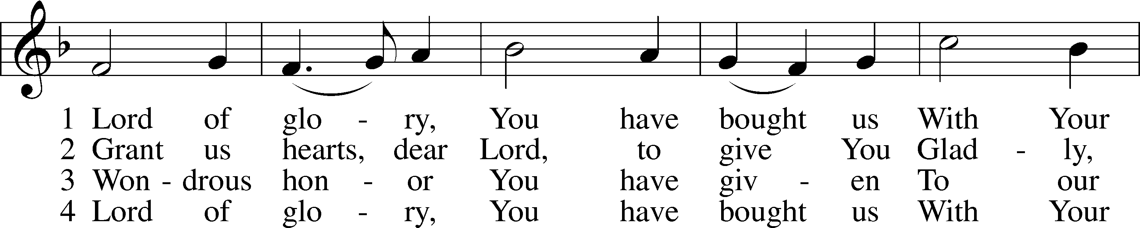

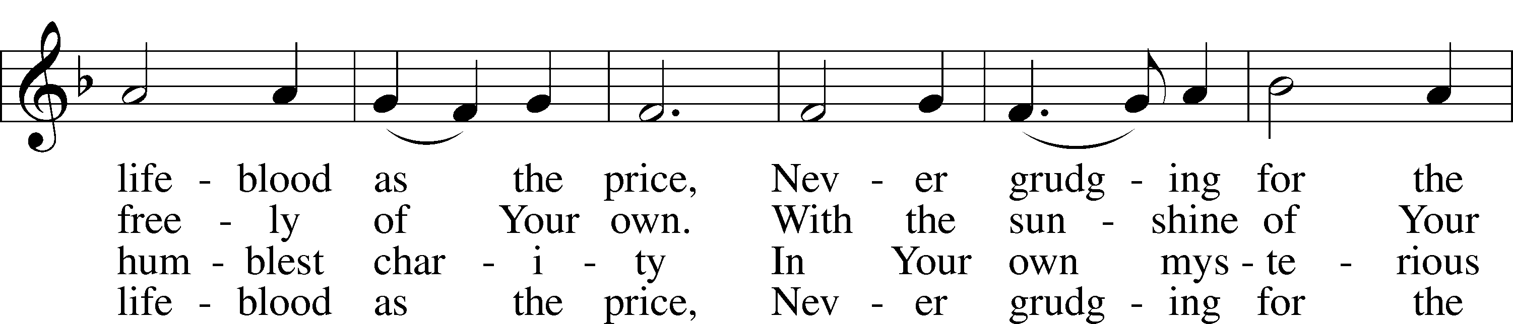

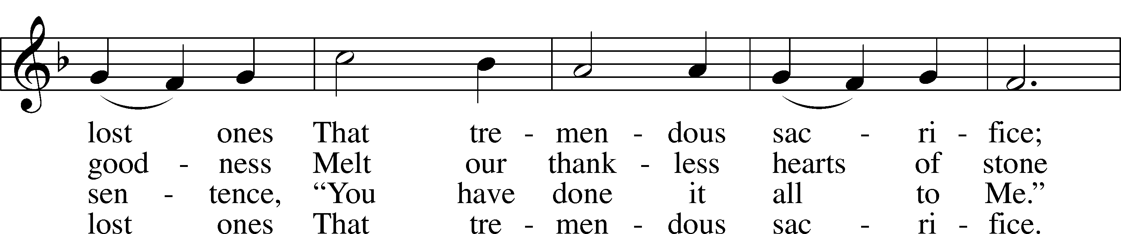

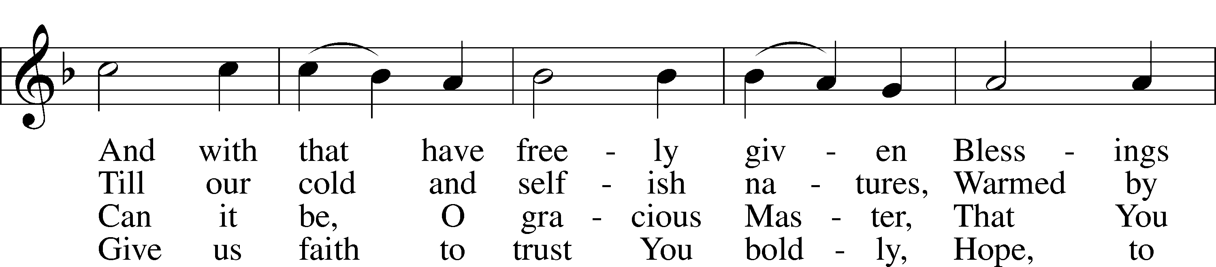

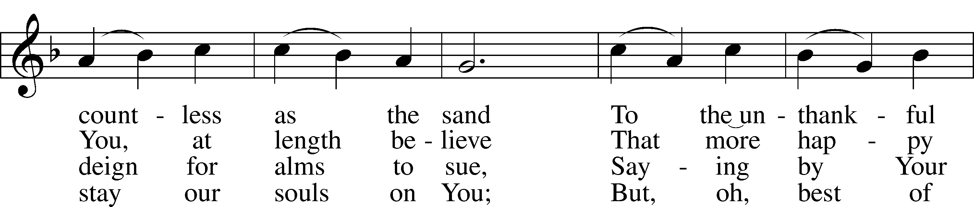

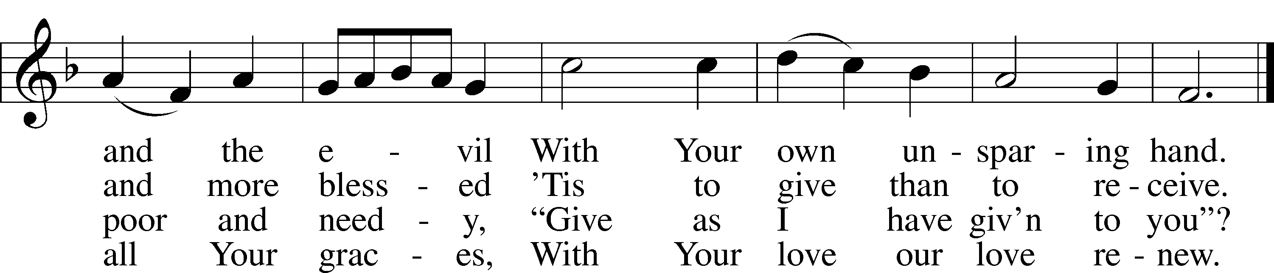

Text: Eliza S. Alderson, 1818–89, alt.  
Tune: Rowland H. Prichard, 1811–87  
Text and tune: Public domain

# Confession and Absolution

Stand

The sign of the cross may be made by all in remembrance of their Baptism.

Invocation Matthew 28:19b; 18:20

P In the name of the Father and of the T Son and of the Holy Spirit.

C **Amen.**

Exhortation Psalm 124:8; Psalm 130:3–4; Luke 18:13

P Our help is in the name of the Lord,

C **who made heaven and earth.**

P If You, O Lord, kept a record of sins, O Lord, who could stand?

C **But with You there is forgiveness; therefore You are feared.**

P Since we are gathered to hear God’s Word, call upon Him in prayer and praise, and receive the body and blood of our Lord Jesus Christ in the fellowship of this altar, let us first consider our unworthiness and confess before God and one another that we have sinned in thought, word, and deed, and that we cannot free ourselves from our sinful condition. Together as His people let us take refuge in the infinite mercy of God, our heavenly Father, seeking His grace for the sake of Christ, and saying: God, be merciful to me, a sinner.

Kneel/Stand

Confession of Sins

C **Almighty God, have mercy upon us, forgive us our sins, and lead us to everlasting life. Amen.**

Absolution [John 20:19–23]

P Almighty God in His mercy has given His Son to die for you and for His sake forgives you all your sins. As a called and ordained servant of Christ, and by His authority, I therefore forgive you all your sins in the name of the Father and of the T Son and of the Holy Spirit.

C **Amen.**

Stand

# Service of the Word

Introit Psalm 119:137–140, 142; antiphon: v. 144

Your testimonies are righteous forever;  
 give me understanding that I may live.  
**Righteous are you, O Lord,  
 and right are your just decrees.**You have appointed your testimonies in righteousness  
 and in all faithfulness.  
**My zeal consumes me,  
 because my foes forget your words.**Your promise is well tried,  
 and your servant loves it.  
**Your righteousness is righteous forever,  
 and your law is true.  
Glory be to the Father and to the Son**  
 **and to the Holy Spirit;**  
**as it was in the beginning,**  
 **is now, and will be forever. Amen.**  
Your testimonies are righteous forever;  
 give me understanding that I may live.

Kyrie Mark 10:47

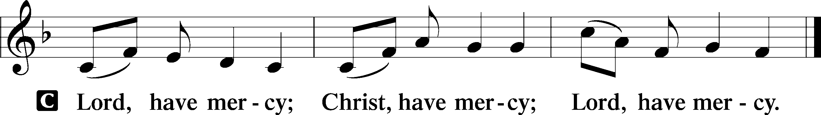

Salutation and Collect of the Day

P The Lord be with you.

C **And also with you.**

P Let us pray.

O Lord, keep Your Church in Your perpetual mercy; and because without You we cannot but fall, preserve us from all things hurtful, and lead us to all things profitable to our salvation; through Jesus Christ, Your Son, our Lord, who lives and reigns with You and the Holy Spirit, one God, now and forever.

C **Amen.**

Sit

Old Testament Reading Amos 8:4–7

4Hear this, you who trample on the needy  
 and bring the poor of the land to an end,  
5saying, “When will the new moon be over,  
 that we may sell grain?  
And the Sabbath,  
 that we may offer wheat for sale,  
that we may make the ephah small and the shekel great  
 and deal deceitfully with false balances,  
6that we may buy the poor for silver  
 and the needy for a pair of sandals  
 and sell the chaff of the wheat?”

7The Lord has sworn by the pride of Jacob:  
“Surely I will never forget any of their deeds.”

A This is the Word of the Lord.

C **Thanks be to God.**

Gradual Psalm 34:9, 19, alt.

Fear the Lord, you his saints,  
 for those who fear him lack nothing!  
**Many are the afflictions of the righteous,  
 but the Lord delivers him out of them all.**

Epistle 1 Timothy 2:1–15

1First of all, then, I urge that supplications, prayers, intercessions, and thanksgivings be made for all people, 2for kings and all who are in high positions, that we may lead a peaceful and quiet life, godly and dignified in every way. 3This is good, and it is pleasing in the sight of God our Savior, 4who desires all people to be saved and to come to the knowledge of the truth. 5For there is one God, and there is one mediator between God and men, the man Christ Jesus, 6who gave himself as a ransom for all, which is the testimony given at the proper time. 7For this I was appointed a preacher and an apostle (I am telling the truth, I am not lying), a teacher of the Gentiles in faith and truth.

8I desire then that in every place the men should pray, lifting holy hands without anger or quarreling; 9likewise also that women should adorn themselves in respectable apparel, with modesty and self-control, not with braided hair and gold or pearls or costly attire, 10but with what is proper for women who profess godliness—with good works. 11Let a woman learn quietly with all submissiveness. 12I do not permit a woman to teach or to exercise authority over a man; rather, she is to remain quiet. 13For Adam was formed first, then Eve; 14and Adam was not deceived, but the woman was deceived and became a transgressor. 15Yet she will be saved through childbearing—if they continue in faith and love and holiness, with self-control.

A This is the Word of the Lord.

C **Thanks be to God.**

Stand

Alleluia and Verse

Alleluia

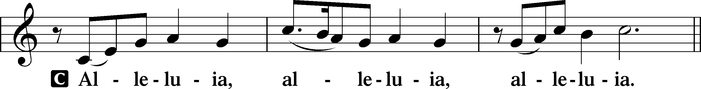

Verse John 20:31

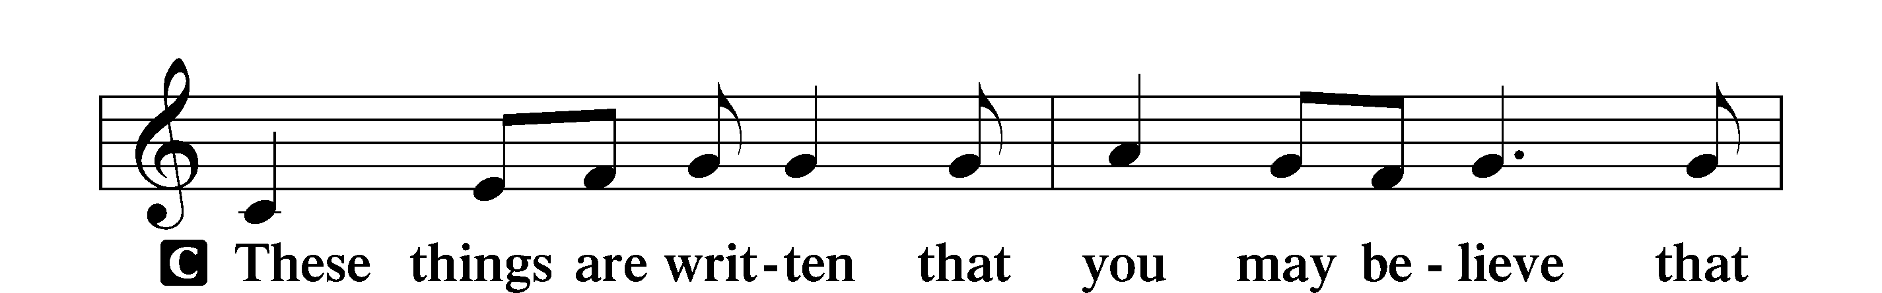

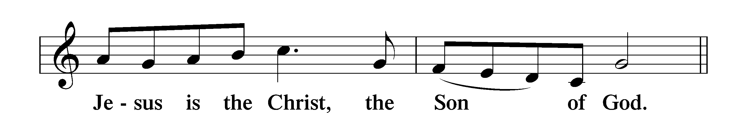

Alleluia

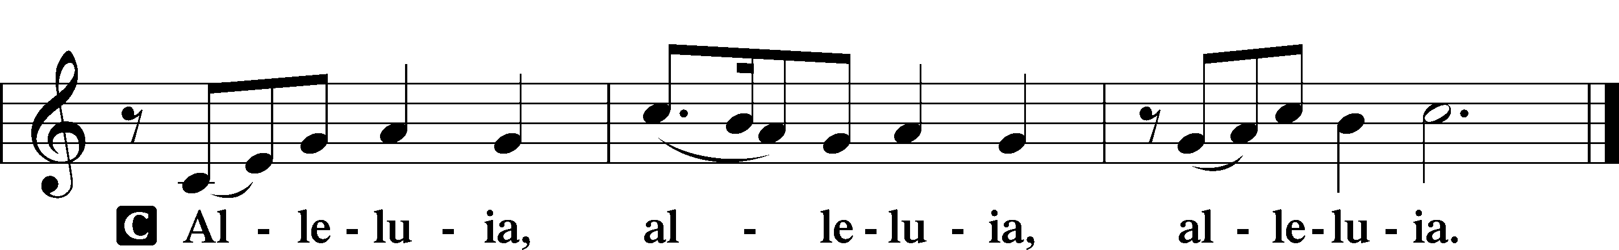

Holy Gospel Luke 16:1–15

P The Holy Gospel according to St. Luke, the sixteenth chapter.

C **Glory to You, O Lord.**

1[Jesus] also said to the disciples, “There was a rich man who had a manager, and charges were brought to him that this man was wasting his possessions. 2And he called him and said to him, ‘What is this that I hear about you? Turn in the account of your management, for you can no longer be manager.’ 3And the manager said to himself, ‘What shall I do, since my master is taking the management away from me? I am not strong enough to dig, and I am ashamed to beg. 4I have decided what to do, so that when I am removed from management, people may receive me into their houses.’ 5So, summoning his master’s debtors one by one, he said to the first, ‘How much do you owe my master?’ 6He said, ‘A hundred measures of oil.’ He said to him, ‘Take your bill, and sit down quickly and write fifty.’ 7Then he said to another, ‘And how much do you owe?’ He said, ‘A hundred measures of wheat.’ He said to him, ‘Take your bill, and write eighty.’ 8The master commended the dishonest manager for his shrewdness. For the sons of this world are more shrewd in dealing with their own generation than the sons of light. 9And I tell you, make friends for yourselves by means of unrighteous wealth, so that when it fails they may receive you into the eternal dwellings.

10“One who is faithful in a very little is also faithful in much, and one who is dishonest in a very little is also dishonest in much. 11If then you have not been faithful in the unrighteous wealth, who will entrust to you the true riches? 12And if you have not been faithful in that which is another’s, who will give you that which is your own? 13No servant can serve two masters, for either he will hate the one and love the other, or he will be devoted to the one and despise the other. You cannot serve God and money.”

14The Pharisees, who were lovers of money, heard all these things, and they ridiculed him. 15And he said to them, “You are those who justify yourselves before men, but God knows your hearts. For what is exalted among men is an abomination in the sight of God.”

P This is the Gospel of the Lord.

C **Praise to You, O Christ.**

Nicene Creed

C **I believe in one God,**

**the Father Almighty,**

**maker of heaven and earth**

**and of all things visible and invisible.**

**And in one Lord Jesus Christ,**

**the only-begotten Son of God,**

**begotten of His Father before all worlds,**

**God of God, Light of Light,**

**very God of very God,**

**begotten, not made,**

**being of one substance with the Father,**

**by whom all things were made;**

**who for us men and for our salvation came down from heaven**

**and was incarnate by the Holy Spirit of the virgin Mary**

**and was made man;**

**and was crucified also for us under Pontius Pilate.**

**He suffered and was buried.**

**And the third day He rose again according to the Scriptures**

**and ascended into heaven**

**and sits at the right hand of the Father.**

**And He will come again with glory to judge both the living and the dead,**

**whose kingdom will have no end.**

**And I believe in the Holy Spirit,**

**the Lord and giver of life,**

**who proceeds from the Father and the Son,**

**who with the Father and the Son together is worshiped and glorified,**

**who spoke by the prophets.**

**And I believe in one holy Christian and apostolic Church,**

**I acknowledge one Baptism for the remission of sins,**

**and I look for the resurrection of the dead**

**and the life** T **of the world to come. Amen.**

Sit

Children's Sermon

730 What Is the World to Me

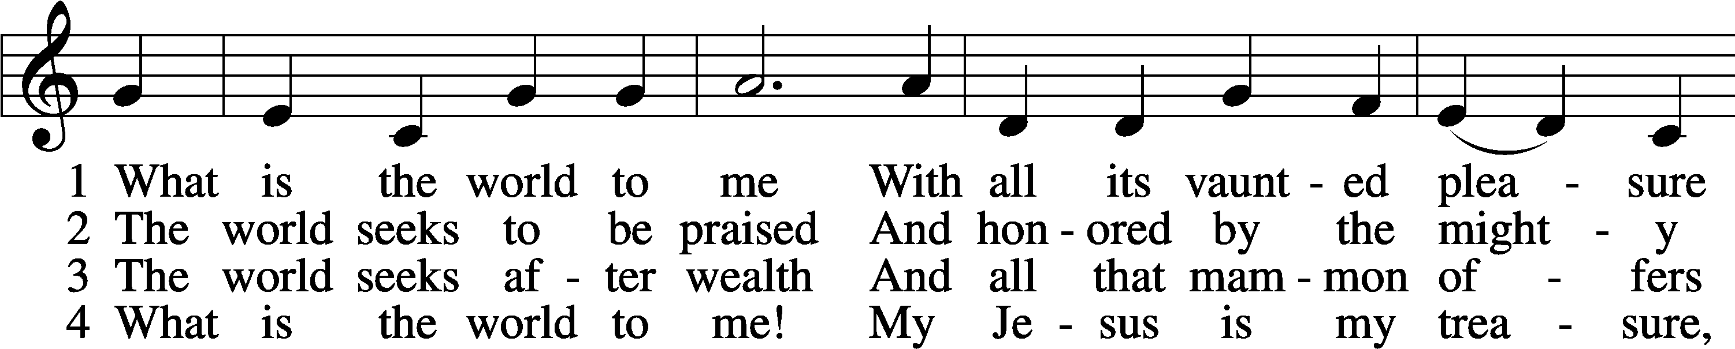

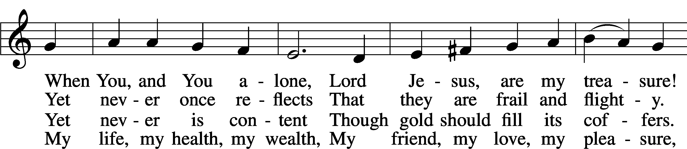

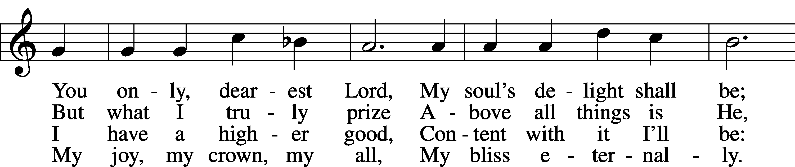

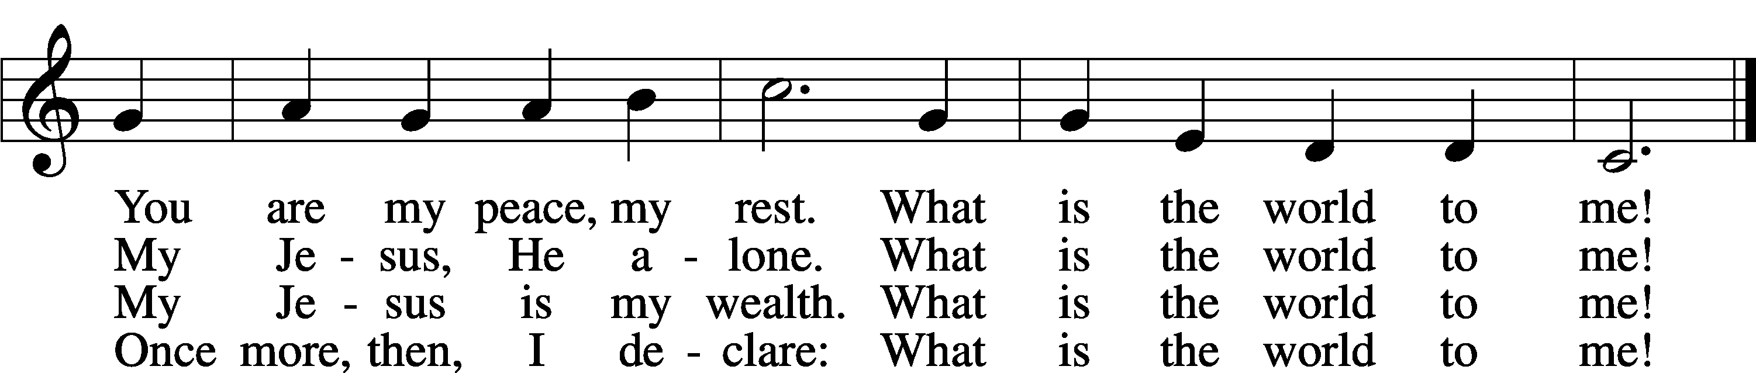

Text: Georg Michael Pfefferkorn, 1645–1732; tr. August Crull, 1845–1923, alt.  
Tune: Ahasverus Fritsch, 1629–1701  
Text and tune: Public domain

Sermon

Stand

Prayer of the Church

Following the prayers, the people may greet one another in the name of the Lord, saying, “Peace be with you,” as a sign of reconciliation and of the unity of the Spirit in the bond of peace (Matt. 5:22–24; Eph. 4:1–3).

Sit

Offering

805 Praise God, from Whom All Blessings Flow

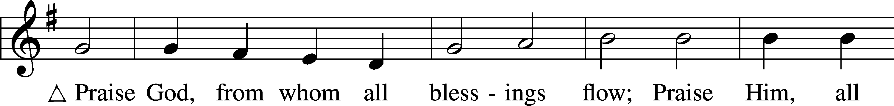

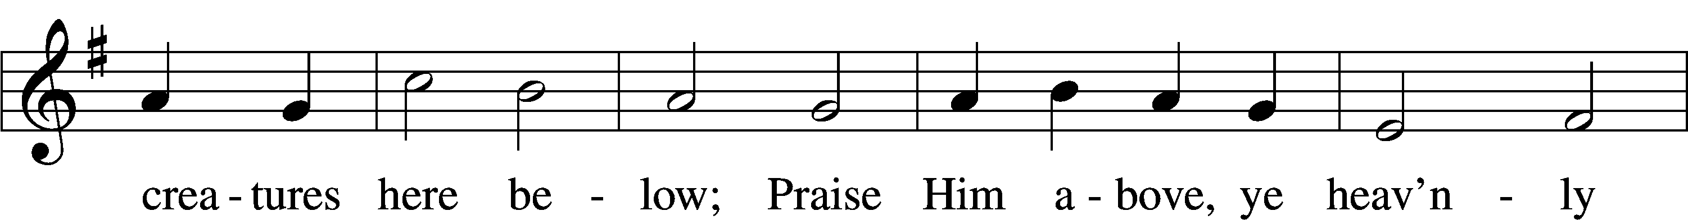

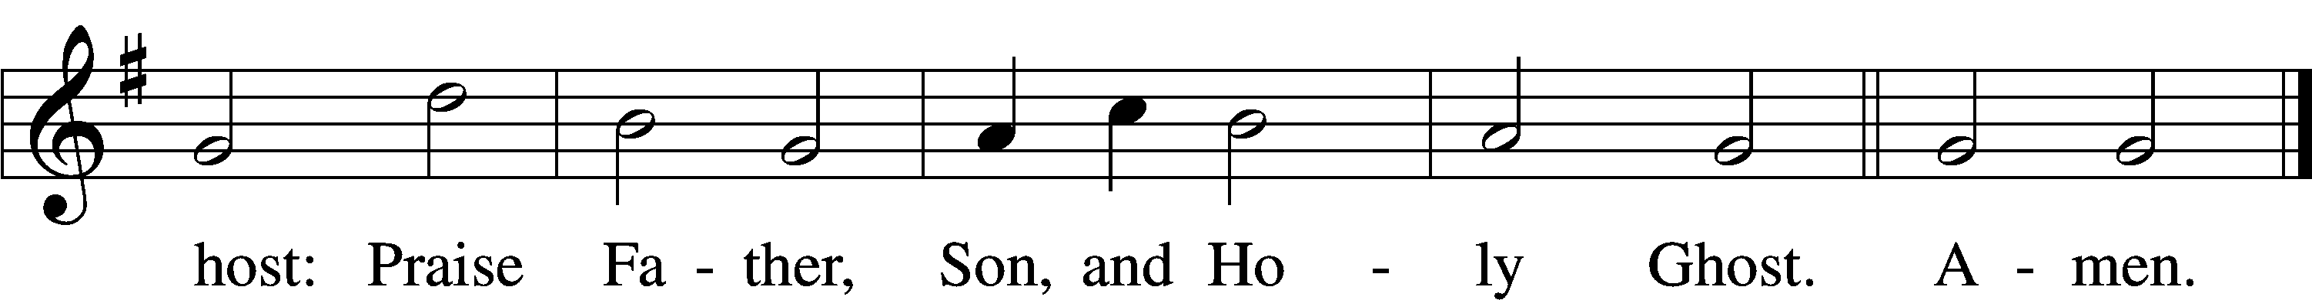

Text: Thomas Ken, 1637–1711  
Tune: Trente quatre Pseaumes de David, 1551, Geneva, ed. Louis Bourgeois  
Text and tune: Public domain

# Service of the Sacrament

Stand

Preface 2 Timothy 4:22; [Colossians 3:1]; [Psalm 136]

P The Lord be with you.

C **And also with you.**

P Lift up your hearts.

C **We lift them to the Lord.**

P Let us give thanks to the Lord our God.

C **It is right to give Him thanks and praise.**

P It is truly good, right, and salutary that we should at all times and in all places give thanks to You, O Lord, holy Father, almighty and everlasting God, for the countless blessings You so freely bestow on us and all creation. Above all, we give thanks for Your boundless love shown to us when You sent Your only-begotten Son, Jesus Christ, into our flesh and laid on Him our sin, giving Him into death that we might not die eternally. Because He is now risen from the dead and lives and reigns to all eternity, all who believe in Him will overcome sin and death and will rise again to new life. Therefore with angels and archangels and with all the company of heaven we laud and magnify Your glorious name, evermore praising You and saying:

Sanctus Isaiah 6:3; Matthew 21:9

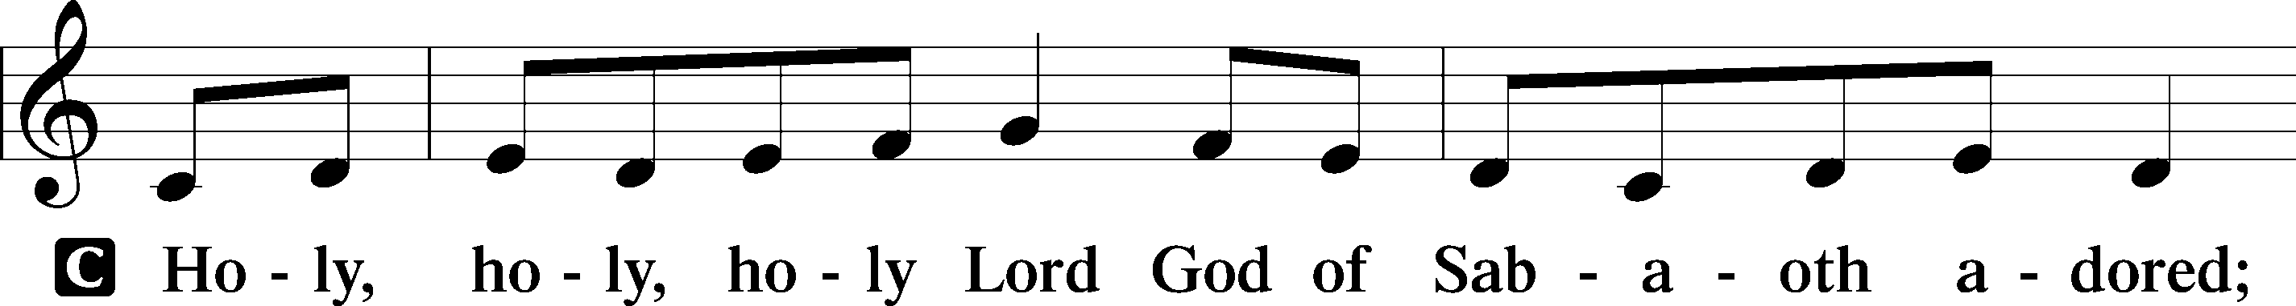

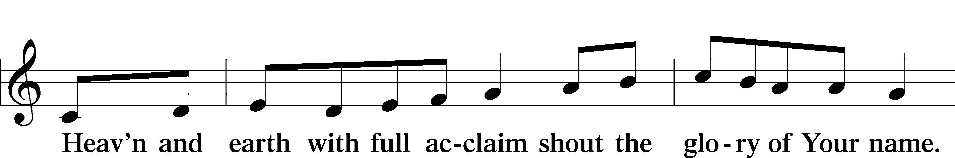

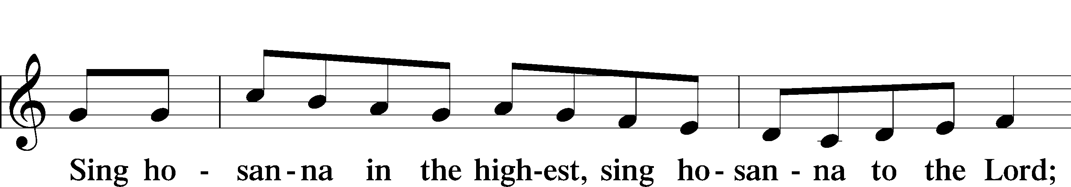

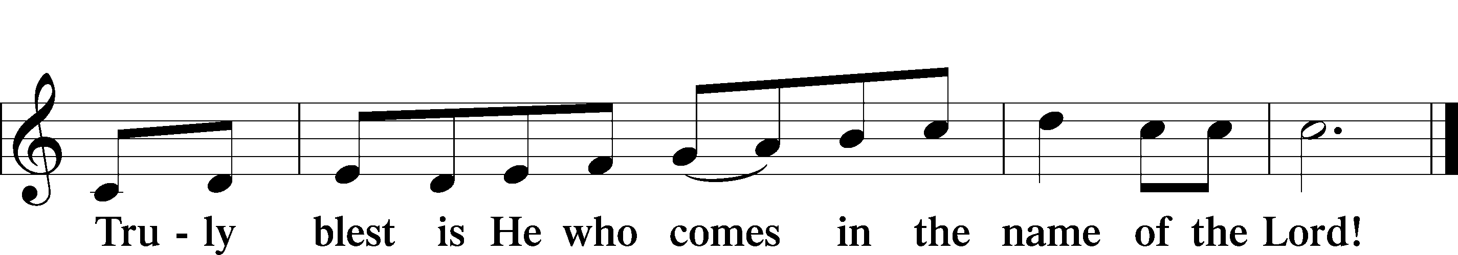

Text: Stephen P. Starke

Prayer of Thanksgiving

P Blessed are You, O Lord our God, king of all creation, for You have had mercy on us and given Your only-begotten Son that whoever believes in Him should not perish but have eternal life.

In Your righteous judgment You condemned the sin of Adam and Eve, who ate the forbidden fruit, and You justly barred them and all their children from the tree of life. Yet, in Your great mercy, You promised salvation by a second Adam, Your Son, Jesus Christ, our Lord, and made His cross a life-giving tree for all who trust in Him.

We give You thanks for the redemption You have prepared for us through Jesus Christ. Grant us Your Holy Spirit that we may faithfully eat and drink of the fruits of His cross and receive the blessings of forgiveness, life, and salvation that come to us in His body and blood.

Hear us as we pray in His name and as He has taught us:

Lord’s Prayer

C **Our Father who art in heaven,**

**hallowed be Thy name,**

**Thy kingdom come,**

**Thy will be done on earth**

**as it is in heaven;**

**give us this day our daily bread;**

**and forgive us our trespasses**

**as we forgive those**

**who trespass against us;**

**and lead us not into temptation,**

**but deliver us from evil.**

**For Thine is the kingdom**

**and the power and the glory**

**forever and ever. Amen.**

The Words of Our Lord

P Our Lord Jesus Christ, on the night when He was betrayed, took bread, and when He had given thanks, He broke it and gave it to the disciples and said: “Take, eat; this is My T body, which is given for you. This do in remembrance of Me.”

In the same way also He took the cup after supper, and when He had given thanks, He gave it to them, saying: “Drink of it, all of you; this cup is the new testament in My T blood, which is shed for you for the forgiveness of sins. This do, as often as you drink it, in remembrance of Me.”

Pax Domini

P The peace of the Lord be with you always.

C **Amen.**

Agnus Dei John 1:29

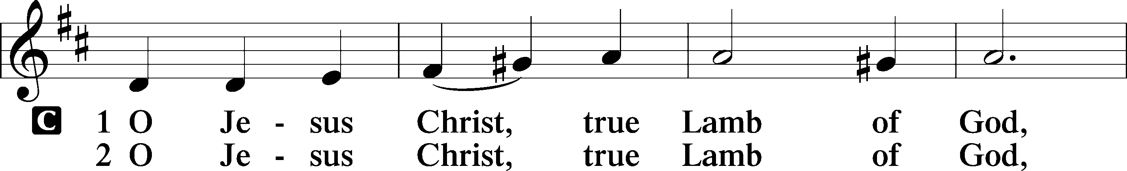

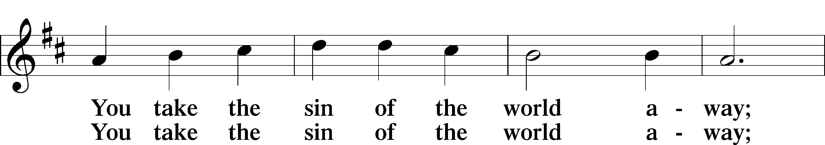

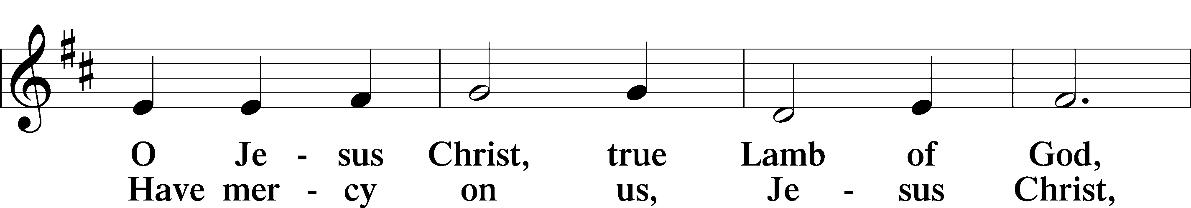

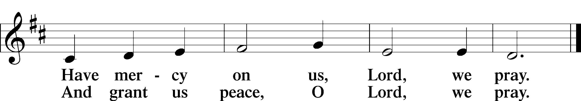

Text: Stephen P. Starke

Sit

Distribution

The pastor and those who assist him receive the body and blood of Christ first and then distribute them to those who come to receive, saying:

Take, eat; this is the true body of our Lord and Savior Jesus Christ, given into death for your sins.

**Amen.**

Take, drink; this is the true blood of our Lord and Savior Jesus Christ, shed for the forgiveness of your sins.

**Amen.**

In dismissing the communicants, the following is said:

The Dismissal

P The body and blood of our Lord Jesus Christ strengthen and preserve you in body and soul to life everlasting. Depart T in peace.

C **Amen.**

628 Your Table I Approach

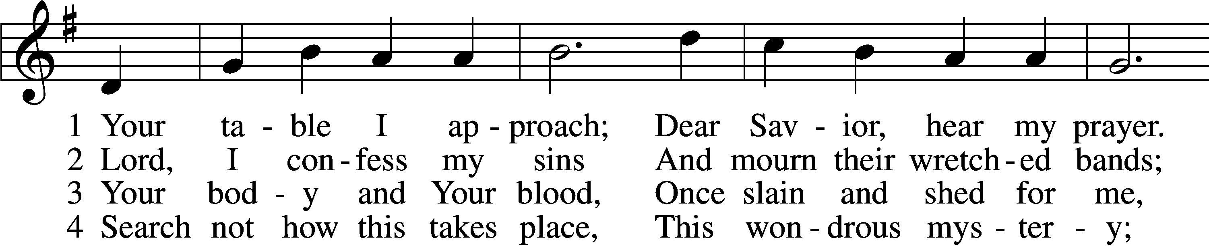

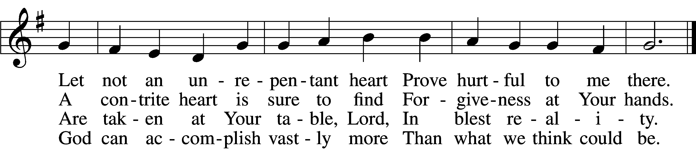

5 O grant, most blessèd Lord,  
 That earth and hell combined  
May not about this sacrament  
 Raise doubt within my mind.

6 Oh, may I never fail  
 To thank You day and night  
For Your true body and true blood,  
 O God, my peace and light.

Text: Gerhard Wolter Molanus, 1633–1722; tr. Matthias Loy, 1828–1915, alt.  
Tune: Trente quatre Pseaumes de David, 1551, Geneva, ed. Louis Bourgeois  
Text and tune: Public domain

637 Draw Near and Take the Body of the Lord

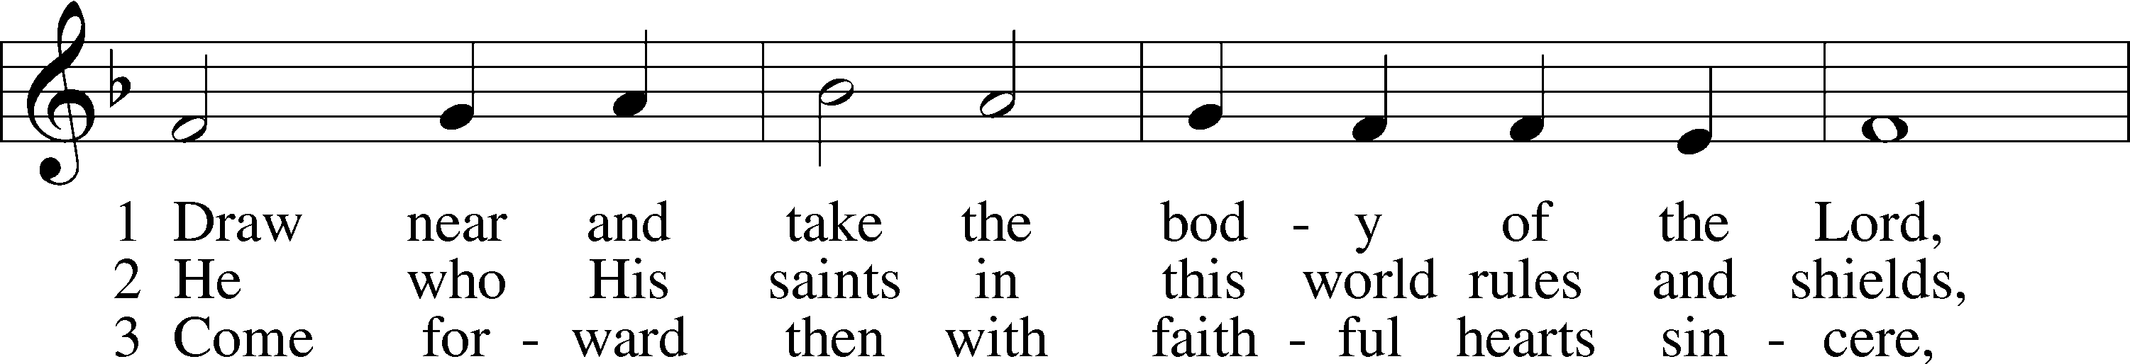

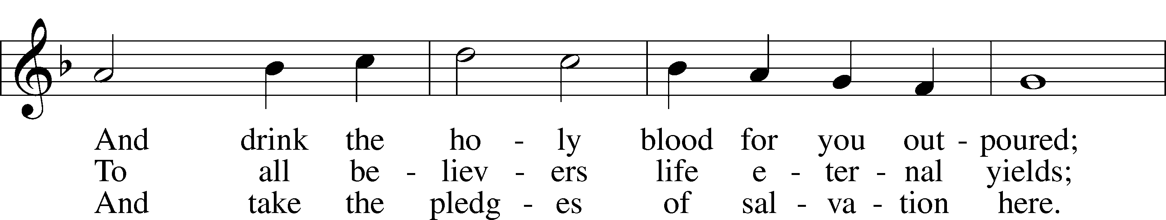

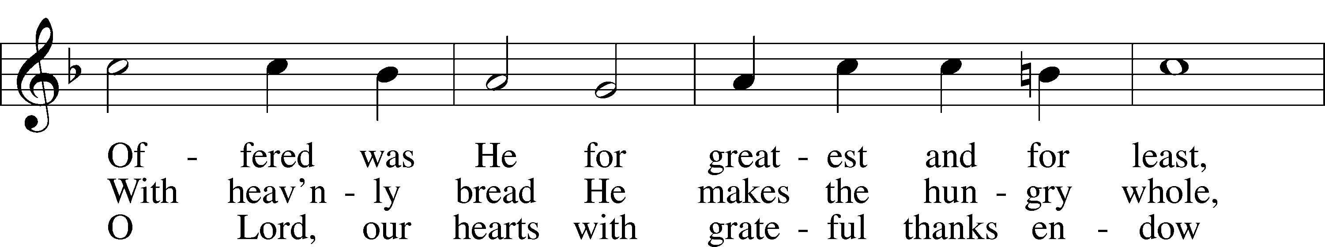

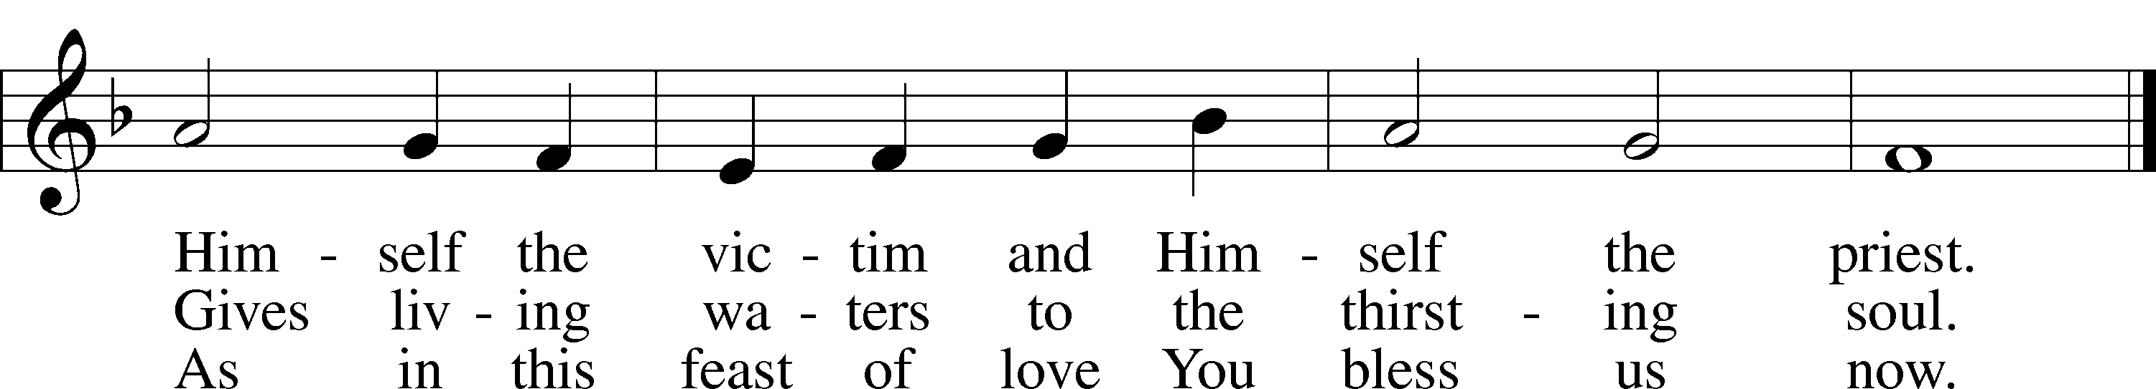

Text: Latin, 7th cent.; tr. John Mason Neale, 1818–66, alt.  
Tune: Trente quatre Pseaumes de David, 1551, Geneva, ed. Louis Bourgeois  
Text and tune: Public domain

537 Beautiful Savior

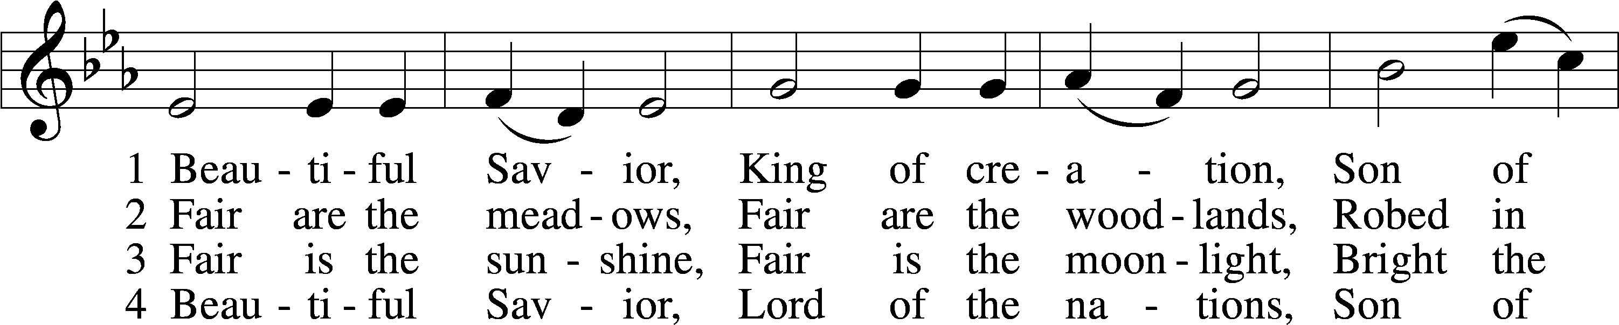

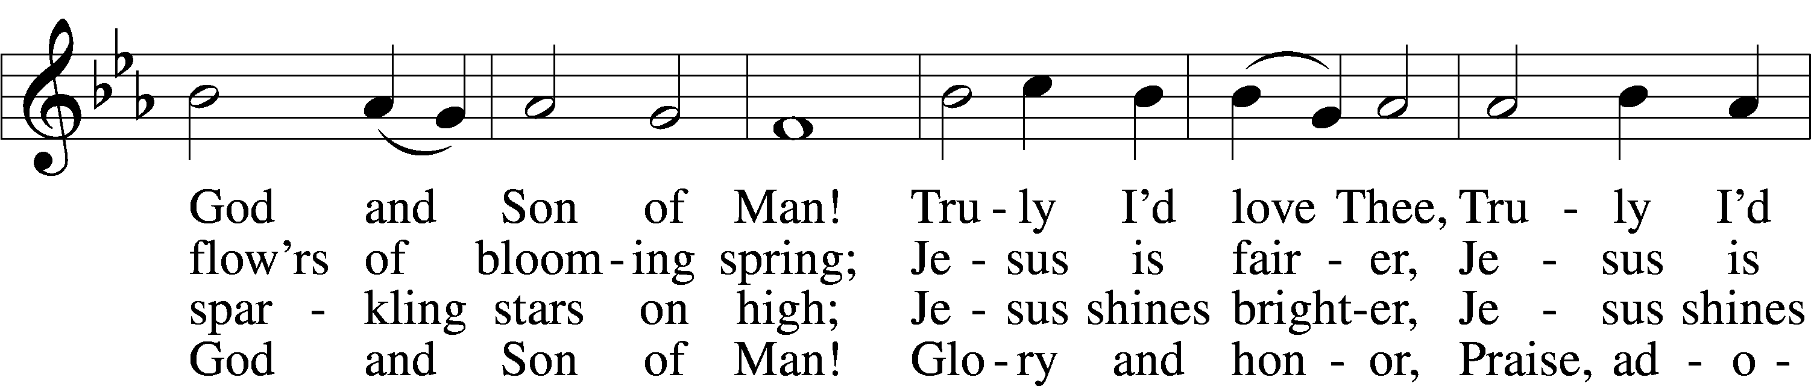

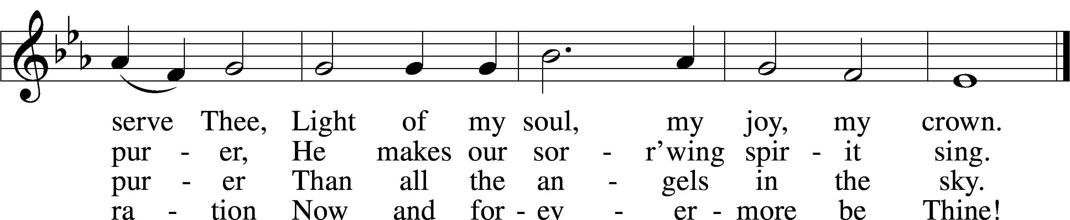

Text: Münsterisch Gesangbuch, 1677, Münster; tr. Joseph A. Seiss, 1823–1904  
Tune: Silesian, 19th cent.  
Text and tune: Public domain

547 The Lamb

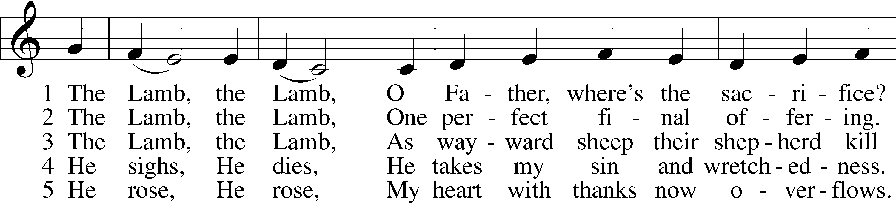

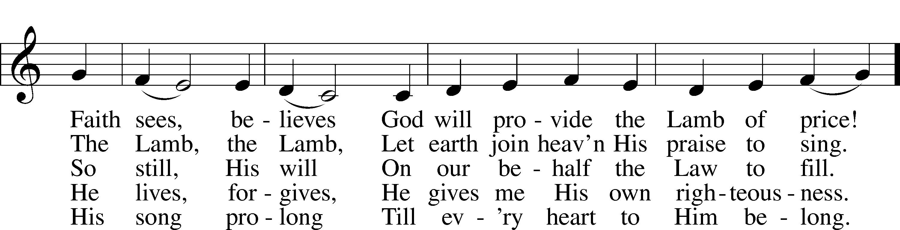

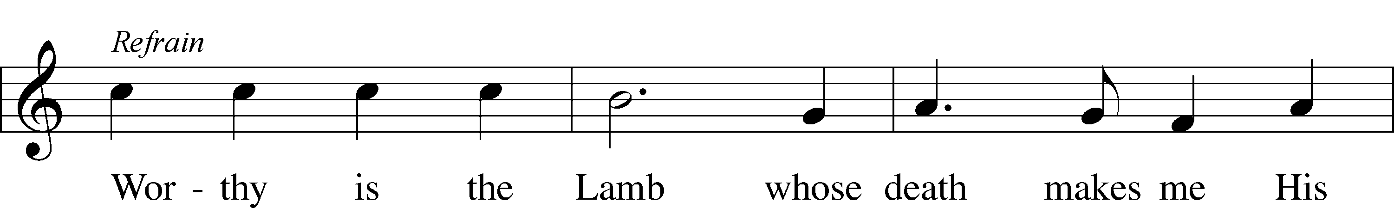

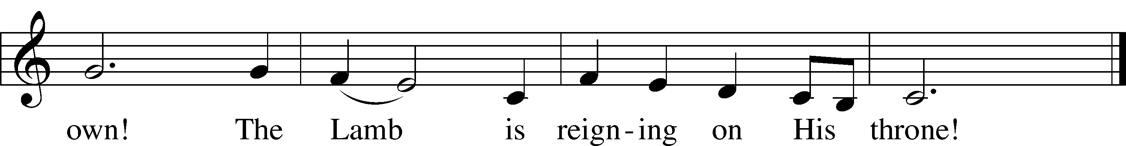

Text and tune: Gerald P. Coleman, 1953–2023  
Text and tune: © 1987 and 1997 MorningStar Music Publishers. Used by permission: LSB Hymn License no. 110005011

Stand

Nunc Dimittis Luke 2:29–32

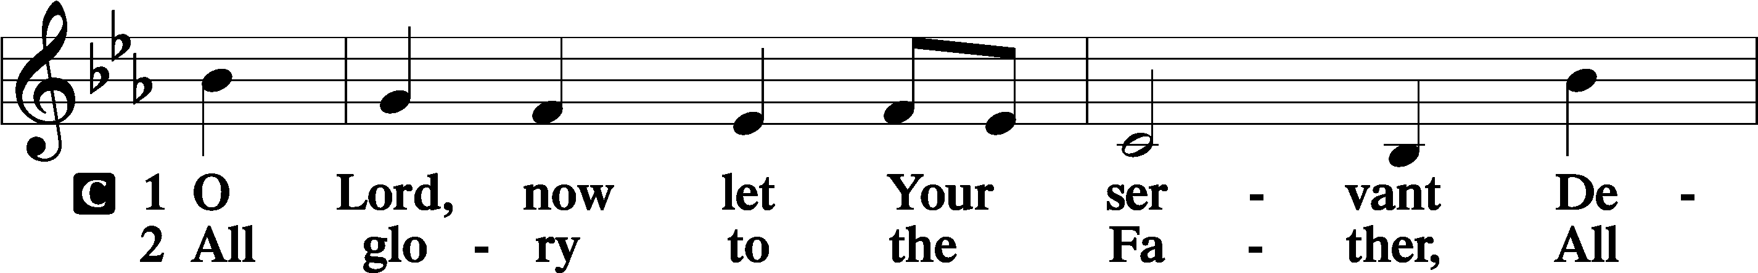

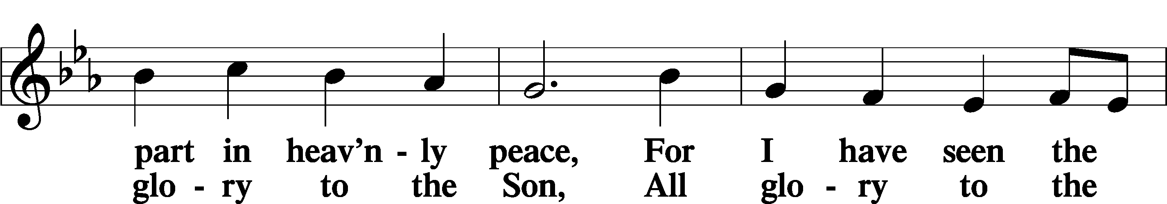

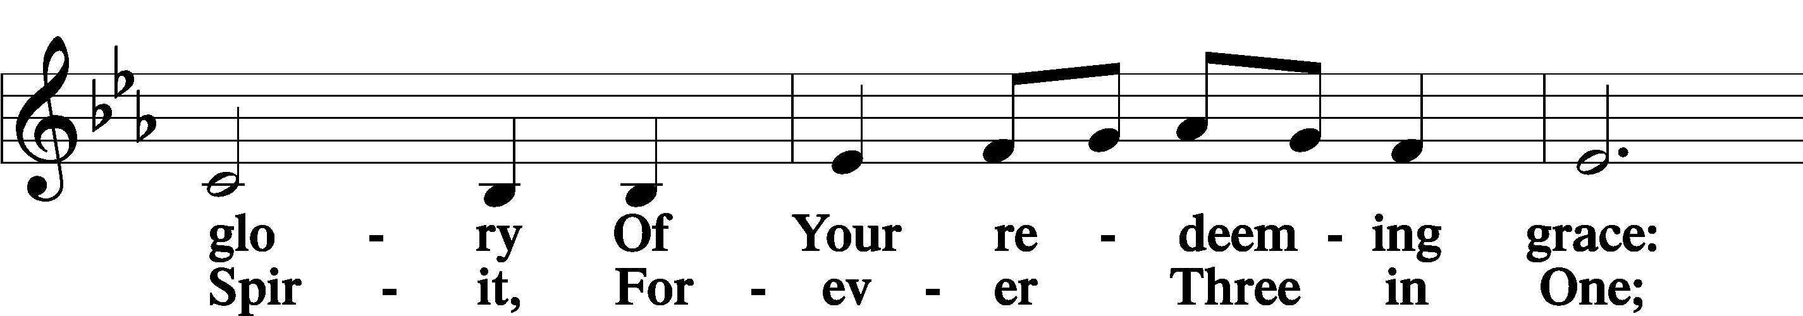

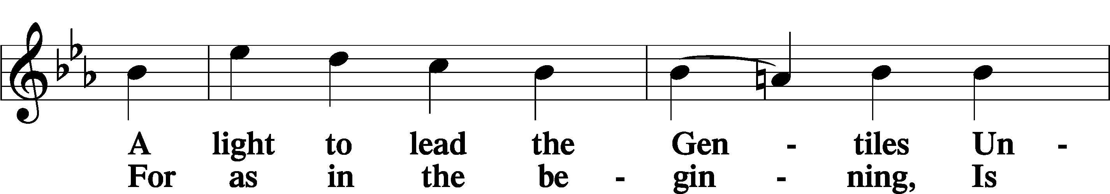

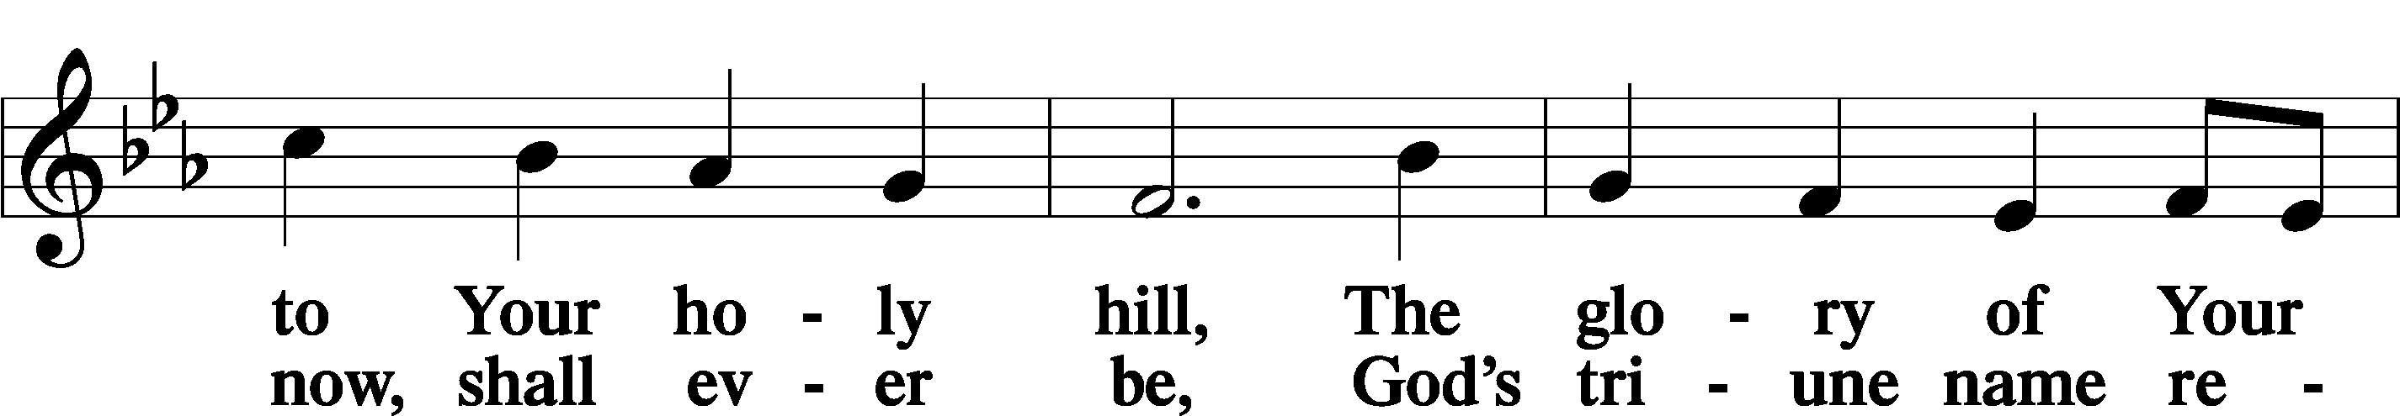

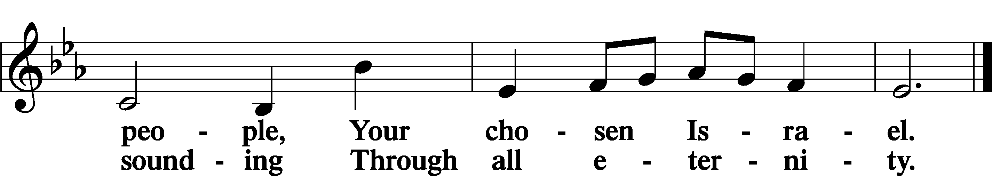

Post-Communion Collect

A Let us pray.

We give thanks to You, almighty God, that You have refreshed us through this salutary gift, and we implore You that of Your mercy You would strengthen us through the same in faith toward You and in fervent love toward one another; through Jesus Christ, Your Son, our Lord, who lives and reigns with You and the Holy Spirit, one God, now and forever.

C **Amen.**

Benedicamus Psalm 103:1

A Let us bless the Lord.

C **Thanks be to God.**

Benediction

P The Lord bless you and keep you.

The Lord make His face shine on you and be gracious to you.

The Lord look upon you with favor and T give you peace.

C **Amen.**

844 Lord of All Nations, Grant Me Grace

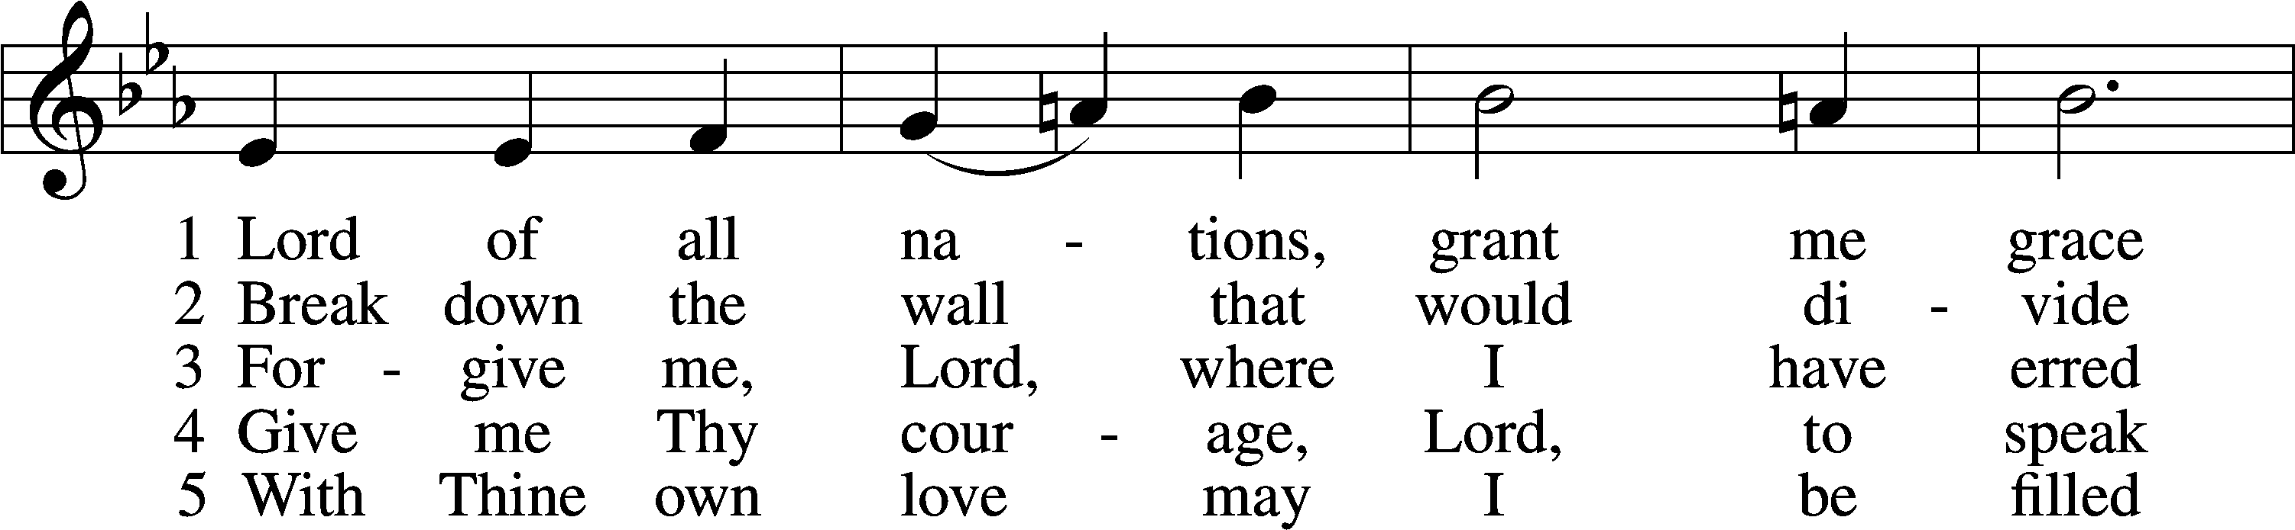

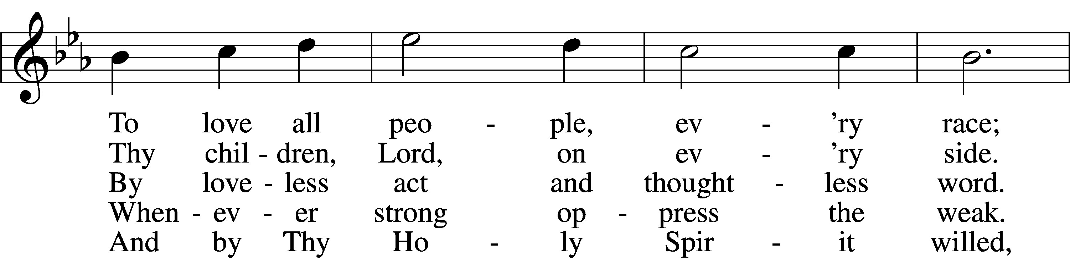

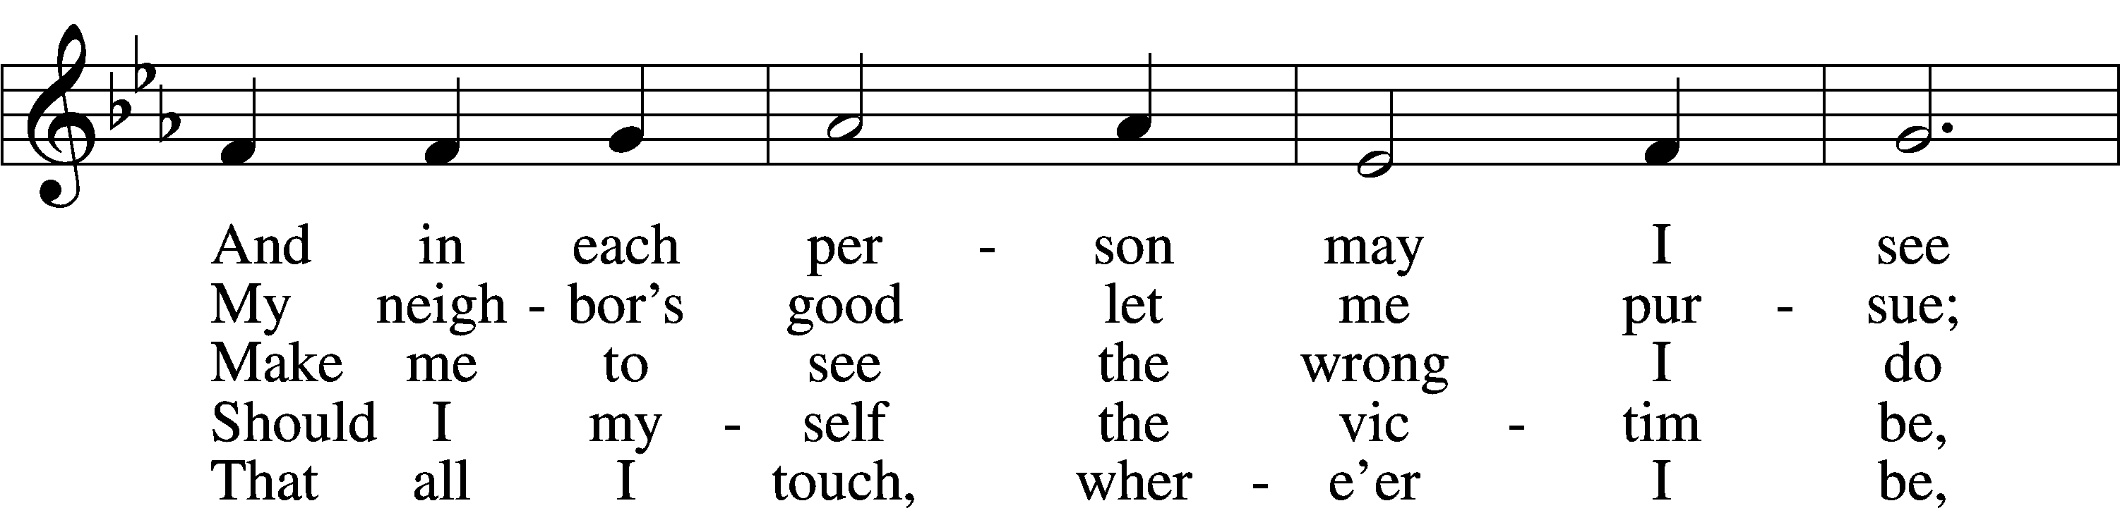

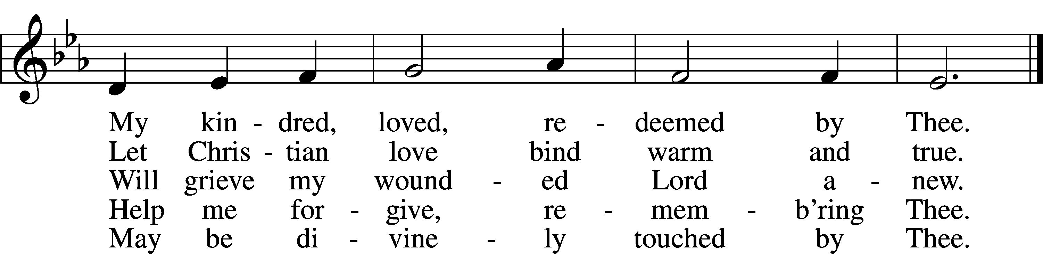

Text: Olive Wise Spannaus, 1916–2018, alt.  
Tune: Georg Joseph, 17th cent., adapt.  
Text: © 1969 Concordia Publishing House. Used by permission: LSB Hymn License no. 110005011  
Tune: Public domain

Acknowledgments

Divine Service, Setting Four from Lutheran Service Book

Unless otherwise indicated, Scripture quotations are from the ESV® Bible (The Holy Bible, English Standard Version®), copyright © 2001 by Crossway, a publishing ministry of Good News Publishers. Used by permission. All rights reserved.

Created by Lutheran Service Builder © 2025 Concordia Publishing House.