On entering the church

P Lord, I love the habitation of Your house and the place

where Your glory dwells. In the multitude of Your tender

mercies prepare my heart that I may enter Your house to

worship and confess Your holy name; through Jesus Christ,

my God and Lord.

Before worship

C O Lord, our creator, redeemer, and comforter, as we come

together to worship You in spirit and in truth, we humbly

pray that You would open our hearts to the preaching of

Your Word so that we may repent of our sins, believe in

Jesus Christ as our only Savior, and grow in grace and

holiness. Hear us for His sake.

**507 Holy, Holy, Holy *sts. 1–4***

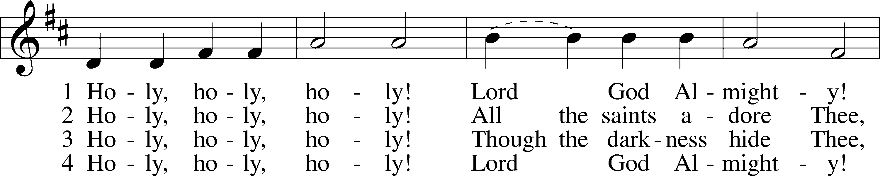

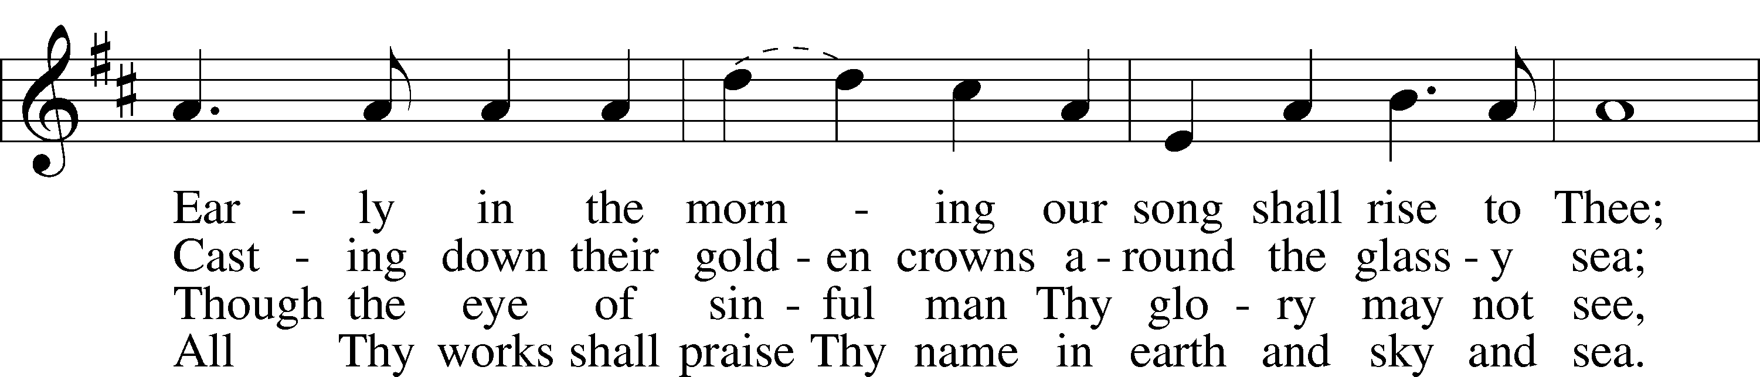

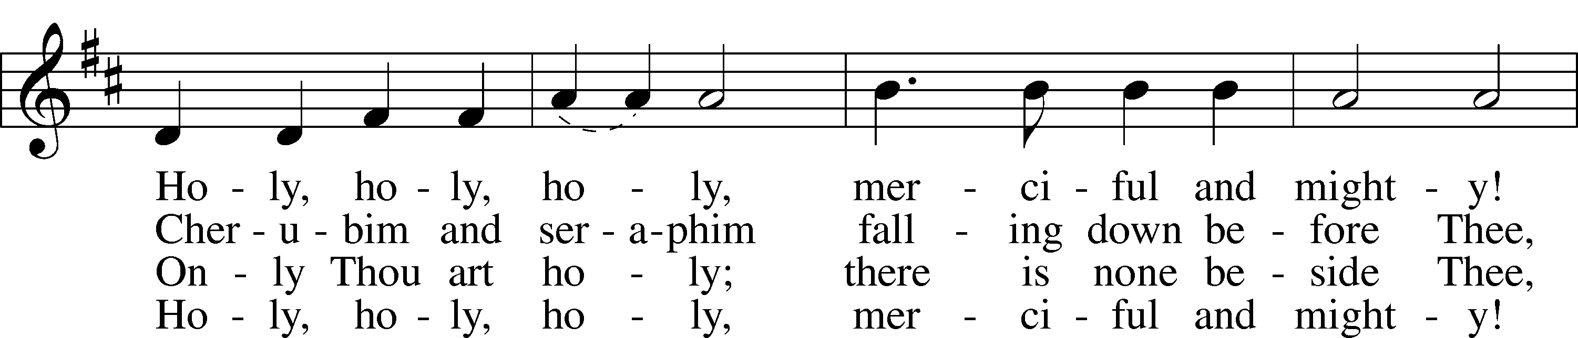

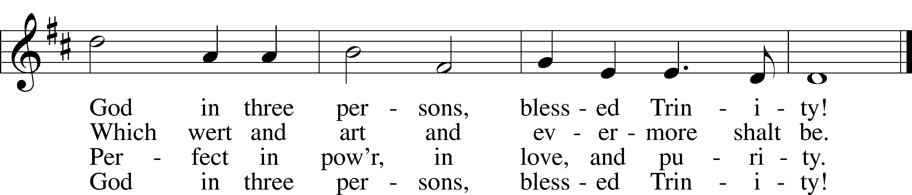

*Text: Reginald Heber, 1783–1826  
Tune: John B. Dykes, 1823–76  
Text and tune: Public domain*

# Confession and Absolution

Stand

The sign of the cross may be made by all in remembrance of their Baptism.

Invocation Matthew 28:19b; 18:20

P In the name of the Father and of the T Son and of the Holy Spirit.

C **Amen.**

Exhortation Psalm 124:8; Psalm 130:3–4; Luke 18:13

P Our help is in the name of the Lord,

C **who made heaven and earth.**

P If You, O Lord, kept a record of sins, O Lord, who could stand?

C **But with You there is forgiveness; therefore You are feared.**

P Since we are gathered to hear God’s Word, call upon Him in prayer and praise, and receive the body and blood of our Lord Jesus Christ in the fellowship of this altar, let us first consider our unworthiness and confess before God and one another that we have sinned in thought, word, and deed, and that we cannot free ourselves from our sinful condition. Together as His people let us take refuge in the infinite mercy of God, our heavenly Father, seeking His grace for the sake of Christ, and saying: God, be merciful to me, a sinner.

Kneel/Stand

Confession of Sins

C **Almighty God, have mercy upon us, forgive us our sins, and lead us to everlasting life. Amen.**

Absolution [John 20:19–23]

P Almighty God in His mercy has given His Son to die for you and for His sake forgives you all your sins. As a called and ordained servant of Christ, and by His authority, I therefore forgive you all your sins in the name of the Father and of the T Son and of the Holy Spirit.

C **Amen.**

Stand

# Service of the Word

Introit Psalm 16:8–11; antiphon: Liturgical Text

Blessèd be the Holy Trinity and the undivided Unity.  
 Let us give glory to him because he has shown his mercy to us.  
**I have set the Lord always before me;  
 because he is at my right hand, I shall not be shaken.**Therefore my heart is glad, and my whole being rejoices;  
 my flesh also dwells secure.  
**For you will not abandon my soul to Sheol,  
 or let your holy one see corruption.**You make known to me the path of life;  
 in your presence there is fullness of joy; at your right hand are pleasures forevermore.  
**Glory be to the Father and to the Son**  
 **and to the Holy Spirit;**  
**as it was in the beginning,**  
 **is now, and will be forever. Amen.**  
Blessèd be the Holy Trinity and the undivided Unity.  
 Let us give glory to him because he has shown his mercy to us.

Kyrie Mark 10:47

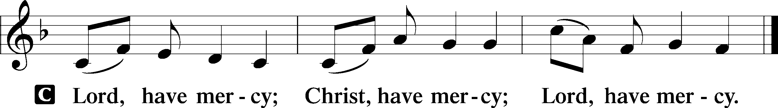

Gloria in Excelsis Luke 2:14; John 1:29

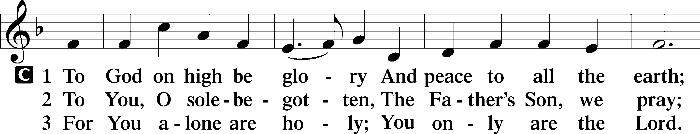

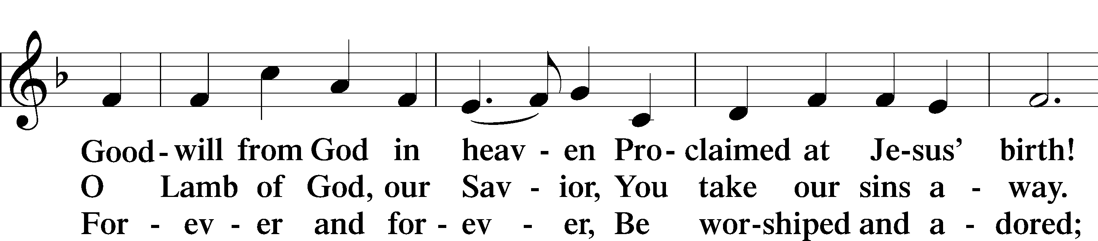

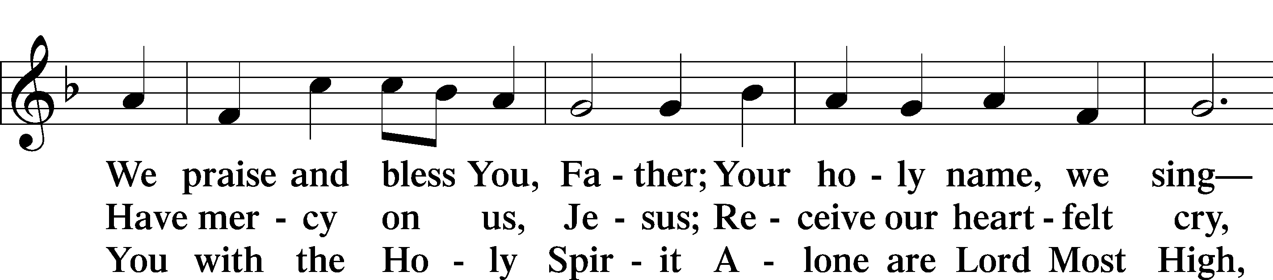

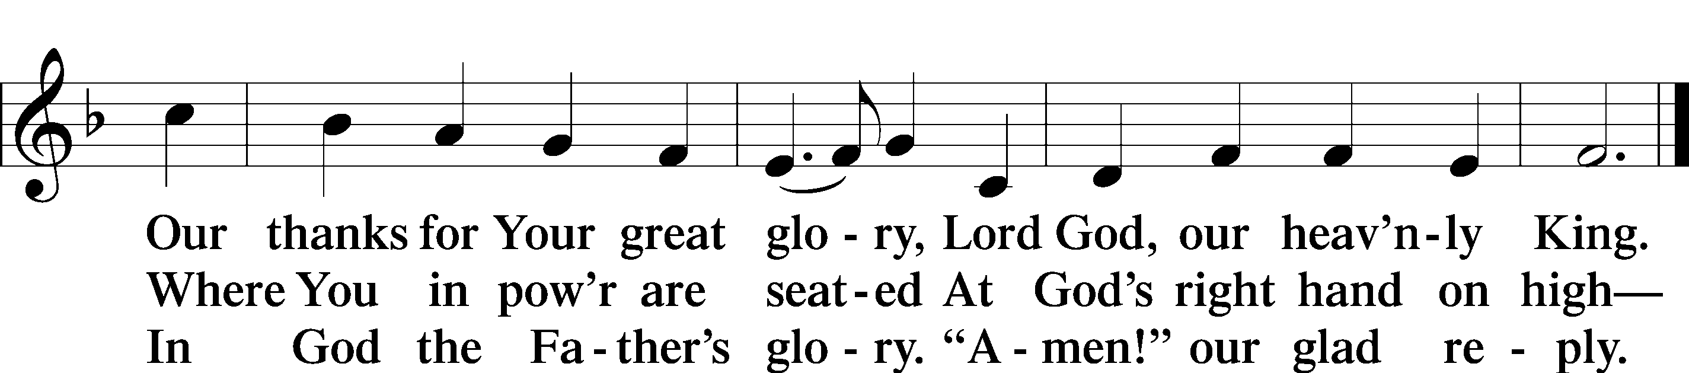

Text: Stephen P. Starke

Salutation and Collect of the Day

P The Lord be with you.

C **And also with you.**

P Let us pray.

Almighty and everlasting God, You have given us grace to acknowledge the glory of the eternal Trinity by the confession of a true faith and to worship the Unity in the power of the Divine Majesty. Keep us steadfast in this faith and defend us from all adversities; for You, O Father, Son, and Holy Spirit, live and reign, one God, now and forever.

C **Amen.**

Sit

Old Testament Reading Proverbs 8:1–4, 22–31

1Does not wisdom call?  
 Does not understanding raise her voice?  
2On the heights beside the way,  
 at the crossroads she takes her stand;  
3beside the gates in front of the town,  
 at the entrance of the portals she cries aloud:  
4“To you, O men, I call,  
 and my cry is to the children of man. . . .

22“The Lord possessed me at the beginning of his work,  
 the first of his acts of old.  
23Ages ago I was set up,  
 at the first, before the beginning of the earth.  
24When there were no depths I was brought forth,  
 when there were no springs abounding with water.  
25Before the mountains had been shaped,  
 before the hills, I was brought forth,  
26before he had made the earth with its fields,  
 or the first of the dust of the world.  
27When he established the heavens, I was there;  
 when he drew a circle on the face of the deep,  
28when he made firm the skies above,  
 when he established the fountains of the deep,  
29when he assigned to the sea its limit,  
 so that the waters might not transgress his command,  
when he marked out the foundations of the earth,  
 30then I was beside him, like a master workman,  
and I was daily his delight,  
 rejoicing before him always,  
31rejoicing in his inhabited world  
 and delighting in the children of man.”

A This is the Word of the Lord.

C **Thanks be to God.**

Gradual Romans 10:8b, 10

The word is near you, in your mouth and in your heart,  
 the word of faith that we proclaim.  
**For with the heart one believes and is justified,  
 and with the mouth one confesses and is saved.**

Second Reading Acts 2:14a, 22–36

14Peter, standing with the eleven, lifted up his voice and addressed them, . . .

22“Men of Israel, hear these words: Jesus of Nazareth, a man attested to you by God with mighty works and wonders and signs that God did through him in your midst, as you yourselves know— 23this Jesus, delivered up according to the definite plan and foreknowledge of God, you crucified and killed by the hands of lawless men. 24God raised him up, loosing the pangs of death, because it was not possible for him to be held by it. 25For David says concerning him,

“‘I saw the Lord always before me,  
 for he is at my right hand that I may not be shaken;  
26therefore my heart was glad, and my tongue rejoiced;  
 my flesh also will dwell in hope.  
27For you will not abandon my soul to Hades,  
 or let your Holy One see corruption.  
28You have made known to me the paths of life;  
 you will make me full of gladness with your presence.’

29“Brothers, I may say to you with confidence about the patriarch David that he both died and was buried, and his tomb is with us to this day. 30Being therefore a prophet, and knowing that God had sworn with an oath to him that he would set one of his descendants on his throne, 31he foresaw and spoke about the resurrection of the Christ, that he was not abandoned to Hades, nor did his flesh see corruption. 32This Jesus God raised up, and of that we all are witnesses. 33Being therefore exalted at the right hand of God, and having received from the Father the promise of the Holy Spirit, he has poured out this that you yourselves are seeing and hearing. 34For David did not ascend into the heavens, but he himself says,

“‘The Lord said to my Lord,  
Sit at my right hand,  
 35until I make your enemies your footstool.’

36Let all the house of Israel therefore know for certain that God has made him both Lord and Christ, this Jesus whom you crucified.”

A This is the Word of the Lord.

C **Thanks be to God.**

Stand

Alleluia and Verse

Alleluia

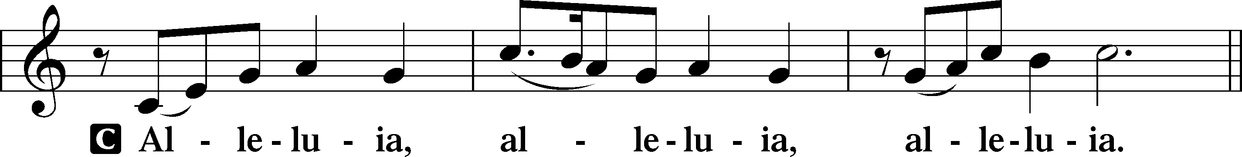

Verse John 20:31

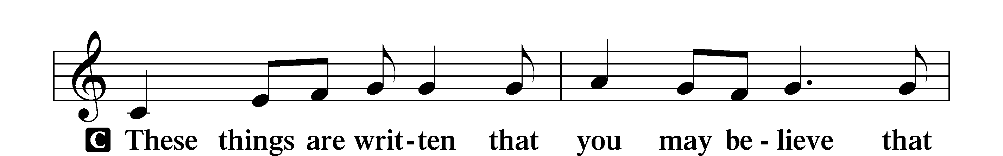

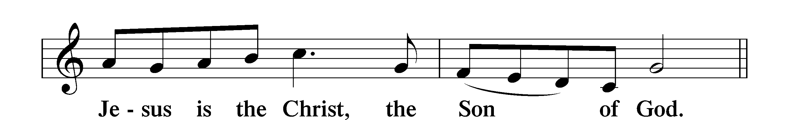

Alleluia

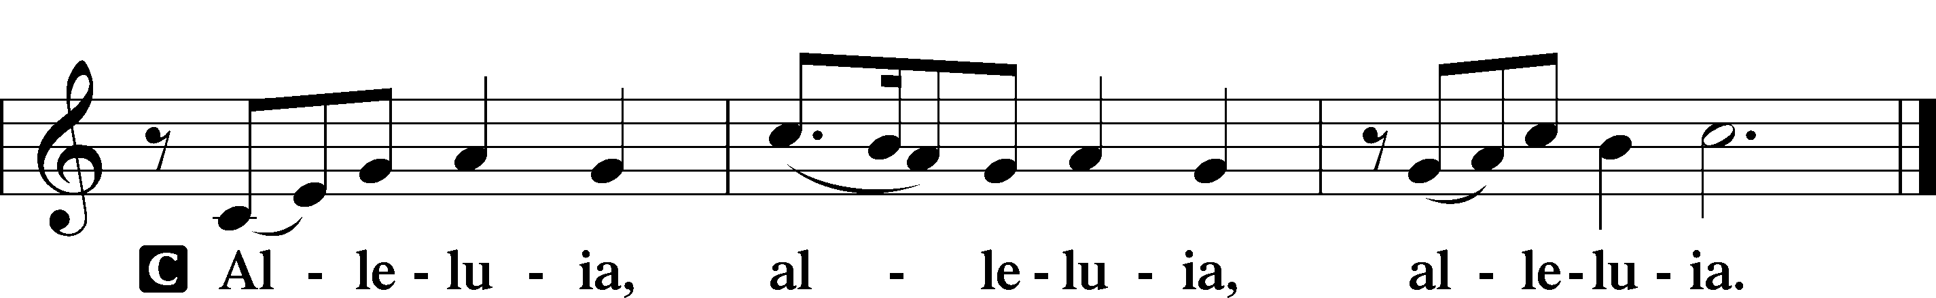

Holy Gospel John 8:48–59

P The Holy Gospel according to St. John, the eighth chapter.

C **Glory to You, O Lord.**

48The Jews answered [Jesus], “Are we not right in saying that you are a Samaritan and have a demon?” 49Jesus answered, “I do not have a demon, but I honor my Father, and you dishonor me. 50Yet I do not seek my own glory; there is One who seeks it, and he is the judge. 51Truly, truly, I say to you, if anyone keeps my word, he will never see death.” 52The Jews said to him, “Now we know that you have a demon! Abraham died, as did the prophets, yet you say, ‘If anyone keeps my word, he will never taste death.’ 53Are you greater than our father Abraham, who died? And the prophets died! Who do you make yourself out to be?” 54Jesus answered, “If I glorify myself, my glory is nothing. It is my Father who glorifies me, of whom you say, ‘He is our God.’ 55But you have not known him. I know him. If I were to say that I do not know him, I would be a liar like you, but I do know him and I keep his word. 56Your father Abraham rejoiced that he would see my day. He saw it and was glad.” 57So the Jews said to him, “You are not yet fifty years old, and have you seen Abraham?” 58Jesus said to them, “Truly, truly, I say to you, before Abraham was, I am.” 59So they picked up stones to throw at him, but Jesus hid himself and went out of the temple.

P This is the Gospel of the Lord.

C **Praise to You, O Christ.**

Nicene Creed

C **I believe in one God,**

**the Father Almighty,**

**maker of heaven and earth**

**and of all things visible and invisible.**

**And in one Lord Jesus Christ,**

**the only-begotten Son of God,**

**begotten of His Father before all worlds,**

**God of God, Light of Light,**

**very God of very God,**

**begotten, not made,**

**being of one substance with the Father,**

**by whom all things were made;**

**who for us men and for our salvation came down from heaven**

**and was incarnate by the Holy Spirit of the virgin Mary**

**and was made man;**

**and was crucified also for us under Pontius Pilate.**

**He suffered and was buried.**

**And the third day He rose again according to the Scriptures**

**and ascended into heaven**

**and sits at the right hand of the Father.**

**And He will come again with glory to judge both the living and the dead,**

**whose kingdom will have no end.**

**And I believe in the Holy Spirit,**

**the Lord and giver of life,**

**who proceeds from the Father and the Son,**

**who with the Father and the Son together is worshiped and glorified,**

**who spoke by the prophets.**

**And I believe in one holy Christian and apostolic Church,**

**I acknowledge one Baptism for the remission of sins,**

**and I look for the resurrection of the dead**

**and the life** T **of the world to come. Amen.**

Sit

Children's Sermon

940 Holy God, We Praise Thy Name sts. 1–5

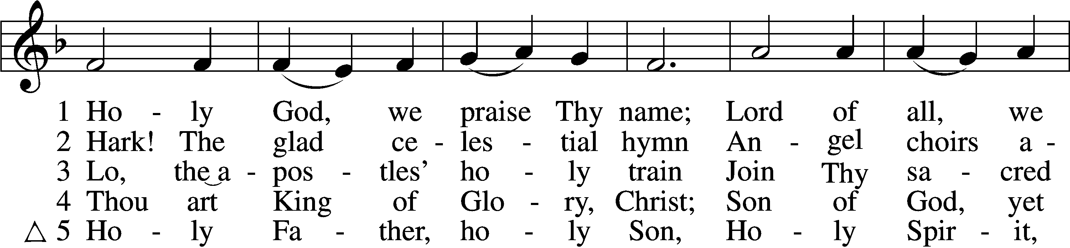

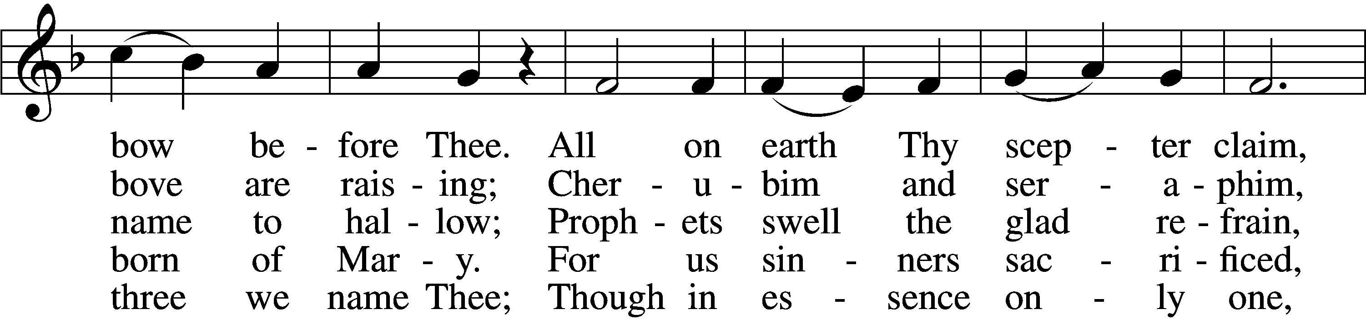

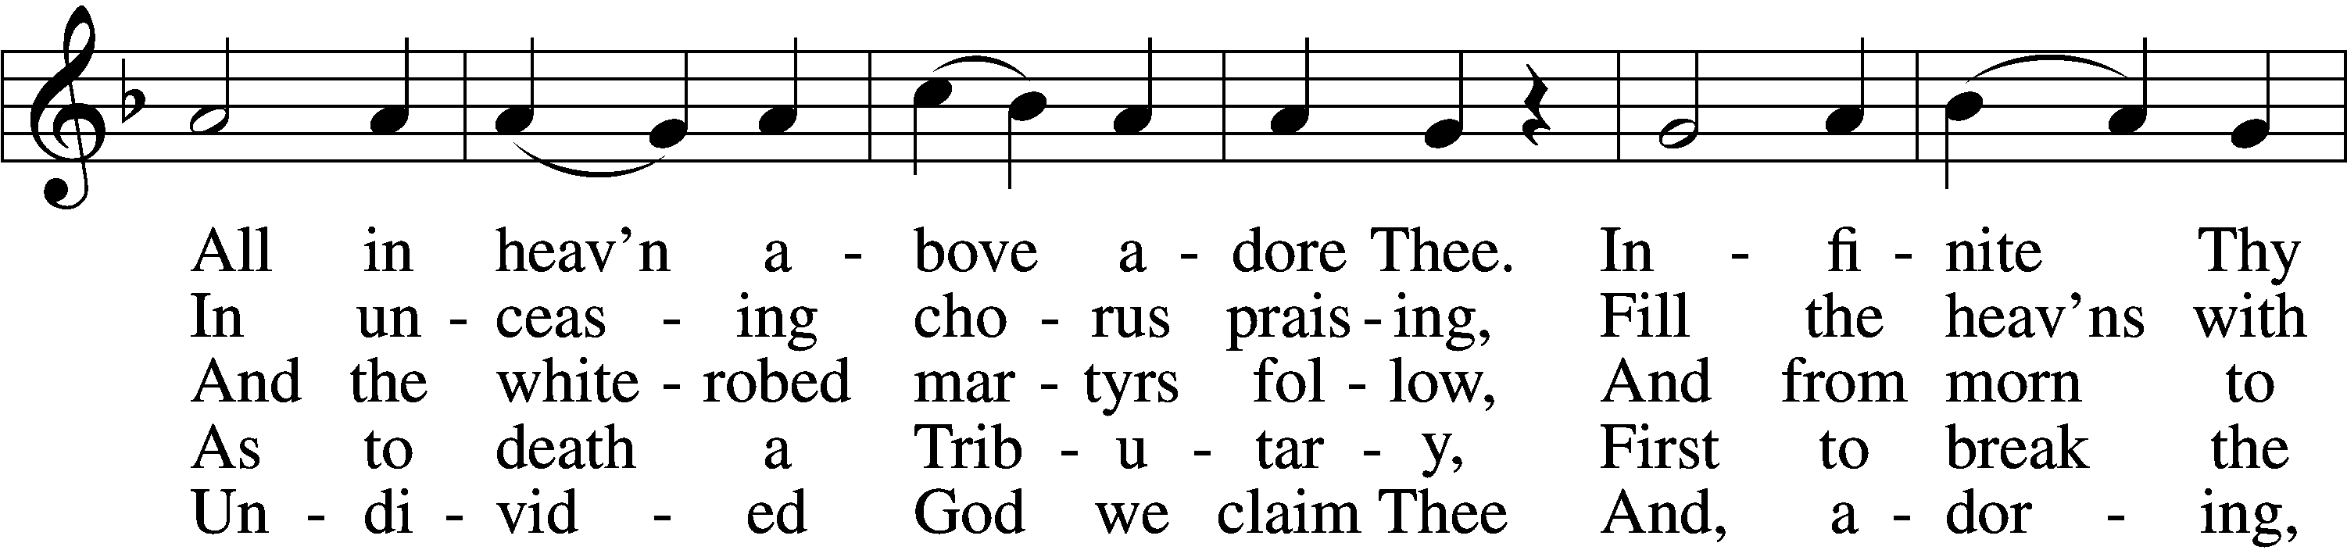

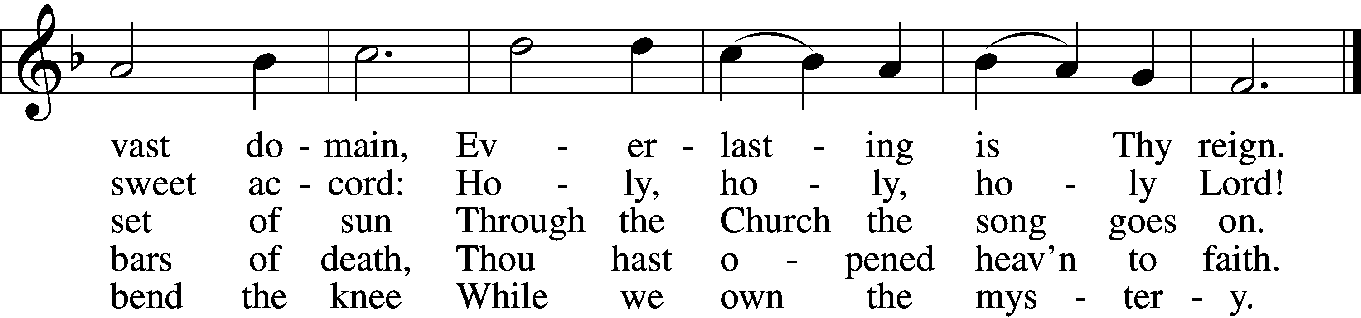

Text: Latin, c. 4th cent.; German version Katholisches Gesangbuch, 1774, Vienna; tr. Clarence A. Walworth, 1820–1900, alt.  
Tune: Katholisches Gesangbuch, 1774, Vienna  
Text and tune: Public domain

Sermon

Stand

Prayer of the Church

Following the prayers, the people may greet one another in the name of the Lord, saying, “Peace be with you,” as a sign of reconciliation and of the unity of the Spirit in the bond of peace (Matt. 5:22–24; Eph. 4:1–3).

Sit

Offering

805 Praise God, from Whom All Blessings Flow

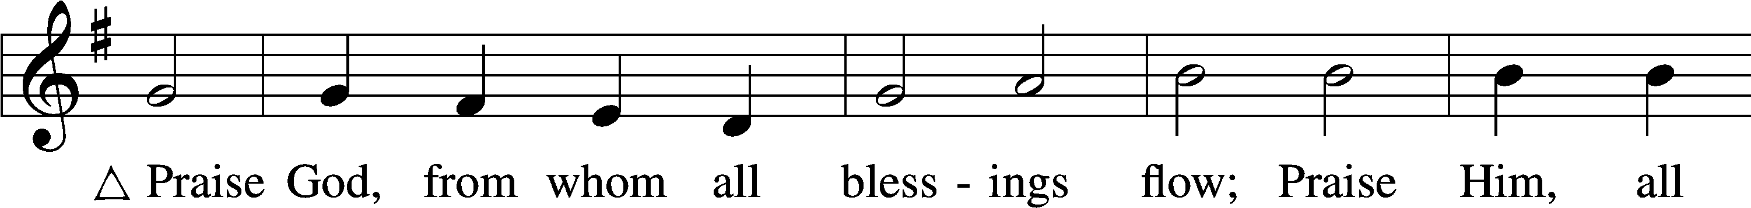

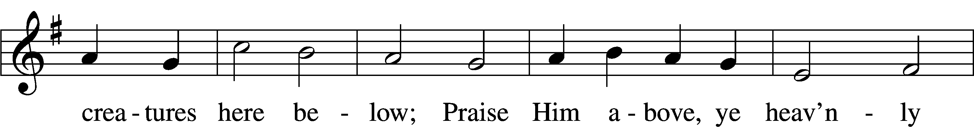

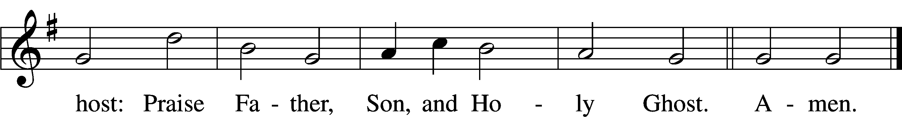

Text: Thomas Ken, 1637–1711  
Tune: Trente quatre Pseaumes de David, 1551, Geneva, ed. Louis Bourgeois  
Text and tune: Public domain

# Service of the Sacrament

Stand

Preface 2 Timothy 4:22; [Colossians 3:1]; [Psalm 136]

P The Lord be with you.

C **And also with you.**

P Lift up your hearts.

C **We lift them to the Lord.**

P Let us give thanks to the Lord our God.

C **It is right to give Him thanks and praise.**

P It is truly good, right, and salutary that we should at all times and in all places give thanks to You, O Lord, holy Father, almighty and everlasting God, for the countless blessings You so freely bestow on us and all creation. Above all, we give thanks for Your boundless love shown to us when You sent Your only-begotten Son, Jesus Christ, into our flesh and laid on Him our sin, giving Him into death that we might not die eternally. Because He is now risen from the dead and lives and reigns to all eternity, all who believe in Him will overcome sin and death and will rise again to new life. Therefore with angels and archangels and with all the company of heaven we laud and magnify Your glorious name, evermore praising You and saying:

Sanctus Isaiah 6:3; Matthew 21:9

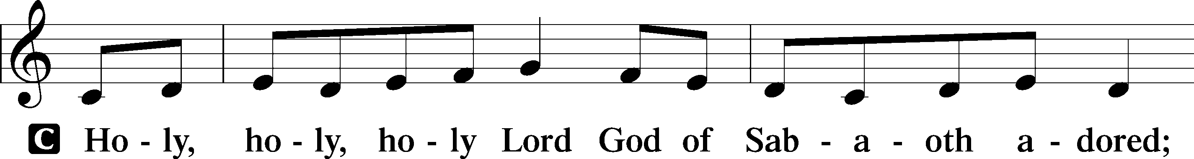

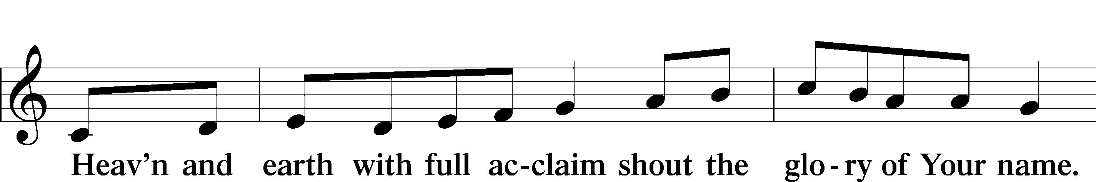

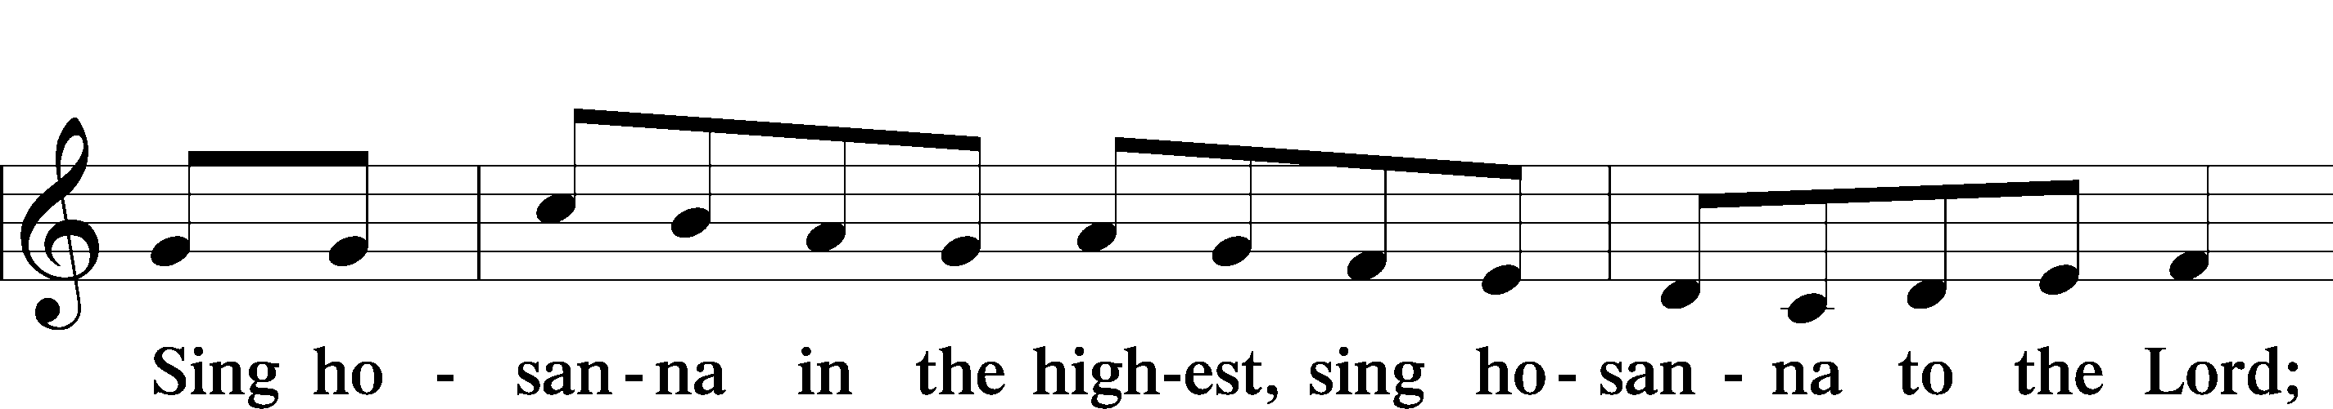

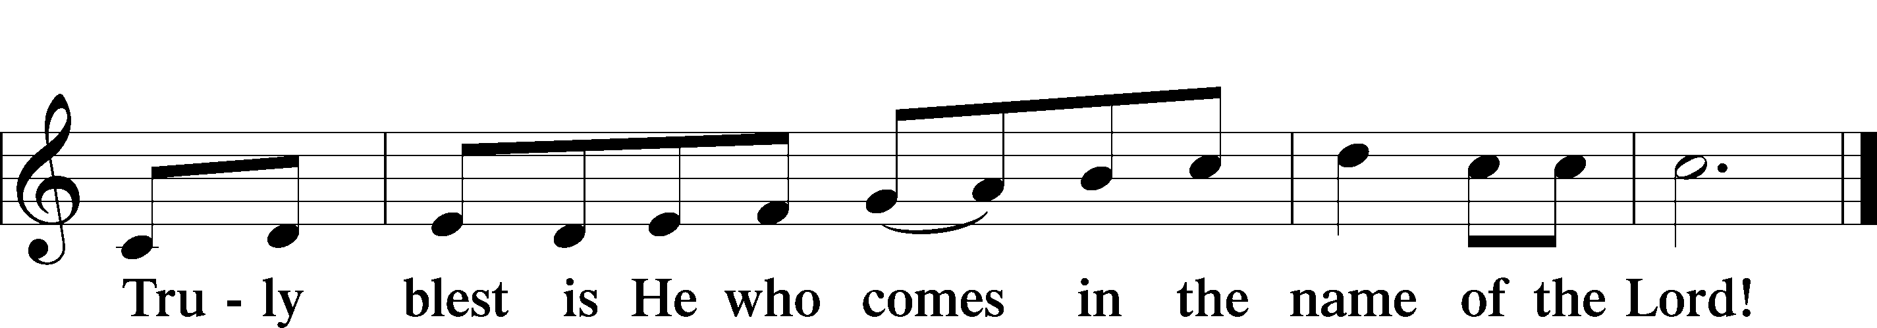

Text: Stephen P. Starke

Prayer of Thanksgiving

P Blessed are You, O Lord our God, king of all creation, for You have had mercy on us and given Your only-begotten Son that whoever believes in Him should not perish but have eternal life.

You once revealed Your name to Moses in the burning bush; and through Your beloved Son, Jesus Christ, You unveiled the mystery of Your holy name in the Trinity of persons and the Unity of being.

Grant that we, who have been baptized and instructed in the triune name, may faithfully eat and drink of Your Son’s body and blood and worship You in spirit and truth, O Father, through Your Son in the Holy Spirit.

Hear us as we pray in His name and as He has taught us:

Lord’s Prayer

C **Our Father who art in heaven,**

**hallowed be Thy name,**

**Thy kingdom come,**

**Thy will be done on earth**

**as it is in heaven;**

**give us this day our daily bread;**

**and forgive us our trespasses**

**as we forgive those**

**who trespass against us;**

**and lead us not into temptation,**

**but deliver us from evil.**

**For Thine is the kingdom**

**and the power and the glory**

**forever and ever. Amen.**

The Words of Our Lord

P Our Lord Jesus Christ, on the night when He was betrayed, took bread, and when He had given thanks, He broke it and gave it to the disciples and said: “Take, eat; this is My T body, which is given for you. This do in remembrance of Me.”

In the same way also He took the cup after supper, and when He had given thanks, He gave it to them, saying: “Drink of it, all of you; this cup is the new testament in My T blood, which is shed for you for the forgiveness of sins. This do, as often as you drink it, in remembrance of Me.”

Pax Domini

P The peace of the Lord be with you always.

C **Amen.**

Agnus Dei John 1:29

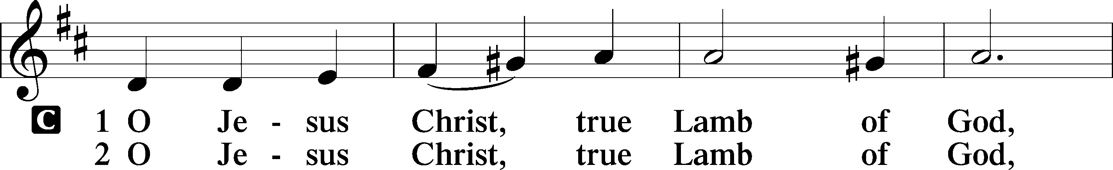

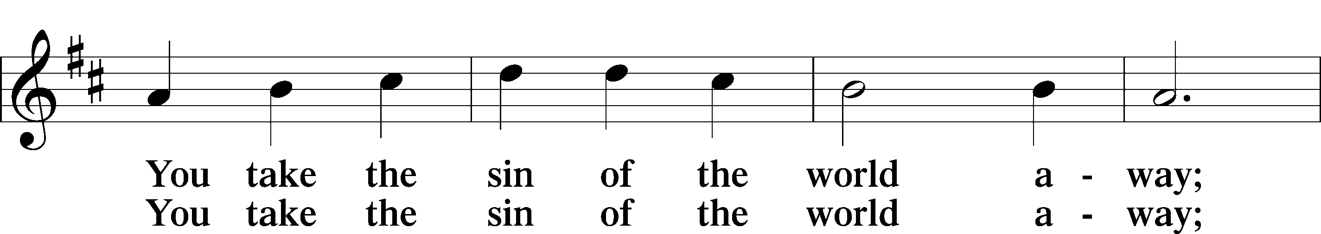

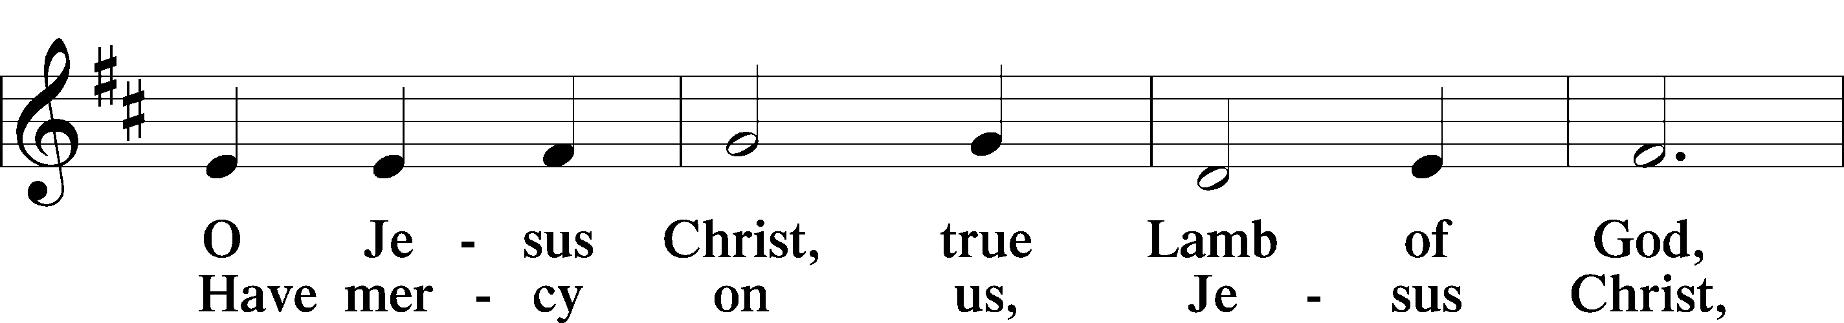

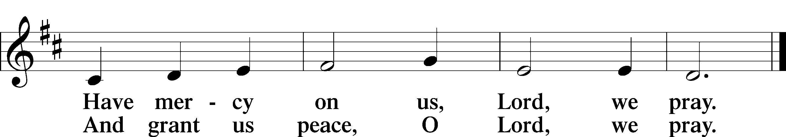

Text: Stephen P. Starke

Sit

Distribution

The pastor and those who assist him receive the body and blood of Christ first and then distribute them to those who come to receive, saying:

Take, eat; this is the true body of our Lord and Savior Jesus Christ, given into death for your sins.

**Amen.**

Take, drink; this is the true blood of our Lord and Savior Jesus Christ, shed for the forgiveness of your sins.

**Amen.**

In dismissing the communicants, the following is said:

The Dismissal

P The body and blood of our Lord Jesus Christ strengthen and preserve you in body and soul to life everlasting. Depart T in peace.

C **Amen.**

633 At the Lamb’s High Feast We Sing

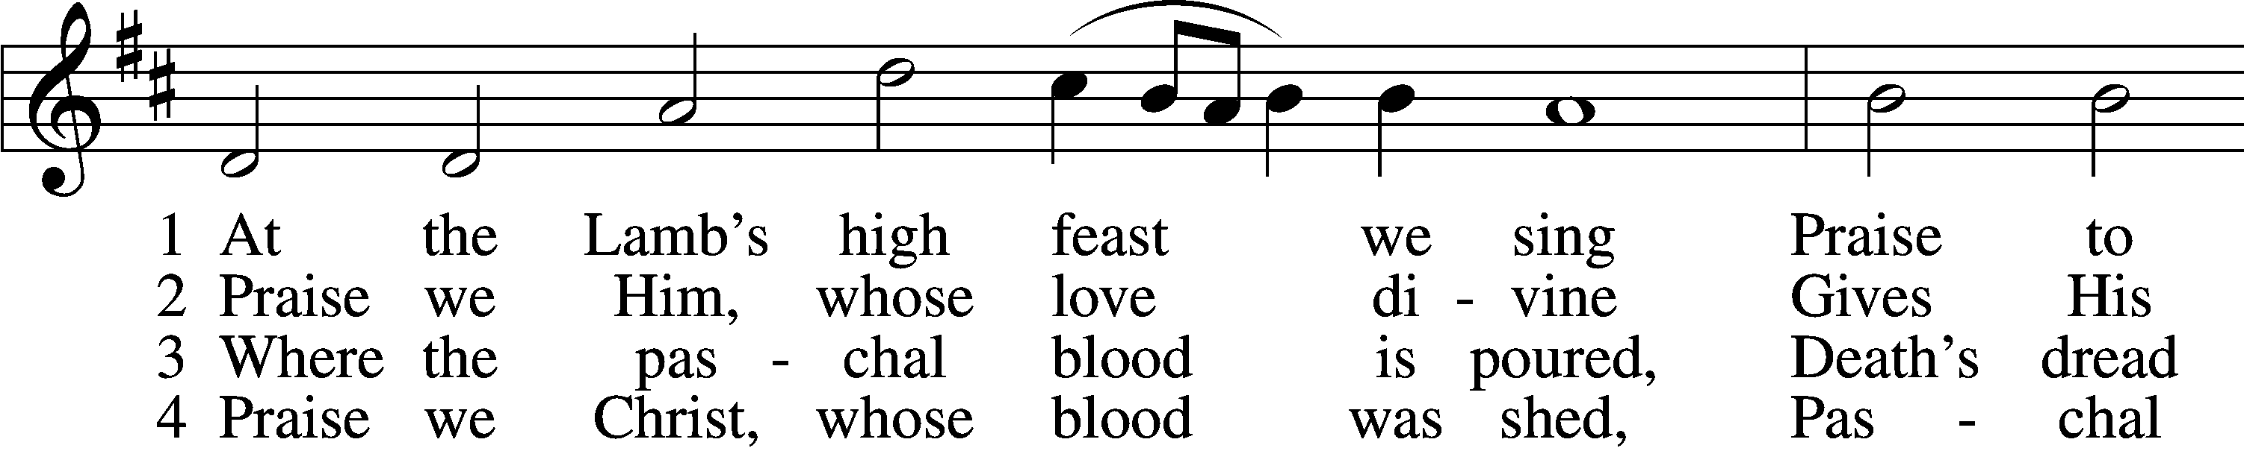

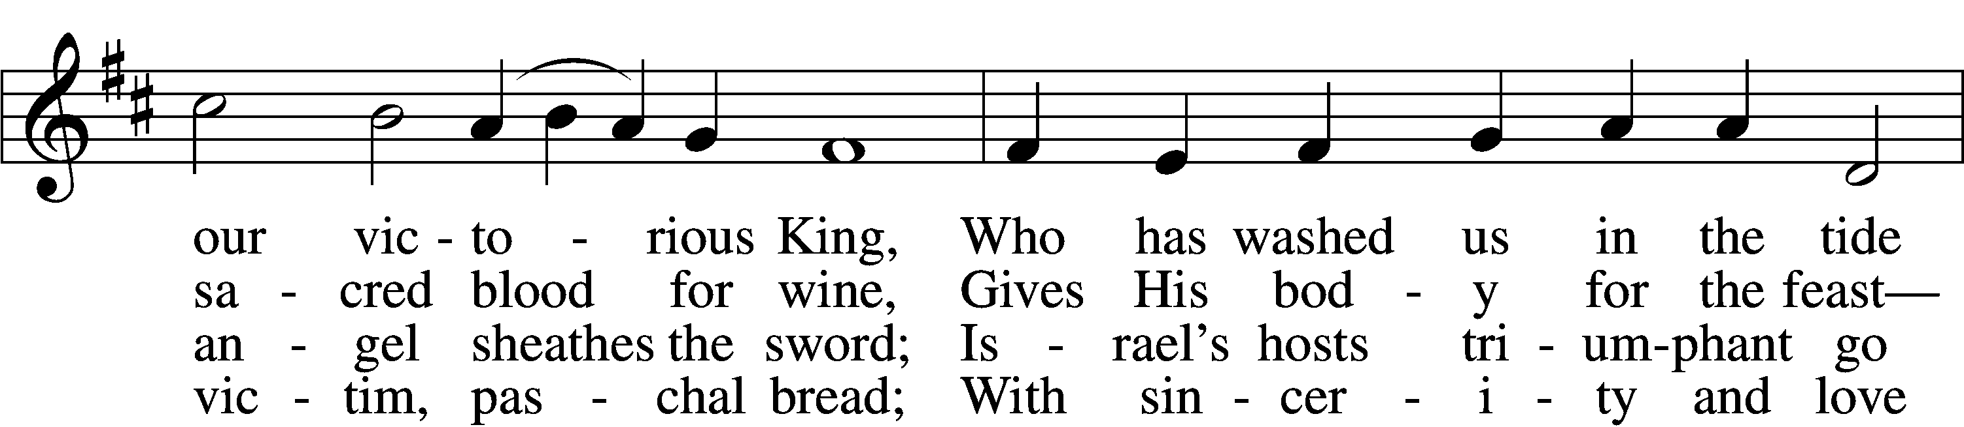

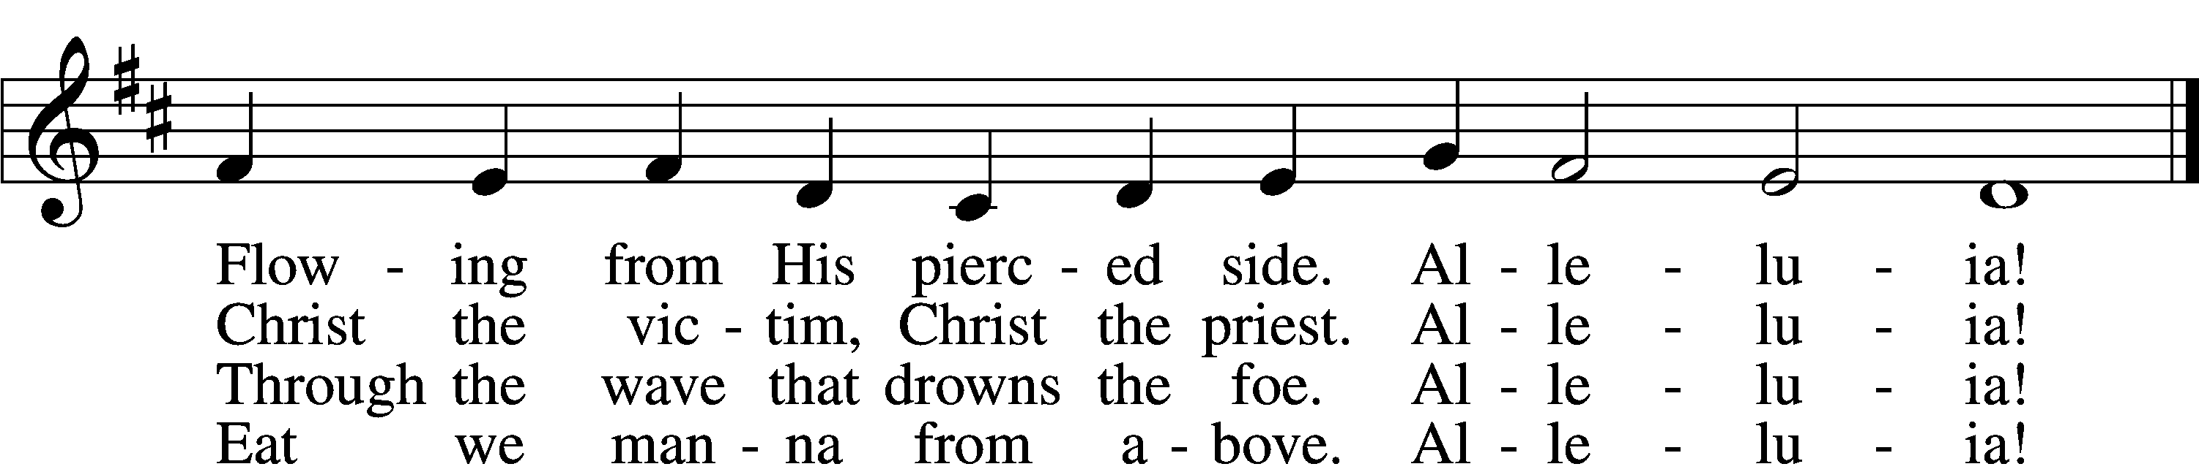

5 Mighty Victim from the sky,  
Hell’s fierce pow’rs beneath You lie;  
You have conquered in the fight,  
You have brought us life and light.  
 Alleluia!

6 Now no more can death appall,  
Now no more the grave enthrall;  
You have opened paradise,  
And Your saints in You shall rise.  
 Alleluia!

7 Easter triumph, Easter joy!  
This alone can sin destroy;  
From sin’s pow’r, Lord, set us free,  
Newborn souls in You to be.  
 Alleluia!

D 8 Father, who the crown shall give,  
Savior, by whose death we live,  
Spirit, guide through all our days:  
Three in One, Your name we praise.  
 Alleluia!

Text: Latin, c. 5th–10th cent.; tr. Robert Campbell, 1814–68, alt.  
Tune: Kirchengeseng, 1566, Ivancice  
Text and tune: Public domain

628 Your Table I Approach

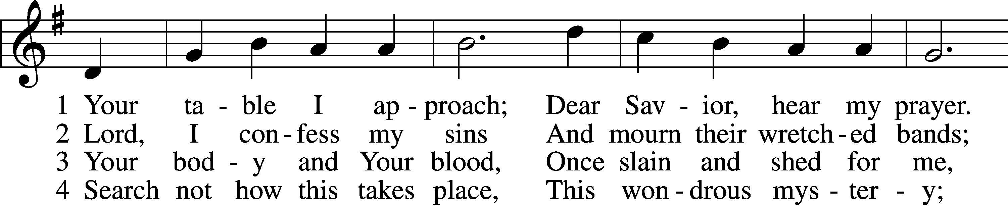

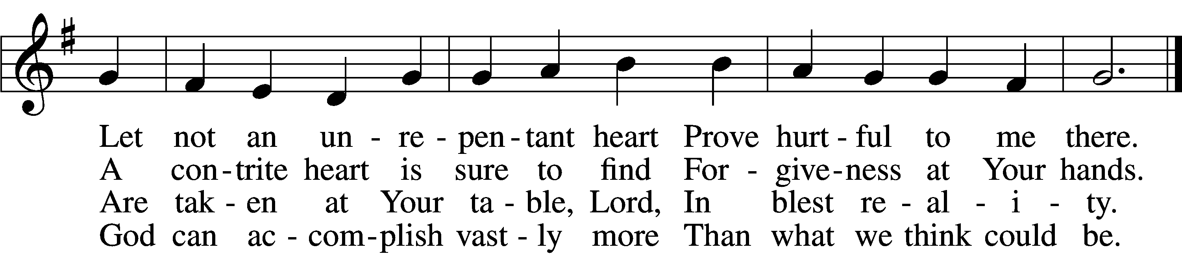

5 O grant, most blessèd Lord,  
 That earth and hell combined  
May not about this sacrament  
 Raise doubt within my mind.

6 Oh, may I never fail  
 To thank You day and night  
For Your true body and true blood,  
 O God, my peace and light.

Text: Gerhard Wolter Molanus, 1633–1722; tr. Matthias Loy, 1828–1915, alt.  
Tune: Trente quatre Pseaumes de David, 1551, Geneva, ed. Louis Bourgeois  
Text and tune: Public domain

618 I Come, O Savior, to Thy Table

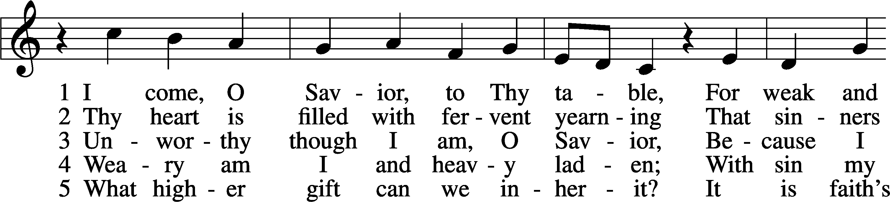

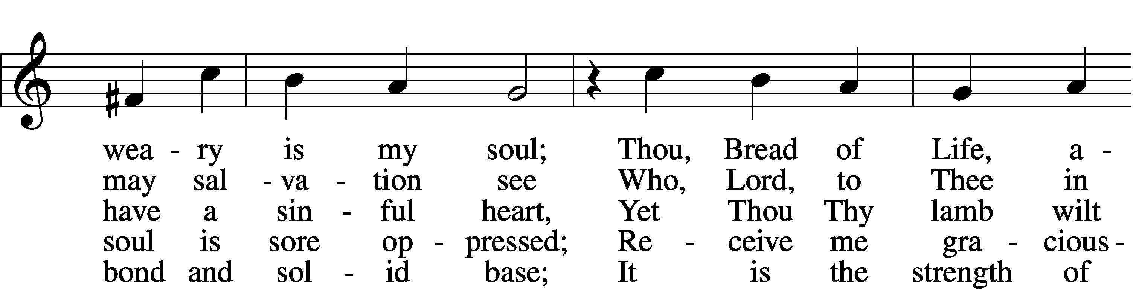

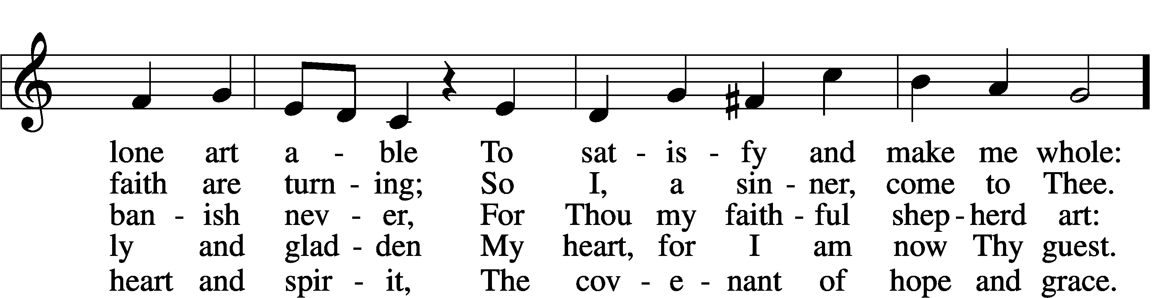

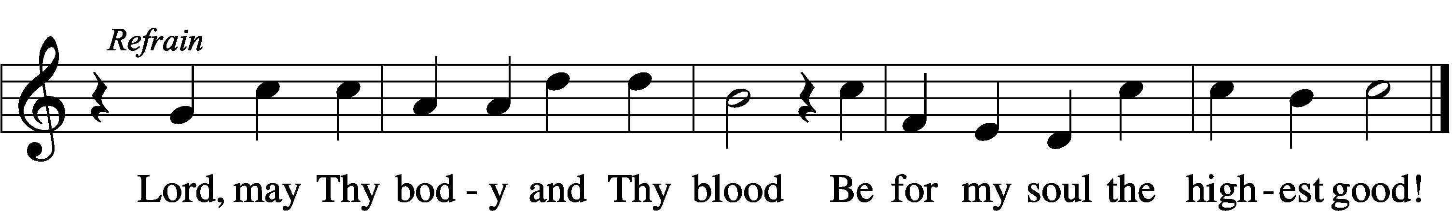

Text: Friedrich Christian Heyder, 1677–1754; tr. The Lutheran Hymnal, 1941, abr.  
Tune: Emskirchner Choral-Buch, 1756, Leipzig  
Text: © 1941 Concordia Publishing House. Used by permission: LSB Hymn License no. 110005011  
Tune: Public domain

924 Lord, Dismiss Us with Your Blessing

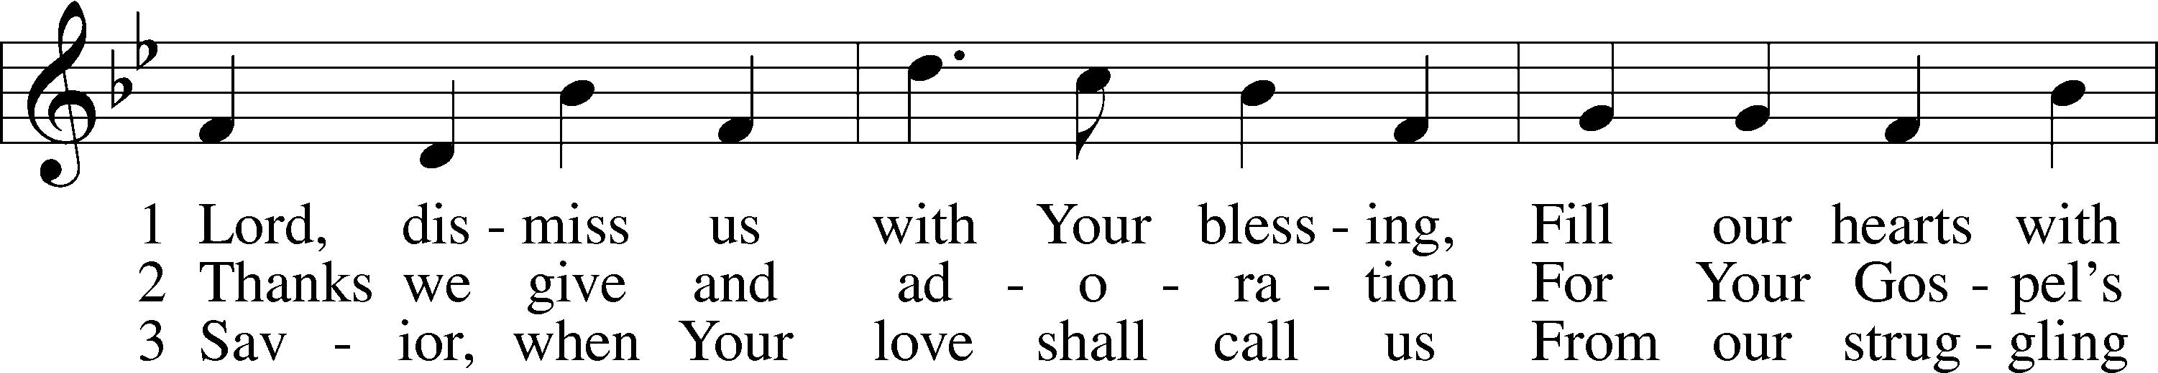

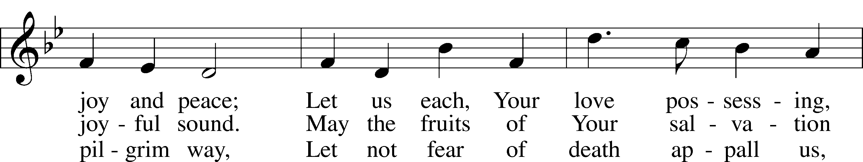

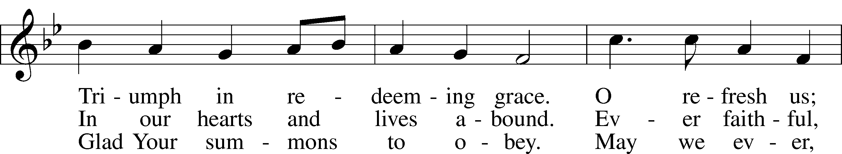

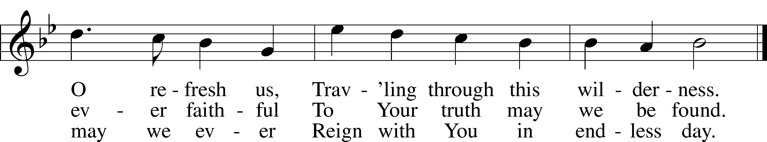

Text (sts. 1–2): attr. John Fawcett, 1740–1817, alt.; (st. 3): Godfrey Thring, 1823–1903, alt.  
Tune: Henry T. Smart, 1813–79  
Text and tune: Public domain

Stand

Nunc Dimittis Luke 2:29–32

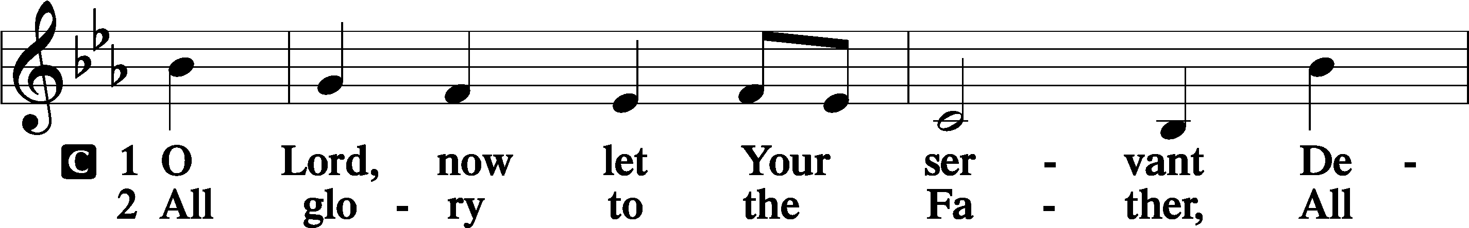

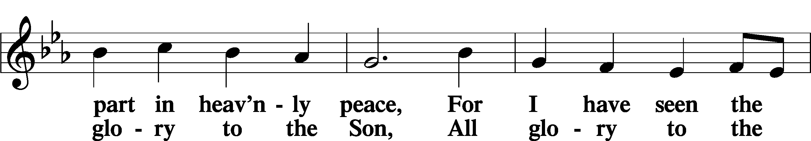

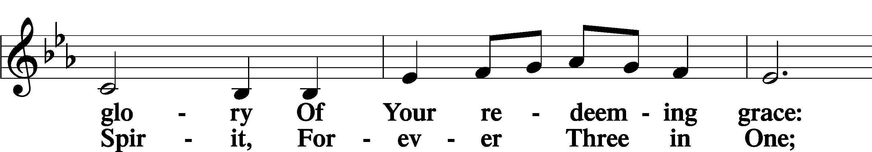

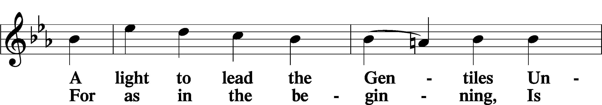

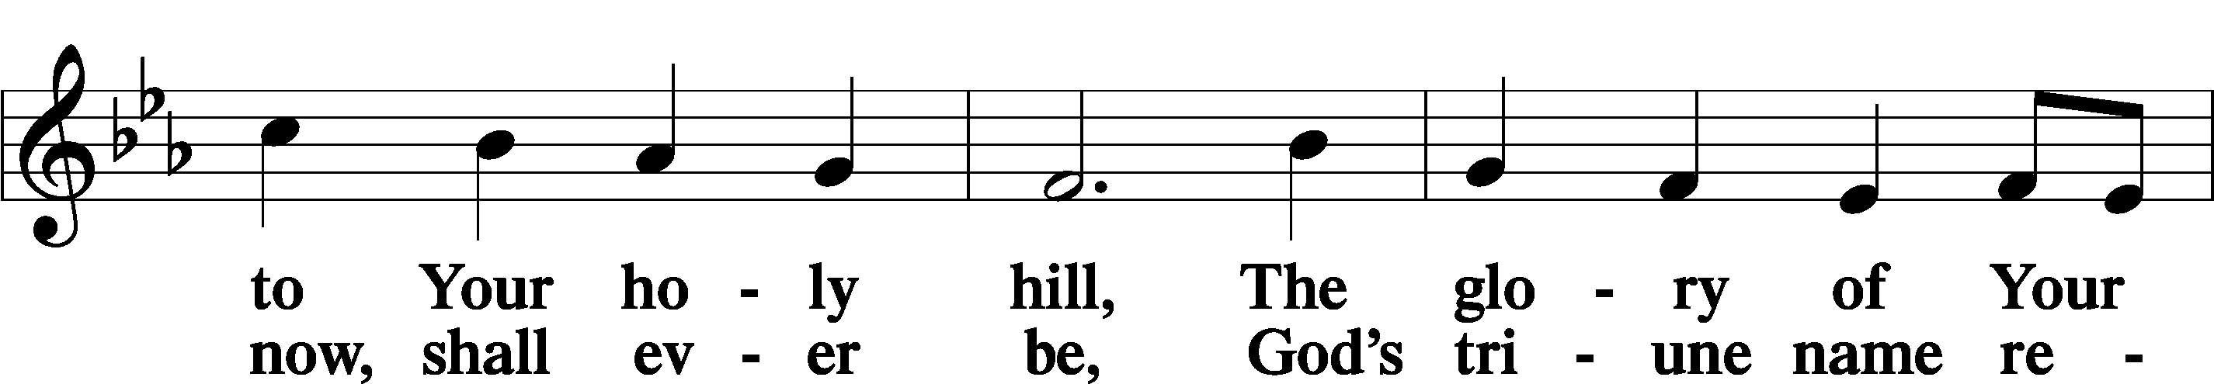

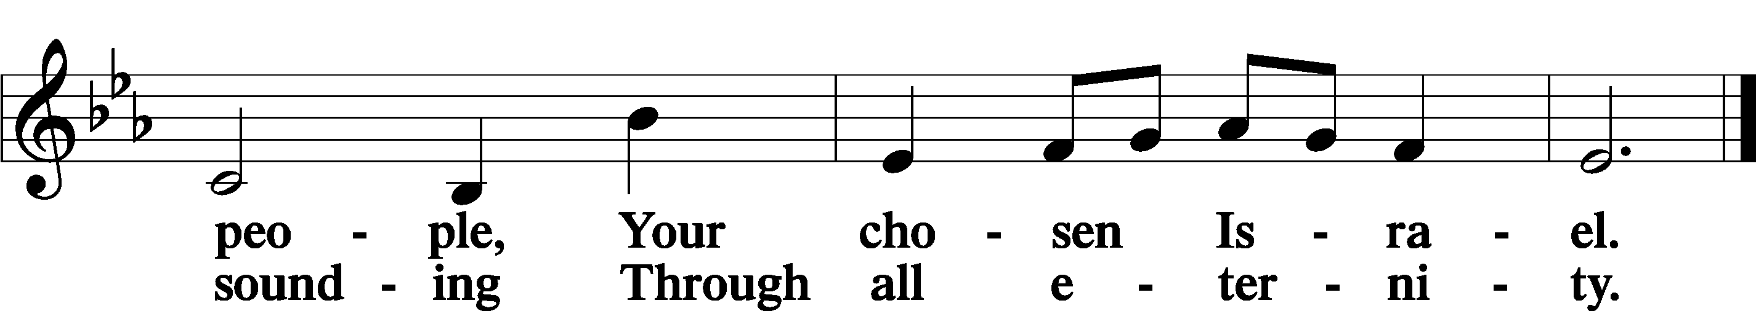

Post-Communion Collect

A Let us pray.

We give thanks to You, almighty God, that You have refreshed us through this salutary gift, and we implore You that of Your mercy You would strengthen us through the same in faith toward You and in fervent love toward one another; through Jesus Christ, Your Son, our Lord, who lives and reigns with You and the Holy Spirit, one God, now and forever.

C **Amen.**

Benedicamus Psalm 103:1

A Let us bless the Lord.

C **Thanks be to God.**

Benediction

P The Lord bless you and keep you.

The Lord make His face shine on you and be gracious to you.

The Lord look upon you with favor and T give you peace.

C **Amen.**

953 We All Believe in One True God

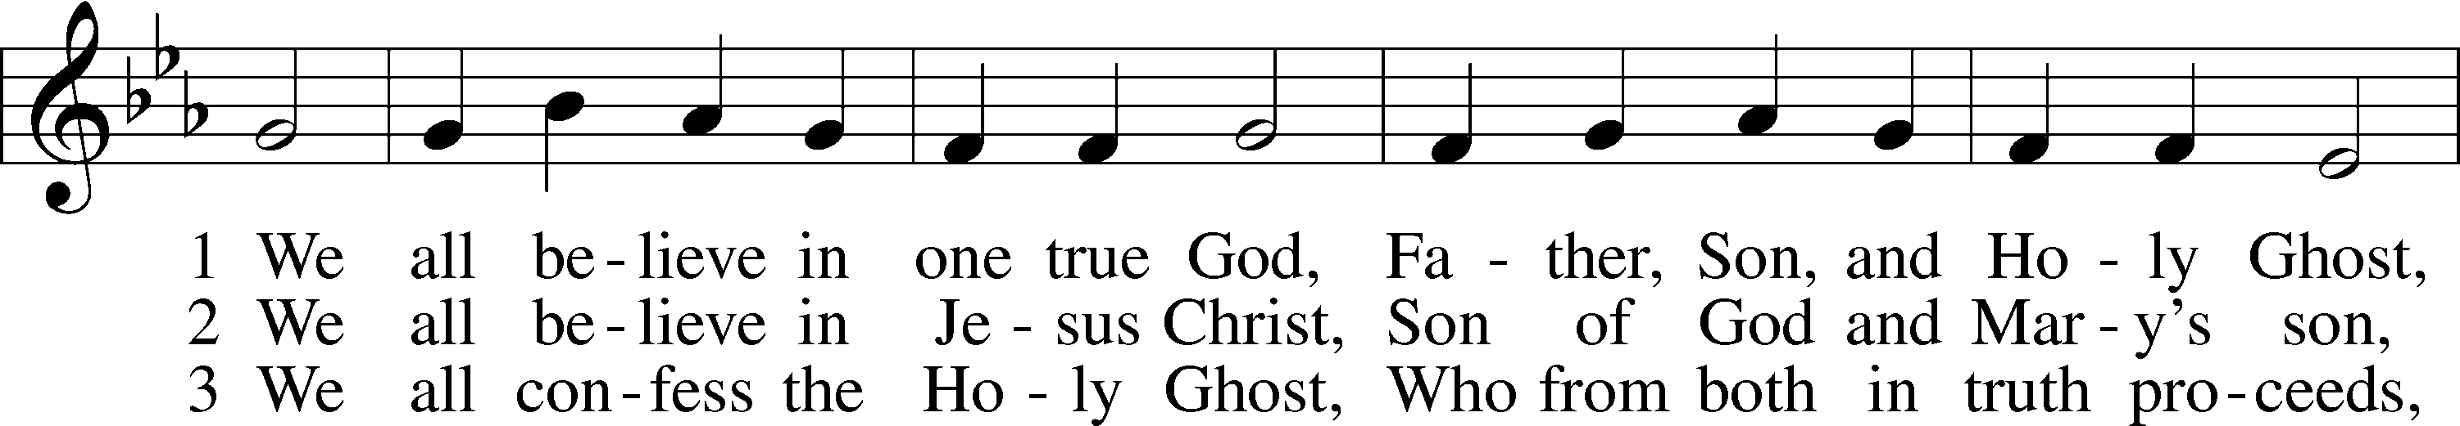

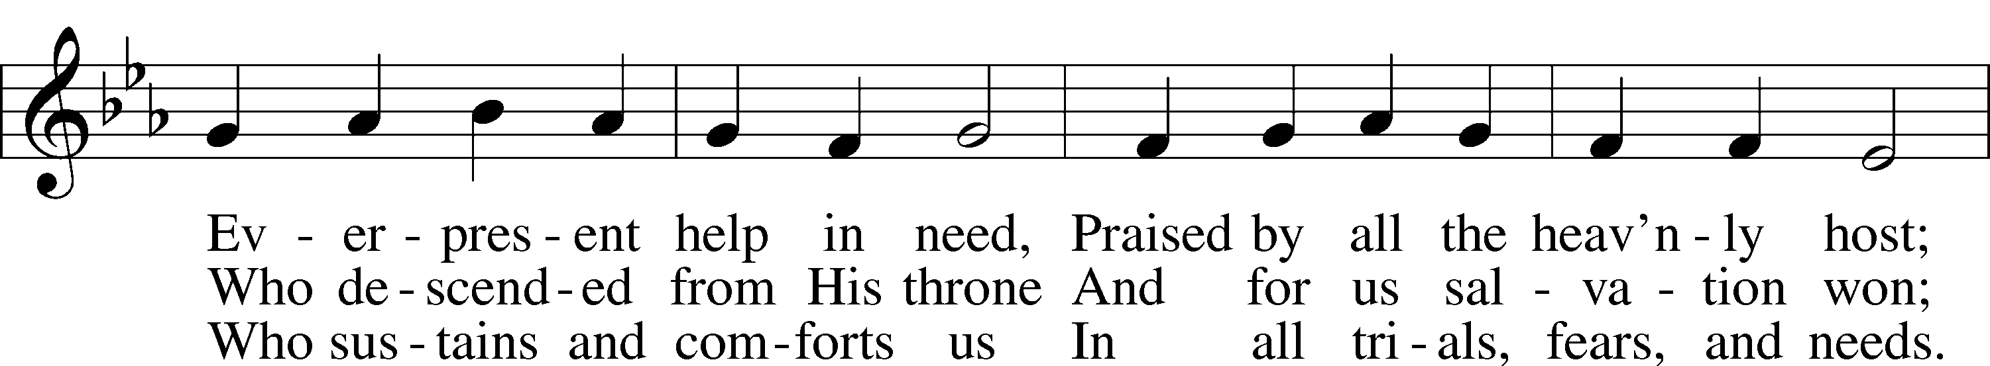

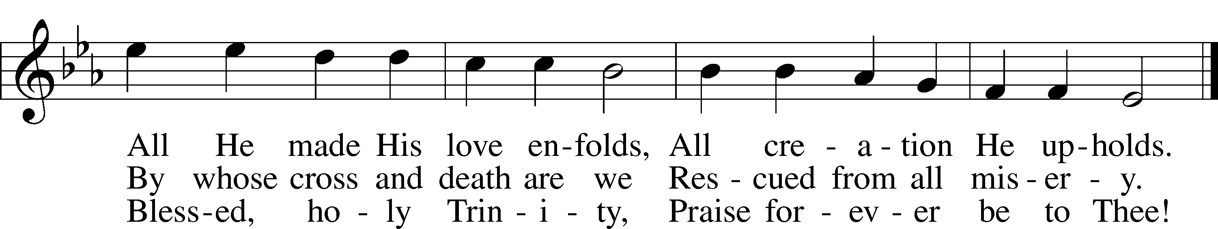

Text: Tobias Clausnitzer, 1619–84; tr. Catherine Winkworth, 1827–78, alt.  
Tune: Neu-vermehrtes . . . Gesangbuch, 1693, 3rd ed., Meiningen  
Text and tune: Public domain

Acknowledgments

Divine Service, Setting Four from Lutheran Service Book

Unless otherwise indicated, Scripture quotations are from the ESV® Bible (The Holy Bible, English Standard Version®), copyright © 2001 by Crossway, a publishing ministry of Good News Publishers. Used by permission. All rights reserved.

Created by Lutheran Service Builder © 2025 Concordia Publishing House.