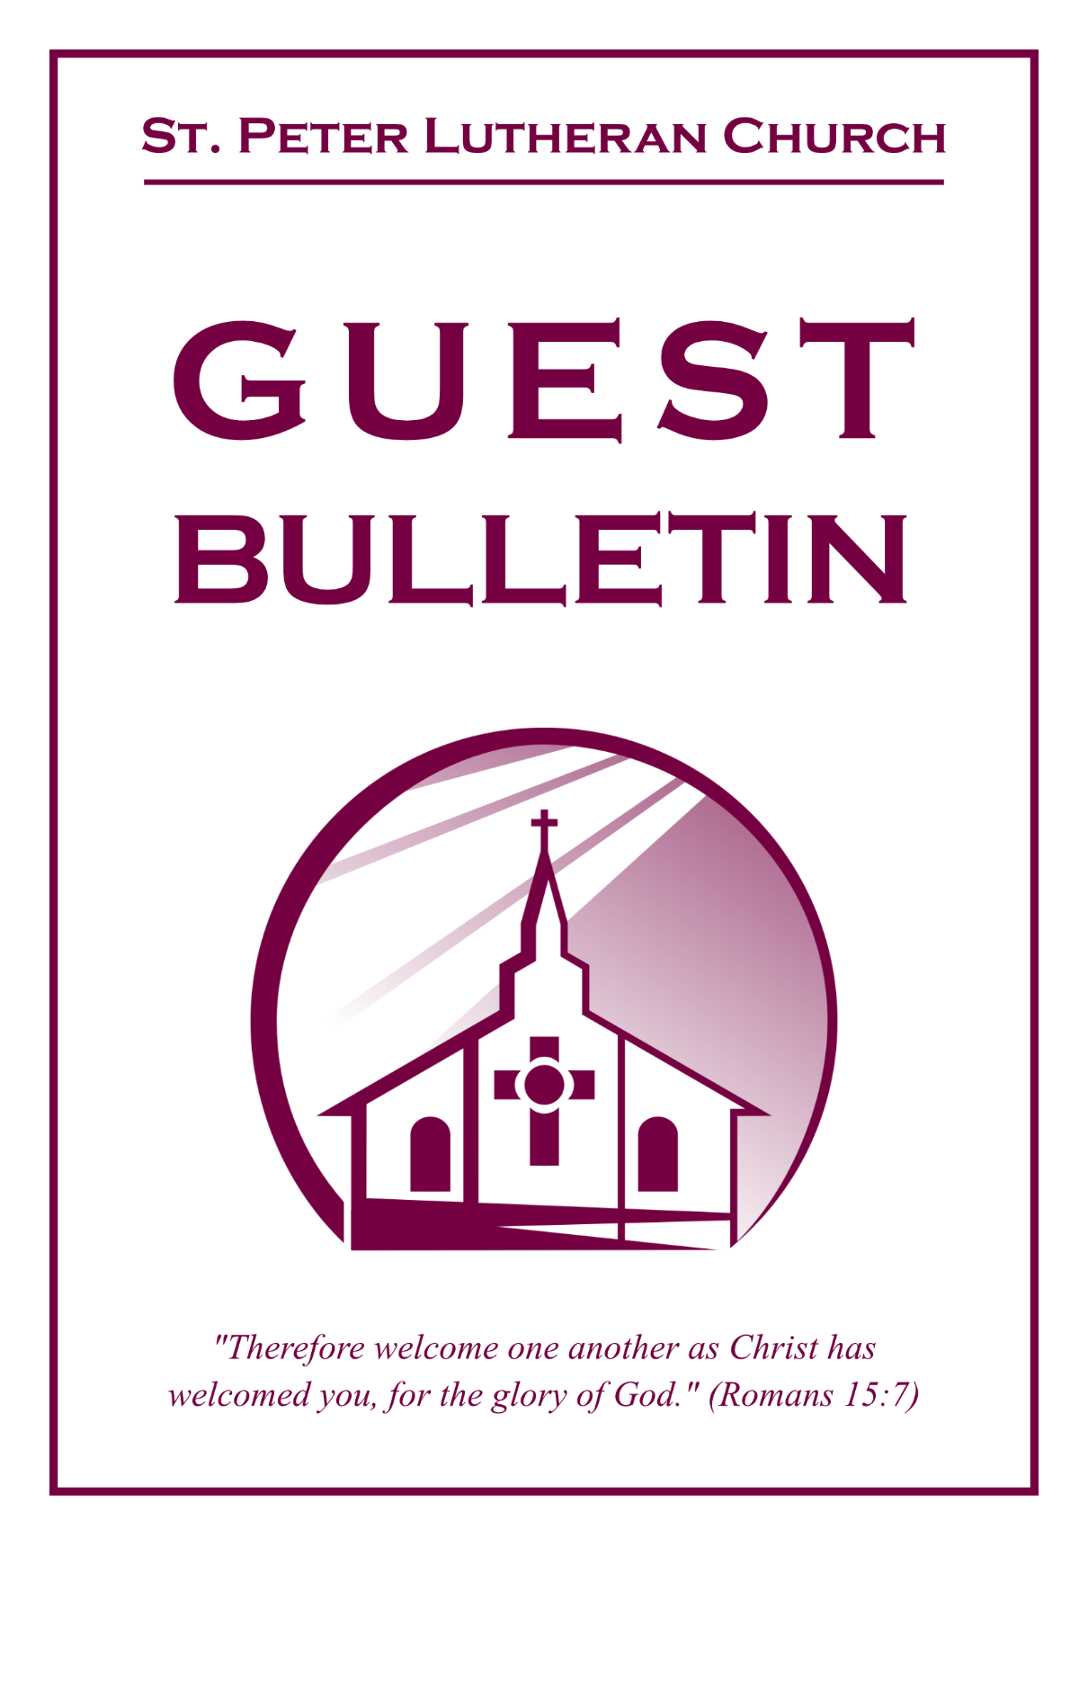

October 18, 2026



St. Peter Lutheran Church
Missouri Synod
906 Highway 59N, P.O. Box 133

Bowie, Texas 76230

Church (940) 872-1886 Fax ((940) 872-8837

Church E-mail: stpetertexscty@gmail.com
To Our Guests and Visitors:

We welcome all our friends in Christ who have come to worship with us. If you are a guest, please feel at home with us, sign our guest register, and worship with us whenever you are able. If you do not have a church home, we invite you to
consider becoming a part of our church family.

Website: www.stpetertex.com
Communion Statement:

The Lord’s Supper is celebrated at this congregation in the confession and glad confidence that, as He says, our Lord gives into our mouths not only bread and wine but His very Body and Blood to eat and drink for the forgiveness of sins and to strengthen our union with Him and one another.

Our Lord invites to His table those who trust in His words, repent of all sin, and set aside any refusal to forgive and love as He forgives and loves us, that they may show forth His death until He comes.

Because those who eat and drink our Lord’s Body and Blood unworthily do so to their great harm, and because Holy Communion is a confession of the faith, which is confessed at this altar, guests who are not confirmed members of an LCMS congregation and have not previously communed at this altar, are asked to first speak with our pastor.

If you are unable to do so before the service, it is out of Christian love and care for your souls that we ask you to refrain from communing this morning.

For further study, please see Matthew 5:23ff, 10:32ff, 18:15–35, 26:26–29; 1 Corinthians 11:17–34.

If you desire to receive a blessing for yourself or your children, please approach during
communion, cross your arms over your chest and bow your head as you kneel at the
altar rail.

Who Receives the Sacrament of the Altar Worthily?
Fasting and bodily preparation are certainly fine outward training. But that person is truly worthy and well prepared who has faith in these words: “Given and shed for you for the forgiveness of sins.” But anyone who does not believe these words or doubts them is unworthy and unprepared; for the words “for you” require all hearts to believe.
How May I Prepare?
See Dr. Luther’s self–examination questions and answers in the
LSB Hymnal on page 329

Upon entering the Sanctuary. please turn off cell phones, pagers. etc. Use the time as a quiet time for personal reflection and meditation in preparation for worship. This is a time for anyone to join in praying for the service, and for the church in general.
549 All Hail the Power of Jesus’ Name
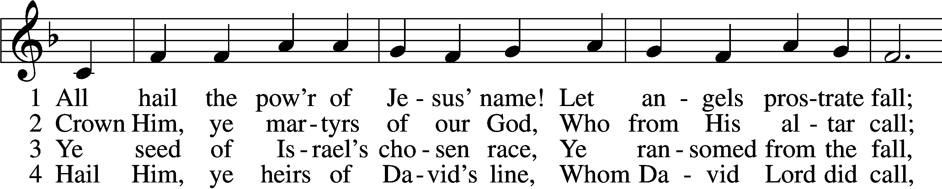
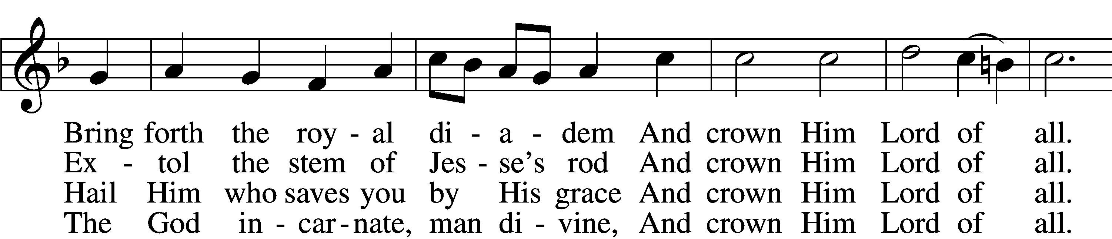
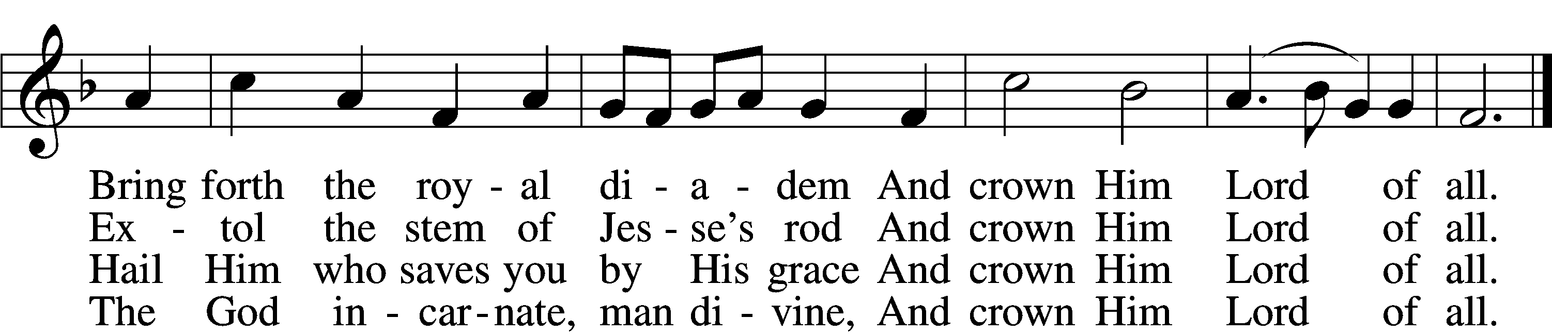

5 Sinners, whose love can ne’er forget
The wormwood and the gall,
Go, spread your trophies at His feet
And crown Him Lord of all.
Go, spread your trophies at His feet
And crown Him Lord of all.

6 Let ev’ry kindred, ev’ry tribe,
On this terrestrial ball
To Him all majesty ascribe
And crown Him Lord of all.
To Him all majesty ascribe
And crown Him Lord of all.

7 Oh, that with yonder sacred throng
We at His feet may fall!
We’ll join the everlasting song
And crown Him Lord of all.
We’ll join the everlasting song
And crown Him Lord of all.
Text (sts. 1–5): Edward Perronet, 1726–92, alt.; (sts. 6–7): A Selection of Hymns, 1787, London, alt.
Tune: Oliver Holden, 1765–1844
Text and tune: Public domain

Confession and Absolution

Stand

The sign of the cross may be made by all in remembrance of their Baptism.

Invocation Matthew 28:19b; 18:20
P In the name of the Father and of the T Son and of the Holy Spirit.
C Amen.

Exhortation Hebrews 10:22; Psalm 124:8; Psalm 32:5
P Beloved in the Lord! Let us draw near with a true heart and confess our sins unto God our Father, beseeching Him in the name of our Lord Jesus Christ to grant us forgiveness.
P Our help is in the name of the Lord,
C who made heaven and earth.
P I said, I will confess my transgressions unto the Lord,
C and You forgave the iniquity of my sin.

Kneel/Stand

Silence for reflection on God’s Word and for self-examination.

Confession of Sins
P O almighty God, merciful Father,
C I, a poor, miserable sinner, confess unto You all my sins and iniquities with which I have ever offended You and justly deserved Your temporal and eternal punishment. But I am heartily sorry for them and sincerely repent of them, and I pray You of Your boundless mercy and for the sake of the holy, innocent, bitter sufferings and death of Your beloved Son, Jesus Christ, to be gracious and merciful to me, a poor, sinful being.

Absolution [John 20:19–23]
P Upon this your confession, I, by virtue of my office, as a called and ordained servant of the Word, announce the grace of God unto all of you, and in the stead and by the command of my Lord Jesus Christ I forgive you all your sins in the name of the Father and of the T Son and of the Holy Spirit.
C Amen.

Stand

Service of the Word

Introit Psalm 121:1–4, 7–8; antiphon: v. 5
The Lord is your keeper;
the Lord is your shade on your right hand.
I lift up my eyes to the hills.
From where does my help come?
My help comes from the Lord,
who made heaven and earth.
He will not let your foot be moved;
he who keeps you will not slumber.
Behold, he who keeps Israel
will neither slumber nor sleep.
The Lord will keep you from all evil;
he will keep your life.
The Lord will keep your going out and your coming in
from this time forth and forevermore.
Glory be to the Father and to the Son
and to the Holy Spirit;
as it was in the beginning,
is now, and will be forever. Amen.
The Lord is your keeper;
the Lord is your shade on your right hand.

Gloria Patri
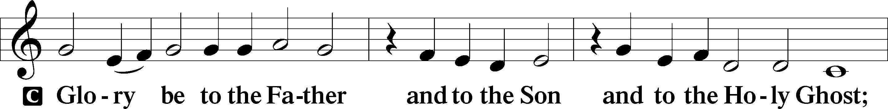
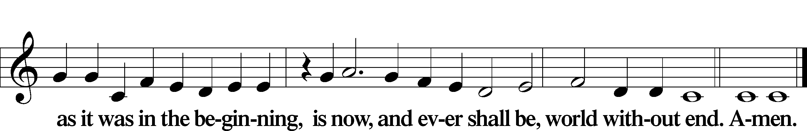

Kyrie Mark 10:47
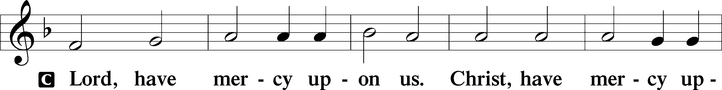
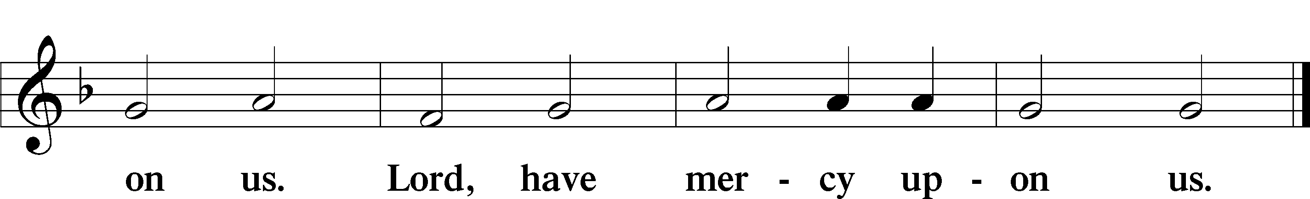

Gloria in Excelsis Luke 2:14; John 1:29
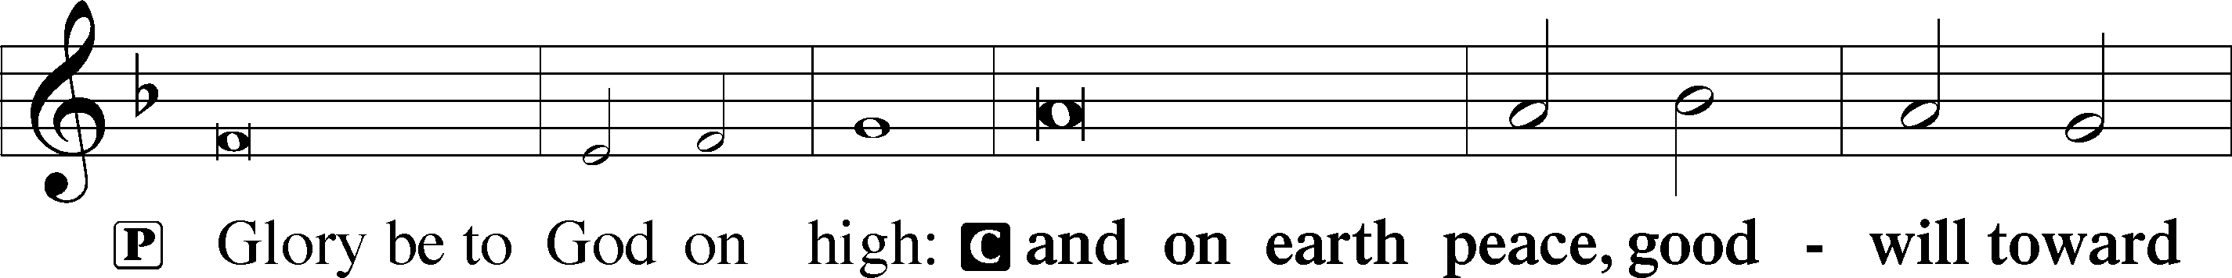
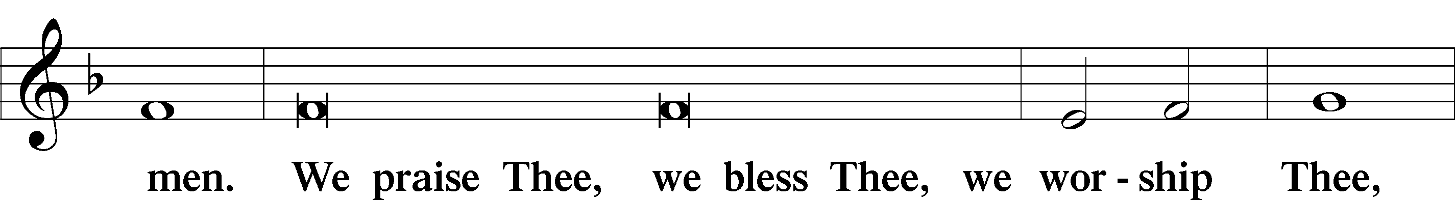
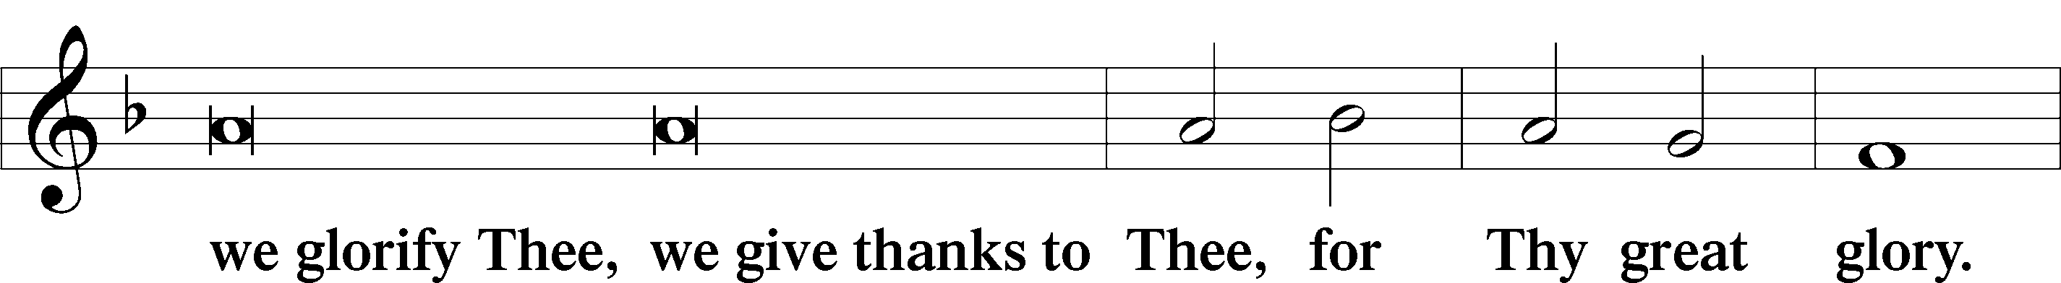
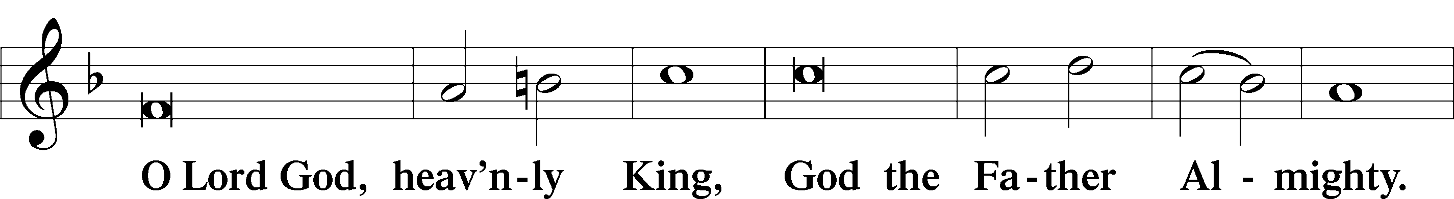
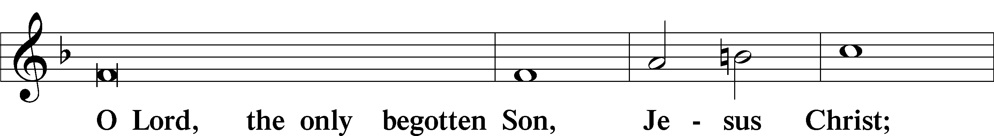
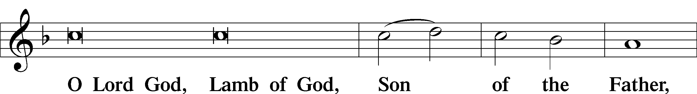
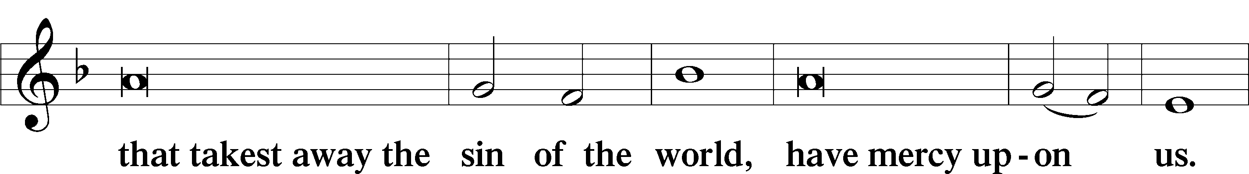
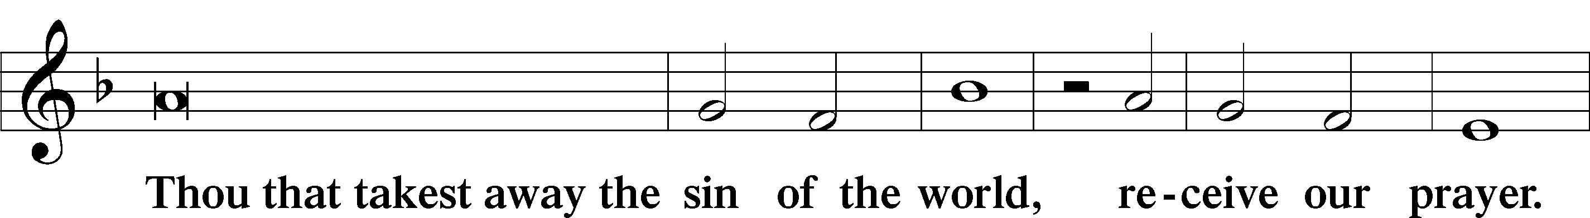
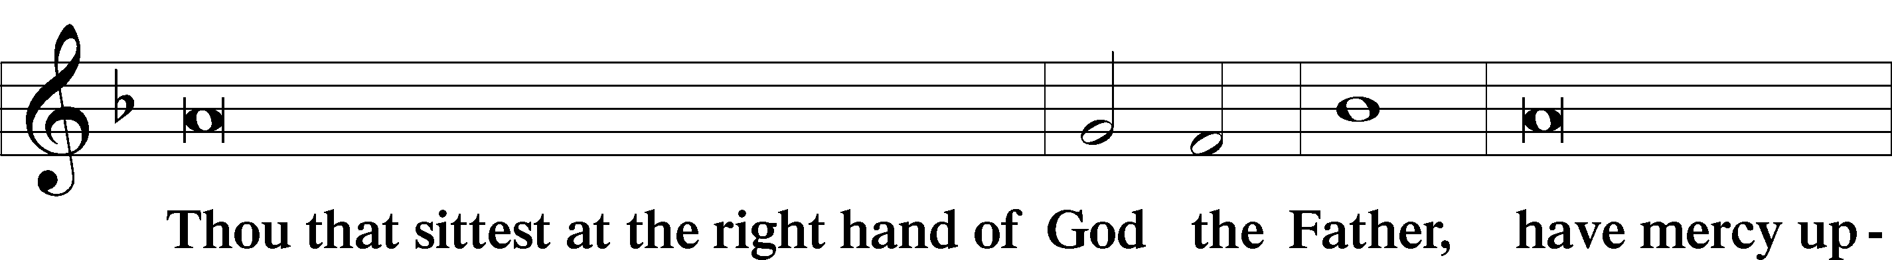
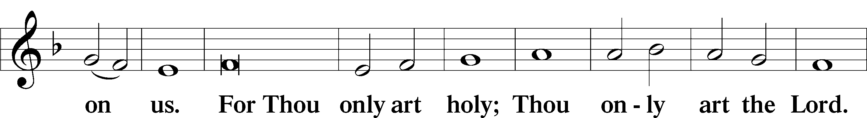
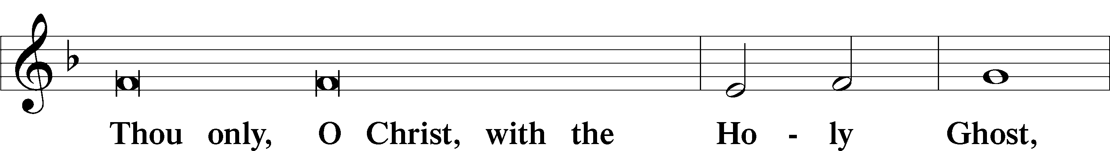
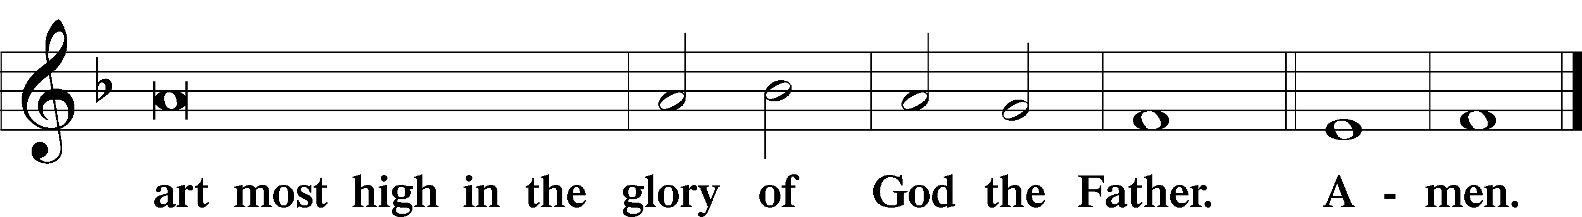

Salutation and Collect of the Day
P The Lord be with you.
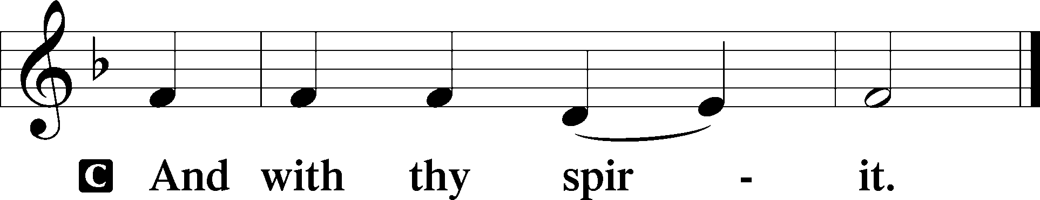

P Let us pray.
O God, the protector of all who trust in You, have mercy on us that with You as our ruler and guide we may so pass through things temporal that we lose not the things eternal; through Jesus Christ, Your Son, our Lord, who lives and reigns with You and the Holy Spirit, one God, now and forever.

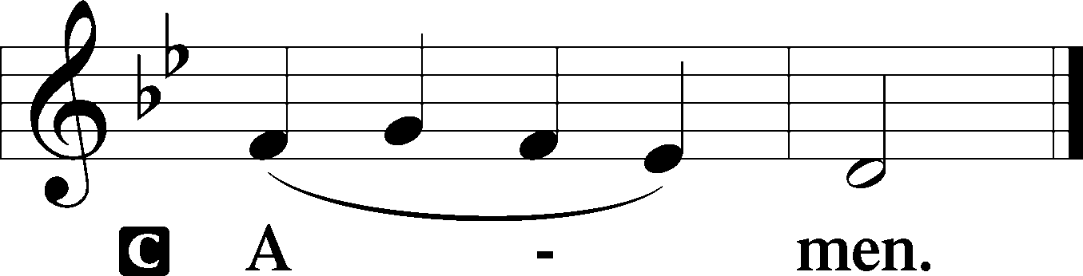

Sit

Old Testament Reading Isaiah 45:1–7
1Thus says the Lord to his anointed, to Cyrus, whose right hand I have grasped, to subdue nations before him and to loose the belts of kings, to open doors before him that gates may not be closed: 2“I will go before you and level the exalted places, I will break in pieces the doors of bronze and cut through the bars of iron, 3I will give you the treasures of darkness and the hoards in secret places, that you may know that it is I, the Lord, the God of Israel, who call you by your name. 4For the sake of my servant Jacob, and Israel my chosen, I call you by your name, I name you, though you do not know me. 5I am the Lord, and there is no other, besides me there is no God; I equip you, though you do not know me, 6that people may know, from the rising of the sun and from the west, that there is none besides me; I am the Lord, and there is no other. 7I form light and create darkness, I make well-being and create calamity, I am the Lord, who does all these things.”
A This is the Word of the Lord.
C Thanks be to God.

Gradual Psalm 91:11; 103:1
He will command his angels concerning you
to guard you in all your ways.
Bless the Lord, O my soul,
and all that is within me, bless his holy name!

Epistle 1 Thessalonians 1:1–10
1Paul, Silvanus, and Timothy, To the church of the Thessalonians in God the Father and the Lord Jesus Christ: Grace to you and peace. 2We give thanks to God always for all of you, constantly mentioning you in our prayers, 3remembering before our God and Father your work of faith and labor of love and steadfastness of hope in our Lord Jesus Christ. 4For we know, brothers loved by God, that he has chosen you, 5because our gospel came to you not only in word, but also in power and in the Holy Spirit and with full conviction. You know what kind of men we proved to be among you for your sake. 6And you became imitators of us and of the Lord, for you received the word in much affliction, with the joy of the Holy Spirit, 7so that you became an example to all the believers in Macedonia and in Achaia. 8For not only has the word of the Lord sounded forth from you in Macedonia and Achaia, but your faith in God has gone forth everywhere, so that we need not say anything. 9For they themselves report concerning us the kind of reception we had among you, and how you turned to God from idols to serve the living and true God, 10and to wait for his Son from heaven, whom he raised from the dead, Jesus who delivers us from the wrath to come.

A This is the Word of the Lord.
C Thanks be to God.

Stand

Alleluia
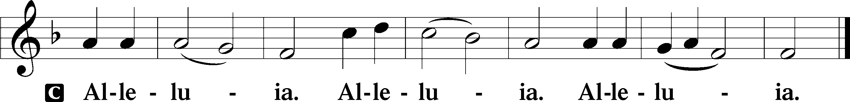
Holy Gospel Matthew 22:15–22
P The Holy Gospel according to St. Matthew, the twenty-second chapter.

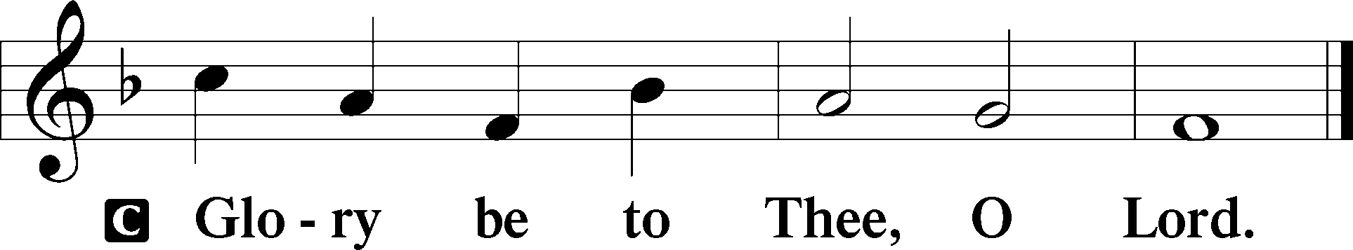

15Then the Pharisees went and plotted how to entangle [Jesus] in his talk. 16And they sent their disciples to him, along with the Herodians, saying, “Teacher, we know that you are true and teach the way of God truthfully, and you do not care about anyone’s opinion, for you are not swayed by appearances. 17Tell us, then, what you think. Is it lawful to pay taxes to Caesar, or not?” 18But Jesus, aware of their malice, said, “Why put me to the test, you hypocrites? 19Show me the coin for the tax.” And they brought him a denarius. 20And Jesus said to them, “Whose likeness and inscription is this?” 21They said, “Caesar’s.” Then he said to them, “Therefore render to Caesar the things that are Caesar’s, and to God the things that are God’s.” 22When they heard it, they marveled. And they left him and went away.

P This is the Gospel of the Lord.

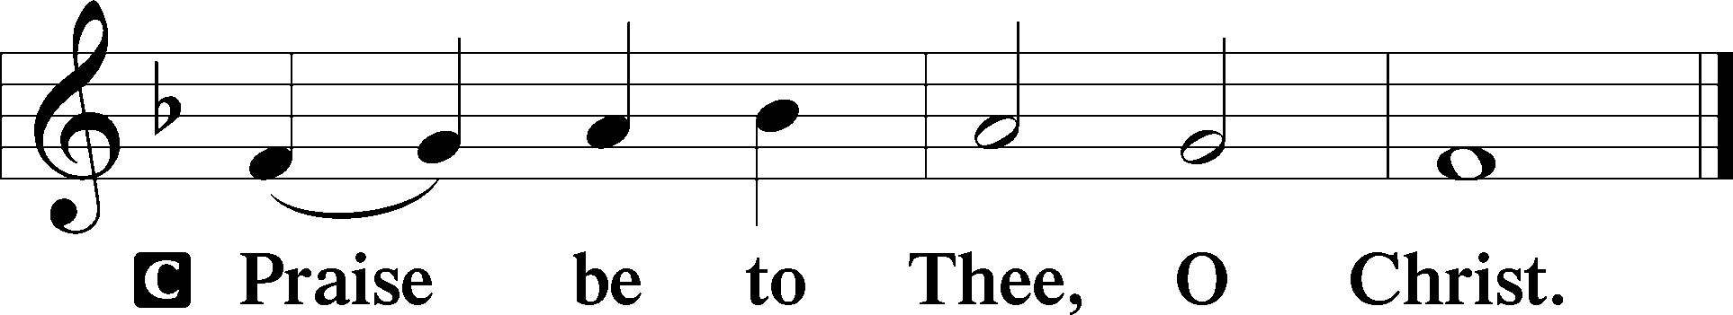

Nicene Creed
C I believe in one God,
the Father Almighty,
maker of heaven and earth
and of all things visible and invisible.

And in one Lord Jesus Christ,
the only-begotten Son of God,
begotten of His Father before all worlds,
God of God, Light of Light,
very God of very God,
begotten, not made,
being of one substance with the Father,
by whom all things were made;
who for us men and for our salvation came down from heaven
and was incarnate by the Holy Spirit of the virgin Mary
and was made man;
and was crucified also for us under Pontius Pilate.
He suffered and was buried.
And the third day He rose again according to the Scriptures
and ascended into heaven
and sits at the right hand of the Father.
And He will come again with glory to judge both the living and the dead,
whose kingdom will have no end.

And I believe in the Holy Spirit,
the Lord and giver of life,
who proceeds from the Father and the Son,
who with the Father and the Son together is worshiped and glorified,
who spoke by the prophets.
And I believe in one holy Christian and apostolic Church,
I acknowledge one Baptism for the remission of sins,
and I look for the resurrection of the dead
and the life T of the world to come. Amen.

Sit

Children's Sermon

940 Holy God, We Praise Thy Name sts. 1–5
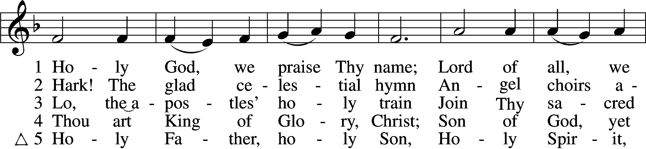
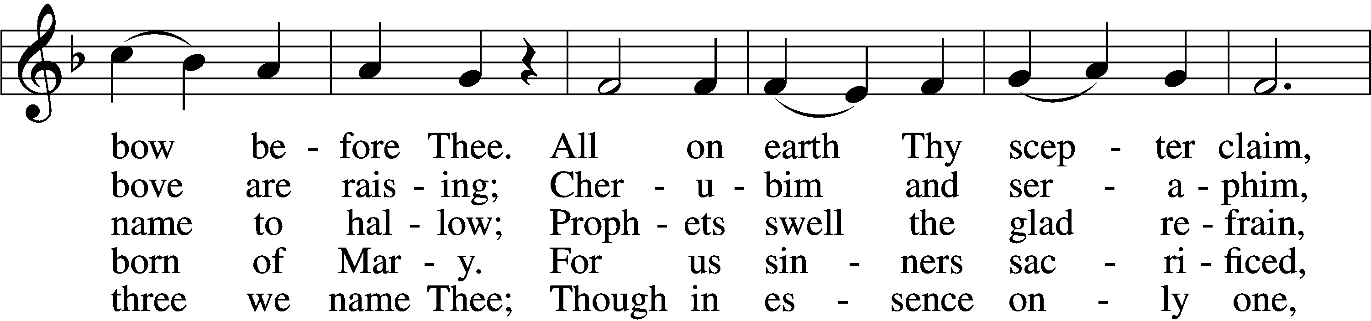
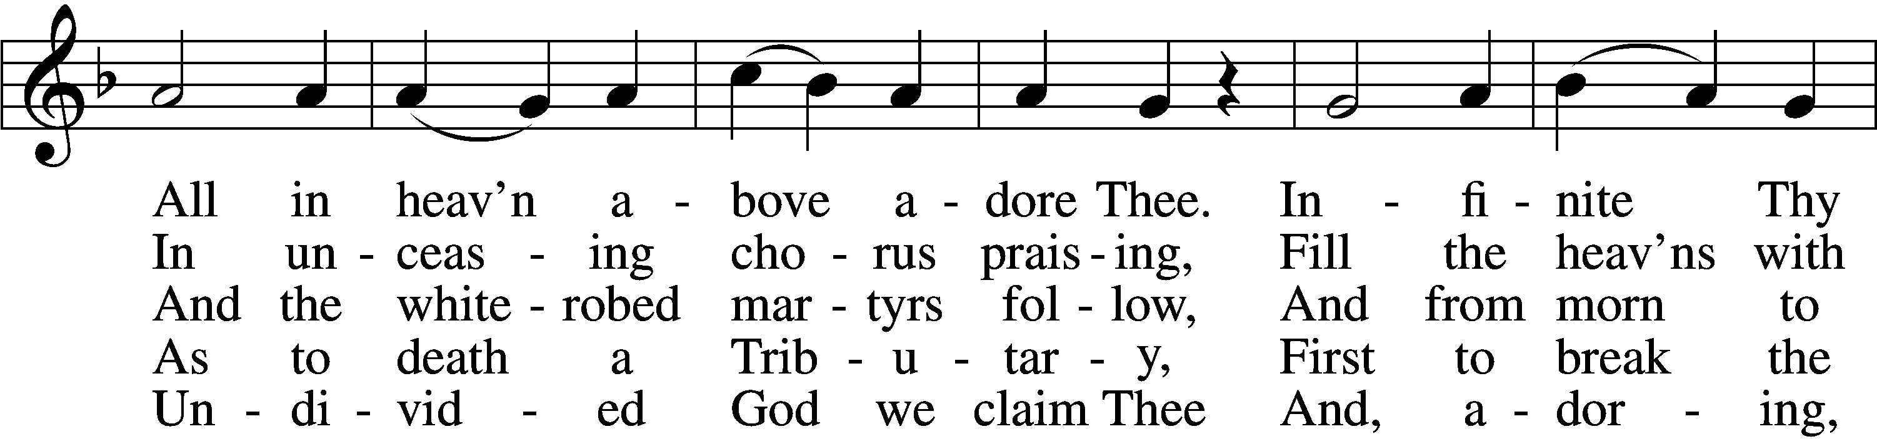
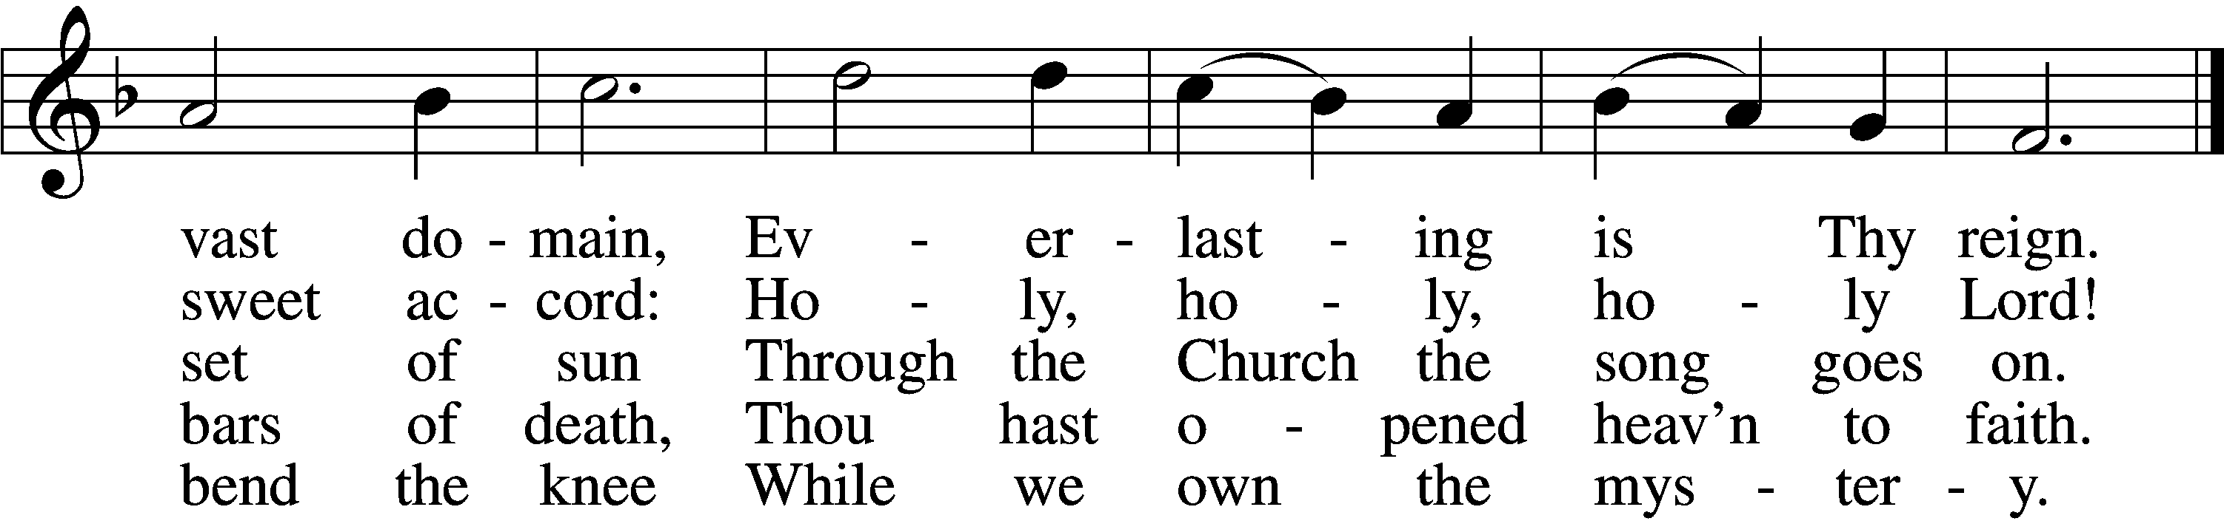
Text: Latin, c. 4th cent.; German version Katholisches Gesangbuch, 1774, Vienna; tr. Clarence A. Walworth, 1820–1900, alt.
Tune: Katholisches Gesangbuch, 1774, Vienna
Text and tune: Public domain

Sermon

Votum
P The peace of God, which passes all understanding, keep your hearts and minds in Christ Jesus.
C Amen.

Stand

Offertory Psalm 51:10–12
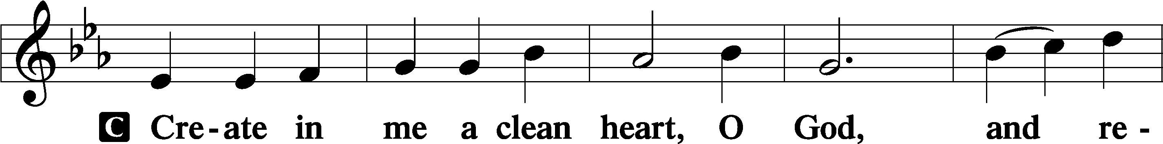
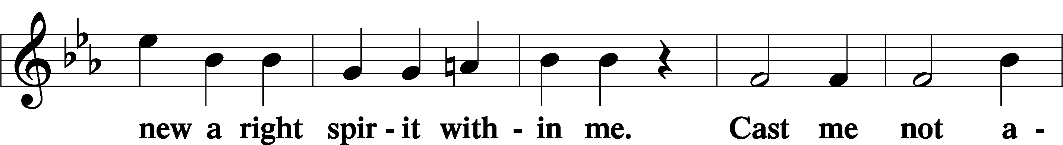
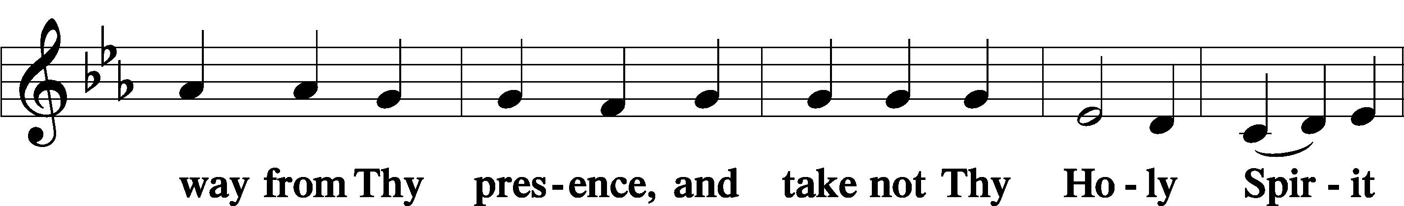
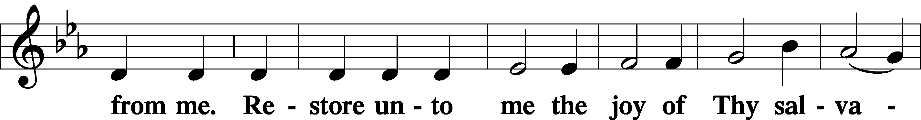
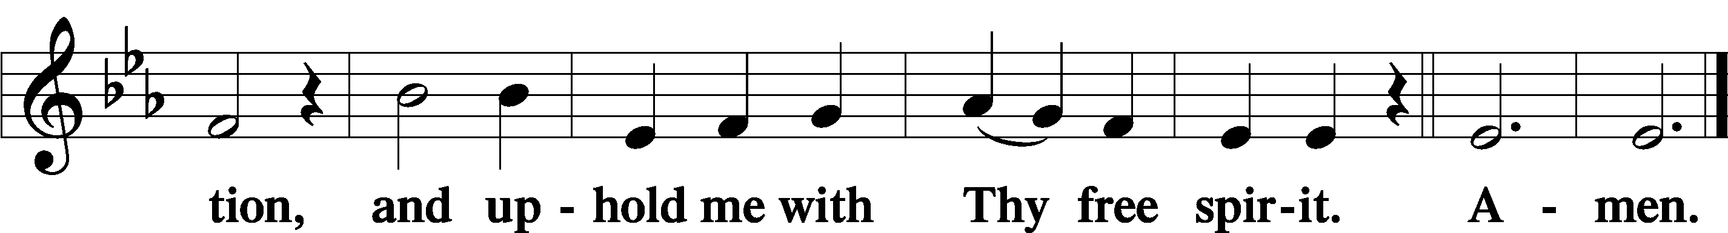

Sit

Offering

Hymn
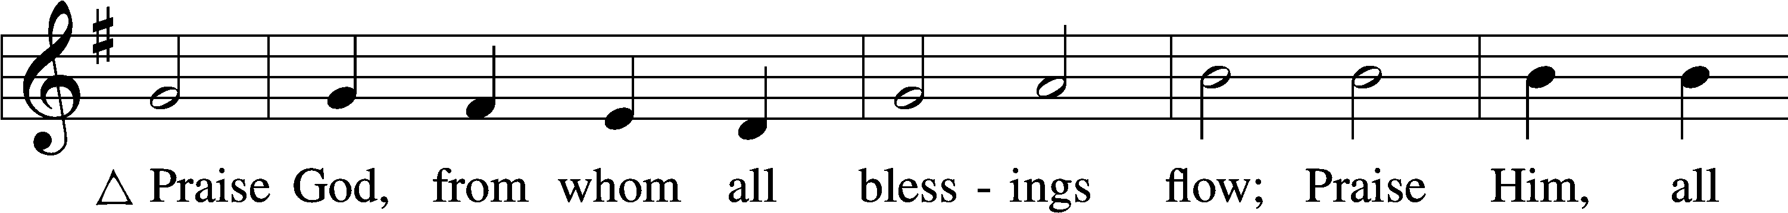
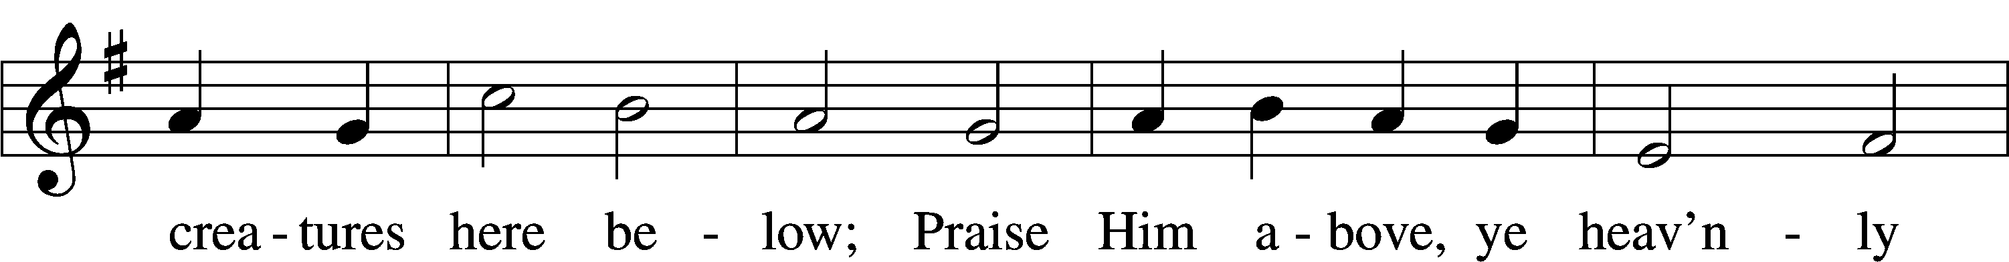
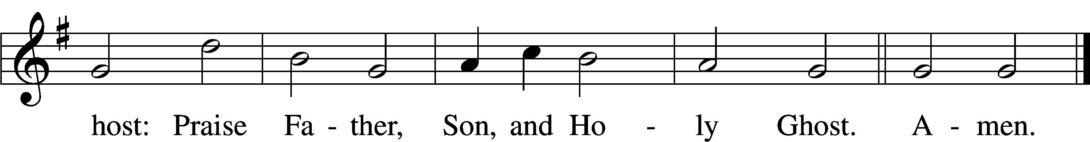
Text: Thomas Ken, 1637–1711
Tune: Trente quatre Pseaumes de David, 1551, Geneva, ed. Louis Bourgeois
Text and tune: Public domain

Stand

Prayer of the Church

Service of the Sacrament

Preface 2 Timothy 4:22; [Colossians 3:1]; [Psalm 136]
P The Lord be with you.
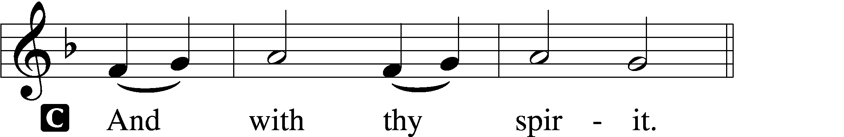

P Lift up your hearts.
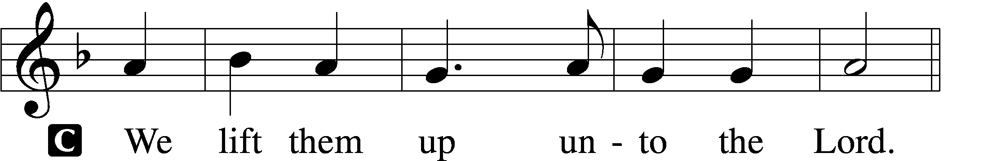

P Let us give thanks unto the Lord, our God.
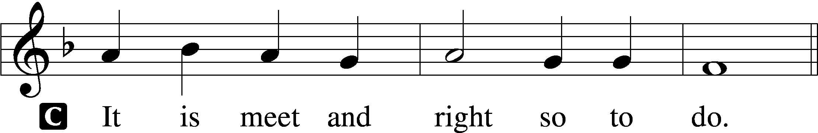

Proper Preface (Full)
P It is truly meet, right, and salutary that we should at all times and in all places give thanks to You, holy Lord, almighty Father, everlasting God, through Jesus Christ, our Lord. Therefore with angels and archangels and with all the company of heaven we laud and magnify Your glorious name, evermore praising You and saying:

Sanctus Isaiah 6:3; Matthew 21:9
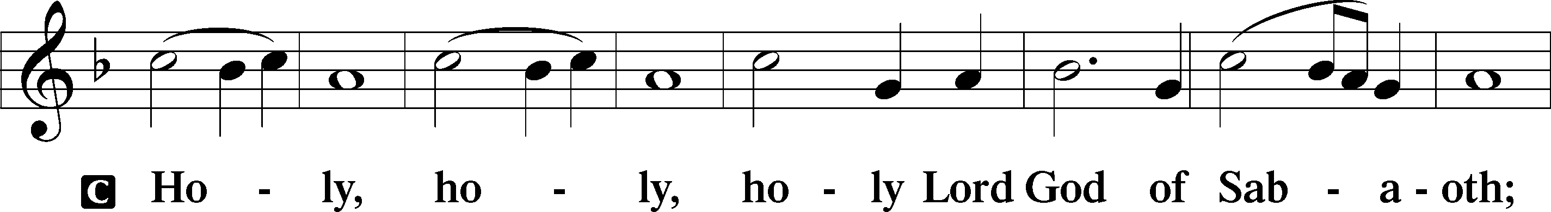
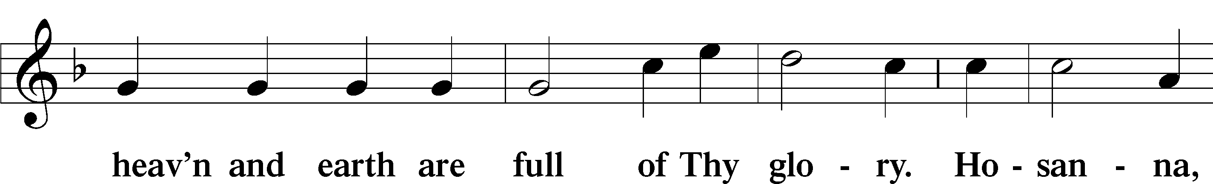
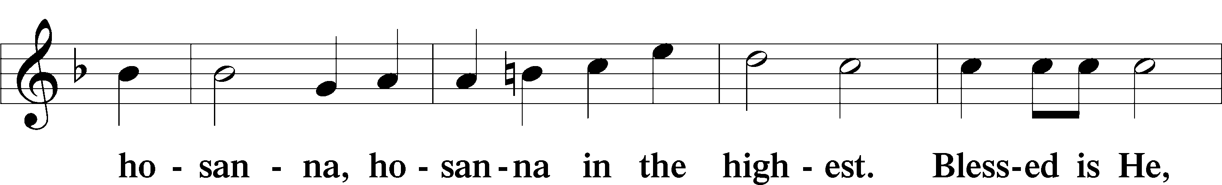
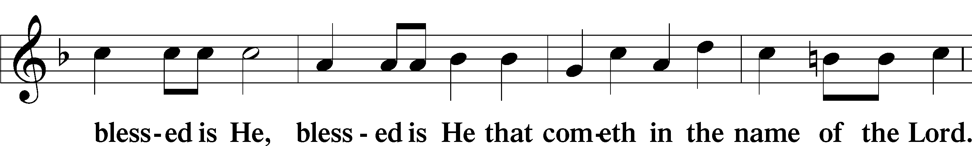
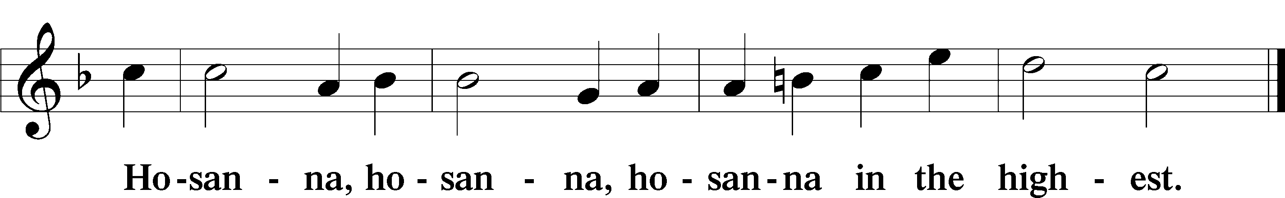

Lord’s Prayer Matthew 6:9–13
P Our Father who art in heaven,
hallowed be Thy name,
Thy kingdom come,
Thy will be done on earth as it is in heaven;
give us this day our daily bread;
and forgive us our trespasses as we forgive those who trespass against us;
and lead us not into temptation,
but deliver us from evil.
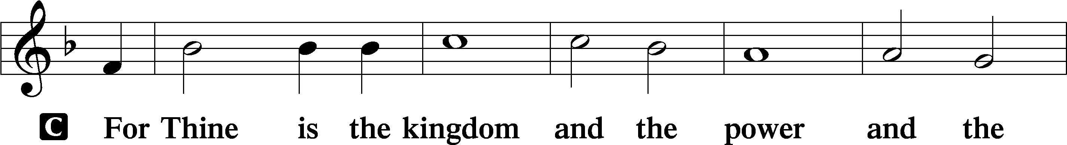
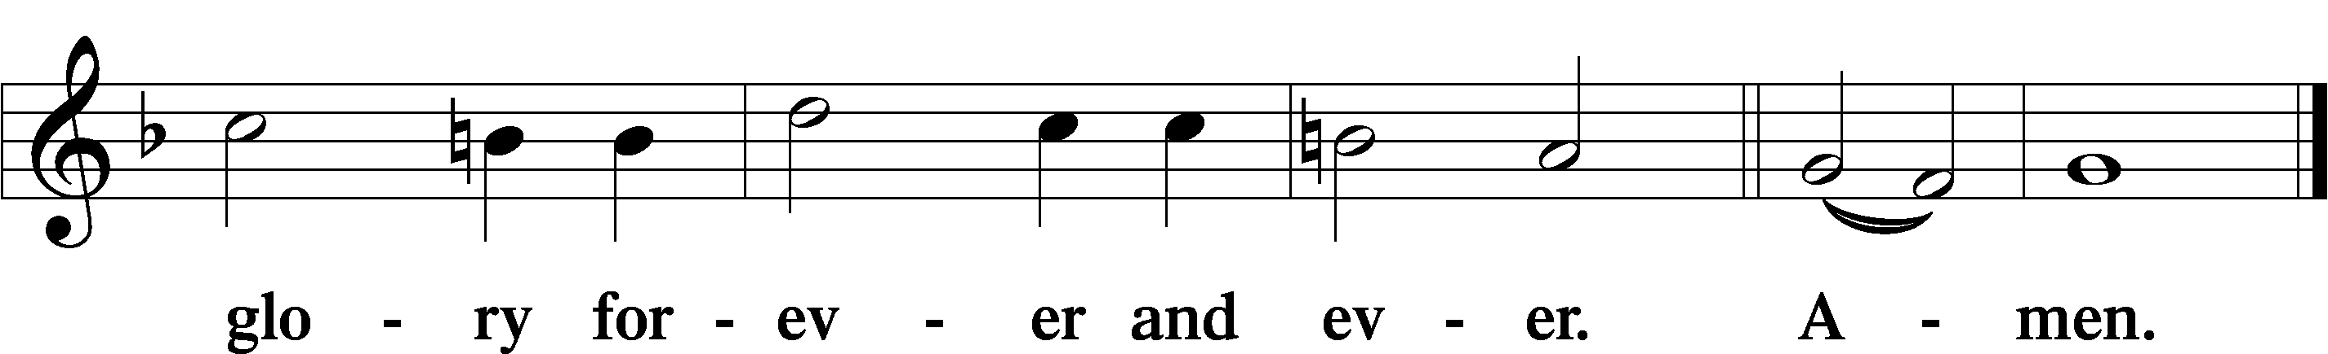

The Words of Our Lord Matthew 26:26–28; Mark 14:22–24; Luke 22:19–20; 1 Corinthians 11:23–25
P Our Lord Jesus Christ, on the night when He was betrayed, took bread, and when He had given thanks, He broke it and gave it to the disciples and said: “Take, eat; this is My T body, which is given for you. This do in remembrance of Me.”

In the same way also He took the cup after supper, and when He had given thanks, He gave it to them, saying: “Drink of it, all of you; this cup is the new testament in My T blood, which is shed for you for the forgiveness of sins. This do, as often as you drink it, in remembrance of Me.”

Pax Domini John 20:19
P The peace of the Lord be with you always.

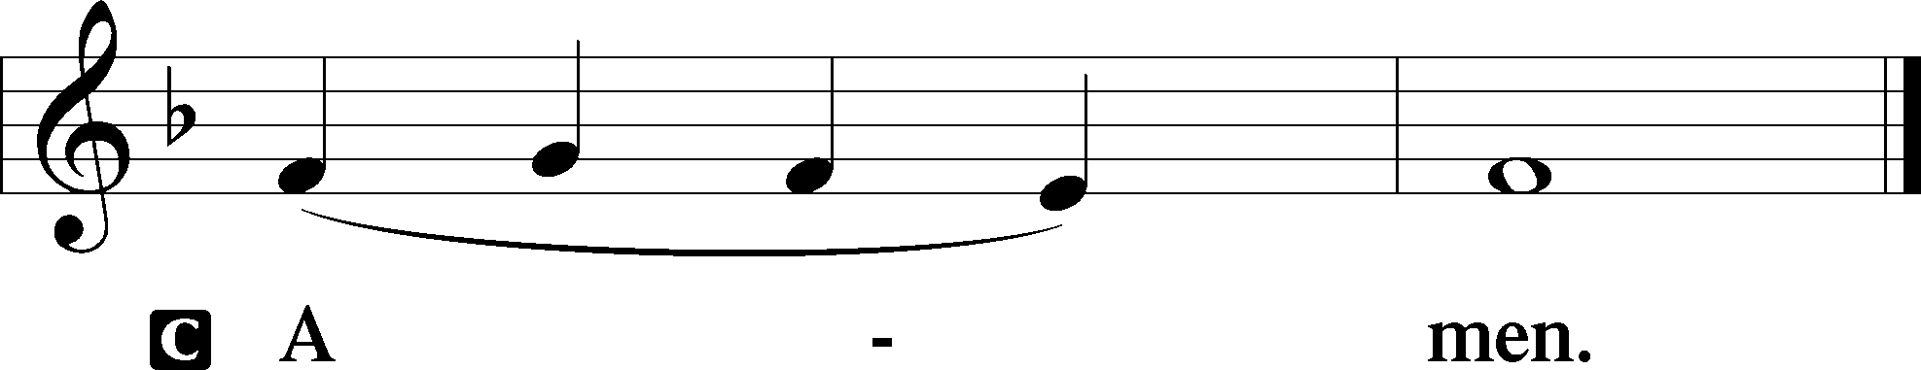

Agnus Dei John 1:29
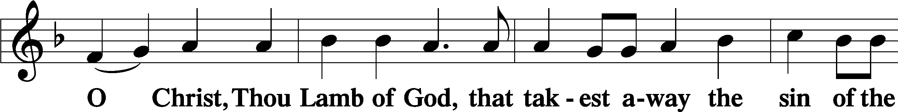
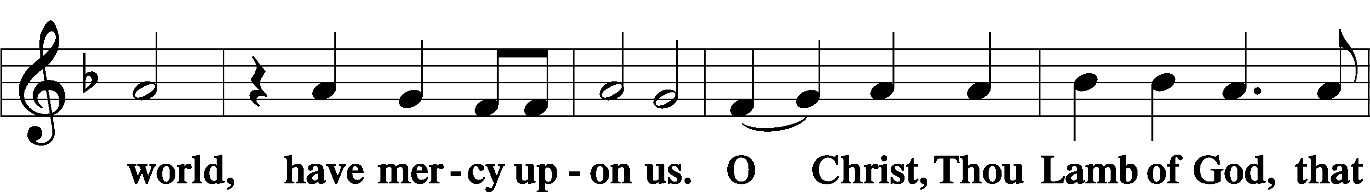
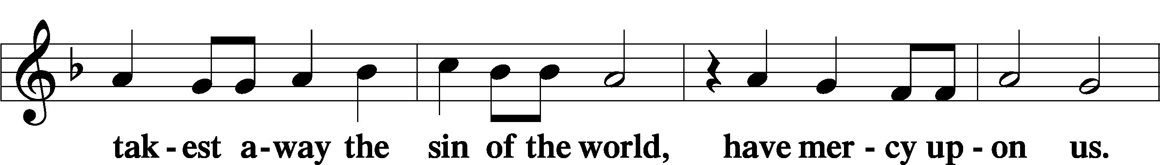
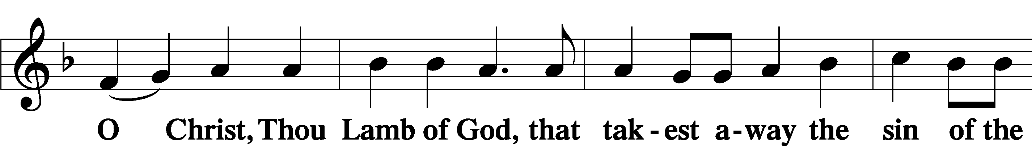
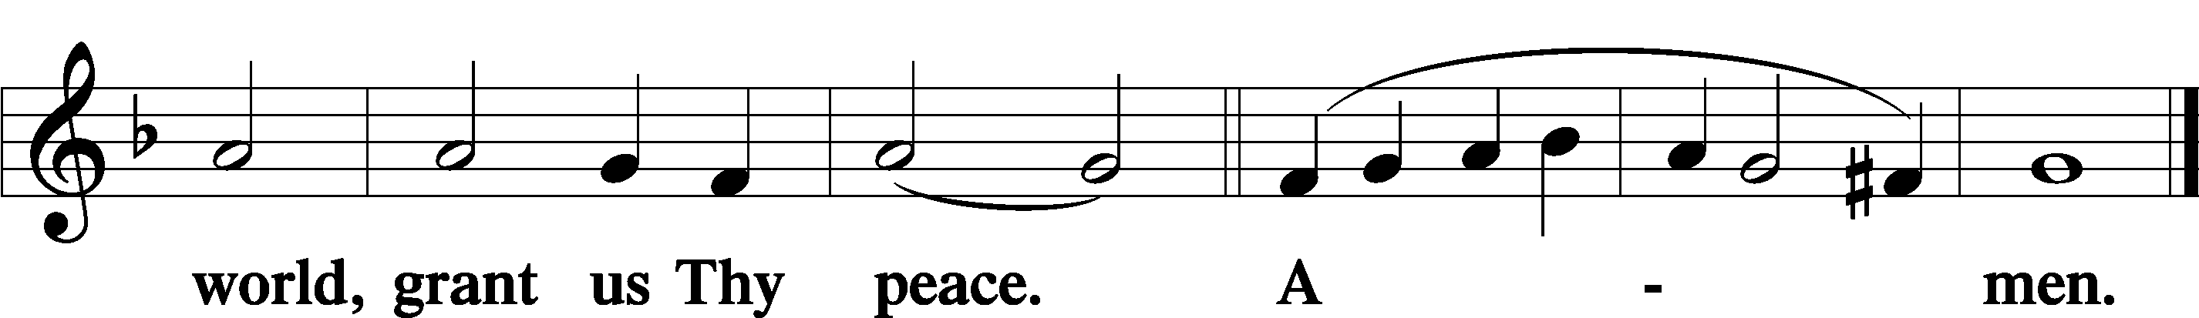

Sit

Distribution

The pastor and those who assist him receive the body and blood of Christ first and then distribute them to those who come to receive, saying:

Take, eat; this is the true body of our Lord and Savior Jesus Christ, given into death for your sins.
Amen.

Take, drink; this is the true blood of our Lord and Savior Jesus Christ, shed for the forgiveness of your sins.
Amen.

In dismissing the communicants, the following is said:

The Dismissal
P The body and blood of our Lord Jesus Christ strengthen and preserve you in body and soul to life everlasting. Depart T in peace.
C Amen.

851 Lord of Glory, You Have Bought Us
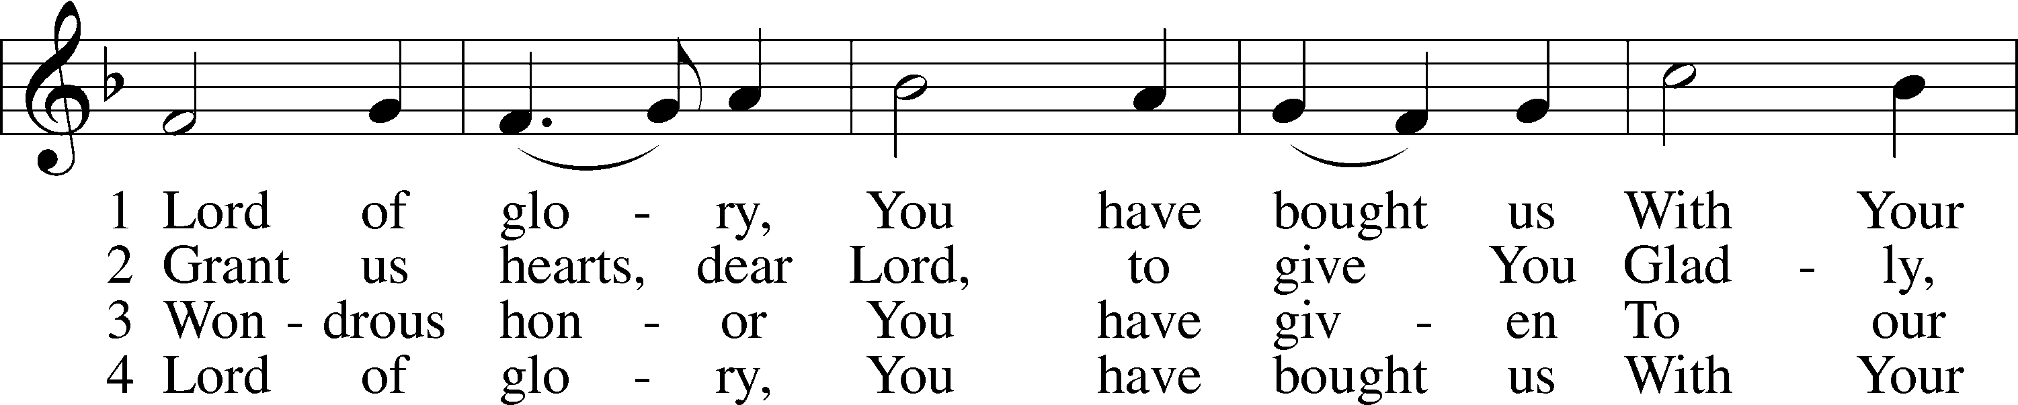
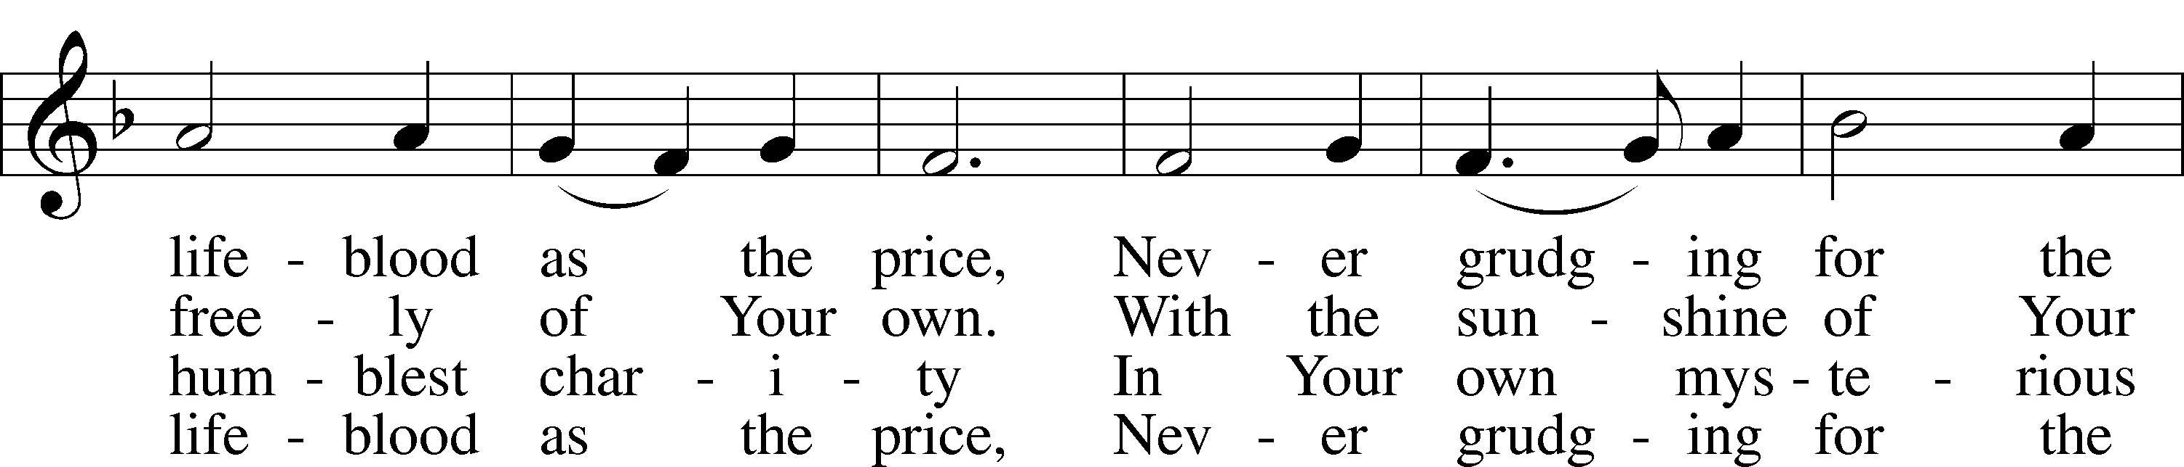
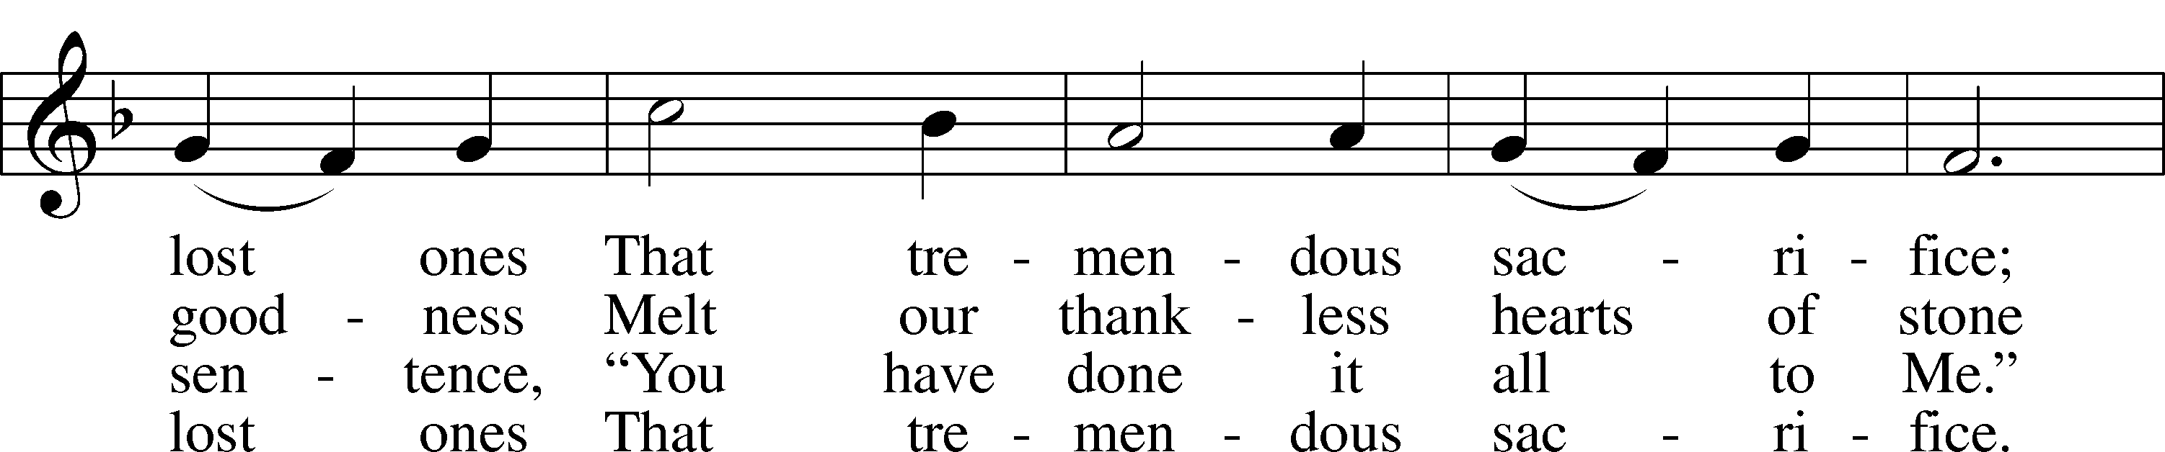
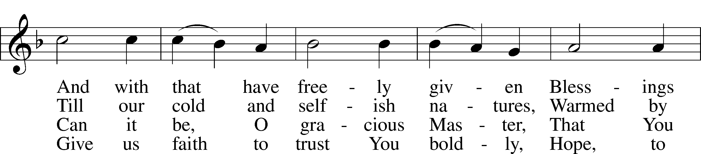
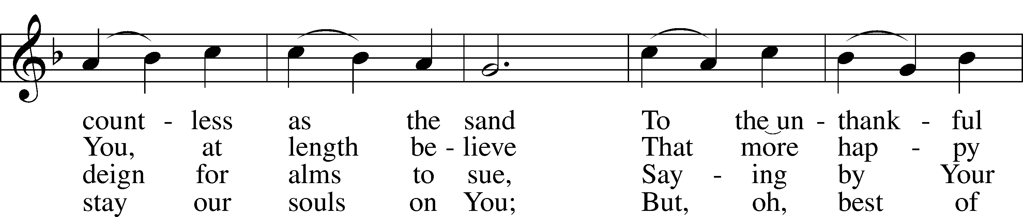
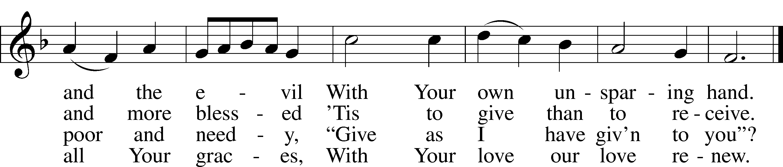
Text: Eliza S. Alderson, 1818–89, alt.
Tune: Rowland H. Prichard, 1811–87
Text and tune: Public domain

643 Sent Forth by God’s Blessing
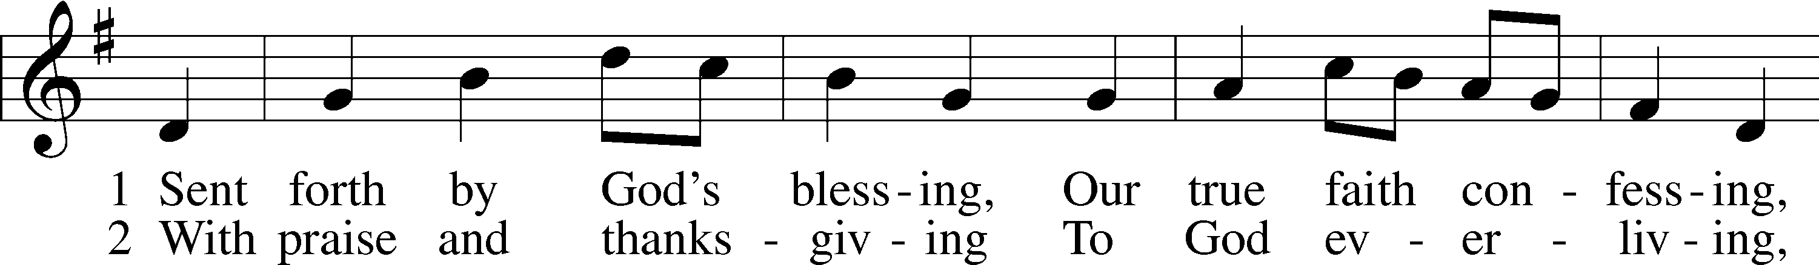
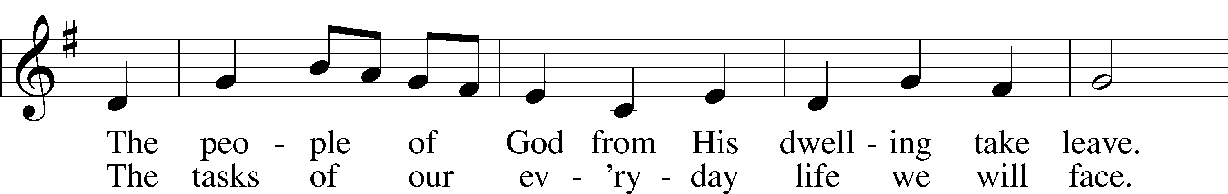
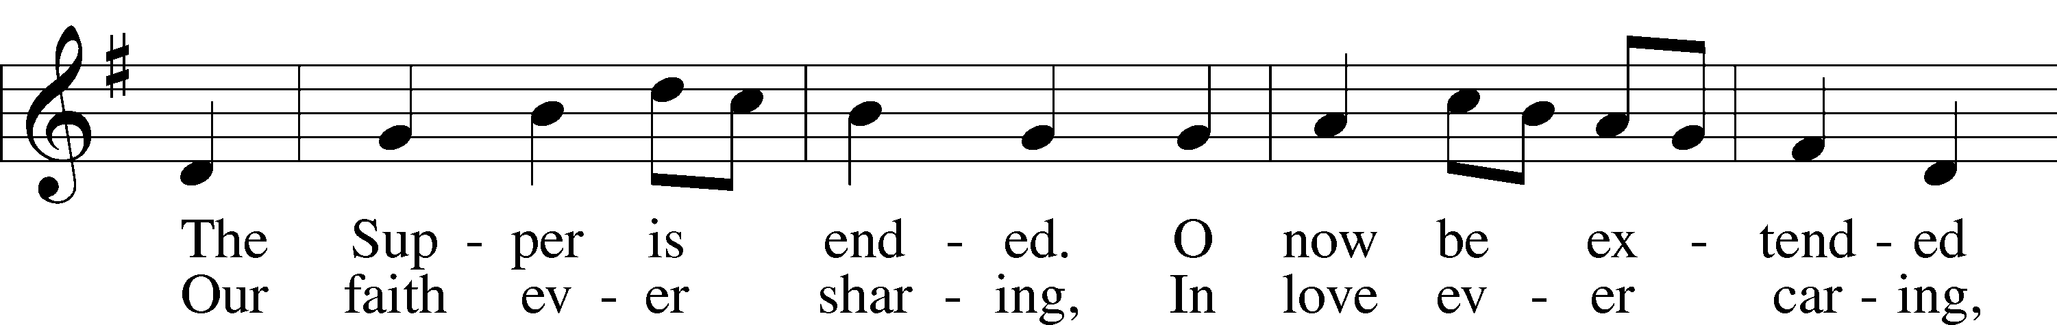
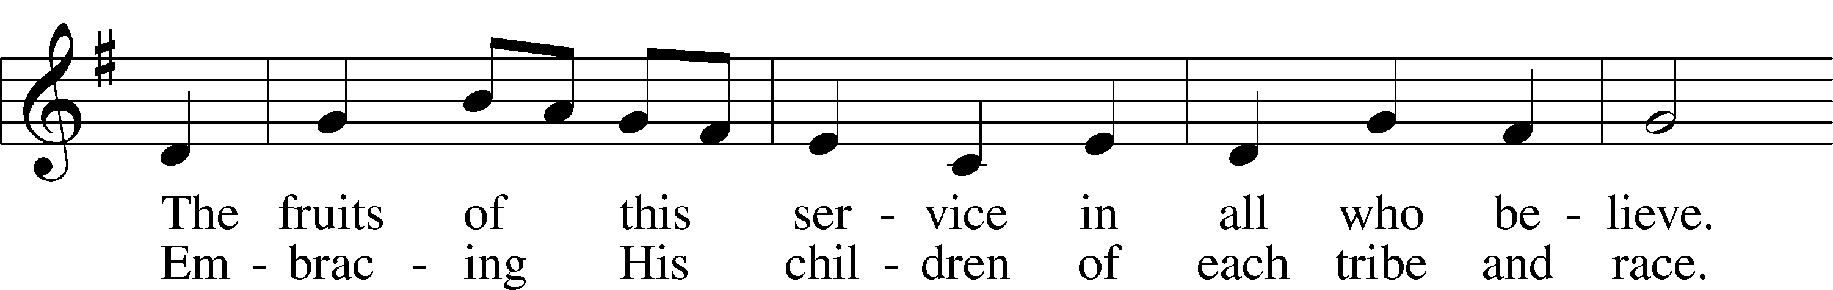
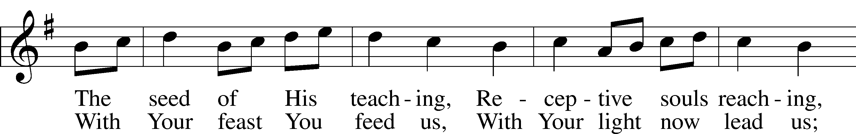
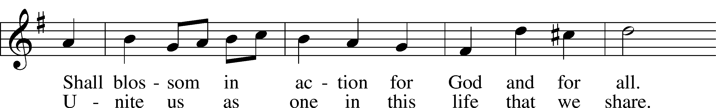
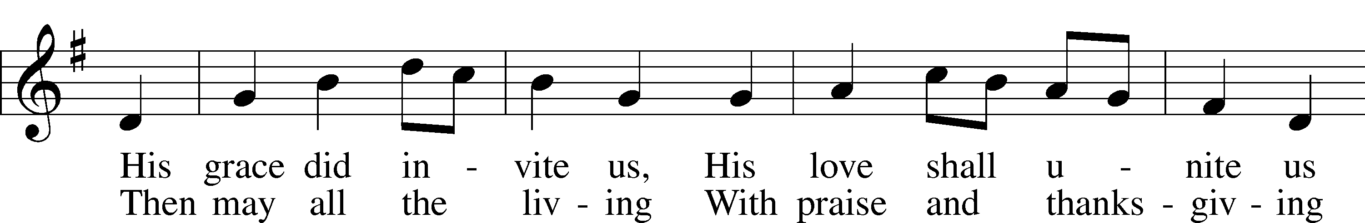
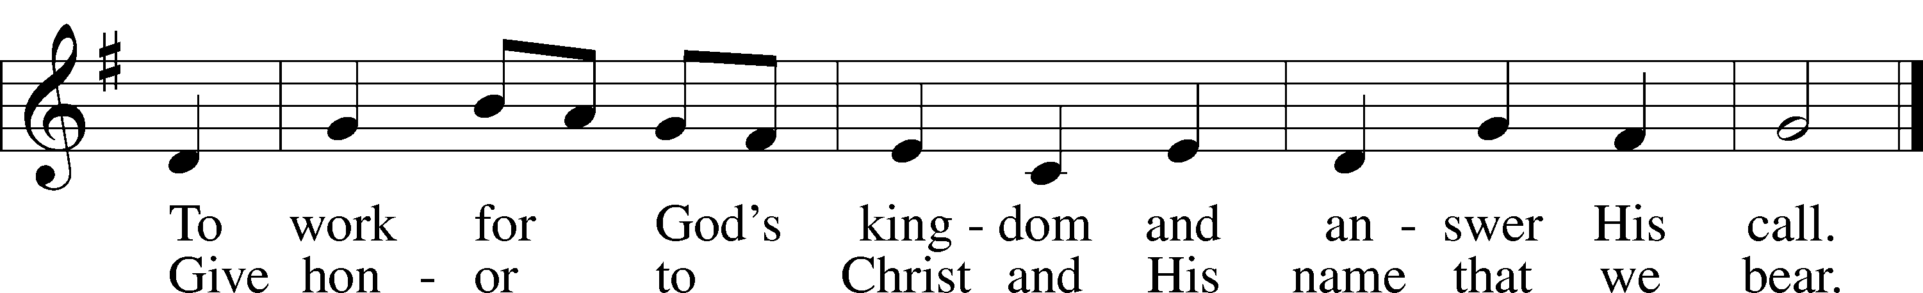
Text: Omer E. Westendorf, 1916–97, alt.
Tune: Welsh
Text: © 1964 World Library Publications. Used by permission: LSB Hymn License no. 110005011
Tune: Public domain

632 O Jesus, Blessed Lord, to Thee
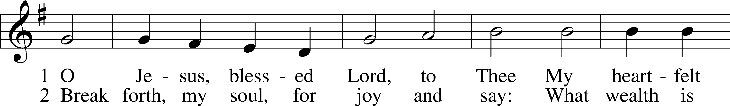
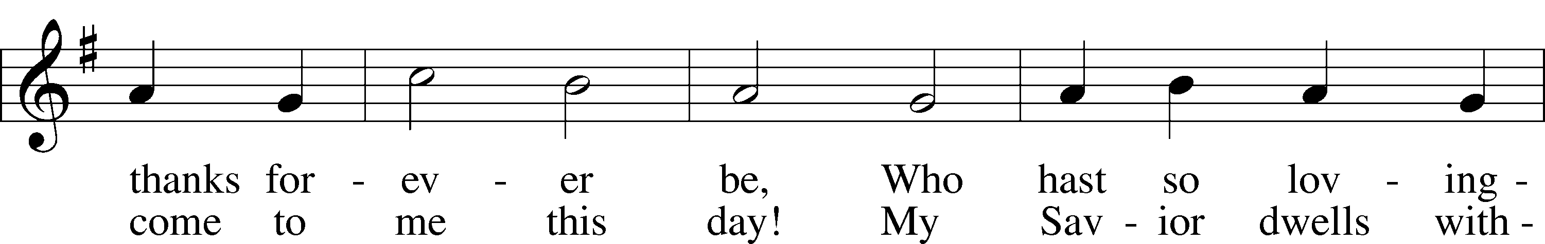
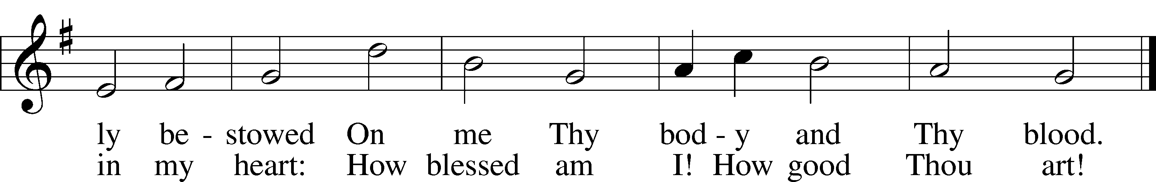
Text: Thomas Hansen Kingo, 1634–1703; tr. Arthur J. Mason, 1851–1928
Tune: Trente quatre Pseaumes de David, 1551, Geneva, ed. Louis Bourgeois
Text and tune: Public domain

Stand

Nunc Dimittis Luke 2:29–32
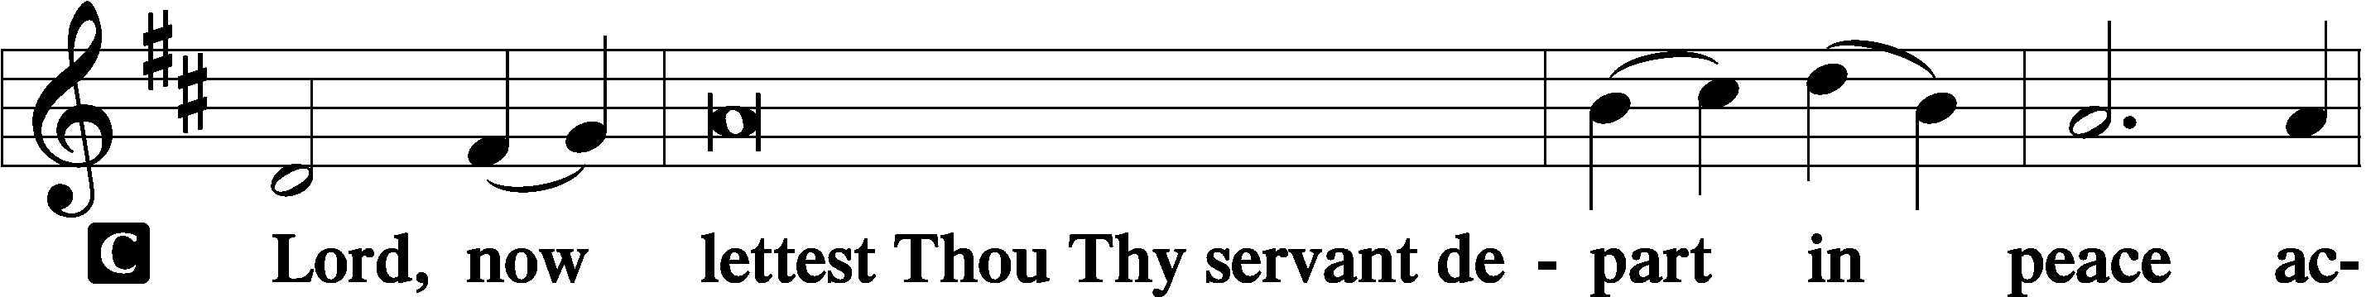

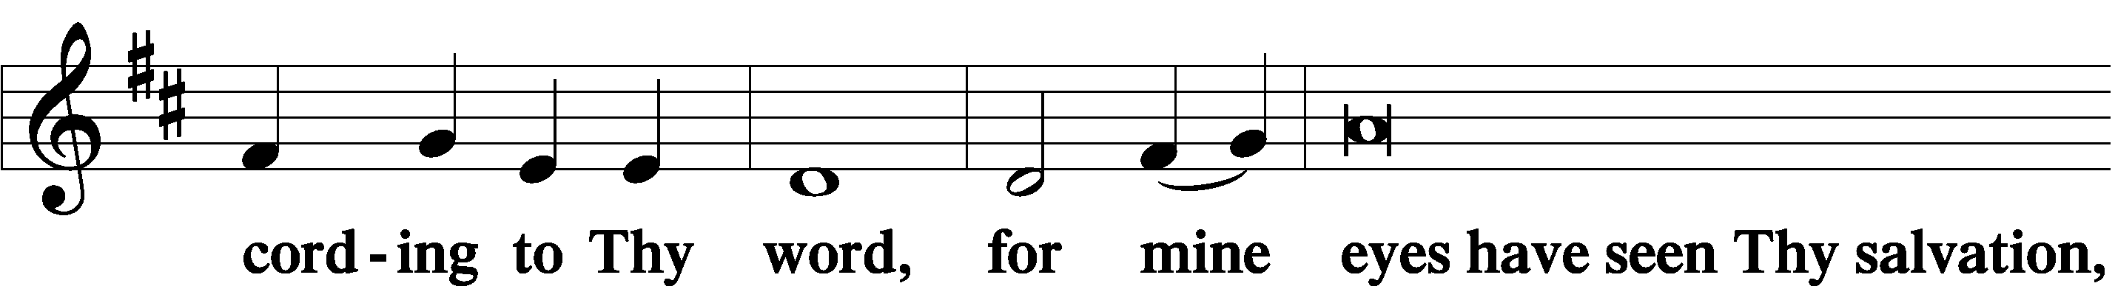

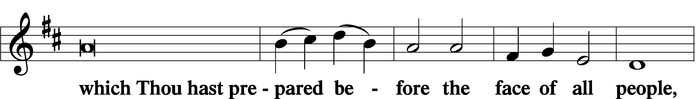

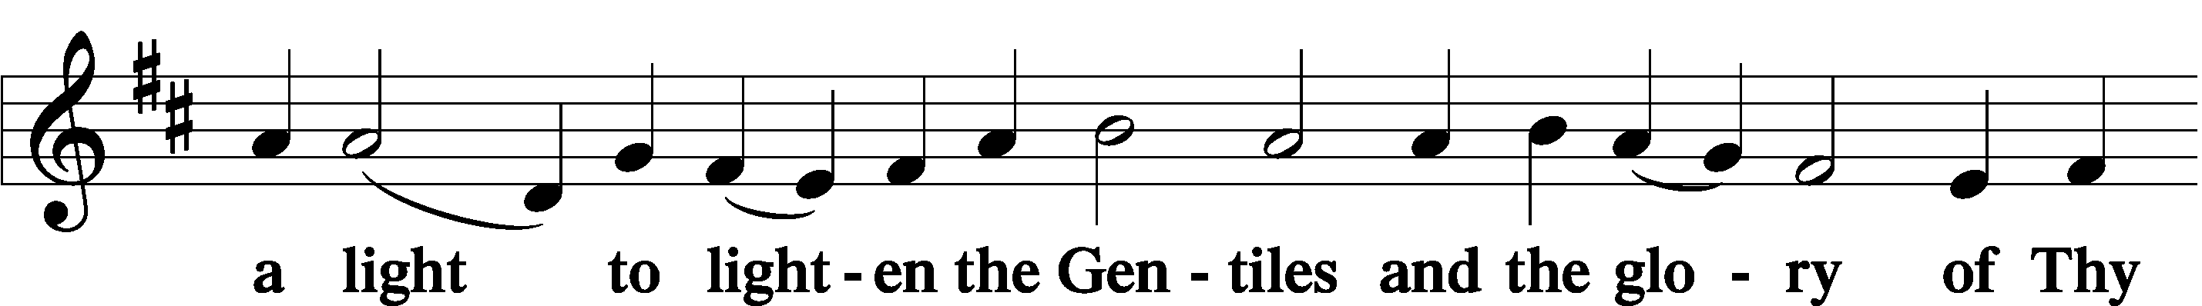

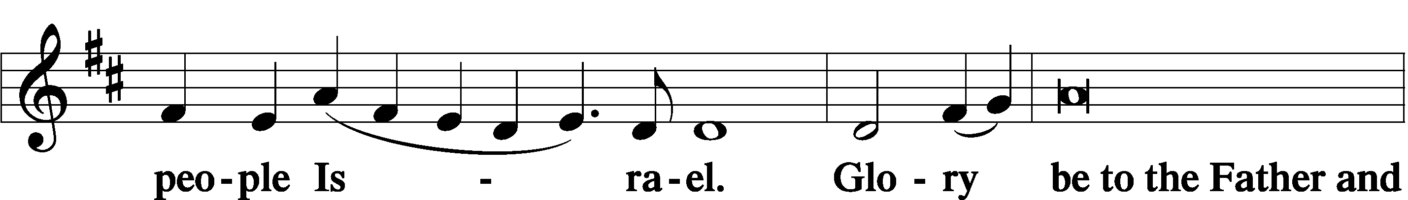

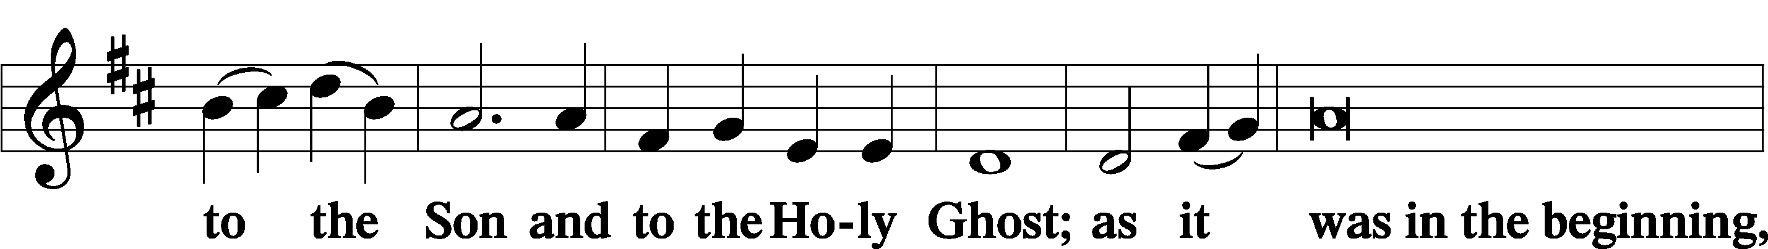

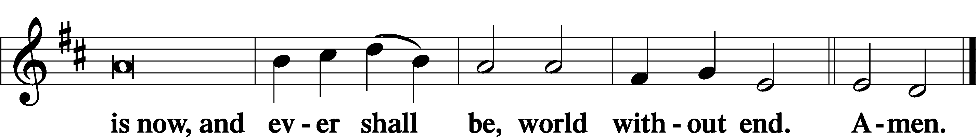

Thanksgiving Psalm 107:1
A O give thanks unto the Lord, for He is good,

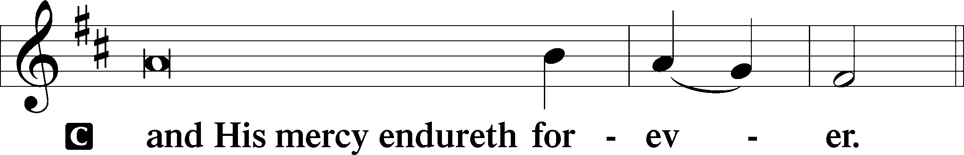

Post-Communion Collect
A Let us pray.
We give thanks to You, almighty God, that You have refreshed us through this salutary gift, and we implore You that of Your mercy You would strengthen us through the same in faith toward You and in fervent love toward one another; through Jesus Christ, Your Son, our Lord, who lives and reigns with You and the Holy Spirit, one God, now and forever.

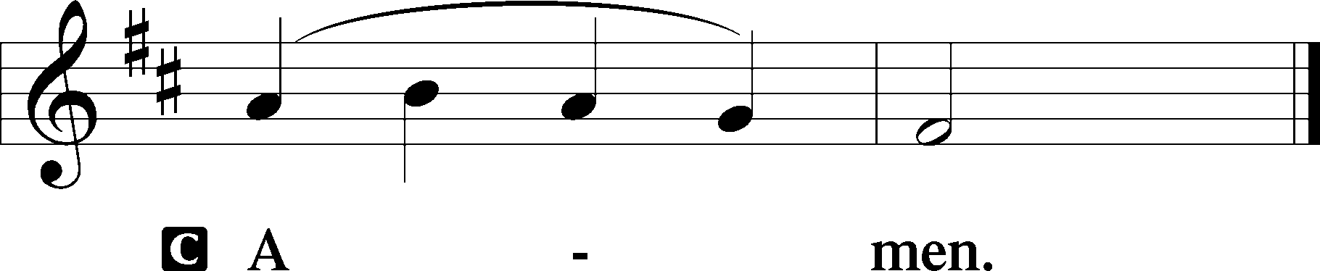

Salutation 2 Timothy 4:22
P The Lord be with you.

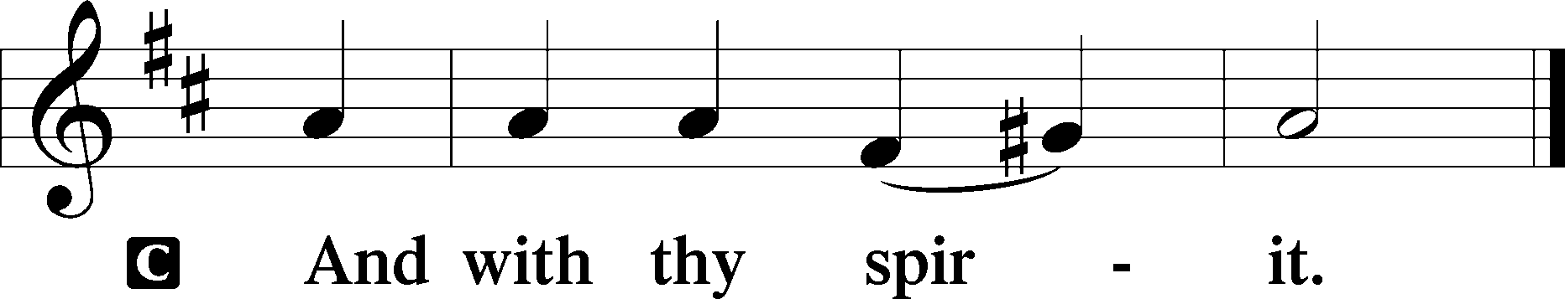

Benedicamus Psalm 103:1
A Bless we the Lord.
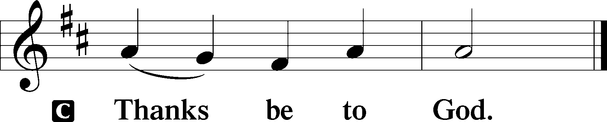

Benediction Numbers 6:24–26
P The Lord bless you and keep you.
The Lord make His face shine upon you and be gracious unto you.
The Lord lift up His countenance upon you and T give you peace.
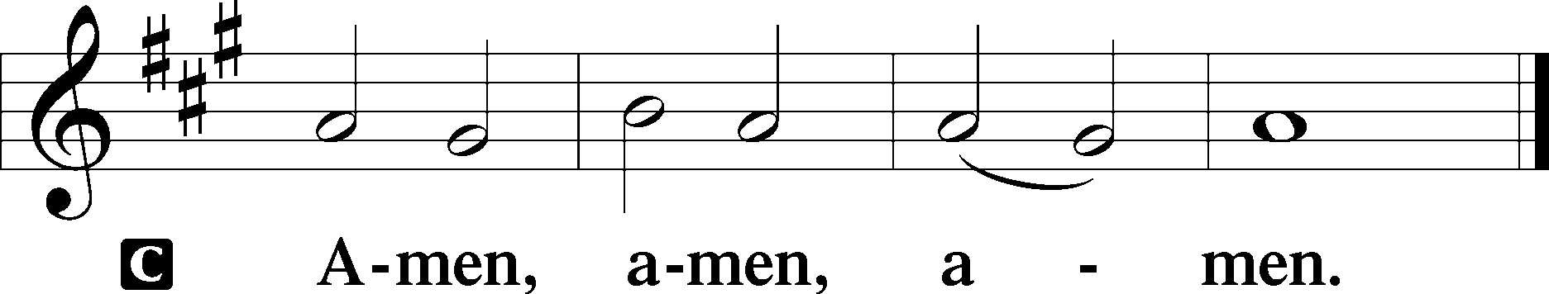

732 All Depends on Our Possessing
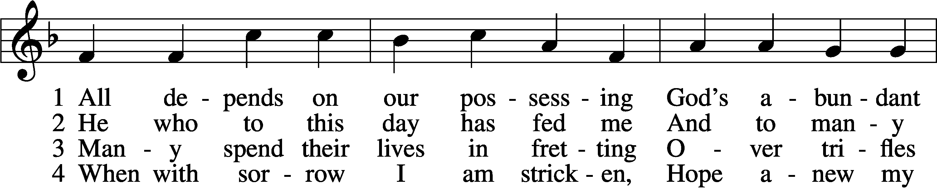
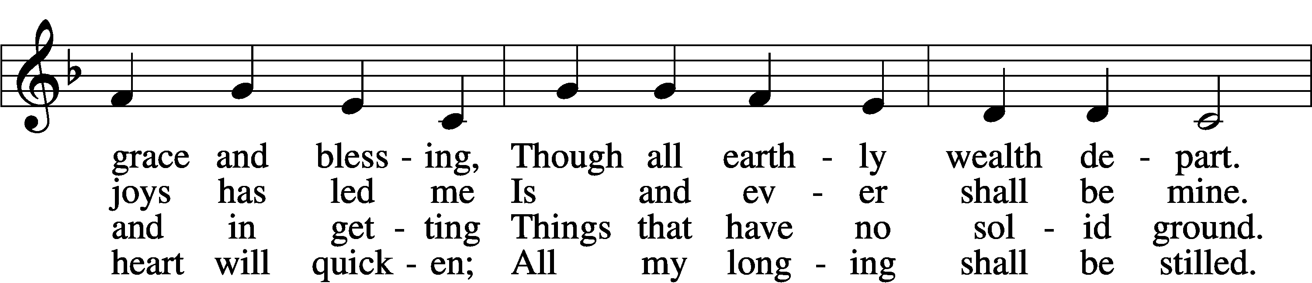
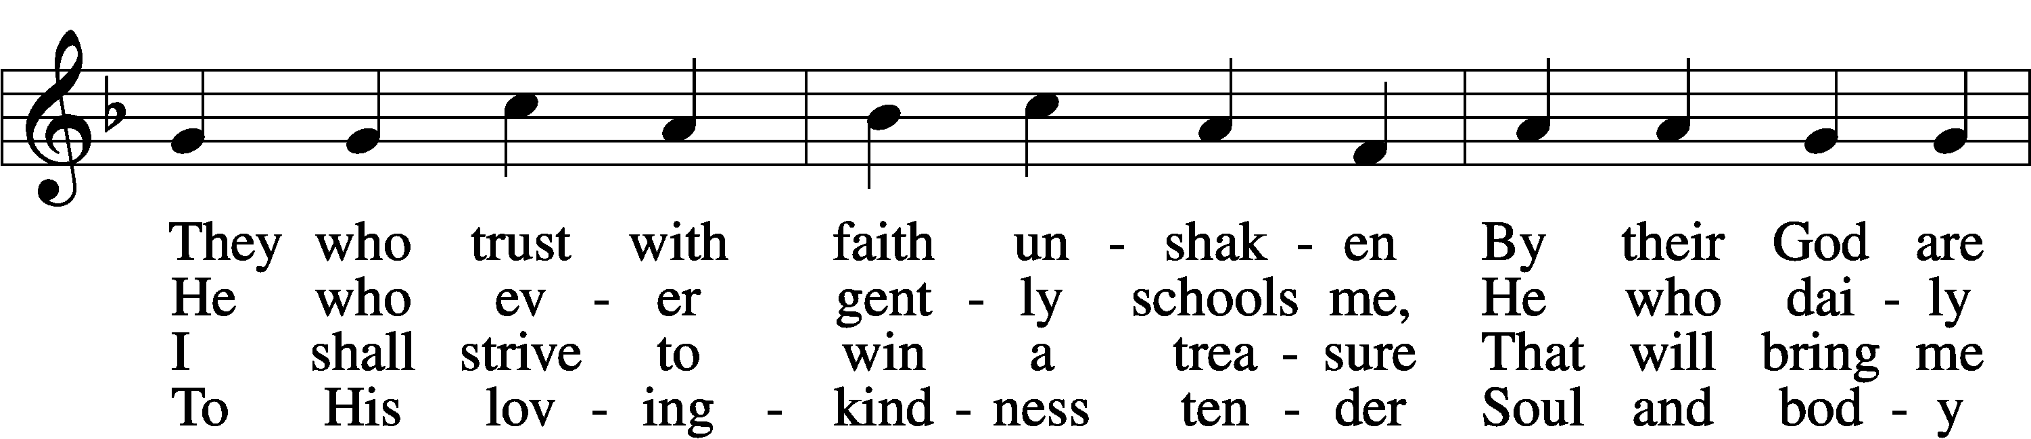
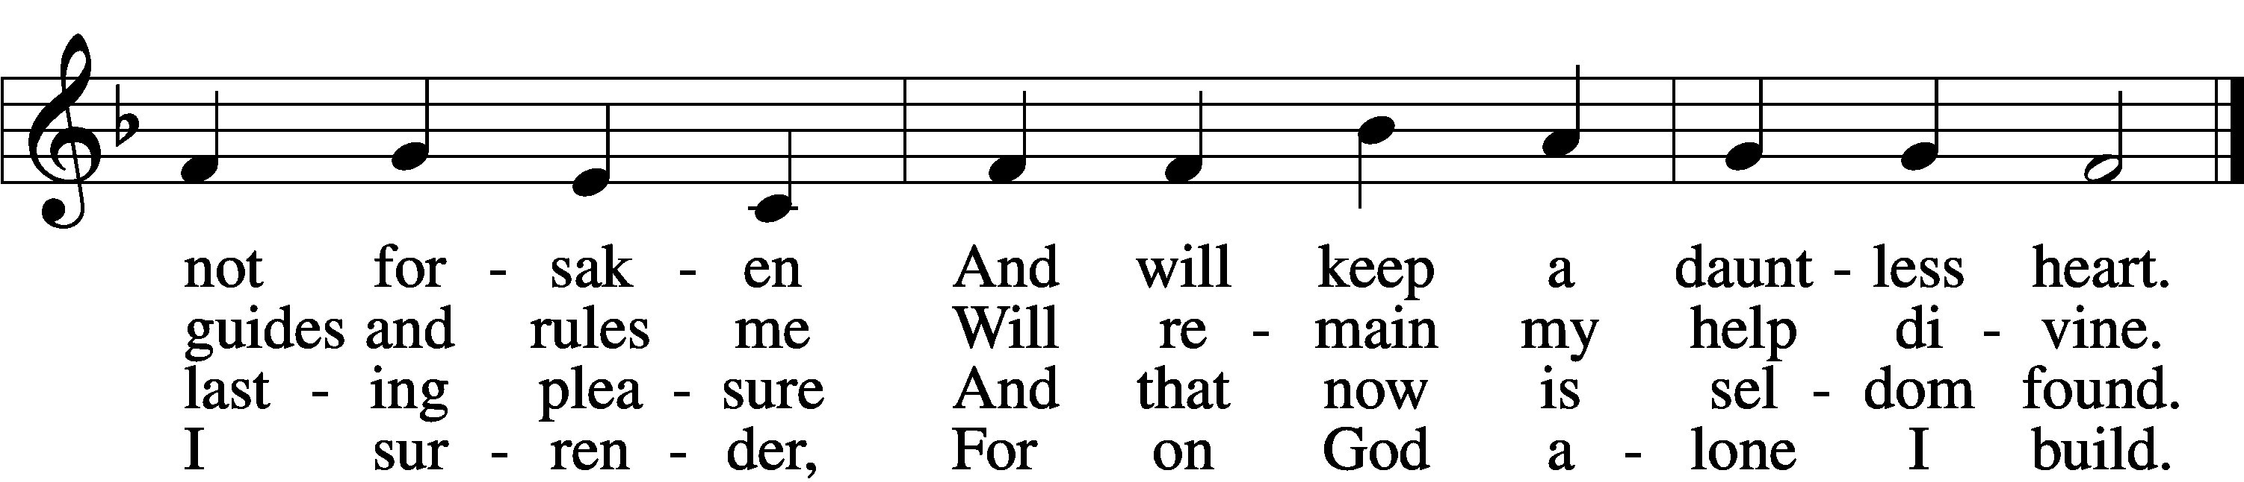

5 Well He knows what best to grant me;
All the longing hopes that haunt me,
Joy and sorrow, have their day.
I shall doubt His wisdom never;
As God wills, so be it ever;
I commit to Him my way.
6 If my days on earth He lengthen,
God my weary soul will strengthen;
All my trust in Him I place.
Earthly wealth is not abiding,
Like a stream away is gliding;
Safe I anchor in His grace.
Text: Andächtige Haus-Kirche, 1676, Nürnberg; tr. Catherine Winkworth, 1827–78, alt.
Tune: Johann Löhner, 1645–1705; adapt. Johann Balthasar König, 1691–1758
Text and tune: Public domain
Acknowledgments
Divine Service, Setting Three from Lutheran Service Book
Unless otherwise indicated, Scripture quotations are from the ESV® Bible (The Holy Bible, English Standard Version®), copyright © 2001 by Crossway, a publishing ministry of Good News Publishers. Used by permission. All rights reserved.
Created by Lutheran Service Builder © 2026 Concordia Publishing House.

