On entering the church

P Lord, I love the habitation of Your house and the place
where Your glory dwells. In the multitude of Your tender
mercies prepare my heart that I may enter Your house to
worship and confess Your holy name; through Jesus Christ,
my God and Lord.

Before worship

C O Lord, our creator, redeemer, and comforter, as we come
together to worship You in spirit and in truth, we humbly
pray that You would open our hearts to the preaching of
Your Word so that we may repent of our sins, believe in
Jesus Christ as our only Savior, and grow in grace and
holiness. Hear us for His sake.

594 God’s Own Child, I Gladly Say It
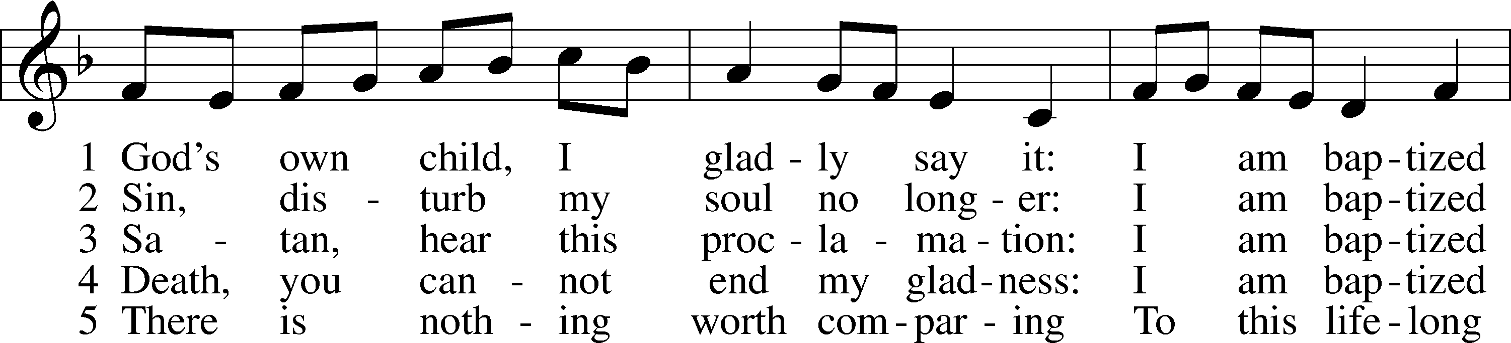
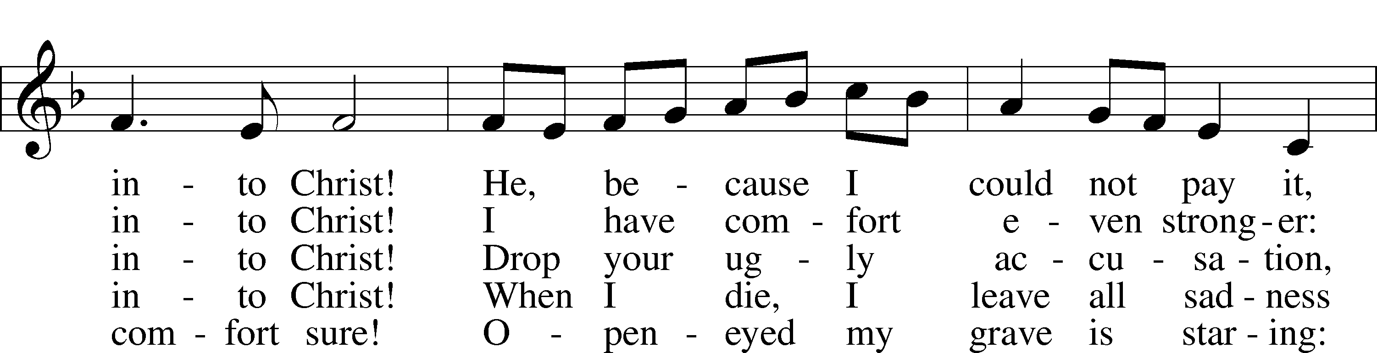
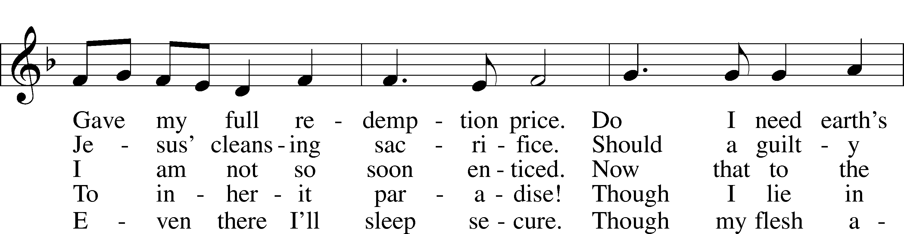
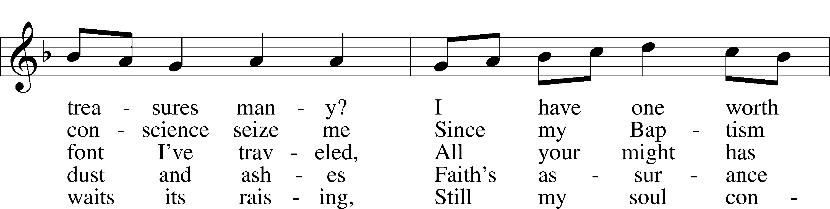
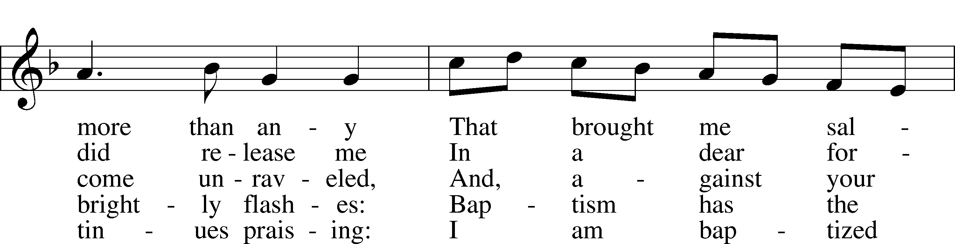
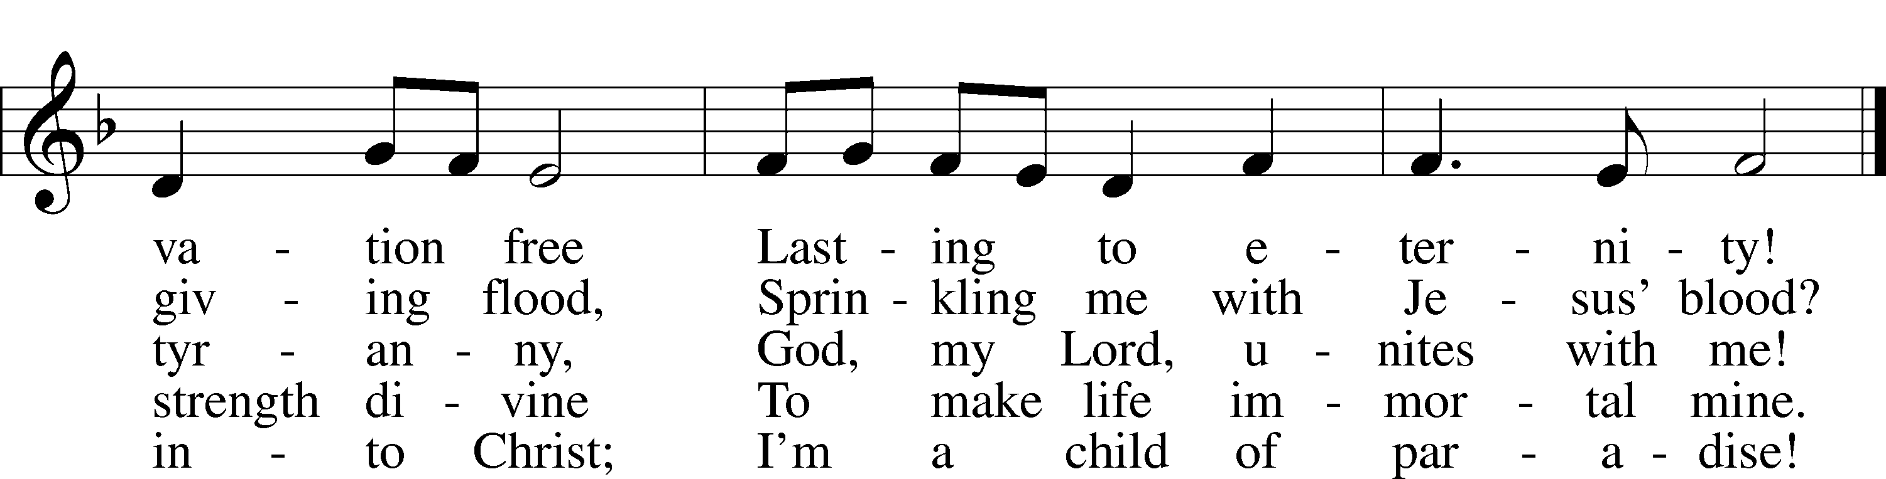
Text: Erdmann Neumeister, 1671–1756; tr. Robert E. Voelker, 1957
Tune: Johann Caspar Bachofen, 1695–1755, alt.
Text: © 1991 Robert E. Voelker. Used by permission: LSB Hymn License no. 110005011
Tune: Public domain

Confession and Absolution
Stand

The sign of the cross may be made by all in remembrance of their Baptism.

Invocation Matthew 28:19b; 18:20
P In the name of the Father and of the T Son and of the Holy Spirit.
C Amen.

Exhortation Hebrews 10:22; Psalm 124:8; Psalm 32:5
P Beloved in the Lord! Let us draw near with a true heart and confess our sins unto God our Father, beseeching Him in the name of our Lord Jesus Christ to grant us forgiveness.

P Our help is in the name of the Lord,
C who made heaven and earth.
P I said, I will confess my transgressions unto the Lord,
C and You forgave the iniquity of my sin.

Kneel/Stand

Silence for reflection on God’s Word and for self-examination.

Confession of Sins
P O almighty God, merciful Father,
C I, a poor, miserable sinner, confess unto You all my sins and iniquities with which I have ever offended You and justly deserved Your temporal and eternal punishment. But I am heartily sorry for them and sincerely repent of them, and I pray You of Your boundless mercy and for the sake of the holy, innocent, bitter sufferings and death of Your beloved Son, Jesus Christ, to be gracious and merciful to me, a poor, sinful being.

Absolution [John 20:19–23]
P Upon this your confession, I, by virtue of my office, as a called and ordained servant of the Word, announce the grace of God unto all of you, and in the stead and by the command of my Lord Jesus Christ I forgive you all your sins in the name of the Father and of the T Son and of the Holy Spirit.
C Amen.

Stand
Service of the Word
Introit Psalm 31:1, 3, 5; antiphon: Revelation 7:14b
These are the ones coming out of the great tribulation.
They have washed their robes and made them white in the blood of the Lamb.
In you, O Lord, do I take refuge; let me never be put to shame;
in your righteousness deliver me.
For you are my rock and my fortress;
and for your name’s sake you lead me and guide me.
Into your hand I commit my spirit;
you have redeemed me, O Lord, faithful God.

Gloria Patri
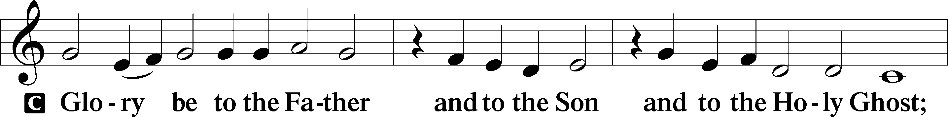
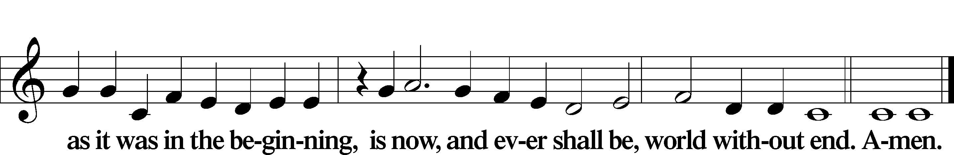

Kyrie Mark 10:47
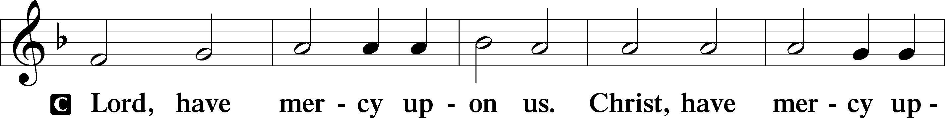
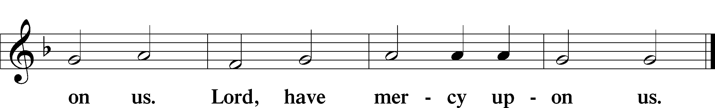

Gloria in Excelsis Luke 2:14; John 1:29
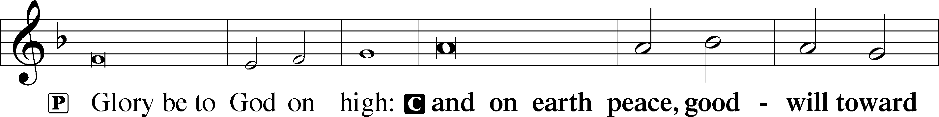
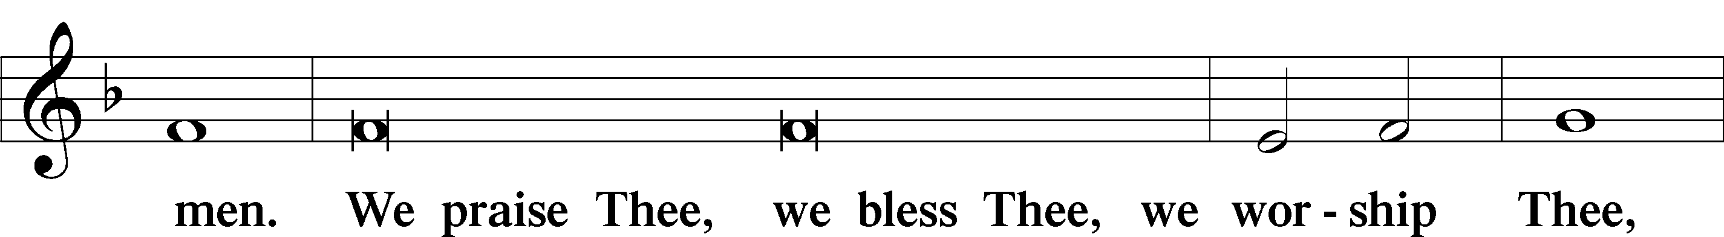
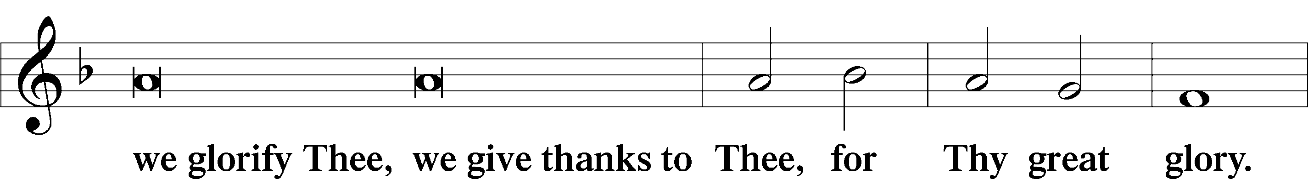
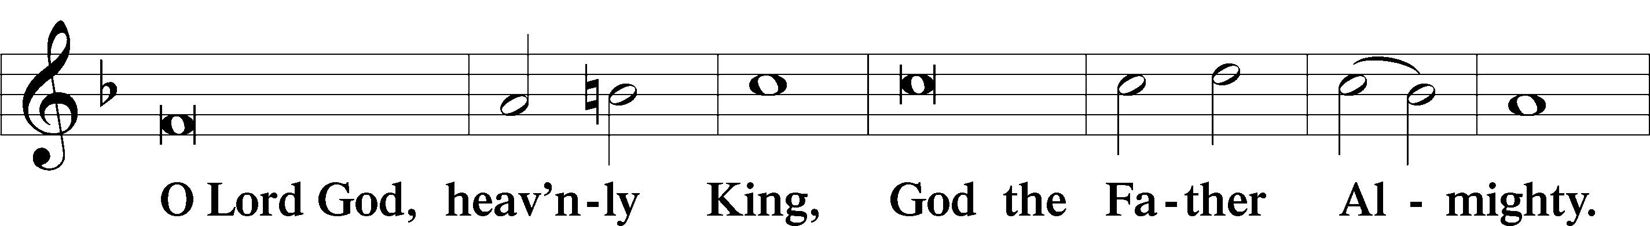
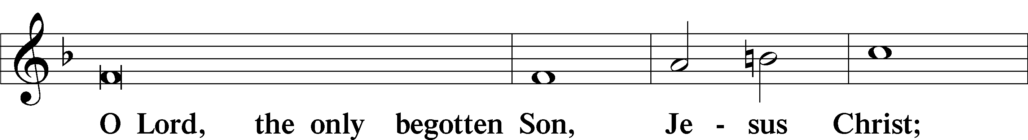
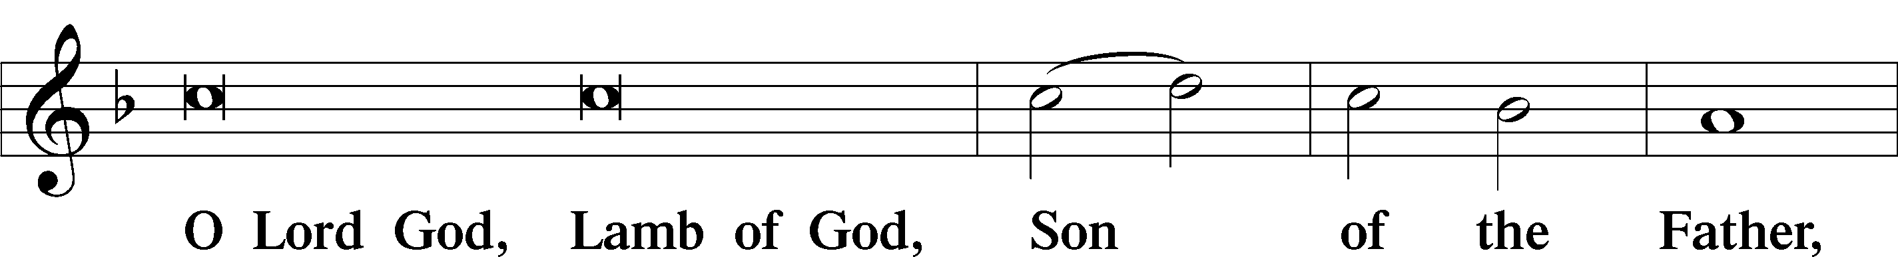
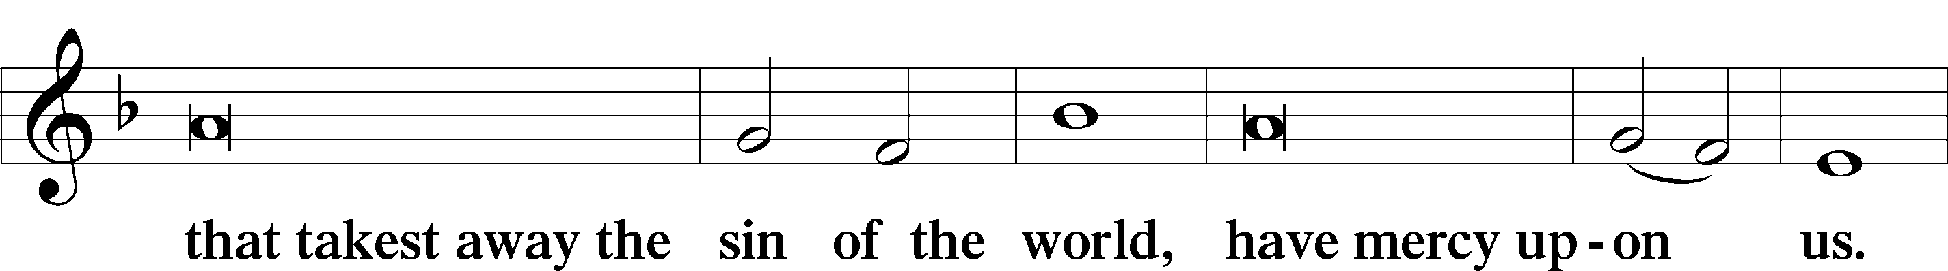
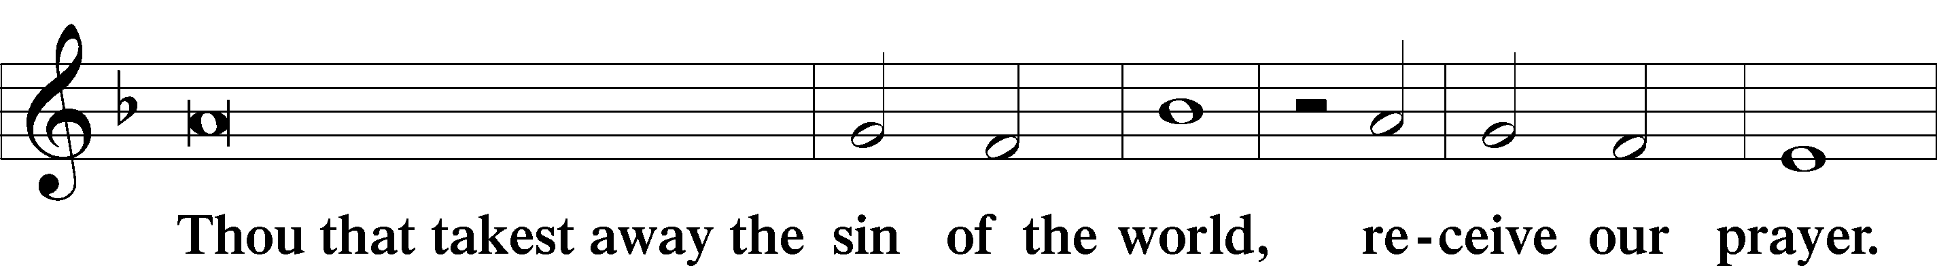
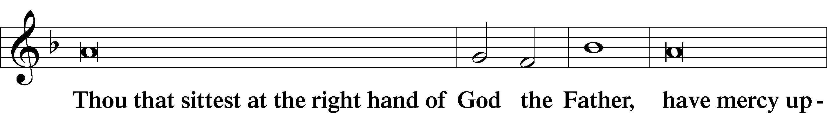
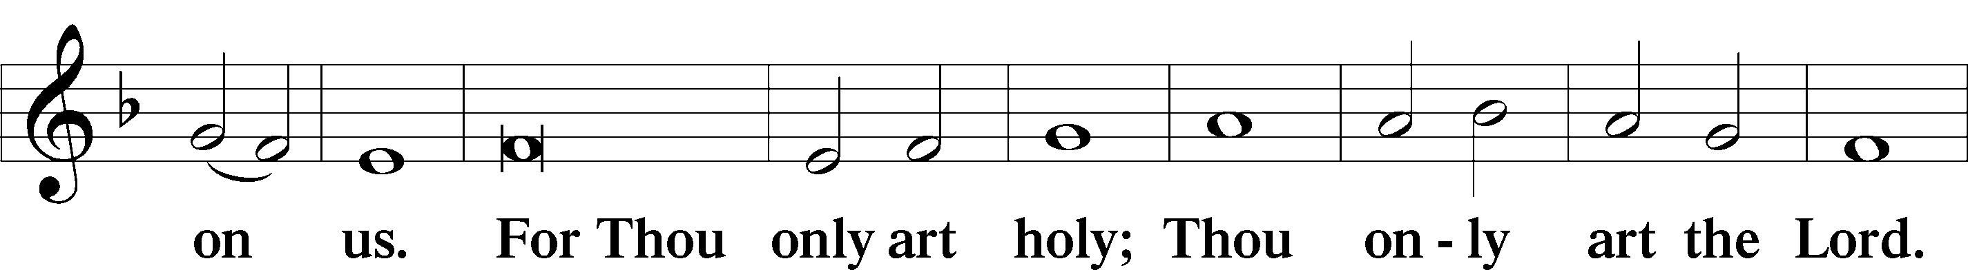
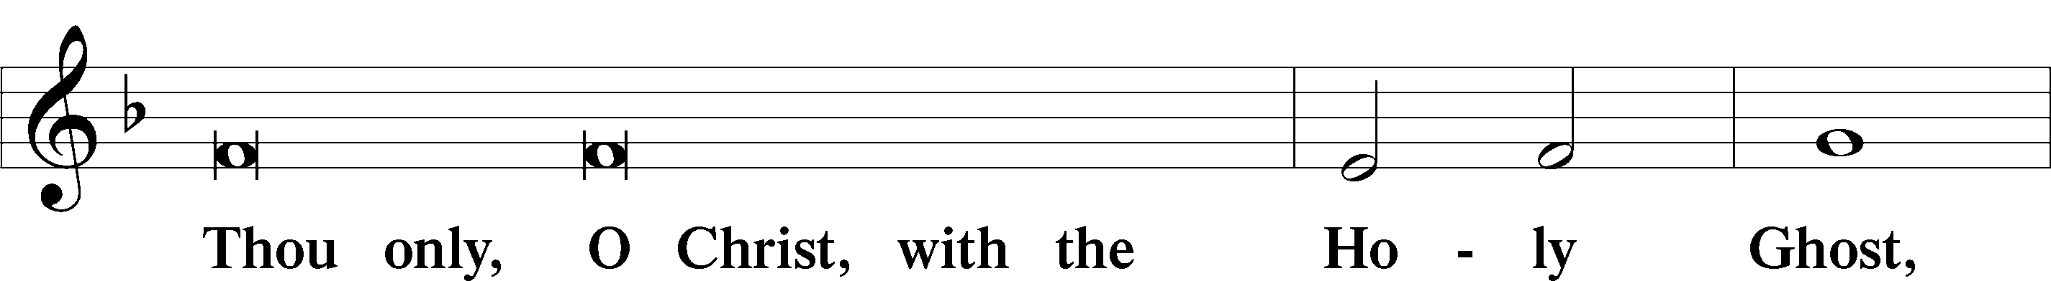
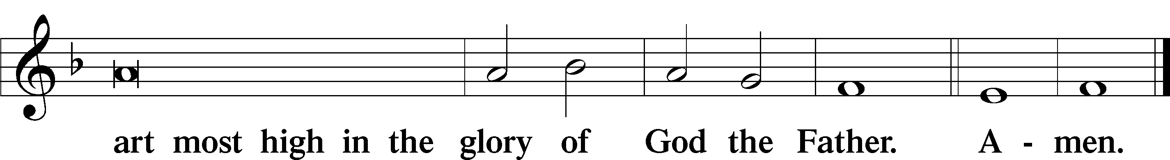

Salutation and Collect of the Day
P The Lord be with you.
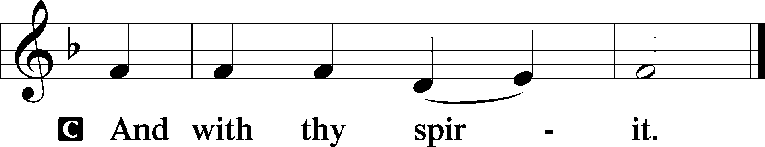

P Let us pray.
Almighty and everlasting God, You knit together Your faithful people of all times and places into one holy communion, the mystical body of Your Son, Jesus Christ. Grant us so to follow Your blessed saints in all virtuous and godly living that, together with them, we may come to the unspeakable joys You have prepared for those who love You; through Jesus Christ, our Lord, who lives and reigns with You and the Holy Spirit, one God, now and forever.

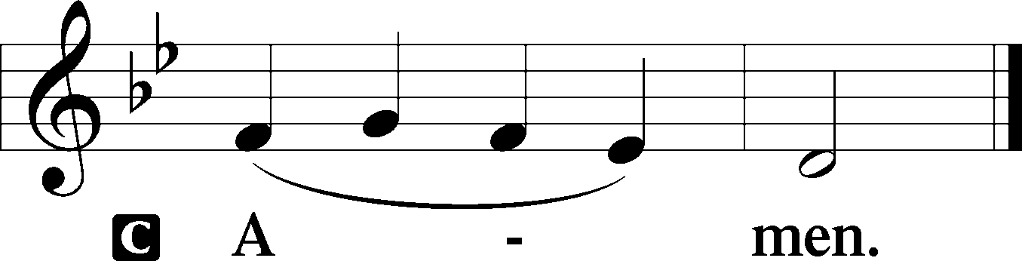

Sit

First Reading Revelation 7:9–17
9After this I looked, and behold, a great multitude that no one could number, from every nation, from all tribes and peoples and languages, standing before the throne and before the Lamb, clothed in white robes, with palm branches in their hands, 10and crying out with a loud voice, “Salvation belongs to our God who sits on the throne, and to the Lamb!” 11And all the angels were standing around the throne and around the elders and the four living creatures, and they fell on their faces before the throne and worshiped God, 12saying, “Amen! Blessing and glory and wisdom and thanksgiving and honor and power and might be to our God forever and ever! Amen.”
13Then one of the elders addressed me, saying, “Who are these, clothed in white robes, and from where have they come?” 14I said to him, “Sir, you know.” And he said to me, “These are the ones coming out of the great tribulation. They have washed their robes and made them white in the blood of the Lamb.
15“Therefore they are before the throne of God,
and serve him day and night in his temple;
and he who sits on the throne will shelter them with his presence.
16They shall hunger no more, neither thirst anymore;
the sun shall not strike them,
nor any scorching heat.
17For the Lamb in the midst of the throne will be their shepherd,
and he will guide them to springs of living water,
and God will wipe away every tear from their eyes.”

A This is the Word of the Lord.
C Thanks be to God.

Gradual Revelation 7:14b; Psalm 84:5
These are the ones coming out of the great tribulation.
They have washed their robes and made them white in the blood of the Lamb.
Blessèd are those whose strength is in you,
in whose heart are the highways to Zion.

Epistle 1 John 3:1–3
1See what kind of love the Father has given to us, that we should be called children of God; and so we are. The reason why the world does not know us is that it did not know him. 2Beloved, we are God’s children now, and what we will be has not yet appeared; but we know that when he appears we shall be like him, because we shall see him as he is. 3And everyone who thus hopes in him purifies himself as he is pure.

A This is the Word of the Lord.
C Thanks be to God.

Stand

Alleluia
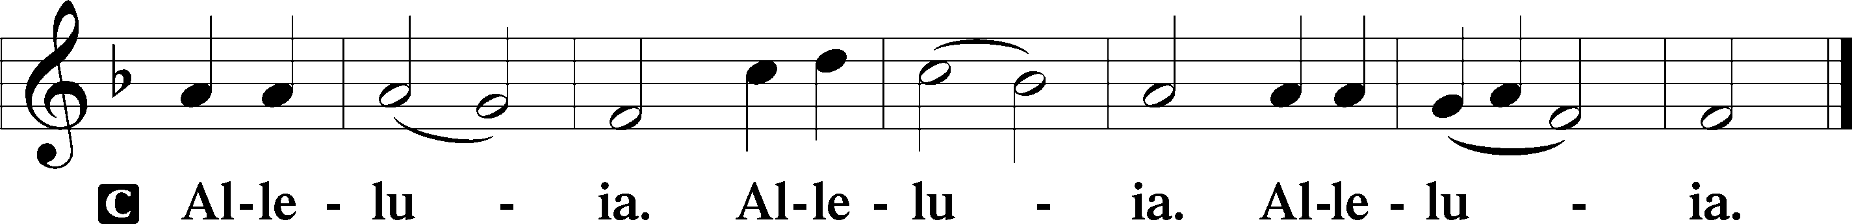

Holy Gospel Matthew 5:1–12
P The Holy Gospel according to St. Matthew, the fifth chapter.

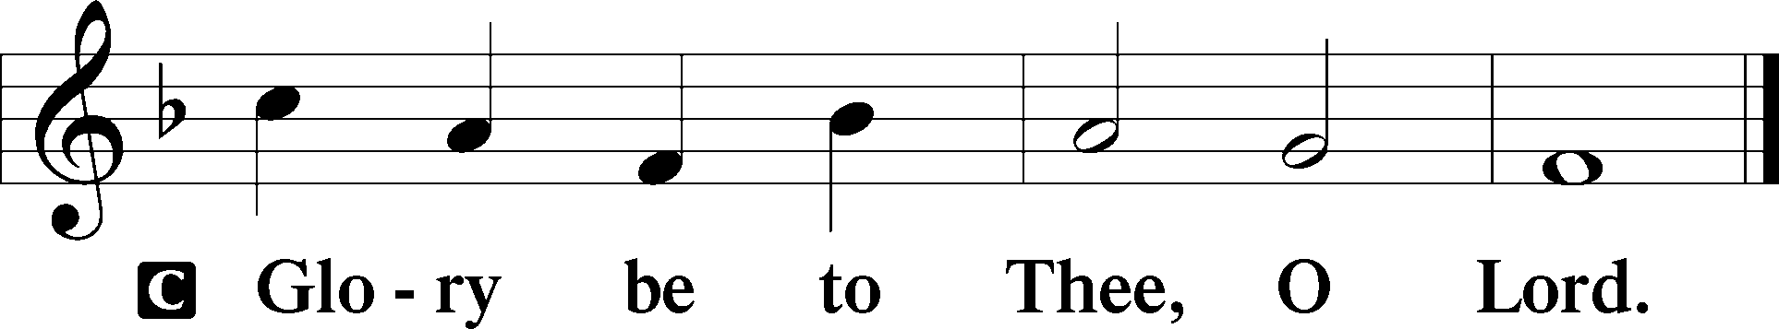

1Seeing the crowds, [Jesus] went up on the mountain, and when he sat down, his disciples came to him.
2And he opened his mouth and taught them, saying:
3“Blessed are the poor in spirit, for theirs is the kingdom of heaven.
4“Blessed are those who mourn, for they shall be comforted.
5“Blessed are the meek, for they shall inherit the earth.
6“Blessed are those who hunger and thirst for righteousness, for they shall be satisfied.
7“Blessed are the merciful, for they shall receive mercy.
8“Blessed are the pure in heart, for they shall see God.
9“Blessed are the peacemakers, for they shall be called sons of God.
10“Blessed are those who are persecuted for righteousness’ sake, for theirs is the kingdom of heaven.
11“Blessed are you when others revile you and persecute you and utter all kinds of evil against you falsely on my account. 12Rejoice and be glad, for your reward is great in heaven, for so they persecuted the prophets who were before you.”

P This is the Gospel of the Lord.

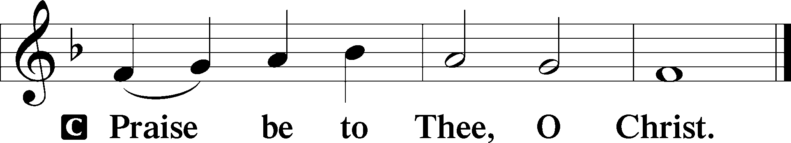

Nicene Creed
C I believe in one God,
the Father Almighty,
maker of heaven and earth
and of all things visible and invisible.
And in one Lord Jesus Christ,
the only-begotten Son of God,
begotten of His Father before all worlds,
God of God, Light of Light,
very God of very God,
begotten, not made,
being of one substance with the Father,
by whom all things were made;
who for us men and for our salvation came down from heaven
and was incarnate by the Holy Spirit of the virgin Mary
and was made man;
and was crucified also for us under Pontius Pilate.
He suffered and was buried.
And the third day He rose again according to the Scriptures
and ascended into heaven
and sits at the right hand of the Father.
And He will come again with glory to judge both the living and the dead,
whose kingdom will have no end.
And I believe in the Holy Spirit,
the Lord and giver of life,
who proceeds from the Father and the Son,
who with the Father and the Son together is worshiped and glorified,
who spoke by the prophets.
And I believe in one holy Christian and apostolic Church,
I acknowledge one Baptism for the remission of sins,
and I look for the resurrection of the dead
and the life T of the world to come. Amen.

Sit

Children's Sermon

677 For All the Saints
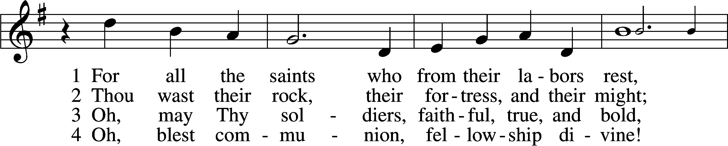
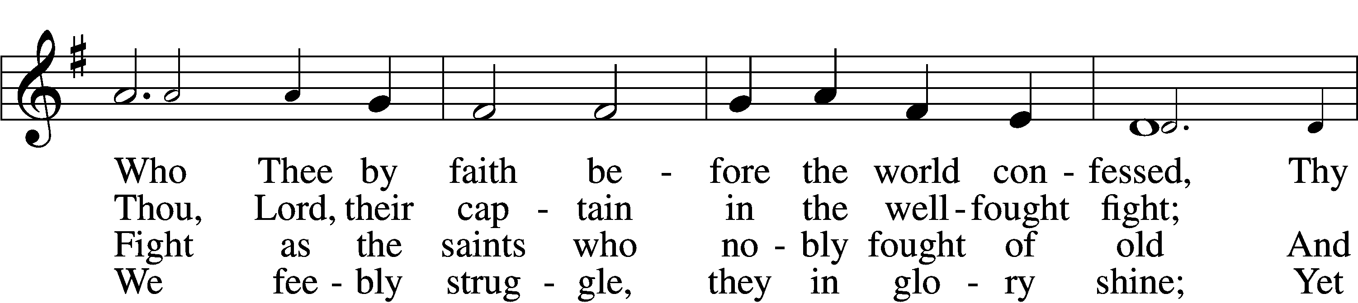
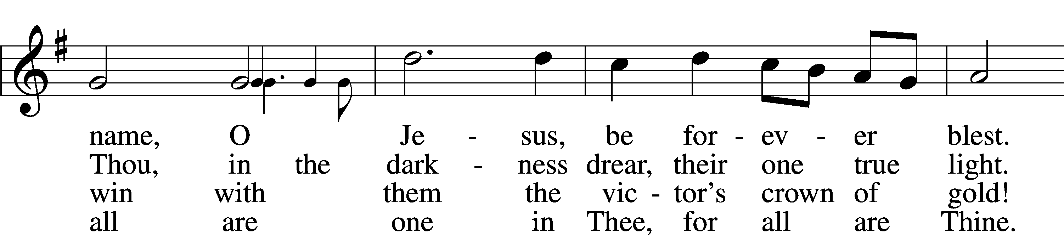
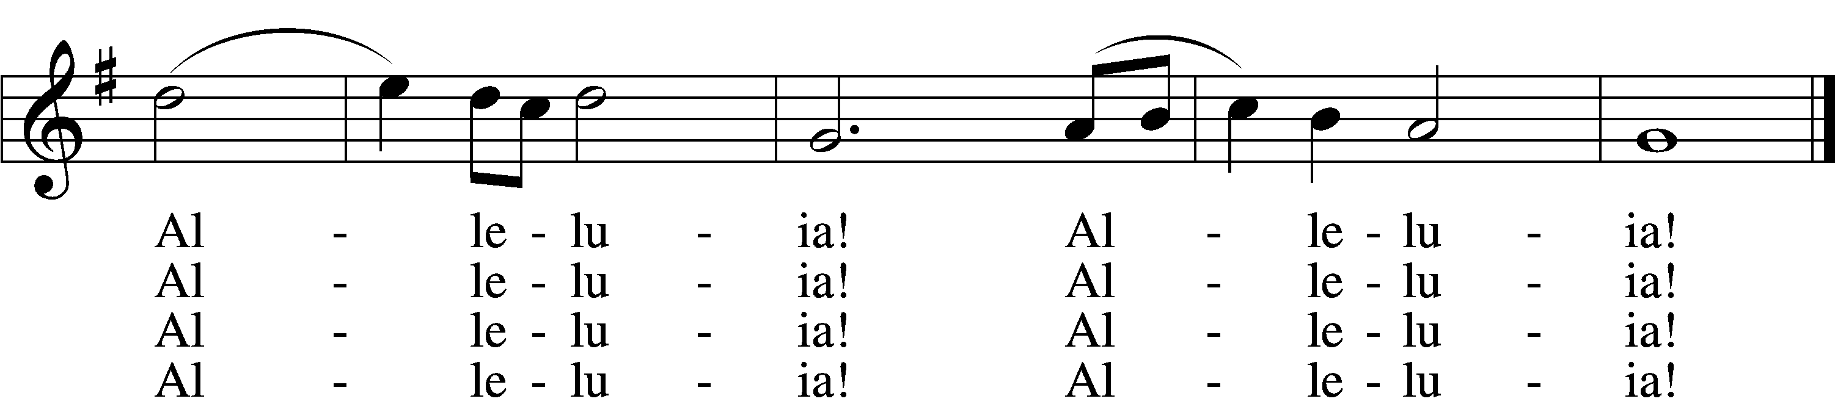

5 And when the fight is fierce, the warfare long,
Steals on the ear the distant triumph song,
And hearts are brave again, and arms are strong.
Alleluia! Alleluia!

6 The golden evening brightens in the west;
Soon, soon to faithful warriors cometh rest;
Sweet is the calm of paradise the blest.
Alleluia! Alleluia!

7 But, lo, there breaks a yet more glorious day:
The saints triumphant rise in bright array;
The King of Glory passes on His way.
Alleluia! Alleluia!

D 8 From earth’s wide bounds, from ocean’s farthest coast,
Through gates of pearl streams in the countless host,
Singing to Father, Son, and Holy Ghost:
Alleluia! Alleluia!
Text: William W. How, 1823–97, alt.
Tune: Ralph Vaughan Williams, 1872–1958
Text and tune: Public domain

Sermon

Votum
P The peace of God, which passes all understanding, keep your hearts and minds in Christ Jesus.
C Amen.

Stand

Offertory Psalm 51:10–12
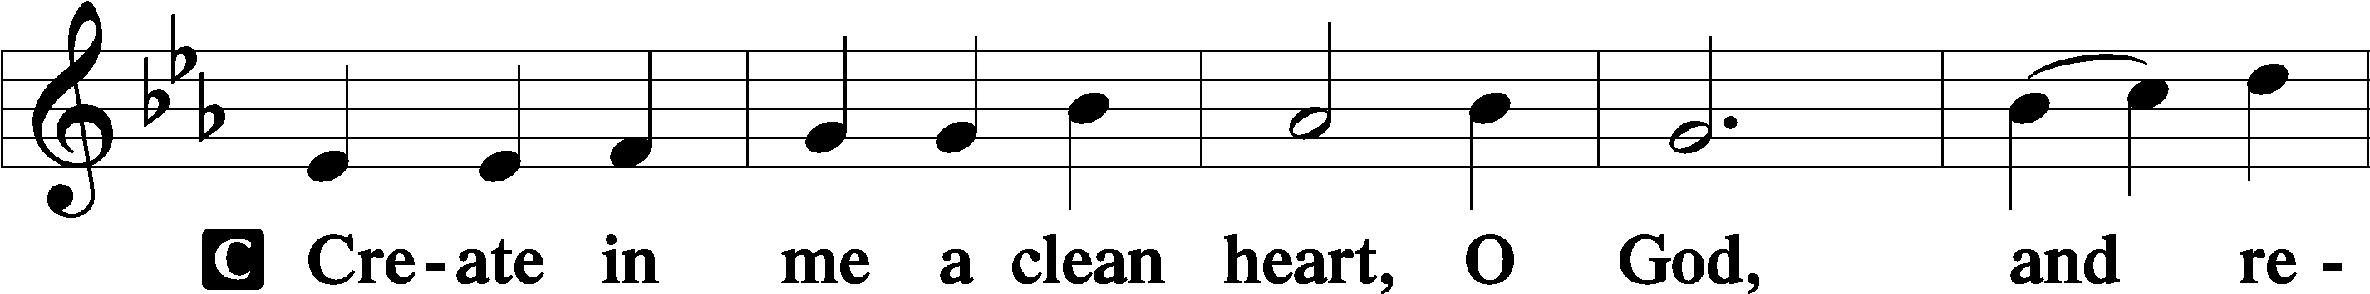
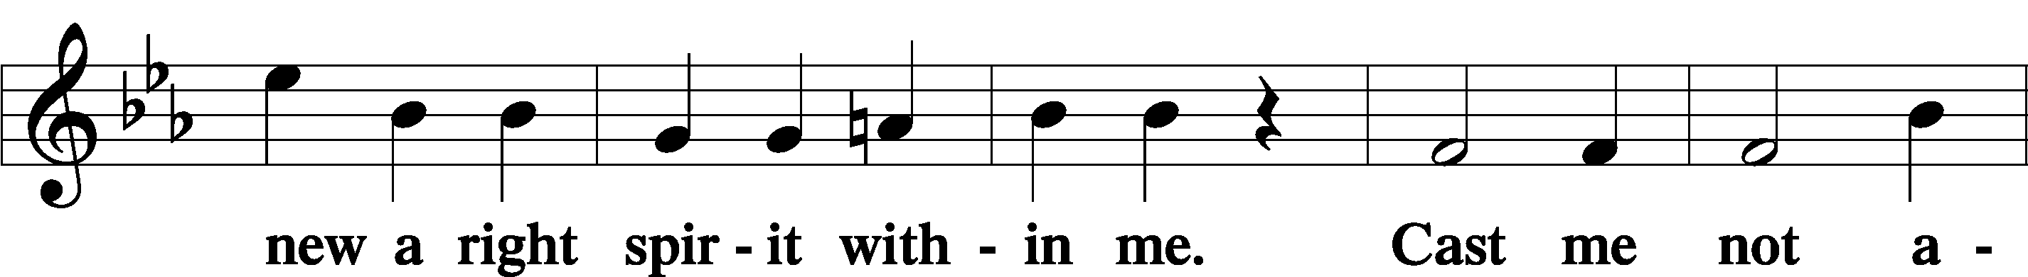
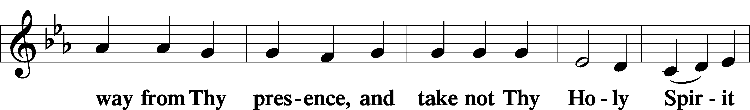
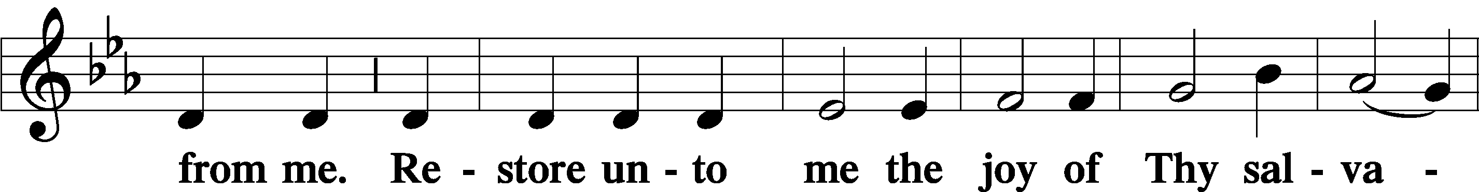
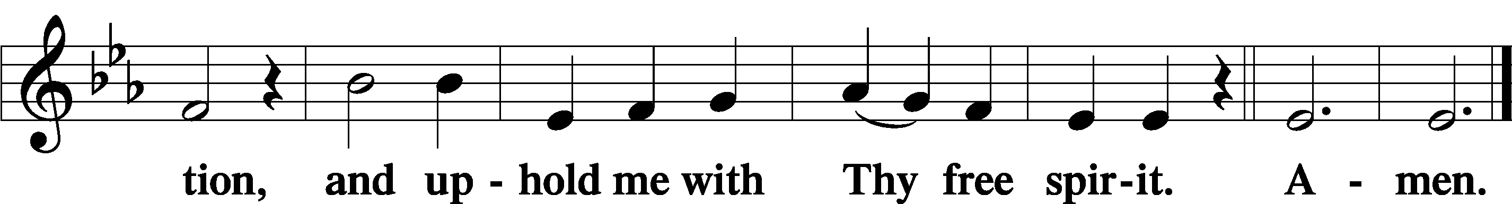

Sit

Offering

805
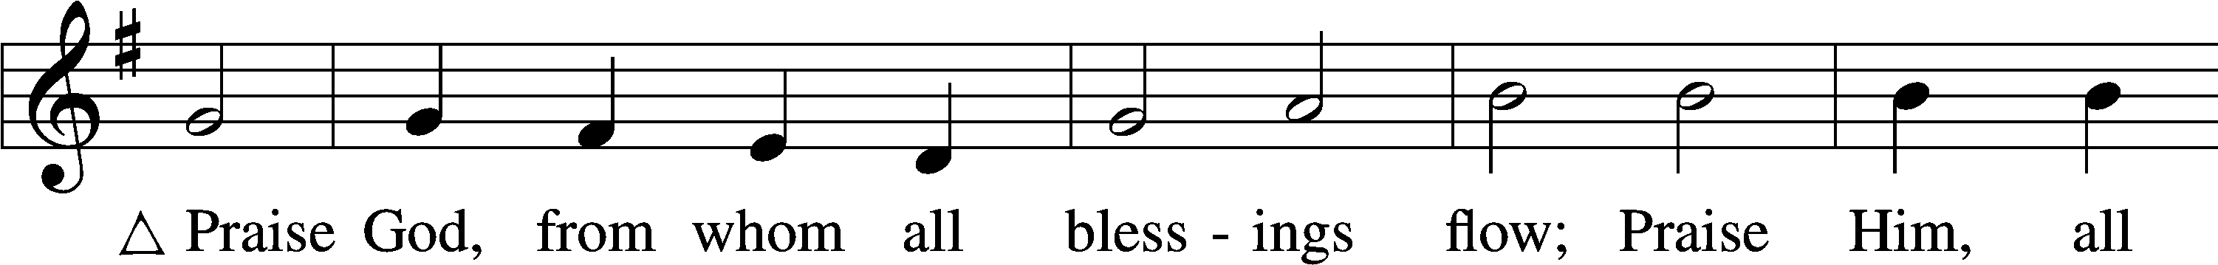
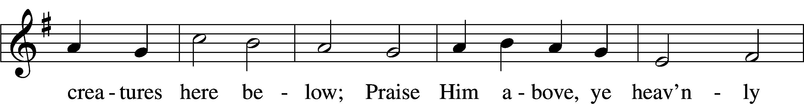
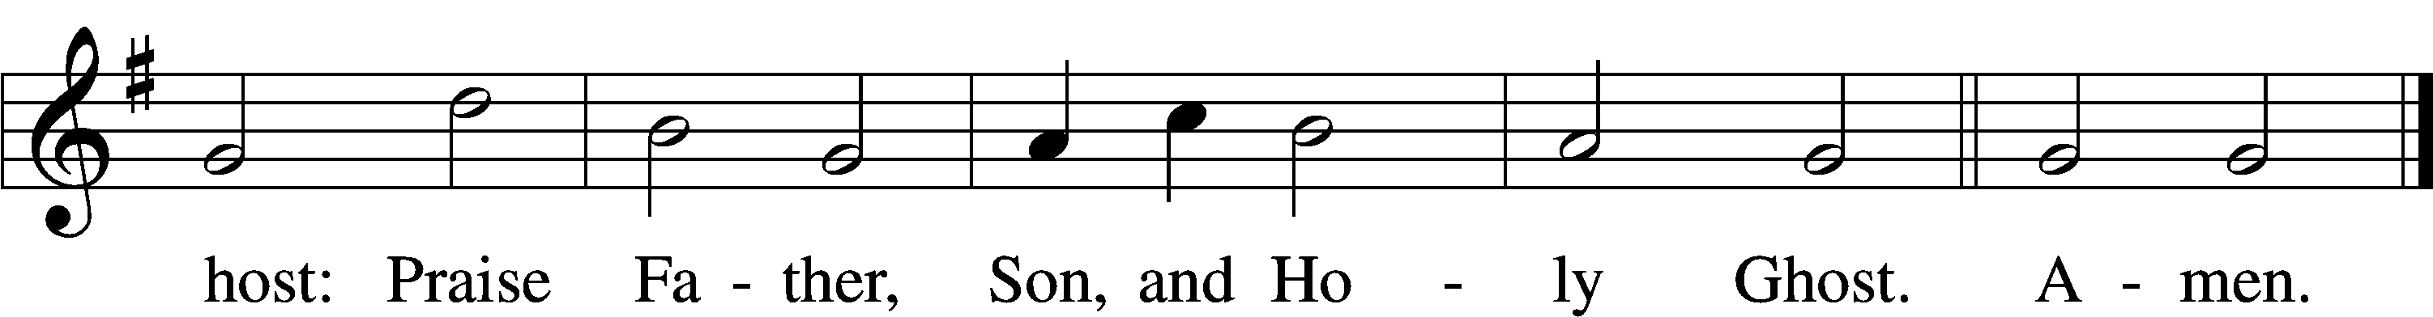
Text: Thomas Ken, 1637–1711
Tune: Trente quatre Pseaumes de David, 1551, Geneva, ed. Louis Bourgeois
Text and tune: Public domain

Stand

Prayer of the Church
Service of the Sacrament

Preface 2 Timothy 4:22; [Colossians 3:1]; [Psalm 136]
P The Lord be with you.
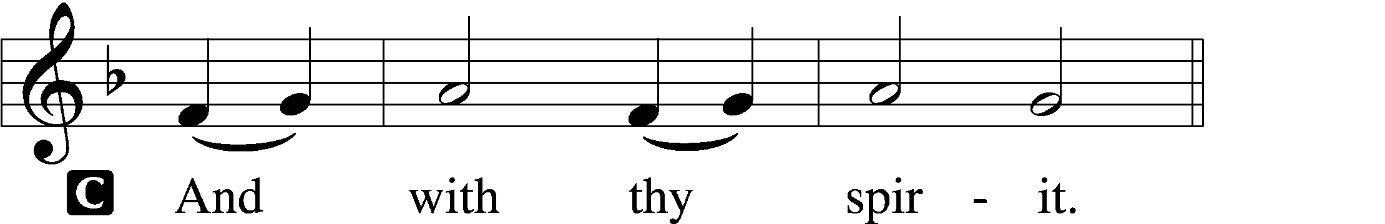

P Lift up your hearts.
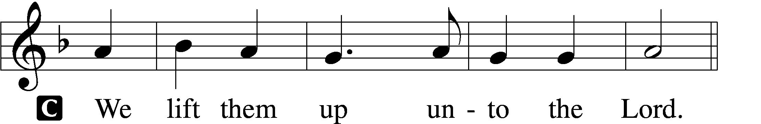

P Let us give thanks unto the Lord, our God.
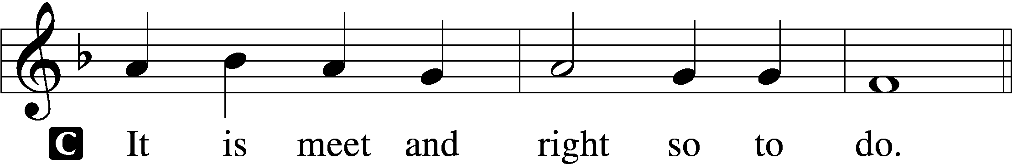

Proper Preface (Full)
P It is truly meet, right, and salutary that we should at all times and in all places give thanks to You, holy Lord, almighty Father, everlasting God. In the communion of all Your saints gathered into the one body of Your Son, You have surrounded us with so great a cloud of witnesses that we, encouraged by their faith and strengthened by their fellowship, may run with perseverance the race that is set before us and, together with them, receive the crown of glory that does not fade away. Therefore with angels and archangels and with all the company of heaven we laud and magnify Your glorious name, evermore praising You and saying:

Sanctus Isaiah 6:3; Matthew 21:9
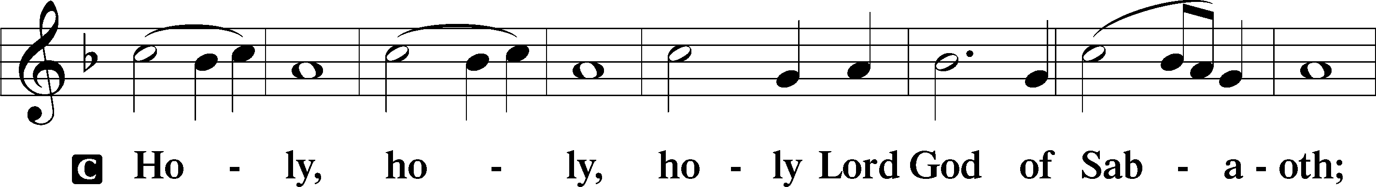
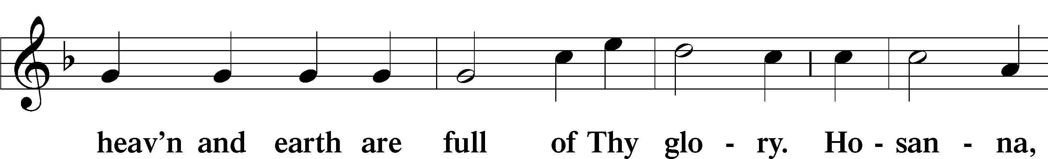
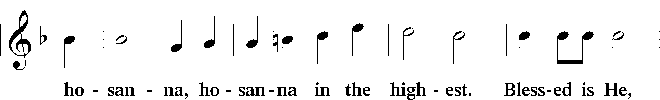
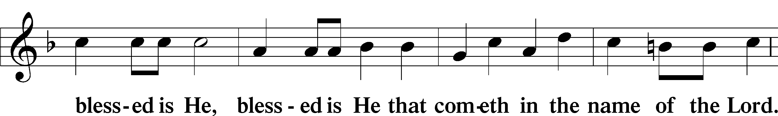
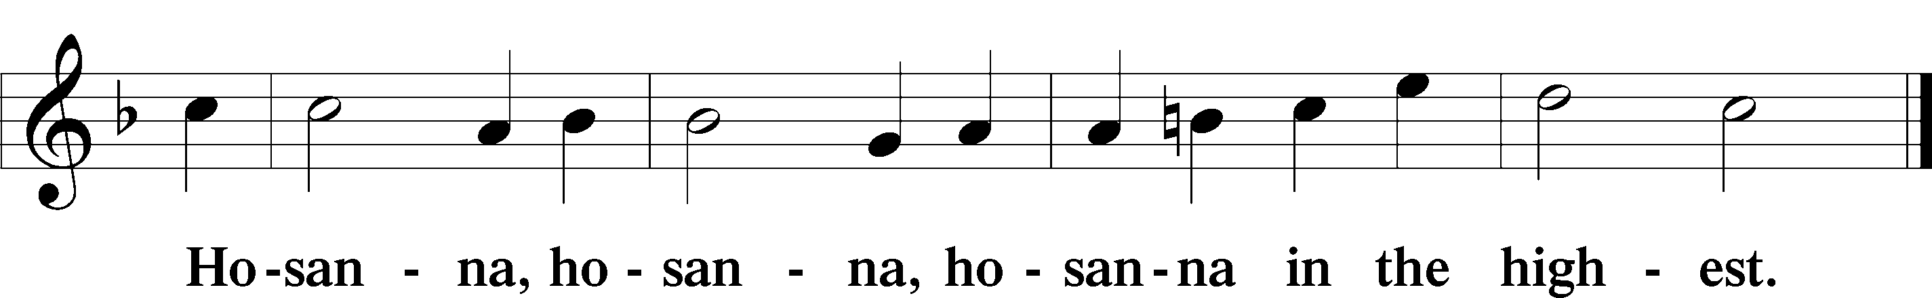

Lord’s Prayer Matthew 6:9–13
P Our Father who art in heaven,
hallowed be Thy name,
Thy kingdom come,
Thy will be done on earth as it is in heaven;
give us this day our daily bread;
and forgive us our trespasses as we forgive those who trespass against us;
and lead us not into temptation,
but deliver us from evil.
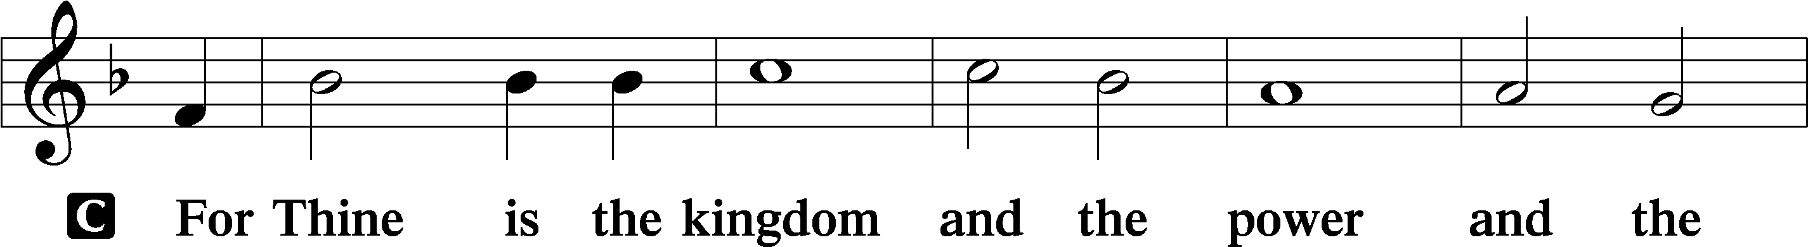
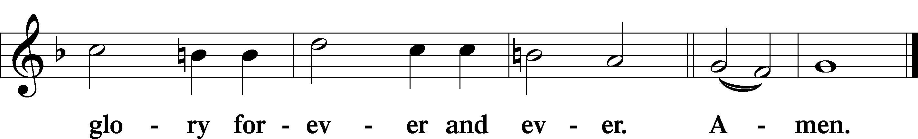

The Words of Our Lord Matthew 26:26–28; Mark 14:22–24; Luke 22:19–20; 1 Corinthians 11:23–25
P Our Lord Jesus Christ, on the night when He was betrayed, took bread, and when He had given thanks, He broke it and gave it to the disciples and said: “Take, eat; this is My T body, which is given for you. This do in remembrance of Me.”

In the same way also He took the cup after supper, and when He had given thanks, He gave it to them, saying: “Drink of it, all of you; this cup is the new testament in My T blood, which is shed for you for the forgiveness of sins. This do, as often as you drink it, in remembrance of Me.”

Pax Domini John 20:19
P The peace of the Lord be with you always.

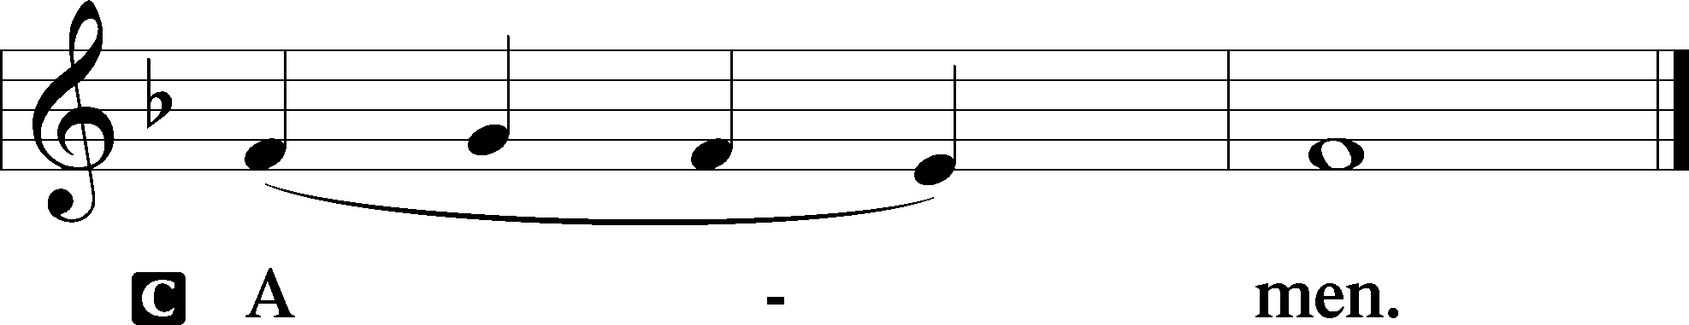

Agnus Dei John 1:29
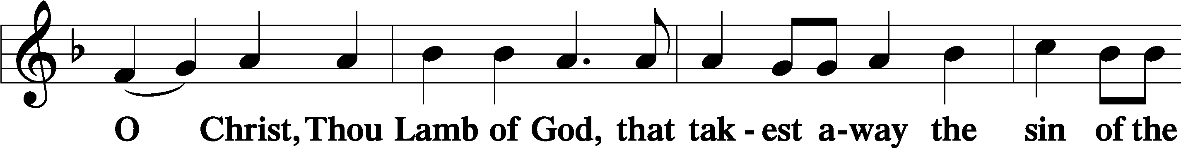
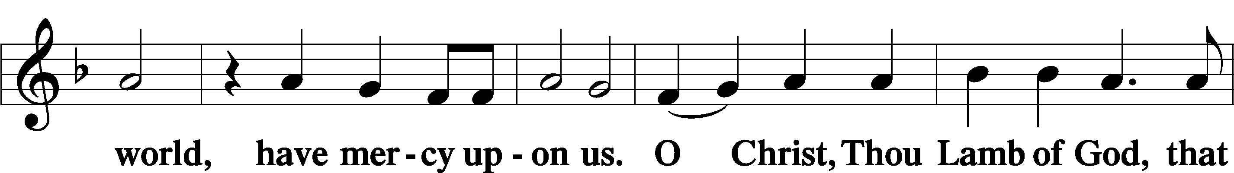
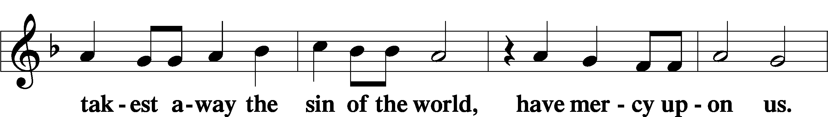
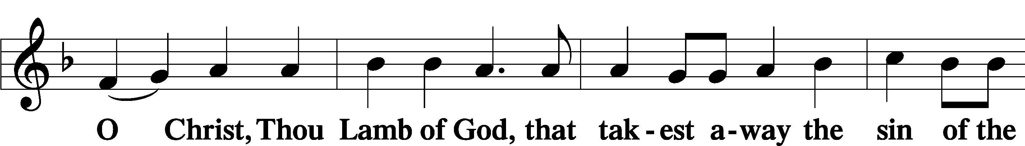
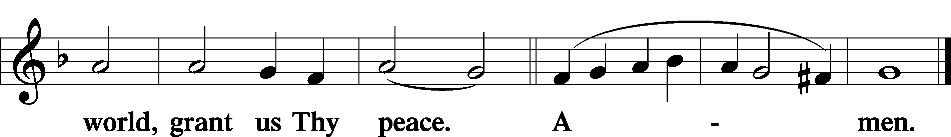

Sit

Distribution

The pastor and those who assist him receive the body and blood of Christ first and then distribute them to those who come to receive, saying:

Take, eat; this is the true body of our Lord and Savior Jesus Christ, given into death for your sins.
Amen.

Take, drink; this is the true blood of our Lord and Savior Jesus Christ, shed for the forgiveness of your sins.
Amen.

In dismissing the communicants, the following is said:

The Dismissal
P The body and blood of our Lord Jesus Christ strengthen and preserve you in body and soul to life everlasting. Depart T in peace.
C Amen.

813 Rejoice, O Pilgrim Throng
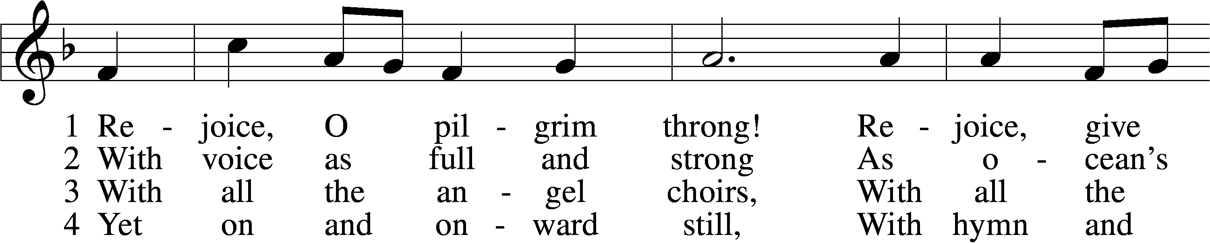
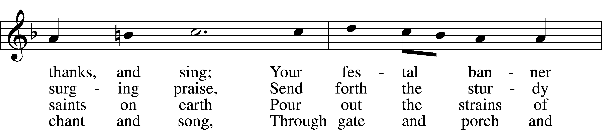
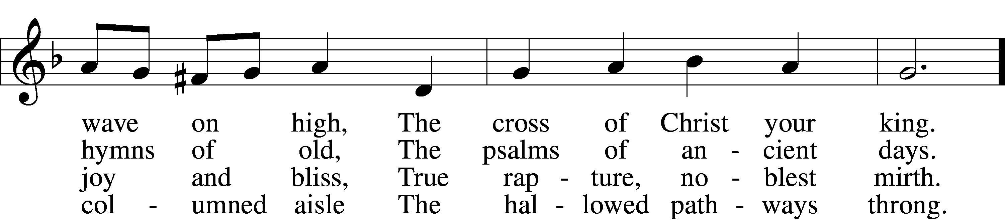
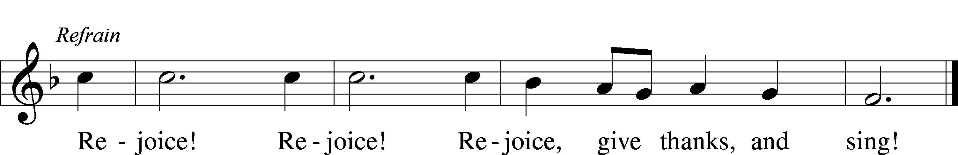

5 Still lift your standard high,
Still march in firm array,
As pilgrims through the darkness wend
Till dawns the golden day. Refrain

6 At last the march shall end;
The wearied ones shall rest;
The pilgrims find their home at last,
Jerusalem the blest. Refrain

D 7 Praise Him who reigns on high,
The Lord whom we adore:
The Father, Son, and Holy Ghost,
One God forevermore. Refrain
Text: Edward H. Plumptre, 1821–91, alt.
Tune: Arthur H. Messiter, 1834–1916
Text and tune: Public domain

700 Love Divine, All Loves Excelling
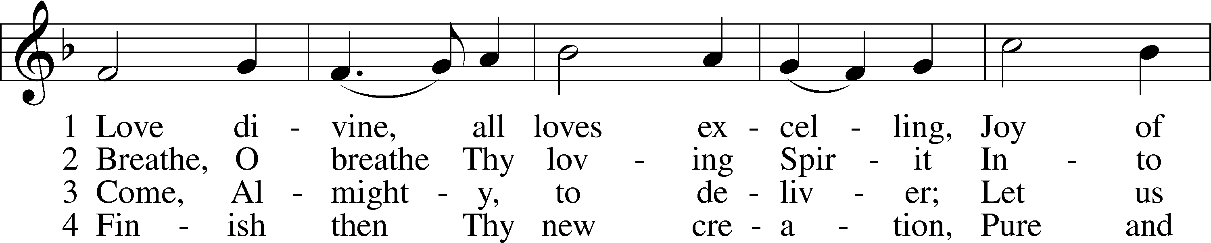
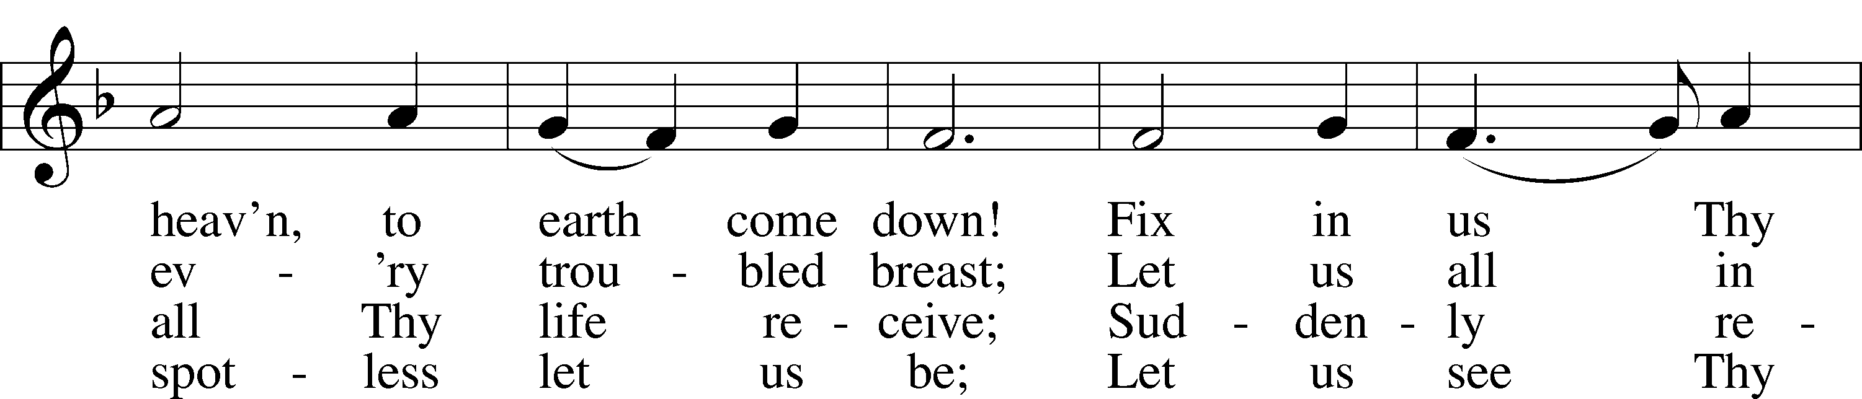
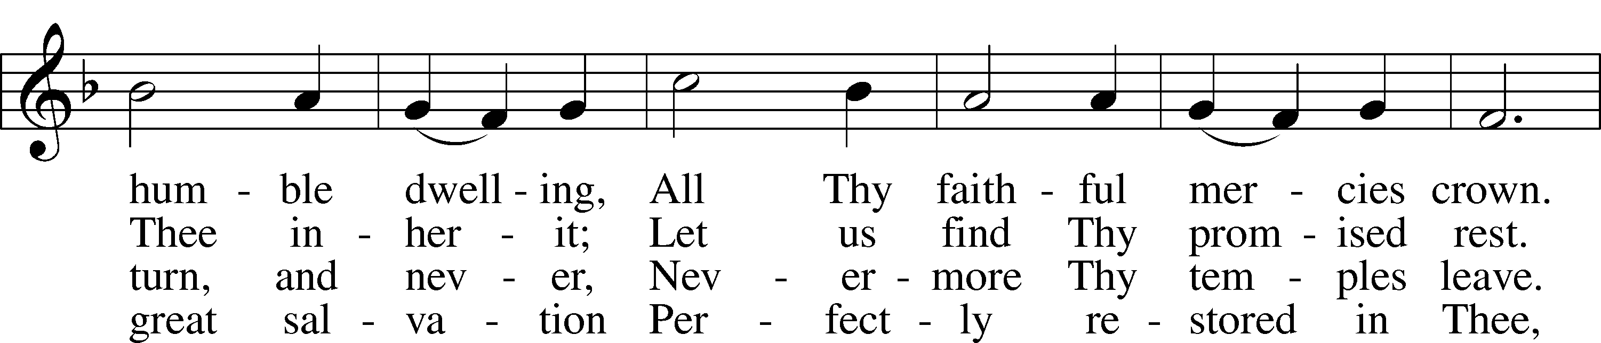
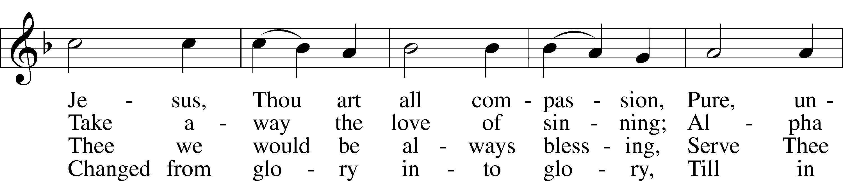
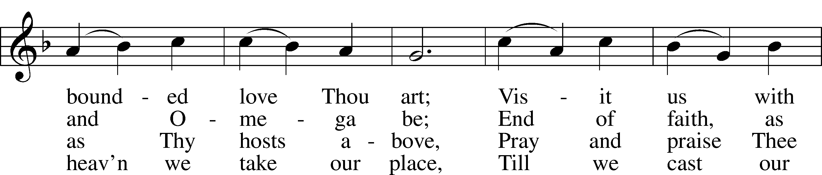
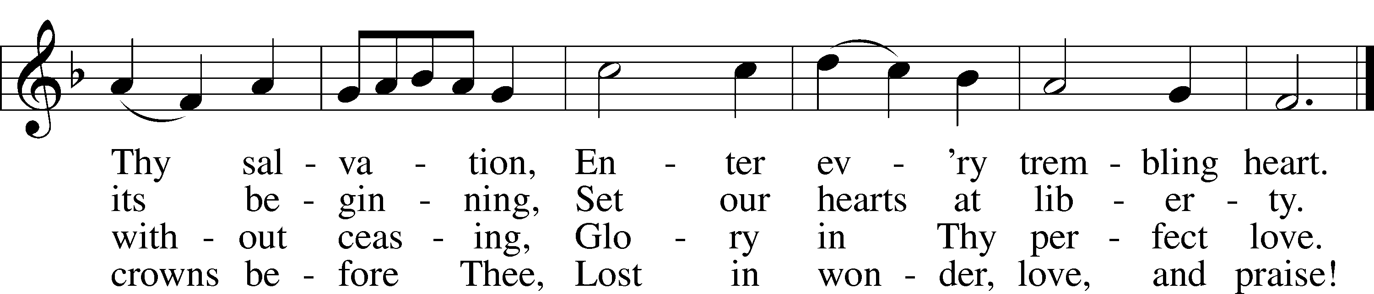
Text: Charles Wesley, 1707–88
Tune: Rowland H. Prichard, 1811–87
Text and tune: Public domain

733 O God, Our Help in Ages Past sts. 1–6
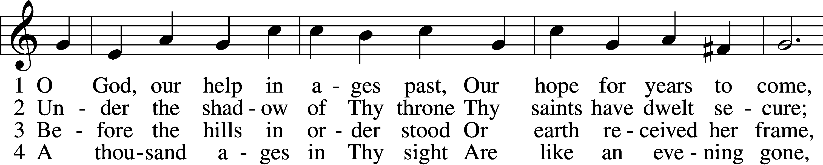
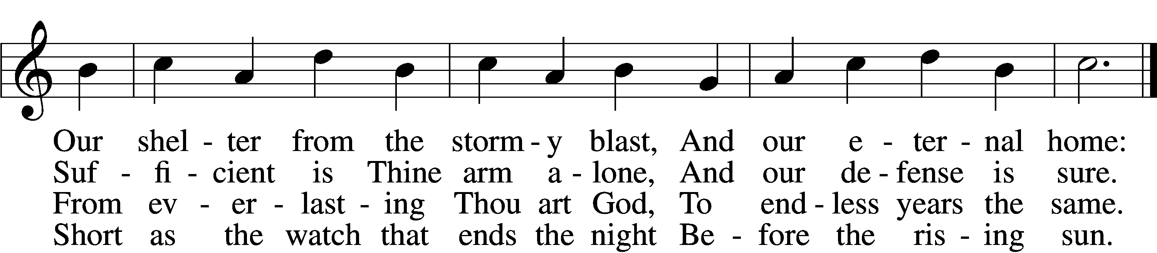

5 Time, like an ever-rolling stream,
Soon bears us all away;
We fly forgotten as a dream
Dies at the op’ning day.

6 O God, our help in ages past,
Our hope for years to come,
Be Thou our guard while troubles last
And our eternal home!
Text: Isaac Watts, 1674–1748, alt.
Tune: William Croft, 1678–1727
Text and tune: Public domain

670 Ye Watchers and Ye Holy Ones
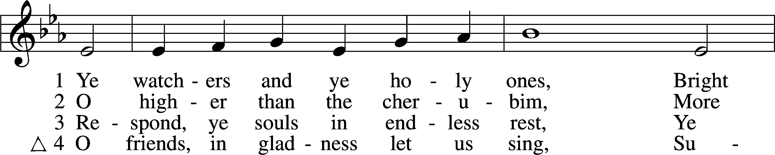
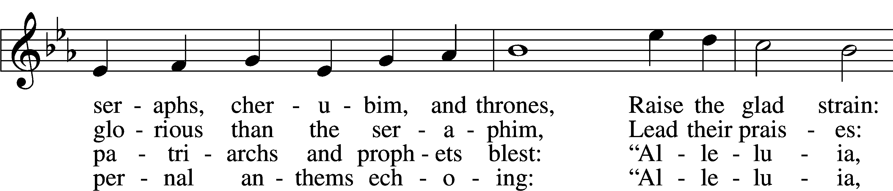
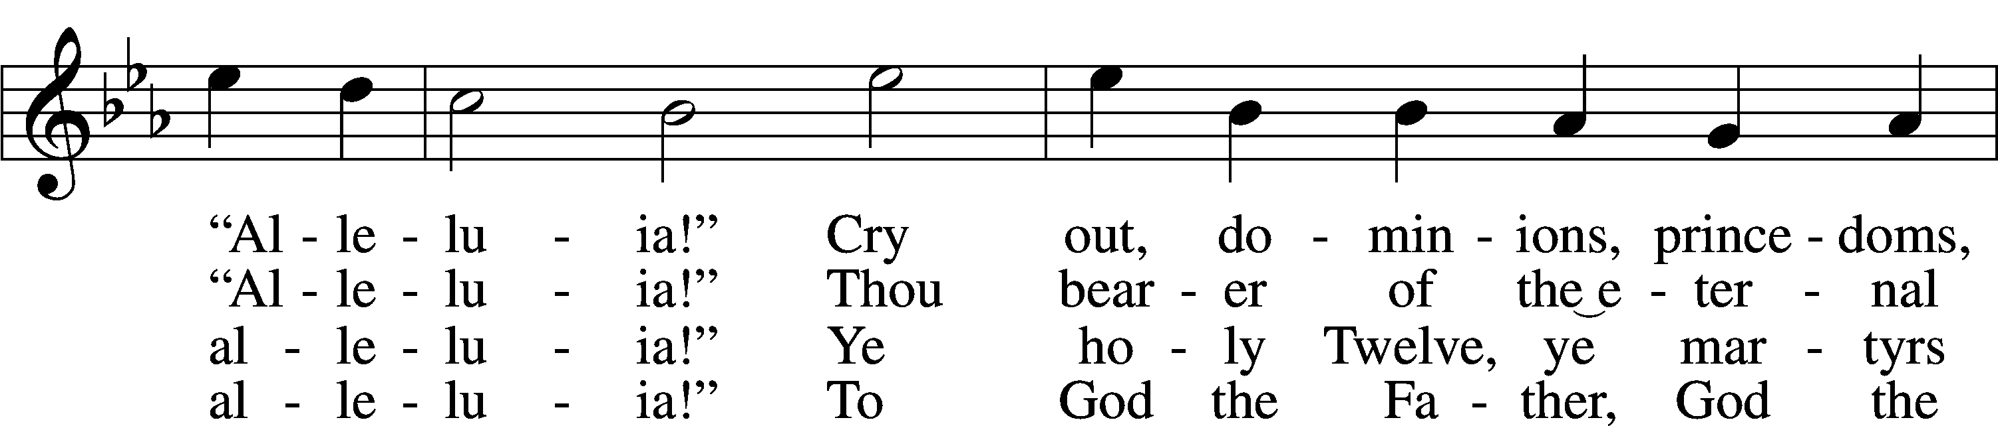
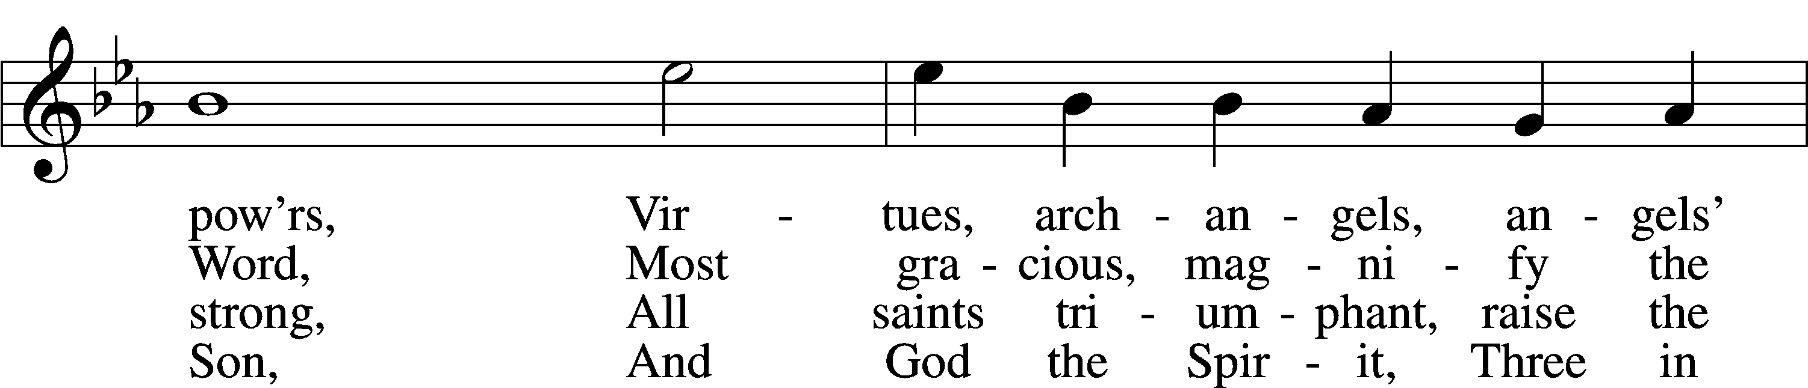
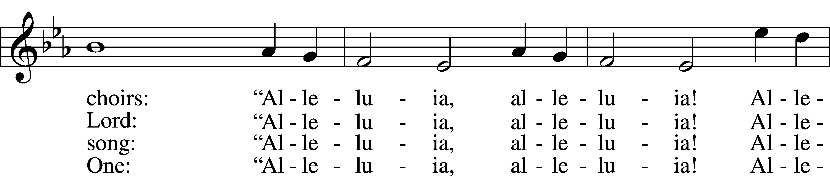
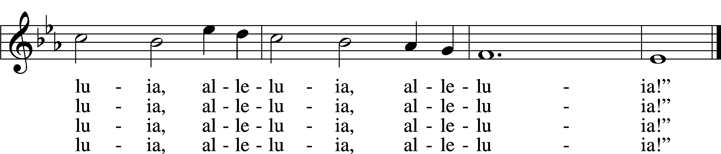
Text: J. Athelstan L. Riley, 1858–1945, alt.
Tune: Geistliche Kirchengesäng, 1623, Köln
Text and tune: Public domain

Stand

Nunc Dimittis Luke 2:29–32
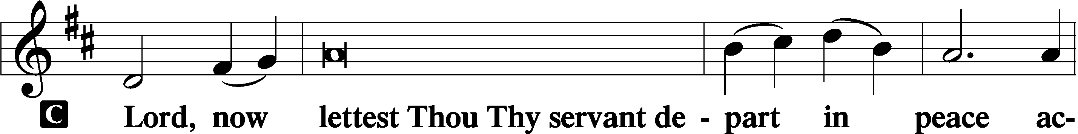

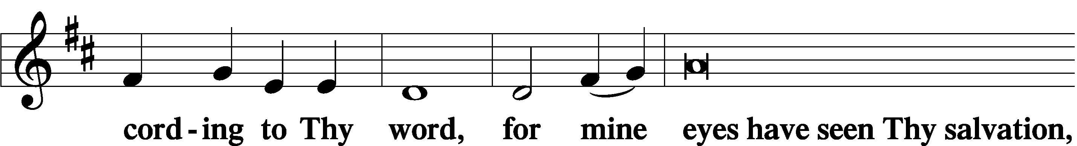

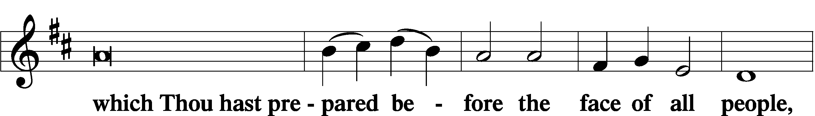

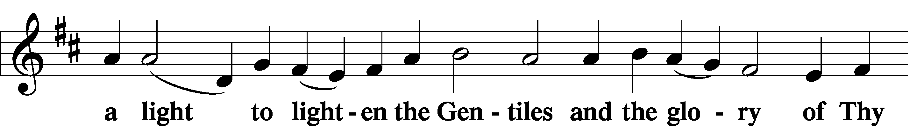

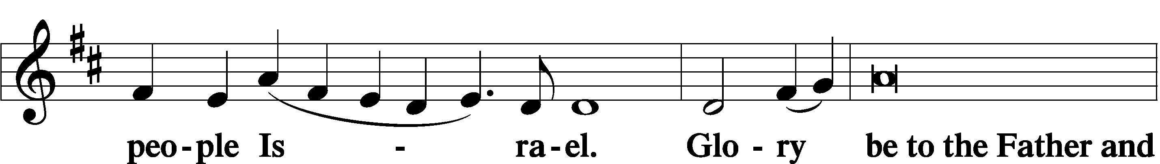

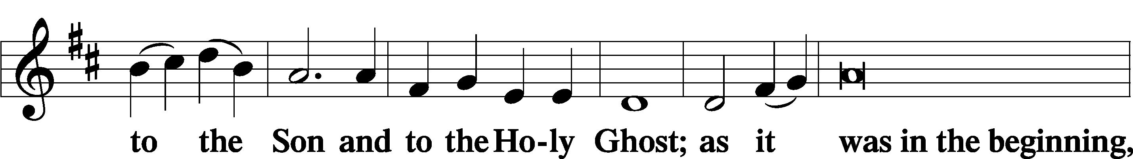

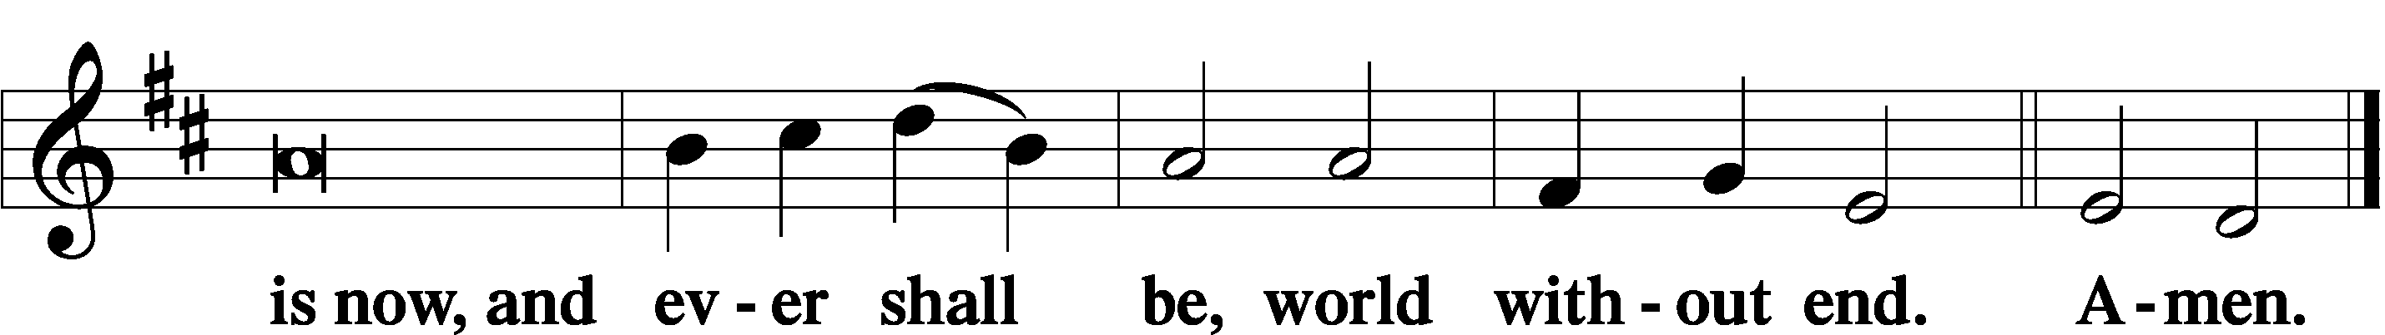

Thanksgiving Psalm 107:1
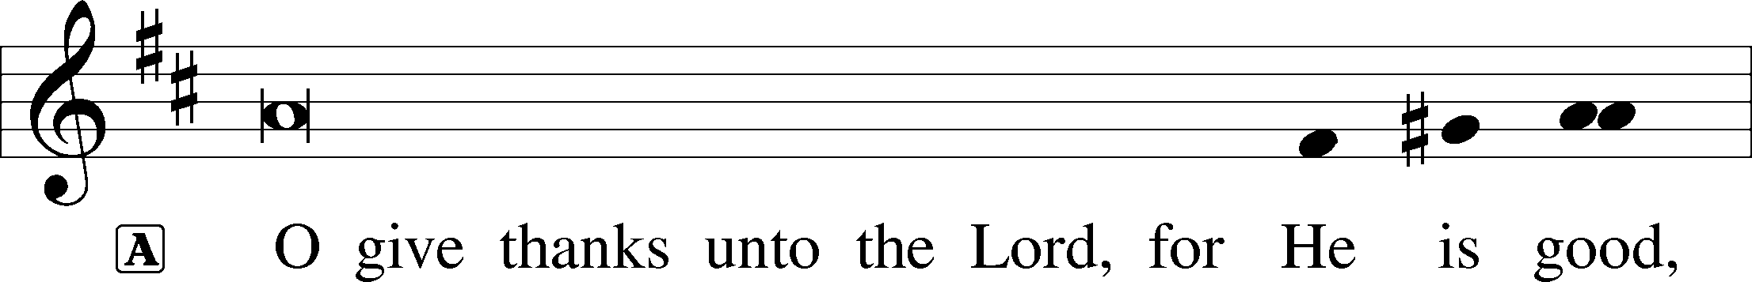

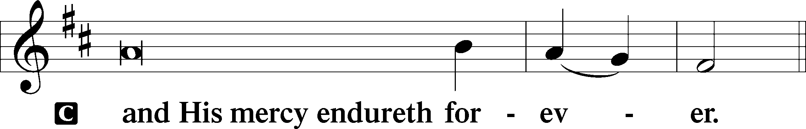

Post-Communion Collect
A Let us pray.
We give thanks to You, almighty God, that You have refreshed us through this salutary gift, and we implore You that of Your mercy You would strengthen us through the same in faith toward You and in fervent love toward one another; through Jesus Christ, Your Son, our Lord, who lives and reigns with You and the Holy Spirit, one God, now and forever.

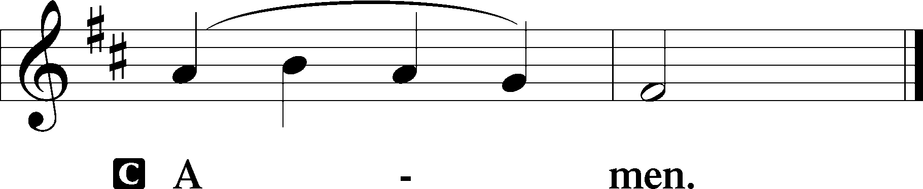

Salutation 2 Timothy 4:22
P The Lord be with you.

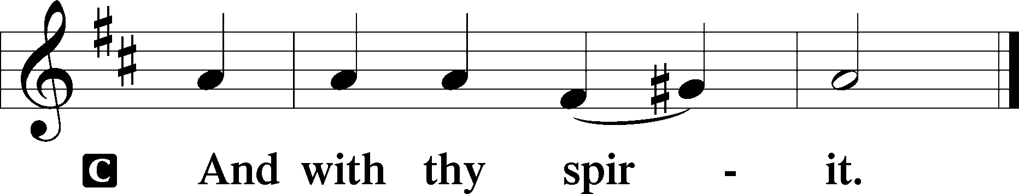

Benedicamus Psalm 103:1
A Bless we the Lord.

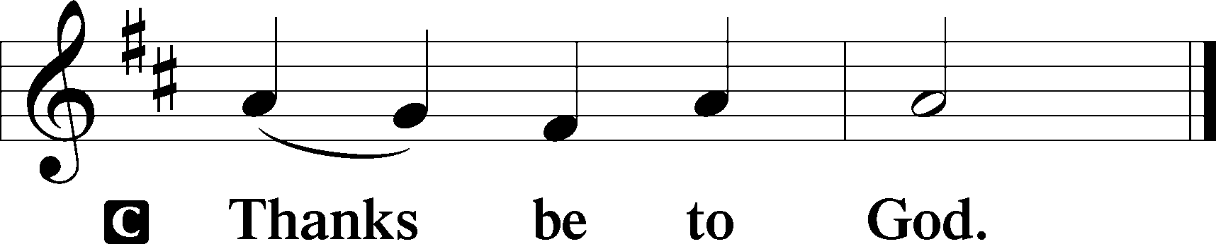

Benediction Numbers 6:24–26
P The Lord bless you and keep you.
The Lord make His face shine upon you and be gracious unto you.
The Lord lift up His countenance upon you and T give you peace.
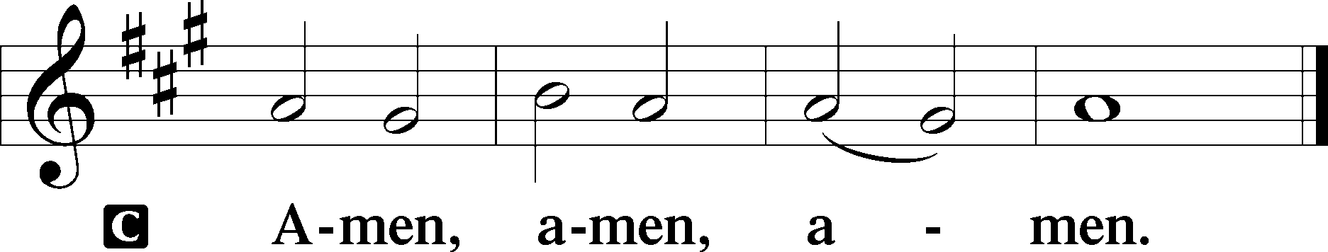

940 Holy God, We Praise Thy Name sts. 1–5
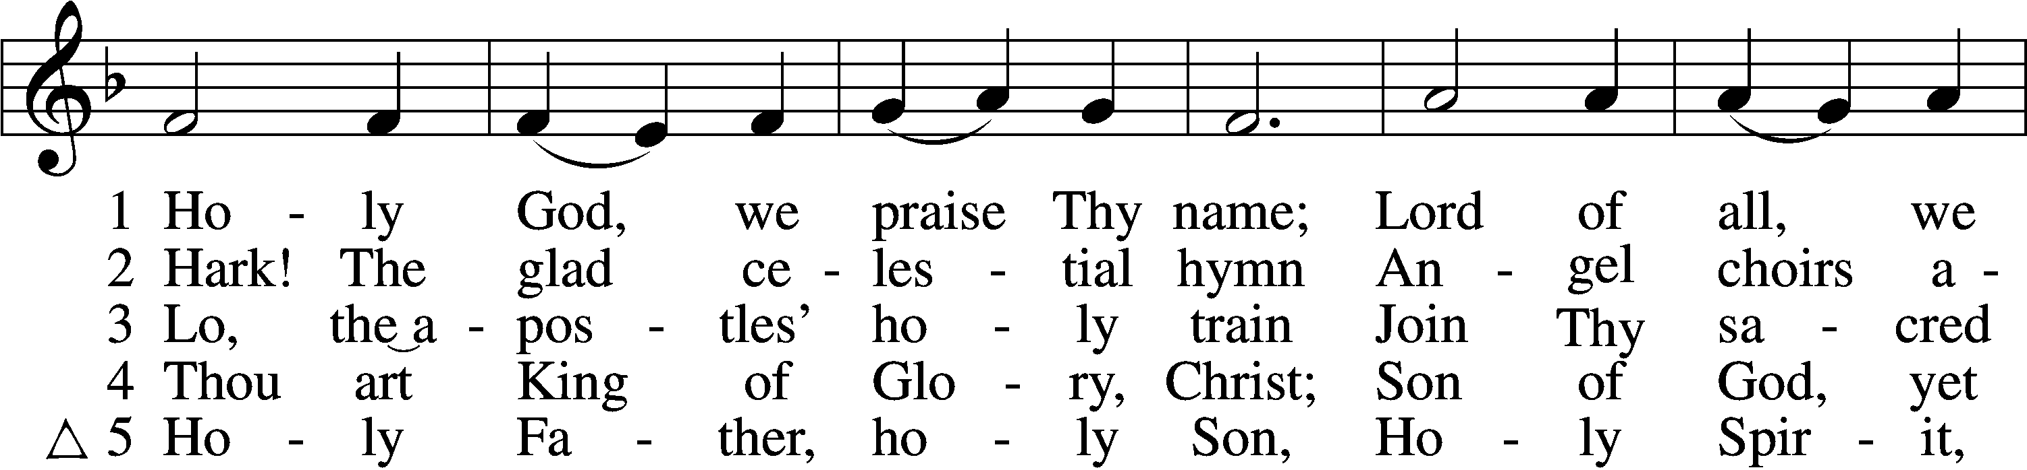
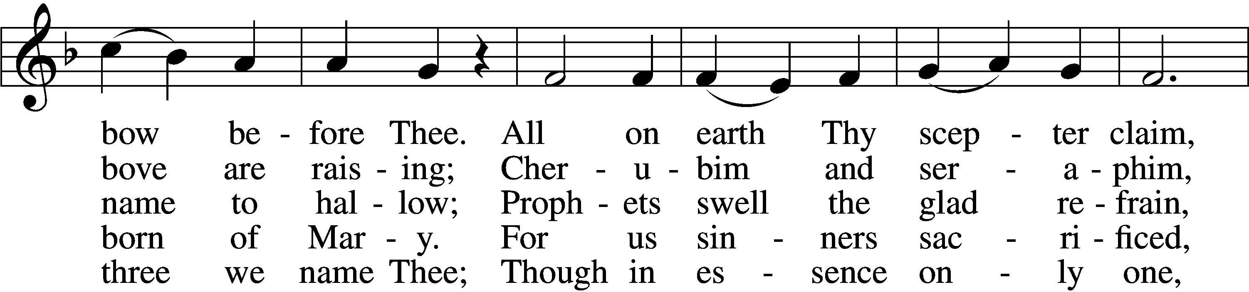
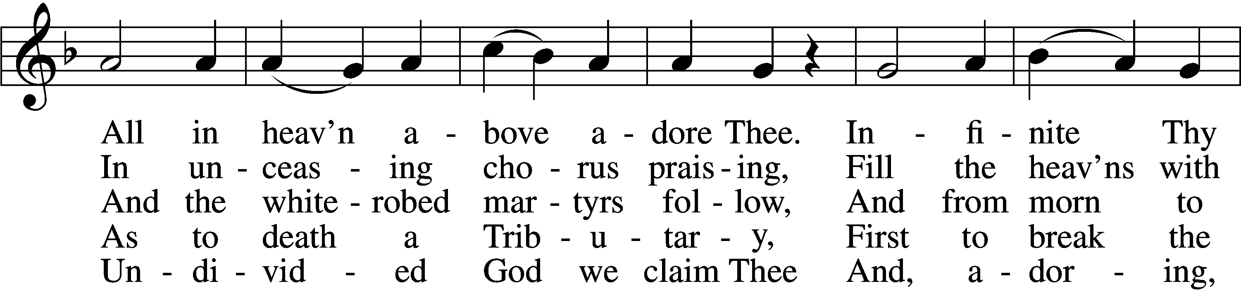
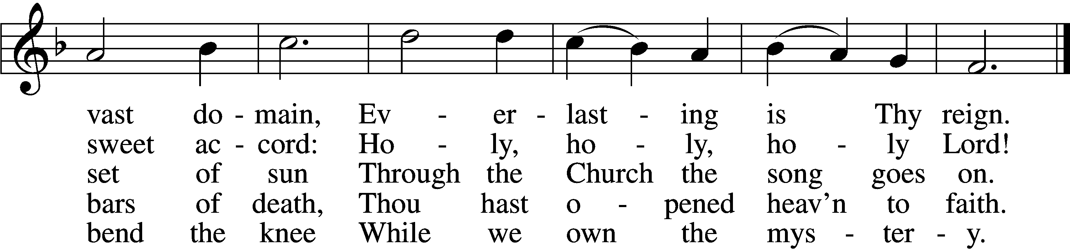
Text: Latin, c. 4th cent.; German version Katholisches Gesangbuch, 1774, Vienna; tr. Clarence A. Walworth, 1820–1900, alt.
Tune: Katholisches Gesangbuch, 1774, Vienna
Text and tune: Public domain
Acknowledgments
Divine Service, Setting Three from Lutheran Service Book
Unless otherwise indicated, Scripture quotations are from the ESV® Bible (The Holy Bible, English Standard Version®), copyright © 2001 by Crossway, a publishing ministry of Good News Publishers. Used by permission. All rights reserved.
Created by Lutheran Service Builder © 2025 Concordia Publishing House.

