On entering the church

P Lord, I love the habitation of Your house and the place
where Your glory dwells. In the multitude of Your tender
mercies prepare my heart that I may enter Your house to
worship and confess Your holy name; through Jesus Christ,
my God and Lord.

Before worship

C O Lord, our creator, redeemer, and comforter, as we come
together to worship You in spirit and in truth, we humbly
pray that You would open our hearts to the preaching of
Your Word so that we may repent of our sins, believe in
Jesus Christ as our only Savior, and grow in grace and
holiness. Hear us for His sake.

523 O Word of God Incarnate
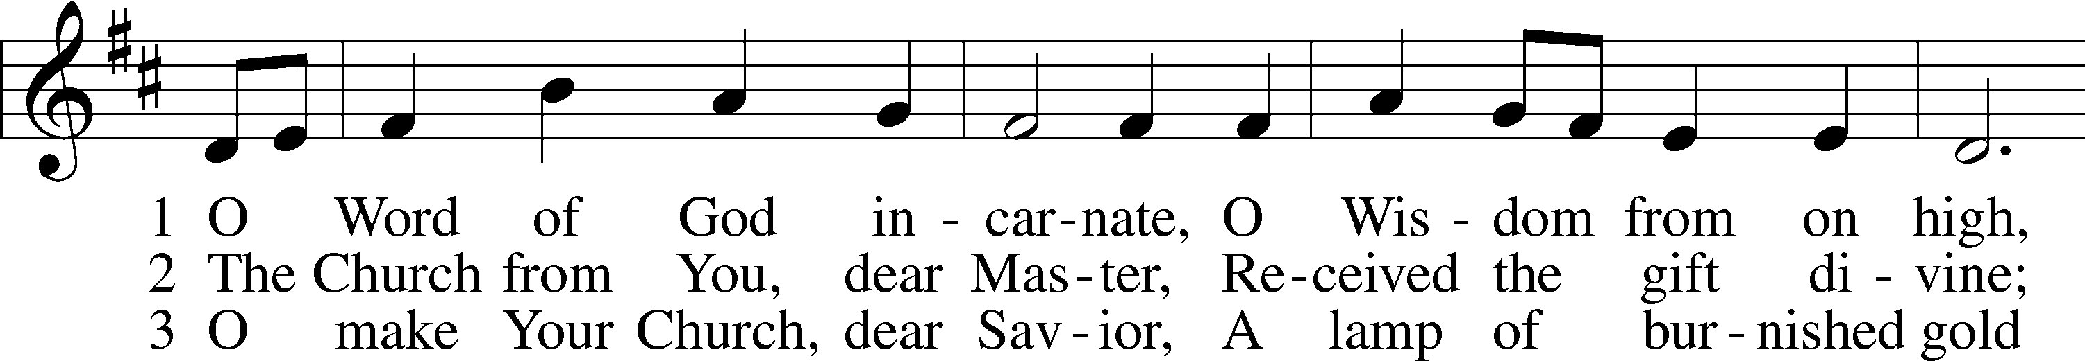
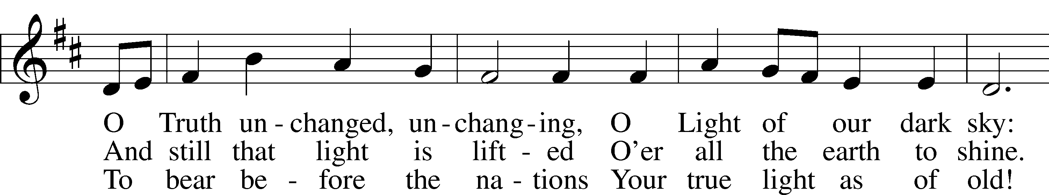
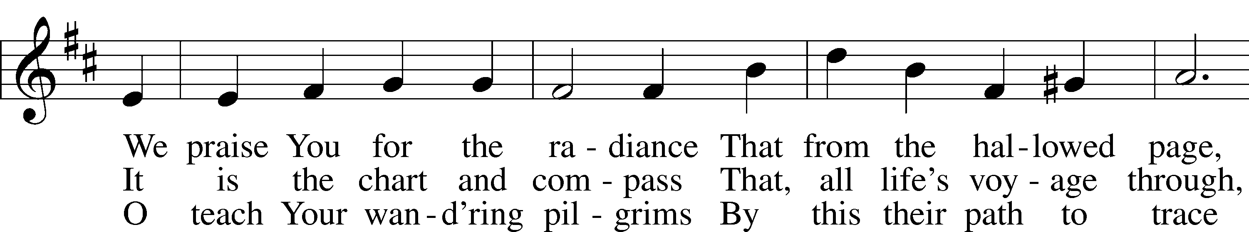
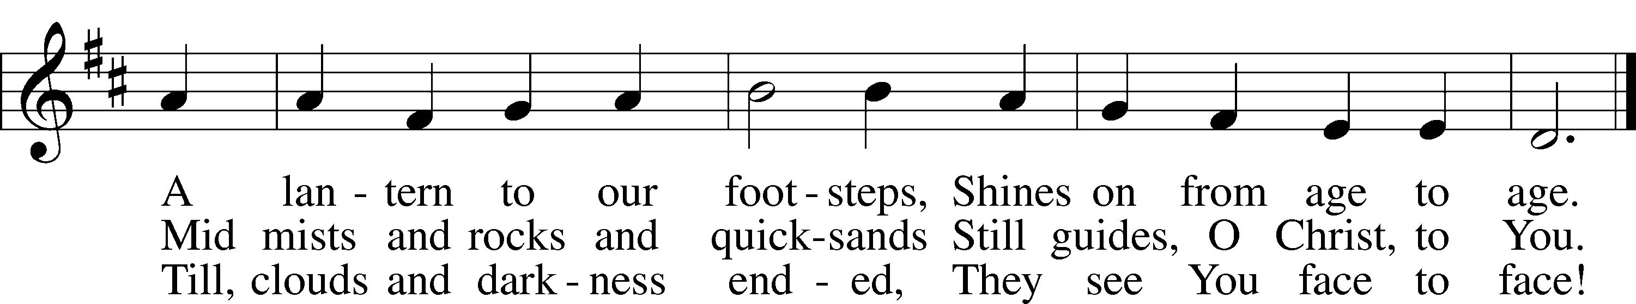
Text: William W. How, 1823–97, alt.
Tune: Neu-vermehrtes . . . Gesangbuch, 1693, 3rd ed., Meiningen
Text and tune: Public domain
Confession and Absolution
Stand

The sign of the cross may be made by all in remembrance of their Baptism.

Invocation Matthew 28:19b; 18:20
P In the name of the Father and of the T Son and of the Holy Spirit.
C Amen.

Exhortation Psalm 124:8; Psalm 130:3–4; Luke 18:13
P Our help is in the name of the Lord,
C who made heaven and earth.

P If You, O Lord, kept a record of sins, O Lord, who could stand?
C But with You there is forgiveness; therefore You are feared.

P Since we are gathered to hear God’s Word, call upon Him in prayer and praise, and receive the body and blood of our Lord Jesus Christ in the fellowship of this altar, let us first consider our unworthiness and confess before God and one another that we have sinned in thought, word, and deed, and that we cannot free ourselves from our sinful condition. Together as His people let us take refuge in the infinite mercy of God, our heavenly Father, seeking His grace for the sake of Christ, and saying: God, be merciful to me, a sinner.
Kneel/Stand

Confession of Sins
C Almighty God, have mercy upon us, forgive us our sins, and lead us to everlasting life. Amen.

Absolution [John 20:19–23]
P Almighty God in His mercy has given His Son to die for you and for His sake forgives you all your sins. As a called and ordained servant of Christ, and by His authority, I therefore forgive you all your sins in the name of the Father and of the T Son and of the Holy Spirit.
C Amen.

Stand
Service of the Word
Introit Psalm 74:18–19, 21, 20a, 22a; antiphon: v. 2a
Remember your congregation, which you have purchased of old,
which you have redeemed to be the tribe of your heritage!
Remember this, O Lord, how the enemy scoffs,
and a foolish people reviles your name.
Do not deliver the soul of your dove to the wild beasts;
do not forget the life of your poor forever.
Let not the downtrodden turn back in shame;
let the poor and needy praise your name.
Have regard for the covenant;
arise, O God, defend your cause.
Glory be to the Father and to the Son
and to the Holy Spirit;
as it was in the beginning,
is now, and will be forever. Amen.
Remember your congregation, which you have purchased of old,
which you have redeemed to be the tribe of your heritage!

Kyrie Mark 10:47
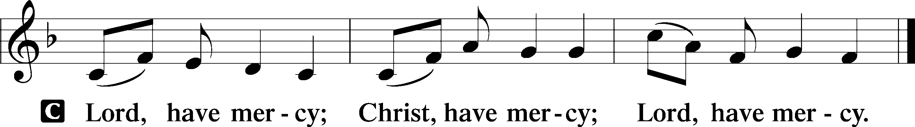

Gloria in Excelsis Luke 2:14; John 1:29
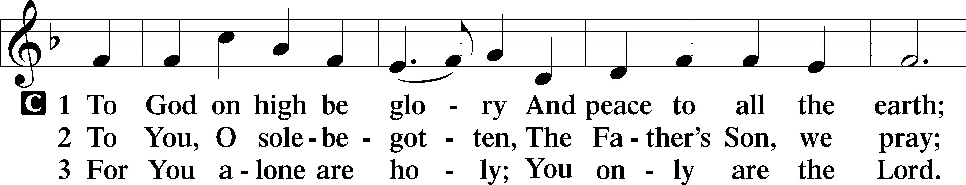
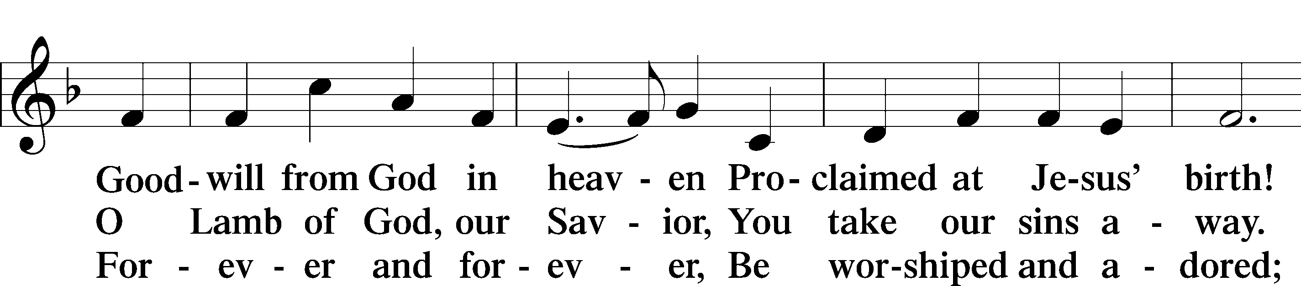
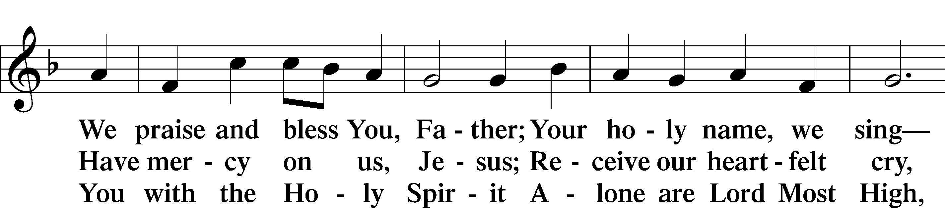
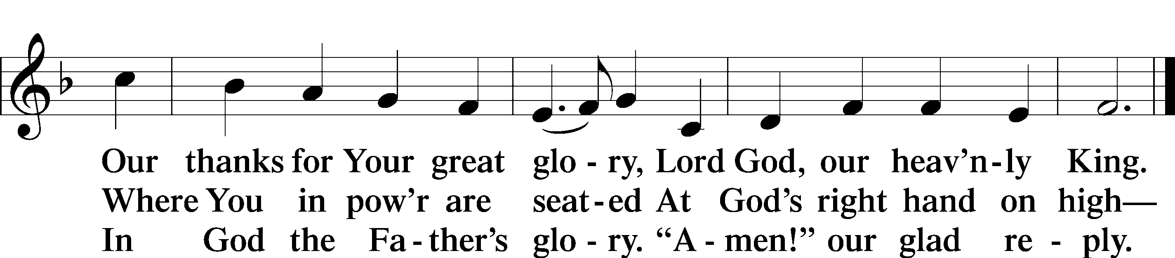
Text: Stephen P. Starke

Salutation and Collect of the Day
P The Lord be with you.
C And also with you.

P Let us pray.
O Lord, almighty and everlasting God, You have commanded us to pray and have promised to hear us. Mercifully grant that Your Holy Spirit may direct and govern our hearts in all things that we may persevere with steadfast faith in the confession of Your name; through Jesus Christ, Your Son, our Lord, who lives and reigns with You and the Holy Spirit, one God, now and forever.

C Amen.

Sit

Old Testament Reading Genesis 32:22–30
22The same night [Jacob] arose and took his two wives, his two female servants, and his eleven children, and crossed the ford of the Jabbok. 23He took them and sent them across the stream, and everything else that he had. 24And Jacob was left alone. And a man wrestled with him until the breaking of the day. 25When the man saw that he did not prevail against Jacob, he touched his hip socket, and Jacob’s hip was put out of joint as he wrestled with him. 26Then he said, “Let me go, for the day has broken.” But Jacob said, “I will not let you go unless you bless me.” 27And he said to him, “What is your name?” And he said, “Jacob.” 28Then he said, “Your name shall no longer be called Jacob, but Israel, for you have striven with God and with men, and have prevailed.” 29Then Jacob asked him, “Please tell me your name.” But he said, “Why is it that you ask my name?” And there he blessed him. 30So Jacob called the name of the place Peniel, saying, “For I have seen God face to face, and yet my life has been delivered.”

A This is the Word of the Lord.
C Thanks be to God.

Gradual Psalm 91:11; 103:1
He will command his angels concerning you
to guard you in all your ways.
Bless the Lord, O my soul,
and all that is within me, bless his holy name!

Epistle 2 Timothy 3:14—4:5
14As for you, continue in what you have learned and have firmly believed, knowing from whom you learned it 15and how from childhood you have been acquainted with the sacred writings, which are able to make you wise for salvation through faith in Christ Jesus. 16All Scripture is breathed out by God and profitable for teaching, for reproof, for correction, and for training in righteousness, 17that the man of God may be competent, equipped for every good work.
1I charge you in the presence of God and of Christ Jesus, who is to judge the living and the dead, and by his appearing and his kingdom: 2preach the word; be ready in season and out of season; reprove, rebuke, and exhort, with complete patience and teaching. 3For the time is coming when people will not endure sound teaching, but having itching ears they will accumulate for themselves teachers to suit their own passions, 4and will turn away from listening to the truth and wander off into myths. 5As for you, always be sober-minded, endure suffering, do the work of an evangelist, fulfill your ministry.

A This is the Word of the Lord.
C Thanks be to God.

Stand

Alleluia and Verse

Alleluia
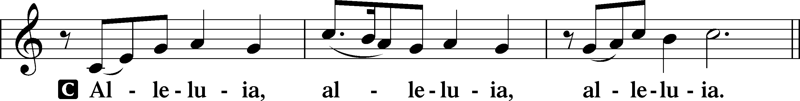

Verse John 20:31
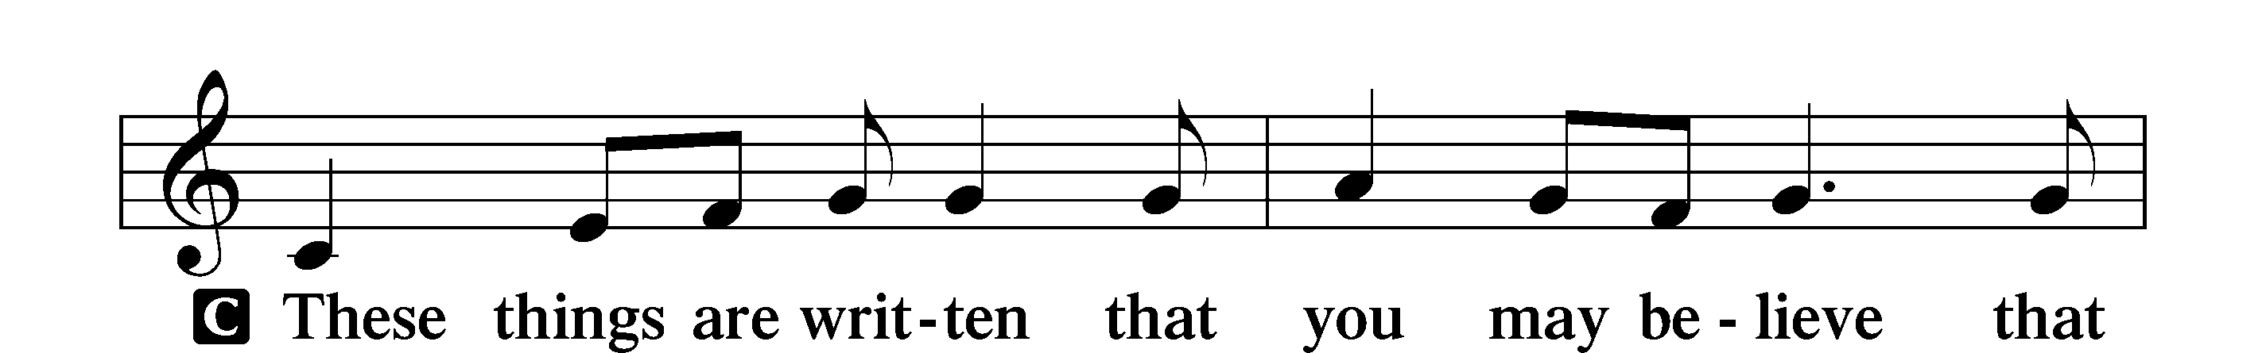
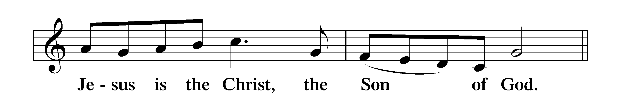

Alleluia
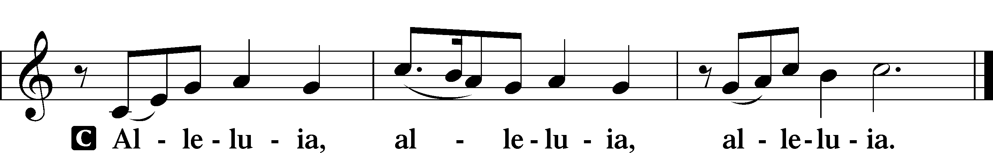

Holy Gospel Luke 18:1–8
P The Holy Gospel according to St. Luke, the eighteenth chapter.
C Glory to You, O Lord.

1[Jesus] told them a parable to the effect that they ought always to pray and not lose heart. 2He said, “In a certain city there was a judge who neither feared God nor respected man. 3And there was a widow in that city who kept coming to him and saying, ‘Give me justice against my adversary.’ 4For a while he refused, but afterward he said to himself, ‘Though I neither fear God nor respect man, 5yet because this widow keeps bothering me, I will give her justice, so that she will not beat me down by her continual coming.’” 6And the Lord said, “Hear what the unrighteous judge says. 7And will not God give justice to his elect, who cry to him day and night? Will he delay long over them? 8I tell you, he will give justice to them speedily. Nevertheless, when the Son of Man comes, will he find faith on earth?”

P This is the Gospel of the Lord.
C Praise to You, O Christ.

Nicene Creed
C I believe in one God,
the Father Almighty,
maker of heaven and earth
and of all things visible and invisible.

And in one Lord Jesus Christ,
the only-begotten Son of God,
begotten of His Father before all worlds,
God of God, Light of Light,
very God of very God,
begotten, not made,
being of one substance with the Father,
by whom all things were made;
who for us men and for our salvation came down from heaven
and was incarnate by the Holy Spirit of the virgin Mary
and was made man;
and was crucified also for us under Pontius Pilate.
He suffered and was buried.
And the third day He rose again according to the Scriptures
and ascended into heaven
and sits at the right hand of the Father.
And He will come again with glory to judge both the living and the dead,
whose kingdom will have no end.

And I believe in the Holy Spirit,
the Lord and giver of life,
who proceeds from the Father and the Son,
who with the Father and the Son together is worshiped and glorified,
who spoke by the prophets.
And I believe in one holy Christian and apostolic Church,
I acknowledge one Baptism for the remission of sins,
and I look for the resurrection of the dead
and the life T of the world to come. Amen.
Sit

Children's Sermon

587 I Know My Faith Is Founded
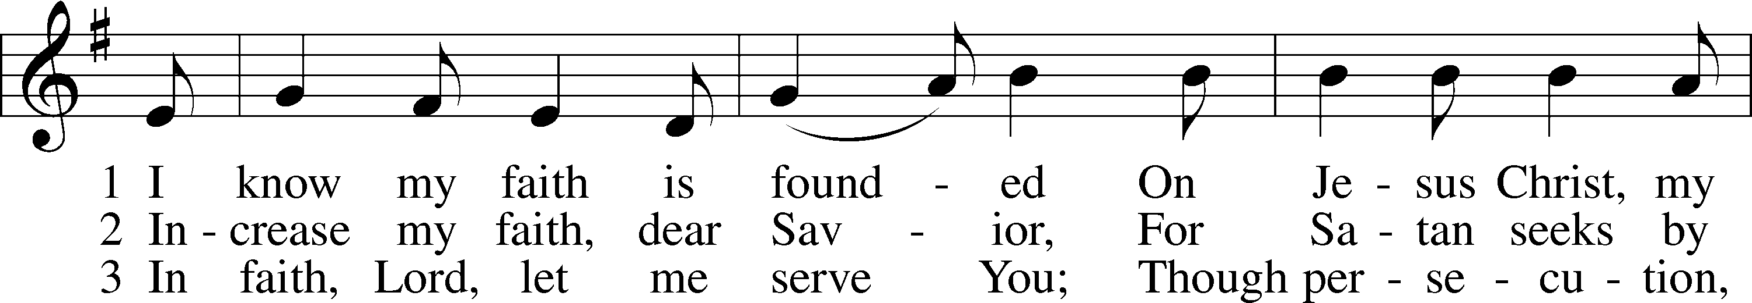
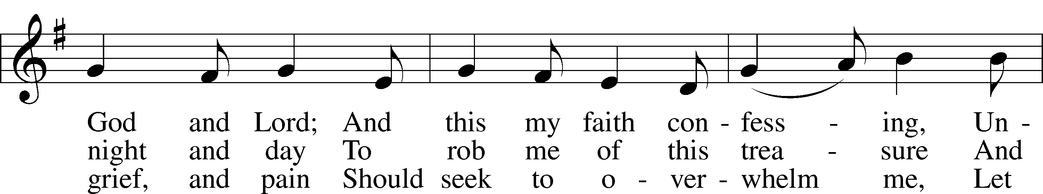
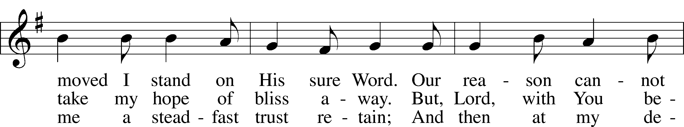
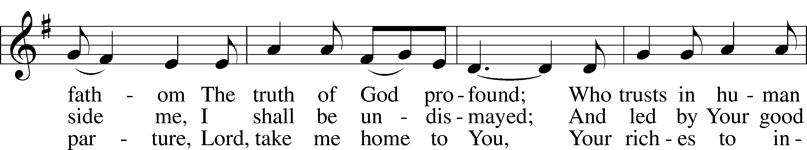
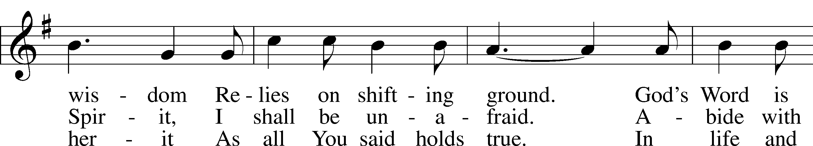
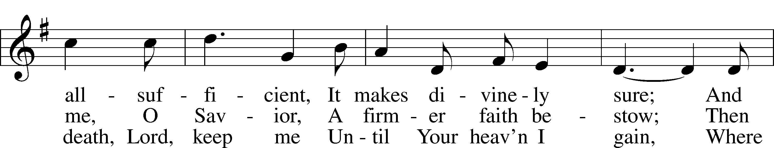
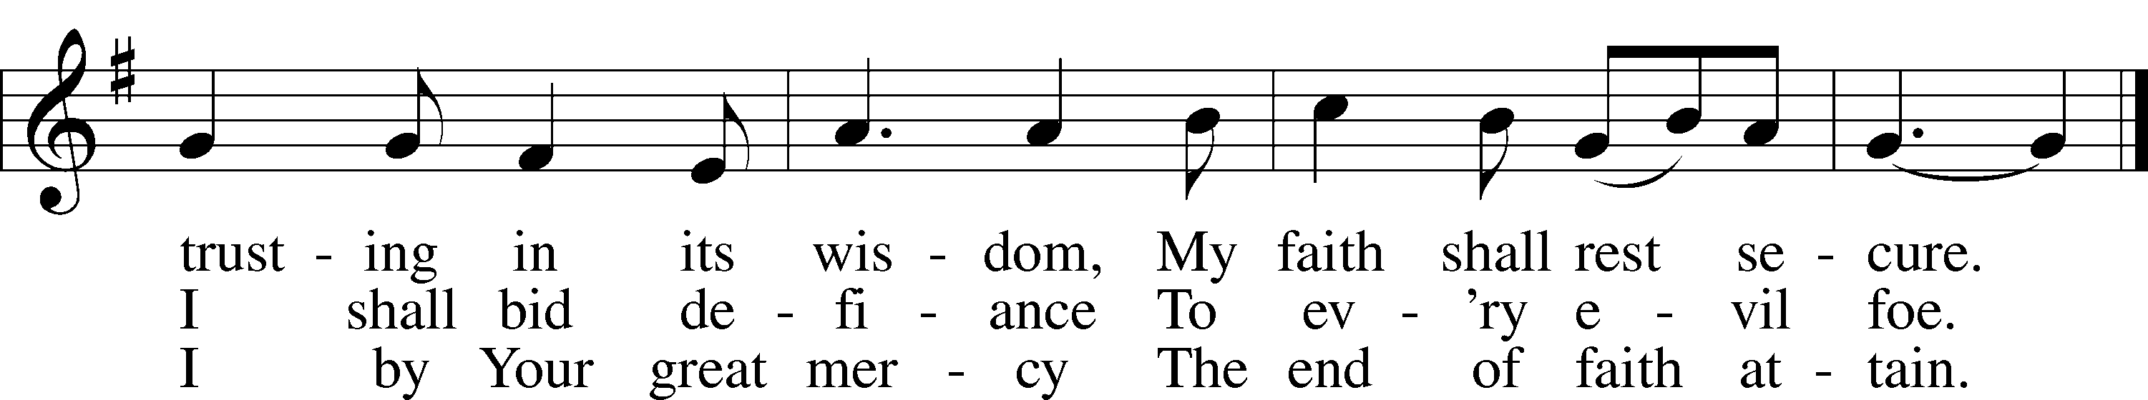
Text: Erdmann Neumeister, 1671–1756; tr. The Lutheran Hymnal, 1941, alt.
Tune: Concentus novi, 1540, Augsburg
Text and tune: Public domain

Sermon

Stand

Prayer of the Church

Following the prayers, the people may greet one another in the name of the Lord, saying, “Peace be with you,” as a sign of reconciliation and of the unity of the Spirit in the bond of peace (Matt. 5:22–24; Eph. 4:1–3).

Sit

Offering

805 Praise God, from Whom All Blessings Flow
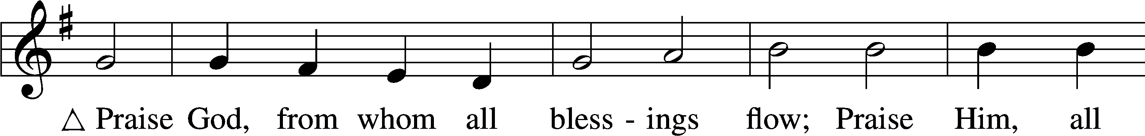
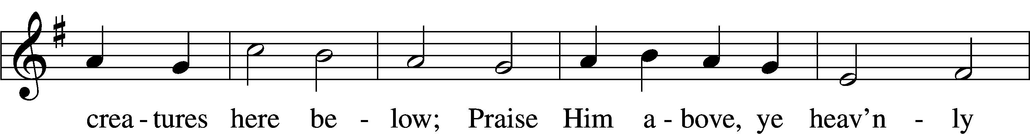
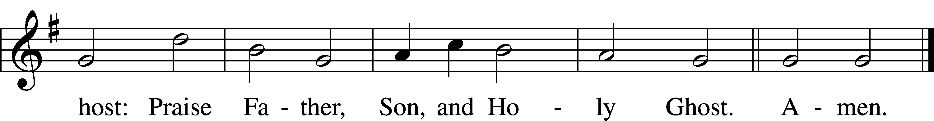
Text: Thomas Ken, 1637–1711
Tune: Trente quatre Pseaumes de David, 1551, Geneva, ed. Louis Bourgeois
Text and tune: Public domain
Service of the Sacrament

Stand

Preface 2 Timothy 4:22; [Colossians 3:1]; [Psalm 136]
P The Lord be with you.
C And also with you.

P Lift up your hearts.
C We lift them to the Lord.

P Let us give thanks to the Lord our God.
C It is right to give Him thanks and praise.

P It is truly good, right, and salutary that we should at all times and in all places give thanks to You, O Lord, holy Father, almighty and everlasting God, for the countless blessings You so freely bestow on us and all creation. Above all, we give thanks for Your boundless love shown to us when You sent Your only-begotten Son, Jesus Christ, into our flesh and laid on Him our sin, giving Him into death that we might not die eternally. Because He is now risen from the dead and lives and reigns to all eternity, all who believe in Him will overcome sin and death and will rise again to new life. Therefore with angels and archangels and with all the company of heaven we laud and magnify Your glorious name, evermore praising You and saying:

Sanctus Isaiah 6:3; Matthew 21:9
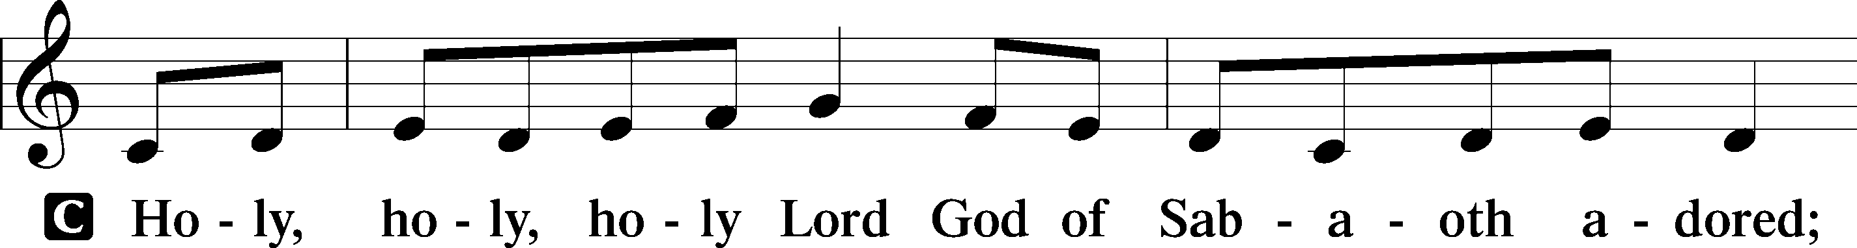
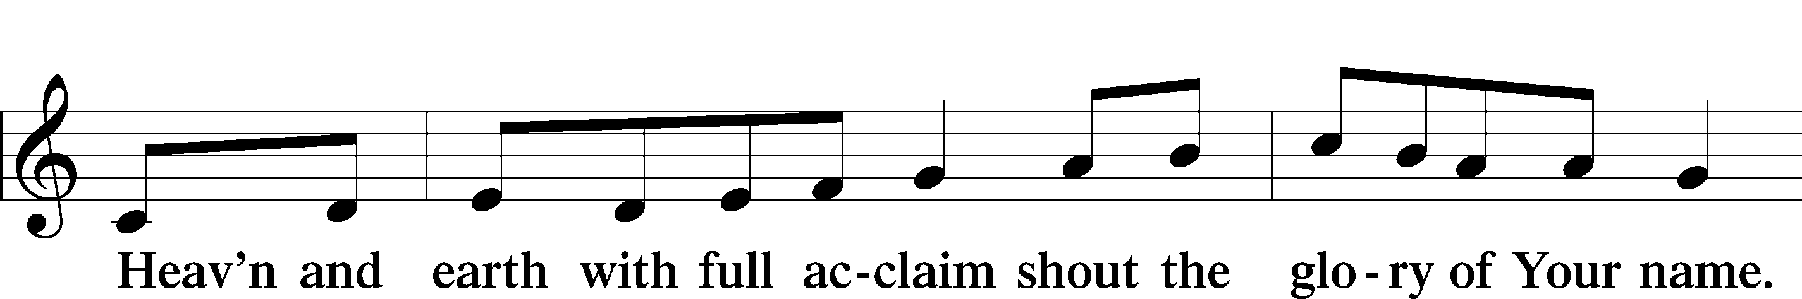
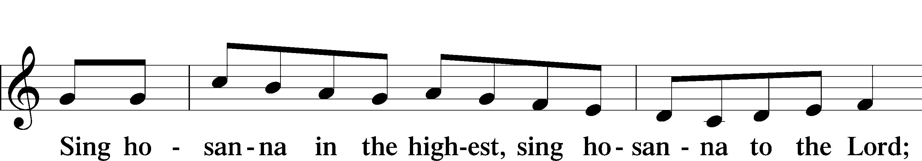
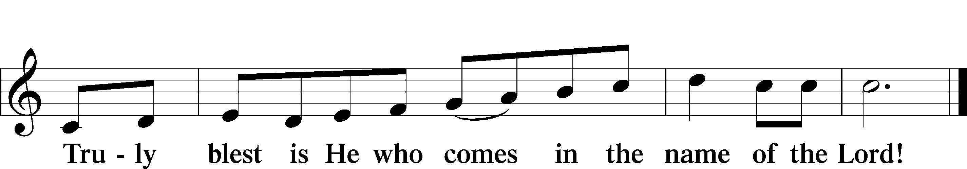
Text: Stephen P. Starke

Prayer of Thanksgiving
P Blessed are You, O Lord our God, king of all creation, for You have had mercy on us and given Your only-begotten Son that whoever believes in Him should not perish but have eternal life.

In Your righteous judgment You condemned the sin of Adam and Eve, who ate the forbidden fruit, and You justly barred them and all their children from the tree of life. Yet, in Your great mercy, You promised salvation by a second Adam, Your Son, Jesus Christ, our Lord, and made His cross a life-giving tree for all who trust in Him.
We give You thanks for the redemption You have prepared for us through Jesus Christ. Grant us Your Holy Spirit that we may faithfully eat and drink of the fruits of His cross and receive the blessings of forgiveness, life, and salvation that come to us in His body and blood.

Hear us as we pray in His name and as He has taught us:

Lord’s Prayer
C Our Father who art in heaven,
hallowed be Thy name,
Thy kingdom come,
Thy will be done on earth
as it is in heaven;
give us this day our daily bread;
and forgive us our trespasses
as we forgive those
who trespass against us;
and lead us not into temptation,
but deliver us from evil.
For Thine is the kingdom
and the power and the glory
forever and ever. Amen.

The Words of Our Lord
P Our Lord Jesus Christ, on the night when He was betrayed, took bread, and when He had given thanks, He broke it and gave it to the disciples and said: “Take, eat; this is My T body, which is given for you. This do in remembrance of Me.”

In the same way also He took the cup after supper, and when He had given thanks, He gave it to them, saying: “Drink of it, all of you; this cup is the new testament in My T blood, which is shed for you for the forgiveness of sins. This do, as often as you drink it, in remembrance of Me.”

Pax Domini
P The peace of the Lord be with you always.
C Amen.

Agnus Dei John 1:29
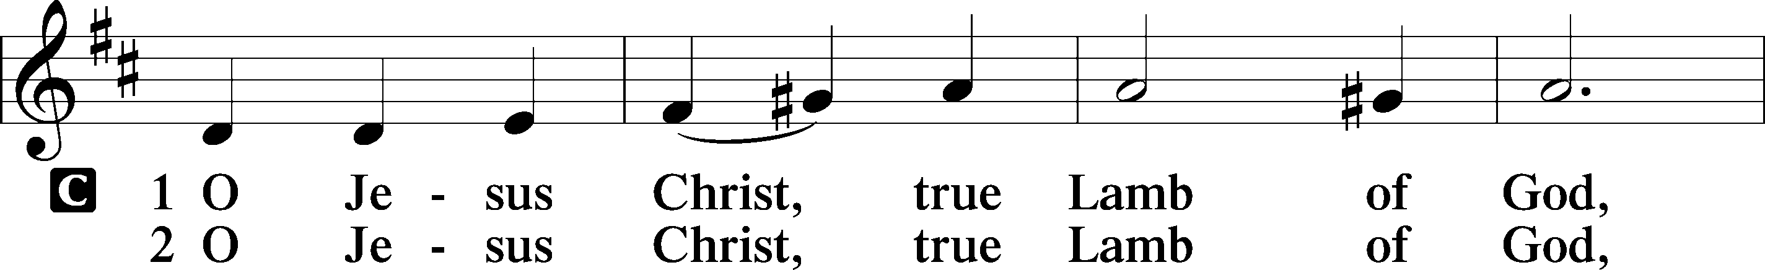
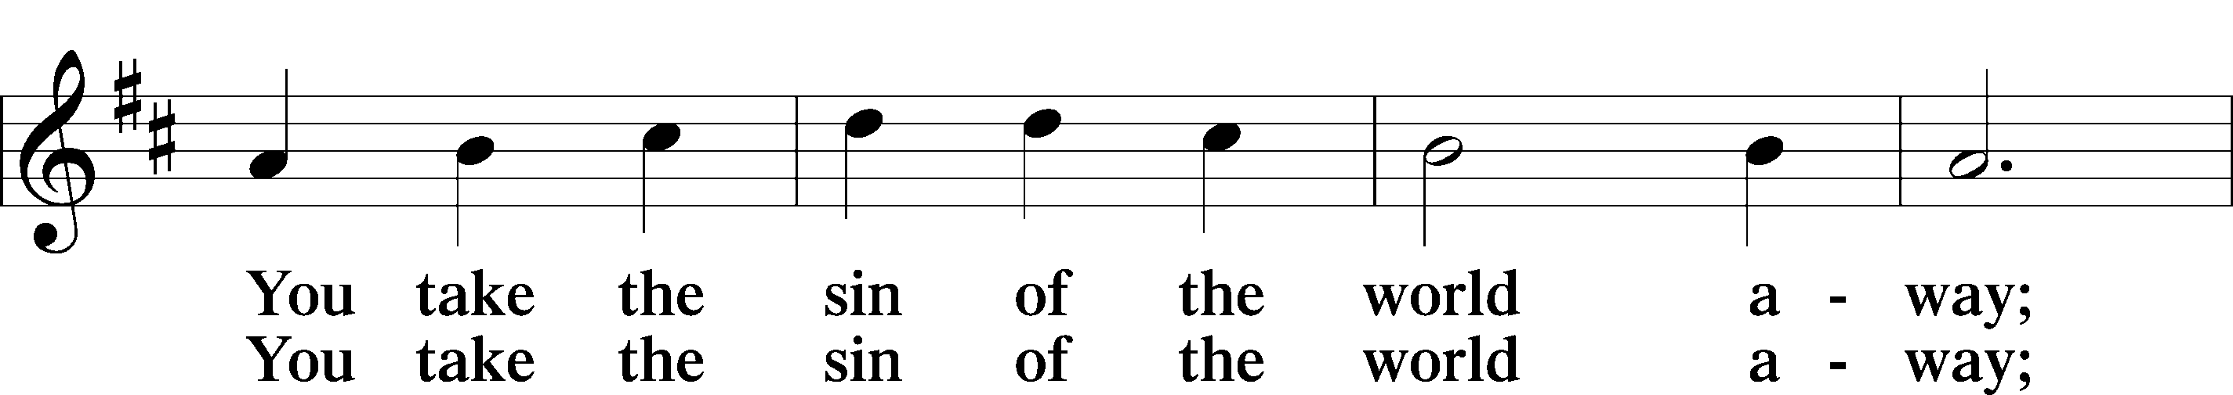
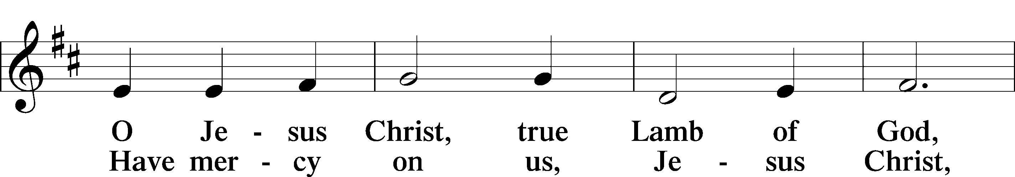
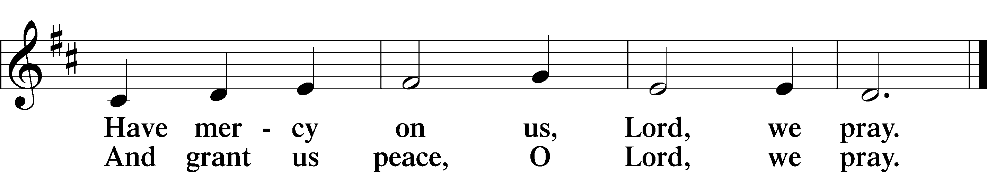
Text: Stephen P. Starke
Sit

Distribution

The pastor and those who assist him receive the body and blood of Christ first and then distribute them to those who come to receive, saying:

Take, eat; this is the true body of our Lord and Savior Jesus Christ, given into death for your sins.
Amen.

Take, drink; this is the true blood of our Lord and Savior Jesus Christ, shed for the forgiveness of your sins.
Amen.

In dismissing the communicants, the following is said:
The Dismissal
P The body and blood of our Lord Jesus Christ strengthen and preserve you in body and soul to life everlasting. Depart T in peace.
C Amen.

725 Children of the Heavenly Father
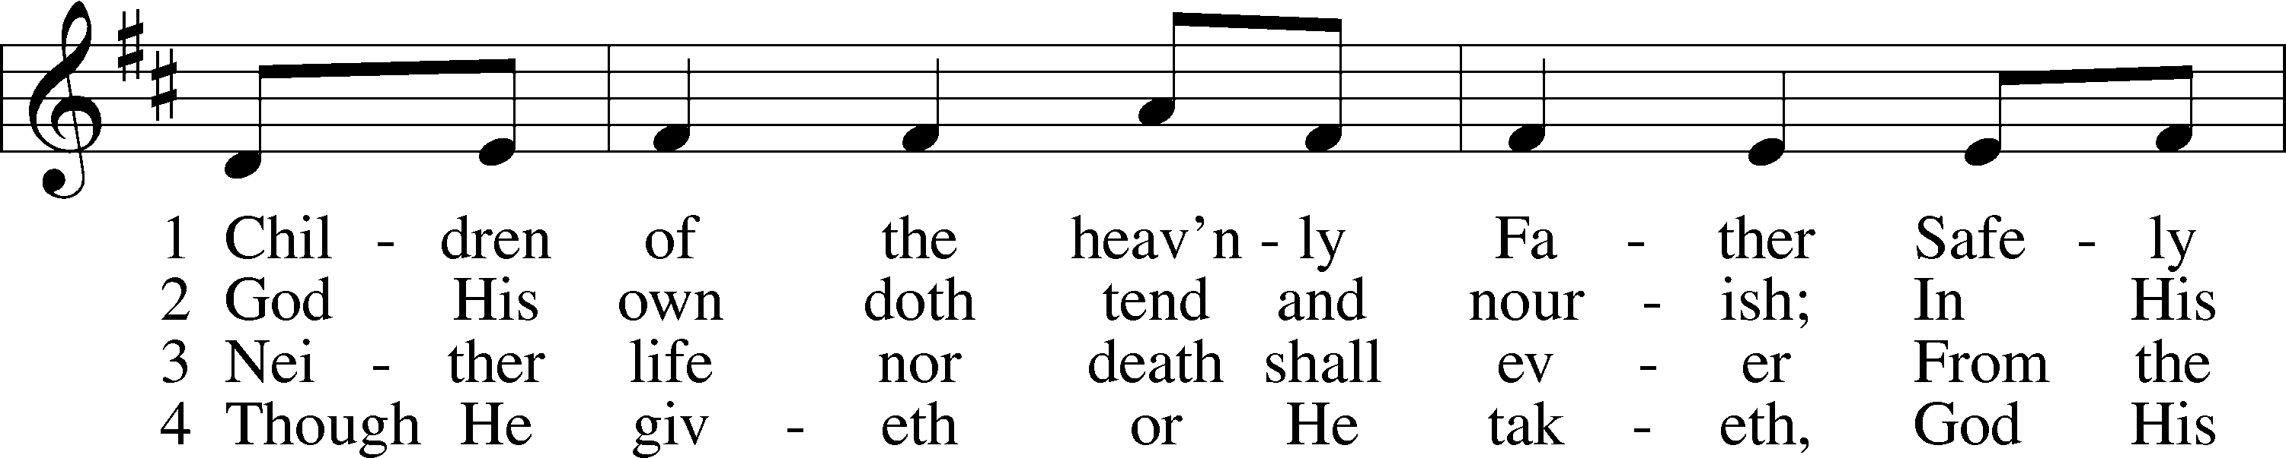
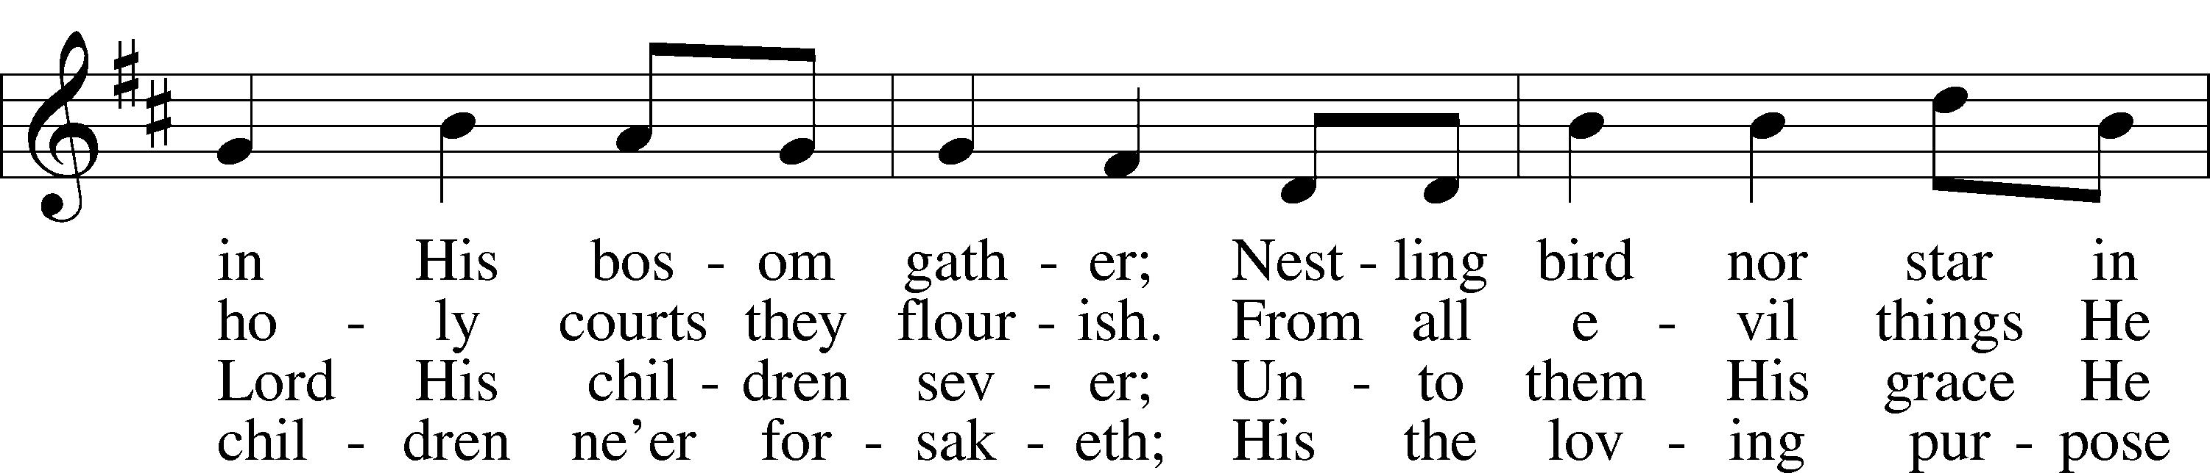
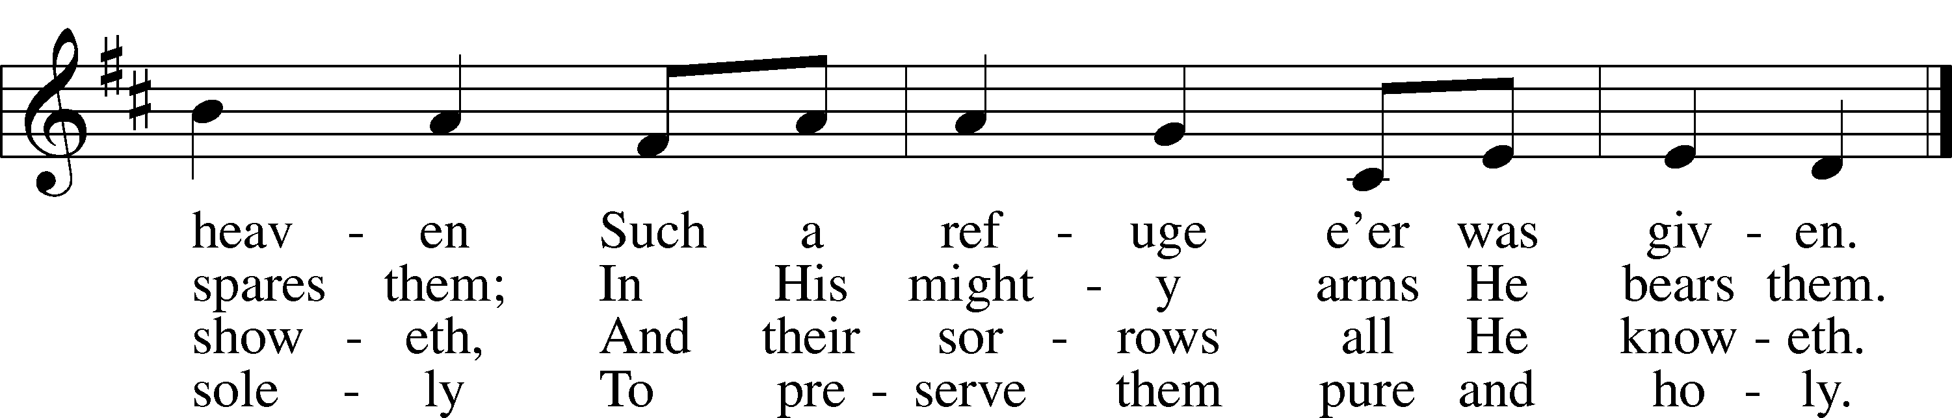
Text: Carolina Sandell Berg, 1832–1903; tr. Ernst W. Olson, 1870–1958
Tune: Lofsånger och andeliga wisor, 1873, Sweden
Text: Public domain
Tune: Public domain
634 The Death of Jesus Christ, Our Lord
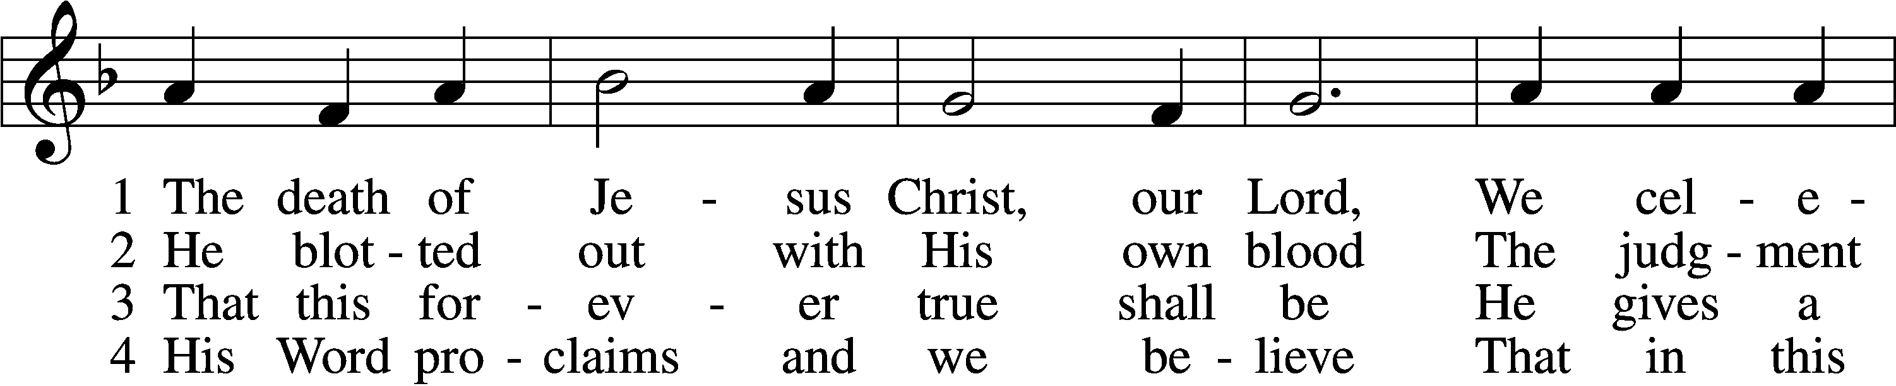
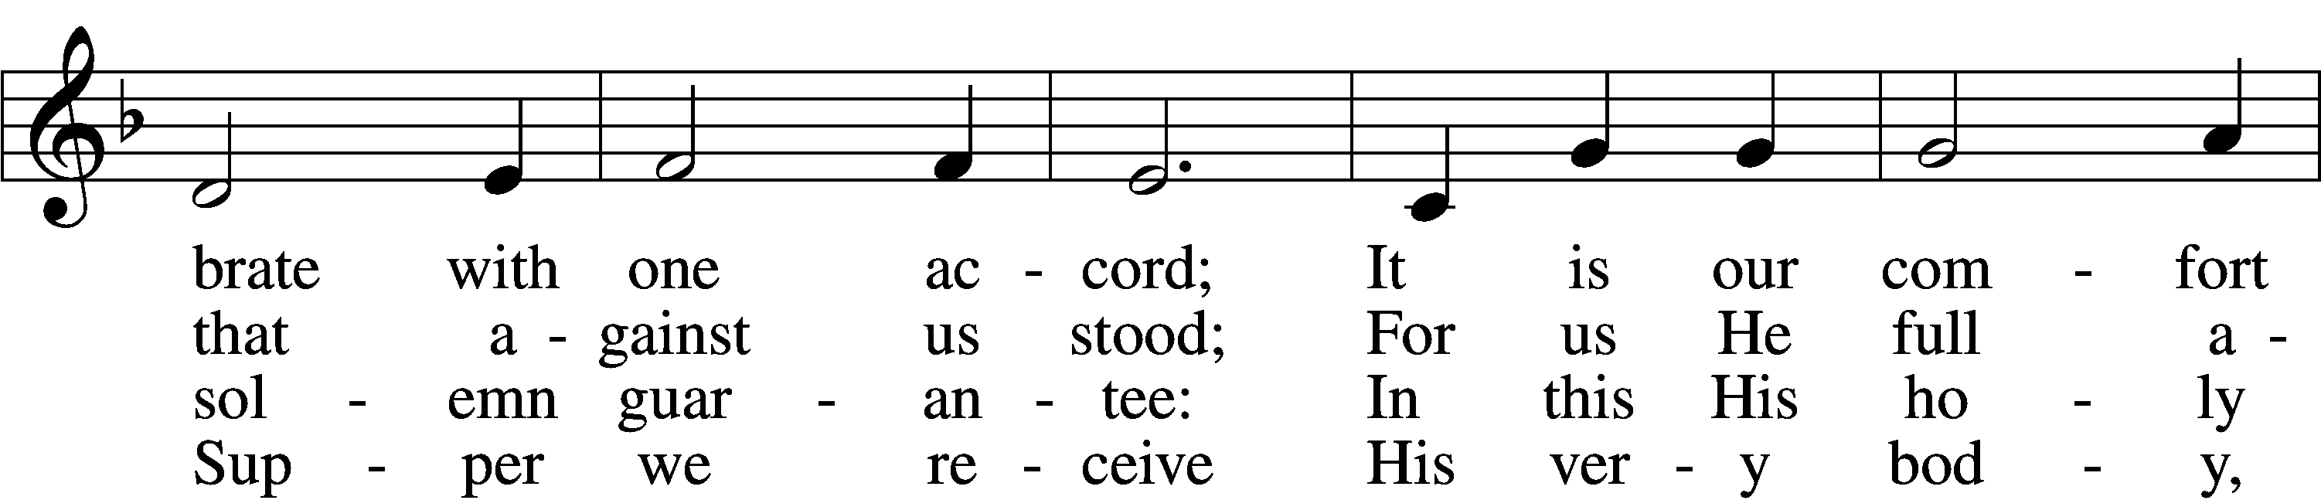
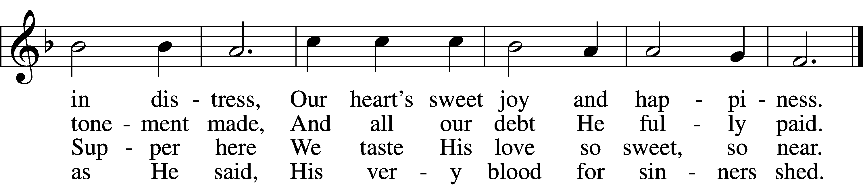

5 We dare not ask how this can be,
But simply hold the mystery
And trust this word where life begins:
“Given and shed for all your sins.”

6 They who this word do not believe
This food unworthily receive,
Salvation here will never find—
May we this warning keep in mind!

7 But blest is each believing guest
Who in these promises finds rest;
For Jesus shall in love remain
With all who here His grace obtain.

8 Help us sincerely to believe
That we may worthily receive
Your Supper and in You find rest.
Amen! They who believe are blest.
Text (sts. 1–4, 6–8): Haquin Spegel, 1645–1714; (sts. 1–4, 6–8): tr. Olof Olsson, 1841–1900, alt.; (st. 5): composite
Tune: Sammlung alter und neuer . . . Melodien, 1742
Text and tune: Public domain
702 My Faith Looks Up to Thee
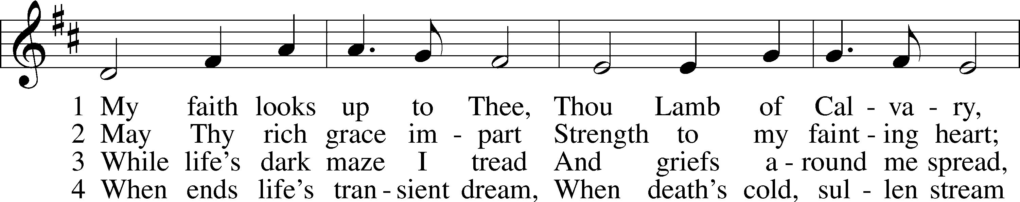
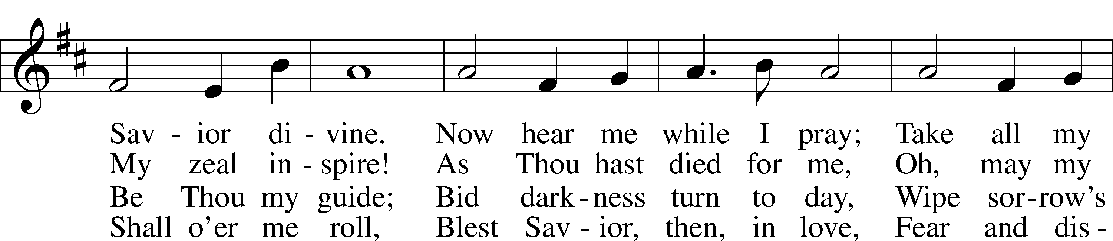
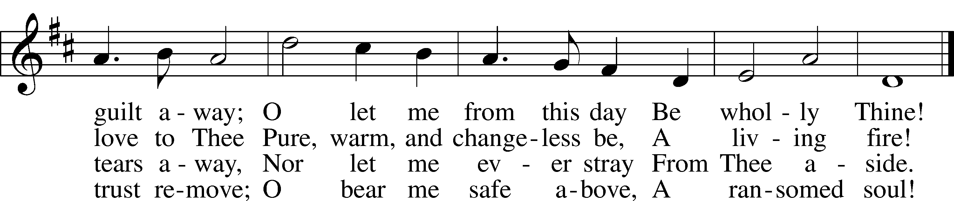
Text: Ray Palmer, 1808–87
Tune: Lowell Mason, 1792–1872
Text and tune: Public domain
623 Lord Jesus Christ, We Humbly Pray
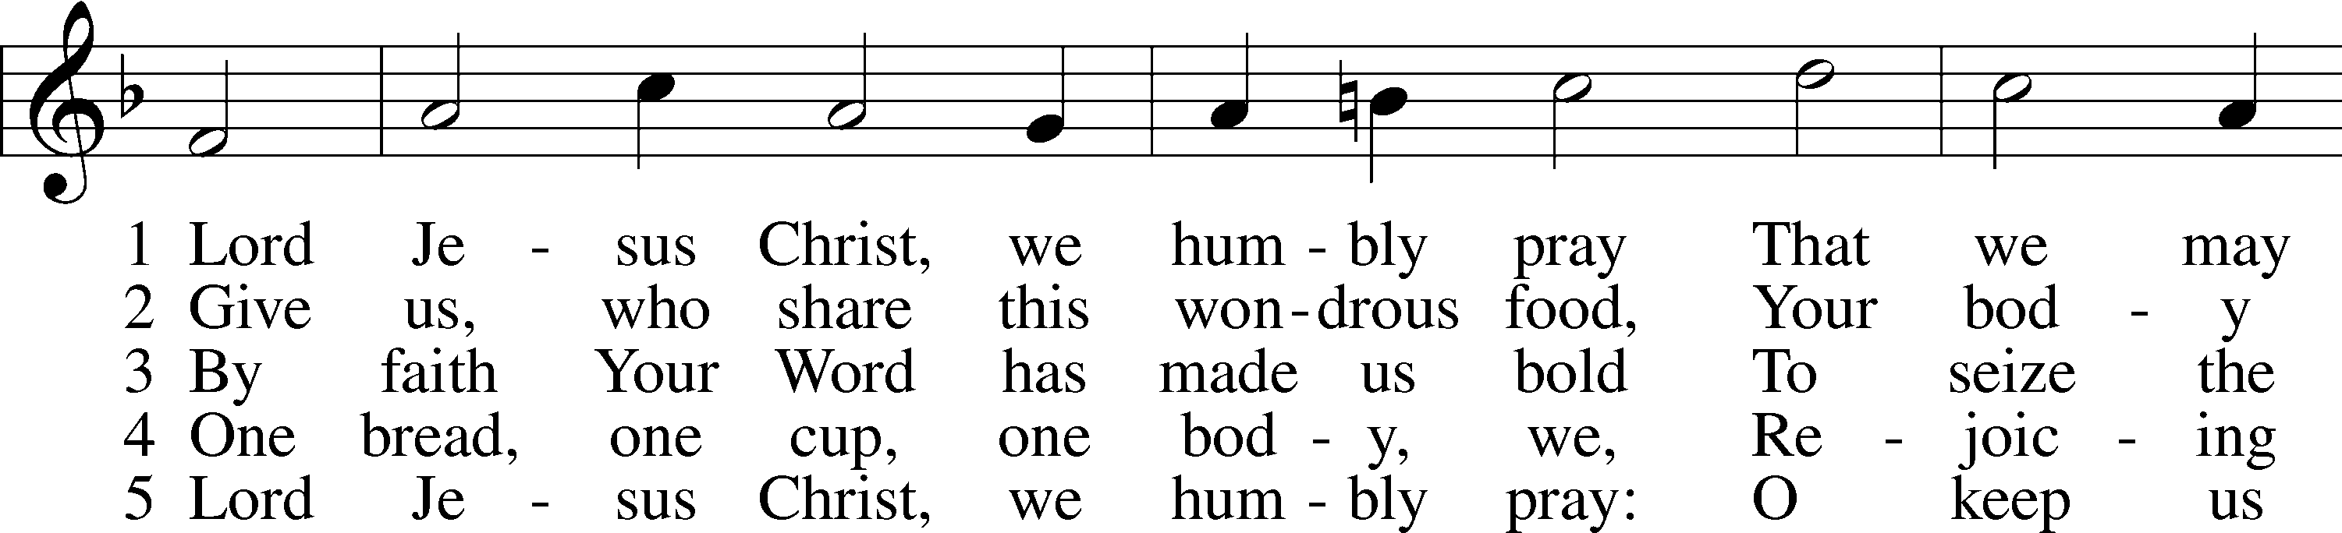
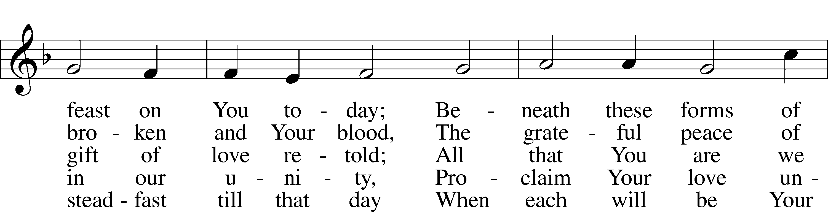
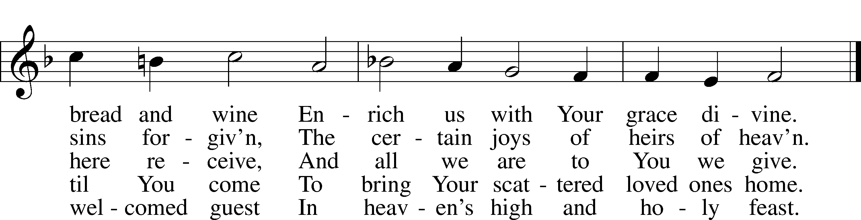
Text: Henry E. Jacobs, 1844–1932, alt.
Tune: Cantionale Germanicum, 1628, Gochsheim
Text and tune: Public domain
Stand

Nunc Dimittis Luke 2:29–32
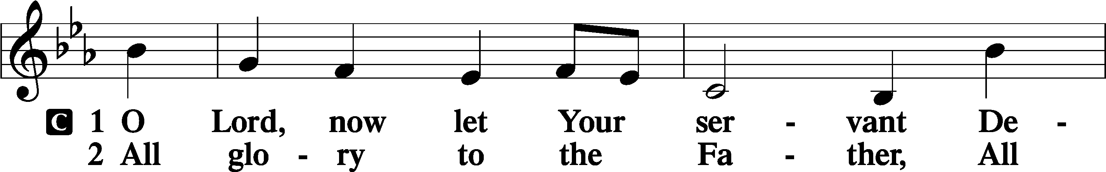
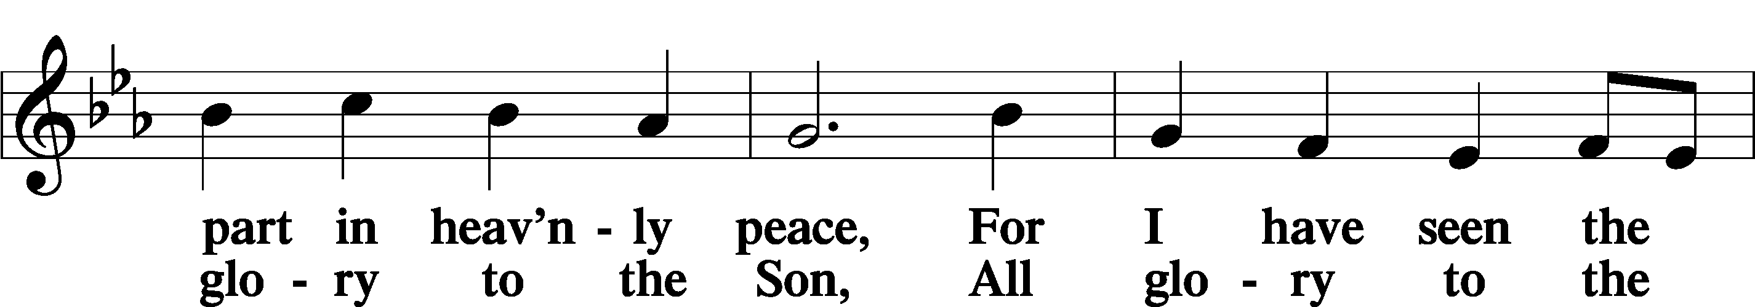
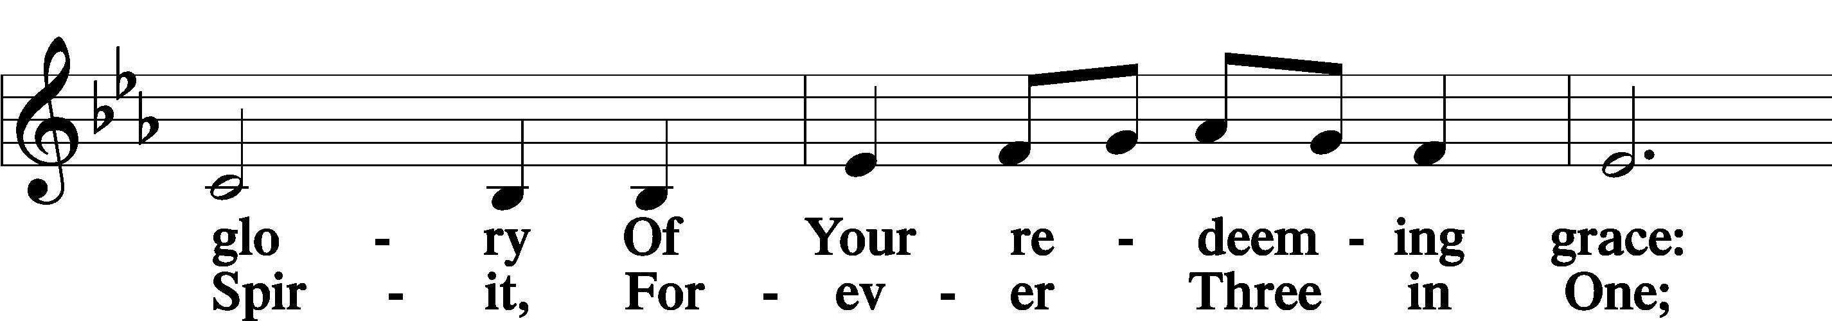
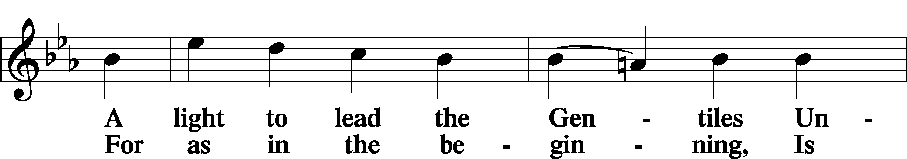
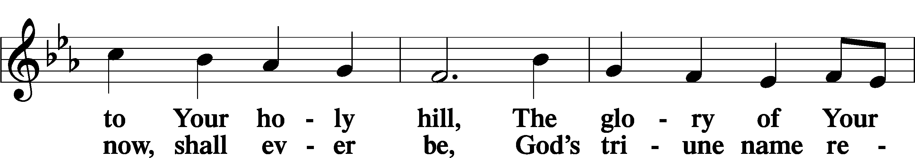
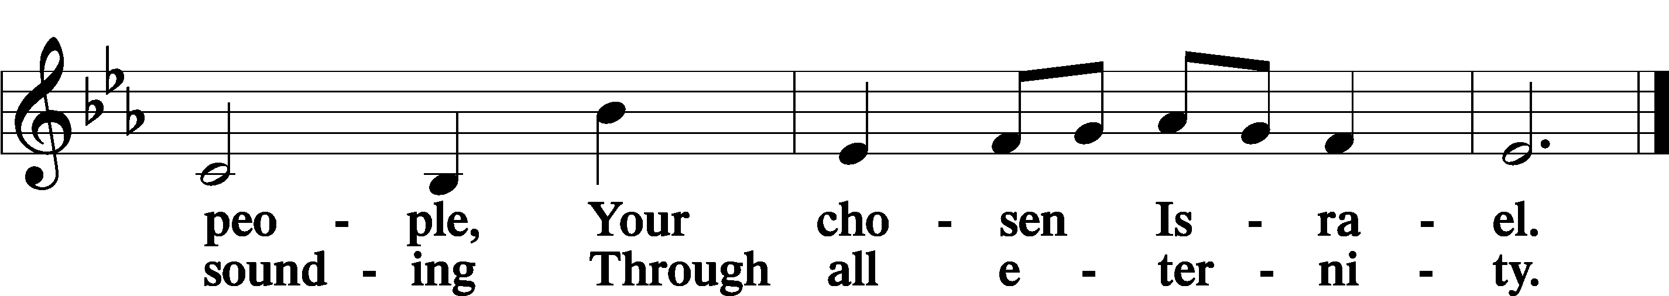

Post-Communion Collect
A Let us pray.
We give thanks to You, almighty God, that You have refreshed us through this salutary gift, and we implore You that of Your mercy You would strengthen us through the same in faith toward You and in fervent love toward one another; through Jesus Christ, Your Son, our Lord, who lives and reigns with You and the Holy Spirit, one God, now and forever.
C Amen.

Benedicamus Psalm 103:1
A Let us bless the Lord.
C Thanks be to God.

Benediction
P The Lord bless you and keep you.
The Lord make His face shine on you and be gracious to you.
The Lord look upon you with favor and T give you peace.
C Amen.

690 Hope of the World
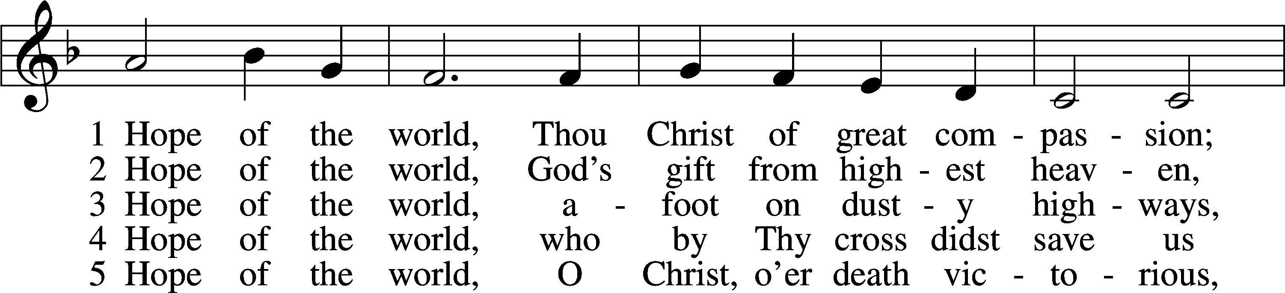
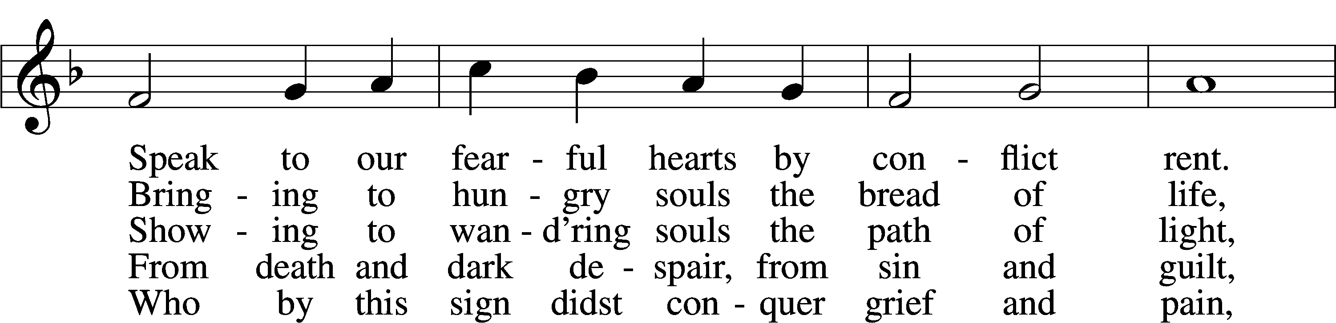
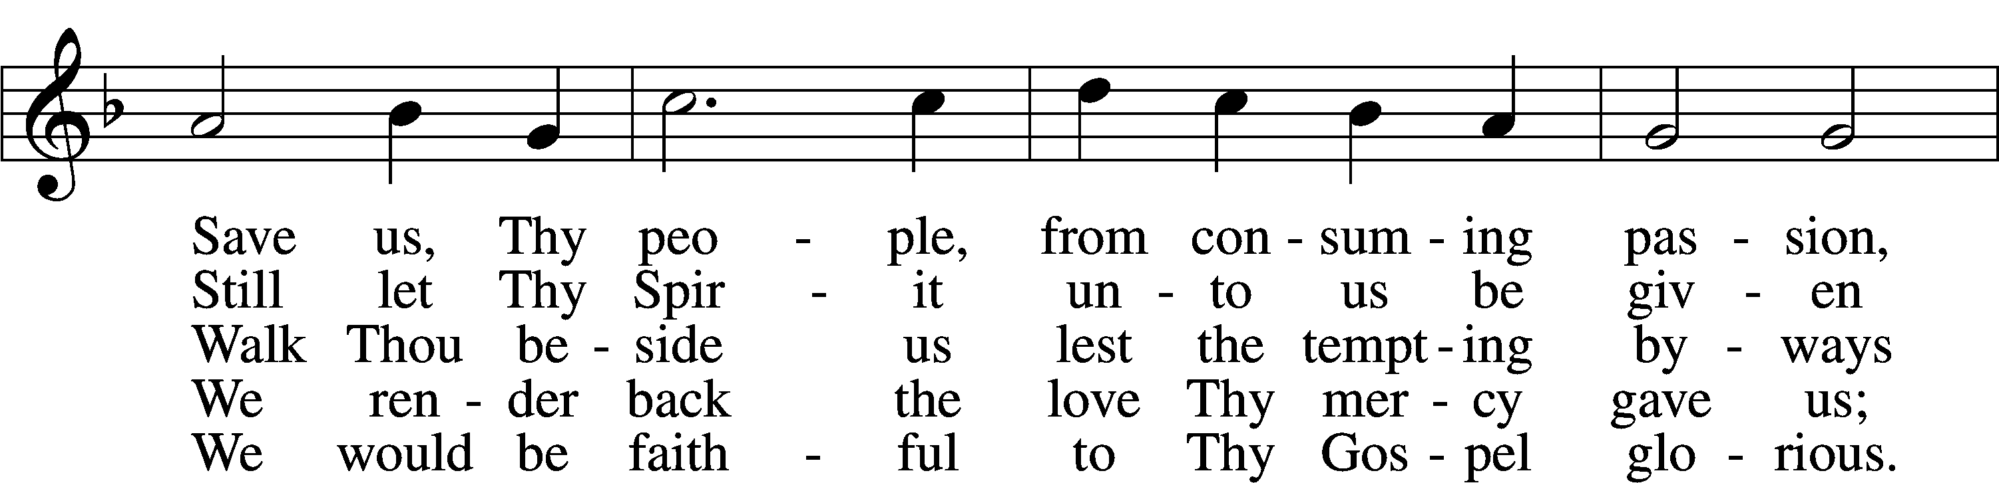
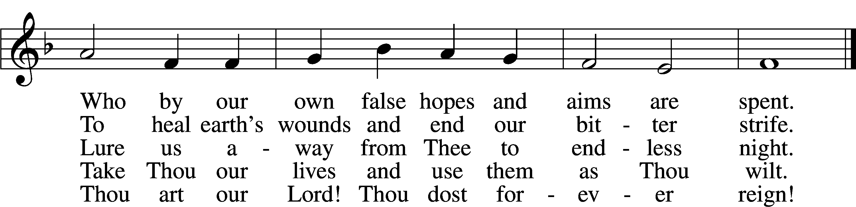
Text: Georgia Harkness, 1891–1974
Tune: Frances R. Havergal, 1836–79
Text: © 1954, renewed 1982 The Hymn Society, admin. Hope Publishing Co. Used by permission: LSB Hymn License no. 110005011
Tune: Public domain
Acknowledgments
Divine Service, Setting Four from Lutheran Service Book
Unless otherwise indicated, Scripture quotations are from the ESV® Bible (The Holy Bible, English Standard Version®), copyright © 2001 by Crossway, a publishing ministry of Good News Publishers. Used by permission. All rights reserved.
Created by Lutheran Service Builder © 2025 Concordia Publishing House.

