On entering the church

P Lord, I love the habitation of Your house and the place

where Your glory dwells. In the multitude of Your tender

mercies prepare my heart that I may enter Your house to

worship and confess Your holy name; through Jesus Christ,

my God and Lord.

Before worship

C O Lord, our creator, redeemer, and comforter, as we come

together to worship You in spirit and in truth, we humbly

pray that You would open our hearts to the preaching of

Your Word so that we may repent of our sins, believe in

Jesus Christ as our only Savior, and grow in grace and

holiness. Hear us for His sake.

645 Built on the Rock

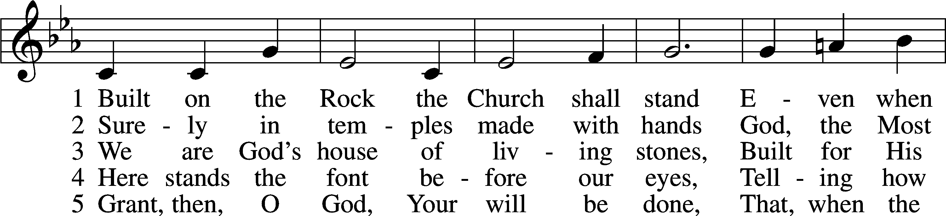

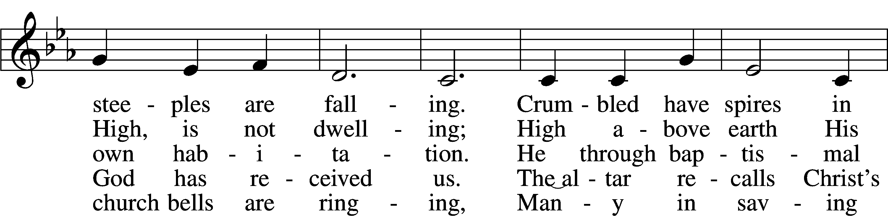

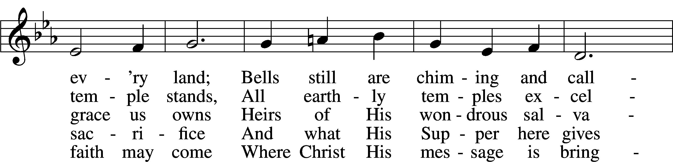

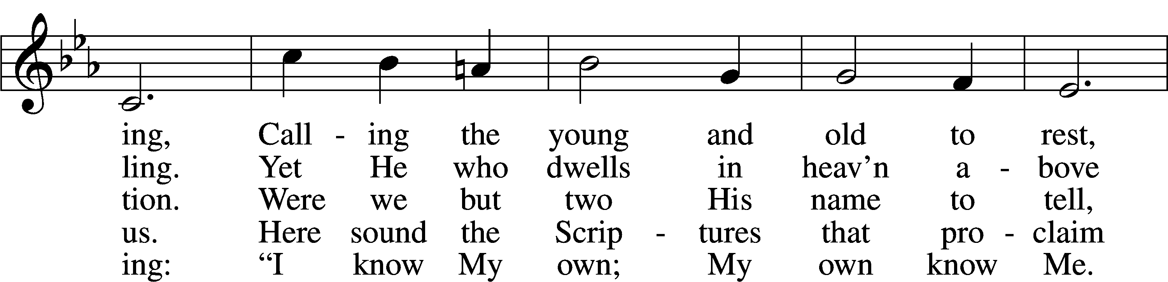

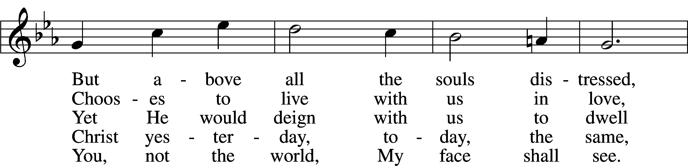

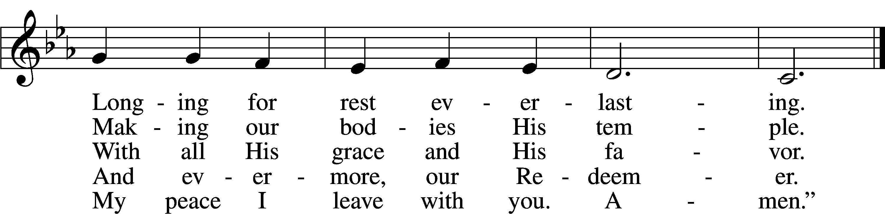

Text: Nikolai Fredrik Severin Grundtvig, 1783–1872, abr.; tr. Carl Döving, 1867–1937, alt.  
Tune: Ludvig M. Lindeman, 1812–87  
Text and tune: Public domain

# Confession and Absolution

The sign of the cross may be made by all in remembrance of their Baptism.

Invocation Matthew 28:19b; 18:20

P In the name of the Father and of the T Son and of the Holy Spirit.

C **Amen.**

Exhortation Hebrews 10:22; Psalm 124:8; Psalm 32:5

P Beloved in the Lord! Let us draw near with a true heart and confess our sins unto God our Father, beseeching Him in the name of our Lord Jesus Christ to grant us forgiveness.

P Our help is in the name of the Lord,

C **who made heaven and earth.**

P I said, I will confess my transgressions unto the Lord,

C **and You forgave the iniquity of my sin.**

Silence for reflection on God’s Word and for self-examination.

Confession of Sins

P Almighty God, our maker and redeemer, we poor sinners confess unto You that we are by nature sinful and unclean and that we have sinned against You by thought, word, and deed. Wherefore we flee for refuge to Your infinite mercy, seeking and imploring Your grace for the sake of our Lord Jesus Christ.

C **O most merciful God, who has given Your only-begotten Son to die for us, have mercy upon us and for His sake grant us remission of all our sins; and by Your Holy Spirit increase in us true knowledge of You and of Your will and true obedience to Your Word, to the end that by Your grace we may come to everlasting life; through Jesus Christ, our Lord. Amen.**

Declaration of Grace Mark 16:16; John 1:12

P Almighty God, our heavenly Father, has had mercy upon us and has given His only Son to die for us and for His sake forgives us all our sins. To those who believe on His name He gives power to become the children of God and has promised them His Holy Spirit. He that believes and is baptized shall be saved.  
  
Grant this, Lord, unto us all.

C **Amen.**

# Service of the Word

Introit Psalm 105:1–5, 8; antiphon: 1 Peter 2:2–3

Like newborn infants, long for the pure spiritual milk, that by it you may grow up to salvation—  
 if indeed you have tasted that the Lord is good.  
**Oh give thanks to the Lord; call upon his name;  
 make known his deeds among the peoples!**Sing to him, sing praises to him;  
 tell of all his wondrous works!  
**Glory in his holy name;  
 let the hearts of those who seek the Lord rejoice!**  
Seek the Lord and his strength;  
 seek his presence continually!  
**Remember the wondrous works that he has done,  
 his miracles, and the judgments he uttered.**  
He remembers his covenant forever,  
 the word that he commanded, for a thousand generations.

Gloria Patri

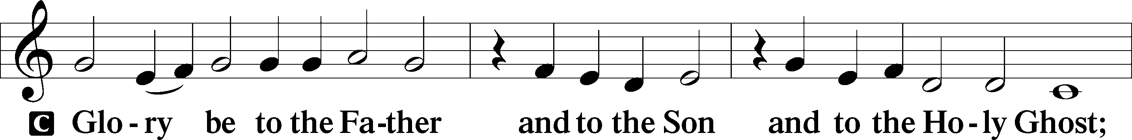

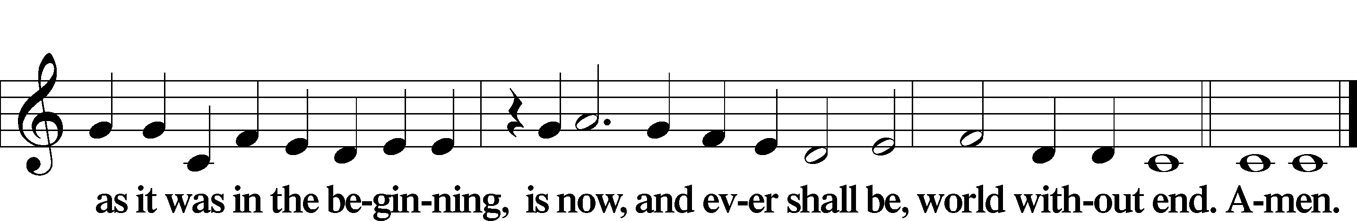

Kyrie Mark 10:47

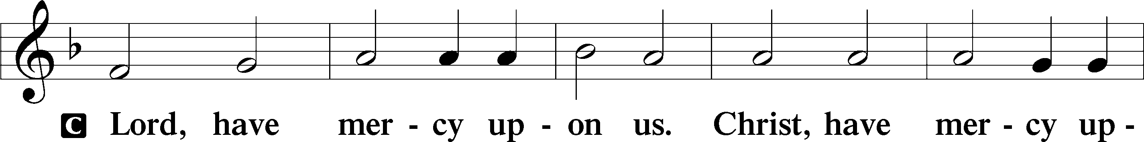

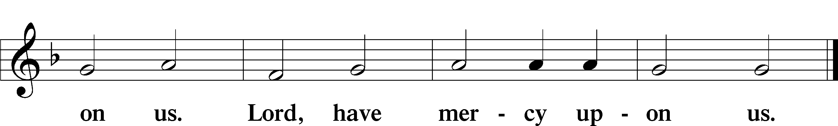

Gloria in Excelsis Luke 2:14; John 1:29

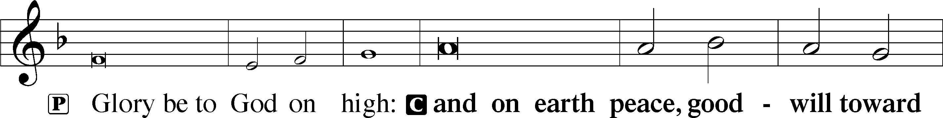

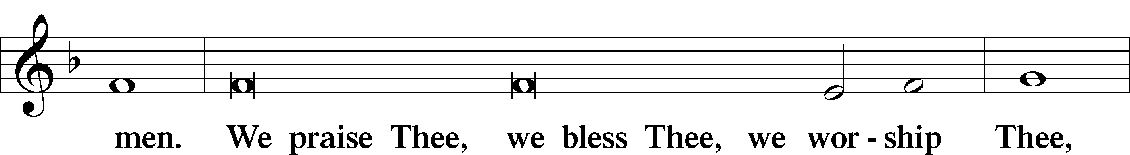

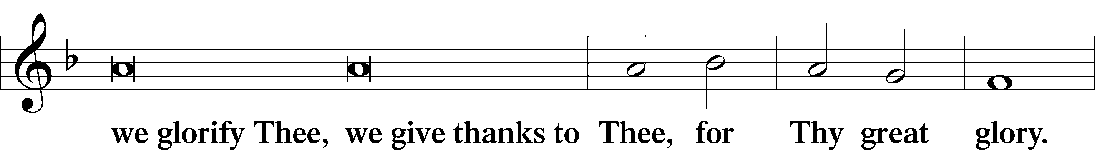

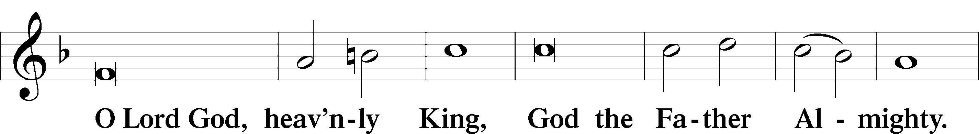

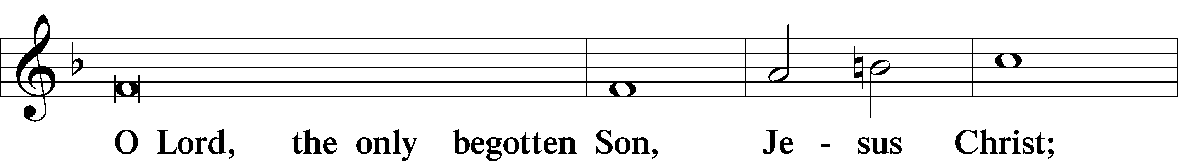

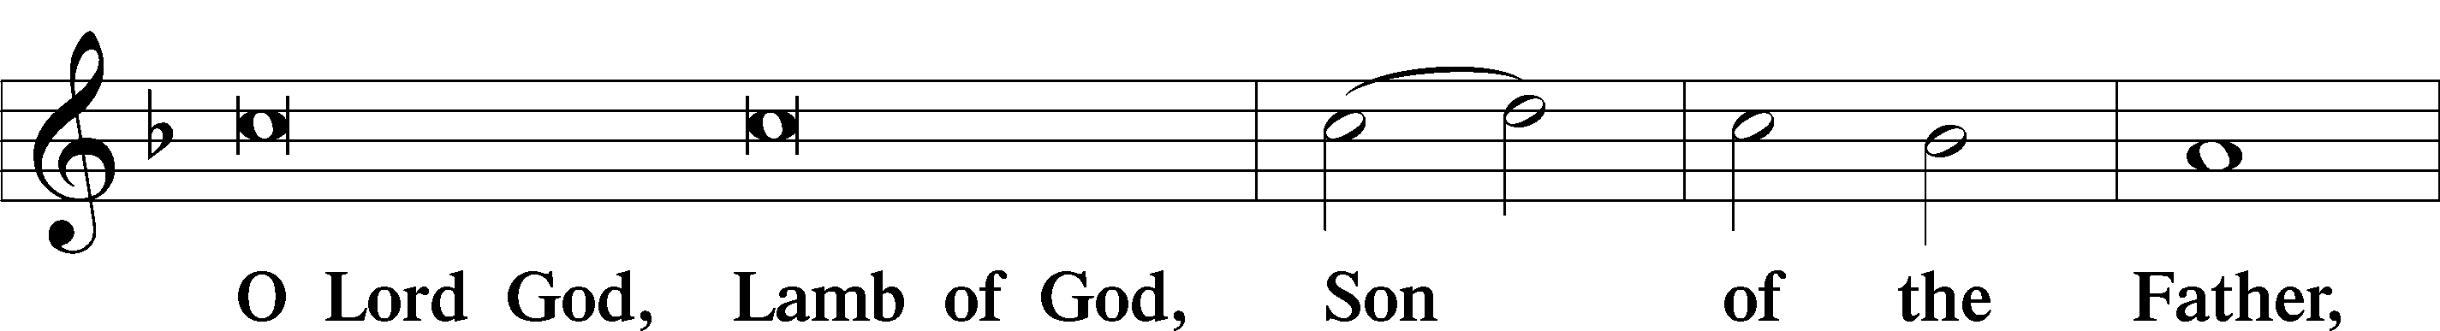

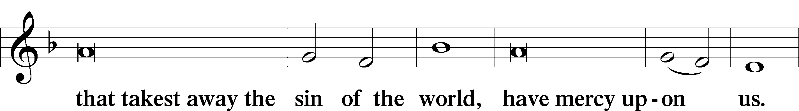

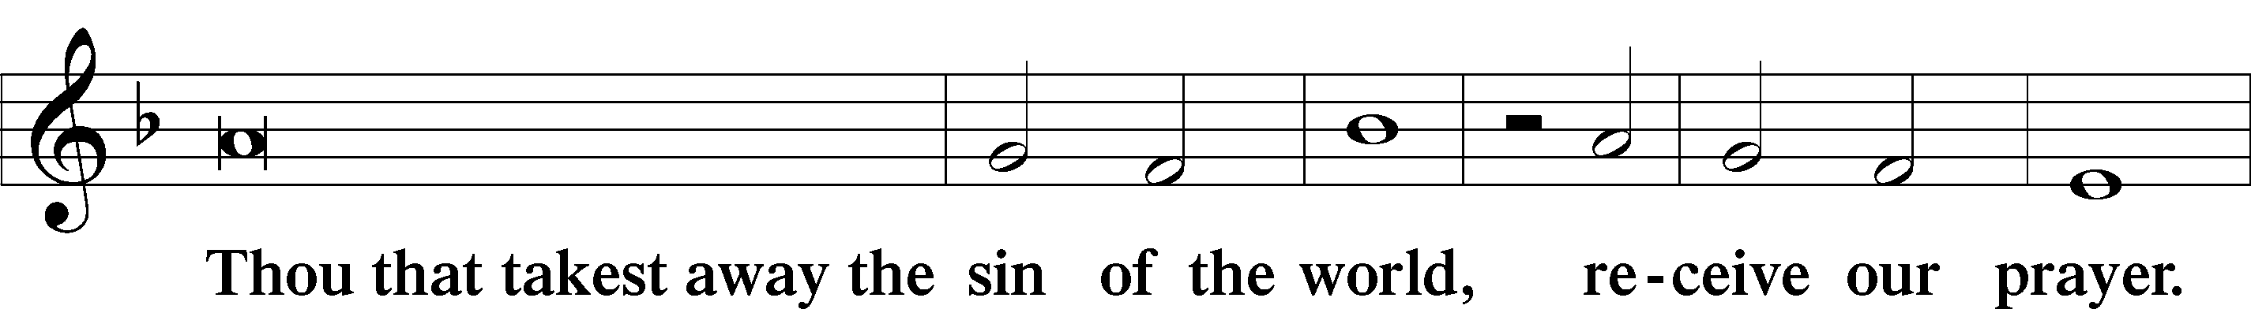

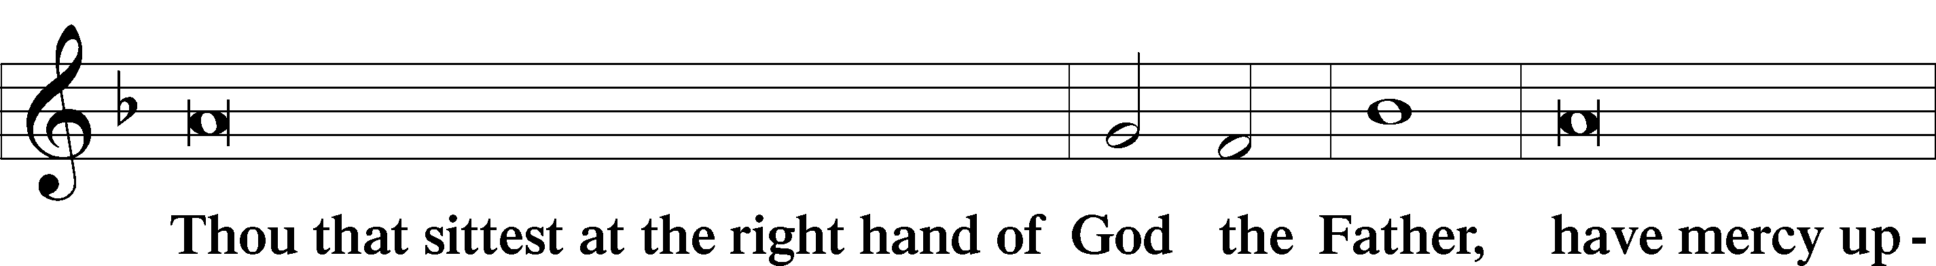

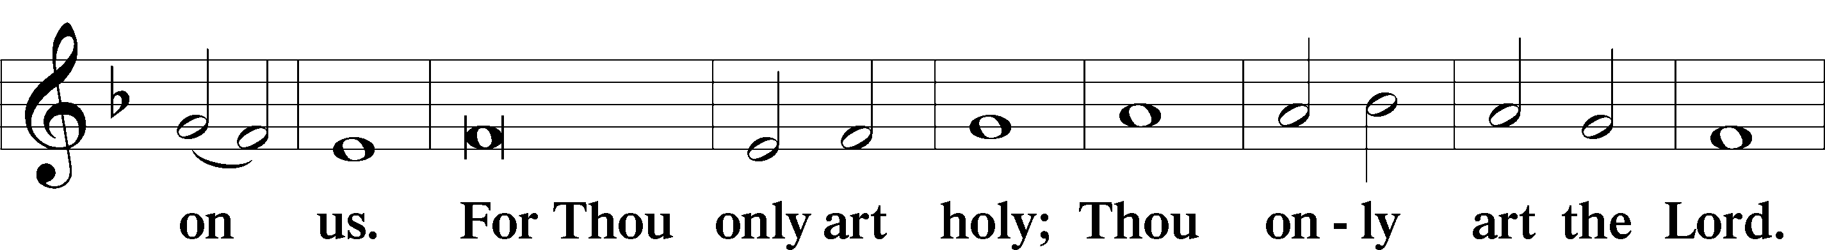

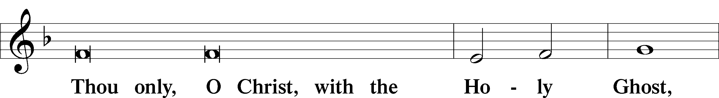

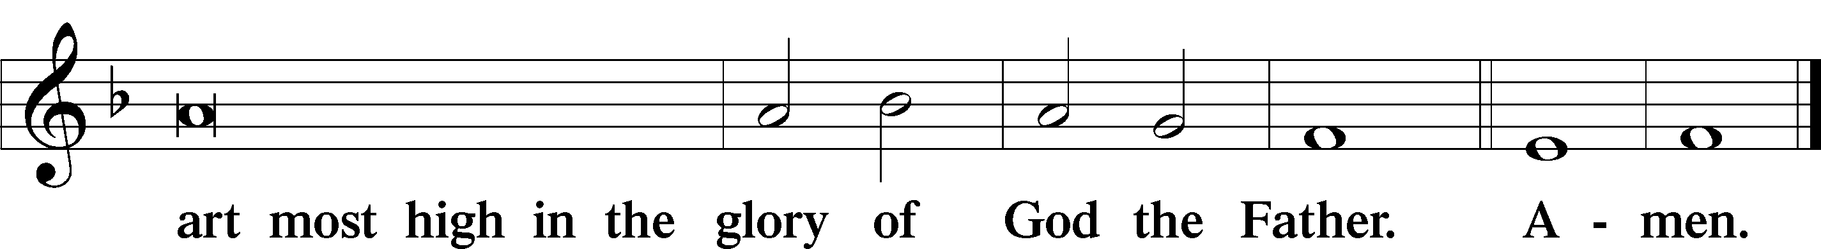

Salutation and Collect of the Day

P The Lord be with you.

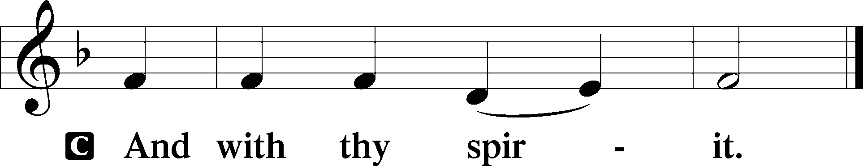

P Let us pray.

Almighty God, grant that we who have celebrated the Lord’s resurrection may by Your grace confess in our life and conversation that Jesus is Lord and God; through the same Jesus Christ, Your Son, who lives and reigns with You and the Holy Spirit, one God, now and forever.

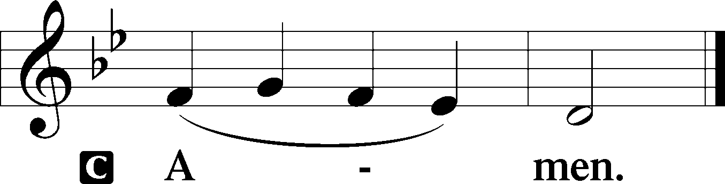

Sit

First Reading Acts 5:12–20

12Now many signs and wonders were regularly done among the people by the hands of the apostles. And they were all together in Solomon’s Portico. 13None of the rest dared join them, but the people held them in high esteem. 14And more than ever believers were added to the Lord, multitudes of both men and women, 15so that they even carried out the sick into the streets and laid them on cots and mats, that as Peter came by at least his shadow might fall on some of them. 16The people also gathered from the towns around Jerusalem, bringing the sick and those afflicted with unclean spirits, and they were all healed.

17But the high priest rose up, and all who were with him (that is, the party of the Sadducees), and filled with jealousy 18they arrested the apostles and put them in the public prison. 19But during the night an angel of the Lord opened the prison doors and brought them out, and said, 20“Go and stand in the temple and speak to the people all the words of this Life.”

A This is the Word of the Lord.

C **Thanks be to God.**

Gradual adapt. from Matthew 28:7; Hebrews 2:7; Psalm 8:6

Christ has risen from the dead.  
 [God the Father] has crowned him with glory and honor.  
**He has given him dominion over the works of his hands;  
 he has put all things under his feet.**

Epistle Revelation 1:4–18

4John to the seven churches that are in Asia:

Grace to you and peace from him who is and who was and who is to come, and from the seven spirits who are before his throne, 5and from Jesus Christ the faithful witness, the firstborn of the dead, and the ruler of kings on earth.

To him who loves us and has freed us from our sins by his blood 6and made us a kingdom, priests to his God and Father, to him be glory and dominion forever and ever. Amen. 7Behold, he is coming with the clouds, and every eye will see him, even those who pierced him, and all tribes of the earth will wail on account of him. Even so. Amen.

8“I am the Alpha and the Omega,” says the Lord God, “who is and who was and who is to come, the Almighty.”

9I, John, your brother and partner in the tribulation and the kingdom and the patient endurance that are in Jesus, was on the island called Patmos on account of the word of God and the testimony of Jesus. 10I was in the Spirit on the Lord’s day, and I heard behind me a loud voice like a trumpet 11saying, “Write what you see in a book and send it to the seven churches, to Ephesus and to Smyrna and to Pergamum and to Thyatira and to Sardis and to Philadelphia and to Laodicea.”

12Then I turned to see the voice that was speaking to me, and on turning I saw seven golden lampstands, 13and in the midst of the lampstands one like a son of man, clothed with a long robe and with a golden sash around his chest. 14The hairs of his head were white like wool, as white as snow. His eyes were like a flame of fire, 15his feet were like burnished bronze, refined in a furnace, and his voice was like the roar of many waters. 16In his right hand he held seven stars, from his mouth came a sharp two-edged sword, and his face was like the sun shining in full strength.

17When I saw him, I fell at his feet as though dead. But he laid his right hand on me, saying, “Fear not, I am the first and the last, 18and the living one. I died, and behold I am alive forevermore, and I have the keys of Death and Hades.

Stand

Alleluia

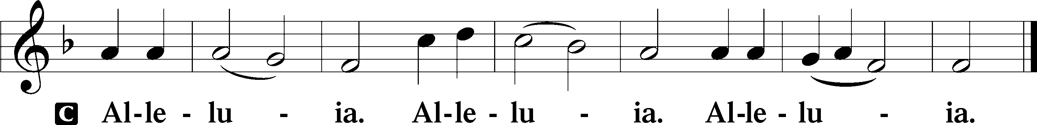

Holy Gospel John 20:19–31

P The Holy Gospel according to St. John, the twentieth chapter.

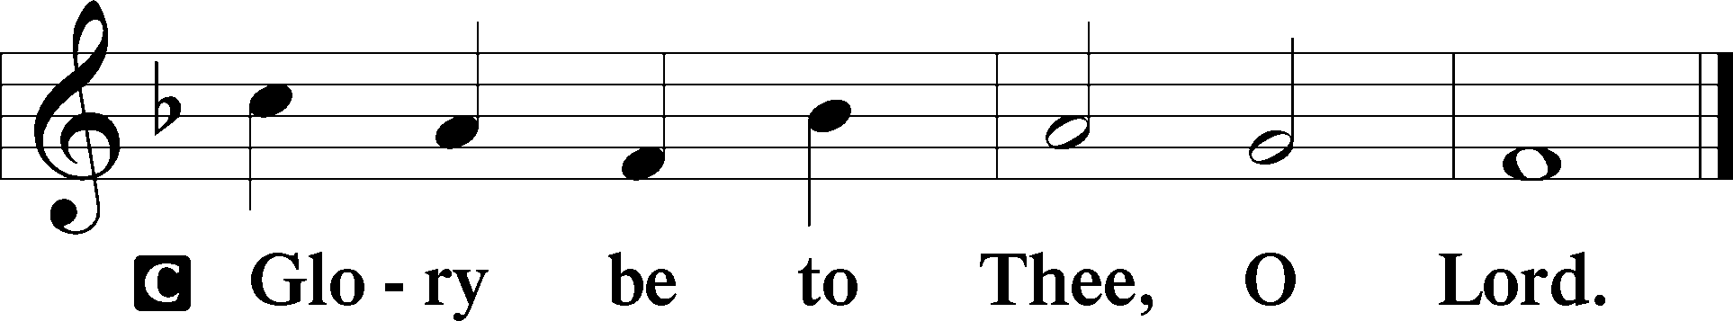

19On the evening of that day, the first day of the week, the doors being locked where the disciples were for fear of the Jews, Jesus came and stood among them and said to them, “Peace be with you.” 20When he had said this, he showed them his hands and his side. Then the disciples were glad when they saw the Lord. 21Jesus said to them again, “Peace be with you. As the Father has sent me, even so I am sending you.” 22And when he had said this, he breathed on them and said to them, “Receive the Holy Spirit. 23If you forgive the sins of anyone, they are forgiven; if you withhold forgiveness from anyone, it is withheld.”

24Now Thomas, one of the Twelve, called the Twin, was not with them when Jesus came. 25So the other disciples told him, “We have seen the Lord.” But he said to them, “Unless I see in his hands the mark of the nails, and place my finger into the mark of the nails, and place my hand into his side, I will never believe.”

26Eight days later, his disciples were inside again, and Thomas was with them. Although the doors were locked, Jesus came and stood among them and said, “Peace be with you.” 27Then he said to Thomas, “Put your finger here, and see my hands; and put out your hand, and place it in my side. Do not disbelieve, but believe.” 28Thomas answered him, “My Lord and my God!” 29Jesus said to him, “Have you believed because you have seen me? Blessed are those who have not seen and yet have believed.”

30Now Jesus did many other signs in the presence of the disciples, which are not written in this book; 31but these are written so that you may believe that Jesus is the Christ, the Son of God, and that by believing you may have life in his name.

P This is the Gospel of the Lord.

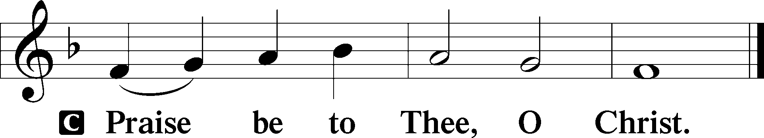

Apostles’ Creed

C **I believe in God, the Father Almighty,**

**maker of heaven and earth.**

**And in Jesus Christ, His only Son, our Lord,**

**who was conceived by the Holy Spirit,**

**born of the virgin Mary,**

**suffered under Pontius Pilate,**

**was crucified, died and was buried.**

**He descended into hell.**

**The third day He rose again from the dead.**

**He ascended into heaven**

**and sits at the right hand of God the Father Almighty.**

**From thence He will come to judge the living and the dead.**

**I believe in the Holy Spirit,**

**the holy Christian Church,**

**the communion of saints,**

**the forgiveness of sins,**

**the resurrection of the body,**

**and the life** T **everlasting. Amen.**

Sit

Children's Sermon

470 O Sons and Daughters of the King sts. 1–5

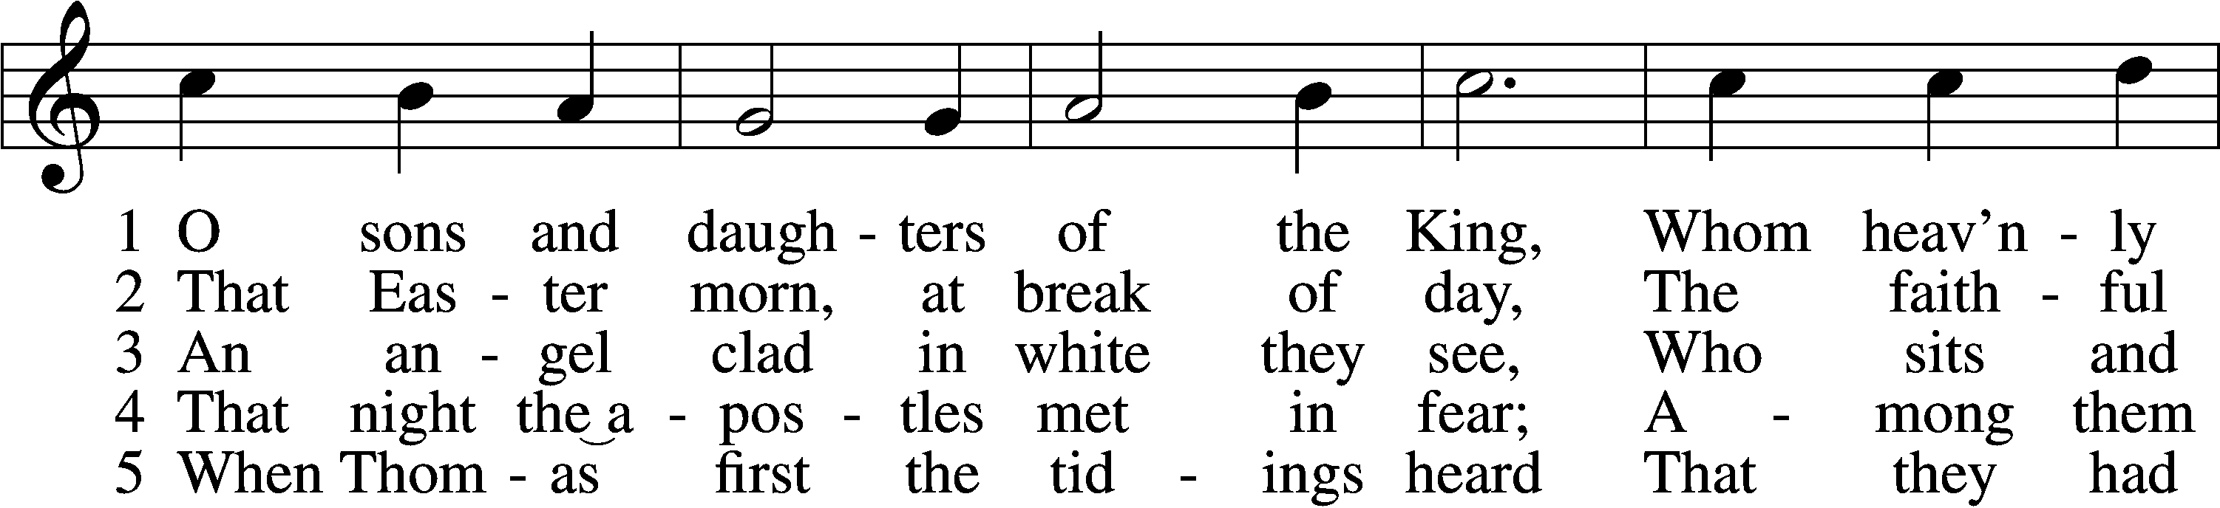

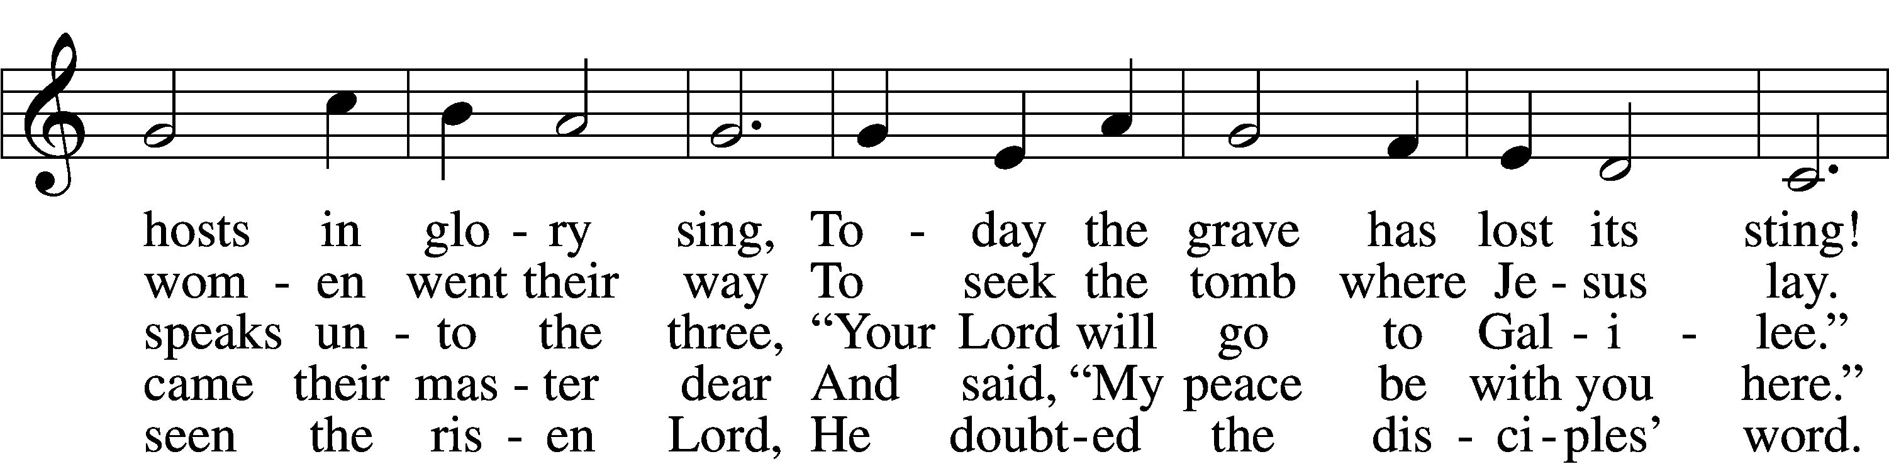

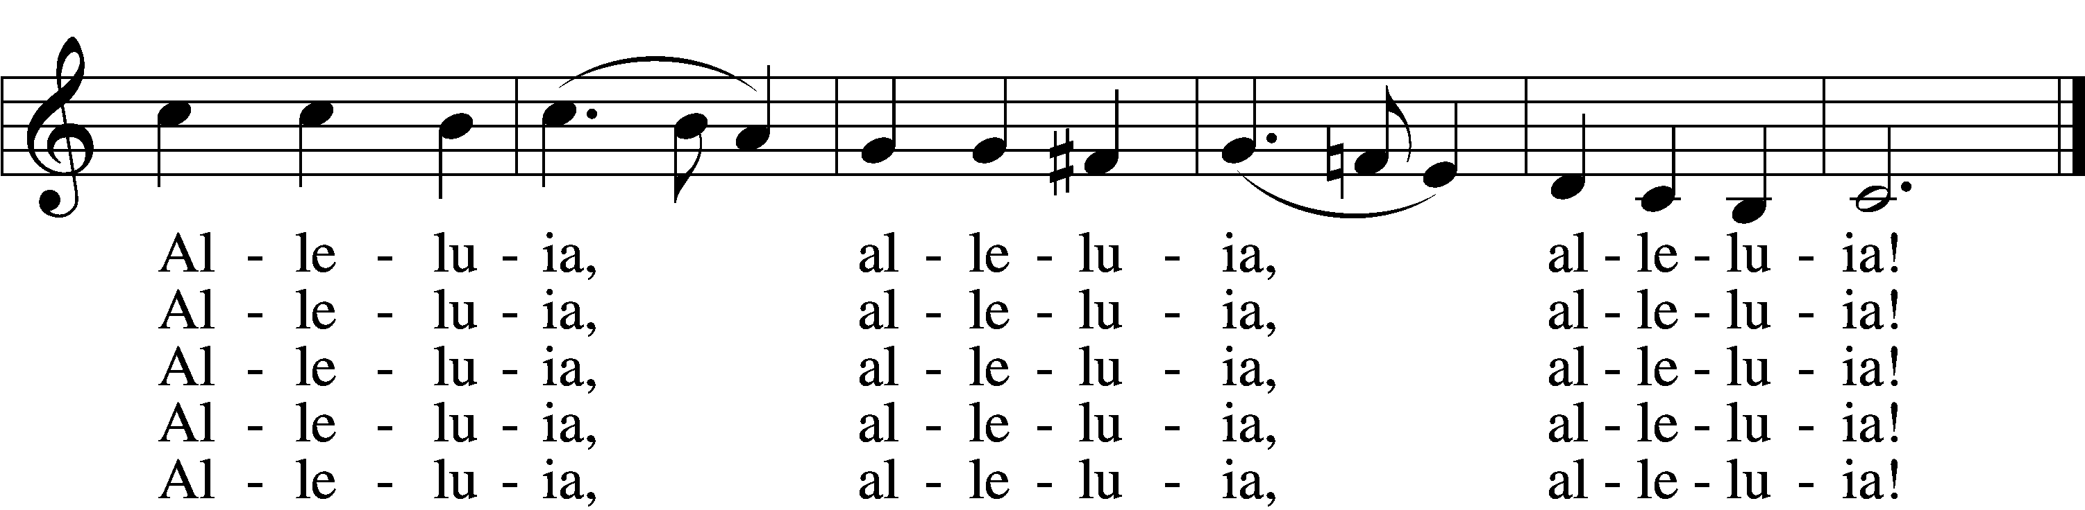

Text: attr. Jean Tisserand, d. 1494; tr. John Mason Neale, 1818–66, alt.  
Tune: Melchior Vulpius, c. 1570–1615  
Text and tune: Public domain

Sermon

470 O Sons and Daughters of the King sts. 6–9

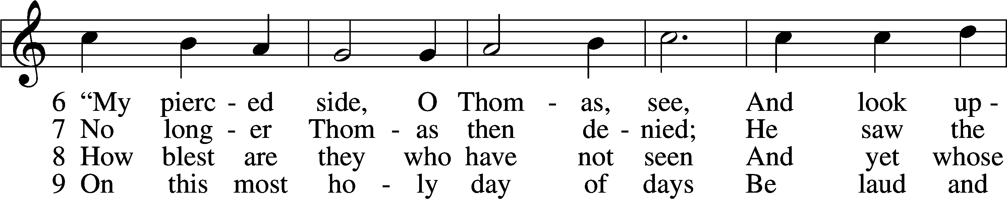

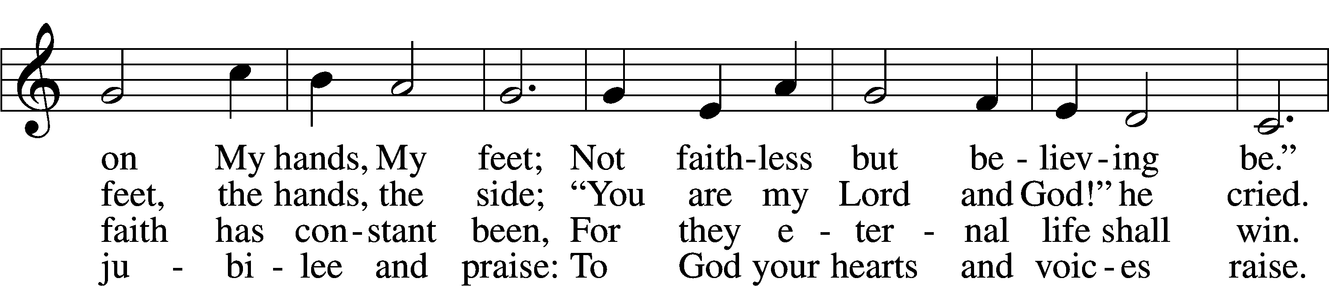

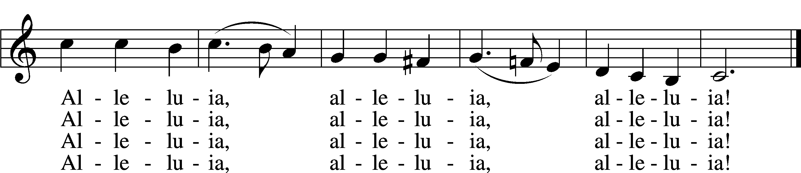

Text: attr. Jean Tisserand, d. 1494; tr. John Mason Neale, 1818–66, alt.  
Tune: Melchior Vulpius, c. 1570–1615  
Text and tune: Public domain

Votum

P The peace of God, which passes all understanding, keep your hearts and minds in Christ Jesus.

C **Amen.**

Stand

Offertory Psalm 51:10–12

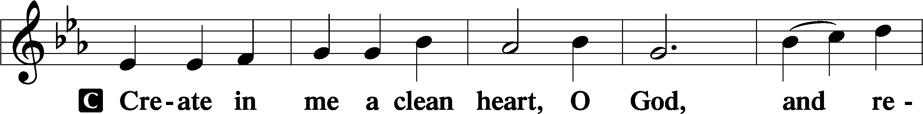

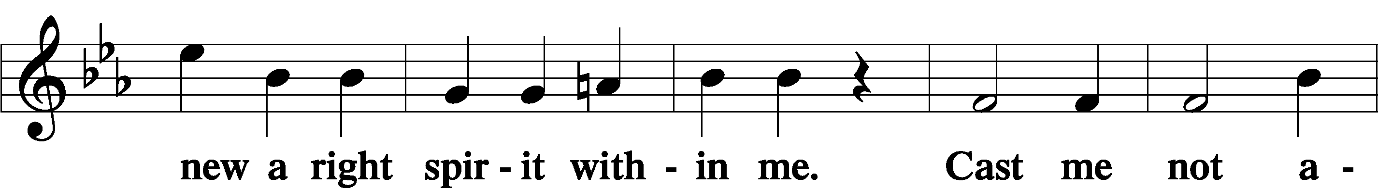

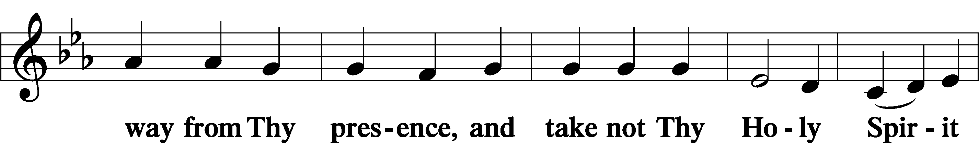

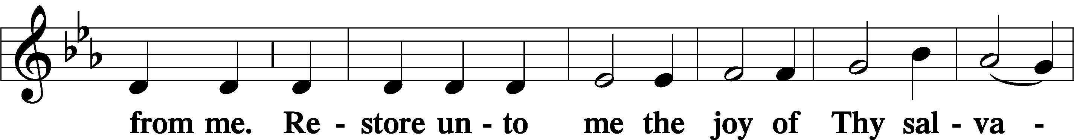

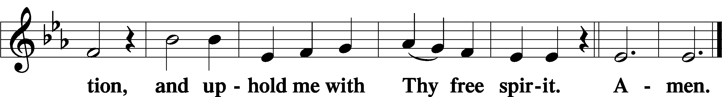

Offering

805 Praise God, from Whom All Blessings Flow

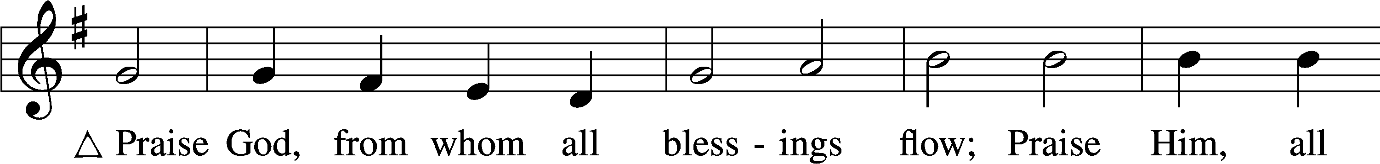

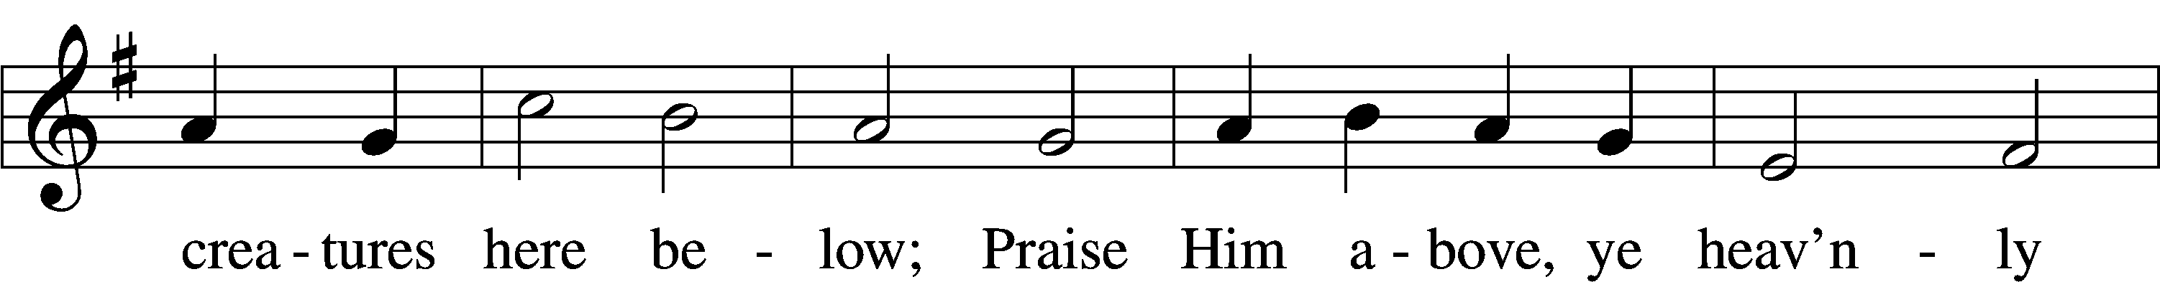

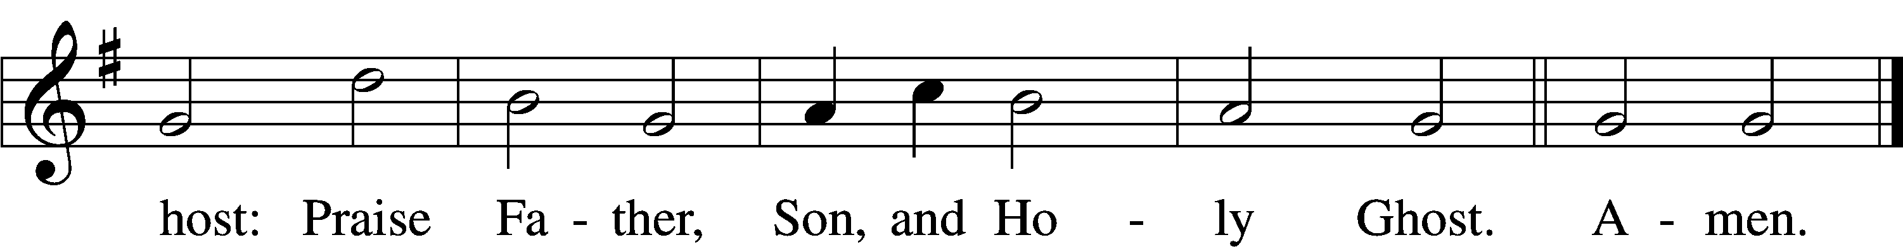

Text: Thomas Ken, 1637–1711  
Tune: Trente quatre Pseaumes de David, 1551, Geneva, ed. Louis Bourgeois  
Text and tune: Public domain

Prayer of the Church

Lord’s Prayer Matthew 6:9–13

P Lord, remember us in Your kingdom and teach us to pray:

C **Our Father who art in heaven,**

**hallowed be Thy name,**

**Thy kingdom come,**

**Thy will be done on earth**

**as it is in heaven;**

**give us this day our daily bread;**

**and forgive us our trespasses**

**as we forgive those**

**who trespass against us;**

**and lead us not into temptation,**

**but deliver us from evil.**

**For Thine is the kingdom**

**and the power and the glory**

**forever and ever. Amen.**

Collect for the Word

Blessed Lord, You have caused all Holy Scriptures to be written for our learning. Grant that we may so hear them, read, mark, learn, and inwardly digest them that, by the patience and comfort of Your holy Word, we may embrace and ever hold fast the blessed hope of everlasting life; through Jesus Christ, Your Son, our Lord, who lives and reigns with You and the Holy Spirit, one God, now and forever.

Benediction

P The Lord bless you and keep you.

The Lord make His face shine on you and be gracious to you.

The Lord look upon you with favor and T give you peace.

C **Amen.**

644 The Church’s One Foundation sts. 1–5

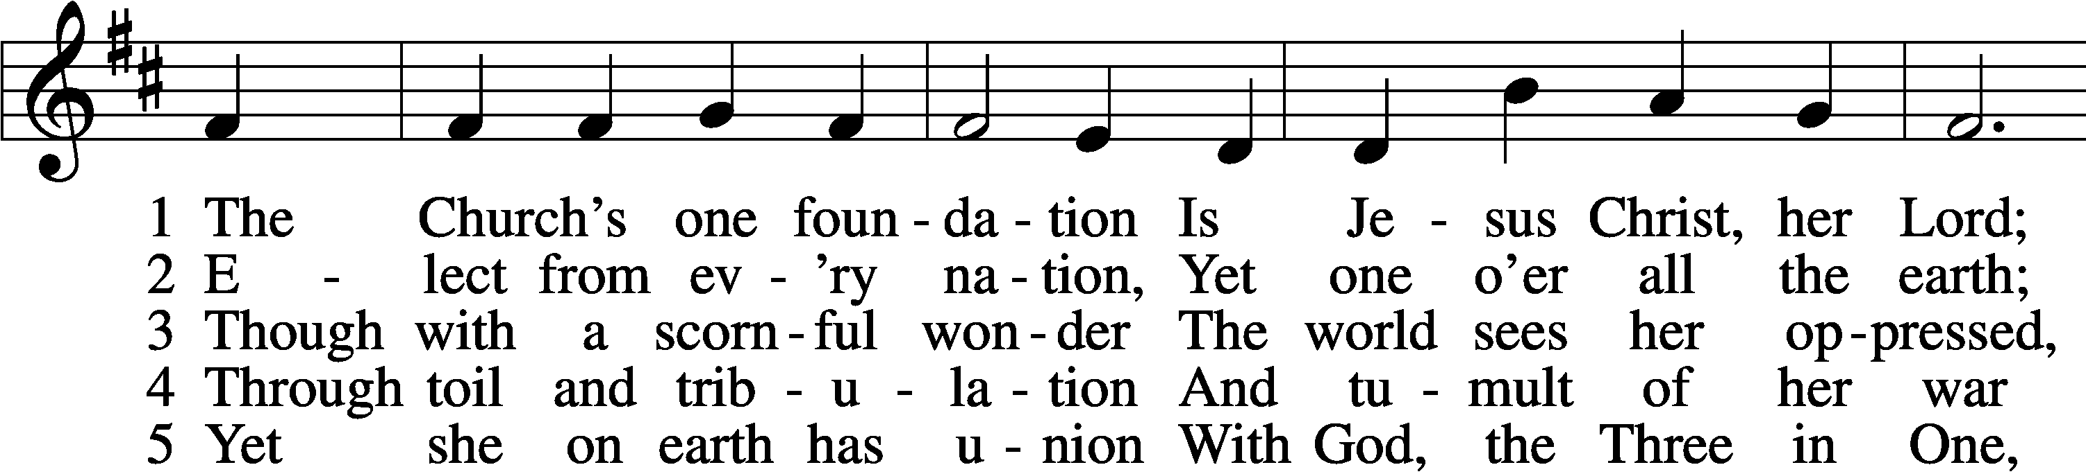

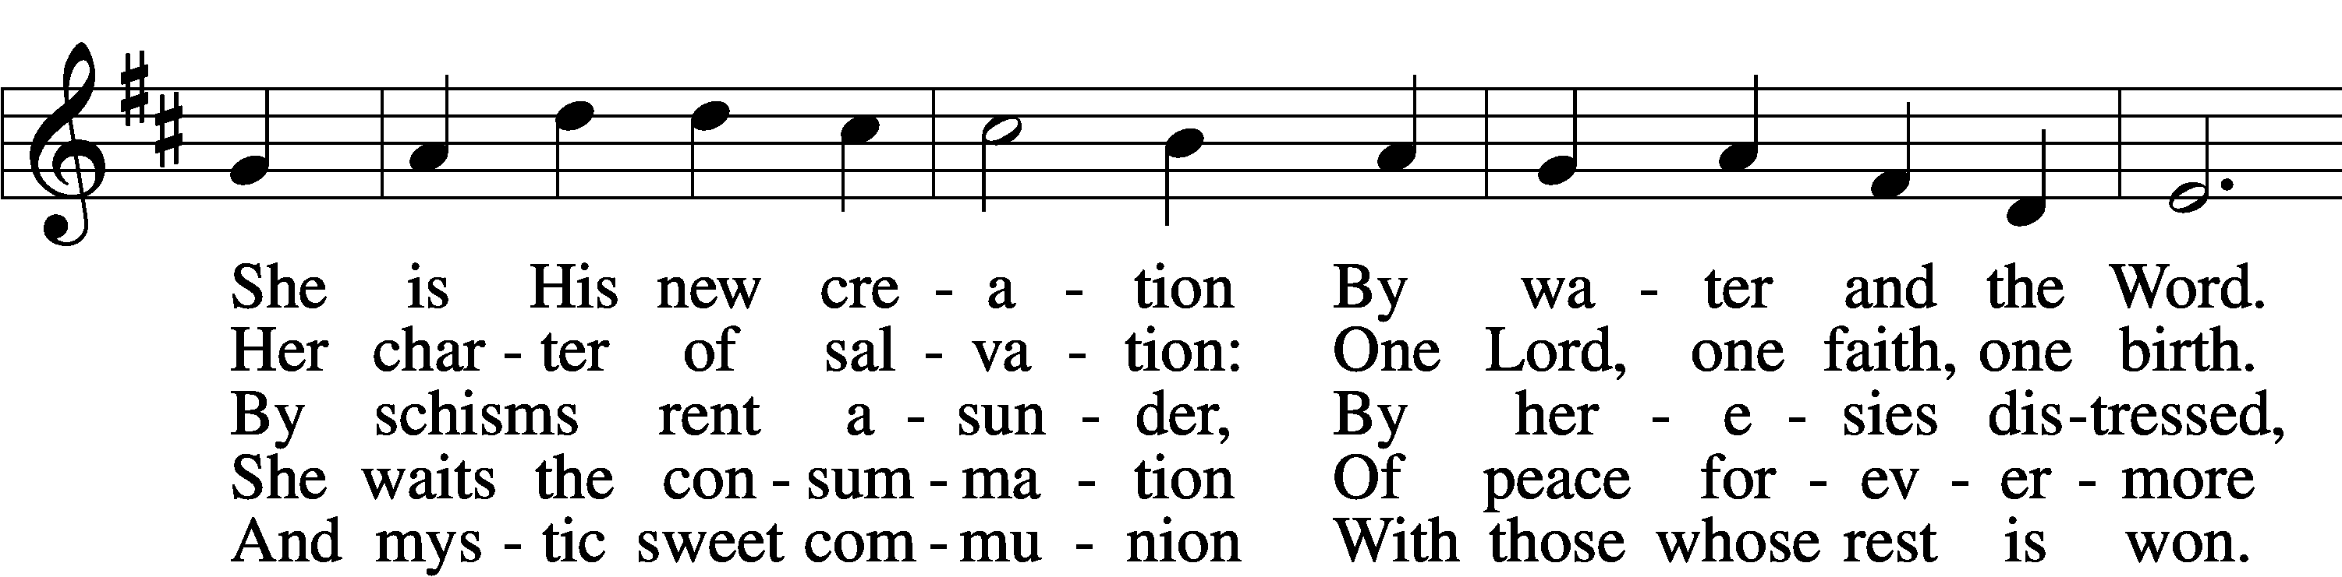

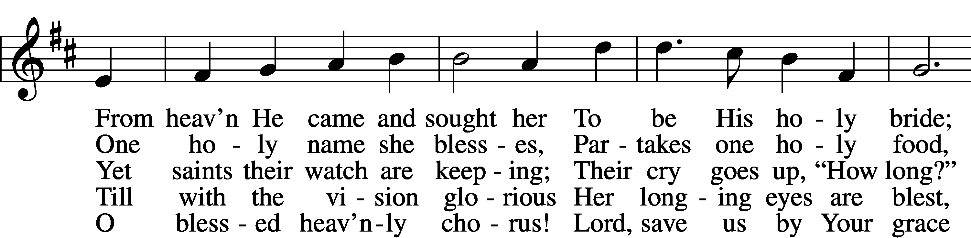

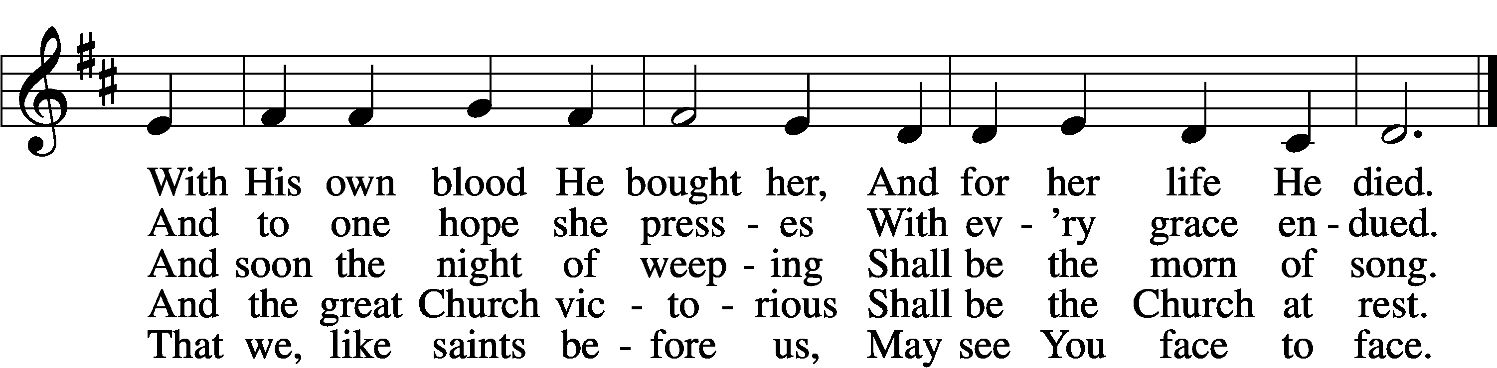

Text: Samuel J. Stone, 1839–1900, alt.  
Tune: Samuel S. Wesley, 1810–76  
Text and tune: Public domain

Acknowledgments

Unless otherwise indicated, Scripture quotations are from the ESV® Bible (The Holy Bible, English Standard Version®), copyright © 2001 by Crossway, a publishing ministry of Good News Publishers. Used by permission. All rights reserved.

Created by Lutheran Service Builder © 2025 Concordia Publishing House.