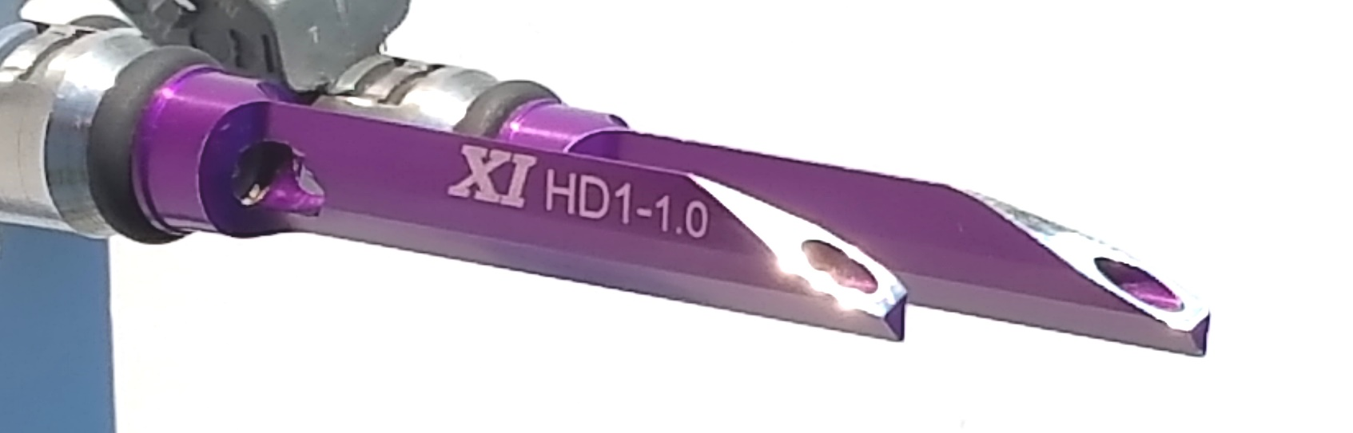

HYBRID FUEL INJECTION (HFI)
aka DYNO-BLADES
TECHNICAL EVALUATION SERIES No. 3

REVENGE OF THE INTERNAL COMBUSTION ENGINE
over
THE ELECTRIC MOTORCYCLE!

The Internal Combustion (IC) engine is fraudulently under attack and it needs all the allies it can get.

The IC engine is the single most important development of the last 2 centuries. Most all of the great technological advances of today, the smart phone, medical advances, space travel, Etc. all owe there existence to a world economy that was accelerated and powered by the IC engine, FACT! Now that their environmental impact has been reduced to negligible amounts all of the sudden we are told that CO2 is a problem.

CO2 is simply the most powerful, pristine, life generating natural substance on this planet, AND, it is the same whether it is coming out of the front end of a buffalo or the ass end of an awesome V-Twin powered road machine. Real and repeatable science proves that plants are starving for CO2, needing perhaps 4 times the current levels to preform and produce at their optimum and most efficient levels. When we responsibly and efficiently put out CO2 we are literally helping to feed a population that we were told by “scientists” 50 years ago were all supposed to be staving by now due to inadequate agricultural production (Of course we were all supposed to be burned up anyway due to “depletion of the O-Zone Layer”). Making CO2 a pollution has enormous political ramifications designed to redistribute wealth and destroy constitutional rights and freedoms, including, the biker lifestyle! I am personally very offended by this and have been dedicated to fighting against it for decades now, in fact, long before I invented HFI.

Make no mistake, powerful forces hope to force you into an electric motorcycle. That could come sooner then you think if you do not pay attention, you could be forced to pay huge penalties for running an IC powered vehicle or they could just be banned all together. Even Harley Davidson is feeling the pressure and trying to nudge you in that direction for political correctness reasons as a recent article discusses.

Here is the link:
https://www.theverge.com/2018/1/31/16955928/harley-davidson-electric-motorcycle-2019

WHAT CAN BE DONE?

No. 1 is: Support any new technological development that helps the IC engine maintain an overall practical performance advantage over electric power. One of the big drawbacks of electric power is limited “range”. Therefore, any improvement in the IC engines efficiency will help it maintain this powerful advantage over electric power. Further, as illustrated by the DYNO-BLADE comparison chart below, an improvement in efficiency brings many other advantages that help the IC engine maintain a practical advantage over electric power. To be able to do this AND make more power at the same time is just plain sweet revenge!

Currently there is no totally new, simple, safe and low cost modification to the V-Twin that can claim any measurable improvement in the kinds of IC engine dynamics that will actually help win the debate over electric power, other than, Hybrid Fuel Injection, aka DYNO-BLADES!

“You are just saying that because you want to sell a bunch of DYNO-BLADES and make a ton of money!”

Yes, this company is headed towards a big success and we intend to keep it that way, it's the American way, so what! If we cured the common cold I would hope to be well compensated even as I enjoy helping my fellow man, same as here! Profit motive aside, my love for the IC engine is real!

I have been publicly making the claim for over a year now, in fact it is on the back of my business cards:

“The first totally new concept in bolt on performance in 30+ years!”

We are still waiting for a challenge to that claim.

XCENTRICK INNOVATIONS Ltd.
xcentrickinn.com
330-373-8106
2009 20th St. S
Brookings, SD 57006
By:
Reggie D. Huff-President
rhuff@xcentrickinn.com

Multiple Patents Pending

© 2018 XCENTRICK INNOVATIONS Ltd.

DYNO-BLADES® vs AIR CLEANER vs COMBO

AIR CLEANER KIT
V-TWIN DATA POINT DYN0-BLADES® W/O COVER COMBO
*PEAK HP | +2-10 | +3-5 | +5-15
*PEAK TORQUE FT/LB | +3-12 | -1-+2 | +2-12
*TORQUE BELOW 3000 RPM % +OR- | +5-20% | -2-0% | +3-20%
*POWER @ 25% THROTTLE | +7-25% | 0% | +7-25%
*FUEL EFFICIENCY % + OR - | +5-15% | 0% | +5-15%
IMPROVED THROTTLE RESPONSE | YES | NO | YES
COOLER EXHAUST & OPERATING Ts | YES | NO | YES
SMOOTHER POWER OUTPUT DUE TO BETTER CYLINDER BALANCE & MORE STABLE COMBUSTION | YES | NO | YES
LOWER HARMFUL EMISSIONS | YES | NO | YES
REDUCES OIL CONTAMINATION FOR LONGER ENGINE LIFE | YES | NO | YES
AVERAGE COST INSTALLED | $250-290 | $210-350 | $400-600
PAY FOR ITSELF WITHIN FRACTION OF LIFE CYCLE OF ENGINE | YES X 2+ | NO | YES
*@ Full, actual & typical operating temperatures.
For more information see xcentrickinn.com or call 330-373-8106
Multiple Patents Pending Worldwide
© 2018 XCENTRICK INNOVATIONS Ltd.

