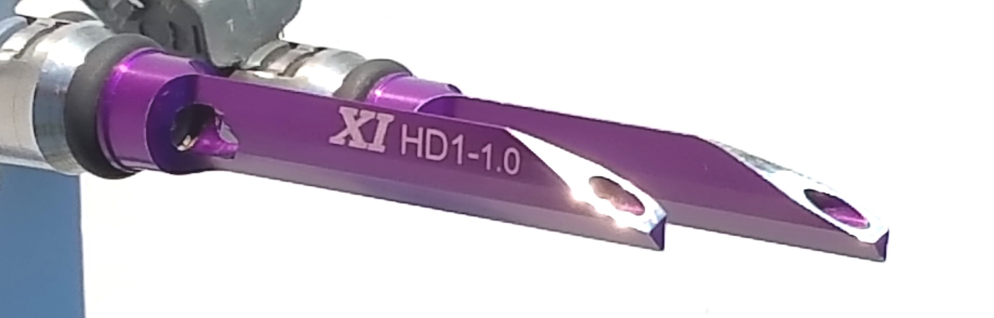



HYBRID FUEL INJECTION (HFI)

aka ***DYNO-BLADES***

TECHNICAL EVALUATION SERIES No. 4

**USING HFI TO INCREASE COMPRESSION RATIO!**

Increasing compression ratio (CR) in an IC engine increases thermal efficiency and performance across the operating range. This is why pushing the CR up to its maximum safe usable level is a very common performance engine modification. Therefore, any other modification that has the effect of raising the safe usable level of CR would be a very useful performance engine building tool whether it is used to push the CR to a higher safe usable level or not. Such is the case with HFI.

In the **“TECHNICAL EVALUATION SERIES” No.2** we discussed the theory that HFI phase changes some portion of the fuel from a liquid to a vapor with no flow penalty. This would generate what we call the **“Latent Cooling Effect”** (LCE). Recent tests seem to verify earlier tests that showed that with HFI the closer to real world operating temps the greater the gains observed. This process would have the effect of suspending more of the fuel in the inducted atmosphere which creates a more homogeneous charge. A homogeneous charge burns faster and more evenly and reduces the waste heat transferred to the surrounding structure which would reduce hot spots in the combustion chamber. This alone would tend to raise the safe usable level of CR. In addition, everything else being equal, an LCE generated cooler charge would tend to increase the safe usable level of CR.

The best theoretical estimate, everything else remaining equal, is that the combination of these factors would increase the maximum safe usable level of CR by at least 2.5% minimum. SO, 10.5:1 would become 10.75:1 for example. It is possible that it could be much higher than this but that will need to be confirmed with more testing. The only change that may be required to fully realize the benefits is to the ignition timing which would need to be retarded slightly, if at all.

However, not using HFI to increase CR is an option that renders many benefits as well. First, there still is going to be an increase in usable performance and efficiency at all throttle positions. The safety factor is increased so in cases where the engine is aftermarket tuned with richer air/fuel mixtures to help cool things down that can be reduced resulting in more efficiency. Further, the increased safety margin might be useful in cases where the vehicle will experience wide ranging conditions such as extreme hot weather and/or high mountain ranges with inconsistent fuel quality availability along the way.

**Increased safe & usable CR is yet another highly useful distinguishing characteristic of HFI that common performance mods just cannot compete with & which further supports a redefinition of “Stage 1” to always include *DYNO-BLADES!***

Thank You for your support!

XCENTRICK INNOVATIONS Ltd.

xcentrickinn.com

330-373-8106

2009 20th St. S

Brookings, SD 57006

By:

Reggie D. Huff-President

[rhuff@xcentrickinn.com](mailto:rhuff@xcentrickinn.com)

Multiple Patents Pending

© 2018 XCENTRICK INNOVATIONS Ltd.



*DYNO-BLADES®* vs AIR CLEANERvs COMBO

**AIR CLEANER KIT**

**V-TWIN DATA POINT** *DYN0-BLADES®*  **W/O COVER**  COMBO

|  |  |  |  |
| --- | --- | --- | --- |
| **\*PEAK HP** | **+2-10** | **+3-5** | **+5-15** |
| **\*PEAK TORQUE FT/LB** | **+3-12** | **-1-+2** | **+2-12** |
| **\*TORQUE BELOW 3000 RPM % +OR-** | **+5-20%** | **-2-0%** | **+3-20%** |
| **\*POWER @ 25% THROTTLE** | **+7-25%** | **0%** | **+7-25%** |
| **\*FUEL EFFICIENCY % + OR -** | **+5-15%** | **0%** | **+5-15%** |
| **IMPROVED THROTTLE RESPONSE** | **YES** | **NO** | **YES** |
| **COOLER EXHAUST & OPERATING Ts** | **YES** | **NO** | **YES** |
| **SMOOTHER POWER OUTPUT DUE TO BETTER CYLINDER BALANCE & MORE STABLE COMBUSTION** | **YES** | **NO** | **YES** |
| **LOWER HARMFUL EMISSIONS** | **YES** | **NO** | **YES** |
| **REDUCES OIL CONTAMINATION FOR LONGER ENGINE LIFE** | **YES** | **NO** | **YES** |
| **AVERAGE COST INSTALLED** | $250-290 | **$210-350** | $400-600 |
| **PAY FOR ITSELF WITHIN FRACTION OF LIFE CYCLE OF ENGINE** | **YES X 2+** | **NO** | **YES** |

*@ Full, actual & typical operating temperatures.

For more information see **xcentrickinn.com** or call 330-373-8106

Multiple Patents Pending Worldwide

© 2018 XCENTRICK INNOVATIONS Ltd.