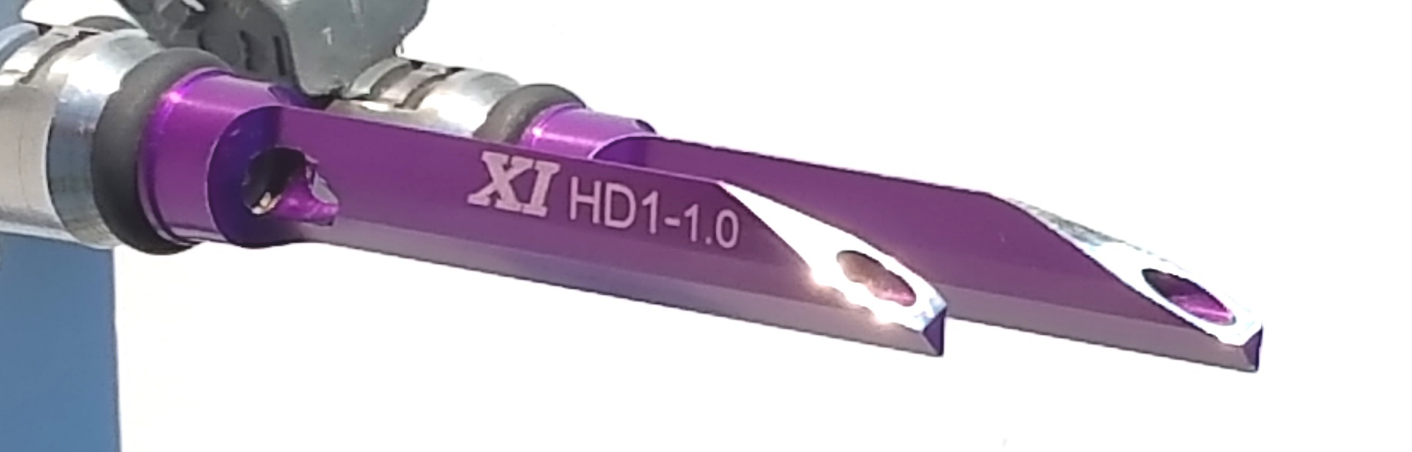



HYBRID FUEL INJECTION (HFI)

aka ***DYNO-BLADES***

TECHNICAL EVALUATION SERIES No. 5

**ANALYZING PHYSICAL PROOF HFI WORKS;**

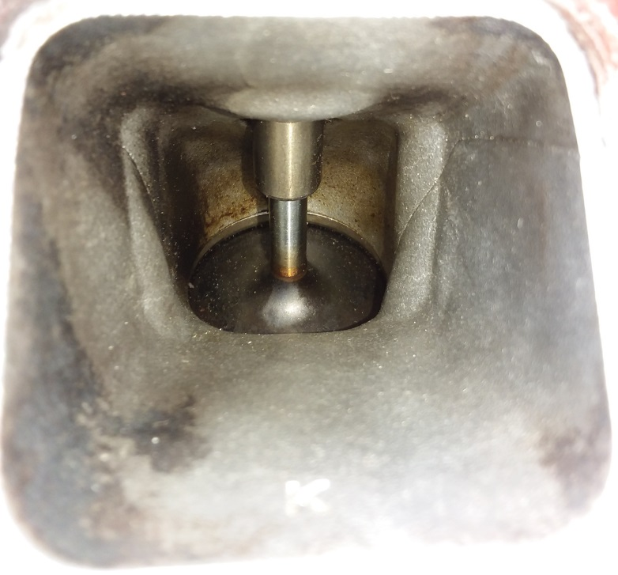**MAKING THE CASE FOR HFI AS THE NEXT GENERATION IN FUEL INJECTION!**

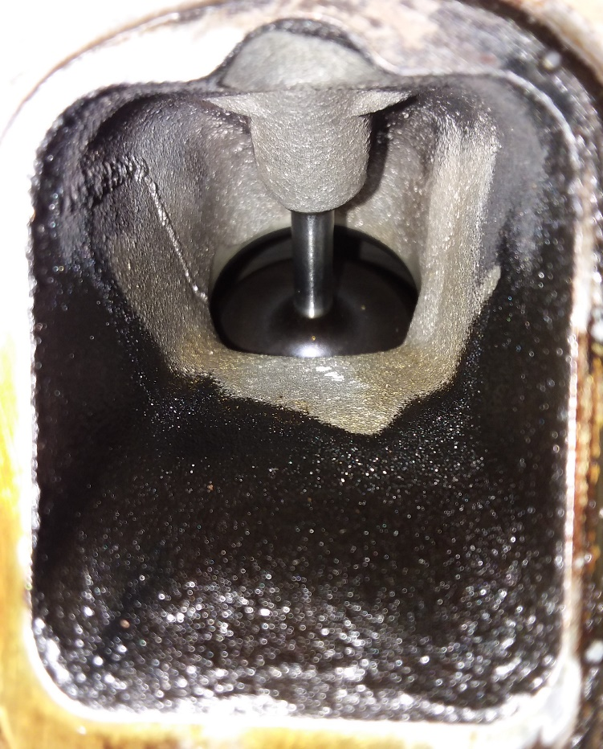

**The (2006) 5.7 HEMI port on the left represents the typical carbon deposit profile of a port FI engine after 113,000 MI. Notice the clear demarcation line indicating where fully atomized, but still liquid, fuel strikes the port wall instantly becoming solid liquid fuel. The (2010) 5.7 HEMI port on the right shows a completely different picture after 183,707 MI the last 48,705 with HFI. It is clear that HFI is working far better than contemplated as solid liquid fuel is replaced with vaporized fuel in apparently most if not all operating conditions, the clear demarcation lines are gone and even the pre-HFI carbon is being slowly removed even from behind the *DYNO-BLADE***

**which could only occur with full or near full vaporization.**

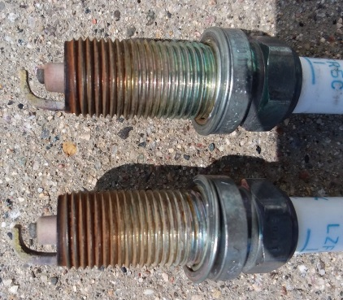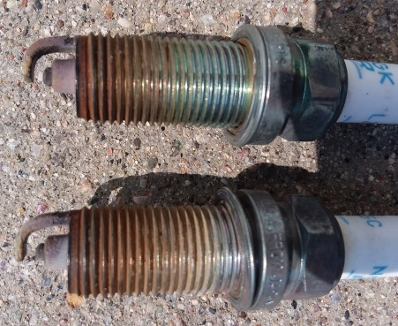

**The NJK spark plugs above were run in the 2010 5.7 HEMI for aprox 60,000 miles before they were swapped out for the Champion Copper Plus plugs below that were run entirely with HFI.**

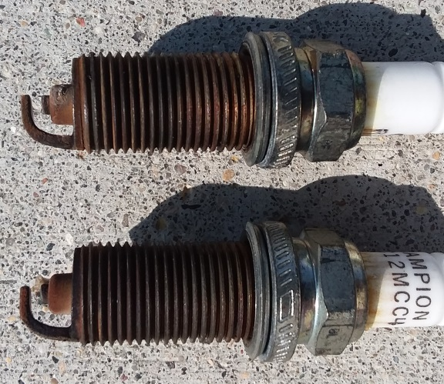

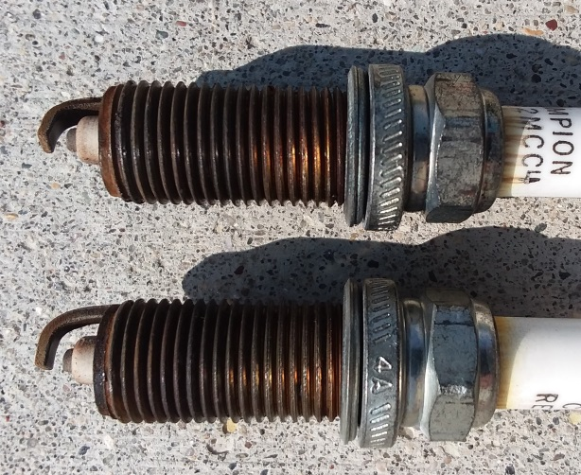

**Although different brands the plugs are the same electrode design, plug gap and heat range and should produce the same or very similar deposit profiles. However, they are very different as one can clearly see.**

Typical naysayers that have attacked HFI with arrogant conviction to rival the White Star Line, have envisioned HFI as a device that will only degrade the masterfully designed atomized fuel spray of the typical OEM designed fuel injector. They have concluded that HFI will only cause fuel to “dribble” or “puddle” solid liquid fuel and lead to all kinds of yet to be fully realized problems. For some the formation of a Black Hole in which everything good and holy is sucked into is within the realm of possibility, and, even hoped for as such would validate their short-sighted & unimaginative engine design instincts. Consider the folly of looking at the design of a pneumatic tire and declaring there is no way that structure will ever hold up a car while completely ignoring the physical dynamics of compressed air that it is specifically designed to take advantage of. In much the same way, HFI does not work as intended without the physical dynamics of mass air flow. To analyze it any other way, pins the tail on the donkey. The long term HFI test revealed here for the first time confirms this fact in rather dramatic fashion and represents a major milestone on the path of establishing HFI as a serious breakthrough and the only logical choice for the next generation of fuel injection!

**ANALYSIS:**

**Test Subject & Details:**

2010 Dodge Charger R/T:

Engine: 5.7 Gen III HEMI

Mileage: At start of test = 135,002, at time of first inspection, 183,707

PCV: Relatively clean and operating properly throughout test. Presence of oil vapor detected at normal levels.

Oil Consumption: Before test = aprox 1qt per 1500 miles, at inspection = aprox 1.25qt per 1500 miles.

Oil: 5W20 Valvoline “High Mileage”

Crankcase ventilation tube to air cleaner: In tact & attached throughout test period

Spark Plug: RE12MCC4 Champion Copper Plus

Gas: Standard 87 OCT 10% ethanol blend throughout test.

Driving mix: Aprox 50/50 Hwy to city.

Weather conditions: Typical all four seasons SD to FL before and after test.

**Observation:** There is no clear evidence of any ongoing or fresh deposits of carbon anywhere in the port. Further, the residual carbon deposits left over from the Port Fuel Injection (PFI) appear to be eroding away. The clear black color of fresh carbon deposits is not present. Further, there is no evidence of solid liquid fuel being present anywhere within the port structure. Aluminum port walls have standard deviation surface oxidation from prolonged exposure to the atmosphere which is slightly duller in appearance then when regularly exposed to liquid gasoline.

The spark plugs have a much tanner discoloration which is limited to one side of the plug.

**Evaluation:** The major causes for the observed result are indicated as:

1. **Full or near full vaporization of fuel with minimal condensation of vaporized fuel occurring within the port structure and/or spark plug electrodes, AND,**
2. **“Latent Cooling Effect” (See “Tech Series No. 2) caused by the fuel vaporization lowers port structure surface temperatures inhibiting the formation of carbon during post operating periods or the side of the spark plug facing the intake valve during operation.**
3. **Tuna-able swirl allows the proper, balanced and beneficial amount of swirl to be achieved using HFI further enhancing the benefits of 1 & 2 above.**
4. **1-3 above enhances homogeneity of the charge leading to the efficient transfer of combustion energy to mechanical means.**

**Conclusion:** The result of this first long term HFI operating inspection is hard to overstate. It is stunning. It largely validates the opinions & theories discussed in the first four “Tech Series”. Further, it lends credibility to all of the claims made in the Comparison Charts (See below) while allowing the possible additional claim of actually cleaning engines with extended use. Still, further, and just as importantly, it virtually removes any credible speculation that, even conceding some short term value, HFI will have some kind of long term deleterious effect. It would appear instead that long term deleterious effects may come from NOT running HFI especially when compared to conventional wisdoms choice of Direct Injection (DI) as the only option for the next generation of gas fuel injection.

HYBRID FUEL INJECTION vs DIRECT INJECTION

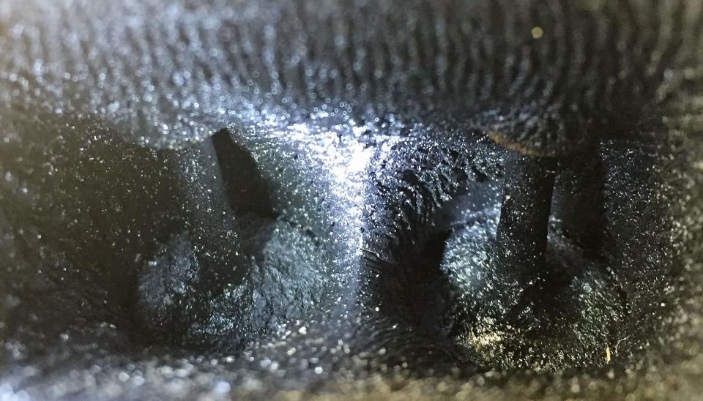

THIS IS YOUR ENGINE ON DI!

THIS IS YOUR ENGINE ON HFI AFTER PFI!

Much more about the case of HFI vs DI in our next Tech Series article.

Thank You for your support & interest!

XCENTRICK INNOVATIONS Ltd.

xcentrickinn.com

330-373-8106

2009 20th St. S

Brookings, SD 57006

By: Reggie D. Huff-President

[rhuff@xcentrickinn.com](mailto:rhuff@xcentrickinn.com)

Date published: August 26, 2018

Multiple Patents Pending

© 2018 XCENTRICK INNOVATIONS Ltd



*DYNO-BLADES®* vs C A Ivs COMBO

**V-8 DATA POINT** *DYN0-BLADES®*  **CAI**  COMBO

|  |  |  |  |
| --- | --- | --- | --- |
| **\*PEAK HP** | **+7-30** | **+5-18** | **+12-45** |
| **\*PEAK TORQUE FT/LB** | **+10-25** | **-1-+20** | **+9-42** |
| **\*TORQUE BELOW 3000 RPM % +OR-** | **+5-20%** | **-2-+5%** | **+3-25%** |
| **\*POWER @ 25% THROTTLE** | **+7-25%** | **0%** | **+7-25%** |
| **\*FUEL EFFICIENCY % + OR -** | **+5-15%** | **0%** | **+5-15%** |
| **IMPROVED THROTTLE RESPONSE** | **YES** | **NO** | **YES** |
| **COOLER EXHAUST & OPERATING Ts** | **YES** | **NO** | **YES** |
| **SMOOTHER POWER OUTPUT DUE TO BETTER CYLINDER BALANCE & MORE STABLE COMBUSTION** | **YES** | **NO** | **YES** |
| **LOWER HARMFUL EMISSIONS** | **YES** | **NO** | **YES** |
| **REDUCES OIL CONTAMINATION FOR LONGER ENGINE LIFE** | **YES** | **NO** | **YES** |
| **AVERAGE COST INSTALLED** | $400-450 | **400-500** | $750-900 |
| **PAY FOR ITSELF WITHIN FRACTION OF LIFE CYCLE OF ENGINE** | **YES X 2+** | **NO** | **YES** |

*@ Full, actual & typical operating temperatures.

For more information see **xcentrickinn.com** or call 330-373-8106

Multiple Patents Pending Worldwide Made in the USA

© 2018 XCENTRICK INNOVATIONS Ltd.



*DYNO-BLADES®* vs AIR CLEANERvs COMBO

**AIR CLEANER KIT**

**V-TWIN DATA POINT** *DYN0-BLADES®*  **W/O COVER**  COMBO

|  |  |  |  |
| --- | --- | --- | --- |
| **\*PEAK HP** | **+2-10** | **+3-5** | **+5-15** |
| **\*PEAK TORQUE FT/LB** | **+3-12** | **-1-+2** | **+2-12** |
| **\*TORQUE BELOW 3000 RPM % +OR-** | **+5-20%** | **-2-0%** | **+3-20%** |
| **\*POWER @ 25% THROTTLE** | **+7-25%** | **0%** | **+7-25%** |
| **\*FUEL EFFICIENCY % + OR -** | **+5-15%** | **0%** | **+5-15%** |
| **IMPROVED THROTTLE RESPONSE** | **YES** | **NO** | **YES** |
| **COOLER EXHAUST & OPERATING Ts** | **YES** | **NO** | **YES** |
| **SMOOTHER POWER OUTPUT DUE TO BETTER CYLINDER BALANCE & MORE STABLE COMBUSTION** | **YES** | **NO** | **YES** |
| **LOWER HARMFUL EMISSIONS** | **YES** | **NO** | **YES** |
| **REDUCES OIL CONTAMINATION FOR LONGER ENGINE LIFE** | **YES** | **NO** | **YES** |
| **AVERAGE COST INSTALLED** | $250-290 | **$210-350** | $400-600 |
| **PAY FOR ITSELF WITHIN FRACTION OF LIFE CYCLE OF ENGINE** | **YES X 2+** | **NO** | **YES** |

*@ Full, actual & typical operating temperatures.

For more information see **xcentrickinn.com** or call 330-373-8106

Multiple Patents Pending Worldwide Made in the USA

© 2018 XCENTRICK INNOVATIONS Ltd.