Smoothies  sTRAWBERRY, BLUEBERRY, MIXED BERRY, PINEAPPLE, MANGO, PEACH, banana 5.00  aDDS: PROTeiN .50 nON DAIRY MILK 1.00 KALE, SPINACH OR AVOCADO .50 EACH  smoothie bowls  STRAWBERRIES n CREAM, PINEAPPLE BANANA PEACH  AVOCADO KALE, PEACH ORANGE BERRY, MIXED BERRY  CHOCOLATE PEANUT BUTTER BANANA, BLUEBERRY SPINACH PINEAPPLE, MANGO PINEAPPLE  oR bUILD YOUR OWN!! 7.00  drinks  SM MD LG  COFFEE 1.83 2.09 2.28  COLD BREW 3.50 4.00 4.50  NITRO 4.50 5.00 5.50  TEA 1.99 2.24 2.48  AMERICANO 1.83 2.78 3.73  BREVE 3.69 4.52 5.43  CAPPUCCINO 3.49 4.32 5.23  CHAI LATTE 3.29 3.89 4.39  LATTE 3.49 4.32 5.23  RED EYE 2.78 3.01 3.33  MATCHA 3.29 3.89 4.39  HOT COCO 2.79 3.21 3.61  ESPRESSO 1.00  Coffee Flavor Shot .50 Espresso Flavor Shot .75 Non Dairy Milk 1.00 Extra Espresso Shot .95  FLAVORS: Vanilla, Hazelnut, Caramel, Chocolate, White Chocolate, Peanut Butter, Salted Caramel, Irish Cream, Maple, Coconut, Raspberry, Strawberry, Blueberry  *Flavors subject to change  BOTTLED BEVERAGES: Soda, Water, Juice 2.00 | 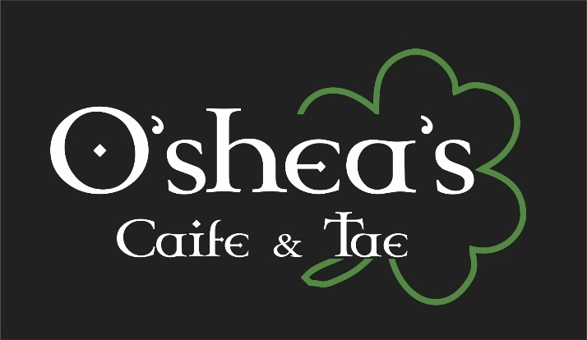  - Coffee and Tea Shop  - enter as stranger,  - leave as friends  - Cheers!  44 Nashua Rd  Londonderry, NH 03053  603-540-2971  https://osheasnh.com
Bagel, English Muffin, Texas Toast, Croissant, GF Bagel*  Plain Cream cheese 2.50  Flavored cream cheese 3.50  BAGELS: Plain*, Onion, Blueberry, Wheat, Cinnamon Raisin*, Everything*, Asiago, Garlic, Spinach, Sundried Tomato, Jalapeno  CREAM CHEESES: Mixed Berry, Cranberry Walnut, Smoked Salmon, Cookies N Cream, Maple Walnut, Jalapeno Avocado, Olive, Veggie, Bacon Jalapeno, Sundried Tomato, Brown Sugar Cinnamon  BUTTERS: Honey, Herb, Brown Sugar Cinnamon  ½ DOZEN BAGELS 5.90 DOZEN BAGELS 10.90  8 OZ PLAIN CREAM CHEESE 5.00 8 OZ FLAVORED CREAM CHEESE 6.00  Breakfast Sandwiches  O’so basic 4.50  Egg, Meat(Ham, Sausage or Bacon), Cheese(American or Cheddar), Bagel  O’VEGGIE 4.50  Egg, Tomato, Spinach, American, Veggie Cream Cheese, Spinach Bagel  o’ranchero 5.50  Egg, Cheddar, Bacon, Salsa, Avocado Jalapeno Cream Cheese, Asiago Bagel  o’seas 5.00  Egg, Tomato, Red Onion, Salmon Cream Cheese, Onion Bagel  o’burn baby burn 5.50  Egg, Cheddar, Sausage, Bacon Jalapeno Cream Cheese, Jalapeno Bagel  o’sunny day 5.00  Egg, Spinach, Cheddar, Sundried Tomato Cream Cheese, Sundried Tomato Bagel  o’gawd 6.50  Egg, Ham, Bacon, Sausage, Cheddar, Plain Cream Cheese  Garlic Bagel | Salads  o’caeSAR  Romaine, Shredded Parmesan Cheese, Homemade Croutons 5.90  o’garden  Lettuce, Tomato, Cucumber, Homemade Croutons 6.25  o’greek  Lettuce, Tomato, Cucumber, Feta, Red Onion, Olives, Homemade Croutons 7.25  o’cobb  Lettuce, Tomato, Cucumber, Hard Boiled Egg, Bacon, Homemade Croutons 7.75  add a scoop of… 2.00  Chicken Salad, Cranberry Walnut Chicken Salad, Buffalo Chicken Salad, Tuna Salad, Egg Salad, Ham Salad  Dressings  Blue Cheese, Balsamic, Caesar, Greek, Honey Mustard  Lunch Sandwiches  Comes with Chips & Pickle 7.90  o’clucker  Chicken Salad, Lettuce, Tomato, Everything Bagel  o’nutty clucker  Cranberry Walnut Chicken Salad, Lettuce, Wheat Bagel  o’spicy clucker  Buffalo Chicken Salad, Lettuce, Tomato, Red Onion, Jalapeno Bagel  o’Clucker of the sea  Tuna Salad, Tomato, American Cheese, Garlic Bagel  o’baby clucker  Egg Salad, Bacon, Lettuce, Texas Toast  o’oinker  Ham Salad, Lettuce, Red Onion, Texas Toast
Garlic Bagel

