OSHA Regulation, 29 CFR Section 1910.38 sets forth the requirements for an Emergency Evacuation Plan GUIDELINES FOR DEVELOPING AN EMERGENCY PLAN FOR YOUR OUTDOOR EVENT
The rented structure will be erected to provide temporary accommodations for your event. Temporary structures can provide protection from moderate weather, but are not designed for use as shelter in severe weather as such conditions could exceed the structure’s ability to protect occupants. In addition, temporary structures may need to be evacuated for other types of emergency situations. (1) It is your (“Lessee’s”) responsibility to ensure your guests’ safety. S&T Party Rentals LLC. recommends that you develop an emergency plan so you are prepared to act decisively in the event of an emergency during your event. Following are suggested guidelines for developing an emergency plan.
BEFORE YOUR EVENT:
- Designate Point person(s):
Designate at least one person who will be in charge of the emergency plan and will be on site for the entire event. The point person(s) will assist in developing the emergency plan, and will be responsible during the event for monitoring the weather, determining whether a situation calls for evacuation and acting decisively and authoritatively to instruct guests to evacuate. The point person(s) can be an individual or a small group. For example:
  - For a wedding, a family member, member of the wedding party, etc.
  - For a corporate event, an event planner, company representative, etc.
  - For a public event, a show manager, representative of the venue, the Fire Chief, etc.
- Emergency conditions: Work with the point person(s) to determine the emergency conditions that will trigger an evacuation of the temporary structure. Following are some examples of situations in which it is unsafe to remain in a temporary structure:
Situation Why you need to evacuate.
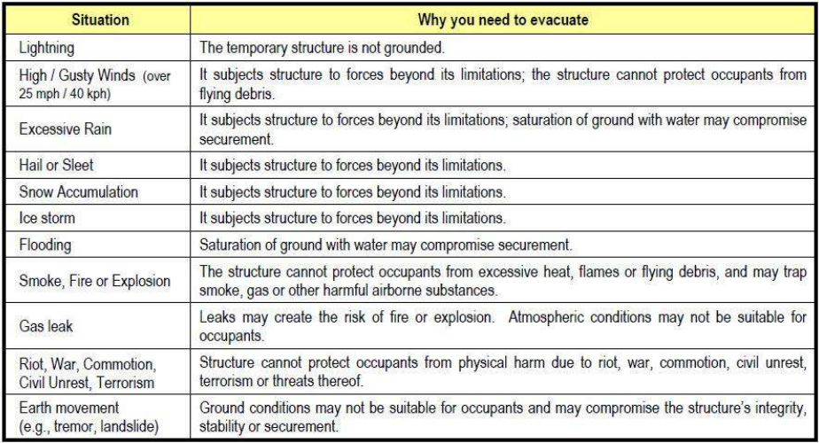

- Emergency Shelter:
  - Work with your point person(s) to determine where guests will seek shelter if necessary: Lessee should create its own unique evacuation plan to suit its specific needs.
    - Identify a nearby permanent building large enough to accommodate your guests, or if no such building is available, another form of reasonably sufficient shelter or other location recommended by the National Weather Service or Emergency Alert System to serve as an emergency shelter.
    - Make sure the building will be open and accessible during your event.
    - Determine how guests will get there (e.g., the route to take, travel by foot or car, etc.).
    - Make a note of the building’s address in case you have to call for emergency assistance.

- Communication:
  - Make sure you have telephone and other methods of communication in the event of injuries. Pre-program emergency numbers in your mobile phone so you can act quickly to call police and/or emergency response personnel if necessary. Depending on the size of your event, backup communications may be needed in situations where there is no electrical power, cell phone signals are interrupted, etc.

- Your Designated Point Person(s) Will be Responsible for:
  - Monitoring a weather source (such as the National Weather Service) two or more hours before your event begins, checking specifically for SEVERE WEATHER ALERTS.
  - Deciding whether or not to proceed with the event under the tent(s) based on that information.
  - Checking each tent structure for any changes since installation (for example, stakes pulling out of the ground, loose poles, ropes or straps etc.).
- DURING YOUR EVENT:
  - Monitor the weather, and implement your EVACUATION PLAN IF ANY ONE OR MORE OF THE FOLLOWING OCCUR(S):
  - Severe Weather Alert: If a Severe Weather Alert is posted by the National Weather Service.
  - Lightning Strike: If lightning strikes within 1 mile (count of less than 5 seconds between lighting and thunder).
  - Threatening Weather: Dark clouds are approaching. High Winds: High winds causing large trees to sway or leaves to be ripped off trees (typically, winds in excess of 25 mph / 40 kph).
  - Smoke, Fire or Explosion.
  - Heavy Precipitation: Heavy rain, hail, sleet, snow or ice begins falling or accumulating on the tent(s) (e.g., rain falling so hard that it runs off the tent walls in sheets, snow piling up on the top(s) of the tent(s), etc.).
  - Flooding: Water running through the tent or surrounding area.
  - Gas leak.
  - Anchoring Failure: Any of the tent anchoring devices fail(s) or the tent, any pole(s) or wall(s) begin(s) to move, tilt or bend.

- IF A DECISION IS MADE TO EVACUATE YOU MUST:
  - Make a Public Announcement: Announce immediately that there is a weather or other emergency and that it is unsafe to stay under the tent. Tell your guests that they must leave the tent without delay and take shelter in the location(s) you’ve chosen as emergency shelters.
  - Render Assistance: Assist your guests along the evacuation route to the emergency shelter.
FOLLOWING AN EVACUATION:
After an evacuation, even if the tent(s) or other temporary structure(s) appear(s) to be intact, it/they may not be safe to re-enter. For example, one or more stakes may have been pulled out of the ground or there may be loose poles, ropes or straps. Contact S&T Party Rentals so we can inspect each structure BEFORE you permit anyone to reenter and/or resume your event.
I, the undersigned, have been informed of my responsibility to have an emergency evacuation plan and of the need to be prepared to carry out this plan in case of a weather-related or other emergency.

Signature of Customer/Lessee/Authorized Signatory

_____________________________________________ Date: __________________________

