NVGMS PILLAICHAVADY, PUDUCHERRY
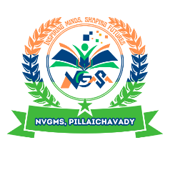
MONTHLY
Syllabus
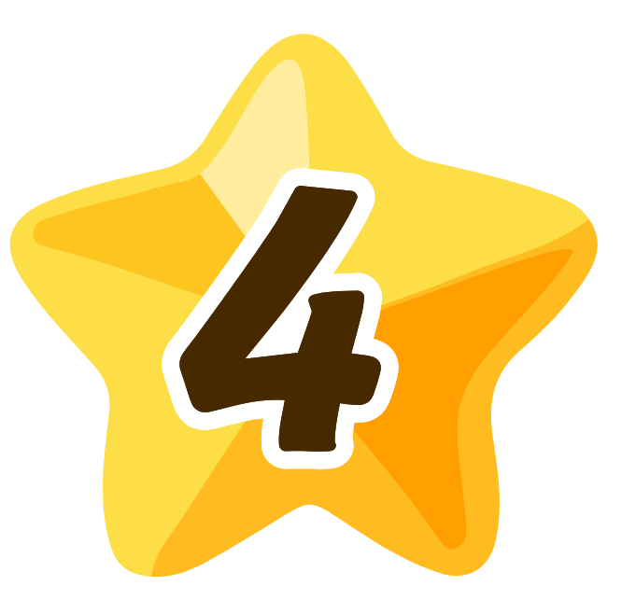
IV Standard

NVGMS PILLAICHAVADY, PUDUCHERRY
MONTHLY SYLLABUS - APRIL 2025
Subject | Topic Of The Lesson | Signature of the Subject Teacher
தமிழ் | - அன்னைத் தமிழே!  - பனைமரச் சிறப்பு
ENGLISH | Unit :1 My Land  Chapter 1 – Together We can
MATHS | - Shapes Around Us
EVS | Unit :1 Our Community  Chapter 1 – Living Together

Signature of the Head of the Institution Signature of the Class Teacher

NVGMS PILLAICHAVADY, PUDUCHERRY
MONTHLY SYLLABUS - JUNE 2025
Subject | Topic Of The Lesson | Signature of the Subject Teacher
தமிழ் | - யார் தலைவர்?  - முளைப்பாரி – பாடல்
ENGLISH | Unit :1 My Land  Chapter 2 – The Tinkling Bells
MATHS | - Hide and Seek
EVS | Unit :1 Our Community  Chapter 2 – Exploring Our Neighbourhood

Signature of the Head of the Institution Signature of the Class Teacher

NVGMS PILLAICHAVADY, PUDUCHERRY
MONTHLY SYLLABUS - JULY 2025
Subject | Topic Of The Lesson | Signature of the Subject Teacher
தமிழ் | - விடியும் வேலை  - கரிகாலன் கட்டிய கல்லணை
ENGLISH | Unit :1 My Land  Chapter 3 – Be Smart, Be Safe
MATHS | - Pattern Around Us  - Thousands Around Us
EVS | Unit :2 Life Around Us  Chapter 3 – Nature Trail

Signature of the Head of the Institution Signature of the Class Teacher

NVGMS PILLAICHAVADY, PUDUCHERRY
MONTHLY SYLLABUS - AUGUST 2025
Subject | Topic Of The Lesson | Signature of the Subject Teacher
தமிழ் | - வெற்றி வேற்கை  - காவல்காரர்
ENGLISH | Unit :2 My Beautiful World  Chapter 4 – One Thing at a Time
MATHS | - Sharing and Measuring
EVS | Unit :2 Life Around Us  Chapter 4 – Growing up with Nature

Signature of the Head of the Institution Signature of the Class Teacher

NVGMS PILLAICHAVADY, PUDUCHERRY
MONTHLY SYLLABUS - SEPTEMBER 2025
Subject | Topic Of The Lesson | Signature of the Subject Teacher
தமிழ் | - யானையும் பானையும்  - பனிமலை பயணம்  - உள்ளங்கையில் ஓர் உலகம்
ENGLISH | Unit :2 My Beautiful World  Chapter 5 – The Old Stag
MATHS | - Measuring Length  - The cleanest Village
EVS | Unit :3 Health and Well-being  Chapter 5 – Food for Health

Signature of the Head of the Institution Signature of the Class Teacher

NVGMS PILLAICHAVADY, PUDUCHERRY
MONTHLY SYLLABUS - OCTOBER 2025
Subject | Topic Of The Lesson | Signature of the Subject Teacher
தமிழ் | - எழில் கொஞ்சும் அருவி  - அன்பின் வழி
ENGLISH | Unit :2 My Beautiful World  Chapter 6 – Braille
MATHS | - Weigh it, Pour it
EVS | Unit :3 Health and Well-being  Chapter 6 – Happy and Healthy Living

Signature of the Head of the Institution Signature of the Class Teacher

NVGMS PILLAICHAVADY, PUDUCHERRY
MONTHLY SYLLABUS - NOVEMBER 2025
Subject | Topic Of The Lesson | Signature of the Subject Teacher
தமிழ் | - நன்னெறி  - உலாவரும் செயற்கைக்கோள்
ENGLISH | Unit :3 Fun with Games  Chapter 7 – Fit Body, Fit Mind, Fit Nation
MATHS | 9. Equal Groups
EVS | Unit :4 Things Around Us  Chapter 7 – How Things Work

Signature of the Head of the Institution Signature of the Class Teacher

NVGMS PILLAICHAVADY, PUDUCHERRY
MONTHLY SYLLABUS - DECEMBER 2025
Subject | Topic Of The Lesson | Signature of the Subject Teacher
தமிழ் | - மாசு இல்லா உலகம்  - காட்டுக்குள்ளே பாட்டுப்போட்டி
ENGLISH | Unit :3 Fun with Games  Chapter 8 – The Lagori Champions
MATHS | 10. Elephants, Tigers, and Leopards
EVS | Unit :4 Things Around Us  Chapter 8 – How Things are Made

Signature of the Head of the Institution Signature of the Class Teacher

NVGMS PILLAICHAVADY, PUDUCHERRY
MONTHLY SYLLABUS - JANUARY 2026
Subject | Topic Of The Lesson | Signature of the Subject Teacher
தமிழ் | - இனிமை நிறைந்த பூமி  - மலையும் எதிரொலியும்
ENGLISH | Unit :3 Fun with Games  Chapter 9 - Hekko
MATHS | 11. Fun with Symmetry  12. Ticking Clocks and Turning Calendar
EVS | Unit :5 Our Environment  Chapter 9 – Different Lands, Different  Lives

Signature of the Head of the Institution Signature of the Class Teacher

NVGMS PILLAICHAVADY, PUDUCHERRY
MONTHLY SYLLABUS - FEBRUARY 2026
Subject | Topic Of The Lesson | Signature of the Subject Teacher
தமிழ் | - திருக்குறள் கதைகள்  - விளையாட்டு விழா
ENGLISH | Unit :4 Up High  Chapter 10 – The Swing  Unit :4 Up High  Chapter 11 – A Journey to the Magical Mountains
MATHS | 13. The Transport Museum
EVS | Unit :5 Our Environment  Chapter 10 – Our Sky

Signature of the Head of the Institution Signature of the Class Teacher

NVGMS PILLAICHAVADY, PUDUCHERRY
MONTHLY SYLLABUS - MARCH 2026
Subject | Topic Of The Lesson | Signature of the Subject Teacher
தமிழ் | - கல்வி அழகே அழகு  மீள்பார்வை
ENGLISH | Unit :4 Up High  Chapter 12 – Maheshwar
MATHS | 14. Data Handling
EVS | REVISION

Signature of the Head of the Institution Signature of the Class Teacher

NVGMS PILLAICHAVADY, PUDUCHERRY

Annual
Syllabus
IV Standard

NVGMS PILLAICHAVADY, PUDUCHERRY
ANNUAL SYLLABUS - 2025 - 26
CLASS : IV SUBJECT: தமிழ்

மாதம் | பாடத்தலைப்பு
ஏப்ரல் | - அன்னைத் தமிழே!  - பனைமரச் சிறப்பு
ஜுன் | - யார் தலைவர்?  - முளைப்பாரி – பாடல்
ஜுலை | - விடியும் வேலை  - கரிகாலன் கட்டிய கல்லணை
ஆகஸ்ட் | - வெற்றி வேற்கை  - காவல்காரர்
செப்டம்பர் | - யானையும் பானையும்  - பனிமலை பயணம்  - உள்ளங்கையில் ஓர் உலகம்
அக்டோபர் | - எழில் கொஞ்சும் அருவி  - அன்பின் வழி
நவம்பர் | - நன்னெறி  - உலாவரும் செயற்கைக்கோள்
டிசம்பர் | - மாசு இல்லா உலகம்  - காட்டுக்குள்ளே பாட்டுப்போட்டி
ஜனவரி | - இனிமை நிறைந்த பூமி  - மலையும் எதிரொலியும்
பிப்ரவரி | - திருக்குறள் கதைகள்  - விளையாட்டு விழா
மார்ச் | - கல்வி அழகே அழகு  மீள்பார்வை

Signature of the Head of the Institution Signature of the Class Teacher
NVGMS PILLAICHAVADY, PUDUCHERRY
ANNUAL SYLLABUS - 2025 - 26
CLASS : IV SUBJECT: English

MONTH | CONTENT
APRIL | Unit :1 My Land  1. Together We can
JUNE | Unit :1 My Land  2. The Tinkling Bells
JULY | Unit :1 My Land  3. Be Smart, Be Safe
AUGUST | Unit :2 My Beautiful World  4. One Thing at a Time
SEPTEMBER | Unit :2 My Beautiful World  5. The Old Stag
OCTOBER | Unit :2 My Beautiful World - 6. Braille
NOVEMBER | Unit 3: Fun with Games - 7. Fit Body, Fit Mind, Fit Nation
DECEMBER | Unit 3: Fun with Games  8. The Lagori Champions
JANUARY | Unit 3: Fun with Games  9. Hekko
FEBRUARY | Unit 4: Up High  10. The Swing  Unit 4: Up High  11. A Journey to the Magical Mountains
MARCH | Unit 4: Up High  12. Maheshwar

Signature of the Head of the Institution Signature of the Class Teacher
NVGMS PILLAICHAVADY, PUDUCHERRY
ANNUAL SYLLABUS - 2025 - 26

CLASS : IV SUBJECT: Maths

MONTH | CONTENT
APRIL | Chapter 1 : Shapes Around Us
JUNE | Chapter 2 : Hide and Seek
JULY | Chapter 3 : Pattern Around Us  Chapter 4 : Thousands Around Us
AUGUST | Chapter 5 : Sharing and Measuring
SEPTEMBER | Chapter 6 : Measuring Length  Chapter 7 : The Cleanest Village
OCTOBER | Chapter 8 : Weigh it, Pour it
NOVEMBER | Chapter 9 : Equal Groups
DECEMBER | Chapter 10 : Elephants, Tigers and Leopards
JANUARY | Chapter 11 : Fun with Symmetry  Chapter 12 : Ticking Clocks and Turning Calendar
FEBRUARY | Chapter 13 : The Transport Museum
MARCH | Chapter 14 : Data Handling

Signature of the Head of the Institution Signature of the Class Teacher
NVGMS PILLAICHAVADY, PUDUCHERRY
ANNUAL SYLLABUS - 2025 - 26

CLASS : IV SUBJECT: EVS

MONTH | CONTENT
APRIL | Unit 1: Our Community  Chapter 1: Living Together
JUNE | Unit 1: Our Community  Chapter 2: Exploring Our Neighbourhood
JULY | Unit 2: Life Around Us  Chapter 3: Nature Trail
AUGUST | Unit 2: Life Around Us  Chapter 4: Growing up with Nature
SEPTEMBER | Unit 3: Health and Well-being  Chapter 5: Food for Health
OCTOBER | Unit 3: Health and Well-being  Chapter 6: Happy and Healthy Living
NOVEMBER | Unit 4: Things Around Us  Chapter 7: How Things Work
DECEMBER | Unit 4: Things Around Us  Chapter 8: How Things are Made
JANUARY | Unit 5: Our Environment  Chapter 9: Different Lands, Different Lives
FEBRUARY | Unit 5: Our Environment  Chapter 10: Our Sky
MARCH | REVISION

Signature of the Head of the Institution Signature of the Class Teacher

