Company No 10423466

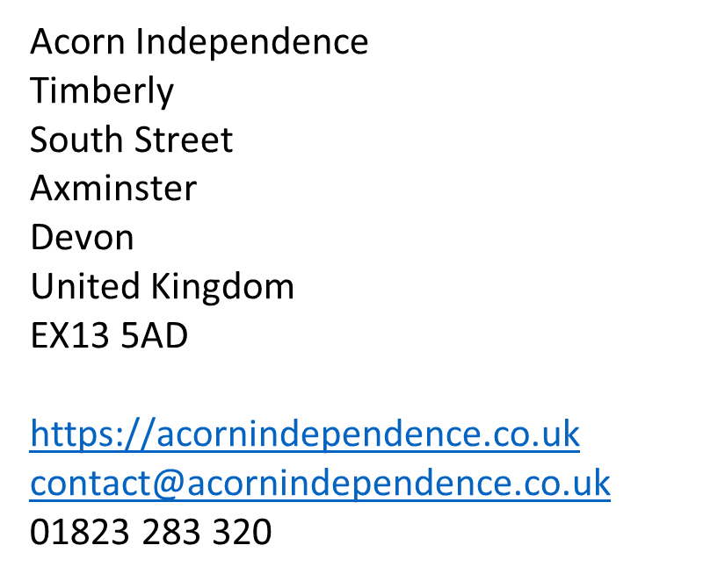

Applicant Application Form

|  |  |  |  |  |  |  |  |  |  |  |  |  |  |  |  |  |  |  |  |  |
| --- | --- | --- | --- | --- | --- | --- | --- | --- | --- | --- | --- | --- | --- | --- | --- | --- | --- | --- | --- | --- |
| Applicant Information | | | | | | | | | | | | | | | | | | | | |
| Full Name: | | |  | | | | | | | | | | | | | | | | | |
| Maiden Name (if applicable): | | | |  | | | | | | | | Date: | | |  | | | | | |
| Address (including postcode): | | | |  | | | | | | | | | | | | | | | | |
|  | | | | | | | | | | | | | | | | | | | | |
| Home Phone: | |  | | | | | | | | | E-mail Address: | | |  | | | | | | |
| Mobile Phone: | |  | | | | | | | | | Date of Birth: | | |  | | | | | | |
| Date Available: | | |  | | | | | | | | National Insurance No: | | | | |  | | | | |
| Position Applied for: | | |  | | | | | | | | | | | | | | | | | |
| Are you a citizen of the United Kingdom? | | | | | | |  | |  | If no, are you authorised to work in the U.K.? | | | | | | | | | YES | NO |
| Do you hold a Full UK Driving License? | | | | | | YES | NO | | Any Endorsements?  If Yes please detail: | | |  | | | | | | | | |
| Previous Employment - Starting with current or most recent employer | | | | | | | | | | | | | | | | | | | | |
| Please ensure dates of employment are completed in the following format (DD/MM/YYYY) | | | | | | From: | |  | | | | | To: | | | |  | | | |
| Company: |  | | | | | | | | | | | | Phone: | | | | |  | | |
| Address: |  | | | | | | | | | | | | Reporting to: | | | | |  | | |
| Job Title: |  | | | | | | | | | | | | Current salary: | | | | |  | | |
| Main Responsibilities: | | | | | | | | | | | | | | | | | | | | |
|  | | | | | | | | | | | | | | | | | | | | |
| Reason for Leaving: | | | | |  | | | | | | | | | | | | | | | |
| Notice required: | | | | |  | | | | | | | | | | | | | | | |
| Reason for gap in employment (if applicable): | | | | |  | | | | | | | | | | | | | | | |

|  |  |  |  |  |  |  |
| --- | --- | --- | --- | --- | --- | --- |
| **Please give details of all previous employment since leaving education and account for any period of unemployment, to include periods of travelling, maternity leave. If more space is needed please continue on the continuation sheet.** | | | | | | |
| Please ensure dates of employment are completed in the following format (DD/MM/YYYY) | | | From: |  | To: |  |
| Company: |  | | | | Phone: |  |
| Address: |  | | | | | |
| Job Title: |  | | | | | |
| Responsibilities: |  | | | | | |
| Reason for Leaving: | |  | | | | |
| Reason for gap in employment: (if applicable) | |  | | | | |
|  | | | | | | |
| Please ensure dates of employment are completed in the following format (DD/MM/YYYY) | | | From: |  | To: |  |
| Company: |  | | | | Phone: |  |
| Address: |  | | | | | |
| Job Title: |  | | | | | |
| Responsibilities: |  | | | | | |
| Reason for Leaving: | |  | | | | |
| Reason for gap in employment: (if applicable) | |  | | | | |
|  | | | | | | |
| Please ensure dates of employment are completed in the following format (DD/MM/YYYY) | | | From: |  | To: |  |
| Company: |  | | | | Phone: |  |
| Address: |  | | | | | |
| Job Title: |  | | | | | |
| Responsibilities: |  | | | | | |
| Reason for Leaving: | |  | | | | |
| Reason for gap in employment: (if applicable) | |  | | | | |
|  | | | | | | |
| Please ensure dates of employment are completed in the following format (DD/MM/YYYY) | | | From: |  | To: |  |
| Company: |  | | | | Phone: |  |
| Address: |  | | | | | |
| Job Title: |  | | | | | |
| Responsibilities: |  | | | | | |
| Reason for Leaving: | |  | | | | |
| Reason for gap in employment: (if applicable) | |  | | | | |
|  | | | | | | |
| Please ensure dates of employment are completed in the following format (DD/MM/YYYY) | | | From: |  | To: |  |
| Company: |  | | | | Phone: |  |
| Address: |  | | | | | |
| Job Title: |  | | | | | |
| Responsibilities: |  | | | | | |
| Reason for Leaving: | |  | | | | |
| Reason for gap in employment: (if applicable) | |  | | | | |
|  | | | | | | |
| Please ensure dates of employment are completed in the following format (DD/MM/YYYY) | | | From: |  | To: |  |
| Company: |  | | | | Phone: |  |
| Address: |  | | | | | |
| Job Title: |  | | | | | |
| Responsibilities: |  | | | | | |
| Reason for Leaving: | |  | | | | |
| Reason for gap in employment: (if applicable) | |  | | | | |
|  | | | | | | |

|  |  |  |  |
| --- | --- | --- | --- |
| **Education** | | | |
| Please give details of all academic (including secondary school), professional or technical qualifications held by you, giving the dates and the name and address of the place obtained. If more space is needed please continue on a the continuation sheet. | | | |
| Qualification | Date obtained | Mark/Grade | Name and address of place obtained |
|  |  |  |  |
|  |  |  |  |
|  |  |  |  |

|  |
| --- |
| **Please give details of your reasons for applying for this post:** |
|  |
| **Please give details of your experiences, abilities and attitudes that make you suitable for this post:** |
|  |
| **Please give details of your hobbies and interests:** |
|  |

|  |  |  |  |  |  |  |  |  |  |
| --- | --- | --- | --- | --- | --- | --- | --- | --- | --- |
| **References** | | | | | | | | | |
| Please provide us with the details of your referees. They will be asked to provide information about your ability to carry out the job. At least one should be your present employer (last employer if unemployed, school or college, if a student). | | | | | | | | | |
| Please note if you have ever undertaken similar work or worked with groups or individuals that may be deemed vulnerable we will need to approach any of your past employers for a reference and/or verification of the reasons for period of employment ending. | | | | | | | | | |
| **Referee 1 – Current/Most Recent Employer** | | | | | | | | | |
| Name: | | |  | | | Company: |  | | |
| Address: | | |  | | | | | | |
| Email: |  | | | | | | | Phone No: |  |
| In what capacity do you know the above? | | | | |  | | | | |
| Can they be contacted if offered an interview? | | | | |  | | | | |
| **Referee 2** | | | | | | | | | |
| Name: | | |  | | | Company: |  | | |
| Address: | | |  | | | | | | |
| Email: |  | | | | | | | Phone No: |  |
| In what capacity do you know the above? | | | | |  | | | | |
| Can they be contacted if offered an interview? | | | | |  | | | | |
| **Character Referee – A professional you have known for over 5 years** | | | | | | | | | |
| Name: | | |  | | | Company: |  | | |
| Address: | | |  | | | | | | |
| Email: |  | | | | | | | Phone No: |  |
| In what capacity do you know the above? | | | | |  | | | | |
| Can they be contacted if offered an interview? | | | | |  | | | | |
| **Additional Referees – Please list all additional referees where you have worked with children, young people and vulnerable adults** | | | | | | | | | |
| Name: | | |  | | | Company: |  | | |
| Address: | |  | | | | | | | |
| Email: |  | | | | | | | Phone No: |  |
| In what capacity do you know the above? | | | | |  | | | | |
| Can they be contacted if offered an interview? | | | | |  |  | | | |
|  | | | | |  |  | | | |
| Name: | | |  | | | Company: |  | | |
| Address: | |  | | | | | | | |
| Email: |  | | | | | | | Phone No: |  |
| In what capacity do you know the above? | | | | |  | | | | |
| Can they be contacted if offered an interview? | | | | |  | | | | |
|  | | | | |  |  | | | |
| Name: | | |  | | | Company: |  | | |
| Address: | |  | | | | | | | |
| Email: |  | | | | | | | Phone No: |  |
| In what capacity do you know the above? | | | | |  | | | | |
| Can they be contacted if offered an interview? | | | | |  | | | | |
|  | | | | |  |  | | | |
| Name: | | |  | | | Company: |  | | |
| Address: | |  | | | | | | | |
| Email: |  | | | | | | | Phone No: |  |
| In what capacity do you know the above? | | | | |  | | | | |
| Can they be contacted if offered an interview? | | | |  | | | | | |
|  | | | | |  |  | | | |
| Name: | | |  | | | Company: |  | | |
| Address: | |  | | | | | | | |
| Email: |  | | | | | | | Phone No: |  |
| In what capacity do you know the above? | | | | |  | | | | |
| Can they be contacted if offered an interview? | | | | |  | | | | |
|  | | | | |  |  | | | |

|  |  |  |  |
| --- | --- | --- | --- |
| **Disability** | | | |
| Do you consider that you have a disability as defined by the Disability Discrimination Act 1995 which has a substantial and long term adverse effect on your ability to carry out normal day to day activities? | | Yes/No |  |
| If yes please give brief details of the disability: |  | | |

|  |  |  |  |
| --- | --- | --- | --- |
| **Absence** | | | |
| Do you have any medical issues that could impact on your ability to do the job? | | Yes/No |  |
| If yes please give brief details: |  | | |

|  |  |
| --- | --- |
| **Rehabilitation of Offenders Act 1974 – Notice to Offenders** | |
| This post is exempt from the provisions of Section 4(2) of the Rehabilitation of Offenders Act 1974. Due to the nature of the establishment, your entitlement to withhold information which, for other purposes is ‘spent’ does not apply and should be declared unless otherwise “protected” from disclosure under the Rehabilitation of Offenders Act 1974 (Exceptions) Order 1975 (as amended in 2013). Please detail any convictions below. Failure to disclose convictions may lead to dismissal. Any disclosures will be treated in the strictest confidence and will be considered only in relation to this application. | |
| Do you have any criminal convictions? | Yes/No |
| If yes, please give detail in an email to [imogengould@acornindependence.co.uk](mailto:imogengould@acornindependence.co.uk).  These details will be checked with the police as the post involves working directly with children. | |

|  |  |  |  |
| --- | --- | --- | --- |
| **Disciplinary Procedures** | | | |
| Have you ever been subject to a disciplinary procedure or gross misconduct within your past/current employment? | | Yes/No |  |
| If yes please give brief details: |  | | |

|  |
| --- |
| **Disclosure and Barring Service (formally CRB)** |
| Any person who is offered employment with us will be required to complete and lodge with us a DBS Application Form before starting work and will be made aware of the DBS Code of Practice. They will have to then ensure the DBS is added to, and remains on, the update service. |

|  |  |
| --- | --- |
| **Declaration:** | |
| I declare that to the best of my knowledge the information given in this application is correct. I understand that any false or inaccurate information will invalidate my application and if I become employed may result in my dismissal. I understand that Acorn Independence will approach any of your employers for a reference and/or verification of the reasons for period of employment ending. | |
| Applicant Name: |  |
| Signature of Applicant: |  |
| Date (DD/MM/YYYY): |  |
|  |  |
|  |  |
| **Please send your completed Applicant Application Form to:** [**contact@acornindependence.co.uk**](mailto:contact@acornindependence.co.uk) | |