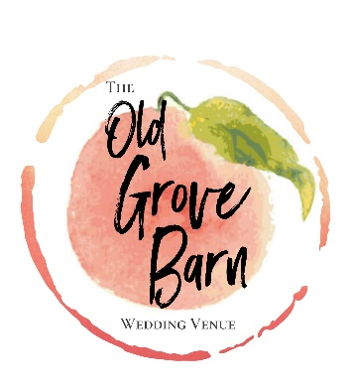
RECEPTION RENTAL INCLUSIONS
- Reception seating for up to 225 guests
- 12 - 60” round tables- seats 8-9
- 12 - 9’X32” Farmhouse tables- seats 10
- Slimline head tables for Bridal party with white linens and skirting (white or ruffled burlap)
- 6’X30” catering tables (2) and linens for buffet
- 6 High Top Laminate Tables for Cocktail Hour (Linens rented separately)
- Antique table for Cake display
- Misc. rustic furniture
- Battery operated PA system
  - Blue tooth enabled/ Usb and sd card compatible
  - Two wireless mics – one handheld and one headset or lapel
- Dimmable barn lighting
- Handicap accessible climate controlled bathrooms for men and women
- 40X60 pavilion on NORTH side of dance hall for dinner seating
  - Great location for dinner seating
  - Custom Clear sides for climate control
- Catering work station including
  - Warming oven
  - Refrigerator (holds 5 large bags of ice)
  - Freezer (holds 7 bags of ice)
  - Microwave
- Antique Bar including:
  - 4 Tap Kegerator (holds two ½ barrels and two slim quarter barrel at same time)
  - Taps and wine and bottle openers
  - Antique Mantel and fireplace
  - Wine Fridge ( holds 15 regular size or 9 large)
  - Standing cooler for ice
  - Antique wash tubs for drinks
  - Two large rubber look alike barrel for icing additional kegs
- Outdoor spaces
  - Lighted Landscap
  - Large grass area for games
    - Giant Jenga
    - Yard Yahtzee
    - Cornhole
  - Fire Pit for Bonfires
    - Preapproval and adult supervision required
  - Lighted parking
  - Set up and tear down of tables and chairs
  - Staff on site for event
  - Property is professionally sprayed for Mosquitos and Tick
Complimentary Décor Items:

Cupcake Stands
Whiskey Barrels
Lanterns – white (12)
Bird cage Lanterns (Dark Brown) 18 count
Screen door photo displays
Burlap table runners
Lace Table Runners
Round Wood Slices
Wooden Boxes (holds two pint size regular mouth canning jars)
Shephard Hooks
Table number Markers (several varieties
Numerous Vintage Plant Stands for Mini Desserts or Cupcakes
Small Glass Votive holders (120 count)
White Draping for Ceremony Arch
Clear Glass Vodka Bottles and Kombucha Bottles (48 each)
Large lot of signage – please let us know what type of sign you need (we probably have it or can create)
Flower girl baskets
Ring bearer pillow
Faux greenery in baby seeded eucalyptus, silver dollar eucalyptus, and lambs ear
Faux flower arch piece

