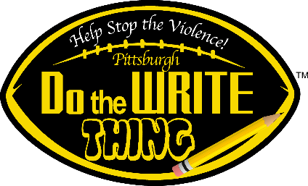

"Do the Write Thing Challenge”

COVER SHEET

and

STUDENT AND PARENT/GUARDIAN CONSENT FORM

**Please Type (Preferred) or Print Legibly in Black or Blue Ink**

Thank you for participating in the **Pittsburgh** “**Do the Write Thing Challenge**.” To have your entry considered for selection as a Student National Ambassador, you and a parent or guardian must complete this Cover Sheet and sign the Student and Parent/Guardian Consent Statement below.

**Students’ First Name**: _______________________  **Last Name**___________________________________________

**School**: ___________________________________________ **School’s Phone #**: ( ) ________ -_____________

**Grade**: ________ **Parent’s Full Name**: ____________________________________________________________

**Student’s Home Address**: ________________________________________________________________

**City, State & Zip**: ________________________________________________________________________

**Parent’s Phone Number**: ( ) ________ - ___________ **Student’s Sex**: **M _________ F_________**

**Student’s T-shirt size (Circle One)**: Small Medium Large X-Large

**Teacher’s Full Name**: _____________________________________________________________________

**Teacher’s Phone Number**: ( ) ________ - __________ **Email**:______________________________________

**STUDENT AND PARENT/GUARDIAN CONSENT STATEMENT**

The National Campaign to Stop Violence (NCSV), which sponsors the “Do the Write Thing Challenge,” will publish selected students writings and quotations in a book and in a discussion paper on youth violence. Before publishing your writing, the NCSV requires your written consent and the written consent of a parent or guardian. If you and your parent or guardian agree to permit the NCSV to publish your writing, please sign the statement following: We agree to give ownership of the attached student writing to the National Campaign to Stop Violence so that it can be considered for recognition and published. The NCSV may further disclose the writing to the media and other parties as part of their national program.

_____________________________________ _________________________________________

Student’s Signature Date Parent’s Signature Date

_____________________________________________ ________________________________________________

Student’s Email Address Parent’s Email Address

FOLLOW US ONLINE:

  

/DtWTchallenge @DtWTChallenge @DtWTChallenge