GWX POLYCARBONATE SOLID SHEETS

# FEATURES OF PRODUCTS Light Transmission

fine light Transmission (88%).no yellowing .atomization and poor light transmission will occur on boards exposed under sunshine.

# UV-Protection

with an ultraviolet coextruded fim on the sunshine,it can preventthe resin fatigue oryellowing caused by the ultravio:rt, and ttcnsfer it into the visible light,it has the fine stabilizsingeffect for the plant photosynthesis(it isextremeiy applicable for protecting the valuable works of art items on display),

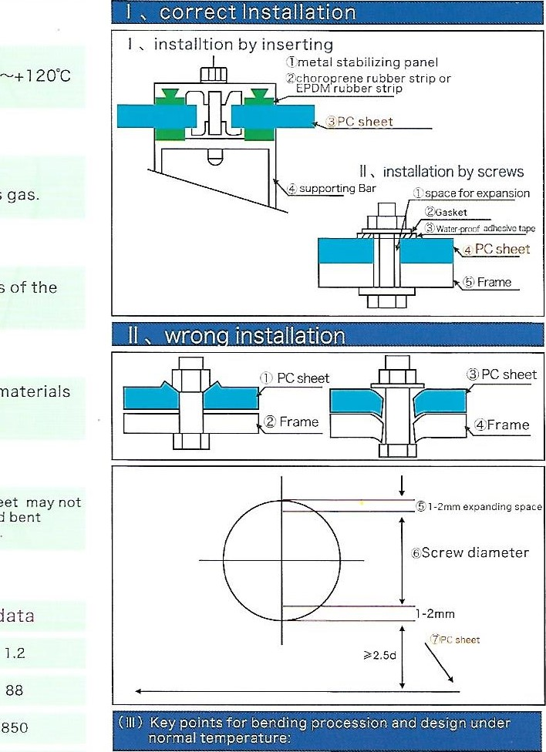

data

Weather Ability

no deformation within the temperature of-40 C

# Fire Retardancy

fire retardant grade Bl audited by the national GB8624-97test,without fire drop nor poisonous gas.

# Impact resistance

the impact strength of pc sheet is 250-300times of the ordinary glass.

# Sound insulation

with good sound insulation effect,it is the best materials recog nized worldwide for sound insulation on expressways

# Portability

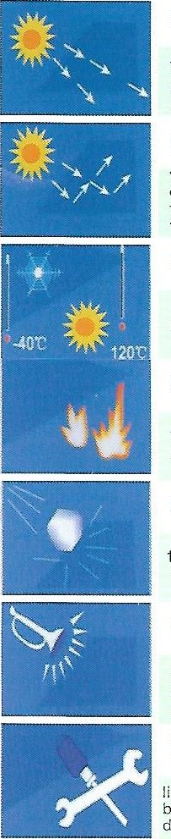light in weight,it is easy to handle and make drills ,the sheet may not break easily during the installation by cutting,and be cold bent directly,it is convenient for construction and processing

Installation instructions:

PC sheet do not contact the surface of cement walls.

1. Clean the frame so as to keep smooth of notch.
2. Use the appropriate sheet thickness which allow enough curvature radius
3. Allow enough space for the expansion of panel, At least

30mm distance between screw hole and the panel's edge 5. Use the neutral silicone, don't use PVC stripes.

6. Use the dynamoelectric cutting tool, (Tungsten carbide makes sure the panel is stable to avoid its shaking. Forbid tear away the film on the surface before cutting.

installation of PC Sheet and Embossed sheet

|  |
| --- |
| Curvature radius>1 thickness mm)  Allowable range for bending 80s Curvature principle of PC panels:Bending procession are prohibited unless its Length *its width |

(IV) No screwsshould be fixed on the bending part,

|  |
| --- |
| No screws should be fixed the part marked in red  width (W) |

Charateristics unit

Specific Gravity G/cm3

Light Transmission

Impact Strength

|  |  |  |
| --- | --- | --- |
| Flexural Strength | N/mm2 | 100 |
| Tensile Strength | N/mm2 |  |
| Modulus of Elasticity | M pa | 2400 |
| Tensile Stress at Break | Mpa | > 65 |
| Elongation at Break |  | >100 |
| Specific Heat | KJ/Kg.k | 1.17 |
| Heat Conductivity | W/m.K | 0.2 |
| Heat Deflection Temperature | •c | 135 |
| Coefficient of Thermal Expansion | mm/ m'C | 0 067 |
| Range of Temperatuer | •c | -40-+120 |
| Effect of Soundproof | 4.5mm PC sheet | reduce 20 db |