📚 Teacher’s Guide for The Whole Enchilada Cookbook: Exploring Mexican Culture Through Food & History

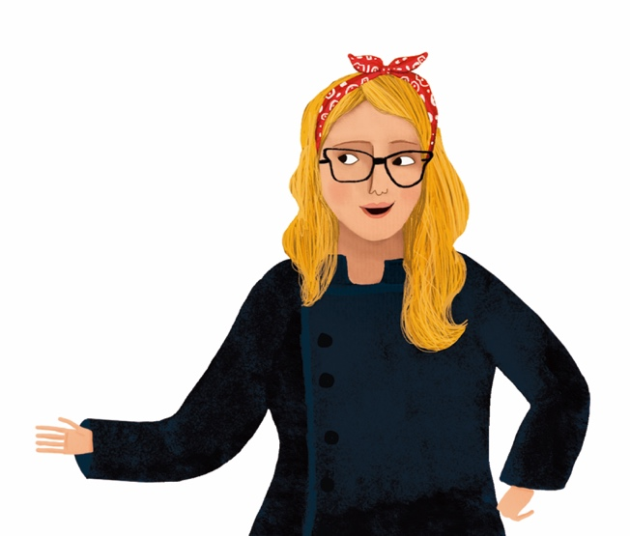
✨ Book Overview
This middle-grade cookbook invites students to explore Mexican culture through vibrant, kid-friendly recipes and biographies. Alongside each dish, young readers learn about key historical figures and cultural milestones—celebrating identity, community, and resilience.

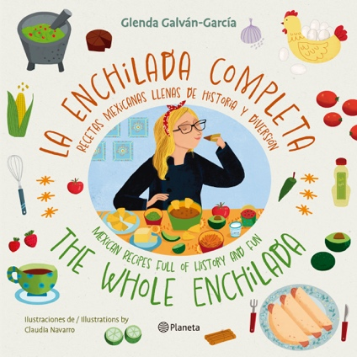
🌟 Learning Objectives
Students will:
- Understand the role of food in cultural identity and storytelling.
- Explore the contributions of key Mexican and Chicano figures.
- Make connections between history, science, and everyday life.
- Practice basic cooking skills and kitchen safety.
- Develop empathy, cultural pride, and curiosity.

📘 Table of Key Themes
Theme | Topics & Figures
Indigenous Heritage | The Mayan People, traditional ingredients, respect for the Earth. The Olmec invention of vulcanization.
Science & Innovation | Mario Molina, Adhara Pérez
Youth Empowerment & Activism | Sylvia Mendez, Xiuhtezcatl Martinez, Adhara Pérez
Latine Representation | Sofia Huerta (sports), Sylvia Mendez (education), cultural pride
Cultural Identity | Food traditions, language, family history
Life Skills | Cooking techniques, teamwork, creativity, responsibility

🗂️ Unit-by-Unit Breakdown

🗺️ Unit 1: Roots and Resilience — The Mayan and Olmec People
Reading Focus: The history and contributions of the Mayan and Olmec civilizations—astronomy, concept of zero, farming, vulcanization and food.
Cooking Activity: Fresh corn tortillas and guacamole en molcajete
Discussion Prompts:
- How do Mayan agricultural practices still influence Mexican cuisine?
- What does "ancestral knowledge" mean?
- Why is corn considered sacred?
- What impact did vulcanization (making of rubber) have on the world?
Extension Activity: Make a glyph or draw a food-based codex inspired by Mayan imagery.

🔬 Unit 2: Science for the Planet — Mario Molina & Adhara Pérez
Reading Focus:
- Mario Molina: Nobel-winning scientist who helped save the ozone layer.
- Adhara Pérez: Child prodigy in astrophysics and STEM advocate with autism.
Cooking Activity: Lime ceviche or citrus aguas frescas—exploring acids and chemistry in food.
Discussion Prompts:
- What role does science play in helping our communities?
- How can we create space for young people with different abilities in STEM?
- What does it mean to be a changemaker at any age?
Extension Activity: Make a “climate-safe kitchen” plan or STEM-themed recipe.

⚖️ Unit 3: Justice on the Plate — Sylvia Mendez
Reading Focus: Sylvia Mendez’s role in ending school segregation in California.
Cooking Activity: Agua de Jamaica or arroz con leche—dishes shared across communities with ingredients that traveled across the globe.
Discussion Prompts:
- Why was Sylvia’s fight for education so important?
- How does food bring people together across differences?
- What injustices still exist in education today?
Extension Activity: Create a poster advocating for equality in your school or neighborhood.

🌿 Unit 4: Youth Voices for the Earth — Xiuhtezcatl Martinez
Reading Focus: Indigenous climate activist and hip-hop artist speaking up for the planet.
Cooking Activity: Plant-based tacos or nopales salad.
Discussion Prompts:
- How does food connect us to the Earth?
- Why is protecting the planet a cultural and moral responsibility?
- What does it mean to be an Indigenous leader in the modern world?
Extension Activity: Write a letter or poem to the Earth inspired by Xiuhtezcatl’s activism.

⚽ Unit 5: Pride on the Field — Sofia Huerta
Reading Focus: Professional soccer player and proud Mexican-American representing in global sports.
Cooking Activity: Energy-packed sopes or healthy fruit paletas.
Discussion Prompts:
- What barriers do Latina athletes face?
- How can we celebrate our dual identities like Sofia does?
- What does teamwork in sports and in the kitchen have in common?
Extension Activity: Create a sport-inspired menu for a team or school celebration.

🍽️ Culinary Skills Focus by Grade Level
Grade | Skills
4–5 | Basic measuring, mixing, kitchen safety, reading recipes
6–8 | Knife skills, stovetop cooking, recipe improvisation, plating
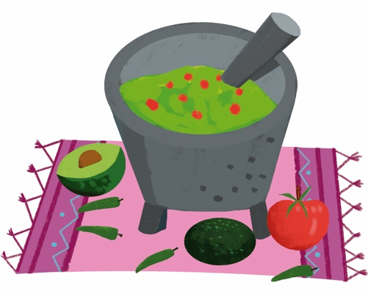

💬 Discussion & Reflection Questions
- How does food help tell the story of a people?
- What lessons can we learn from the lives of these changemakers?
- In what ways can we carry culture, pride, and kindness into the world?

💪️ Assessment Ideas
- Personal recipe reflection journals
- Illustrated biography posters or comic strips
- Present a dish inspired by one historical figure’s values
- End-of-unit “Culture and Courage” presentation combining food and story

🇲🇽 Optional Add-Ons
- Guest speaker: local activist, chef, or STEM role model
- “Culture Through Cuisine” celebration day
- Vocabulary list of Spanish culinary and cultural terms
- Visual recipe cards for ELL learners
- Holiday Celebrations: Cinco de Mayo, Hispanic Heritage Month (September), Dia Del Niño (April 30)

