Points of Contact
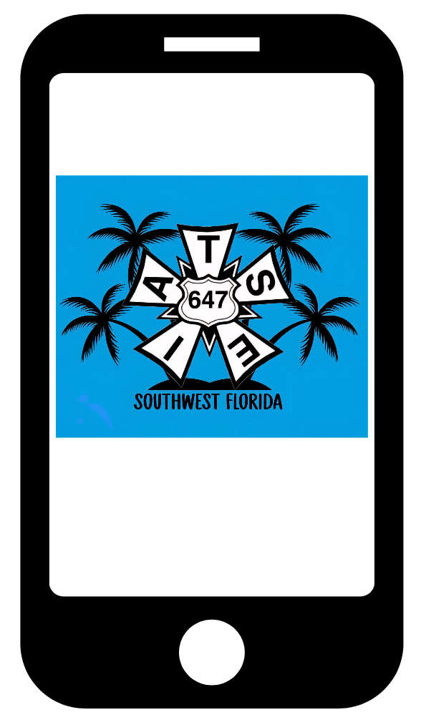 |  | If you need to speak with someone on site these are who to contact:  - Barbara B Mann  - Steward- Justin Schnitker  (239)-980-6470  - Hertz Arena  - Steward- Kasey Ellison  (941)-210-1818  - Artis-Naples  - Steward-Mick Nelson  (239)-245-1516  - Business Agent  - Pete Browning  (239)-498-9090

