|  |  |
| --- | --- |
| **Date Written: 16/8/2020** | **Reviewed: 11/01/2021** |

**SBSS Incident Report Policy and Procedures**

**Definitions:**

* **Risk** is 'The possibility of exposure to danger'
* **Dignity of risk i**s the idea that self-determination and the right to take reasonable risks are essential for dignity and self-esteem and so should not be impeded by excessively cautious caregivers, concerned about their duty of care. (Wikipedia)

**Organisational Risk Appetite:** SBSS has a zero tolerance for occupational violence, including physical, sexual or psychological harm and exploitation towards SBSS staff, participants and service users and the community. SBSS acknowledges that the specific needs of participants who access specialist behaviour support services, and the needs of SBSS as a new organisation in such as dynamic and evolving space under NDIS, requires a robust risk management approach to all aspects of services delivery. SBSS prioritise proactive risk management which focuses on processes of early assessment of dynamic risk factors, prevention-based strategies and risk management / response planning.

**SBSS Position Statement:** Given the issues of the participants that SBSS supports, the risk of harm and likelihood of incidents occurring are greater than that of general population. In the event that an incident has occurred in the delivery of SBSS supports, the following procedures outline recording of all incidents; management of incidents; resolving and reporting of incidents in order to prevent the incident from occurring again in the future

**Context:** Registered NDIS providers are required to record and manage all incidents that happen in the delivery of NDIS supports and services in their internal incident management systems and notify the NDIS Commission of reportable incidents. The following procedures and definitions ensure SBSSS compliance with the [National Disability Insurance Scheme (Incident Management and Reportable Incidents) Rules 2018](https://www.legislation.gov.au/Details/F2018L00633)

NDIS states an Incident Management System must cover:

* Acts, omissions, events or circumstances that occur in connection with providing NDIS supports or services to a person with disability and have, or could have, caused harm to the person with disability.
* Acts by a person with disability that occur in connection with providing NDIS supports or services to the person with disability and which have caused serious harm, or a risk of serious harm, to another person
* Reportable incidents that have or are alleged to have occurred in connection with providing NDIS supports or services to a person with disability.

## Reportable Incidents and the NDIS

SBSS must notify the NDIS Commission of all reportable incidents (including allegations), even where the provider has recorded and responded within their own incident management system.

For an incident to be reportable a certain act or event needs to have happened (or alleged to have happened) **in connection with the provision of supports or services by the registered NDIS provider**. This includes:

* *The death of a person with disability*
* *Serious injury of a person with disability*
* *Abuse or neglect of a person with disability*
* *Unlawful sexual or physical contact with, or assault of, a person with disability*
* *Sexual misconduct, committed against, or in the presence of, a person with disability, including grooming of the person with disability for sexual activity*
* *Unauthorised use of restrictive practices in relation to a person with disability*.

If a reportable incident raises a serious compliance issue, the NDIS Commission has powers to take regulatory action.

* Action might include requiring the provider to undertake specified remedial action, carry out an internal investigation about the incident, or engage an independent expert to investigate and report on the incident.
* The NDIS Commission can also conduct its own investigation and take appropriate enforcement action such as issuing a compliance notice or asking a court to impose a civil penalty.

When notifying the NDIS Commission of a reportable incident, SBSS must follow the set processes and provide the required information using the NDIS Commission Portal ‘My Reportable Incidents’ page to notify and manage all reportable incidents.

There are **3 key steps** to notify the NDIS Commission about reportable incidents. These are outlined below.

* 1. Submit the Immediate Notification Form via the [NDIS Commission Portal](https://www.ndiscommission.gov.au/providers/ndis-commission-portal) **within 24 hours** of key personnel becoming aware of a reportable incident or allegation.
     + The Immediate Notification Form includes a number of sections and questions, concerning details of the reportable incident, actions taken in response to the incident and the individuals involved in the incident.
     + An exception to this rule is notifying the NDIS Commission of the use of a restrictive practice that is unauthorised or not in accordance with a behavior support plan. In these instances, the provider must notify the NDIS Commission within five business days of being made aware of the incident. If however, the incident has resulted in harm to a person with disability, it must be reported within 24 hours.
     + To notify the NDIS Commission of an incident the authorised ‘Notifier’ or ‘Approver’ needs to login to the NDIS Commission Portal and select ‘My Reportable Incidents’ tile at the top of the screen. From here, you will be able to complete an Immediate Notification Form.
     + The NDIS Commission suggests the ‘**Authorised Reportable Incidents Approver**’ is the person you want to have the authority to review and be responsible for submission to the NDIS Commission. This could be the person specified in your incident management system who is responsible for reporting incidents to the NDIS Commission. The authorised ‘Approver’ will have the ability to submit new Reportable Incidents and view previous Reportable Incidents submitted by their organisation.
     + The NDIS Commission suggests the ‘**Authorised Reportable Incidents Notifier**’ is a supporting team member who can assist the ‘Authorised Reportable Incidents Approver’ to collate and report the required information. The authorised ‘Notifier’ will have the ability to create new Reportable Incident notifications to be saved as a draft for review and submission by the authorised ‘Approver’. The authorised ‘Notifier’ will need to inform the authorised ‘Approver’ that the Incident is awaiting their review and submission. The ‘Notifier’ can also view past Reportable Incidents they have created through the page.
  2. Submit a 5 Day Form via the ‘My Reportable Incidents’ portal **within five business days** of key personnel becoming aware of a reportable Incident. This provides additional information and actions taken by the NDIS registered provider.
     + The five-day form is also to be used for incidents involving the unauthorised use of a restrictive practice, other than those resulting in immediate harm of a person with disability.
  3. Submit a final report, if required. When this is the case, the NDIS Commission will notify you via email and tell you the date this is due.
     + If you are required to submit a final report, you will have access to the final report fields on the NDIS Commission Portal for that incident.
     + The report must include an assessment of: The impact on the NDIS participant; Whether the incident could have been prevented; How the incident was managed and resolved; What, if any, changes will prevent further similar events occurring; Whether other persons or bodies need to be notified.

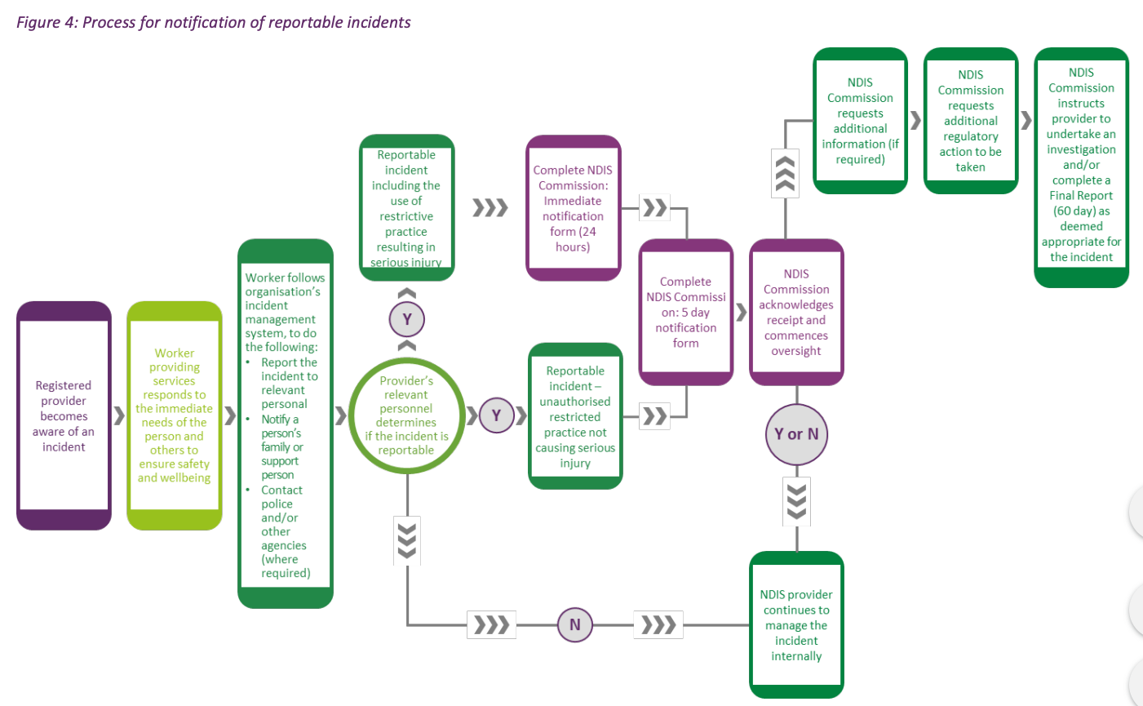

**SBSS Internal Incident Response Procedures**

**Our Commitment**

SBSS is committed to ensure that all incidents, incidents, hazards and near misses at SBSS are reported and investigated to determine their cause(s) and prevent any reoccurrence of the incident/s.

**Procedures:**

**ALL** Incidents, near misses and hazards are to be reported:

* When involving the participant- to be recorded on the participant file and within the SBSS Risk Register
* When involving a SBSS Director- to be recorded on the staff file and recorded on the SBSS Risk Register
* When involving both to be recorded on participant and staff file and recorded on the SBSS Risk Register

The incidents that must be recorded and managed are:

* incidents that have, or could have, caused harm to a person with disability receiving supports or services; and
* Acts by a person with disability that happen in connection with the provision of supports or services and that have caused serious harm, or a risk of serious harm, to another person; and
* reportable incidents that are alleged to have occurred in connection with the provision of supports or services.

SBSS Director is responsible for recording all incidents on the on Risk Register as soon as practical.

Once an incident, near miss, or hazard has occurred or has been identified the Director will:

* 1. Make sure everyone and the area is safe, call for assistance if required, provide First Aid as appropriate, and take immediate action to manage risks and prevent further injury;
  2. Notify emergency services as soon as practicable. If a person has died or suffered serious injury as a result of an incident at a workplace. The Director is responsible for;
     1. Notifying the NDIS commissioner within 24 hrs if incident was a reportable incident.
     2. Notifying WorkSafe immediately on 132 360
     3. A written report must be sent to WorkSafe on the WorkSafe approved form within 48 hours
  3. If repair or maintenance is required in response to the incident, Director will conduct a risk assessment and prioritise any work required.
  4. Log all relevant details of the incident. The **details of the incident report** should be written in objective language and be clear, factual, accurate, respectful, concise and specific. Reports should include:
* *description of the incident, including the impact on, or harm caused to, any person with disability affected by the incident*
* *whether the incident is a reportable incident;*
* *if known—the time, date and place at which the incident occurred;*
* *if paragraph (iii) does not apply—the time and date the incident was first identified;*
* *the names and contact details of the persons involved in the incident*;
* *the names and contact details of any witnesses to the incident;*
* *details of the assessment undertaken by management*
* *the actions taken in response to the incident, including actions taken to support or assist persons with disability affected by the incident;*
* *any consultations undertaken with the persons with disability affected by the incident;*
* *whether persons with disability affected by the incident have been provided with any reports or findings regarding the incident;*
* *if an investigation is undertaken by the provider in relation to the incident—the details and outcomes of the investigation;*
* *the name and contact details of the person making the record of the incident.*

* 1. Director responsible for responding to issues raised by the incident and ensuring that all risks are appropriately managed.
  2. The incident **operational review** (follow up) section of the report is to be completed by the Director *within 4 working* *days* (unless it is a reportable incident in which case must be completed within 24 hours).
     1. All incidents are to be assessed in relation to the following, with the assessment considering the views of persons with disability affected by the incident:
* *whether the incident could have been prevented;*
* *how well the incident was managed and resolved;*
* *what, if any, remedial action needs to be undertaken to prevent further similar incidents from occurring, or to minimize their impact;*
* *whether other persons or bodies need to be notified of the incident.*
  1. The **Director’s response** will include:
* Checking the incident to ensure that SBSS fulfilled their requirements in the initial response to the incident, including ensuring data in the report is complete and accurate.
* Planning and carrying out actions in response to the incident. Actions may be required to ensure supports remain appropriate, or to ensure understanding in what occurred and why it occurred, or to reduce the impact of the incident, or prevent recurrence of the incident.
* Communicating the incident to other agencies, stakeholders and people who may be involved in the response to the incident as appropriate.
* Ensure the person impacted by the incident is appropriately consulted and informed about their rights and the steps being taken to manage the incident.
* Recording all actions taken and planned actions clearly on the incident report.
* Incidents categorised as high risk will be responded to within 24 hours by Director
* All incident records will be stored for a minimum of 7 years and a log is maintained under the organizational risk register.
  1. Director will complete a review of the current policy and Organisational Risk Register at minimum, 12 monthly identify any needed quality and OH&S improvements.

**Related Documents**

|  |
| --- |
| Risk Management Policy and Procedure |
| Occupational Violence and Aggression Policy |
| NDIS Incident Report Template (for all NDIS funded services) and SBSS Incident Report Template (for all non-NDIS funded services) |
| Worker Health and Safety Policy |
| Operational Incident Review Report |