Specialist Behaviour Support Services

Hard Words

This book has some hard words

The first time we write a hard word
- the word is in blue

- we write what the hard word means.

You can get help with this book

You can get someone to help you

- read this book

- know what this book is about

- find more information

About this book

This book is written by Specialist Behaviour Support Services
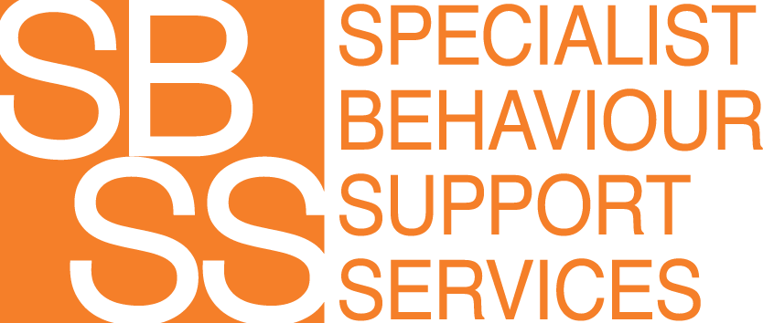
  - Specialist Behaviour Support Services is also called SBSS

This book is written so service users know how SBSS works and what rules are followed

- A service user is a person who chooses to get support from SBSS

About SBSS

SBSS helps service users live

happy

healthy lives

By

decreasing behaviours of concern,

and increasing skills

Behaviours of concern are actions that might not be safe or healthy

SBSS uses positive behavior support

Positive behavior support means changing things to help a person feel better

Positive behaviour support also means fewer or no restrictive practices

Restrictive practices are things that stop people from doing what they want
    - For example, if a person is kept in a locked room

Everyone has rights, like

  - The right to be safe

  - The right to be happy
  - The right to choose

SBSS respects people’s rights, whether they are a:

- Service user

- Child

- Aboriginal person

- Person who speaks a different language
TIS National can help with translations
Ph: 131 450

You also have the right to make a complaint if you don’t like
Something

Ph: 1800 035 544 Website: www.ndiscommission.gov.au

Who can give positive behaviour support?

Only people who are registered are allowed to give positive behaviour support

Registered means checked and approved
- All SBSS practitioners are registered to give positive behaviour support
- A practitioner is a worker who provides positive behaviour support

Types of support SBSS can give

Assessment
- An assessment is a report about the person, their needs, and their behaviour
- A risk assessment is a report about everyone’s safety.

Behaviour Support Plan
- A behaviour support plan lists the things people are going to do to make things better

Teaching the person and others what they can do different

Fees
SBSS are paid for services by the National Disability Insurance Scheme, also called the NDIS
      - The NDIS provides funding to support people who have a disability
The NDIS pays
      - $214.41 per hour for positive behaviour support
      - $193.99 per hour for a behaviour support plan and teaching

Hours
SBSS practitioner usually work between 9am and 5pm on weekdays. Appointments outside of these times can be arranged if they are needed

Contact Us
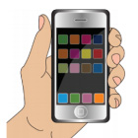
0466 394 771

referrals@sbss.org.au

specialistbehavioursupport.com.au

Consent and Authorisation Form
Name of service user: ____________________________________________
I, (print name) ___________________________________________________, of
(Address)_________________________________________________________________

Provide consent for the provision of Behaviour Support services as detailed below:
Perform assessments, conduct observations and intervention sessions in line with documented therapeutic or behavioural support plans and goals
P Provide recommendations, consultation, updates, reports, resources and training to support team and teaching staff.

I provide consent for the exchange of information as specified below:
Name of person or agency information to be exchanged with:
By signing this form, I agree that this form has been explained and understood.

I also agree that this form can be photocopied and still remain valid within 12 months from the date signed below.
Service User Name (print)
Participant or Representative Signature: |  | Date:
Relationship to service user

