Specialist Behaviour Support Services

Hard Words

This book has some hard words

The first time we write a hard word
- the word is in blue

- we write what the hard word means.

You can get help with this book

You can get someone to help you

- read this book

- know what this book is about

- find more information

About this book

This book is written by Specialist Behaviour Support Services
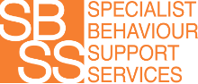
  - Specialist Behaviour Support Services is also called SBSS

This book is written so service users know how SBSS works and what rules are followed

- A service user is a person who chooses to get support from SBSS

About SBSS

SBSS uses positive behaviour support

Positive behaviour support means changing things to help a person feel better

Positive behaviour support also means fewer or no restrictive practices
Restrictive practices are things that stop people from doing what they want

About Restrictive Practices

We will only use restrictive practices
to stop people from getting hurt

If we use a restrictive practice,
it will be for as little time as possible

Types of Restrictive Practices

Forcing a person
to be on their own

Using medicine
to change a person’s behaviour

Separating a person
from everybody else

Restricting a person’s access
to places or things

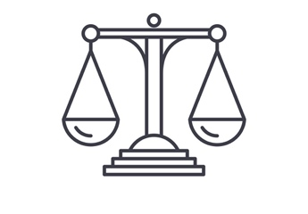
Your rights

Everyone has rights, like

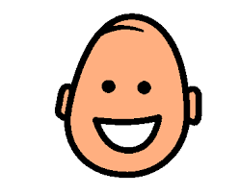
  - The right to be safe

  - The right to be happy

  - The right to choose

You also have the right to make a complaint
if you don’t like something

Contact Us
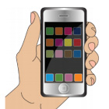
0466 394 771

referrals@sbss.org.au

specialistbehavioursupport.com.au

