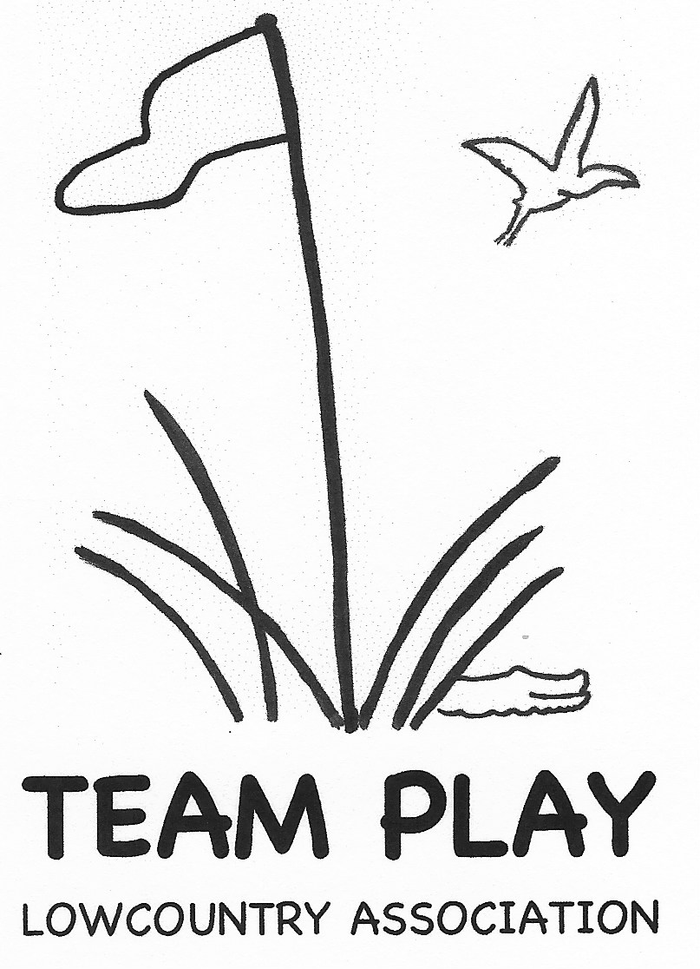 2026 Team Dues Form

Club: Click or tap here to enter text.

Number of Teams: Click or tap here to enter text.

Submitted by: Click or tap here to enter text.

Total Dues for 2026 are $360 per team, the same as they were in the prior 2 years. Please retain $144 per team to tip your club’s cart attendants.

|  |  |  |  |
| --- | --- | --- | --- |
| # of Teams | Total Dues | Less Tips | Pay LTPA |
| 1 | $360 | $144 | $216 |
| 2 | $720 | $288 | $432 |
| 3 | $1080 | $432 | $648 |
|  |  |  |  |
|  |  |  |  |
|  |  |  |  |

The dues submitted to LowCountry Team Play Association are used for charitable contributions, luncheon and administration costs.

Make checks payable to **Lowcountry Team Play Association.**  Dues must be received no later than January 16, 2026 (date of Captains Meeting) to secure your team’s spot**.**

You can bring your check to the Captains meeting or mail to our Treasurer, Cynthia Leaf, 4001 Spring Island, Okatie, SC 29909.

Revised: 07/11/2025