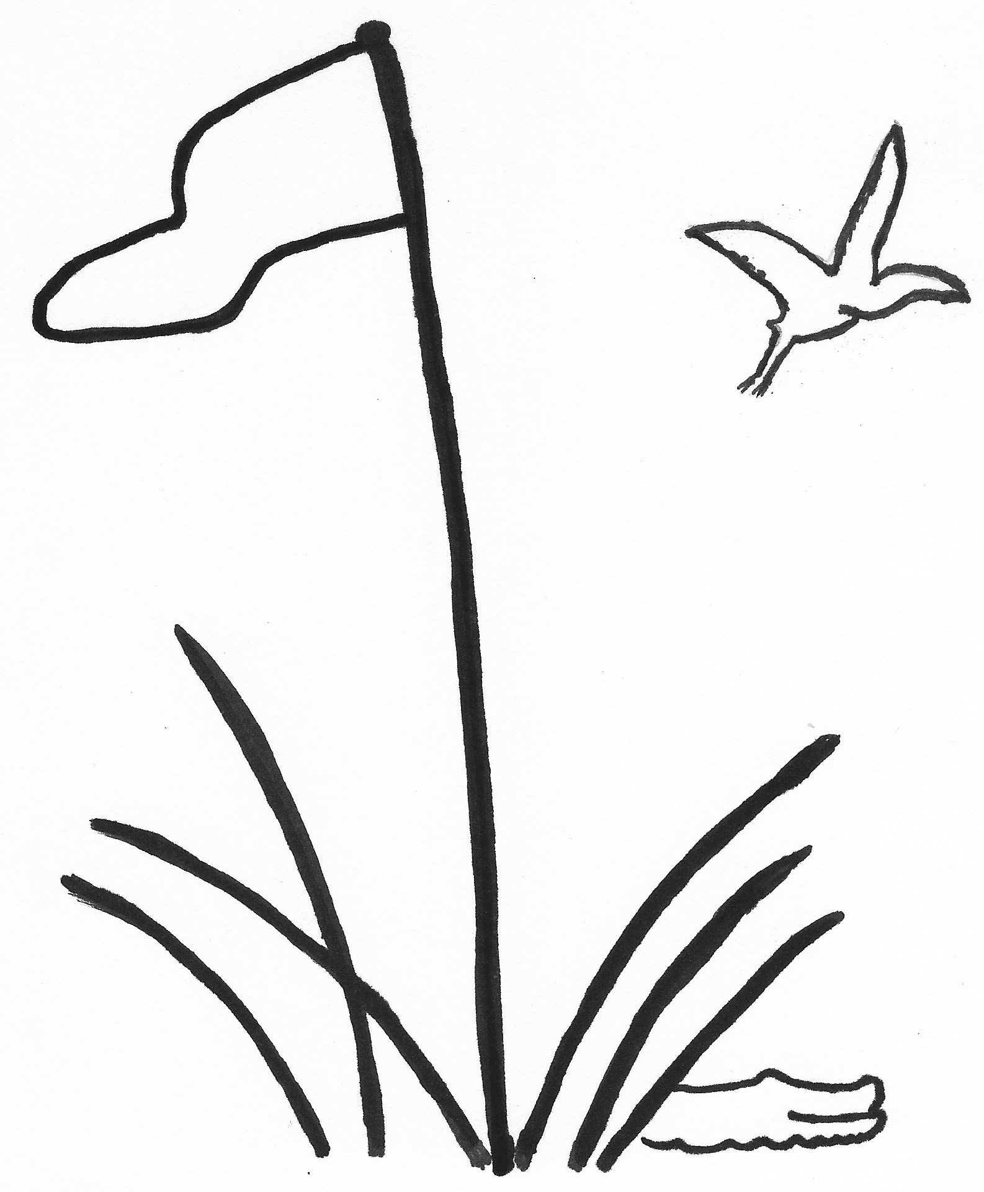
TEAM ROSTER
2026

TEAM PLAY Index as of December 15, 2025
LOWCOUNTRY ASSOCIATION Due January 14, 2026

Division, Club and Team Number Captain Name
D1 Hampton Hall I |  | Donna Cortina
D2
D3 Hampton Hall II |  | Jeanne Gerace
D4
D5 Hampton Hall III |  | Wendy Schollaert
D6
Rank | Player’s Name  Last, First | Index |  | Rank | Player’s Name  Last, First | Index
1 | Rezzetano, Renee | 2.8 |  | 21 | Sheridan, Robin | 16.7
2 | Imel, Colleen | 4.6 |  | 22 | Cousino, Martha | 16.8
3 | Kapur, Julie | 4.7 |  | 23 | Smith, Helen | 16.8
4 | Cortina, Donna | 6.7 |  | 24 | Holmes, Dorothy | 16.8
5 | Shineman, Sandi | 6.7 |  | 25 | Wiemels, Christine | 17.2
6 | Ouimette, Lili | 7.4 |  | 26 | Feeley, JoAnne | 18.2
7 | Buontempo, Natalie | 8.6 |  | 27 | Mason, Patsy | 18.7
8 | Peebles, Mary Jane | 10.7 |  | 28 | Hund, Judy | 20.7
9 | Marquardt, Catherine | 11.3 |  | 29 | Wallace, Susan | 20.8
10 | Bieck, Karen | 11.8 |  | 30 | Hammond, Susan | 20.9
11 | Rocca, Colette | 12.3 |  | 31 | Pohlman, Patty | 21
12 | Gerace, Jeanne | 12.6 |  | 32 | Hardman, Barbara | 21.6
13 | Kermisch, Deb | 13.4 |  | 33 | Canter, Linda | 21.9
14 | Schollaert, Wendy | 13.5 |  | 34 | Barry, Katie | 22.5
15 | Miller, Mary | 13.6 |  | 35 | Zagar, Jane | 23.1
16 | Fitzgerald, Theresa | 14.5 |  | 36 | Nelson, Trudi | 24
17 | Santee, Beth | 15.1 |  | 37
18 | McLain, Janet | 15.6 |  | 38
19 | Lowry, Rhonda | 15.7 |  | 39
20 | Vincent, Nancy | 16.3 |  | 40

Complete Roster and email to your Division Chair and the General Chair, Carol Hammond

Clubs of the Lowcountry Team Play Association: Belfair, Berkeley Hall, Callawassie, Colleton River, Country Club of HH, Dataw, Dolphin Head,
Haig Point, Hampton Hall, Long Cove, May River, Moss Creek, Oldfield, Palmetto Hall, Port Royal, Sea Pines, Spring Island, Sun City, The Golf Club, Wexford

