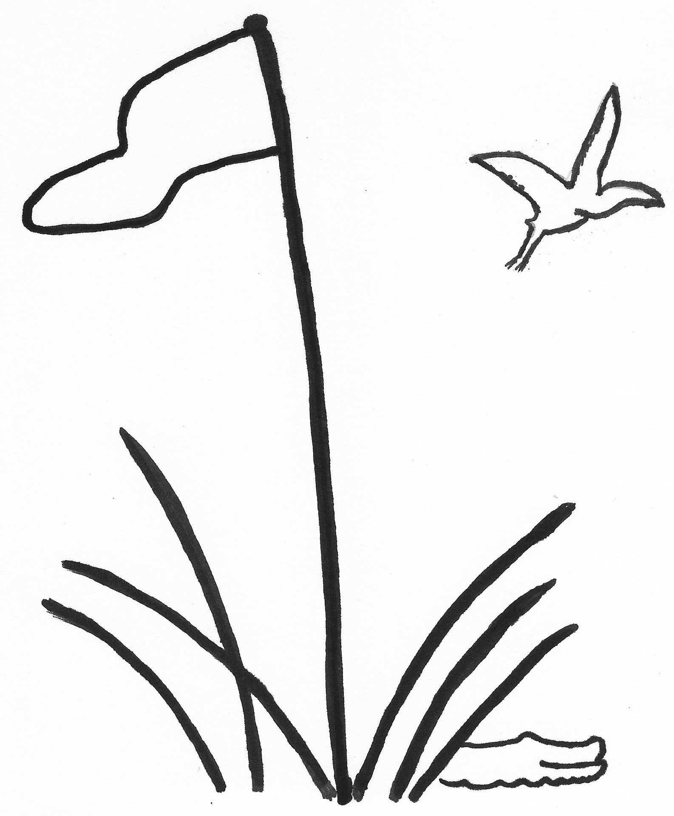
TEAM ROSTER
2026

TEAM PLAY Index as of December 15, 2025
LOWCOUNTRY ASSOCIATION Due January 14, 2026

Division, Club and Team Number Captain Name
D1
D2 Moss Creek I |  | Linnea Wilson and Laura Collins
D3 Moss Creek II |  | Linnea Wilson and Laura Collins
D4
D5
D6
Rank | Player’s Name  Last, First | Index |  | Rank | Player’s Name  Last, First | Index
1 | Linnea Wilson | 9.5 |  | 21
2 | Malynda Carruth | 9.9 |  | 22
3 | Elise Chapman | 10.7 |  | 23
4 | Judy Sparzo | 11.0 |  | 24
5 | Sheila Martin | 11.1 |  | 25
6 | Nicki Slusser | 12.4 |  | 26
7 | Debbie Retzer | 13.0 |  | 27
8 | Chris Kraimer | 13.4 |  | 28
9 | Laura Collins | 13.5 |  | 29
10 | Mary Ann Weiss | 13.7 |  | 30
11 | Melissa Folk | 14.1 |  | 31
12 | Shirley Douglas | 14.4 |  | 32
13 | Judy Clark | 14.5 |  | 33
14 | Jan Kirk | 14.8 |  | 34
15 | Amy Amos | 16.7 |  | 35
16 | Trang Buck | 18.7 |  | 36
17 | Irene Vouvalides | 18.8 |  | 37
18 | Liz Barry | 19.5 |  | 38
19 | Nancy Landwehr | 21.3 |  | 39
20 | Liz Morgan | 21.4 |  | 40

Complete Roster and email to your Division Chair and the General Chair, Carol Hammond

Clubs of the Lowcountry Team Play Association: Belfair, Berkeley Hall, Callawassie, Colleton River, Country Club of HH, Dataw, Dolphin Head,
Haig Point, Hampton Hall, Long Cove, May River, Moss Creek, Oldfield, Palmetto Hall, Port Royal, Sea Pines, Spring Island, Sun City, The Golf Club, Wexford

