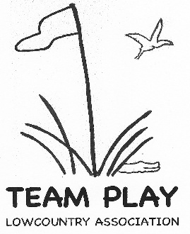
2026 Team Dues Form

Club:

Number of Teams:

Submitted by:

Total Dues for 2026 are $360 per team, the same as they were in the prior 2 years. Please retain $144 per team to tip your club’s cart attendants.

# of Teams | Total Dues | Less Tips | Pay LTPA
1 | $360 | $144 | $216
2 | $720 | $288 | $432
3 | $1080 | $432 | $648

The dues submitted to LowCountry Team Play Association are used for charitable contributions, luncheon and administration costs.

Make checks payable to Lowcountry Team Play Association. Dues must be received no later than January 16, 2026 (date of Captains Meeting) to secure your team’s spot.
You can bring your check to the Captains meeting or mail to our Treasurer, Cynthia Leaf, 4001 Spring Island, Okatie, SC 29909.

Revised: 07/11/2025

