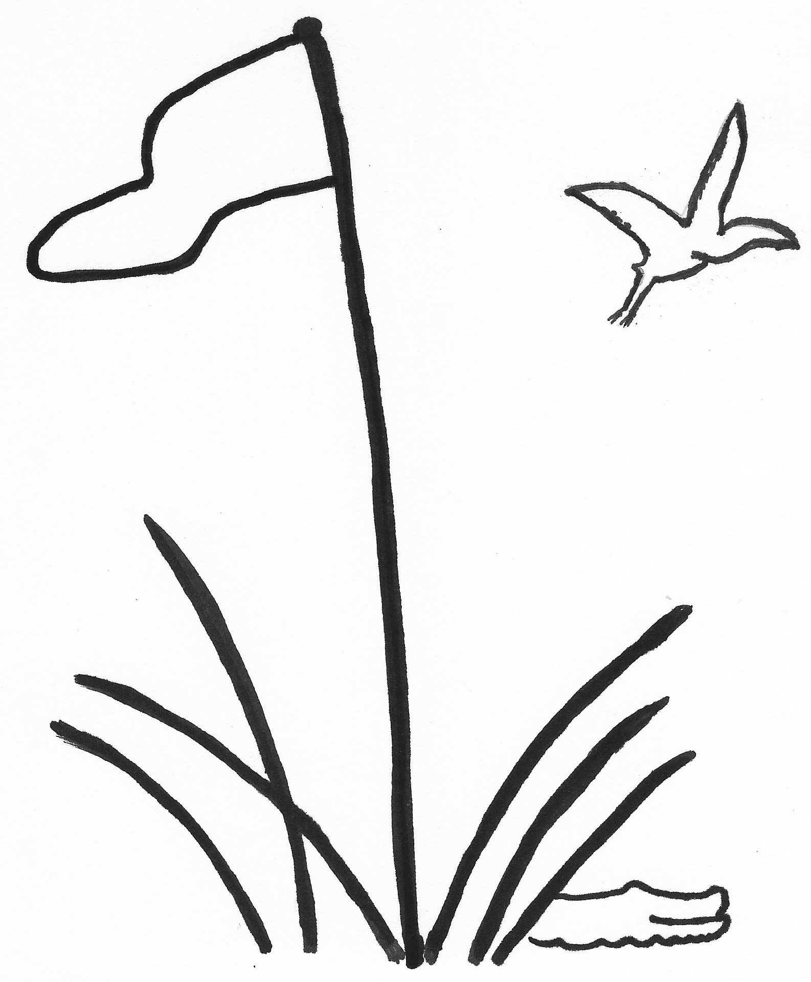
TEAM ROSTER
2026

TEAM PLAY Index as of December 15, 2025
LOWCOUNTRY ASSOCIATION Due January 14, 2026

Division, Club and Team Number Captain Name
D1 Callawassie Island I |  | Janet Paro
D2
D3
D4
D5 Callawassie Island II |  | Janet Paro/Deb Fox
D6
Rank | Player’s Name  Last, First | Index |  | Rank | Player’s Name  Last, First | Index
1 | Isabel McMahon | +1.3 |  | 21 | Madelon Hassberger | 18.9
2 | Susan Marchese | 5.5 |  | 22 | Katy Depew | 19.5
3 | Kate Tidgewell | 8.0 |  | 23 | Janet Abrams | 20.2
4 | Sheila Ahearn | 8.6 |  | 24 | Bitt Dennis | 21.6
5 | Kathy Levin | 11.0 |  | 25 | Janet Matlock | 21.8
6 | Tara O’Donnell | 11.2 |  | 26 | Karen Schwarz | 22.3
7 | Janet Paro | 11.6 |  | 27 | Mary Donnelly | 22.6
8 | Cindy Young | 12.4 |  | 28 | Dottie Foote | 23.5
9 | Maureen Boggs | 12.5 |  | 29 | Deb Fox | 23.7
10 | Lisa Gerardi | 14.1 |  | 30 | Vicky Lenz | 23.9
11 | Gianna Littlehale | 14.2 |  | 31 | Diane Doherty | 24.3
12 | Gail Teem | 14.6 |  | 32 | Kelly Wewer | 25.0
13 | Debbie Cork | 15.4 |  | 33
14 | Annette Moore | 15.5 |  | 34
15 | Lena Claesson | 15.6 |  | 35
16 | Debbie Kiss | 15.9 |  | 36
17 | Maggie Weaver | 16.7 |  | 37
18 | Kate Barry | 16.8 |  | 38
19 | Susan Acker | 18.3 |  | 39
20 | Karen Gottschall | 18.4 |  | 40

Complete Roster and email to your Division Chair and the General Chair, Carol Hammond

Clubs of the Lowcountry Team Play Association: Belfair, Berkeley Hall, Callawassie, Colleton River, Country Club of HH, Dataw, Dolphin Head,
Haig Point, Hampton Hall, Long Cove, May River, Moss Creek, Oldfield, Palmetto Hall, Port Royal, Sea Pines, Spring Island, Sun City, The Golf Club, Wexford

