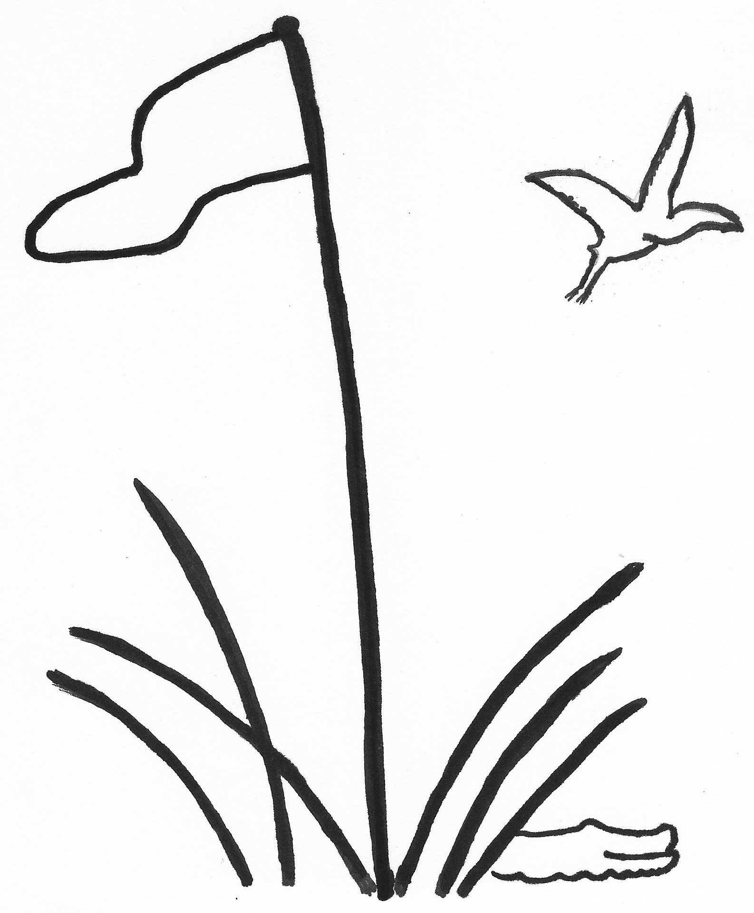
TEAM ROSTER
2026

TEAM PLAY Index as of December 15, 2025
LOWCOUNTRY ASSOCIATION Due January 14, 2026

Division, Club and Team Number Captain Name
D1 Callawassie Island I |  | Janet Paro
D2
D3
D4
D5 Callawassie Island II |  | Janet Paro/Deb Fox
D6
Rank | Player’s Name  Last, First | Index |  | Rank | Player’s Name  Last, First | Index
1 | Isabel McMahon | +1.3 |  | 21 | Katy Depew | 19.5
2 | Susan Marchese | 5.5 |  | 22 | Janet Abrams | 20.2
3 | Kate Tidgewell | 8.0 |  | 23 | Bitt Dennis | 21.6
4 | Sheila Ahearn | 8.6 |  | 24 | Janet Matlock | 21.8
5 | Kathy Levin | 11.0 |  | 25 | Karen Schwarz | 22.3
6 | Tara O’Donnell | 11.2 |  | 26 | Mary Donnelly | 22.6
7 | Janet Paro | 11.6 |  | 27 | Dottie Foote | 23.5
8 | Cindy Young | 12.4 |  | 28 | Deb Fox | 23.7
9 | Maureen Boggs | 12.5 |  | 29 | Vicky Lenz | 23.9
10 | Lisa Gerardi | 14.1 |  | 30 | Dianne Doherty | 24.3
11 | Gianna Littlehale | 14.2 |  | 31 | Kelly Wewer | 25.0
12 | Gail Teem | 14.6 |  | 32
13 | Annette Moore | 15.5 |  | 33
14 | Lena Claesson | 15.6 |  | 34
15 | Debbie Kiss | 15.9 |  | 35
16 | Maggie Weaver | 16.7 |  | 36
17 | Kate Barry | 16.8 |  | 37
18 | Susan Acker | 18.3 |  | 38
19 | Karen Gottschall | 18.4 |  | 39
20 | Madelon Hassberger | 18.9 |  | 40

Complete Roster and email to your Division Chair and the General Chair, Carol Hammond

Clubs of the Lowcountry Team Play Association: Belfair, Berkeley Hall, Callawassie, Colleton River, Country Club of HH, Dataw, Dolphin Head,
Haig Point, Hampton Hall, Long Cove, May River, Moss Creek, Oldfield, Palmetto Hall, Port Royal, Sea Pines, Spring Island, Sun City, The Golf Club, Wexford

