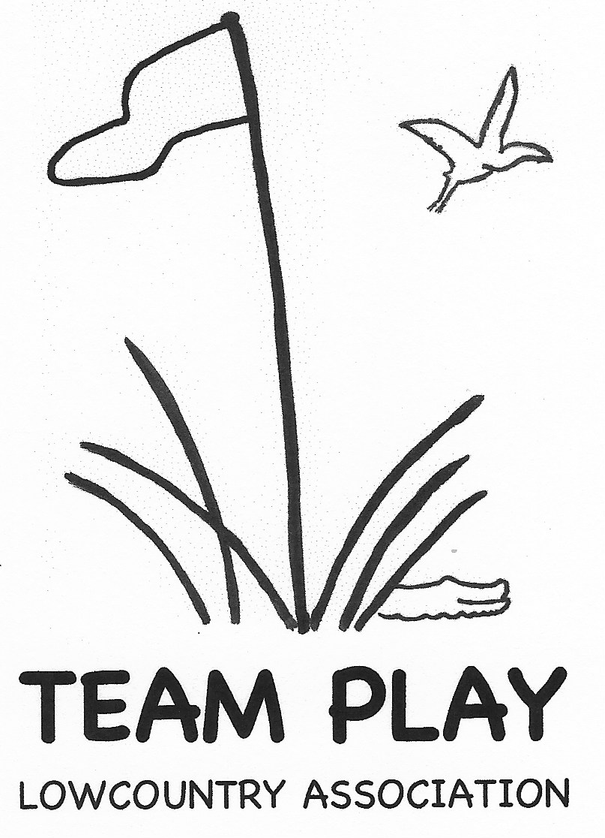 REGISTRATION FORM

Course Reservation Contract

for 2026 team play

**Team Captain:**

Complete contact information and work out play dates with your Golf Shop. Email contract between April 1 - May 15, 2025 to Laura Collins at [laurac4567@yahoo.com](mailto:laurac4567@yahoo.com). **Form must be complete to reserve a team(s) for 2026.**

Club: _____________________________ Division(s): ___________________

Captain(s) for contract contact: _____________________________________

Phone:_(_____)______________Email:________________________________

**Golf Shop:**

The Lowcountry Team Play Association thanks you for granting us your course for our Team Matches. Please complete and return to your club’s team captain.

Team play takes place between February 2 and March 20, 2026. Please do not schedule a back-to-back play date and rain date, plan the rain date in the following week(s). Nine tee times are needed for each division, either consecutive, or shotgun.

**DATE** Play Date 1st Choice _________________ Rain Date: __________________

Play Date 2nd Choice_________________ Rain Date: __________________

**TIME**

Shotgun start at ____________________ OR,

Tee times will start at ___________ with________ minute intervals

Play will begin on the first tee _________ and/or tenth tee ________

There will be a total of ______ tee times

**TOURNAMENT FEE** is $ _______ per person (include tax if applicable).

Golf Course _______________ Golf Pro Signature ________________________

Date ____________________

Revised: 3-21-25