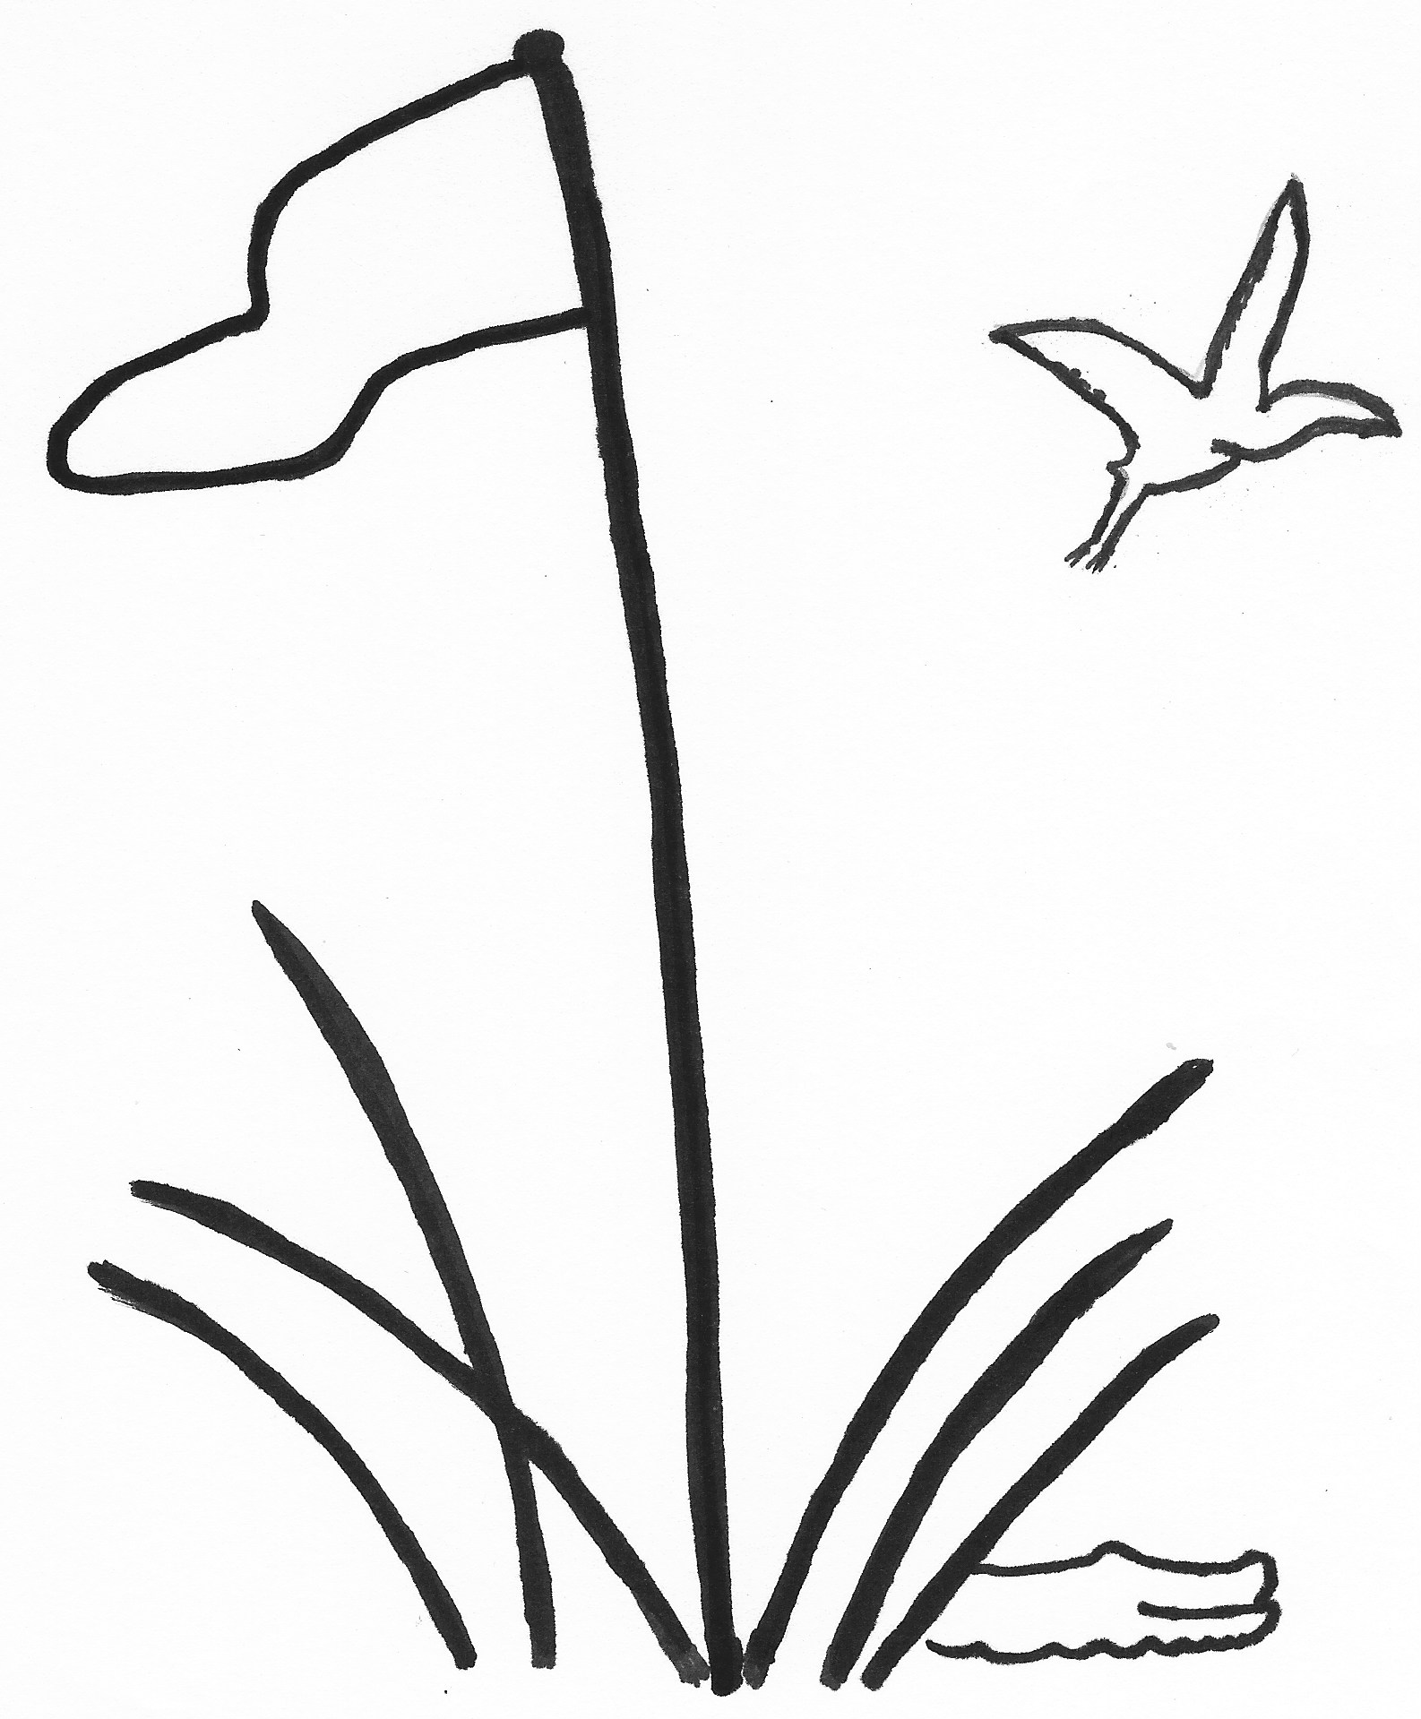 TEAM ROSTER

**2025**

**TEAM PLAY** Index as of December 15, 2024

LOWCOUNTRY ASSOCIATION Due January 17, 2025

Division, Club and Team Number Captain Name

|  |  |  |  |  |  |  |
| --- | --- | --- | --- | --- | --- | --- |
| D1 | |  | | | | |
| D2 | |  | | | | |
| D3 | |  | | | | |
| D4 | |  | | | | |
| D5 | |  | | | | |
| D6 | |  | | | | |
|  |  |  |  |  |  |  |
| Rank | Player’s Name  Last, First | Index |  | Rank | Player’s Name  Last, First | Index |
| 1 |  |  |  | 21 |  |  |
| 2 |  |  |  | 22 |  |  |
| 3 |  |  |  | 23 |  |  |
| 4 |  |  |  | 24 |  |  |
| 5 |  |  |  | 25 |  |  |
| 6 |  |  |  | 26 |  |  |
| 7 |  |  |  | 27 |  |  |
| 8 |  |  |  | 28 |  |  |
| 9 |  |  |  | 29 |  |  |
| 10 |  |  |  | 30 |  |  |
| 11 |  |  |  | 31 |  |  |
| 12 |  |  |  | 32 |  |  |
| 13 |  |  |  | 33 |  |  |
| 14 |  |  |  | 34 |  |  |
| 15 |  |  |  | 35 |  |  |
| 16 |  |  |  | 36 |  |  |
| 17 |  |  |  | 37 |  |  |
| 18 |  |  |  | 38 |  |  |
| 19 |  |  |  | 39 |  |  |
| 20 |  |  |  | 40 |  |  |

Complete Roster and email to your Division Chair and the General Chair

*Clubs of the Lowcountry Team Play Association: Belfair, Berkeley Hall, Callawassie, Colleton River, Country Club of HH, Dataw, Dolphin Head,*

*Haig Point, Hampton Hall, Long Cove, May River, Moss Creek, Palmetto Hall, Port Royal, Sea Pines, Spring Isl, Sun City, The Golf Club, Wexford*