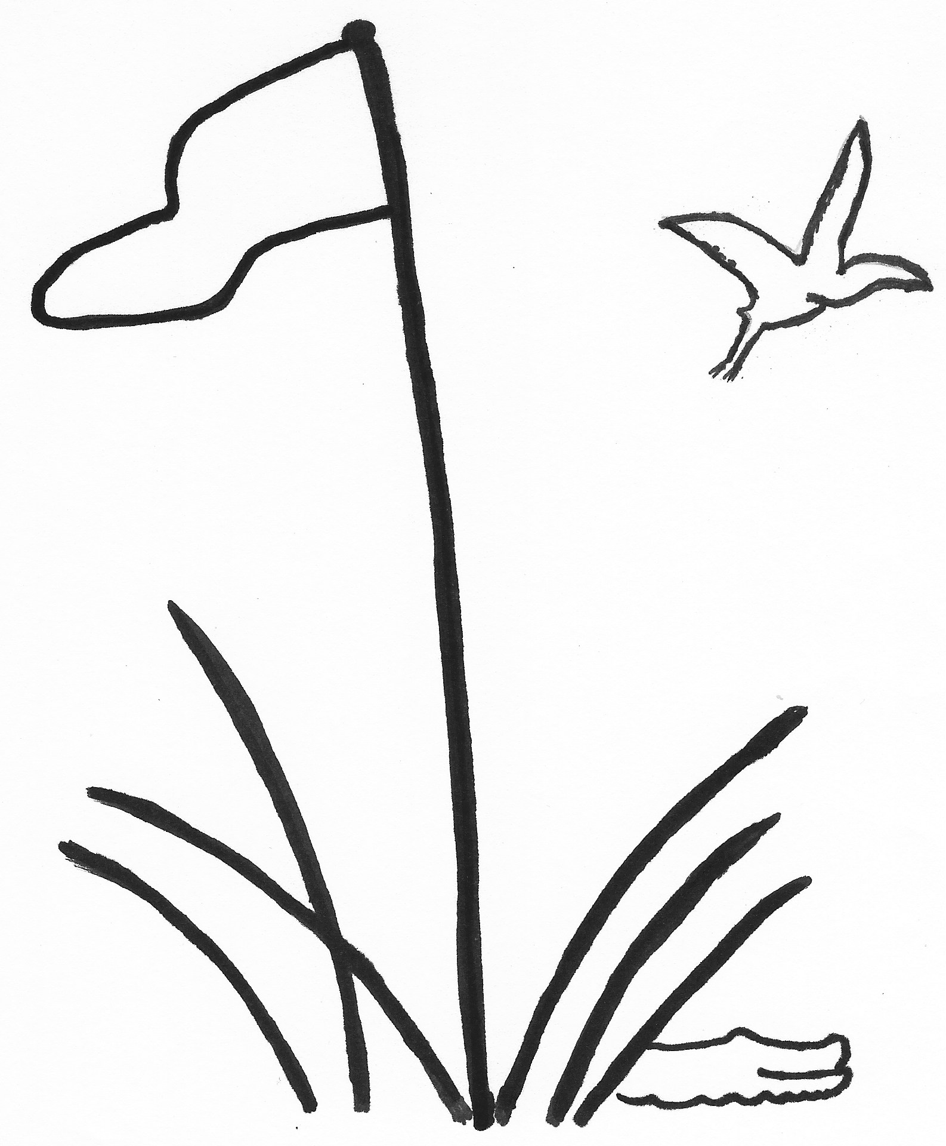
Lowcountry Team
February - March 2023
Handicap Revision Date Dec 15, 2022
Team Captain Meeting Jan 6, 2023
Team Roster Deadline Jan 7, 2023
Annual Meeting Mar 24, 2023
Sun | Monday | Tuesday | Wednesday | Thursday | Friday | Sat
 | February | February | February | February | February
5 | 6  1,2,5 Long Cove | 7  2,4 Moss Creek | 8  1,3,5 Colleton | 9  4 Port Royal | 10 | 11
12 | 13  3 Dataw  1,2,5 RD Long Cove | 14  1,2,4 Belfair | 15  4 RD Port Royal | 16  1,3 Berkeley  4 Haig Point | 17  5 Sun City | 18
19 | 20  2 Spring Island  3 RD Dataw | 21  1,2,4 RD Belfair | 22  3,5 Wexford  4 RD Haig Point | 23  2,4 Sea Pines | 24  1,3,5 RD Colleton | 25
 | Feb/March | Feb/March | March | March | March
26 | 27  4 Palmetto Hall  2,5 Dolphin Head | 28  3,5 CC of HH  1,4 Golf Club | 1  3,5 RD Wexford | 2  1,3 RD Berkeley | 3  1 Sun City | 4
5 | 6  3 Callawassie  4 RD Palmetto Hall | 7  2,4 RD Moss Creek | 8  3 May River | 9  2,4 RD Sea Pines | 10  2,5 RD Dolphin Head  1 RD Sun City 1 | 11
12 | 13  1,2,5, Hampton Hall  3 RD Callawassie | 14  1,4 RD Golf Club  2 RD Spring Island | 15  3 RD May River | 16 | 17  5 RD Sun City 5 | 18
19 | 20  1,2,5 RD Hampton Hall | 21  3,5 RD CC of HH | 22 | 23 | 24 | 25
26 | 27 | 28 | 29 | 30 | 31

