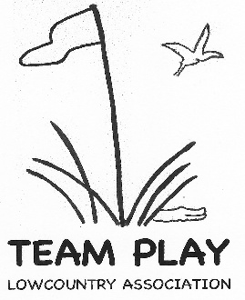
REGISTRATION FORM
Course Reservation Contract
for 2027 team play

Team Captain:
Complete contact information and work out play dates with your Golf Shop. Email contract between April 1 - May 15, 2026, to Carol Hammond at carolnaco@aol.com AND Laura Collins at Laurac4567@yahoo.com

Form must be 100% complete to reserve a team(s) for 2027 and receive final approval from the Board.

Club:
Captain(s) for Contract Contact
Phone:
Email:
Division(s):

Golf Shop:
The Lowcountry Team Play Association thanks you for granting us your course for our Team Matches. Please complete and return to your club’s team captain.

Team play takes place between February 2 and March 23, 2027. Please do not schedule a back-to-back play date and rain date. If possible, plan the rain date in the following week(s). Nine tee times are needed for each division, either consecutive, or shotgun. Consider start times beginning no earlier than 10 a.m. and no later than 11:00 a.m. during Eastern Standard Time dates.

DATE
Play Date 1st Choice: |  | Rain Date 1st Choice:
Play Date 2nd Choice: |  | Rain Date 2nd Choice:

TIME
Shotgun start at:
Tee Time start at: |  | Minute Intervals
Play will begin on: | 1st Tee | 10th Tee
Total of Tee Times:

MATCH FEE is $ _______ per person (include tax if applicable).

Golf Course: | Date:
Golf Pro Signature:

Revised: 03-24-2026

