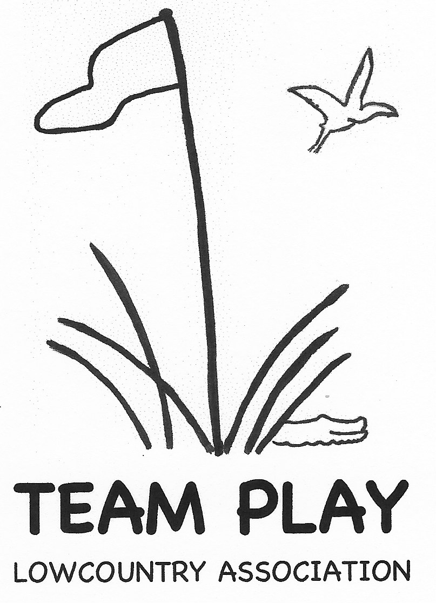
REGISTRATION FORM
Course Reservation Contract
for 2027 team play

Team Captain:
Complete contact information and work out play dates with your Golf Shop. Email contract between April 1 - May 15, 2026, to Carol Hammond at carolnaco@aol.com. Form must be complete to reserve a team(s) for 2027 and receive final approval from the Board.

Club: ________________________________ Division(s): _________________________

Captain(s) for contract contact: __________________________________________________

Phone:_(_____)____________Email:_____________________________________

Golf Shop:
The Lowcountry Team Play Association thanks you for granting us your course for our Team Matches. Please complete and return to your club’s team captain.

Team play takes place between February 2 and March 23, 2027. Please do not schedule a back-to-back play date and rain date. If possible, plan the rain date in the following week(s). Nine tee times are needed for each division, either consecutive, or shotgun.

DATE Play Date 1st Choice _________________ Rain Date: __________________

Play Date 2nd Choice _________________ Rain Date: __________________

TIME
Shotgun start at ____________________ OR,

Tee times will start at ___________ with ________ minute intervals

Play will begin on the first tee _________ and/or tenth tee ________

There will be a total of ______ tee times

MATCH FEE is $ _______ per person (include tax if applicable).

Golf Course _________________ Golf Pro Signature _____________________________

Date ____________________

Revised: 10-29-2025

