Greetings from
EAST NELSON UMC
Welcome

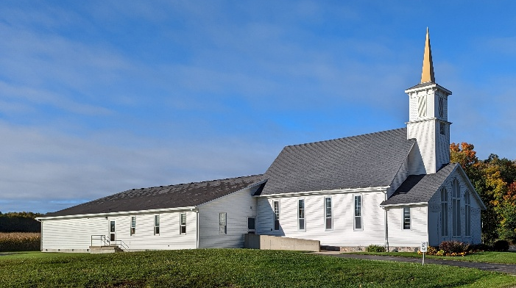

August 23, 2026

SUNDAY SERVICE TIME: 9:15 AM
Livestream on YouTube Channel: https://www.youtube.com/@eastnelsonumc8554

9024 18 MILE RD | CEDAR SPRINGS | MI | 49319
Desk: 616-799-0738 | cell 616-799-6510

eastnelsonumc@gmail.com
http://www.eastnelsonumc.org

Contact Pastor Michelle Vallier @
231-329-5483 | pastormvallier@outlook.com

SERVICE ORDER

PRELUDE – Kathi Jo DeYoung
LIGHT OF CHRIST
WELCOME and OPENING PRAYER - Pastor Michelle
SONG: Spirit, Spirit of Gentleness (TFWS 2120)
(Congregation remains seated)
LIFE OF THE CHURCH

PRAYER OF THANKS AND PRAISE - Pastor Michelle
OPENING WORDS -- Gloria Cole
SONG: I Could Sing Of Your Love Forever
SONG: I’ll Go Where You Want Me To Go

*CALL TO WORSHIP
Ldr: We have come to worship God, the living God,
ALL: Who calls prophets and teachers to bear witness.
Ldr: We have come to praise God, the almighty God,
ALL: Who answers the forces of hatred and hurt with the power of grace.
Ldr: We have come to worship God, all-gracious God,
ALL: Who chooses even you and me,
to receive and carry the Word of life and hope.
All glory to God!
- umcdiscipleship.org, adapted from a post on the United Church of Christ’s Worship Ways Archive. http://www.ucc.org/
PRAISE TEAM: Where Are You In The Storm
(By Sam Hargreaves, Resound Worship)
PRAYER TIME - Pastor Michelle
THE LORD’S PRAYER
SCRIPTURE: Philippians 4:4-9 (NRSVUE)
Romans 16:1-7 (NRSVUE)
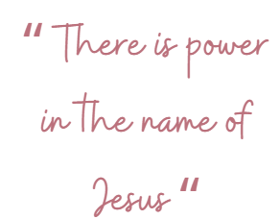
HYMN OF PREPARATION: Spirit of the Living God (UMH 393)
MESSAGE – Pastor Michelle
OFFERING of our tithes and gifts
PRAYER OF THANKS - Pastor Michelle
DOXOLOGY (UMH 94)
CLOSING SONG: I Surrender All/chorus to
I Know Whom I Have Believed
BENEDICTION
GOD BE WITH YOU
*Special thanks to the many volunteers who make our morning worship a wonderful place to be, the Praise Team and coffee servers and cookie suppliers. We Love YOU!

Piano – Kathi Jo DeYoung
Liturgist – Sarah Zachow

Video – Gordon DeYoung
Sound – George Bradley
Screens – Jane Lubahn

Events & Announcements
Day | Date | Time | Event
Wed | 08/26/2026 | 4:30 pm | Praise Team
Sat | 08/29/2026 | 10:00 am | AA

- Church contact magnets are available by the bulletins. Please take one.
- Bed Build is Saturday, 9/12 in the parking lot. Donate new twin sheet sets, blankets, and pillows using the box by the mission table.
- Hand2Hand: Donation list of food items is by the Mission table. They are also looking for volunteers to pack and transport bags to the school. Reach out to Craig Owens at 616-667-7773 for volunteer information.
East Nelson Financial Report
Account | Date | Amount | Attend
General Fund Contributions | 08/02/2026 | $4,595.00 | 34
 | 08/09/2026 | $1,475.50 | 34
 | 08/16/2026 | $615.00 | 31
Monthly Total Received - July |  | $4,720.00
Monthly General Fund Goal |  | $11,998.00
Total Donations April-June 2nd QTR |  | $23,896.00
Remember our shut-ins:
Sharon Nielson Barb Schermerhorn Doris Tindall
Prayer List:

Janet Armstrong
Jennifer Eastman
Lisa Hansen
Rebecca Kolka
Janina Lewkowski
Dale Lubahn
LD Norton
Holly (Dorothy Powells niece)
Harvey Schestag
Doug Sherd
Mark Steinacker
Jerry Stuber
Kathy Stuber
Debra VanderWerff
Dorothy Winters

*Names will remain on the prayer list for 1 month unless notified. Prayer chain contact Caroline Bartlette at deadend7501@sbcglobal.net

