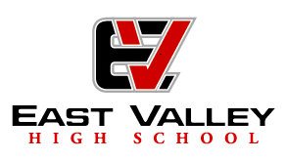
7420 E Main Street Mesa, AZ 85207 480-981-2008 www.evhigh.org

Proposed Budget Public Hearing Agenda
June 26, 2017 4:30 PM
Vance Danzy, President Sheila Dutton, Director Rod Tolman, Director
Kathy Tolman, Secretary Sheri Skousen, Director Director, Vacant
Michael Clement, Director

I. Call to Order: Vance Danzy.
II. Items for Board Discussion and Approval:
1. Approve the School Budget for SY 17-18 and 18-19
The board approved the Proposed Budget at the June 5, 2017 meeting. AZ Statute requires that board approve the proposed budget as the School Year school budge.
III. Items for Board Discussion:
1. Financial Report from Claudina Douglas from ADI to report on the YTD Cash Flow and projections through the end of the year.
2. Report from School Principal V. Danzy on Estimated Student Count; staff changes for the 17—18 school year; any other information for the board .
The next board meeting will be on August 22, 2017. Meetings are at 4:30 PM in the high school lobby.
IV. Adjournment:
For those attending via phone: Please call in at or before 4:30.
Conference call phone number - (712) 432-1500 - 923175#

