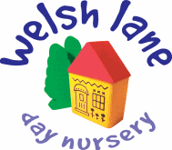
Fee Structure

Non- funded children

0 to 2 years (no funding)

 | 5 Days | 4 Days | 3days | 2 days
Per month | £1,870 | £1,496 | £1,122 | £748
 | Extra day | £88 | AM/PM  Only extra sessions | £49.50

2 to 3 years (no funding)

 | 5 Days | 4 Days | 3days | 2 days
Per month | £1,827.50 | £1,462 | £1,096.50 | £731
 | Extra day | £86 | AM/PM  Only extra sessions | £48

3 and 4 year olds (no funding)

 | 5 Days | 4 Days | 3days | 2 days
Per month | £1,785 | £1,428 | £1,071 | £714
 | Extra day | £84.00 | AM/PM part day or extra sessions | £47.50

The above fees apply only to non-funded children and to secure your child’s non-funded space we require one month’s fees upfront, please refer to our T&C’s.

Funded children

If you are eligible for funding we will require one month’s fees upfront to secure your child’s place. This will not apply if you are accessing the standalone offer. All funded rates are worked out in calendar months as opposed to a monthly average.

From 01/04/2026;
9 months+ funding entitlement for eligible working parents: 22 hours per week

Wraparound hours for our 9 month - 2-year-olds after funding will be charged at £7 per hour plus food (see below)

2-year-old funding entitlement for eligible working parents: 22 hours per week

Wraparound hours for our 2–3-year-olds after funding will be charged at £6.75 per hour plus food (see below)

3+4 year old universal and extended entitlement for eligible children: 11 hours p/w or 22 hours p/w

Wraparound hours after funding will be charged at £6.50 per hour plus food (see below)

A condition of us receiving the funding entitlement means it is not there to cover the cost of meals, other consumables, additional hours or additional activities.

Therefore we will be making the following daily charges:
£2.00 for breakfast, £1.50 for snack, £9.00 lunch, £5.00 for tea.

For one day per week an addition of:
£4.00 for Forest School activities, access to our bespoke Forest School area (this applies to 2, 3 & 4-year-olds)

If you wish to opt out please speak to a member of the management team.

Standalone offer

If you wish to access the funded sessions only with no additional services/hours then you will need to provide food for your child. This has no conditions of access, and the funded hours are free on the point of contact. Our offer is Tuesday- Friday 8:00-13:00 or 8:00-14:00

If you need further support with the additional cost, please speak in confidence to a member of the management team.

We ask that parents provide nappies and wipes.

Additional funding information:

All entitled parents need to check their eligibility through the ‘Best Start in Life’ website, https://beststartinlife.gov.uk, on a regular basis (approximately every three months).

For children aged 3-4 the total entitlement is either 570 hours per year, or 1140 hours if you fall within eligibility, within the current stretched offer from Buckinghamshire Council.

When will my child become eligible for funding?

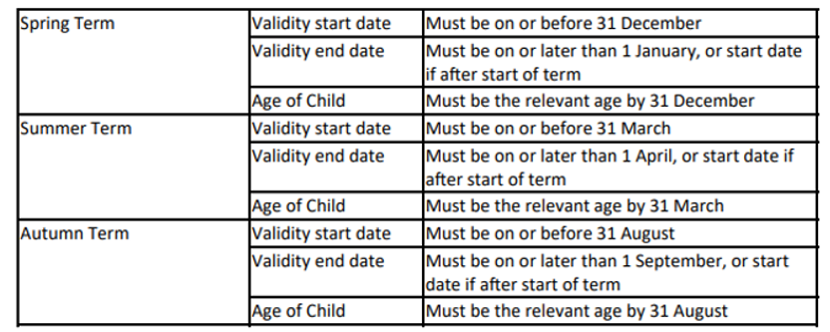

2-year-old funding for families in England receiving additional government support is available. To check your eligibility please visit https://beststartinlife.gov.uk/. The Early Years Pupil Premium is available; please speak to the management team if you think you are eligible for this.

Payment:

All fees are paid by Tax Free Childcare or bank transfer by or around the 10th of the month. Further information on TFCC can be found here: https://beststartinlife.gov.uk/

Fees will be paid irrespective of whether your child is present due to sickness or holiday.
Discount for siblings on non-funded spaces are available: Full time basis 10%, part time basis 5%. Please refer to our Terms and Conditions. We do not offer a sibling discount if children receive any form of funding entitlement.

We hope you find the above information useful and we are always available to speak to you on a one-to-one basis. We hope we can welcome you to the Welsh Lane Day Nursery family.

