HELP US, HELP YOU!!!!!
WHEN SECONDS COUNT
IT IS VERY CHALLENGING FOR OUR FIRST RESPONDERS TO FIND ADDRESSES WHEN THERE IS NO MARKER!!

Please help us by placing an Address Marker in PLAIN sight.
CHILOQUIN FIRE & RESCUE WILL PROVIDE UP TO 2 FREE ADDRESS MARKERS FOR YOUR RESIDENCE
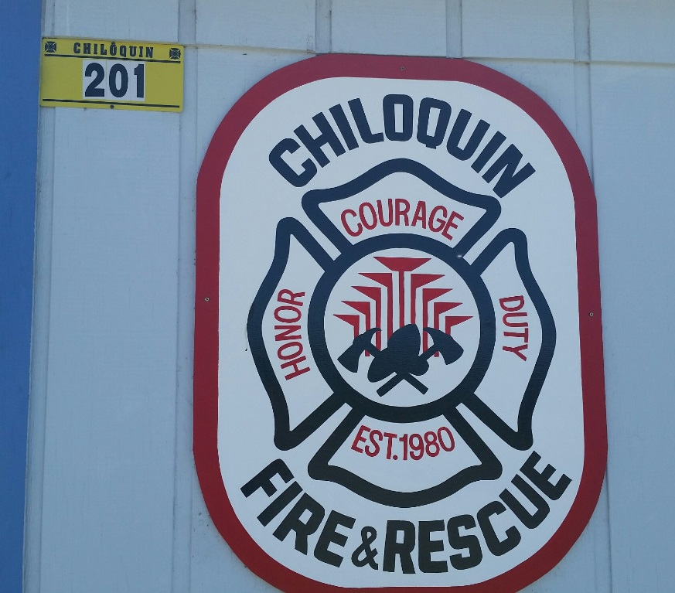
FOR YOUR FREE ADDRESS MARKER, PLEASE COME VISIT US AT OUR DISTRICT OFFICE …. 201 S. FIRST AVENUE, CHILOQUIN
THANK YOU AND BE SAFE
CHILOQUIN FIRE & RESCUE

