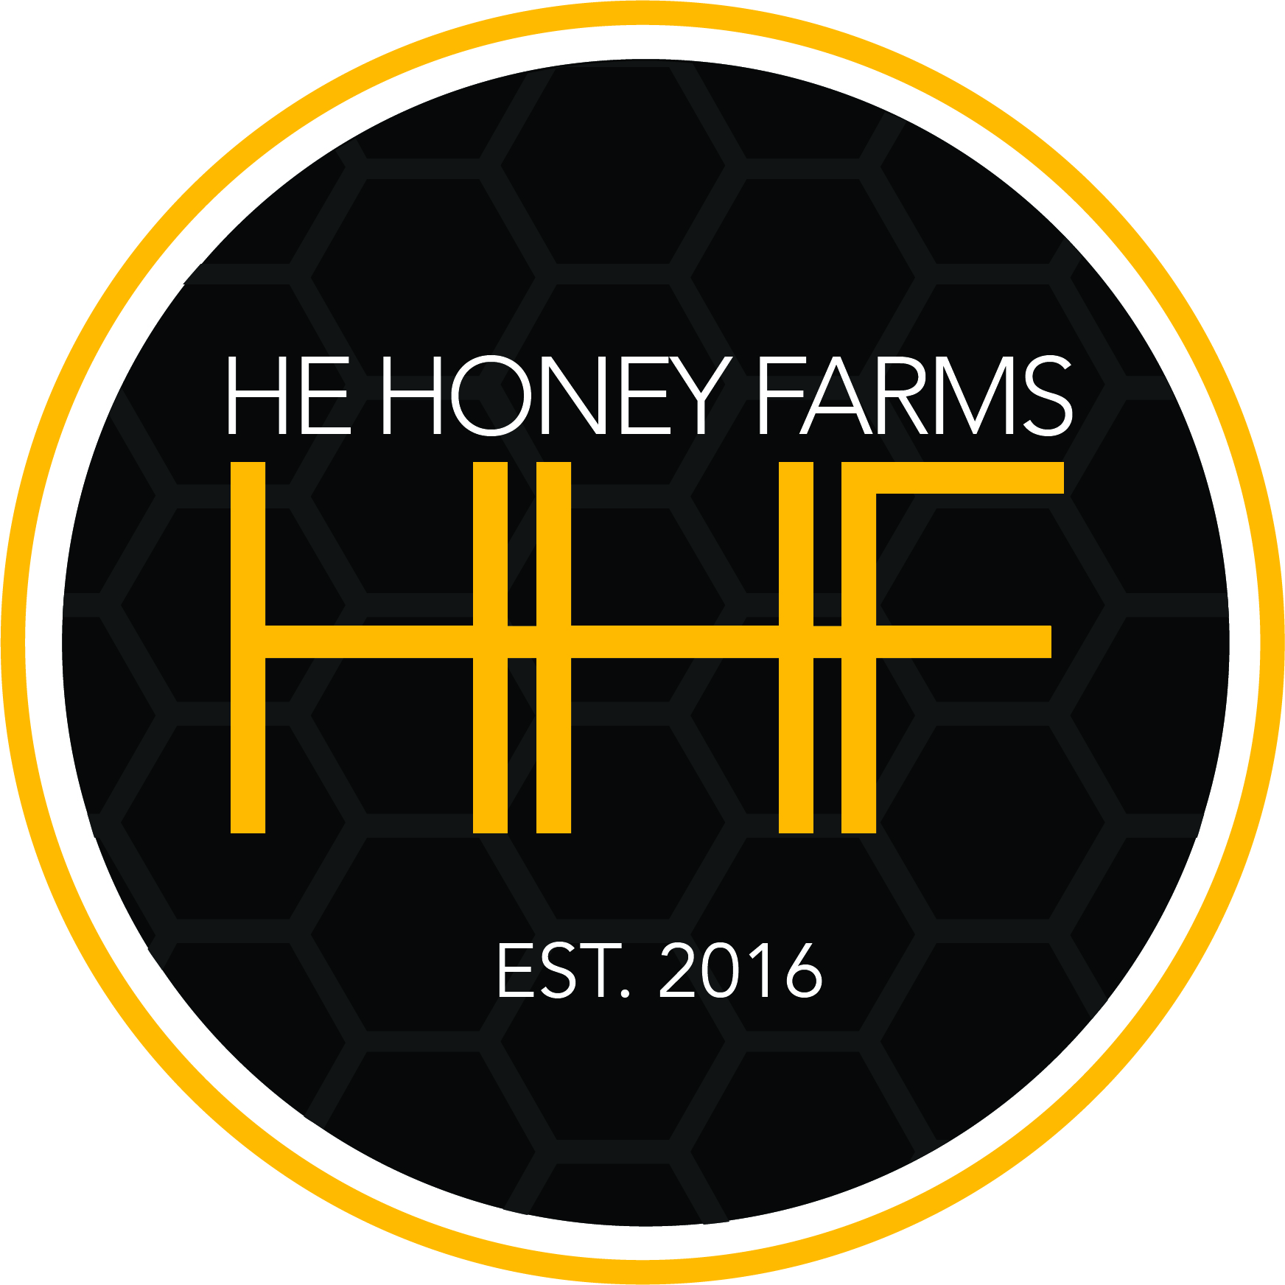
2025 NUCLEUS HIVES “NUCS”

(214)728-5790

P/U DATES: TBD – End of April,
first of May

COST: $225.00 each

Nucleus hives are a young colony of bees from productive, gentle, survivor bees. Each NUC will contain 5 deep frames (3 frames of brood, 2 frames of pollen/nectar) of bees with a 2025 VSH laying queen in a temporary plastic Pro NUC box for transport. We start all NUCs with mated queens, we feel the drone genetics are just as important as the queens. This is a small working colony ready to grow, develop and be moved into a standard deep hive. The queens are marked.
Each NUC may be inspected (bring your own protective gear) at pick-up by the buyer, however, this will cost you a few foragers.

------------------------------------------------------------------------------------------------------------

# of NUCs _______@ $225 ea. = $________ Amount enclosed: $________
**Deposit (half of total) may be paid with check. Balance due at pick up MUST BE CASH.**

Signed _____________________________________ Date __________
Send completed form & check to: HE Honey Farms, 8245 CR 4093, Scurry, TX 75158
Name __________________________________________________________________
Address ________________________________________________________________
Phone __________________________ Email ___________________________________
------------------------------------------------------------------------------------------------------------
Office use: Date form/payment received: _________ Payment/amount _____________

