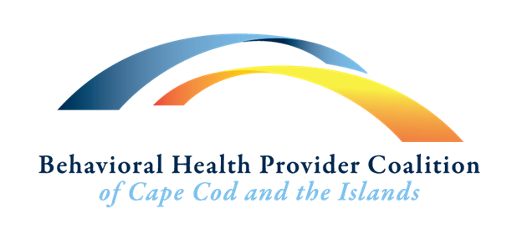

Membership Form

About the Behavioral Health Provider Coalition:

FOCUS: While the focus of this Coalition is on providers of behavioral health services, the ultimate goal is to improve the quality of life for the population we serve. Through improved collaboration, both providers and the people we serve will be better supported. Sharing our collective knowledge will help disseminate the best practices throughout our community.

VISION: Cape Cod and the Islands will have accessible mental health and addiction treatment services within an integrated and cohesive system of care.

MISSION: The Behavioral Health Provider Coalition of Cape Cod and the Islands will facilitate opportunities for networking, communication and sharing knowledge to support an integrated and cohesive system of care to promote wellness in the communities of Cape Cod and the Islands.

Our Goals:
· Present an annual Behavioral Health Summit
· Heighten community awareness of behavioral health services
· Provide opportunities for community discussions about behavioral health to reduce stigma
· Identify areas for systems improvements and collectively advocate for change
· Create stronger linkages between the different resources and people in need
· Provide training to the community using best practices & evidenced base models
· Coordinate outreach programs and resources for providers and the community

Behavioral Health Provider Coalition of Cape Cod and The Islands meetings are open to the public.
If you would like to be listed in the directory of BHPCCCI members, please complete and return this form: by emailing it to coordinator@bhpccapecod.org
Name:_____________________________________________________________________________________________
Organization/Agency/Company (if applicable):____________________________________________________________
Mailing Address:____________________________________________________________________________________
Town:_____________________________State:________________________Zip Code:___________________________
Phone:_______________________Fax:____________________Email:_________________________________________
I am interested in being a member of the Coalition because? _____________________________________________________________________________________________________________________________________________________________________________________________________________________________________________________________________________________________________
Would you be interested in participating in: __Events/Education Planning __Focus Groups __Fundraising __Other_________________________________________________ Do you want to receive notifications of BHPCCCI meetings and information by email? Yes or No

