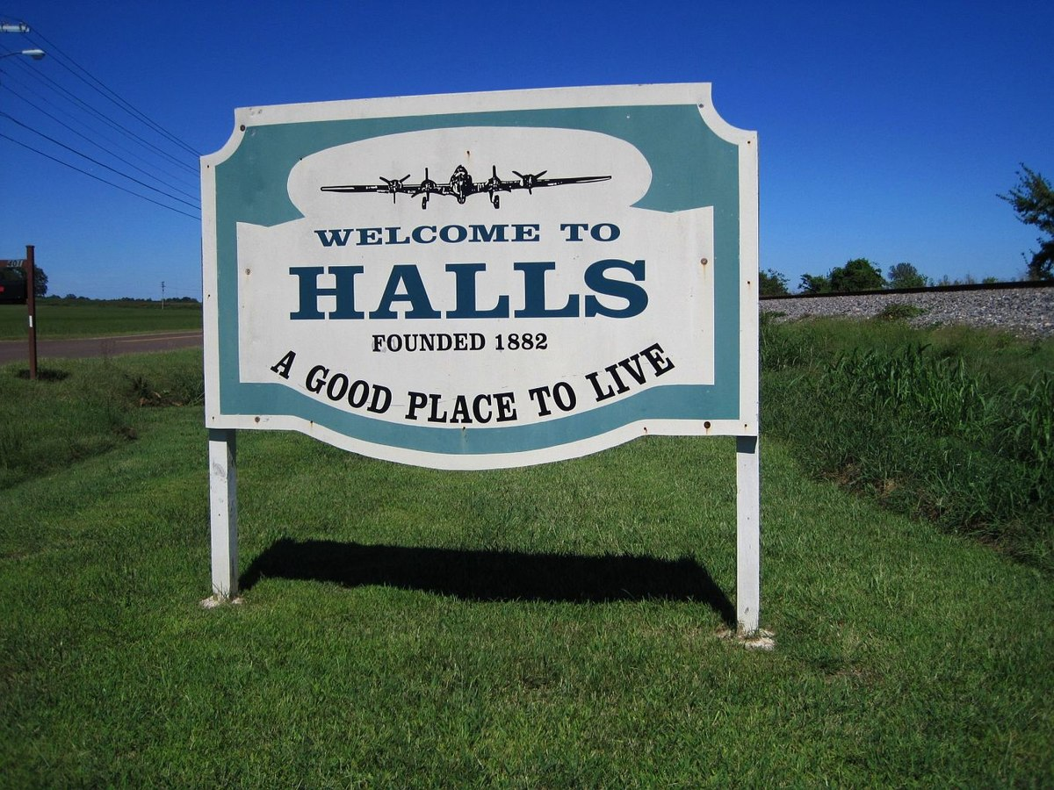
HALLS MUNICIPAL REGIONAL PLANNING COMMISSION
FEBRUARY 16, 2026
Regularly Scheduled Meeting Agenda
Halls Town Hall @ 4:00 PM

I. Call to Order/Establishment of a Quorum
II. Approval of Agenda
III. Approval of the minutes

IV. Hearing of people having business with the Commission. Anyone wishing to address the commission may do so at this time. Speakers must sign in, come forward when called, state their name, and address, and limit their address to 2 minutes.

V. Old Business

VI. New Business

- ELECTION OF OFFICERS
- BUCKNER REZONING REQUEST FROM R-1 TO R-3 AT 113 S. HALL STREET (LAUDERDALE TAX MAP 35G, GROUP C, PARCEL 012.00)
- ANY PROPERTY PRESENTED BUSINESS
VII. Other Business

VIII. Adjournment


102 E. College Street
Jackson, TN 38301
Telephone: (731) 668-6430; Fax: (731) 668-6421
Email: cpate@swtdd.org

MEMORANDUM

TO: Halls Municipal-Regional Planning Commission

FROM: Chris Pate, Regional Planner

DATE: February 9, 2026

SUBJECT: ELECTION OF OFFICERS

A. ELECTION OF OFFICERS

Background

Tennessee Code Annotated and the local bylaws require an election of officers each year see below.

ARTICLE IV

ELECTION OF OFFICERS

Section 1. Nomination of officers shall be made from the floor and officers shall be elected at the annual organization meeting which shall be held during the first meeting of each year in January during which time the Mayor and his or her designate shall act as chairman protem.

Section 2. The nominee for each office receiving a majority vote of the entire membership of the Municipal-Regional Planning Commission shall be declared elected and shall be filled immediately following the election.

Section 3. The term of office for each officer of the Commission shall be one (1) year, or until the election and qualification of his or her successor.

Section 4. Vacancies in offices shall be filled immediately for the unexpired term by regular election procedure.

Title 13 Public Planning And Housing
Chapter 4 Municipal Planning
Part 1 Municipal Planning Commission
Tenn. Code Ann. § 13-4-102 (2012)
13-4-102. Organization of commission -- Rules -- Staff -- Finances.
Each municipal planning commission shall elect its chair from among its appointed members. The term of the chair shall be one (1) year with eligibility for reelection. Each municipal planning commission shall adopt rules for the transaction of business which shall include, but not be limited to, the selection of additional officers from among its members it deems appropriate to fulfill the organizational needs of the municipal planning commission, the requirements for the municipal planning commission to make findings of fact, statements of material evidence and reasons for its actions as part of each motion or action of the municipal planning commission and the keeping of a record of its resolutions, transactions, motions, actions, and determinations which shall be a public record. Any existing provision relating to the appointment of a planning director contained in any municipal, city or town charter or private act must be used in appointing a planning director. In the absence of such a provision, the chief executive officer of the municipality shall have the power to appoint and fix the compensation, within the funds appropriated by the legislative body for this purpose, of a planning director, who shall be qualified by membership in the American Institute of Certified Planners (AICP), experienced in city, regional or state planning or educated in a related academic field. Any person serving as a planning director on March 31, 2010, shall not be required to meet the aforementioned qualifications. For purposes of this section, "chief executive officer" shall mean city manager or administrator, where one exists. In the absence of a city manager or administrator, "chief executive officer" shall mean mayor. Where allowed under the prevailing local authority, the planning director shall have the power and authority to hire and fix the compensation, within the funds appropriated by the legislative body for this purpose, of such other employees and staff as the director may deem necessary for the work of the planning commission. Where allowed under the prevailing local authority, the municipal planning commission may also contract, within funds appropriated by the legislative body for this purpose, with planners or other experts for such services as it may require. In the absence of such authority, only the municipality may contract for such services. The appropriate financial official of the municipality, city or town, within the funds appropriated by the legislative body for this purpose, will disperse funds for the salary or salaries of the planning director and staff and the operational expenses of the planning office and the contracted services of planners or other experts retained to provide assistance to and studies, plans, reviews and reports for the municipal planning commission. The municipal planning commission may also, through the legislative body, receive and expend funds from grants, gifts, contracts, fees, and appropriations from federal, state, other local governments or private sources for the purpose of carrying on its planning functions.
HISTORY: Acts 1935, ch. 34, § 2; C. Supp. 1950, § 3493.2; T.C.A. (orig. ed.), § 13-502; Acts 2010, ch. 701, § 1.

102 E. College Street
Jackson, TN 38301
Telephone: (731) 668-6430; Fax: (731) 668-6421
Email: cpate@swtdd.org

MEMORANDUM

TO: Halls Municipal-Regional Planning Commission

FROM: Christopher Pate, Town Planner

DATE: March 6, 2026

SUBJECT: BUCKNER REZONING REQUEST FROM R-1 TO R-3 AT 113 S. HALL STREET (LAUDERDALE TAX MAP 35G, GROUP C, PARCEL 012.00)
Background
An application has been submitted to rezone an old church (First Assembly of God) into rental housing. The property is 115 feet X 96 feet according to the deed (+/- 9626 measure from the tax map and 11,040 square feet not based deed numbers on a survey). Duplexes in R-2 and R-3 zoning require 9,500 square feet. Townhouses allow for 6,000 square feet per unit in R-3. Multi-family, Elderly Assisted Care, and Elderly Congregate Living would allow for 6000 square feet plus 2000 square feet of lot area for each additional unit (10,000 square feet of lot area would be needed for 3 units). The parking is shown below (Duplexes would apparently be same as single family multi-family). Townhouses are defined in the zoning as the following (defined different in codes or Tennessee Code Annotated)
Townhouse - A building consisting of a series of three (3) or more non-communicating one-family dwelling sections with separate entrance on ground level to each unit, and having a common wall between each two (2) adjacent sections.

b. Residential and Related Uses:

Single family and 2 spaces for each
Multi-family residences dwelling units

Rooming or Boarding 1 space for each two (2)
house rooms to be rented

Elderly Assisted Care Facilities 1.5 spaces for each 2 dwelling units plus 1 for each employee

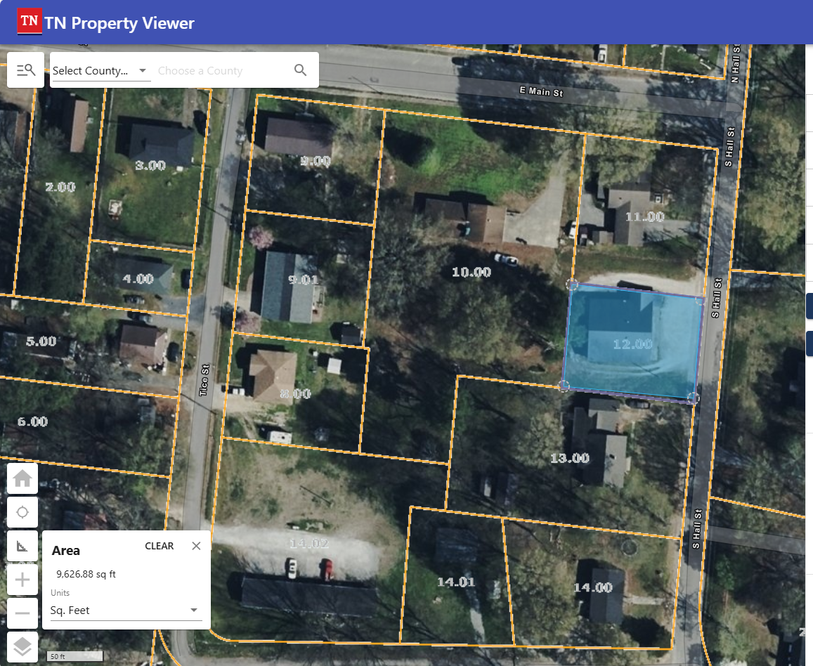
The zoning of the property is currently R-1. The block includes R-2 zoning which allows duplexes depending on lot size and parking. R-3 allows multifamily (apartments) depending on lot size parking and other requirements.
Tice Street appears to have apartments which may have been made nonconforming or “grandfathered” on purpose (since 1988 according to the tax card on Parcel 14.02 See below).
The Master Plan mentions review of the residential district and accessory dwelling units in another part of Town. (See below)

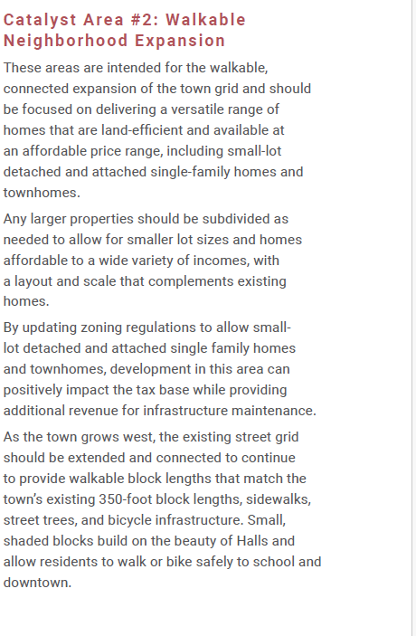

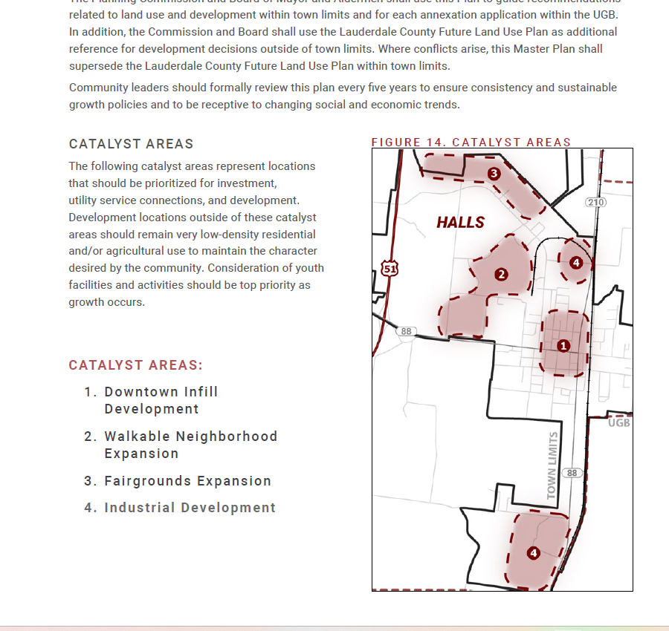
Pursue the following Zoning Ordinance amendments:
■ Update paragraph IV.B.1 which refers to the 1962 zoning map.
■ Develop a permitted uses chart.
■ Develop lot width and setback diagrams for easy visualization of
information.
■ Refine definitions to clarify differences in land use and housing types
and sizes.
■ Clarify where home businesses are allowed.
■ Where appropriate, allow accessory dwelling units (ADUs), adjust
minimum lot area and/or maximum lot coverage, and provide flexibility
in parking requirements to increase housing development opportunities.
■ In all zones, assess lot size and width restrictions, maximum lot
coverage, height restrictions, setbacks, bulk regulations, accessory
structures, parking requirements, and a better mix of uses that supports
community goals.
■ Ensure the regulations allow for a mixed of uses and housing types
consistent with community needs.
■ Consider amending B-1 to allow residential mixed-use, hotel/motel, and/
or civic uses.
■ Consider permitting as a matter of right: schools, public libraries, art
galleries, public museums, parks, playgrounds, municipal athletic fields,
municipal recreation buildings and centers, and religious institutions in
all residential districts.

The current zoning provisions are:

Section A. R-1 (Low-Density Residential) Districts. Within the R-1 (Low-Density Residential) Districts as shown on the zoning map of Halls, Tennessee, the following regulations shall apply:

1. Uses Permitted

a. Single-family dwellings

b. Manufactured residential dwellings as defined in Article X and subject to the provisions of Article III, Section N of this Ordinance.

c. Accessory buildings customarily incidental to the aforementioned permitted use.

d. Real estate signs advertising the sale, rental, or lease of only the premises of which they are maintained, provided that they are not over two (2) square feet in area, and at least fifteen (15) feet from all lot lines.

3. Uses Prohibited

a. Mobile homes on individual lots.

b. Advertising signs and billboards except those specifically permitted under Section B-1 (d) of this Article.

c. Any other use not specifically permitted or permissible on appeal in this Article.

4. Location of Accessory Buildings

a. No accessory building shall be erected in any required front or side yard. Accessory buildings shall not cover more than thirty (30) percent of any required rear yard and shall be at least five (5) feet from all lot lines and from any other building on the same lot.

b. Accessory buildings on corner lots shall conform with front and yard setbacks for both intersecting streets.

Section B. R-2 (Medium-Density) Residential. Within the R-2 (Medium-Density) Residential Districts as shown on the Zoning Map of Halls, Tennessee, the following regulations shall apply:

1. Uses Permitted

a. Single-family dwellings

b. Manufactured residential dwellings as defined in Article X and subject to the provisions of Article III, Section N of this Ordinance.

c. Duplexes

d. Accessory building customarily incidental to any aforementioned permitted use.

e. Real estate signs advertising the sale, rental or lease of only the premises on which they are maintained, provided that they are not over two (2) square feet in area, and at least fifteen (15) feet from all lot lines.

3. Uses Prohibited

a. Mobile homes on individual lots.

b. Advertising signs and billboards except those specifically permitted under Section C-1 (e) of this Article.

c. Any other use not specifically permitted or permissible on appeal in this Article.

4. Location of Accessory Building

a. No accessory building shall be erected in any required front or side yard. Accessory buildings shall not cover more than thirty (30) percent of any required rear yard, and shall be at least five (5) feet from all lot lines and from any other building on the same lot.

b. Accessory buildings on corner lots shall conform with front and yard setbacks for both intersecting streets.

5. Side Yards on Corner Lots. The minimum widths of side yards for dwellings along an intersecting street shall be twenty (20) feet and the structure must lie parallel to the street.

6. Regulations Controlling Lot Area, Lot Width, Yards, Building Coverage and Building Height. The principal building shall be located so as to comply with the following requirements:

a. Minimum required lot area.

1. Single-family
dwelling 7,500 sq. ft.

2. Duplex 9,500 sq. ft.

3. Townhouse 6,000 sq. ft.
per unit

4. Multi-family Elderly Assisted Care, and Elderly Congregate Living

6,000 sq. ft. for the
first dwelling unit plus
2000 sq. ft. for each
additional dwelling unit.

5. Churches 20,000 sq. ft. or 200 sq.
ft. of lot area per
auditorium seat, which-
ever is greater.

6. Schools Eight (8) acres plus one
(1) acre for each 100
students.

7. Other uses As required by the Board
of Zoning Appeals.

b. Minimum required lot widths at the building line.

1. Single-family
dwelling, duplexes,
townhouses, multi-
family dwelling Elderly Assisted Care,
and Elderly Congregate Living 50 feet

2. Churches 70 feet

3. Other uses As required by the BZA.

c. Minimum required front yard.

1. Single-family
dwellings, duplexes,
townhouses, multi-
family dwelling Elderly Assisted Care,
and Elderly Congregate Living 25 feet

2. Churches 30 feet

3. Other uses 30 feet or more as
required by the BZA.

d. Minimum required rear yard.

1. Single-family
dwellings, duplexes,
townhouses, multi-
family dwelling Elderly Assisted Care,
and Elderly Congregate Living 15 feet

2. Churches 20 feet

3. Other uses 15 feet or more as
required by the BZA.

e. Minimum required side yard on each side of lot.

1. Single-family
dwellings, duplexes,
multi-family dwellings Elderly Assisted Care,
and Elderly Congregate Living:

One or two story
buildings 10 feet

Three (3) story
buildings 15 feet

2. Townhouses None on side of townhouse with
common wall - in all other cases the side yard will be 10 feet for one and two story buildings and 15 feet for three story buildings.

3. Churches 15 feet

4. Other uses 10 feet or more as
required by BZA.

f. Maximum lot coverage by all buildings.

1. Single-family dwelling,
duplexes, multi-family
dwellings and
accessories Elderly Assisted Care,
and Elderly Congregate Living 50%

2. Townhouses and
accessories 60%

3. Churches 35%

4. Other uses 50% or less as required
by the BZA

g. Maximum permitted height of structures

1. No building shall exceed three (3) stories or thirty-five (35) feet in height.

2. On a lot less than fifty (50) feet in width at the building line no building shall exceed one and one-half (1 1/2) stories or twenty-five (25) feet in height.

3. No accessory building shall exceed two (2) stories in height.

4. Free standing poles, spires, towers, antennae, and similar structures not designed for, or suitable to human occupancy may exceed the height provisions of this Ordinance provided they comply with all other codes and ordinances, and provided that they are located a distance equal to their own height plus ten (10) feet from the nearest property line.

7. Minimum Off-Street Parking Requirements. (As required in Article III, General Provisions, of this Ordinance).

6. Regulations Controlling Lot Area, Lot Width, Yards, Building Coverage and Building Height. The principal building shall be located so as to comply with the following requirements:

a. Minimum required lot area.

1. Single-family
dwelling 7,500 sq. ft.

2. Duplex 9,500 sq. ft.

3. Townhouse 6,000 sq. ft.
per unit

4. Multi-family, Elderly Assisted Care,
and Elderly Congregate Living 6,000 sq. ft. for the first
dwelling unit plus 2000 sq. ft. for each additional dwelling unit.

5. Churches 20,000 sq. ft. or 200 sq.
ft. of lot area per auditorium seat, which-ever is greater.

6. Schools Eight (8) acres plus one
(1) acre for each 100 students.

7. Other uses As required by the Board
of Zoning Appeals.

b. Minimum required lot widths at the building line.

1. Single-family
dwelling, duplexes,
townhouses, multi-
family dwelling, Elderly Assisted Care,
and Elderly Congregate Living 50 feet

2. Churches 70 feet

3. Other uses As required by the BZA.

c. Minimum required front yard.

1. Single-family
dwellings, duplexes,
townhouses, multi-
family dwelling, Elderly Assisted Care,
and Elderly Congregate Living 25 feet

2. Churches 30 feet

3. Other uses 30 feet or more as
required by the BZA.

d. Minimum required rear yard.

1. Single-family
dwellings, duplexes,
townhouses, multi-
family dwelling Elderly Assisted Care,
and Elderly Congregate Living 15 feet

2. Churches 20 feet

3. Other uses 15 feet or more as
required by the BZA.

e. Minimum required side yard on each side of lot.

1. Single-family
dwellings, duplexes,
multi-family dwellings Elderly Assisted Care,
and Elderly Congregate Living:

One or two story
buildings 10 feet

Three (3) story
buildings 15 feet

2. Townhouses None on side of townhouse
with common wall - in all other cases the side yard will be 10 feet for one and two story buildings and 15 feet for three story buildings.

3. Churches 15 feet

4. Other uses 10 feet or more as
required by BZA.

f. Maximum lot coverage by all buildings.

1. Dwelling Elderly Assisted Care,
and Elderly Congregate Living and
accessories 50%

2. Townhouses and
accessories 60%

3. Churches 35%

4. Other uses 50% or less as required
by the BZA.

g. Maximum permitted height of structures.

1. No building shall exceed three (3) stories or thirty-five (35) feet in height.

2. On a lot less than fifty (50) feet in width at the building line no building shall exceed one and one-half (1 1/2) stories or twenty-five (25) feet in height.

3. No accessory building shall exceed two (2) stories in height.

4. Free standing poles, spires, towers, antennae, and similar structures not designed for, or suitable to human occupancy may exceed the height provisions of this Ordinance provided they comply with all other codes and ordinances, and provided that they are located a distance equal to their own height plus ten (10) feet from the nearest property line.

7. Minimum Off-Street Parking Requirements. (As required in Article III, General Provisions, of this Ordinance).

Section C. R-3 (High-Density Residential) Districts. Within the R-3 (High-Density Residential) Districts as shown on the zoning map of Halls, Tennessee, the following regulations shall apply:

1. Uses Permitted

a. Single-family dwellings

b. Duplexes

c. Townhouses, multi-family dwellings, Elderly Assisted Care, and Elderly Congregate Living shall be permitted as a matter of right, provided, however, that the provisions of this Ordinance are observed and subject to approval of the site plans by the Planning Commission. The Planning Commission may attach such conditions to the permit as are necessary to minimize vehicular and pedestrian congestion, to preserve and protect the character of the district in which the proposed use is located. This power shall include: the power to require greater setbacks and yard spaces than required by other provisions of this Ordinance, the power to require provision of well-designed and supplied play spaces, the power to specify access points and driveways and parking locations, and similar site design matters. This power shall not include the power to specify or alter the architectural style of the proposed buildings, the power to specify building materials or colors, or other similar powers.

d. Accessory Building customarily incidental to any aforementioned permitted use.

e. Real estate signs advertising the sale, rental or lease of only the premises on which they are maintained, provided that they are not over two (2) square feet in area and at least fifteen (15) feet from all lot lines.

The definitions are as follows (Duplex is Two family)

Dwelling, Multi-Family - A residential building designed for or occupied by three or more families, with the number of families in residence not exceeding the number of dwelling units provided.
Dwelling, Single-Family - A detached residential dwelling unit other than a mobile home, designed for and occupied by one family only.
Dwelling, Two-Family - A detached residential building containing two dwelling units, designed for and occupied by two families only.
Dwelling Unit - One room or rooms connected together, constituting a separate independent housekeeping establishment for owner occupancy, or rental or lease on a weekly, monthly, or longer basis, and physically separated from any other room or dwelling units which may be in the same structure and containing independent cooking and sleeping facilities.
Elderly Assisted Care. A facility or development providing elderly care and housing, containing single rooms or other dwelling units which may consist of bedrooms, dinettes, and bathroom facilities, commonly containing group dining halls, recreational areas, and other communal areas provided that 24-hour medical care, medical staffing, and other services are required or provided. For the purposes of this Ordinance, these types of facilities shall be classified as multi-family complexes and apartments.

Elderly Congregate Living. A facility or development providing elderly congregate group housing, containing individual dwelling units which may consist one or bedrooms, dining area, bathing and cooking facilities, or a combination thereof, provided that 24-hour medical care and medical staffing is not required or provided. For the purposes of this Ordinance, these types of facilities shall be classified as multi-family complexes and apartments.

Recommendation

Option 1 (preferred by the regional planner)

Based the size of the lot and the adjoining zoning the Planning Commission could extend the R-2 district on Tice to this property including Parcels 14.01, 14.00, 13.00 and the subject Parcel 12.00). The building could be converted to a duplex, which requires a minimum parcel of 9,500 square feet.

Option 2

The entire block (Tice and S. Hall Streets) can be rezoned to R-3 but lot size (density requirements) will only add one unit more than R-2 (unless property size is larger). The apartment would have 3 units.

Option 3 would be to leave the zoning as is per the existing single-family uses.

Parking will be required for any proposed use if the property is rezoned (multifamily).
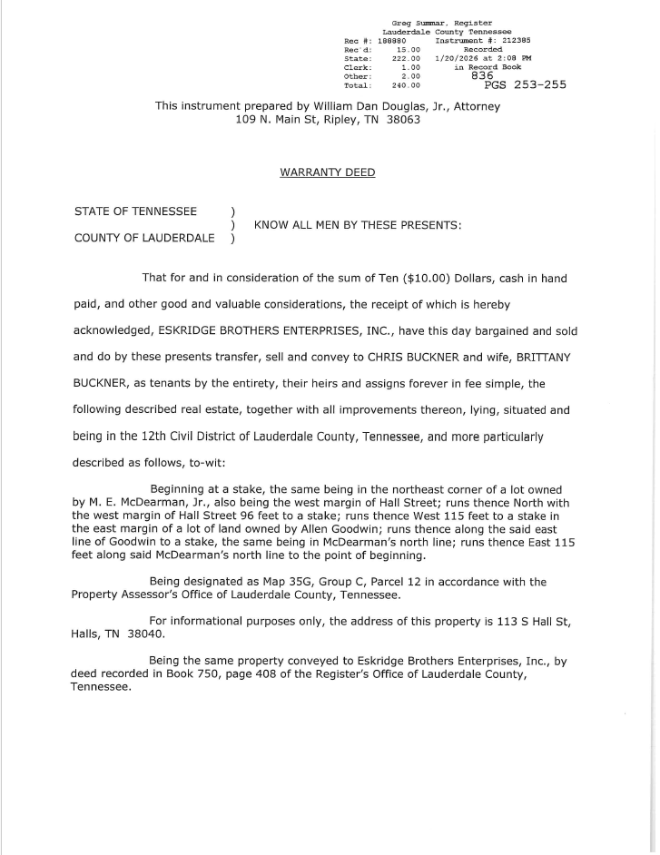

APPLICATION #_______

PLANNING COMMISSION APPLICATION FOR PROPERTY REZONING RECOMMENDATION, TEXT AMENDMENT RECOMMENDATION, OR SITE PLAN REVIEW UNDER THE HALLS ZONING ORDINANCE; MINOR SUBDIVISION FINAL PLAT REVIEW, PRELIMINARY PLAT REVIEW, CONSTRUCTION PLAT REVIEW, OR FINAL PLAT REVIEW UNDER THE SUBDIVISION REGULATIONS OF HALLS, TENNESSEE; OR REQUEST FOR ANNEXATION AND ZONING

I. GENERAL INFORMATION:

Name of Applicant(s) Buckner Christopher Marvin
(Last) (First) (Middle)

Name of Applicant(s) Buckner Brittany Renee
(Last) (First) (Middle)

Address 157 Cody Lane Henning, TN 38041

Phone 731-413-3410 or 731-612-1794

Applicant’s Interest In Property:
Owner___X____
Leasee____________
Prospective Purchaser______
Option Holder______
Other (State)_______________________

Email: c.buckner@roseconstruction.com

II. NATURE OR CHARACTER OF APPLICATION:

A. Zoning Action Requested:

Rezoning Recommendation______

Site Plan Review______ (include Required 9 Copies and PDF sent to City Hall)

Zoning Ordinance Amendment Recommendation_______

Property Location(s) (Address) 113 South Hall Street, Halls, TN 38040

Tax Map and Parcel Number(s) 035G Group C 012.00

Present Zoning R1 Proposed Zoning R3
Classification______________ Classification (If Applicable)____________

Property Description (sketch or attach below a map showing: location of property dimensions, street names, and other characteristics pertinent to this application

Legal Description (attach copy of Plat, Deed, and/or Survey to application)

Reason(s) for Request

There is an imminent need for rental housing in Halls currently and moreso when new industry workers arrive

We are both Lauderdale County natives, our children attend Halls School System, and we are looking to invest in this community thru added rental options and current property rehab on a building that is in need

We currently own eleven other rental properties and have the know how to provide a safe, clean, family friendly property that is accepted by neighbors and sought after by rental candidates.

Lastly, I hope you all give us an opportunity here to prove that we can help fill a void in Halls. We hope to invest more in Halls in the years to come and help our community thrive.

B. Subdivision Regulations Action Requested (include 9 Paper Copies and PDF sent to City Hall):

Preliminary Plat Review ______
Final Plat Review __________________
Minor Subdivision Final Plat Review _________________
Vacate a Plat__________

Property Location (Address):________________________________________

Tax Map and Parcel Number:________________________________________

Present Zoning
Classification:_____________________________________________________

C. Annexation and Zoning Action Requested:

Property Location(s) (Addresses):_____________________________________

Tax Map and Parcel Number(s):_______________________________________

Present Zoning ______________________
Classification(s) (in County):________________________________________________

Description of Intended Use of Property:_________________________________________________________

Property Description (sketch or attach below a map showing: location of property dimensions, street names, and other characteristics pertinent to this application)

Legal Description (attach copies of Deeds, Surveys to application)

Petition by Property Owners (if more than one or not adjacent to Corporate Limits (attach copy to application)

Reason(s) for Request

________________________________________________________________

________________________________________________________________

________________________________________________________________

________________________________________________________________

I hereby certify that the statements made by me herein and the maps and other accompanying data submitted herewith are true and correct.

Christopher Buckner___________
Signature of Applicant

Brittany Buckner______________
Signature of Applicant

______________________________
Signature of Applicant

2/6/2026______________________
Date
Non-refundable Fee

Fee Paid: $_______

Receipt No. ______

Application Status:
Approved_____
Denied______
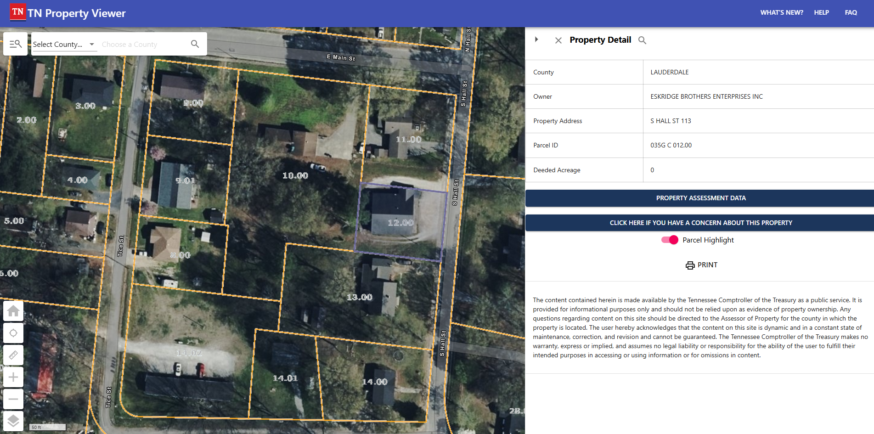
Zoning
