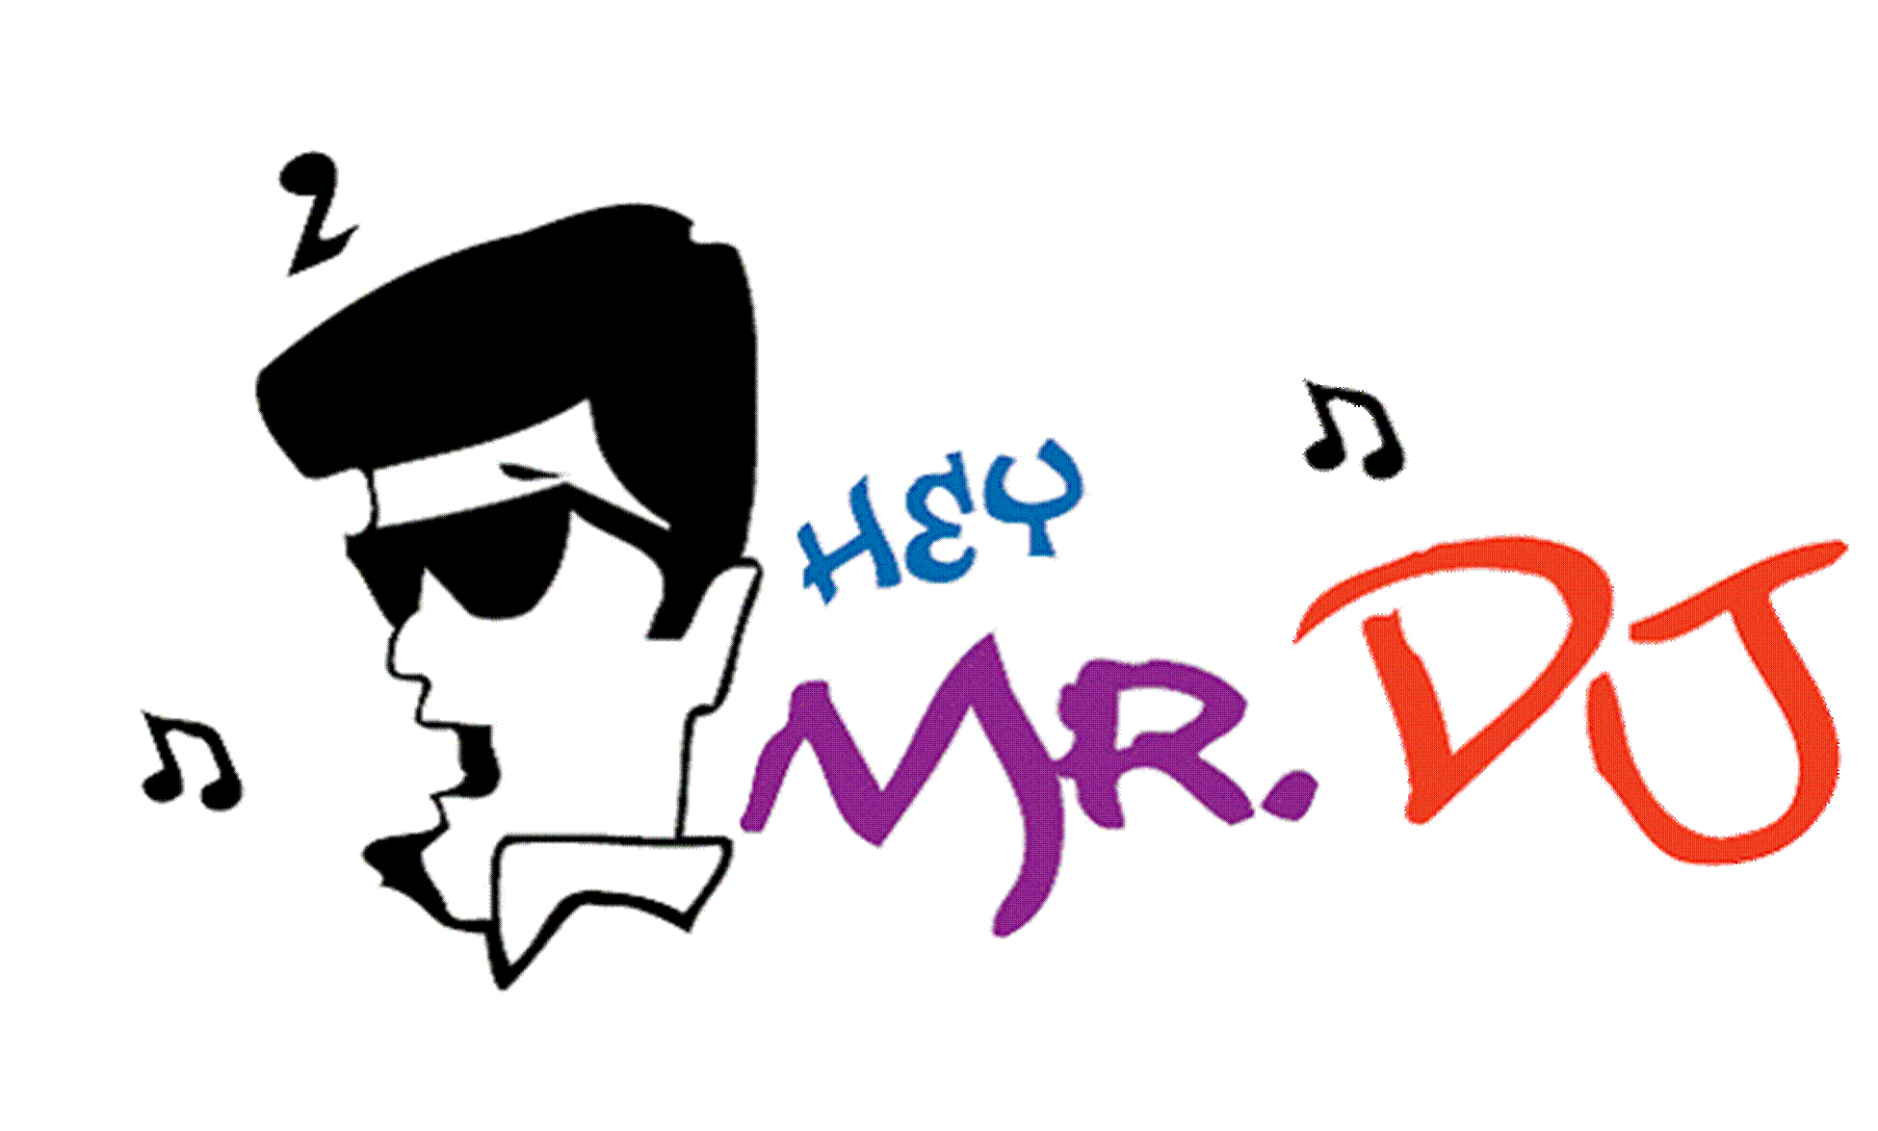
Reception INFORMATION Sheet

The following has been provided to assist you while filling out the Reception PLANNING Sheet. The information includes tips, ideas and suggestions for a successful party. Each BOLD heading corresponds to a section on your planner. If you have any questions, please call us.

Entrance Of Wedding Party
Upon arrival at your reception site, we suggest formally starting the event with a grand entrance of the wedding party followed by the bride & groom. This announcement serves as the kick-off to the party. It is
not being done as an introduction of your bridesmaids and groomsmen, but rather as an enthusiastic recognition of these special loved ones. We will coordinate the entrance order of each couple and then announce each name as they enter to an upbeat musical background.

Entrance Of The Bride & Groom
As your MC announces the entrance of the bride and groom your friends and family will rise and greet you with applause and cheers.

Bride/Groom to Welcome And Thank Guests
A receiving line is a dated and time-consuming method of greeting your guests. The following is a fun and memorable alternative to the typical receiving line. Upon entering the room, we encourage you to acknowledge your guests. We will provide you with a wireless mic. This is a wonderful opportunity to welcome everyone and to do any special acknowledgements, such as guests who have traveled a long distance, or friends or family who have contributed in the preparation of the ceremony or reception. It’s especially meaningful to hear from the bride and groom how important their friends and family are to them.

Food
Immediately following your welcome, we recommend having the meal service begin. Remember, although you have just arrived, your guests have been waiting for some time. During the pre-planning stages, inform your caterer what time you expect to arrive and that you would like the meal service to begin shortly after that. It is easier for the caterer to move the food service back if you are running late than it is for them to move it forward if you are ahead of schedule. Once you have had the opportunity to enjoy your meal, it is a good time for the bride and groom to visit with their guests. Typically, most guests will still be eating and you will have about 20 minutes to mingle table to table.

Toasts
The toast is usually done at the conclusion of the meal. Your MC will coordinate all aspects of this event. After the champagne has been poured, we will have a wireless mic available for your best man, maid of honor, fathers, or any others to say a few words. We strongly discourage open toasting. This can be a slow and awkward process that drastically impacts the smooth flow of your reception. (Continued on back)

Cake Cutting
Following the toasts is the traditional cutting of the cake. You will notice that your guests are now getting more animated, and giving their enthusiastic encouragement to the bride and groom during the feeding of the first piece of cake. The fun of this formality is in the anticipation. We suggest that you have a playful, yet sensible attitude while feeding each other.

Bouquet Toss
As your photographer finishes any additional photos of the bride and groom at the cake table, your MC will gather the single ladies on the dance floor. You will want to be sure to have your throw bouquet handy. Your MC will get the energy level up as he counts the throw with you, 5-4-3-2-1. Following the catch, the photographer will want to get a special photo of the bride with the woman who caught the bouquet. If you want an alternative to this tradition, please let us know. We will be happy to suggest other options that will allow you to give away your bouquet and still create a unique and memorable moment for you and your guests.

Garter Removal/Toss
Your MC will invite all of the single men to the dance floor. For the garter removal, the bride can sit on a chair or on the best man’s knee. The groom will then get down on one knee in front of his bride. Once the garter has been removed, your MC will begin the countdown for the toss, 5-4-3-2-1. The gentleman who catches the garter will then be joined on the dance floor with the woman who caught the bouquet. The bride and groom will then join them for a fun, candid photo.

First Dance Song
All of the attention is now focused on the dance floor. The first few notes of your special song begin to play as you begin to share your first dance as husband and wife. Many couples choose to have the wedding party join them halfway through the dance. By doing this, you give the photographer an opportunity to photograph your wedding party, plus it shortens the amount of time the two of your are dancing.

Parents Dance Song
You can choose a special song for the parents of the bride and groom. Each set of parents is invited to the dance floor to share a special dance with their children. One option is to have all parents and their children join in halfway through this dance.

Father/Daughter Dance Song
One of the most traditional events at the reception is the moment the father of the bride dances with his daughter. This special song can also include the groom with his mother. Your MC can also invite all fathers/daughters or mothers/sons to join in halfway through this dance.

Other Spotlight Dance
For some brides, a special dance with a Stepfather, Uncle, Brother, or close family friend is done in lieu of, or in addition to, a parents dance.

General Dancing
It’s important that the bride and groom remain on the dance floor for the first fast dance as it will make it more inviting as your guests start dancing. As we observe the reaction of your guests, we can then best determine which songs to play. Your MC is an expert at music programming and has the ability to “read the crowd” to keep guest of all ages dancing and having fun.

Money Dance
If you decide to do a money dance, your MC will announce it as an opportunity for your friends and family to share a special slow dance with the bride or groom. The MC will ask the best man and maid of honor to assist him. They will help ensure the timely flow of the guest and collect the money. It’s important that the bride and groom remain on the dance floor at the conclusion of the money dance. As the music tempo picks up, your presence will encourage all guests to join you as the fast dancing resumes.

Types Of Dance Music Preferred
The very best parties always have a mixture of songs that please and entertain all age groups. Below is a general list of various categories and popular artists. We welcome you to highlight all of your favorite music categories.

Big Band/Standards – Duke Ellington, Glenn Miller, Benny Goodman, Nat King Cole, Tommy Dorsey,
Frank Sinatra, Artie Shaw, Johnny Mathis, etc.
50’s/60/s Rock – Beatles, Beach Boys, Jerry Lee Lewis, Elvis, Platters, Bill Haley, Chubby Checker,
Bobby Darin, etc.
Classic Rock – Bob Seger, AC/DC, Van Halen, John Mellencamp, Rolling Stones, Aerosmith,
ZZ Top, Eric Clapton, Elton John, etc.
Funk/Disco – Bee Gees, Village People, Chic, Earth Wind & Fire, Donna Summer, Commodores, Gap
Band, Kool & The Gang, Wild Cherry, etc.
Motown/60’s Soul – Aretha Franklin, James Brown, Four Tops, Temptations, Supremes, Marvin Gaye,
Smokey Robinson, Jackson 5, etc.
Country – Shania Twain, Dixie Chicks, Faith Hill, Tim McGraw, George Strait, Alan Jackson,
Garth Brooks, Alabama, etc.
80’s Retro – Beastie Boys, B-52’s, New Order, Romantics, Cure, INXS, Devo, Clash, Soft Cell,
Modern English, Talking Heads, Billy Idol, etc.
R&B/Hip Hop – Rob Base, Rick James, Prince, Tone Loc, Young MC, Salt-n-Pepa, Will Smith,
C&C Music Factory, MC Hammer, Michael Jackson, Madonna, etc.
Ethnic – Italian, Jewish, Irish, Latin, Greek, Cajun, Polkas, Reggae, etc.
Group Participation Dances – Conga, Shout, YMCA, Electric Slide, Grease, etc.
Current Hits – Subject to change

Dedications, Birthdays, Anniversaries, etc.
Be sure to list any special announcements you would like your MC to make. This is a great way to personalize your event and recognize someone special.

Sensitive Subjects
Your Premier MC will conduct himself or herself in a professional and courteous manner at all times throughout your reception. If you feel we need to be aware of any sensitive information regarding your event, family, or guests, please list it here.

Anything Else We Should Know?
If you are having a video presentation, a singer, musicians, fraternity/sorority serenade, centerpiece giveaway, or any other personalized additions that will make your party unique please list them. Your Premier MC will offer suggestions regarding the sequence and timing of these special touches.

(The back of this page contains additional information regarding the pre-planning of your event)

Things we wanted you to know…Please read and retain for easy reference.

The Hey Mr DJ Staff
Planning your wedding can be a lot of work, but it should also be a lot of fun. Our goal is to provide you with helpful ideas and suggestions that will reduce your work and increase your overall enjoyment. If you have any questions regarding your contract, reception planner, payments, etc., please call and speak with our Office Manager, Connie Morrill. In addition, Randy Bartlett is available during regular business hours to answer any questions regarding special music ideas, traditional formalities, order of events, etc. We can also offer referrals for photographers, videographers, ceremony musicians, or any other wedding services.

Planning Your Wedding Reception
We believe that the pre-reception planning session with your Premier MC is the foundation of a successful event. It is important to note that this planning session will be done in person approximately 4 to 6 weeks prior to your reception, and both bride and groom should attend. In addition, a short meeting by phone or in person will take place the week of your event to cover all the last minute details.

Our Sound System & Set-Up
One of the most important factors in the success of your reception is where our DJ sound system is to be set. It is critical that the DJ system is placed in an area directly next to the dance floor, and that the DJ have a good line of sight to the entrance of the room, head table and cake table. As your Master of Ceremonies, we need to be able to see each of these areas in order to control the timing of each. It is not a good idea to surround your dance floor on all four sides with tables. Remember, our speakers need to carry sound to the dance area. If there are tables directly between the speakers and the dance floor, the guests seated at those tables will have an uncomfortable level of sound. Please be sure to provide us with a minimum of a 6’ X 10’ area to set our sound systems and speakers. If you have guests seated in an adjacent area or room, we can provide additional speakers so that all your guests can hear the announcements and music at a comfortable level. A nominal charge will apply for this customized speaker package.

The Sequence Of Events
In addition to the set-up, the sequence of events is also a very important part of the overall success of your wedding reception. (see reception information sheet) As entertainment professionals, we are experts at helping you plan the best sequence for all the events and formalities. While you may get ideas from others, your Master of Ceremonies is uniquely qualified to create the perfect sequence for you – one that flows smoothly from one event to the next, while maximizing guests enjoyment and participation. If you are planning a tentative agenda with any other wedding professionals (caterer, photographer, etc) please call us first. Randy will be happy to share with you his professional expertise that will help you customize the very best party.

Gratuities
Unlike many other service professionals, we do not contractually add service charges or gratuities. After considering the advanced pre-planning with your MC, the level of service and quality of presentation, along with your overall enjoyment, we believe you should decide for yourself what level of gratuity, if any, you would like to give. As a reference, a tip of 10% - 15% is most common. For accounting purposes, we ask that you pay any gratuity directly to the MC.

Food & Drink
If you would like to provide us with a meal, please discuss it first with your MC. Vendor meals are often available for us without the additional cost being incurred by you. We will make this arrangement with the banquet staff upon our arrival. Our staff never consumes alcoholic beverages. However, providing ice water and soft drinks is greatly appreciated.

