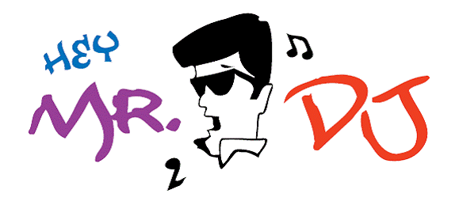

RECEPTION PLANNING SHEET
(Complete and return 2 weeks prior to your event)

Wedding Date______________________Start Time____________End time__________
Wedding Ceremony Location________________________________________________
Reception Location_________________________________Room Name_____________
Address____________________________________________Number of Guests______
Bride’s Name_____________________________________________Age____________
Bride’s Address_____________________________City____________Zip___________
Phone(H)____________Phone(W)___________Occupation_______________________
Brides birthday:__________________________Hometown :______________________
Groom’s Name____________________________________________Age____________
Groom’s Address____________________________City____________Zip___________
Groom’s birthday:__________________________Hometown :____________________ Phone (H)____________Phone(W)___________Occupation_______________________
E-Mail Address (Bride)________________________(Groom)______________________
Address after wedding__________________________City______________Zip_______
Honeymoon Location______________________________________________________

Bride’s Parents (Circle all that apply)
Mother/Step__________________Father/Step___________________Years Married____
Phone_______________________Phone_________________________
Mother/Step__________________Father/Step___________________Years Married____
Phone_______________________Phone_________________________

Grooms Parents (Circle all that apply)
Mother/Step__________________Father/Step___________________Years Married____
Phone_______________________Phone________________________
Mother/Step__________________Father/Step___________________Years Married____
Phone_______________________Phone_________________________

Grandparents (List all who will attend)
Names__________________________________________________Years Married____
Names__________________________________________________Years Married____
Names__________________________________________________Years Married____
Names__________________________________________________Years Married____

Wedding Coordinator___________________________Attending Reception?Yes__No__
Photographer________________________Videographer__________________________
Caterer________________Contact______________________Phone________________

How were you referred to Hey Mr DJ?

Repeat Customer
Saw us perform at_________________________________________________________
Referred by______________________________________________________________
Other(specify)____________________________________________________________
(Complete Both Sides)

**Read “Reception Information Sheet” prior to completing**
Is Hey Mr DJ going to Announce:
Entrance of Wedding Party Yes/No
Entrance of Bride & Groom Yes/No Announced as:___________________________
Bride/Groom to Welcome & Thank Guest Yes/No
Food (Circle One) Buffet Sit Down Approx. Start Time___________________
Toast Best Man (name)_________________Maid/Matron of Honor (name)__________
Father of Bride Yes/No Father of Groom Yes/No
Others____________________________________________________________
Cake Cutting: Yes/N0 Special Song:_______________________________________

First Dance Song__________________________________Artist__________________

Father/Daughter Dance Song________________________Artist__________________
Groom / Mother Dance Song _______________________Artist__________________
All Father/Daughters or all parents/children join in Yes/No
Bouquet Toss Yes/No - Special Song ? _____________________________________

Garter Toss Yes/No - Special Song ?________________________________________

Other spotlight dance?____________________________________________________
Money Dance Yes/No

Anniversary Dance Yes/No

Photo Montage - Yes/No Are we Providing Projector and Screen - Yes/NO

Special Requests
_________________________ _____________________ _____________________ _________________________ _____________________ _____________________
_________________________ _____________________ _____________________
_________________________ _____________________ _____________________

Dedications, Birthdays, Anniversaries, etc.___________________________________
________________________________________________________________________
________________________________________________________________________
Sensitive Subjects________________________________________________________
________________________________________________________________________
________________________________________________________________________
Anything else we should know?_____________________________________________
________________________________________________________________________
________________________________________________________________________
________________________________________________________________________

Please feel free to call or email me with any questions you might have

Tyler C Smith 406-360-0629 ( cell) 406-251-6500 ( office)
Email: heymrdjmt@msn.com

Website : www.djtylert.com

