Santa Cause

School Outreach Program

**Cindy McElduff, Program Director**

[cwmcelduff@aol.com](mailto:cwmcelduff@aol.com)

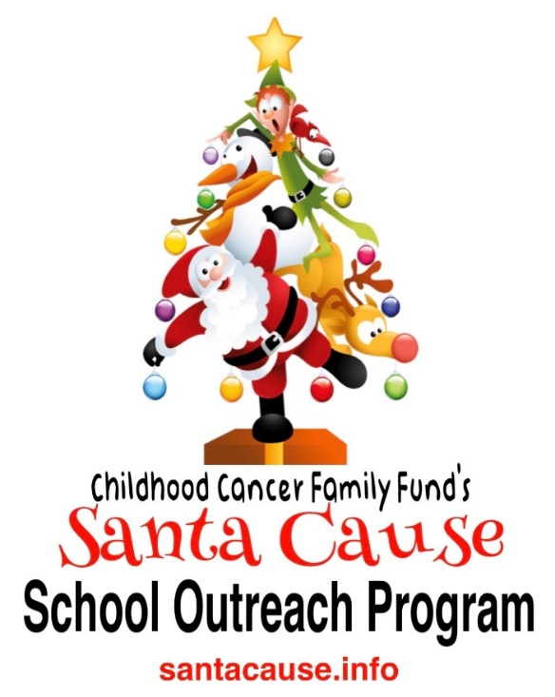

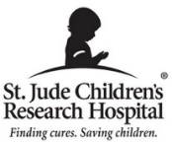 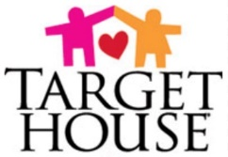

**“It’s a low you’ve never felt before…having zero money for Christmas gifts for your child with cancer is soul crushing. Your organization has lifted a burden from my shoulders.”**

**---Quote from a pediatric cancer patient’s dad**

**Childhood Cancer Family Fund**

**300 Chertsey Court**

**Louisville, KY 40243**

**502-930-9601**

**info@ccff.info**

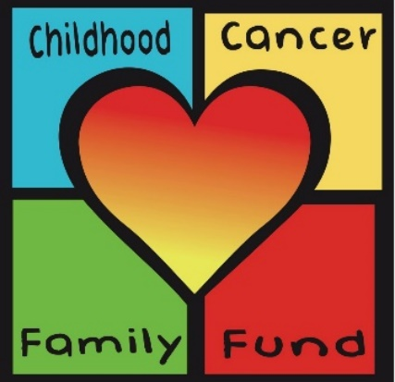

…a mother of one of the pediatric cancer patients entered the room full of gifts and immediately began crying.

**A Christmas Miracle**

Childhood Cancer Family Fund provides Christmas gifts for the pediatric cancer patients at St. Jude Hospital’s Target House long term family housing complex.

Every Christmas pediatric cancer patients’ parents come down to the free Christmas Shop at Target House one family at a time. A volunteer helper assists them with picking out gift for their children. On this night a mother of a patient entered the room that was filled with gifts and immediately began crying. A volunteer asked if she was okay, and through her tears she began to speak. She said she knew her child was going to be celebrating their **final earthly Christmas** and had just one wish for Christmas, one particular toy. She explained that money was tight and there was no way she could afford the only gift her child asked for. She said that just prior to coming down to shop she was online looking at the toy her child requested, trying to figure out the impossible, how she could afford it.

She came to the Christmas Shop just hoping to find something that might be a suitable replacement, but she admitted feeling so bad that she couldn’t afford the last gift her child was ever going to ask for. When she was escorted into the room to shop, she immediately looked on the floor right in front of her. THERE IT WAS! The only thing her child asked for was sitting there waiting to be claimed!

**She was going to be able to provide her child the one gift they asked for, the last gift she would ever be able to give her child.**

Someone out there somewhere donated that gift or the money to buy that gift and provided a Christmas miracle to that family. Your support now can help provide the next Christmas miracle for a family at Target House. **Will you help us provide the next Christmas miracle**?

 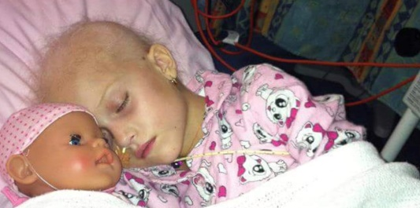

**­**

**Mission Statement**

To provide Christmas gifts to pediatric cancer patients at St. Jude Hospital’s Target House long term family housing unit.

# History of CCFF

**Childhood Cancer Family Fund** (CCFF) is a 501(c)3 nonprofit that provides gifts to pediatric cancer patients at St. Jude Hospital’s Target House Family residence.

CCFF was founded by Mike Crask, a retired Louisville, Ky Police Detective of 24 years. Having witnessed the worst of humanity as a Homicide Detective then helping affected families put shattered lives back together Mike sought out a way to continue to serve others. Through a friendship with a West Tennessee family that had a two-year-old daughter who passed away from brain cancer Mike helped found a nonprofit that provided food and other household goods to St. Jude families at Target House. As Executive Director of that organization Mike helped start the food pantry for struggling families at Target House. In almost 3 years the organization provided nearly $250,000 of food and goods to Target House families.

Running a growing organization 4 hours away from his Louisville, Ky home became more difficult as more events and responsibilities were added. After leaving the organization on solid footing to start a nonprofit that would be based in Louisville but still focus on the place and families he came to love at St. Jude Hospital’s Target House, Childhood Cancer Family Fund was born.

Upon deciding to start Childhood Cancer Family Foundation he wanted the focus to be on one single area of need at Target House. He consulted their staffers and their single greatest need was financial help with their annual free Christmas Shop and their Christmas in July celebration.

Target House is the long-term family residence for pediatric cancer patients and their families while the child is undergoing treatment at St. Jude Hospital. It is a St. Jude Hospital facility, and Target pays for the naming rights. There are 96 families that stay in two-bedroom apartments. Patients needing treatment for at least 3 months and up to 3 years are assigned to live there. The children there range in age from infant to 19. Patients at Target House tend to be the kids most critically in need of treatment. Families stay for free and utilities are paid. Food, household goods and personal hygiene items are not provided. Everyday living expenses are not covered.

There are very few pediatric cancer hospitals in the US so families often must go far away from home to seek treatment for their child. Families are often split up because one parent is with the child, or both parents come to live at Target House. Since normally one or both incomes are lost many of the families living at Target House are really struggling financially.

**Target House Christmas Shop**

Each year donated gifts are used to stock a free Christmas Shop where parents are brought in one family at a time to shop for all of their children with the help of a volunteer. The gift selections are then gift wrapped by volunteers and delivered to the families rooms. There are lots of gifts donated each year but there are not enough donations to cover all the gifts needed, mainly for teens and young adults. Target House must pull thousands of dollars a year from money budgeted for other programs to purchase needed gifts. We want to fill this gap so that their other programs are not negatively affected.

**Christmas in July**

Each July Target House holds a Summer Camp week for the patients at St. Jude Hospital’s Tri Delta, Ronald McDonald and Target Houses. On the final day of Camp Week we host a Christmas in July Celebration where we provide entertainment, music, gifts and a meal for the families.

**Santa Cause**

**School Outreach Program**

... when severe headaches started he knew he had

to see a doctor...his worst fear was confirmed.

Paying It Forward: Dylan’s Inspiring Battle

While playing high school baseball in Louisiana Dylan started seeing double when the ball was hit or thrown to him. At first he thought nothing of it, but when severe headaches started he knew he had to see a doctor. After receiving an MRI exam, his worst fear was confirmed. Dylan was diagnosed with a malignant brain tumor which lead to two brain surgeries to remove the cancerous tissue. After the surgeries Dylan was treated by Doctors at St. Jude Hospital. Over a period of 5 months he received 4 rounds of chemotherapy and multiple doses of radiation.. During the five months of treatment Dylan and his parents lived at Target House. Dylan is now cancer free!

To pay forward the immense community support shown by Choudrant La.to their family during Dylan’s battle with cancer, his mom Cindy McElduff organized a toy drive for the patients at St. Jude Hospital. Over 750 toys and hundreds of dollars in gift cards were collected.

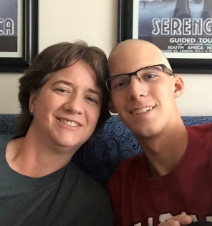 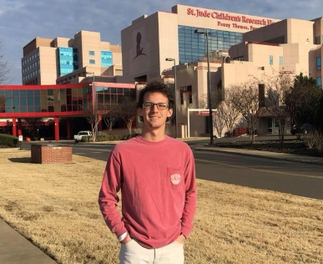

**Today Dylan is CANCER FREE**

**We have taken Cindy’s idea of collecting Christmas Gifts for pediatric cancer patients and developed it into our School Outreach Program. It is the simple idea of partnering with Schools, groups, teams and clubs from first grade to College age and collecting new gifts for the pediatric cancer patients at St. Jude Hospital’s Target House.**

**Cindy is now on the CCFF Board of Directors and is the School Outreach Program Director.**

**The Santa Cause School Outreach Program is for** **Schools, teams, clubs and other youth organizations from 1st Grade to College!**

**The ever-growing program has expanded to schools in Louisiana, Kentucky, Mississippi, Tennessee and Maryland and Texas. More States added for 2019!**

**It is a GREAT way for students to to earn school service hours, develop leadership skills and learn the value of giving back.**

**THERE ARE 3 WAYS TO GET INVOLVED**

**-Toy Drive or Gift Card Drive**a straightforward collection ofnew items or gift cards suitable for Christmas gifts for ages newborn to 19 years old. CCFF will pick up toy donations within certain geographic areas. Participants outside those areas are encouraged to collect gift cards, fundraise or participate in Coins 4 Kids.

**-Student Fundraising Event or Campaign -**a student designed and executed fundraising activity or event. Money raised is turned over to CCFF to purchase Christmas gifts for the kids at Target House.

**-Coins 4 Kids-**the collection of spare change over a designated time period. Coin wars between classes or groups could also be used.

Santacause.info

To sign up or for more info go to Santacause.info

or email Program Director Cindy McElduff at [cwmcelduff@aol.com](mailto:cwmcelduff@aol.com)

or call 502-930-9601

Santa pays a visit!

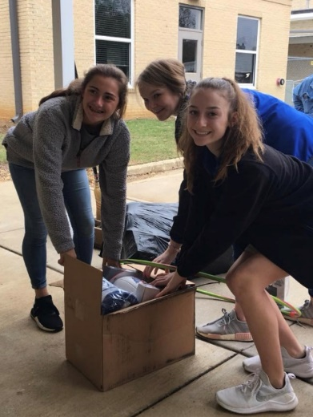

Gifts being delivered! The Christmas Shop at Target House

**Board of Directors and Management Team**

President/Founder

Mike Crask

**Retired Louisville, Ky Police Detective** 

Vice President

Betty Metzmeier

**Retired JCPS teacher**

Treasurer

Michelle Kamber

**Legal Assistant**

Secretary

Christa Hopper

**Manufacturing Supervisor**

Volunteer Coordinator CCFF

Michele Crockett

**Founder, Max Gilpin Beat the Heat Foundation**

Teri Crask

**MRI TECH , University of Louisville Hospital**

Cindy McElduff

**Director of School Outreach**

Angie Miller

**Commercial Property Manager**

Kayla Browning

**Marriott Hotels**

Ron Messina

**Warehouse Manager River City Distributing**

Amanda Crask

**JCPS School Teacher**

Nina Messina

**JCPS Schools**

Ollie Jones

**Owner, Ollie Brown Realtors**

Karen Schmitt

**IheartRadio**

Development Director

Bruce Dyal

Manager, River City Distributing

**Testimonials**

**“My husband and I both had to stop working , we went from having two incomes to zero. You gave us our Christmas Miracle”**

##### A Target House Parent said…

# “We loved being able to partner with you! The Christmas Shop photos you sent were amazing. We plan on using them on our social media accounts to highlight the fabulous work you are doing. Thanks for letting us be a part of this every year.”

--**Katy Willis, Marietta Hospitality**

“Thank you for all you do for the families at Target House. You always go above and beyond, and your efforts are so appreciated. Your deeds for these families truly make a difference for them. During the Christmas Shop one mother told me she would not have had the money for any Christmas gifts for her children if not for your generosity.”

**--St. Jude Target House staff member**

“It takes so much out of me to see my daughter sick like this. It breaks my heart, but to see her smiling at all the presents and everything today, I’m so happy”

**--Target House pediatric cancer parent**

# 

##### For more information, articles and updates, go to [www.ccff.info](http://www.ccff.info)

##### or our Facebook Page Childhood Cancer Family Fund

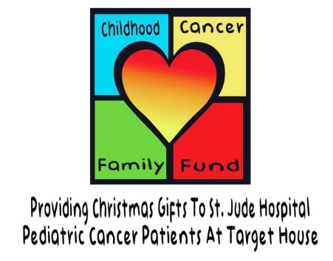

**\*In 2018 we distributed $80,000 of gifts to the families at St. Jude Hospital’s Target House.**

**\*Through a donation from partner Marietta Hospitality we distributed another $120,000 in toiletries to Target House and child and family related nonprofits in Louisville and Memphis.**

**\*In 2019 we have already distributed over $467,000 in gifts and goods to St. Jude families as part of Christmas in July.**

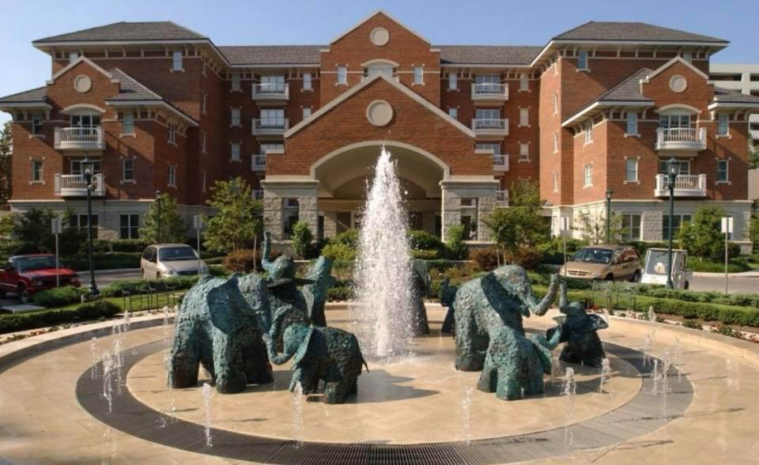

**St Jude Hospital’s Target House**

**Go to Santacause.info to sign up today**

**Cindy McElduff, Program Director**

[cwmcelduff@aol.com](mailto:cwmcelduff@aol.com)

**Mike Crask, President CCFF**

[mikecrask@ccff.info](mailto:mikecrask@ccff.info)

502-930-9601

**100% of all monies, gift cards or gifts donated go directly to St. Jude families at Target House.**

